 | Letter to Fellows  The Future of the Rowland Foundation  April 2022
Dear Rowland Fellows,

I hope this message finds you and your loved ones doing well this spring.

The Rowland Foundation needs your help. When our Board of Trustees meets in May, we will be revisiting our mission statement and thinking about what the next chapter of the Rowland Foundation looks like. As a Rowland Fellow, your experience and ideas need to inform this discussion.

Please take 15 minutes to complete this All Fellows Survey to give back to the Rowland Foundation, a unique organization that means so much to all of us. We need your perspective as a Rowland Fellow to shape the important decisions in the years to come. If you have already completed the survey, deepest thanks for sharing your experience and great ideas!

The All Fellows Survey will close on Friday, April 8th, at which time we will compile and code the data we’ve received in order to bring that information to the Board of Trustees in May. We will also share a summary of results with all of you, esteemed and valued Rowland Fellows, so that you can see the themes that emerge in the responses we receive. Special thanks to Dr. Caitlin Steele, who shared her knowledge of qualitative methods & survey design with me as we developed the survey.

As we think about the future of the Rowland Foundation, here are some of the questions that have been coming up.

Should the Rowland Foundation…
- make Fellowships available to teachers at more age levels? (e.g., Grades 5-12, Grades pk-12)
- support women leaders in Vermont education by making the Rowland Women’s Retreat an annual event?
- help diversify the educator workforce in Vermont? If so, could this lead to more diversity amongst our Fellows?
- host more events to bring together the extended Family of Fellows?
- use media (e.g., video, podcasts, infographics) to publicly share the impact of Fellowship projects?

Of course, many of us are thinking about the future of school in this moment. What does it mean to cultivate strong school communities? What is the democratic mission of public school? What are the essential skills all learners need…and how should we rethink how we teach them?

Along these lines, Heidi Lynn recently sent me this article from Sir Ken Robinson, our very first Rowland keynote speaker back in 2012. And in case you missed it, you might also appreciate this article from Elijah Hawkes, a frequent Rowland Conference presenter and former Rowland principal. Finally, I have been inspired by the work of Gholdy Muhammad, especially her reframing around deficit thinking in education and its impact on our young people. Feel free to check in with any and all of these articles as you think about the future of education and the future of the Rowland Foundation.

Take care and see you soon,

Mike

P.S. Please send me your news! Each month, I’m sharing courtesy posts for upcoming courses & events, and also celebrating new jobs, family vacations, and other news from our extended Rowland Family of Fellows. So please email whatever you’d like to share to michael@therowlandfoundation.org

Rowland Foundation Updates

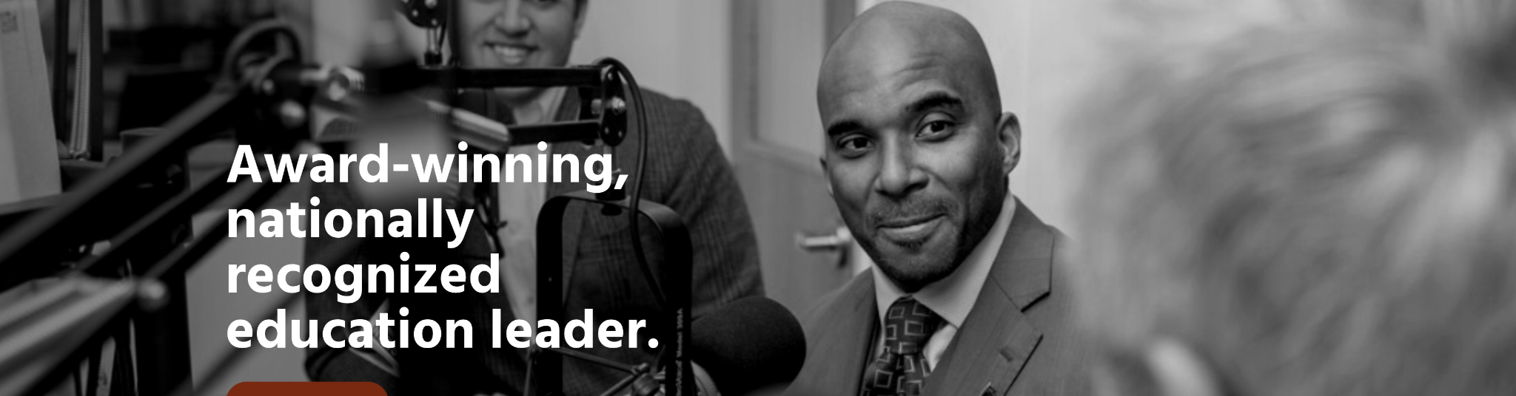
Dr. Luvelle Brown will be the keynote speaker for the 11th Annual Rowland Conference! Dr. Brown serves as Superintendent of Ithaca City School District in New York, and self-identifies as a father, community leader, educator and author. Dr. Brown has already made critical contributions to equity work in Vermont as a consultant, and we’re thrilled to welcome him as keynote speaker for the next Annual Rowland Conference at UVM’s Davis Center on Wednesday, October 26, 2022 with the working theme of Cultivating Authentic Community: Engaging All Stakeholders.

Do you have an idea for a Rowland Conference workshop that connects with this theme? If so, feel free to send us a workshop proposal by downloading, completing, and submitting this Rowland Conference Workshop Proposal Form to Mike Martin by June 1st. Also, feel free to share this opportunity with your colleagues or local experts who would be great presenters.

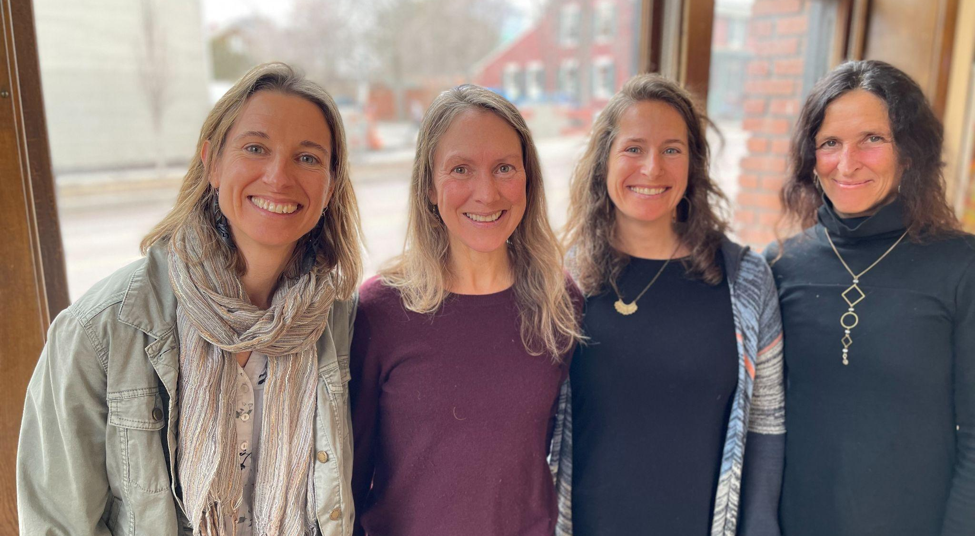
Our first-ever Rowland Encore Grant Team met at the Rowland Offices to begin work on their project, which focuses on technology & wellbeing. Seen here (left to right) Lissa Knauss (RF18), Carrie Felice (RF13), Sarah Ibson (RF13), and Anne Bergeron (RF11).

Our Rowland Leadership Grants are well underway, thanks to the vision and hard work of Luke Dorfman (RF19) and Brian Boyes (RF14). If you would like to get involved with either of these terrific projects, feel free to reach out directly to these outstanding educators:

Rowland Foundation Podcast Series
Luke Dorfman (RF19) ldorfman@wsdvt.org

Popular Music Education
Brian Boyes (RF14) Brian.Boyes@ccsuvt.net

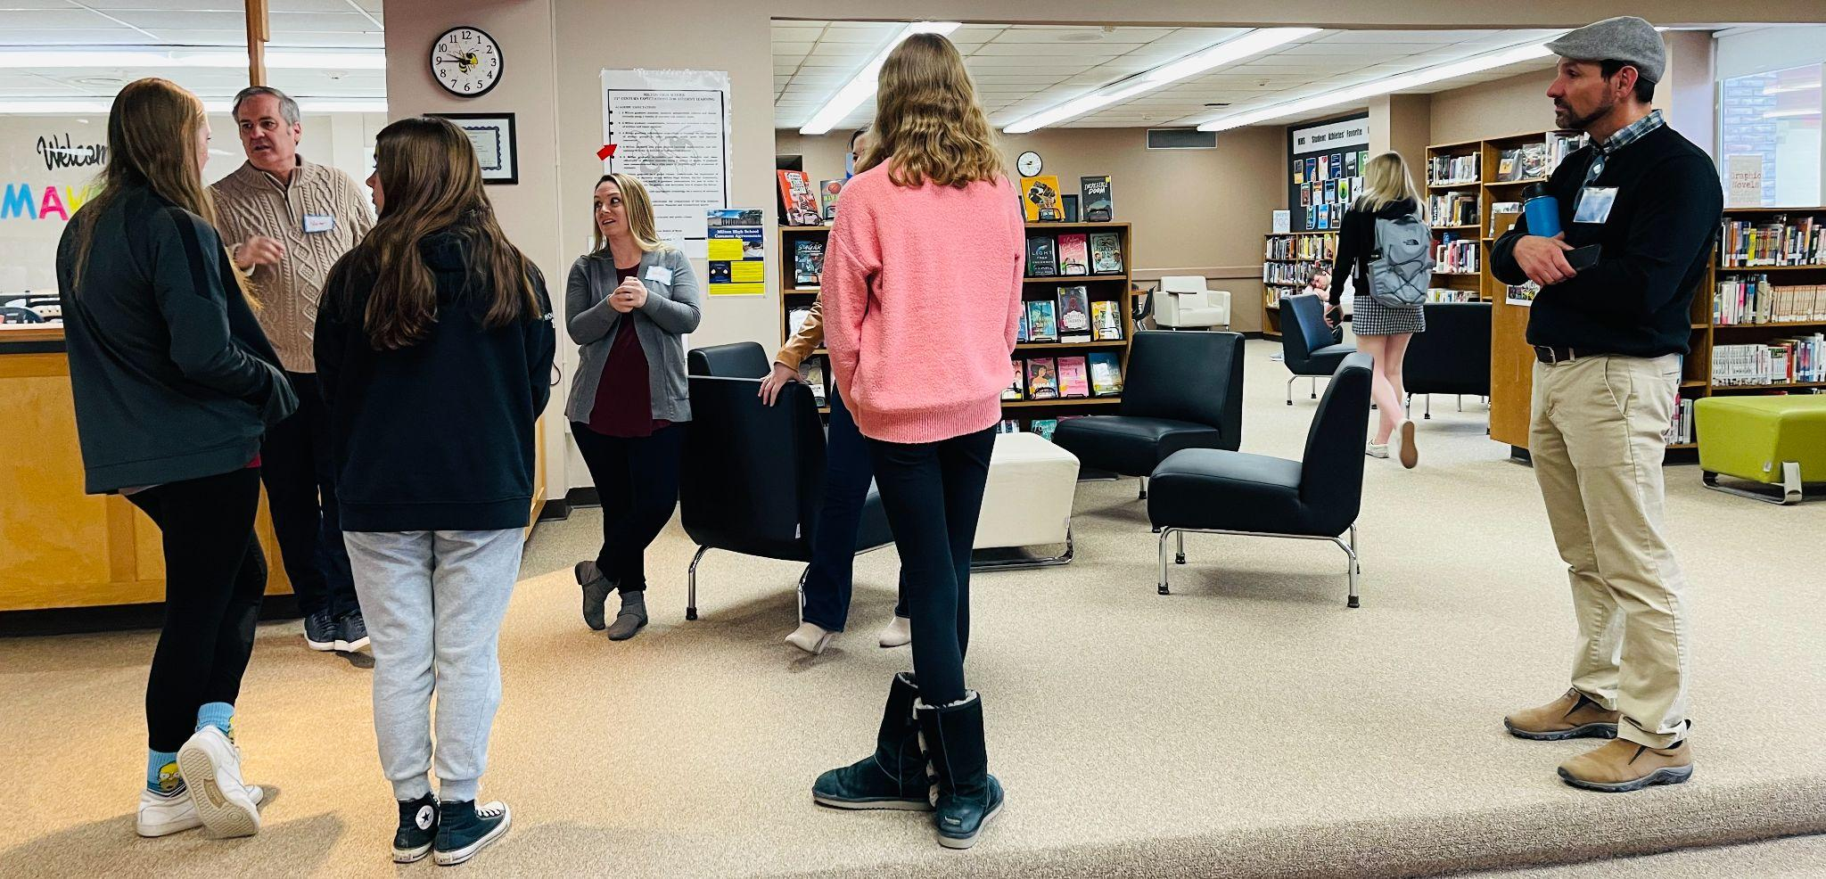
Amazing day at Milton High School with 2020 Rowland Fellows. Charlie MacFadyen, Kristin Cimonetti & Senior Associate Jean Berthiaume seen here talking with students.

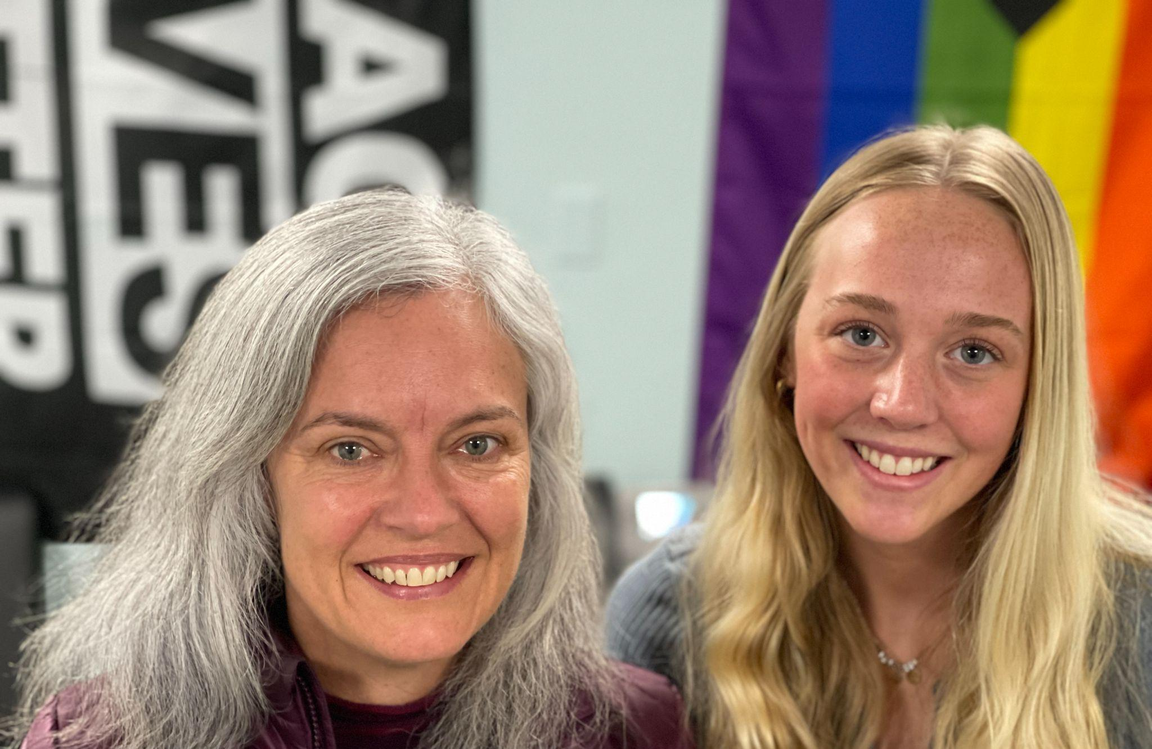
Stacey Shortle (RF20) and student representative Kira McDonald seen here at Milton’s new Racial Justice Center.
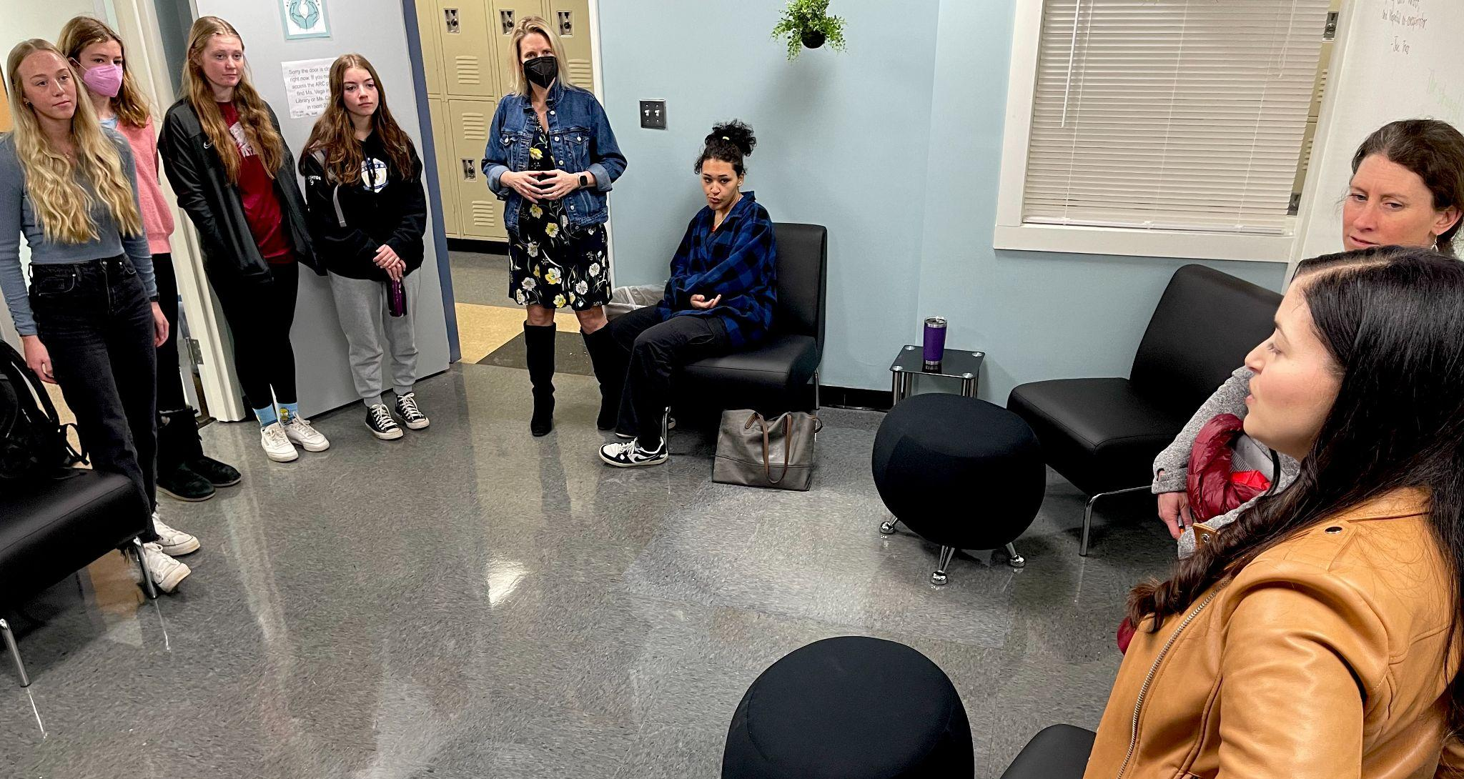
Maryann Carlson (RF20), Jillian Joyce (RF20) & Allie Vega (RF20) talking with students in Milton High School’s Racial Justice Center.

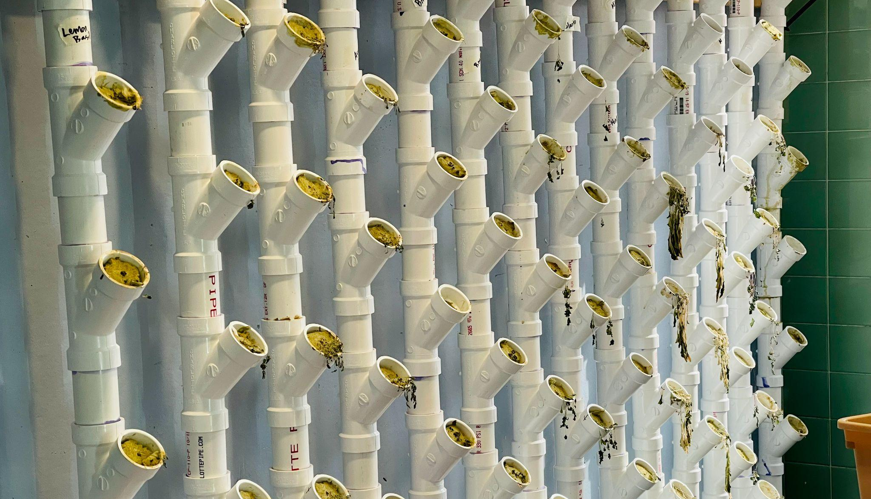
PVC planters at Milton High School ready for spring projects!

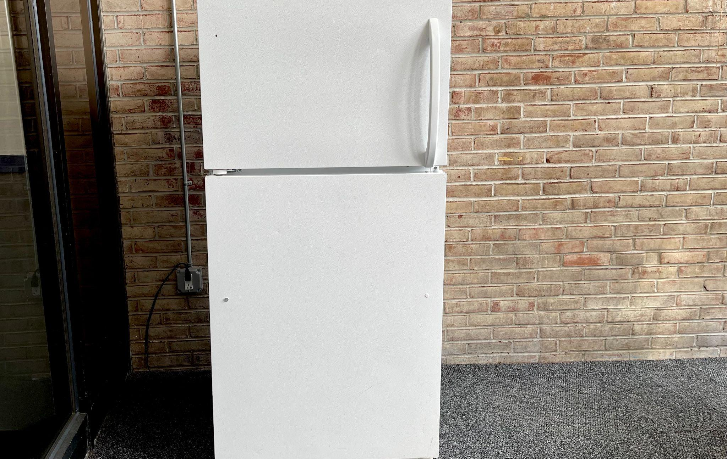
Thanks to a service learning project, ready-to-go meals are stocked and available to all students in this main lobby refrigerator at Milton High School every day.
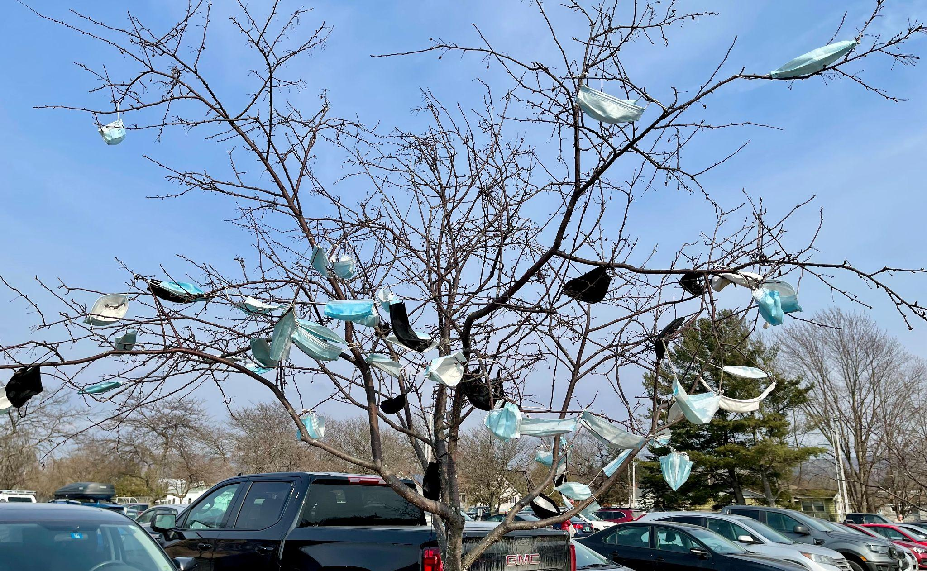
Mask tree! Signs of spring at Milton High School?

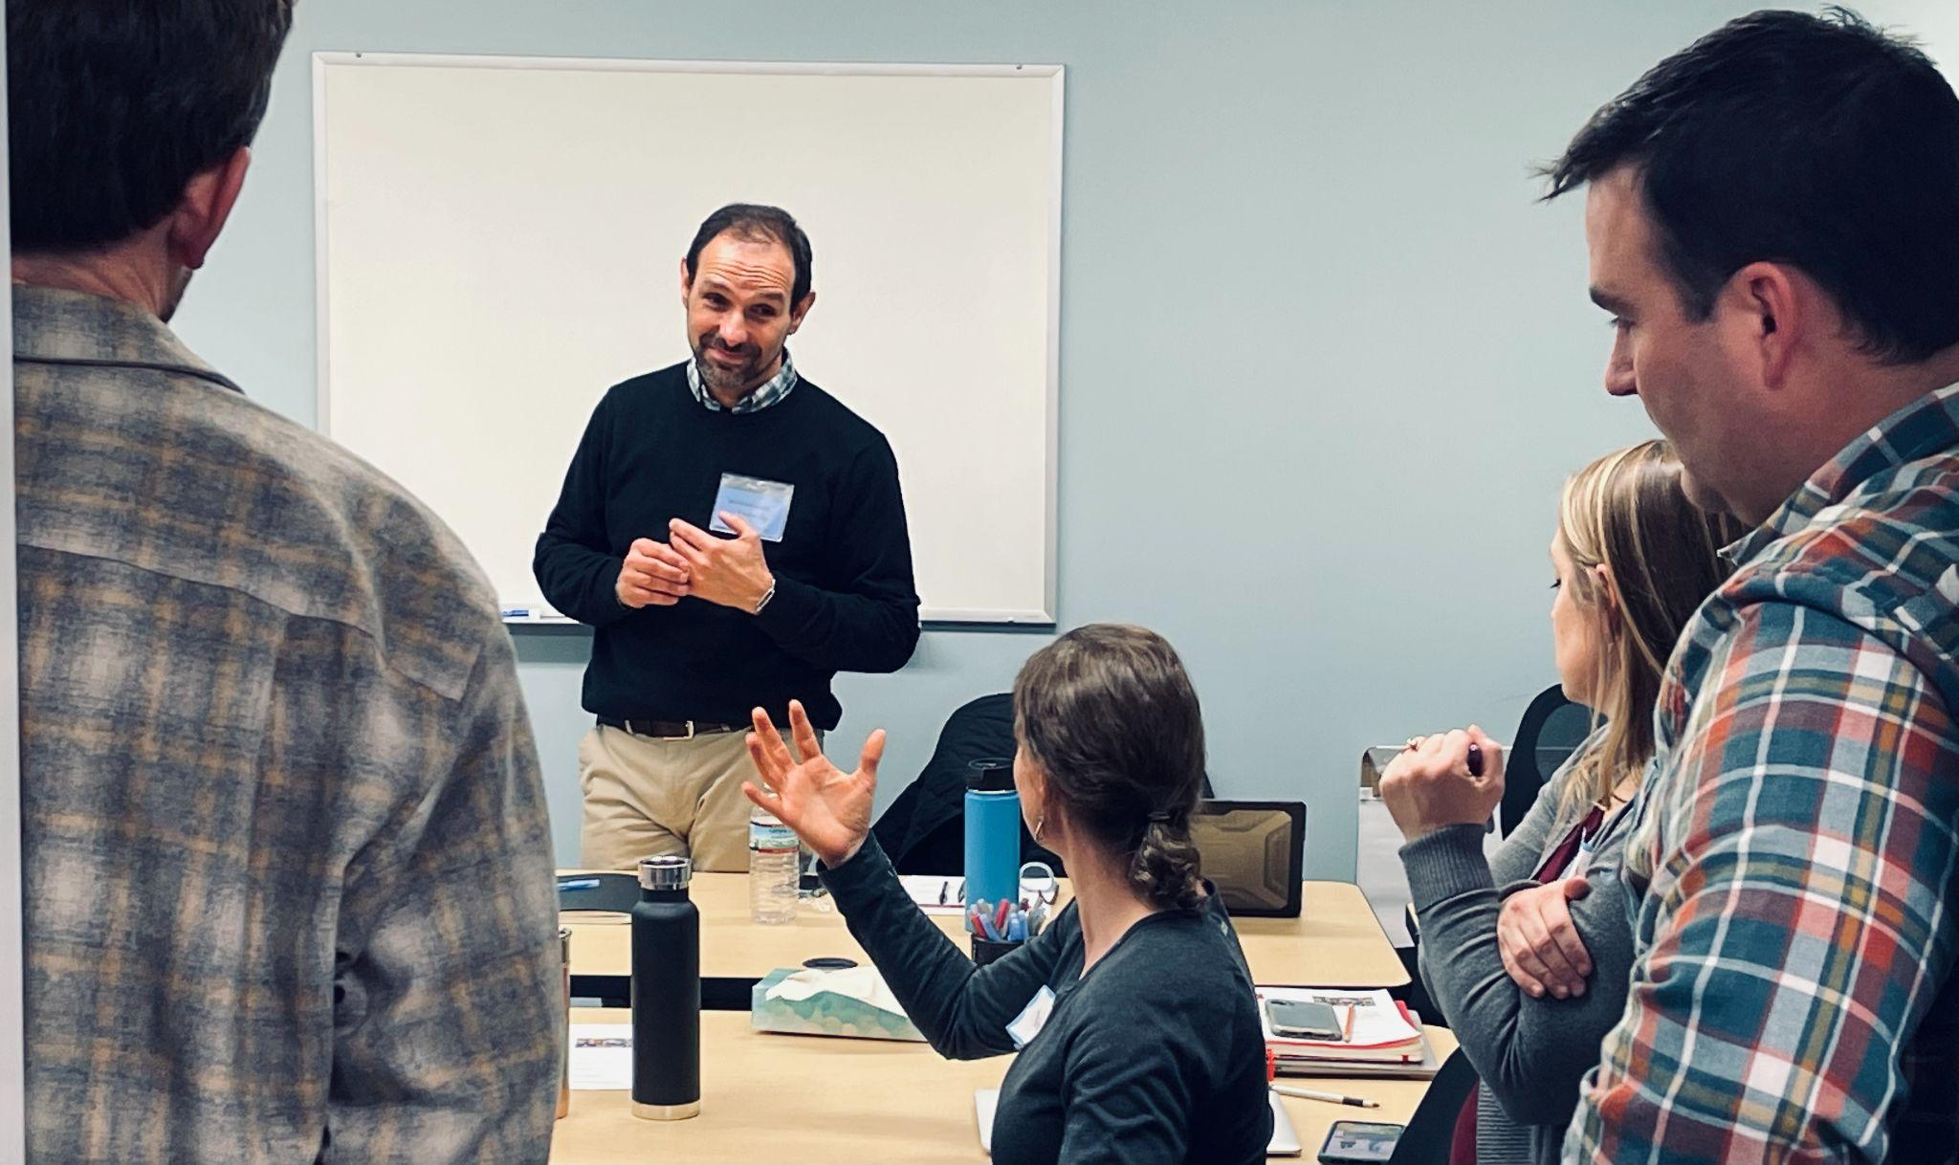
Senior Associate Jean Berthiaume facilitating a 2020 Cohort discussion at Milton High School. Seen here (foreground, left to right) Ben Heintz, Jillian Joyce, Kristin Cimonetti & Tim O’Leary.

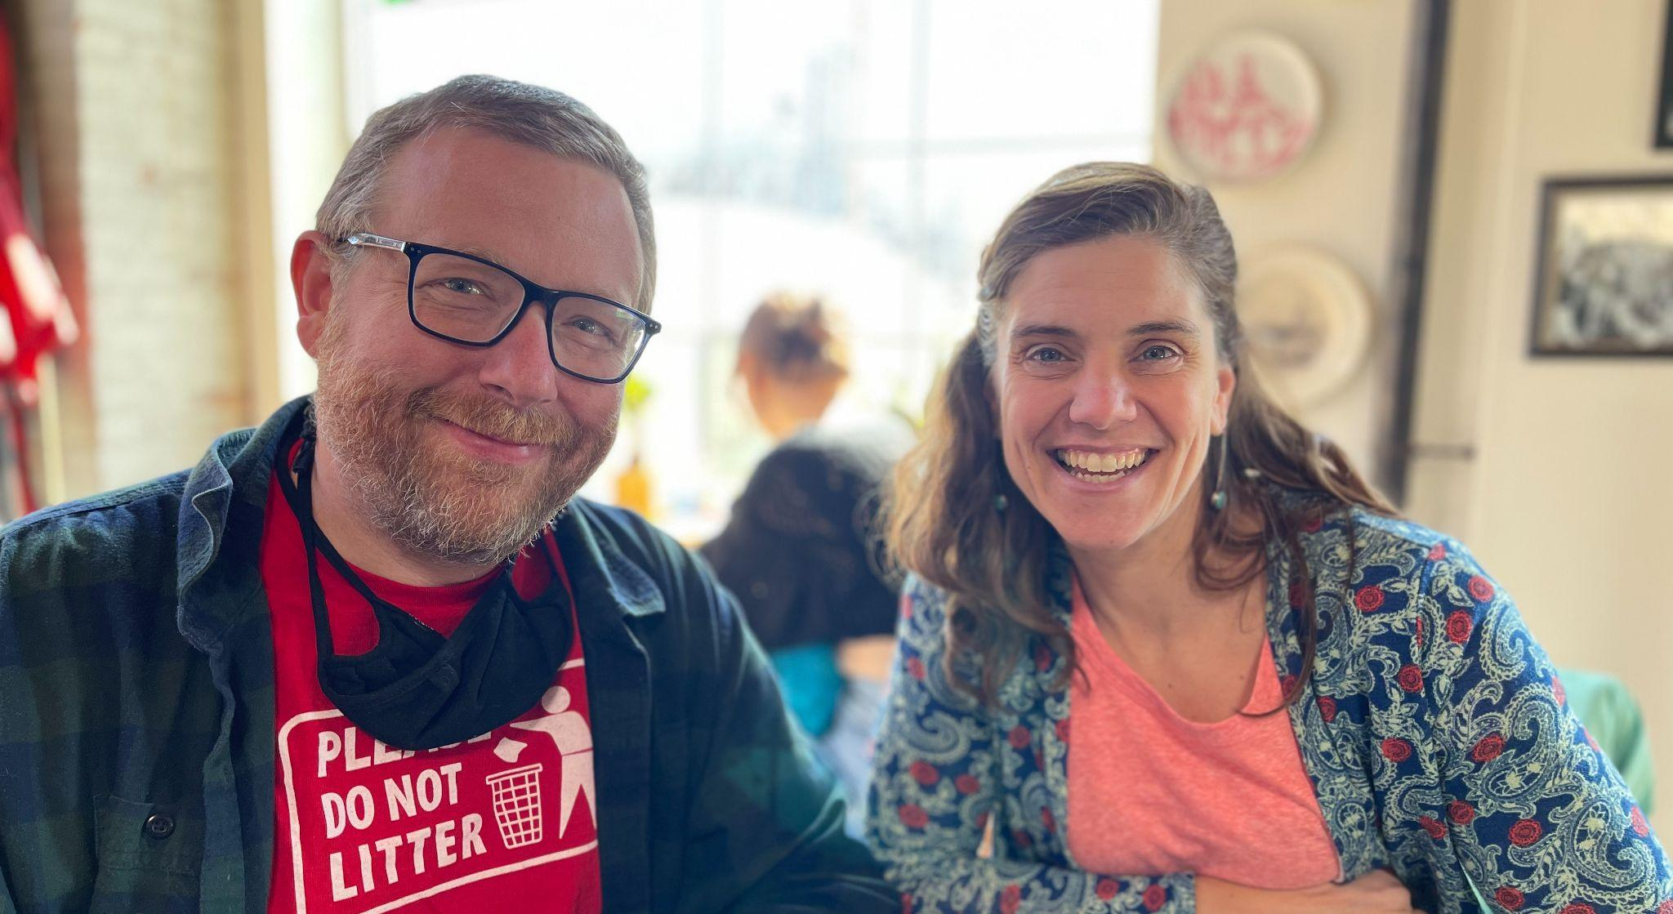
Brent Litterer (RF21) & Rachel Howe (RF21) had lunch with Mike to discuss school budgets, shared leadership, student voice & steering committee work.

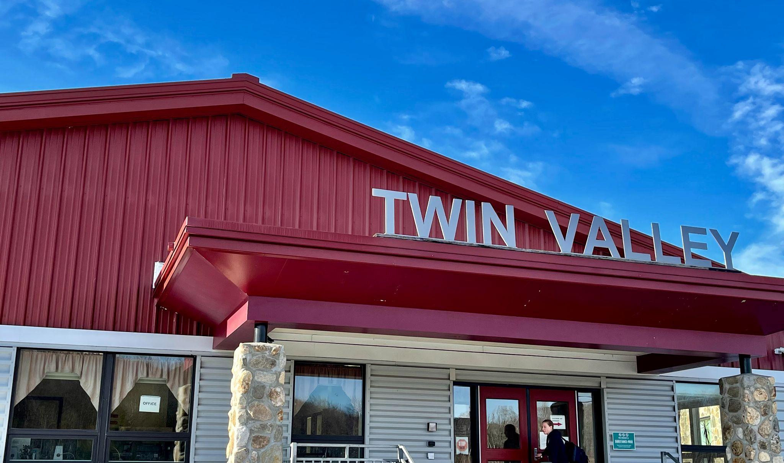
The 2021 Cohort of Rowland Fellows met at Twin Valley Middle/High School for the day.

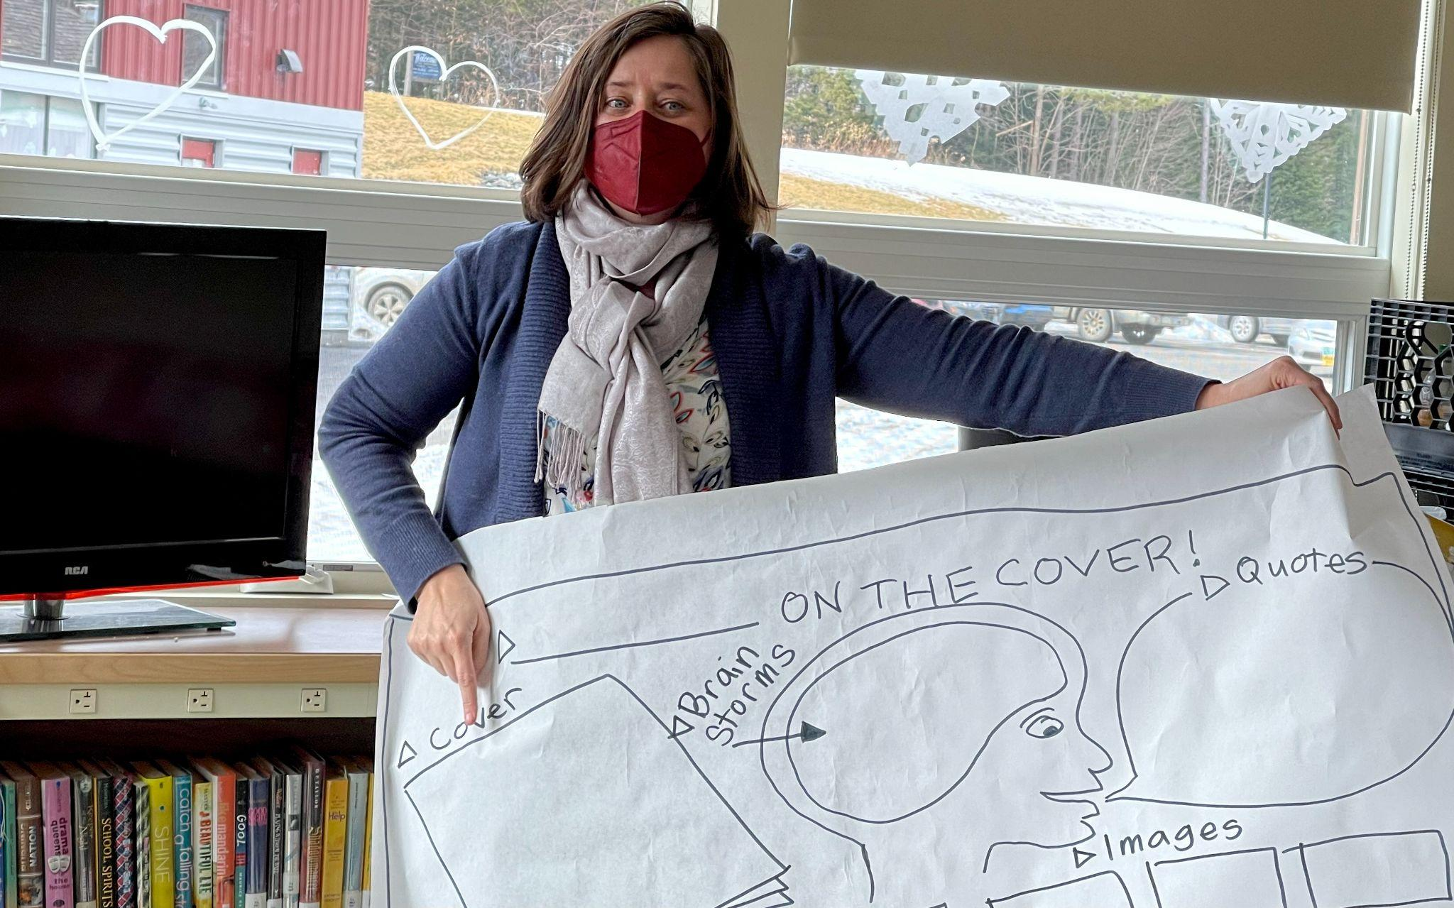
Senior Associate Jeanie Phillips leading Fellows through a gamestorming activity.
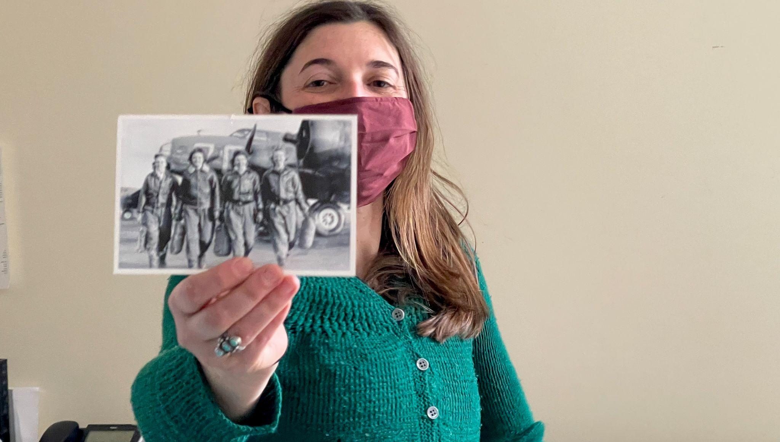
Kat Robbins (RF21) sharing some badass women heroes she identifies with.

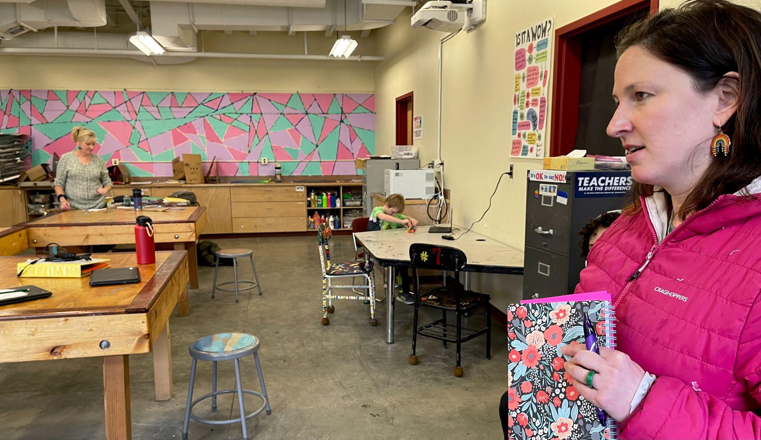
Meeting host Samantha Mundt (RF21) giving a tour of Twin Valley.
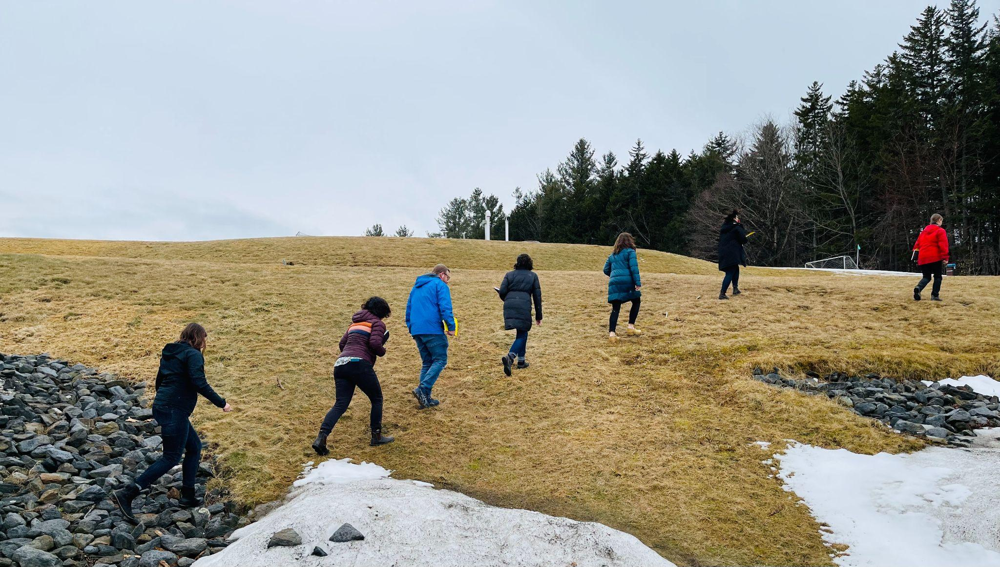
Anja Pfeffer (RF21) leading the 2021 Cohort through some Dare to Be Me place-based learning activities.
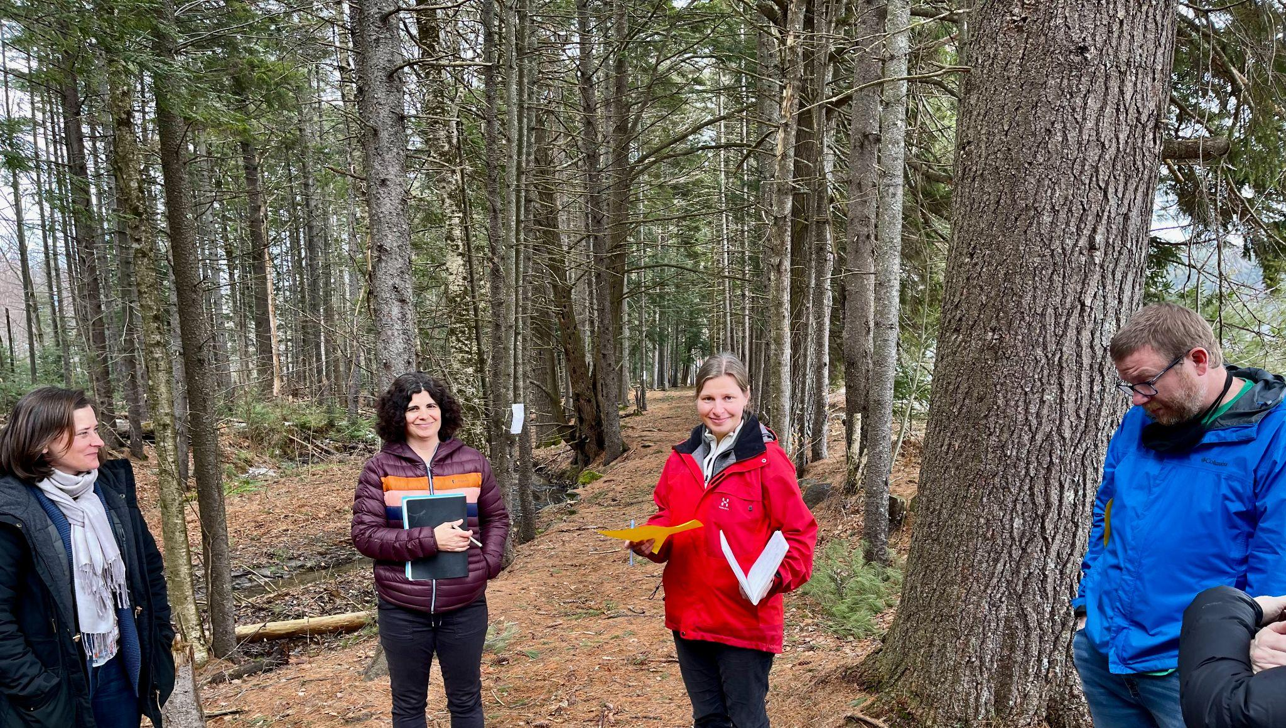
Senior Associate Jeanie Phillips, Janis Boulbol, Anja Pfeffer & Brent Litterer seen here in Dare to Be Me debrief.
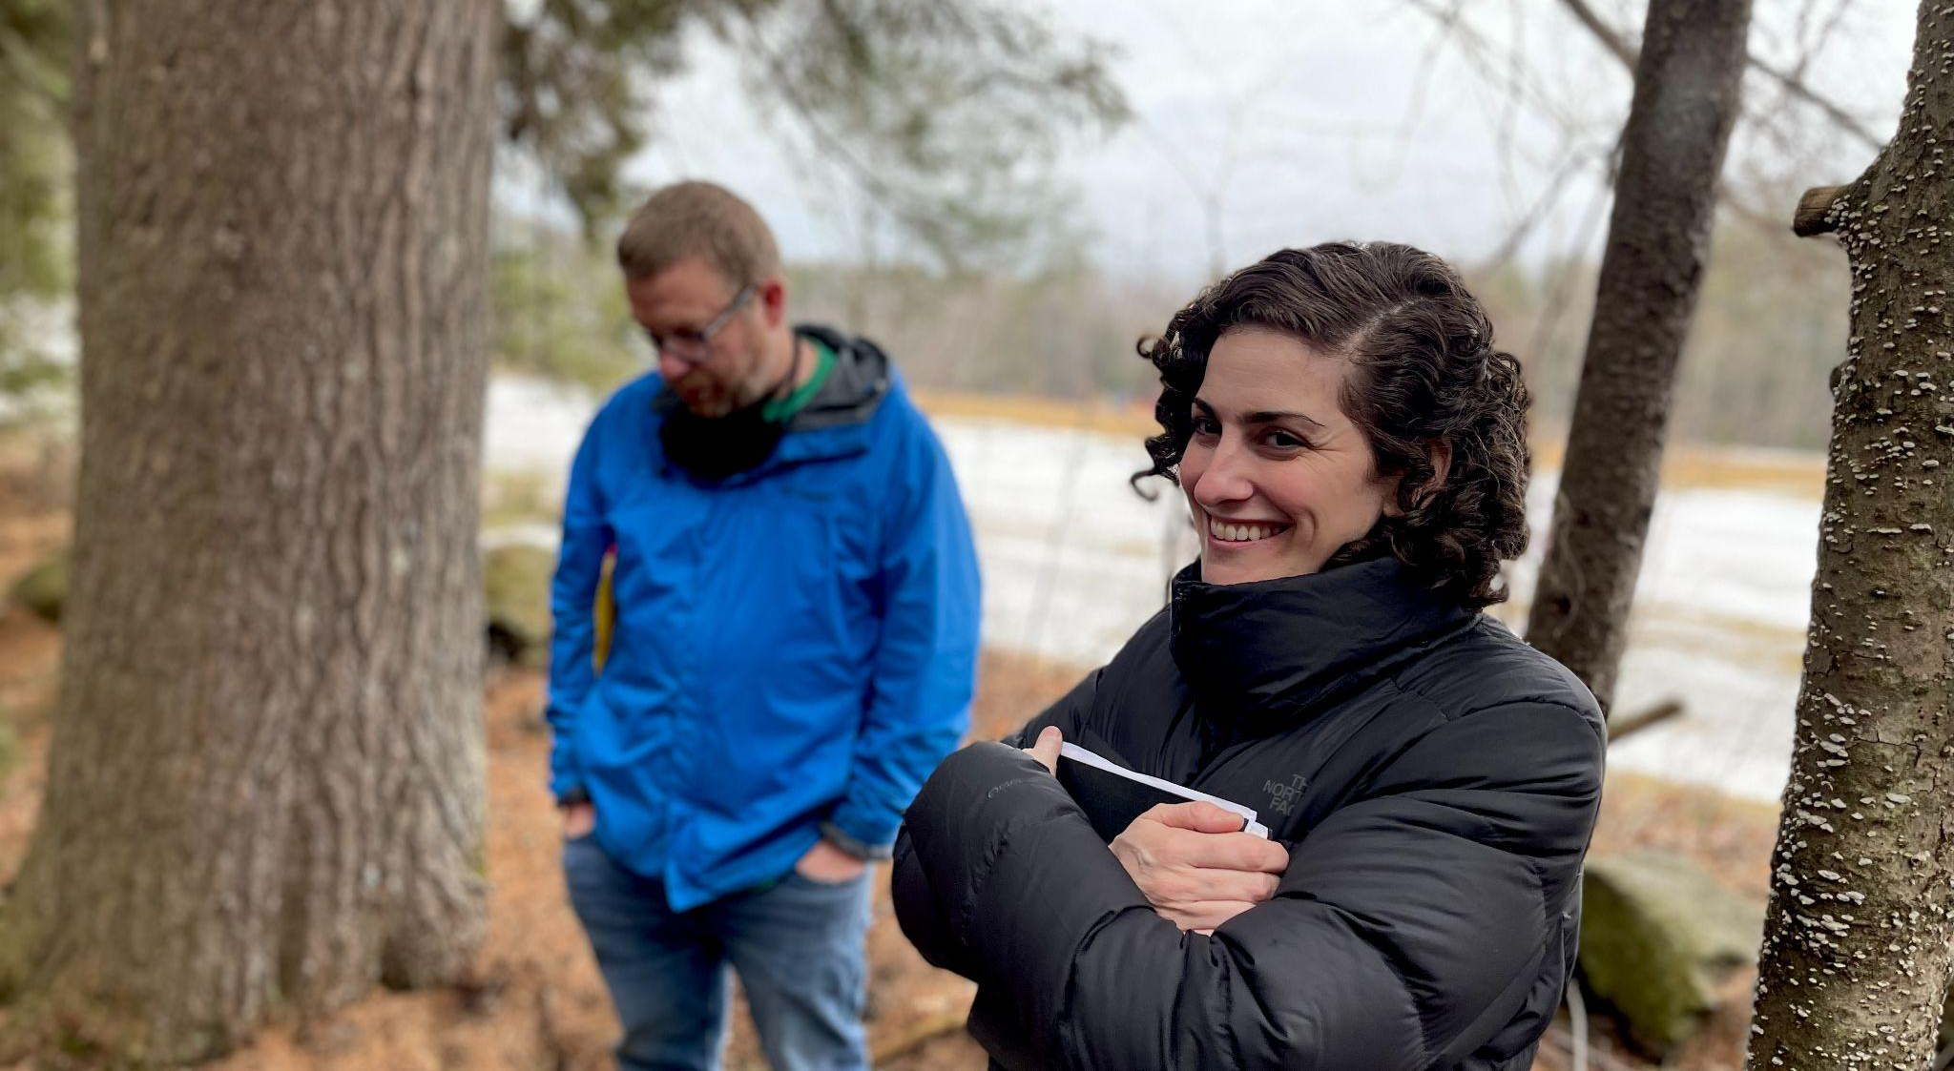
Brent Litterer (RF21) & Nicole Awwad (RF21) participating in Dare to Be Me.

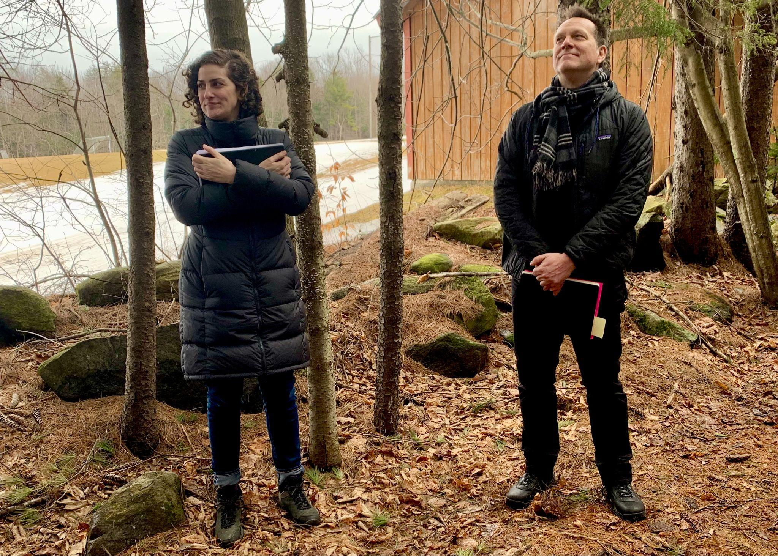
Nicole Awwad (RF21) & Executive Director Mike Martin experiencing Dare to Be Me, a “trauma-transformative and whole person approach to teaching and learning”
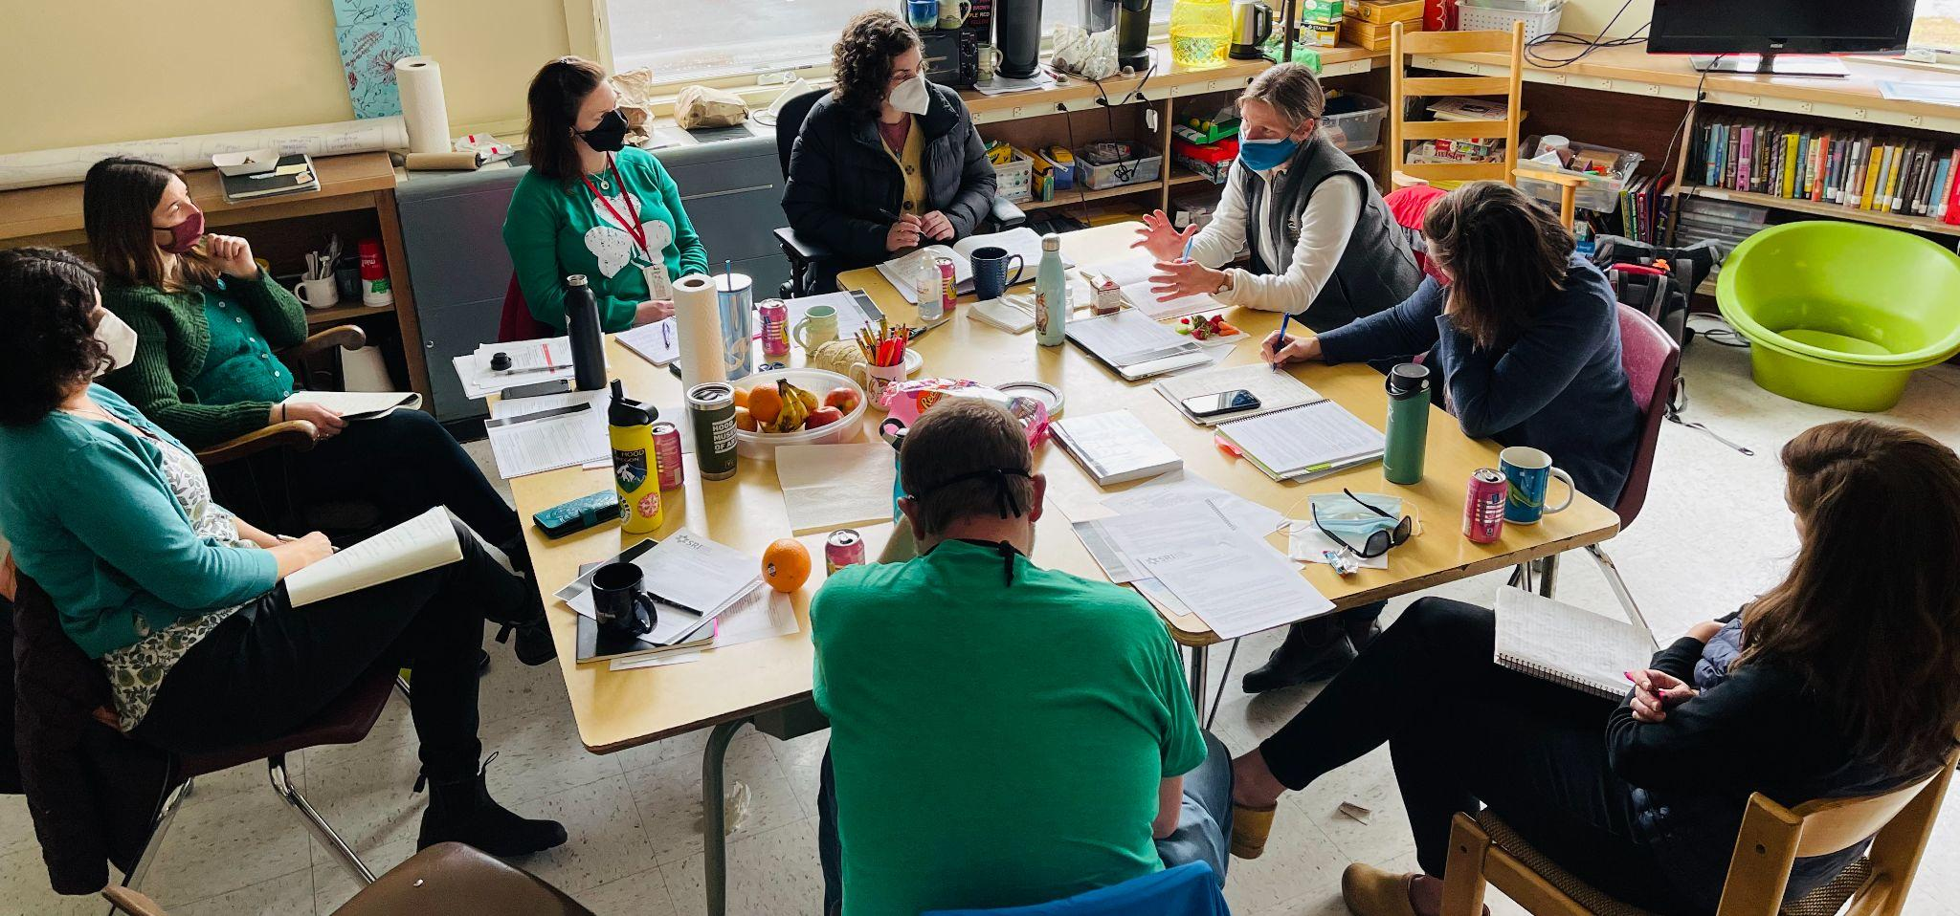
The 2021 Cohort of Rowland Fellows meeting at Twin Valley MS/HS.

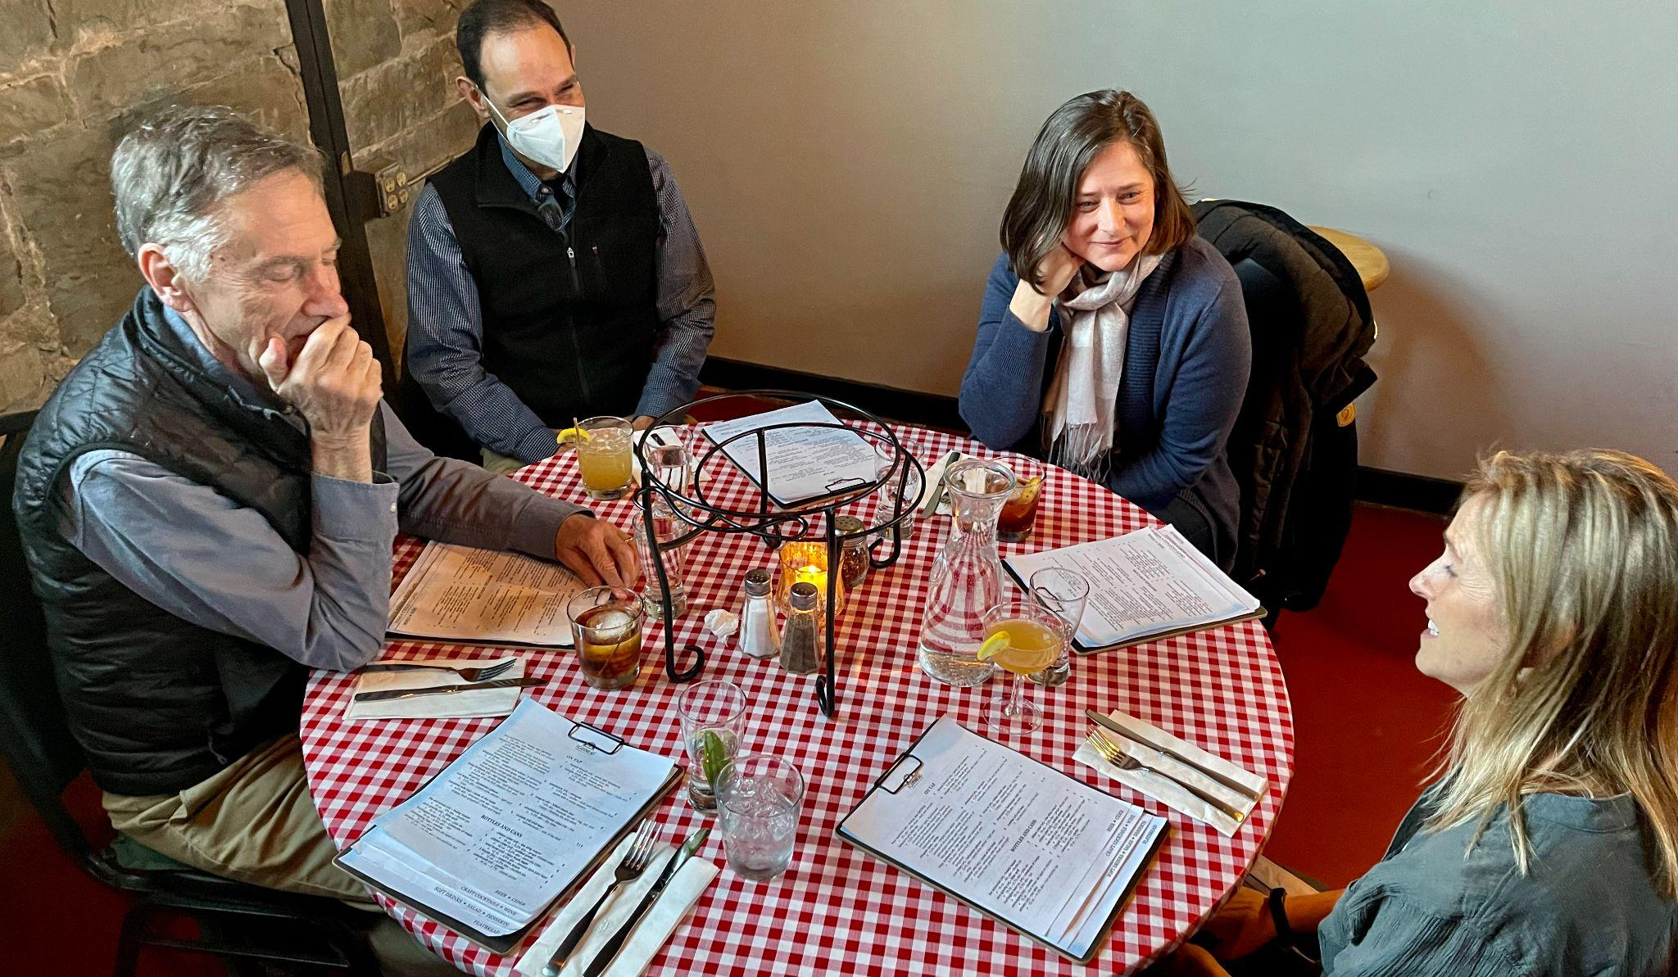
Rowland Foundation Founder & Past-Executive Director Chuck Scranton met with the Senior Associates and new Executive Director to discuss the next chapter of the Rowland Foundation over dinner together. Seen here (left to right) Chuck, Jean Berthiaume (RF09), Jeanie Phillips (RF14) & Lori Lisai (RF15).
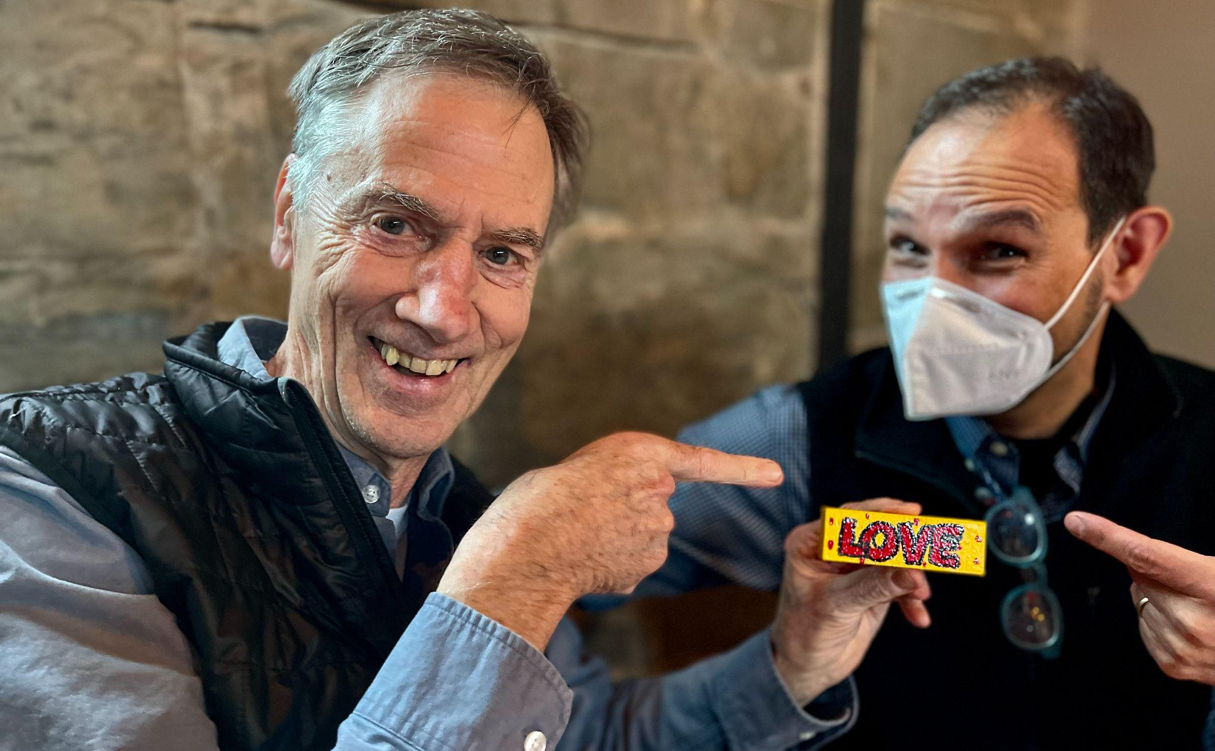
Chuck & Jean keeping the focus on what’s important about the Rowland Foundation.

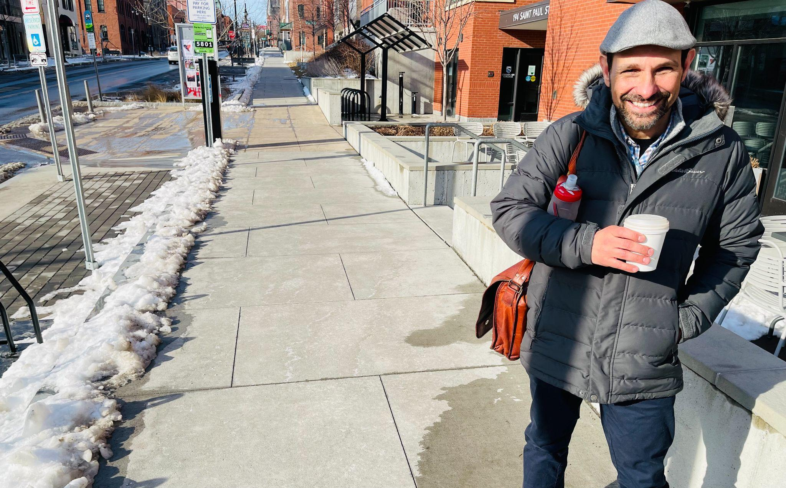
Senior Associate Jean Berthiaume on his way to the Rowland Offices to work with Mike.
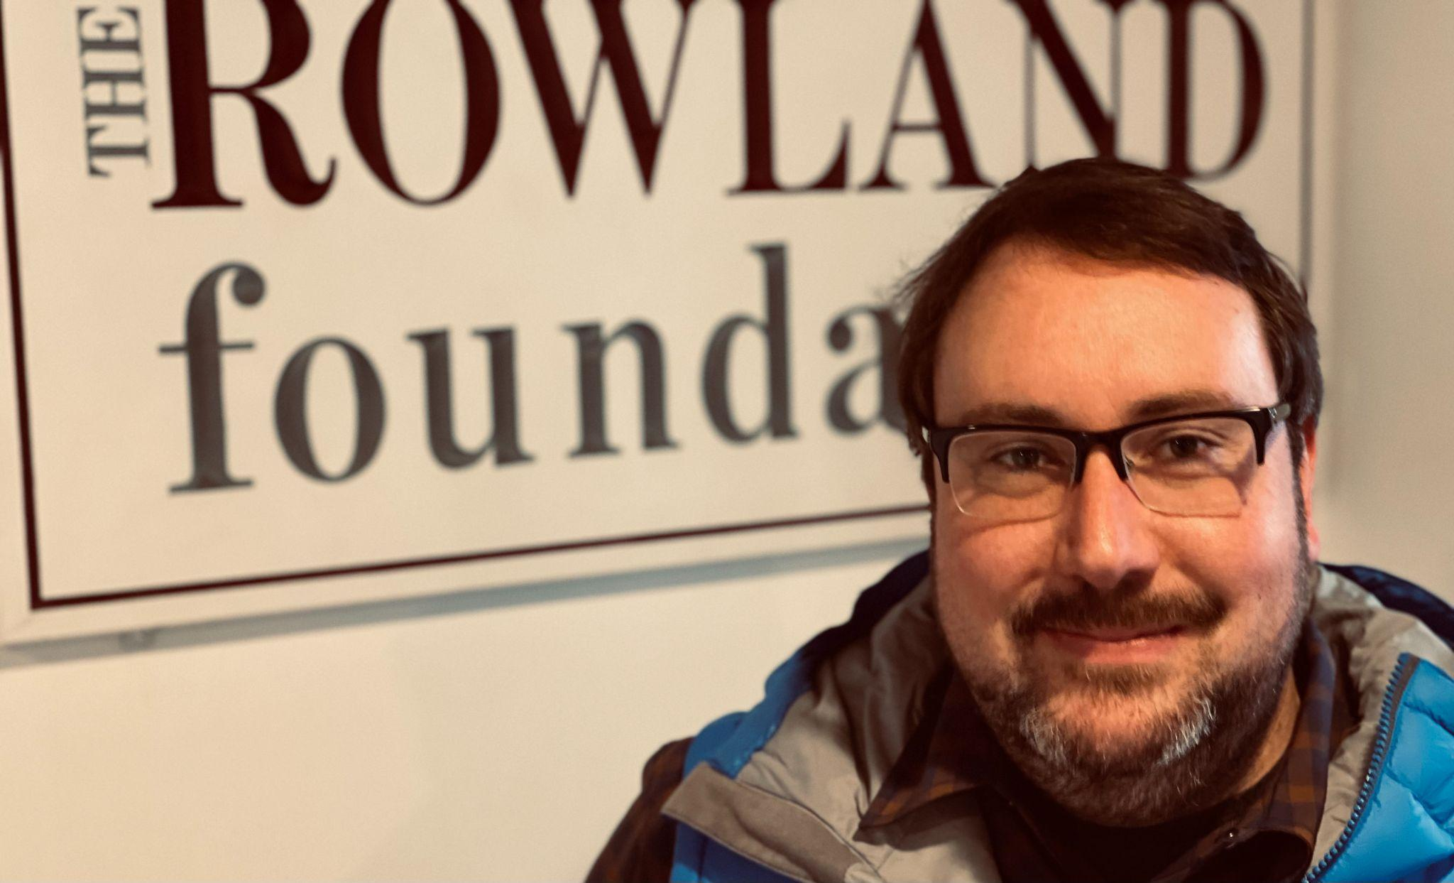
Andrew Jones (RF15) met with Mike at the Rowland Offices to discuss educational policy, school leadership, and Universal Design for Learning.

Celebrations
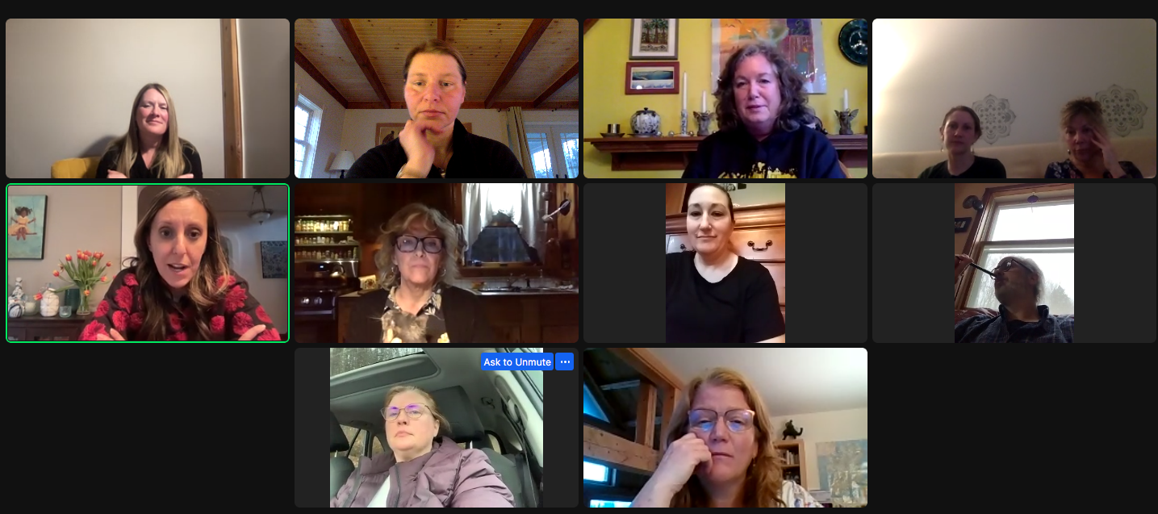
The incredible RFC21 keynote Carla Shalaby joined participants in the Dare to Be Me class taught by Anja Pfeffer (RF21) for an online discussion, including Angela Bauer (RF15). To learn more about the course and when it will be offered next, see Courtesy Postings below.

Harwood Union High School hosted Aida Conroy, currently working with Panorama Education and former Harkness faculty coach at Noble Academy in Chicago, for a two-day visit March 30 and 31. Aida has worked with the HUHS faculty and the Harkness PLC for the past four years, helping to deepen their Harkness practice. Currently over 20 HUHS faculty have been trained in Harkness and are employing this approach to student-driven inquiry in their teaching. In addition, on April 13 Harwood Harkness student leaders will travel to Hazen Union HS to teach middle and high school classes in the "power skills" of Harkness and demonstrate a Harkness discussion for the Hazen faculty. On May 4 the Harkness leaders will conduct an inservice training session for faculty at Mt Abraham UHS. For more information, contact Katherine Cadwell at katherinewcadwell@gmail.com

Jill Prado (RF11) shares that on Feb. 2, the Global Leadership Program at Essex High School, collaborated with Vermont Public Radio to host Aarti Shahani, the award-winning tech journalist for NPR, as part of the GLP Speaker Series. Shahani is also the host of the podcast Art of Power, where she’s interviewed celebrities and leaders including President Barack Obama. You can listen to the broadcast and the interview video here. Students read Aarti's memoir, Here We Are: American Dreams, American Nightmares, and contributed to the questions in the interview with VPR and Vermont Edition's Mikaela Lefrak. The Global Leadership Program (GLP) is Essex High School’s newest academy. Now in its fifth year, the innovative four-year program focuses on three core competencies: global studies, cross-cultural competency, and leadership development. Students grow through globally-focused interdisciplinary coursework, internships with Vermont companies and organizations, and experience-based academic learning beyond the traditional classroom.

Gratitude
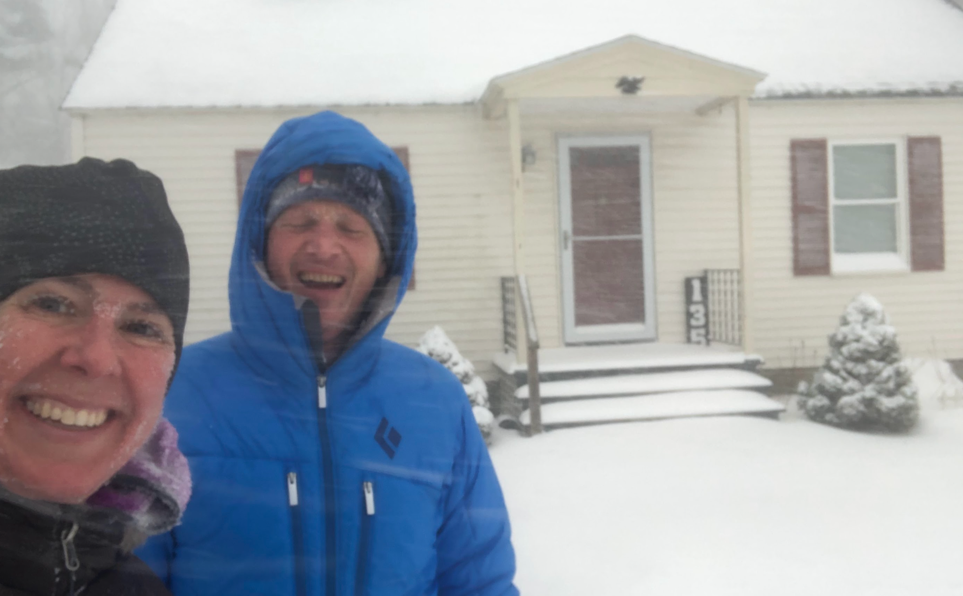
Erica Wallstrom (RF14) is moving to Brunswick, Maine at the end of this school year. She is unsure as to her next professional step, but is exploring a variety of options. Despite the geographic shift, she is thrilled to remain rooted to the work of the Rowland Foundation as an active member of the Rowland Foundation Board of Trustees. Anyone needing an ocean fix is welcome to visit!
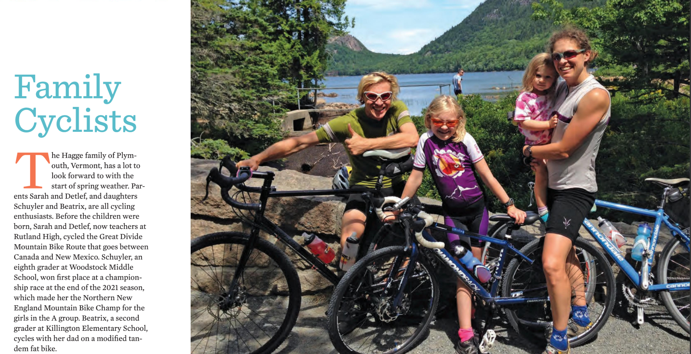
Sarah Hagge (RF16) and her family are featured in the spring edition of Woodstock Magazine. You can read the full article about their incredible passion for biking here.

Courtesy Postings
From Emily Gilmore (RF17): The Great Schools Partnership is hiring for Senior Associates!
Click here for more details regarding this amazing opportunity, and feel free to contact Emily directly to learn more about the work of GSP Senior Associates: egilmore@greatschoolspartnership.org

This summer Andrew Jones (RF15) is teaching Leading School Innovation, a 3-credit UVM graduate course that is specifically designed for teachers & administrators leading change in their schools (e.g., Rowland Fellows). If you’re interested in picking up some new change strategies with a colleague or two, this 2-week seminar may be just what you’re looking for this summer. Assuming several Rowland Fellows will take the course this year, it will also be a unique opportunity to connect and learn from each other across cohorts! UVM registration is now open. To register, click here.

Brian Boyes (RF 14) will be leading an action-based seminar on Popular Music Educators, June 28-30. This 3 day session will take place at the beautiful Sugarhouse Soundworks recording studio in the Mad River Valley. Co-taught with vocal educator Stefanie Weigand, the seminar is designed to support Vermont K-12 music educators unfamiliar to popular music pedagogy but eager to build their toolkit + expand the offerings for students in their schools. Popular Music Education is an equity-based approach to music learning that leverages authentic learning experiences in which students take the lead with the teacher supporting as coach/facilitator. Thanks to support from the Rowland Foundation, this special no-cost opportunity is open to all Vermont music educators. More info and applications can be found here.

Mike McRaith (RF13) would like to share this opportunity made available by some collaborators at MIT:

TeachLab is a podcast that investigates the art and craft of teaching, hosted by Justin Reich, director of the MIT Teaching Systems Lab. For our next season, we're collecting stories of "Subtraction in Action": examples of things that educators have stopped doing. We're trying to answer the age-old question: how do schools successfully retire certain approaches, routines, goals, and practices, so that they can make room for new ideas and innovation?

We're looking for people who have good stories along these lines. If you're an educator with an example of Subtraction in Action, large or small, we'd love to hear from you.
Please contact TeachLab producer Aimee Corrigan at aimeeco@mit.edu

Anja Pfeffer (RF21) is offering two different graduate courses this summer: Dare to Be Me (August 8-18) and Walking With Horses (July 9-15, and offered again August 1-7).
Both are weeklong intensives so that people from farther away can also attend. Since these courses will fill very quickly, and sign-ups happen on a first come, first serve basis, so anyone interested should email Anja so she can let you know when Castleton University opens the registration: anja.pfeffer@therowlandfoundation.org

