 | Letter to Fellows  Poetry  April 2023

Dear Rowland Fellows,

I hope these longer days are bringing you happiness!

Since April is both Women’s History Month and National Poetry Month, it seems appropriate to share some verse from my former colleague Kerrin McCadden, a Vermont poet who is nationally recognized.

This is the opening to Kerrin’s beautiful poem, Epistle: Leaving

Dear train wreck, dear terrible engines, dear spilled freight,
dear unbelievable mess, all these years later I think
to write back. I was not who I am now. A sail is a boat,
a bark is a boat, a mast is a boat and the train was you an me.
Dear dark, dear paper, dear files I can't toss, dear calendar
and visitation schedule, dear hello and goodbye.
If a life is one thing and then another; if no grasses grow
through the tracks; if the train wreck is a red herring;
if goodbye then sincerely. Dear disappeared bodies
and transitions, dear edge of a good paragraph.
Before the wreck, we misunderstood revision.

When you have a moment, you can read the rest of Epistle: Leaving here.

Of course, the 12th Annual Rowland Conference this fall marks the first time that we’ve had a poet/essayist as a keynote speaker, namely, Ross Gay. If you’re not familiar with his work, check out the opening to his powerful poem Catalog of Unabashed Gratitude below.

Friends, will you bear with me today,
for I have awakened
from a dream in which a robin
made with its shabby wings a kind of veil
behind which it shimmied and stomped something from the south
of Spain, its breast aflare,
looking me dead in the eye
from the branch that grew into my window,
coochie-cooing my chin,
the bird shuffling its little talons left, then right,
while the leaves bristled
against the plaster wall, two of them drifting
onto my blanket while the bird
opened and closed its wings like a matador
giving up on murder,
jutting its beak, turning a circle,
and flashing, again,
the ruddy bombast of its breast
by which I knew upon waking
it was telling me
in no uncertain terms
to bellow forth the tubas and sousaphones,
the whole rusty brass band of gratitude
not quite dormant in my belly—
it said so in a human voice,
“Bellow forth”—
and who among us could ignore such odd
and precise counsel?

You can read the rest of this joyful poem by Ross Gay here. Or you can hear him read it in this Bon Iver collaboration here. Please note! Probably not for young children. You’ll encounter some saucy language and adult moments therein.

I got hooked on Ross Gay when Jeanie Phillips lent me The Book of Delights during the pandemic. When I felt flat or a little low, I’d open it up to a random page and savor one of its poignant and usually really funny vignettes. Right now, I’m making my way through Ross Gay’s Be Holding which is a fantastic love song to Dr. Julius Irving, amongst other things.

If you’re looking for Ross Gay’s latest book, be sure to check out Inciting Joy, which is a collection of essays that really knocked me back on my heels.

If you’re interested in a great conversation about writing, amongst other things, check out this interview with Ross Gay where one piece of advice he offers young writers is “Look at plants.”

Wishing you all the joys of spring.

Take care and see you soon,

Mike

P.S. I send this letter out to all Rowland Fellows & Trustees every first Friday of the month. Please consider sending me your news, photos, courtesy postings, and anything else you would like to share with our vibrant network of Rowland Fellows.

Rowland Foundation Updates

Introducing the 2023 Cohort of Rowland Fellows!
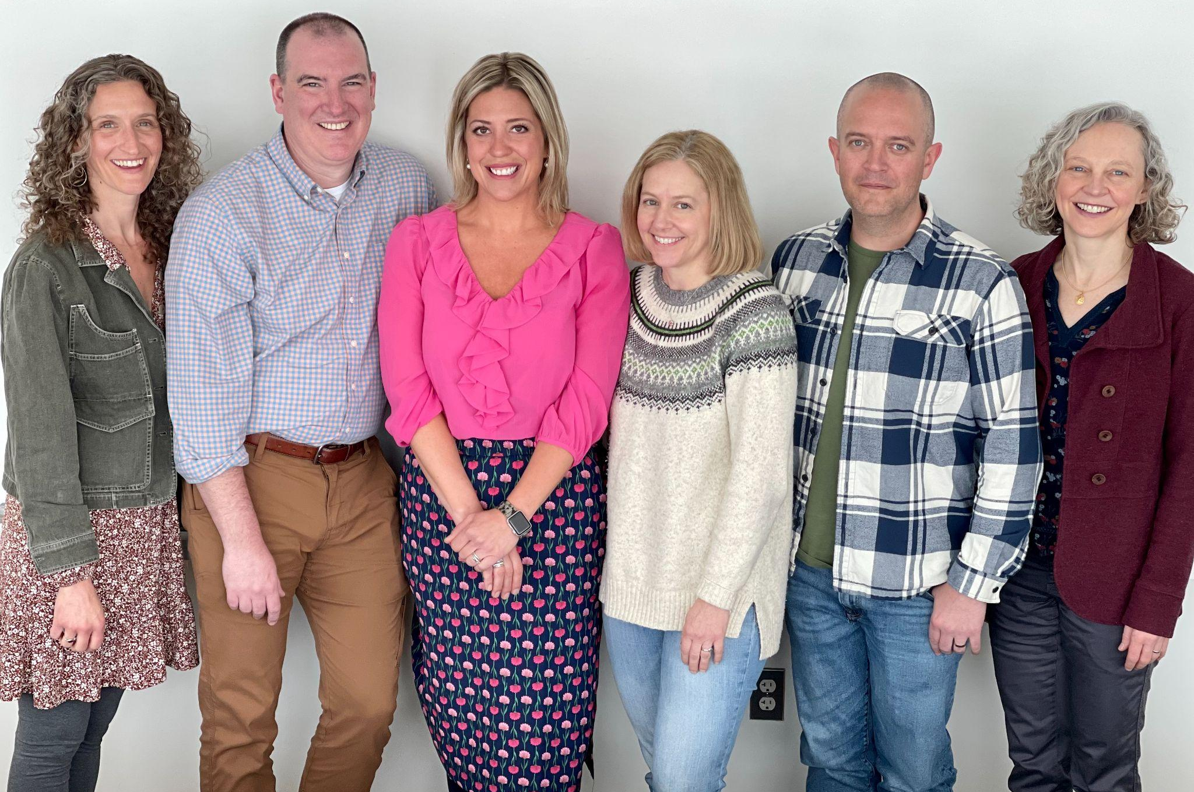
Seen here at New Fellows Orientation (left to right) Jessica Kessler, Christopher Sheehan, Carrie Gilman, Elizabeth Placencia, Adam Murray & Lindsay McQueen

12th Annual Rowland Conference Keynote Ross Gay
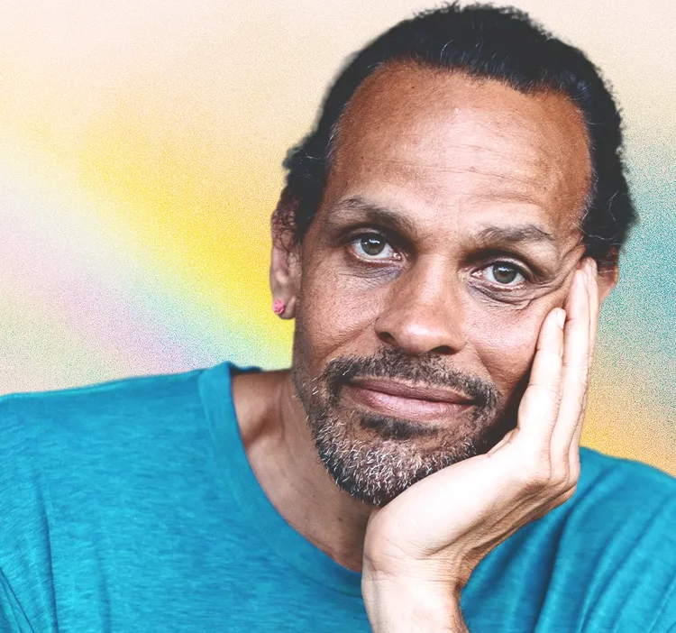
Yes! The essayist, poet, and educator Ross Gay will be our next keynote speaker for the 12th Annual Rowland Conference, to take place at UVM on Thursday, October 26, 2023. Dr. Gay is a professor at Indiana University Bloomington and the author of the New York Times best-seller The Book of Delights. His new book of essays is Inciting Joy. Stay tuned for early bird registration which opens on May 5th!

Call for Proposals: 12th Annual Rowland Conference
Do you or someone you know have a great workshop idea that connects with our conference theme of Growing Community: Making Space for Joy & Creativity in School? If so please, submit your proposal using this form on or before May 15, 2023.

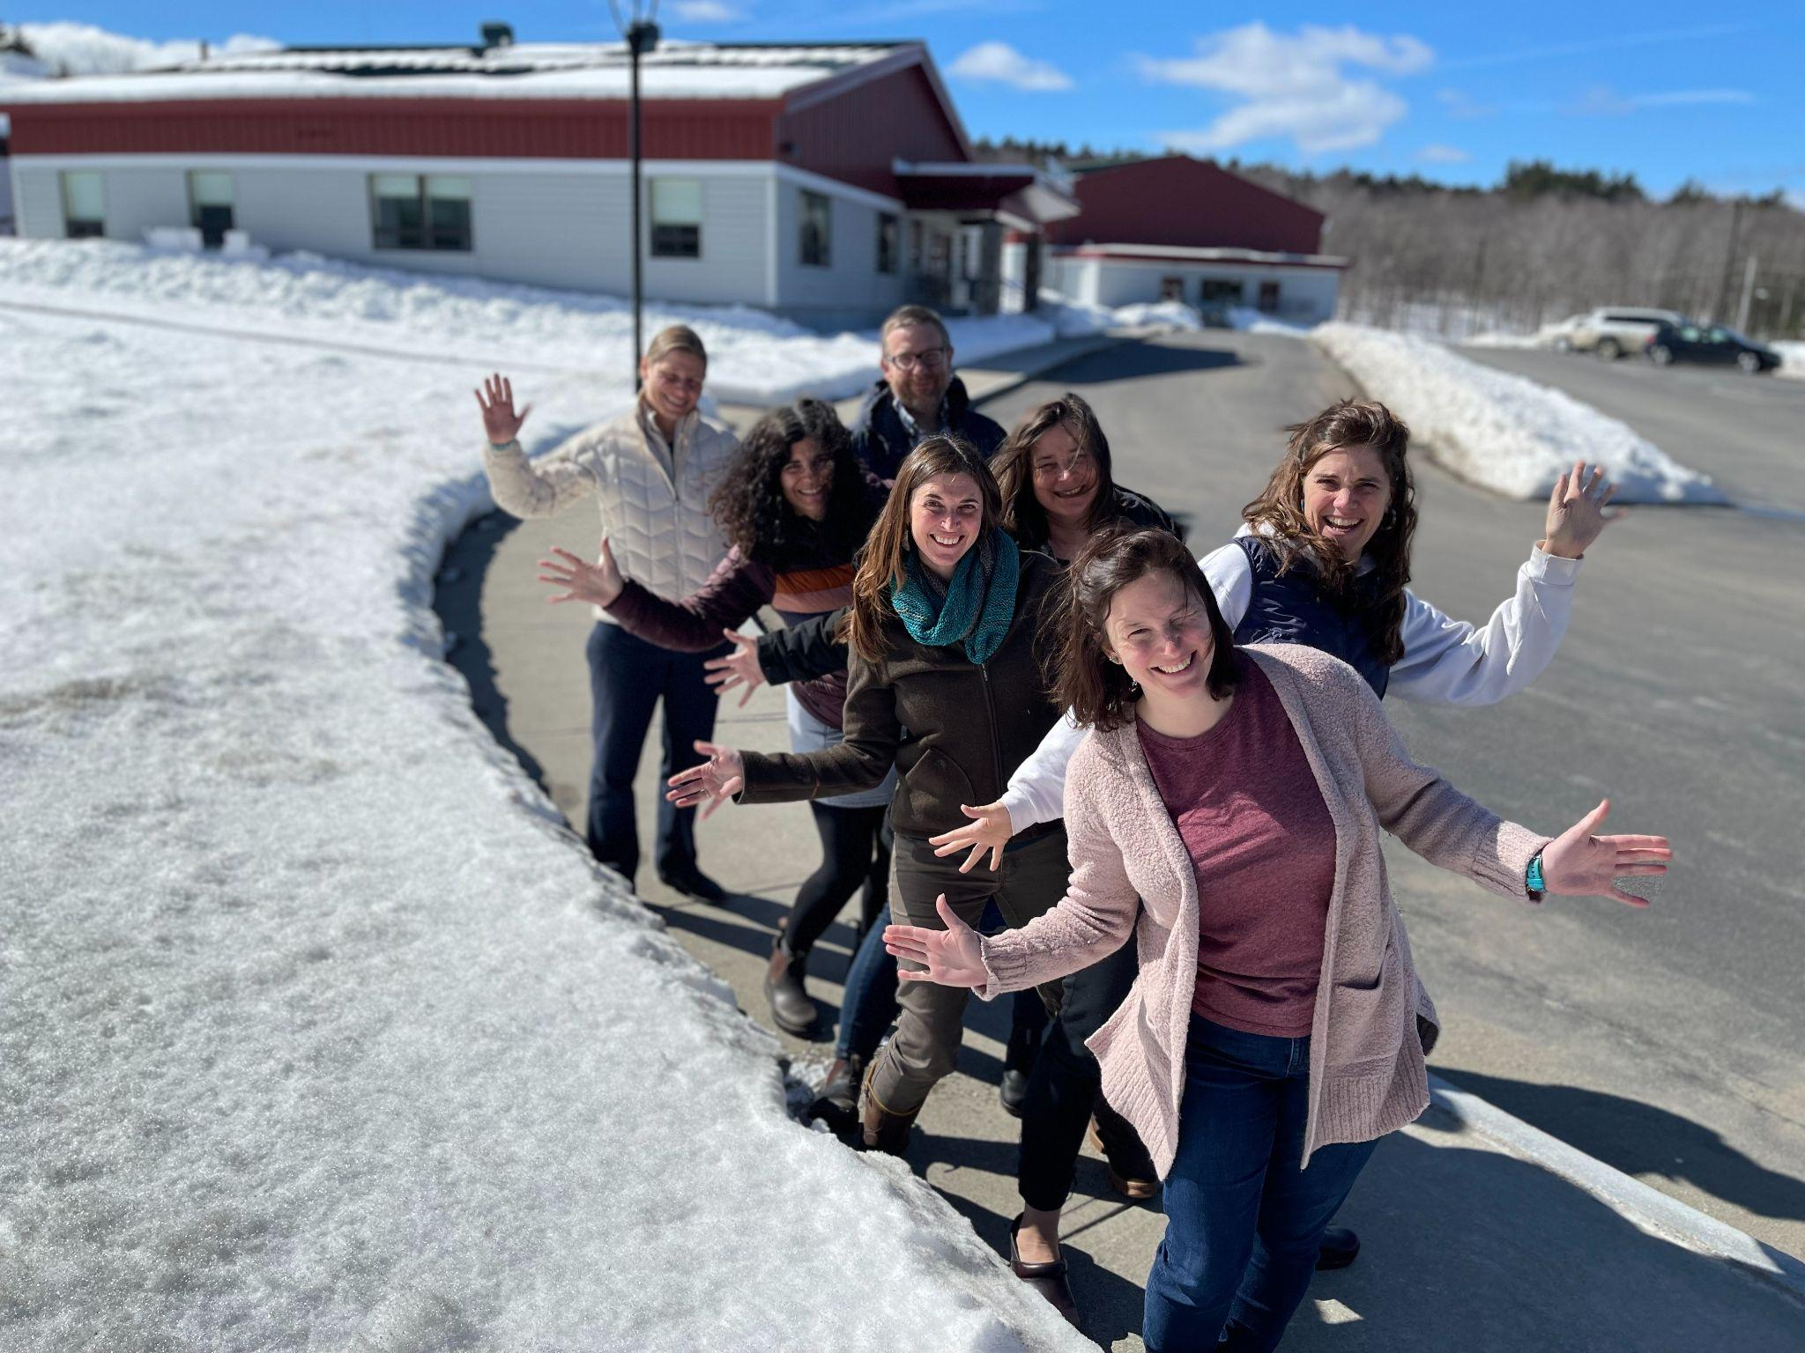
The 2021 Rowland Cohort met at Twin Valley Middle High School in Whitingham, VT.
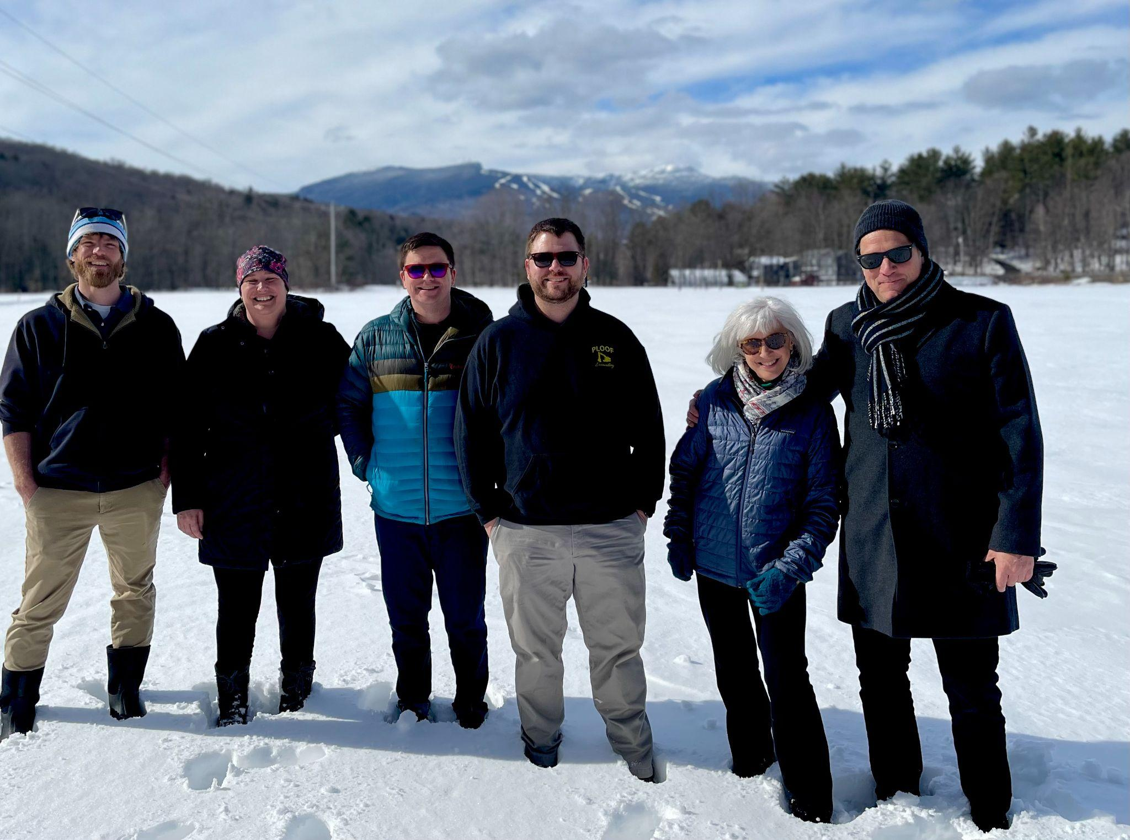
The 2022 Cohort met at Stowe High School and walked in the snow.
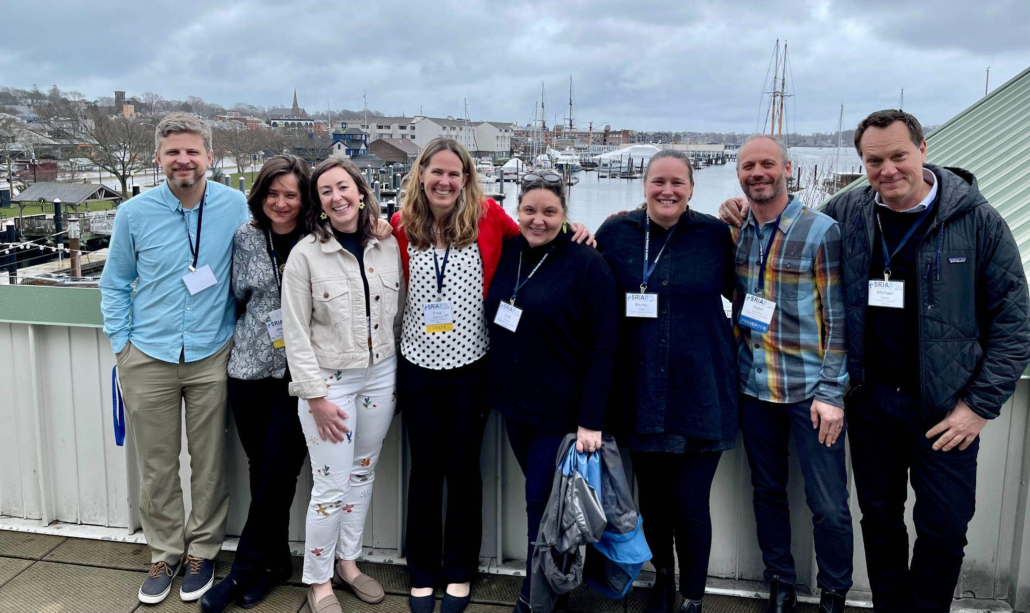
Rowland Fellows attended, presented at, and helped organize this year’s School Redesign In Action (SRIA) conference in Newport, RI. Seen here (left to right) Michael Ruppel (RF17), Senior Associate Jeanie Phillips (RF14), Emily Gilmore (RF17), Trustee Erica Wallstrom (RF14), Lisa Manning Floyd (RF15), Becky Ebel (RF22), Gabe Hamilton (RF15), Executive Director Mike Martin (RF09)
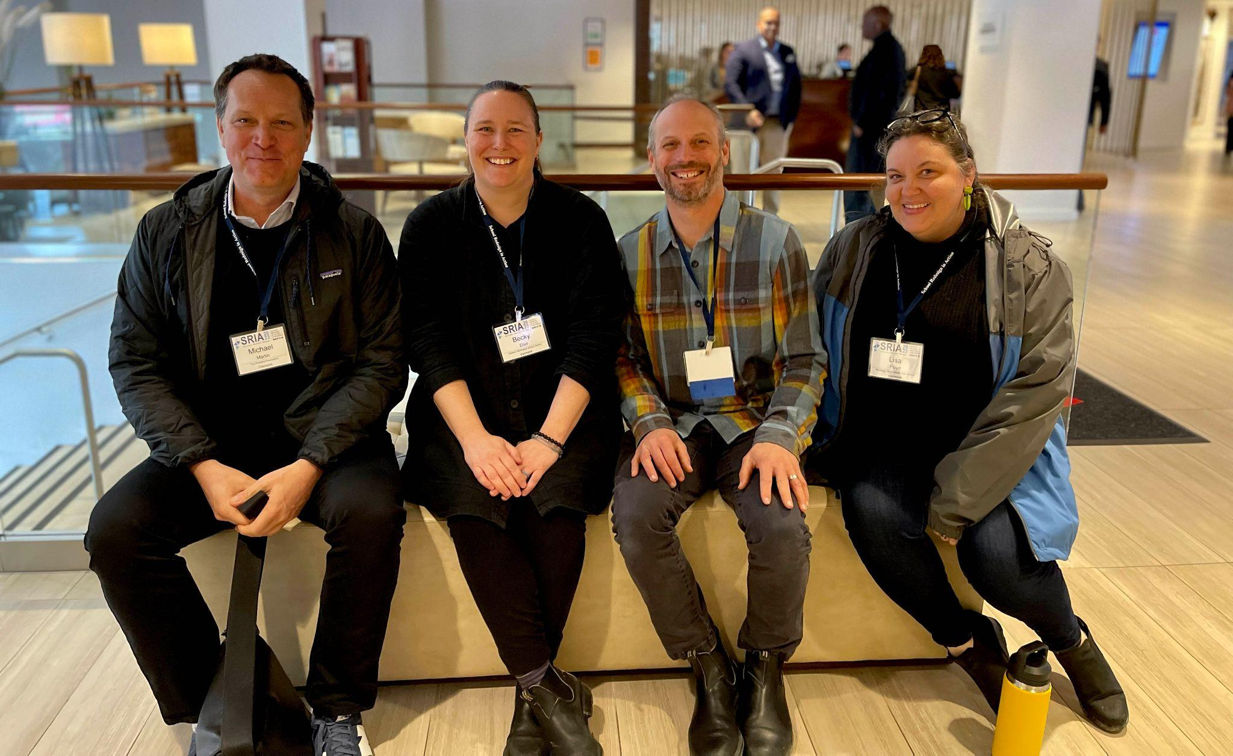
Rowland Fellows catching up and connecting at the SRIA Conference. Seen here (left to right) Mike Martin (RF09), Becky Ebel (RF22), Gabe Hamilton (RF15), Lisa Manning Floyd (RF15)
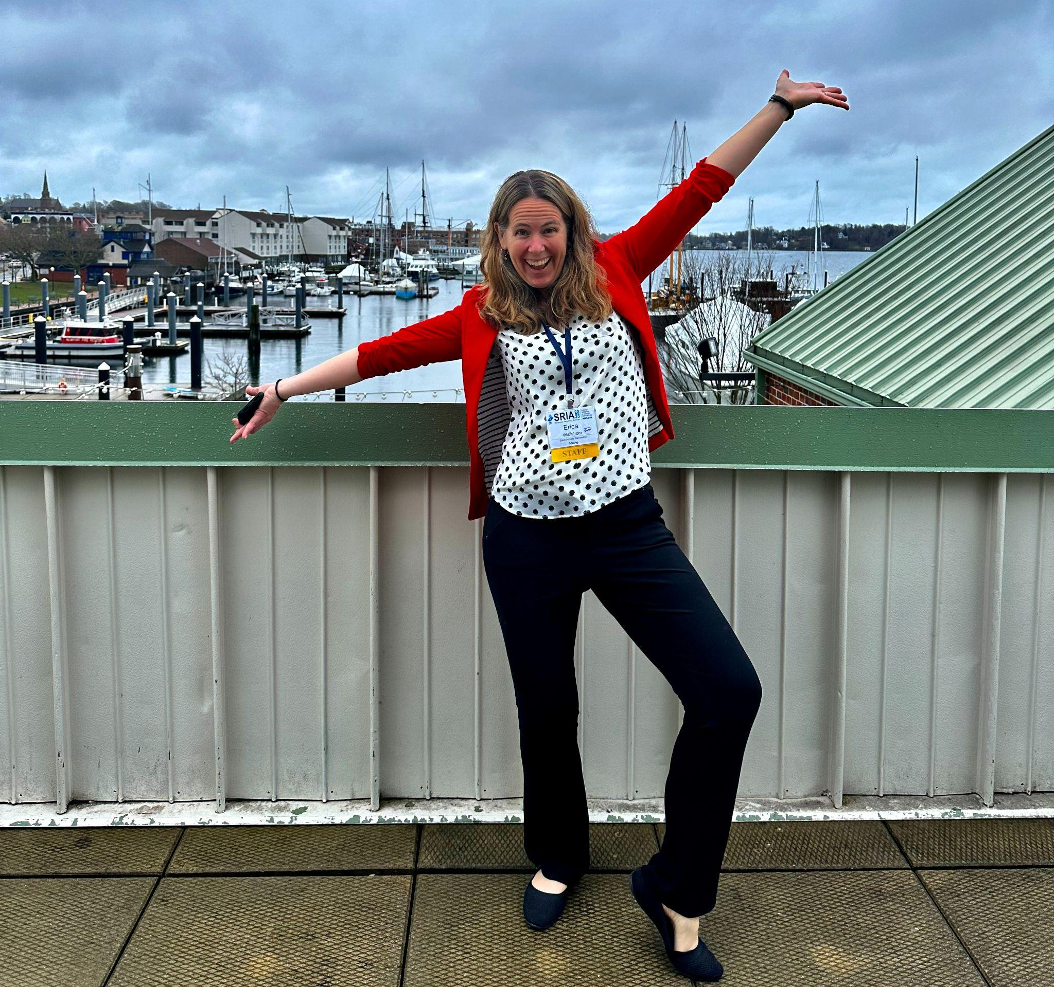
Erica Wallstrom (RF14) bringing joy to a cloudy day at SRIA.

The Rowland Diversifying the Educator Workforce (DEW) Grant
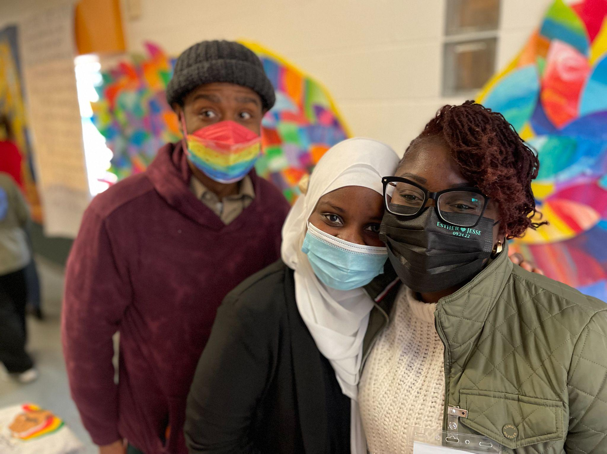
Big shout-out to our Rowland DEW Grant recipients, seen here at the Reimagining Schools Conference in South Royalton, VT. These aspiring educators of color are already making a difference with their work in Vermont schools, even as they complete coursework and meet licensure requirements. Seen here (left to right) Infinite Culcleasure, Safia Haji & Esther Charlestin.

The Rowland Women Leadership Retreat
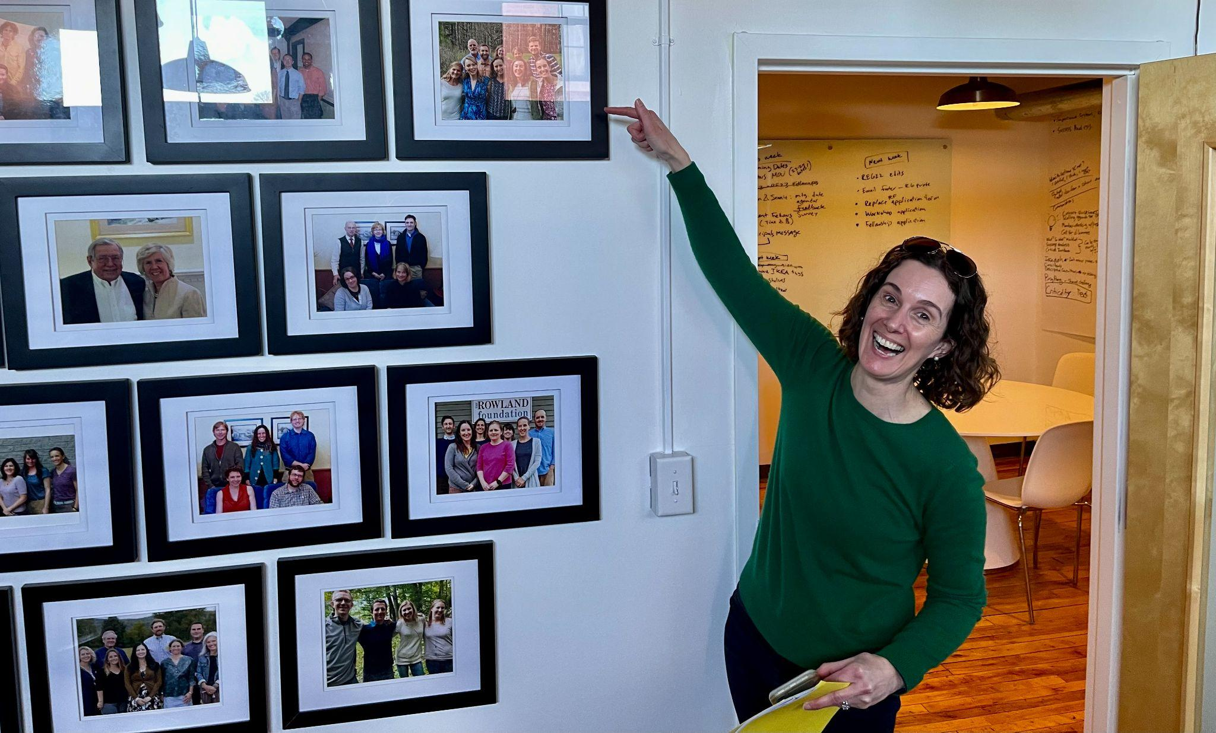
The Rowland Women Leadership Retreat will take place at Basin Harbor on Sunday, June 4 through Monday, June 5. Thanks to all of you who have already registered. Feel free to contact Marsha Cassel (RF14), Gretchen Muller (RF17) (seen here at the Rowland Foundation Office), and Tara Cariano (RF18) with any questions.

The New Rowland Encore Grant Team
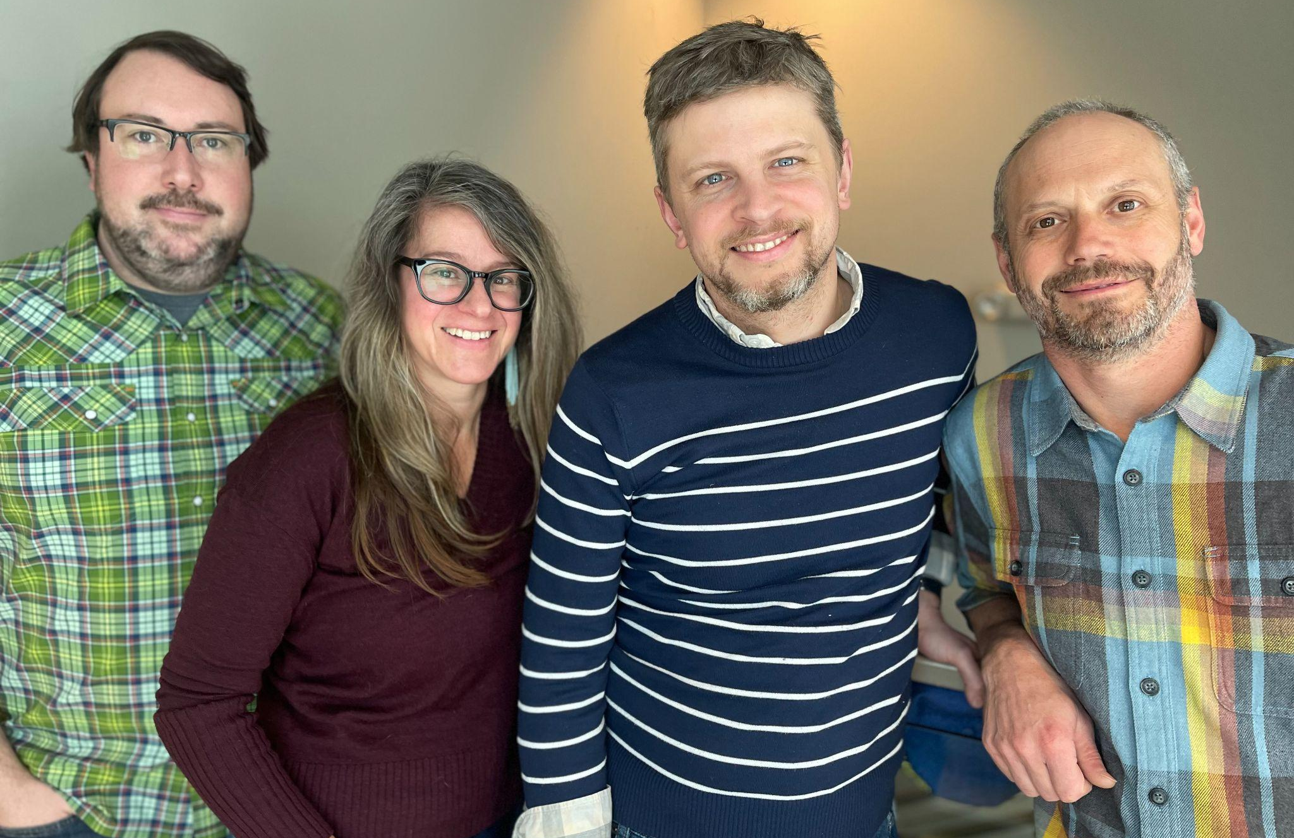
Congratulations to our 2023 Rowland Encore Grant Team! Seen here at the Rowland Foundation Office in Burlington, (left to right) Andrew Jones (RF15), Jess DeCarolis (RF09), Michael Ruppel (RF17) & Gabe Hamilton (RF15) will be focusing on deeper learning approaches in their work together.

Sharing Our Work
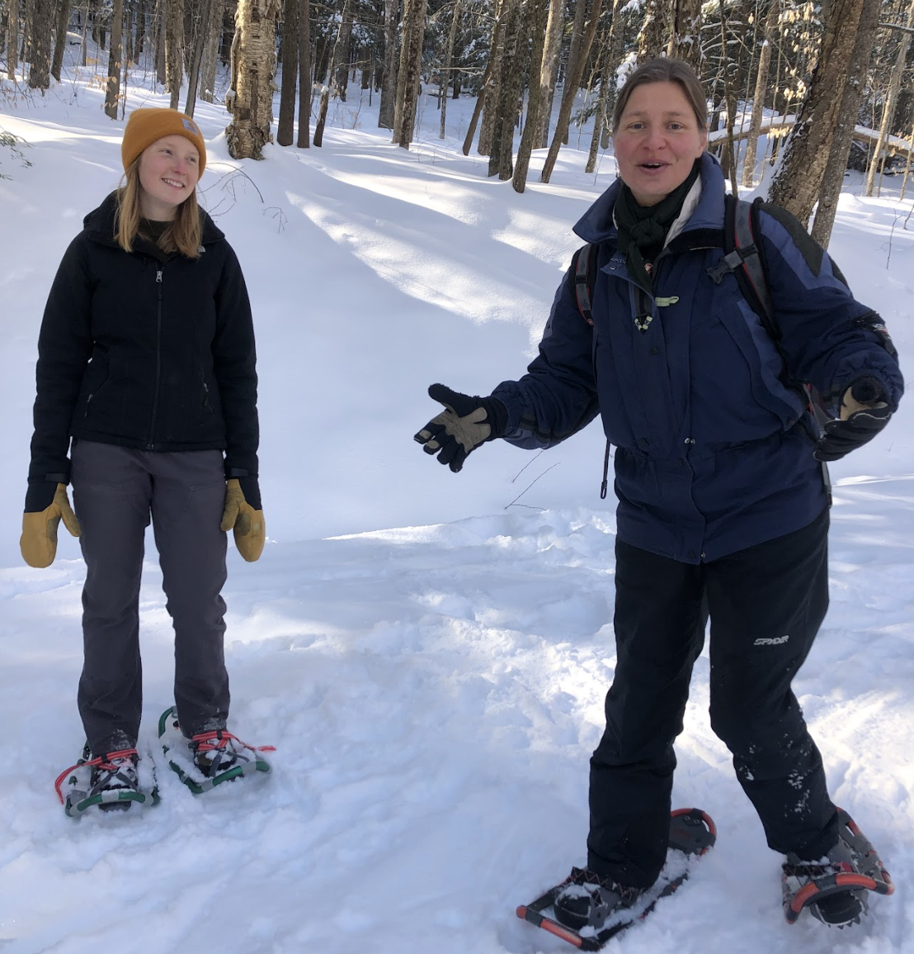
Anja Pfeffer (RF21) joined Woodstock Union High School CRAFT teachers for a lovely PD session on snowshoes. Anja led a sensory walk as an example of the Dare to be Me form of education that she and her students are leading the way on. This created a grounding and bonding experience for our educators. Thank you, Anja!

The Reimagining Schools Conference
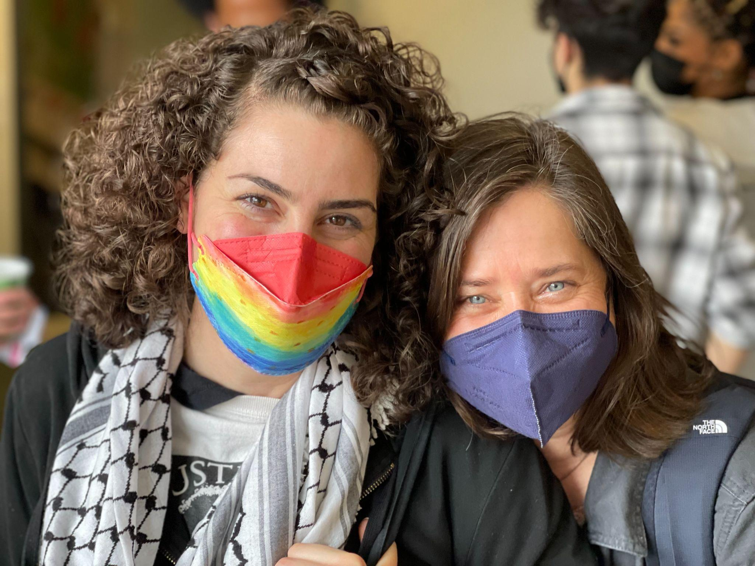
Many Rowland Fellows attended, volunteered at, and helped organize the first-ever Reimagining Schools Conference in South Royalton, sponsored by the Educational Justice Coalition, including Nicole Awwad (RF21) & Jeanie Phillips (RF14) seen here.
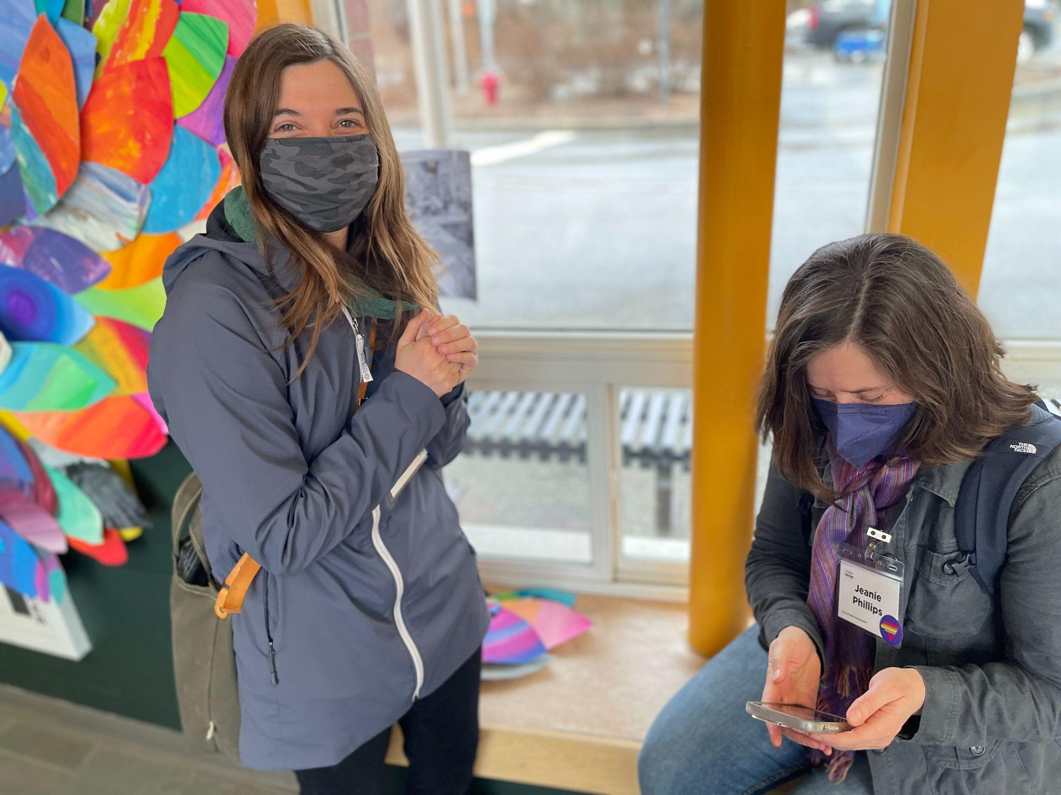
Kat Robbins (RF21) & Jeanie Phillips (RF14) seen here at the Reimagining Schools Conference.
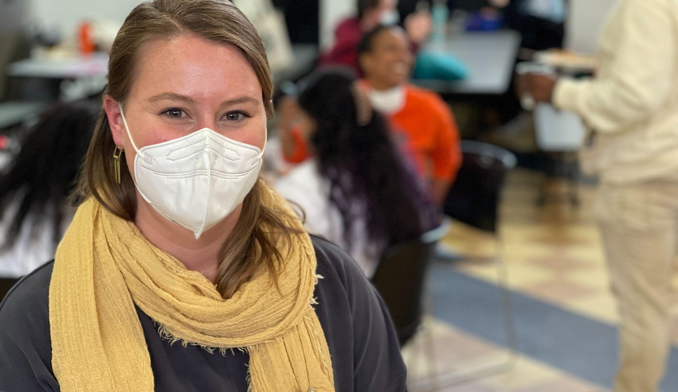
Emily Therrien (RF19) at the Reimagining Schools Conference.
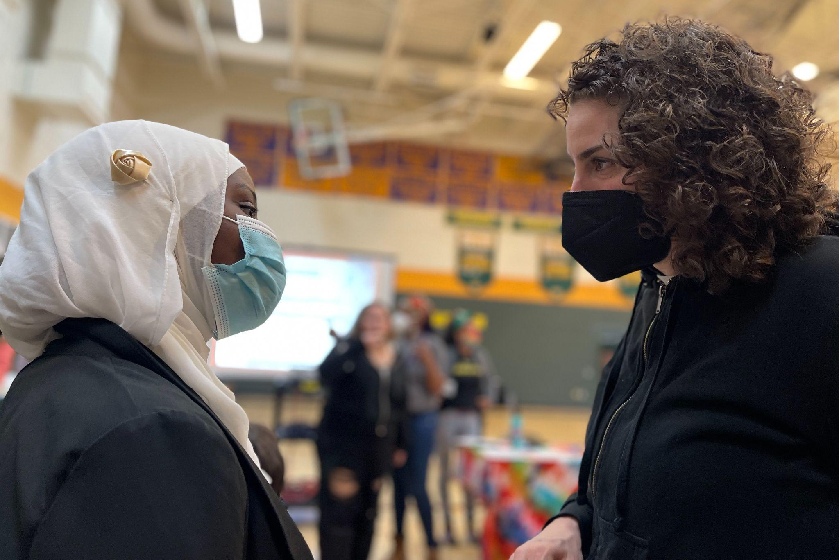
Safia Haji & Nicole Awwad (RF21) at the Reimagining Schools Conference. Nicole & Safia also know each other from the Spark Teacher Education Institute where Nicole teaches.
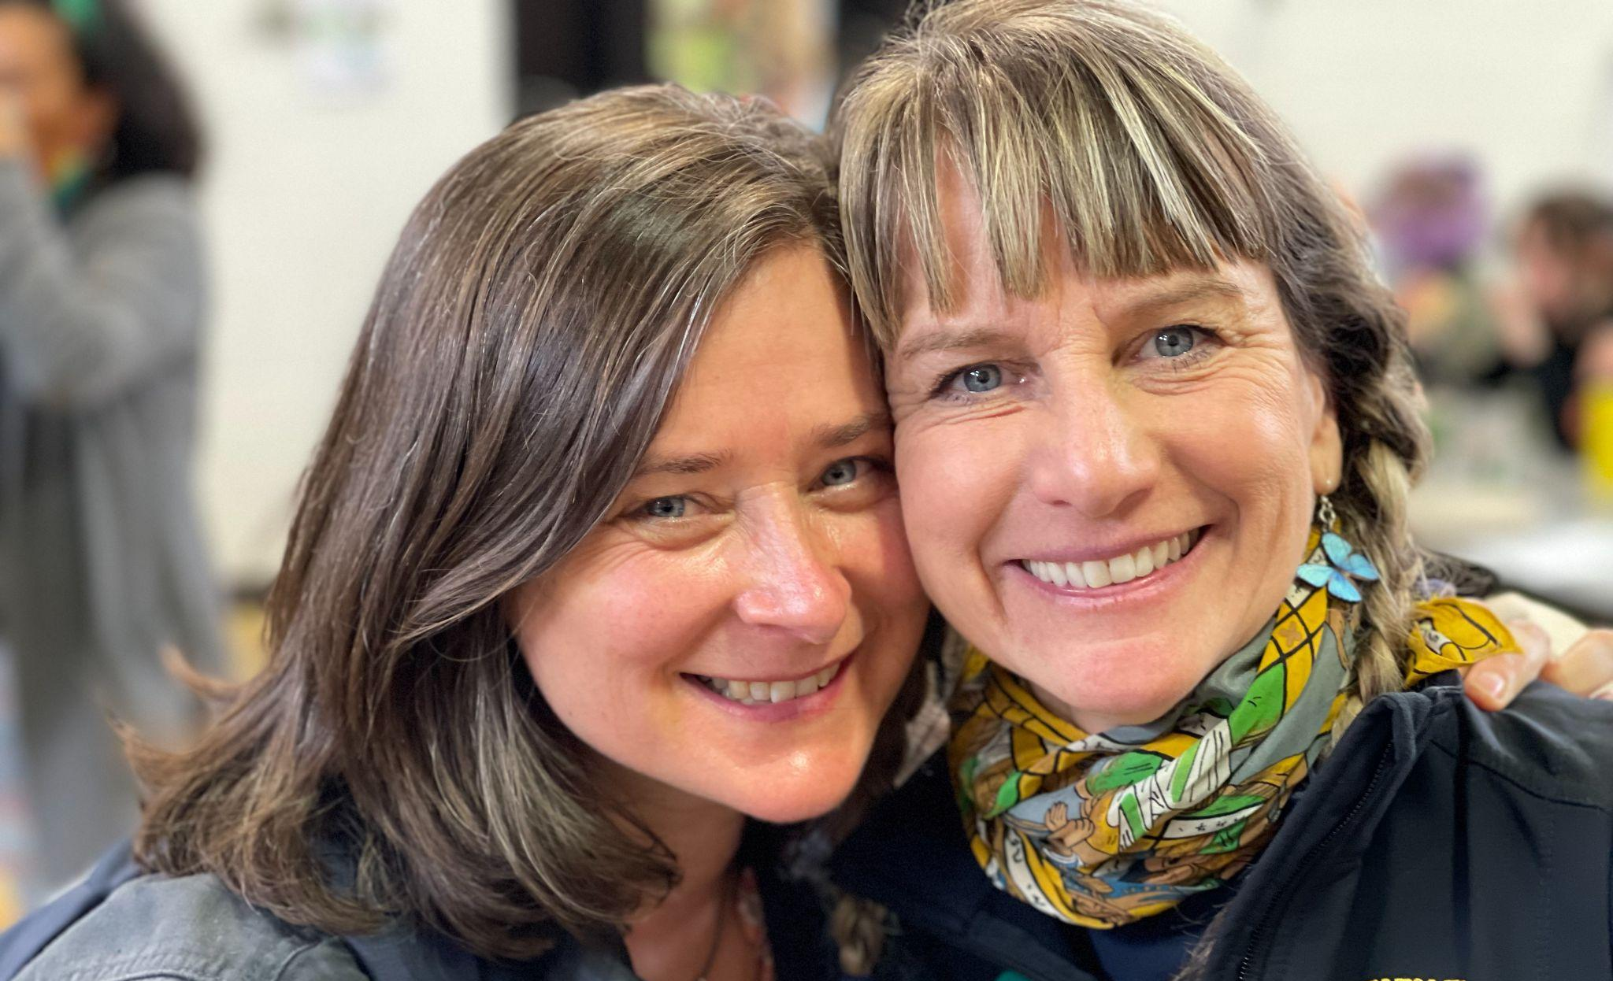
Jeanie Phillips (RF14) connecting with Mary Schell (RF10) at the Reimagining Schools Conference.
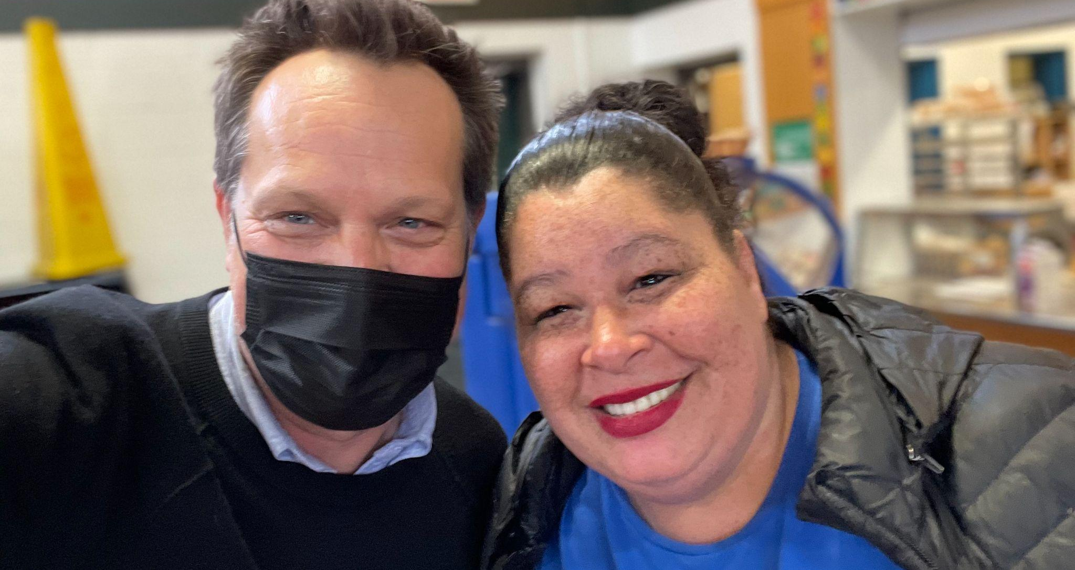
Mike Martin (RF09) seen here connecting with his fellow Act 1 Working Group member Mia Schultz who also serves as President of the Rutland Area National Association for the Advancement of Colored People (NAACP). Mia recently authored this op-ed in the Bennington Banner.

Celebrations
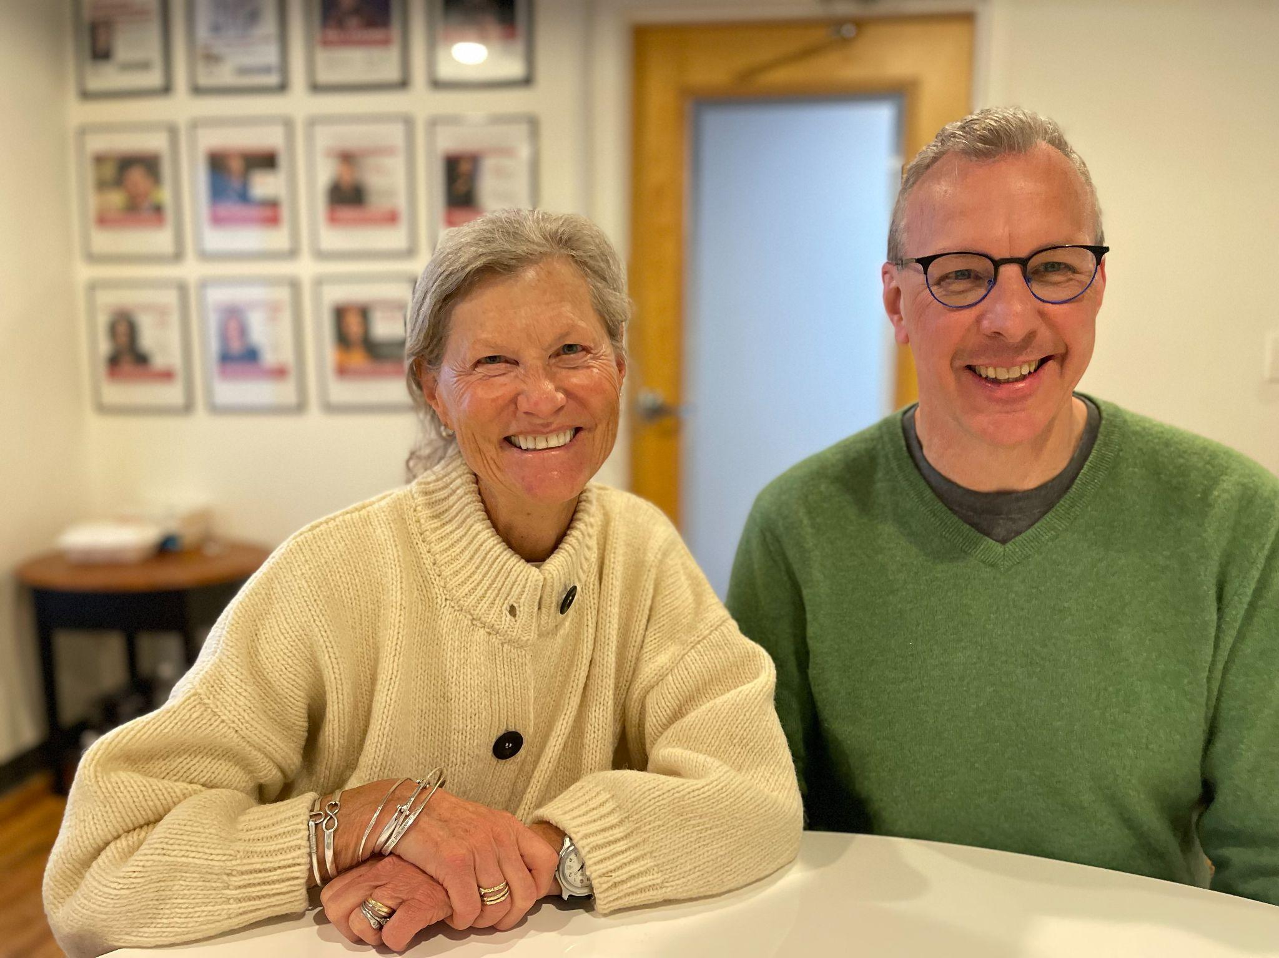
Kathy Cadwell (RF16) & Superintendent Mike Leichliter met with Mike Martin to celebrate the National School Boards Association Magna Award that Harwood received this year for its work with Harkness Teaching, an approach that grew out of Kathy’s Rowland Fellowship work. Kathy continues to consult with a number of schools around Vermont. If you’re interested in having her come work at your school, you can contact her at: katherinewcadwell@gmail.com

From March 23rd to March 25th, Dr. Andrew Jones (RF15) presented some of his research at the annual Association for Education Finance and Policy (AEFP) conference in Denver, Colorado. He was awarded a "Practitioner Subsidy Award" to cover his conference fees and much of his travel costs. This was the third time Andrew has presented at this conference (2019, 2022, 2023). This year, he led a poster presentation that focused on some of the findings from his dissertation research. Specifically, his poster is titled, "Translating Education Reforms: The Role of Instructional Coaches in Supporting Teacher Sensemaking of School Change Initiatives." You can view the poster HERE. (Please note: you will need to zoom in to read some of the text.)

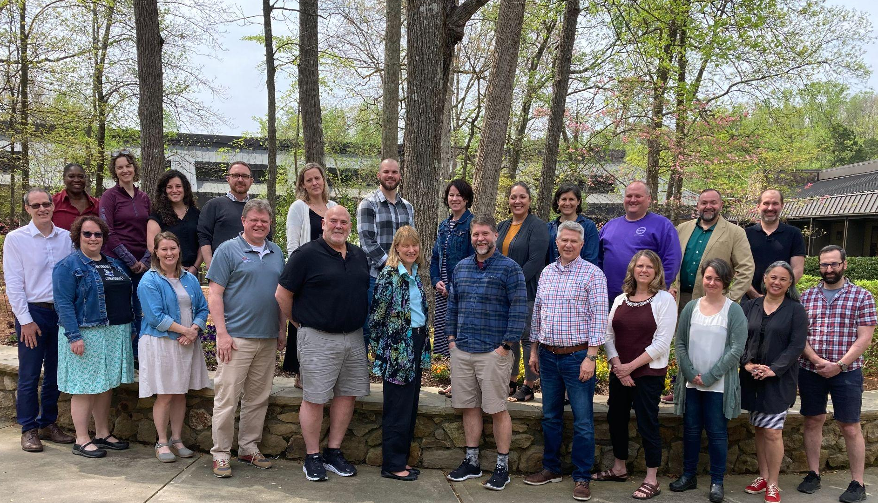
Congratulations to the new Waddington Cohort! Seen here are the latest Vermont school leaders to participate in this nationally recognized Leadership Development Program, seen here at a training in Greensboro, NC with support from the VPA and Mike McRaith (RF13). Shout-out to Emily Therrien (RF19) (front row, third from left), Sandra Mings-Lamar (RF16) (front row, sixth from left), and Matthew DeBlois (RF09) (back row, fourth from left).

Courtesy Postings
If you missed our new Collaborative Practices for Equity course last fall, mark your calendars for the next time it will run with our 2023 Cohort and other Vermont educators: August 16-18, Sept. 25, and Nov. 10. Senior Associate Jeanie Phillips (RF14) will be teaching the course at Shelburne Farms again, sharing wonderful food and a beautiful setting each day. The course is co-sponsored by the Rowland Foundation, Great Schools Partnership, and Shelburne Farms. If you’d like to learn more about this amazing professional learning opportunity, feel free to contact Rowland Fellows from this year’s alumni: Anne Bergeron (RF11), Sam Bromley (RF22), Bryan Dickinson (RF22), Devon Karpak (RF22), Becky Ebel (RF22), Gretchen Muller (RF17), Samantha Mundt (RF21), Anja Pfeffer (RF21), Kat Robbins (RF21), Kerianne Severy (RF17) & Patti Tomashot (RF22).

