 | Letter to Fellows  Taming the Phone  August 2022

Dear Rowland Fellows,

I hope this message finds you and your loved ones well this summer.

Even after a normal school year, it sometimes takes teachers most of the summer to find their balance again. So after last year, I’ve been thinking about how teachers are feeling right about now. I mean, when August comes around, many of us have had the chance to change our brainwaves with summer travel or outdoor adventures, and we begin to feel like ourselves again. So how do we sustain that feeling instead of submitting to the deluge of noise and obligations that comes with September?

Well, maybe taming our phones might help. Sure, there are plenty of things that are beyond our control at work, with family, in life, but can’t we get a handle on that thing in our pocket that keeps demanding our attention? Personally, whenever I feel like my phone is running me more than the other way around, I like to put my phone in a room where I’m not and let it cool off a little. This is an ongoing struggle, and my friends get annoyed with my slow responses sometimes, but I still have friends, and showing my phone that it’s not the boss of me feels great. In a world where stuff is flying at us every moment, setting some boundaries with messages and notifications makes me feel powerful, like I’ve taken back a little control over my life.

64% of Americans use their phones on the toilet, 70% of us check our phones within 5 minutes of a notification, and 71% of us check our phones within 10 minutes of waking up, according to a recent study. Other data shows that too many of us go to bed with our phones, have trouble leaving our phone at home when going out, or feel anxiety as soon as our phone’s charge dips too low. Of course, phones are not the only source of stress and anxiety in today’s world, but there seems to be a growing trend towards digital minimalism, an awareness that setting some boundaries with our phones and other screens may help us feel better and lead healthier lives.

I’m just old enough to remember teaching before email. Looking back, I’m struck by how that was in fact a totally different job. I’ve always been an early adopter of education technology, and my teaching was often the better for it, but nowadays everything just seems out of control, as if our workplaces have grown into what Cal Newport calls the hyperactive hivemind. And we bring our work everywhere with us.

Teaching is hard now and our young people are struggling. This fall, perhaps we can try to take back some of our life by putting our phones back in their place. Personally, I feel better when I turn off the anxiogenic pinging of notifications, when I step back from social media, and when I let messages sit for a minute before I hit people back. I don’t feel pulled in quite as many directions and I feel a little more in control (whether or not that’s actually true).

I know things will always be busy and often get noisy in our world. Still, I keep up the struggle with my phone because I don’t want to feel like the tool of my tool. I wish you luck in your own struggle with balance in the months to come.

Take care and see you soon,

Mike

P.S. In response to systemic racism in school, in 2019 the Legislature passed Act 1, a law to establish ethnic & social equity studies standards in Vermont schools. Act 1 established a working group to “review standards for student performance adopted by the State Board of Education and..., recommend to the State Board updates and additional standards to recognize fully the history, contributions, and perspectives of ethnic groups and social groups.” Mike McRaith (RF13) and I have been serving as members of the Act 1 Working Group for the past two years.

After compiling feedback on draft EQS revisions received from the VSBA, VSA, VPA, VTCLA, expert readers, and other stakeholders, the Act I Working Group submitted proposed revisions of the Educational Quality Standards (EQS) to the Vermont State Board of Education last month in order to meet its charge from the Legislature. Please take a moment to read the proposed changes to EQS here. Curriculum leaders will notice a new emphasis on Universal Design for Learning, Culturally Responsive Pedagogy, and Restorative Practices—none of which are included in the existing Vermont Educational Quality Standards (2013).

The State Board of Education has now formed an EQS Subcommittee chaired by Tammy Kolbe & Kim Gleason and asked the Act I Working Group to provide a brief rationale for each of the EQS sections with proposed revisions. The Act I Working Group has now submitted the rationale for all changes to the State Board for consideration.

If you would like to voice your support for these important changes to the EQS, our state’s educational quality standards, feel free to send a short note to the State Board’s EQS Subcommittee:
Jennifer.Samuelson@vermont.gov, Tammy.Kolbe@partner.vermont.gov, Patrick.Brown@partner.vermont.gov, Tom.Lovett@vermont.gov, Kimberly.g.gleason@vermont.gov

P.P.S. Please send me your news! Each month, I’m sharing courtesy posts for upcoming courses & events, and also celebrating new jobs, family vacations, and other news from our extended Rowland Family of Fellows. So please email whatever you’d like to share to michael@therowlandfoundation.org

Rowland Foundation Updates

The Annual Rowland Conference: Keynote Speaker Dr. Gholdy Muhammad

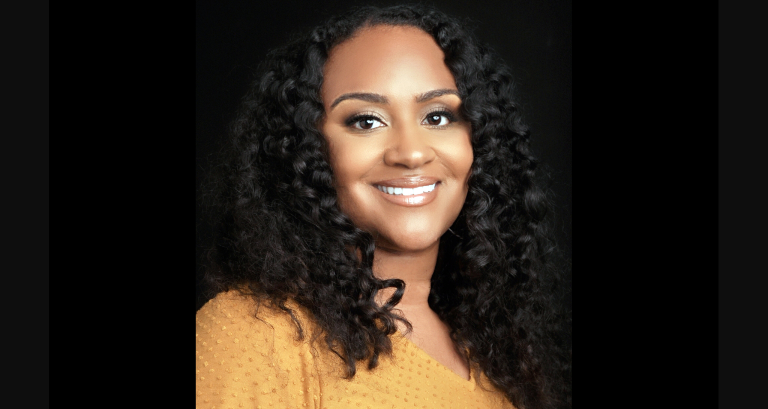
Congratulations to everyone who pre-registered conference teams in June! You have your teams’ spots reserved and will save 20% on the conference fee when UVM Events Registration opens in early September. We’ll send a notification to Rowland Fellows as soon as conference registration opens next month.

Dr. Gholdy Muhammad will deliver our keynote for the 11th Annual Rowland Conference at UVM’s Davis Center on Wednesday, October 26, 2022 on the theme of Cultivating Genius: An Equity Model for Culturally & Historically Responsive Education.

Dr. Muhammad’s book Cultivating Genius is a seminal work which seems more timely than ever with the recent passage of Act 28, “An act relating to improving prekindergarten through grade 12 literacy within the State,” and also Act 1, “An act relating to ethnic and social equity studies standards for public schools”. As you may already know, the Act 1 Ethnic & Social Equity Standards Advisory Working Group has just submitted proposed revisions to Vermont’s Educational Quality Standards to the State Board of Education.

The All Fellows Survey Results
If you still haven’t had the chance to, be sure to check out the Summary of Results from the All Fellows Survey for some excellent thinking and strategies relating to leading change in schools. You can also watch this short video for survey highlights in Rowland Fellows’ own words—the quotes are inspiring and also provide great insights on the joys and challenges of leading school change.

The All Fellows Retreat & Social
Save the date! The All Fellows Retreat will take place on Tuesday, October 25th (1:00-4:00pm) at the Hilton Burlington again. The traditional All Fellows Social will take place immediately afterwards at The Farmhouse Tap & Grill in Burlington.

Rowland Encore Grant: Team Disconnect/Reconnect
Seen here (left to right) this year’s Rowland Encore Grant Team, Lissa Knauss (RF18) Anne Bergeron (RF11), Carrie Felice (RF13) & Sarah Ibson (RF13), who met in Cape Cod this summer for a “super productive, mindful, nature-inspired, design charrette week filled with collaboration and camaraderie!”
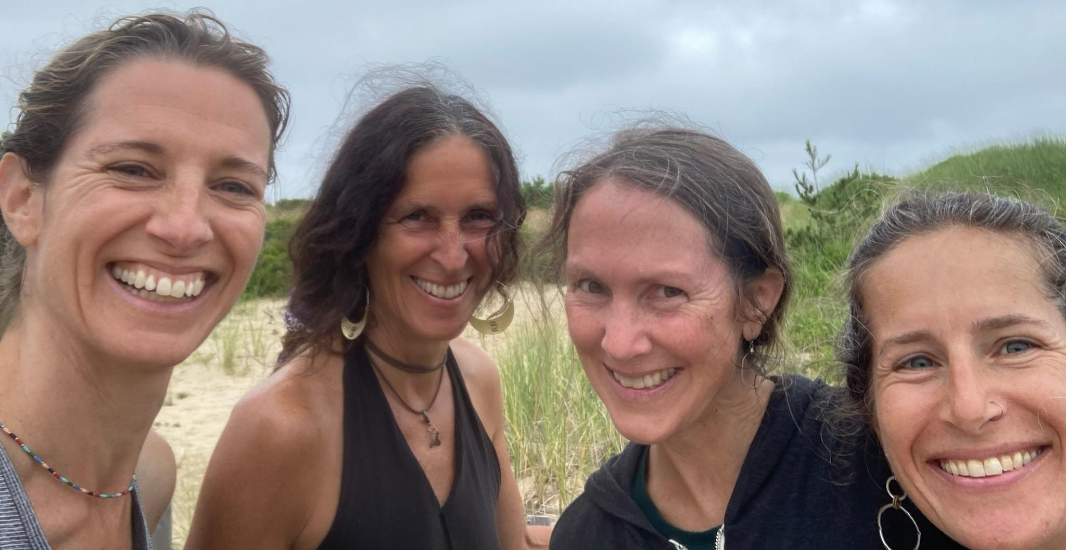
They reported, “Our Digital Wellness outcomes were strongly influenced by a paradigm-shifting, two-hour interview we conducted with the director of the Digital Wellness Lab at Boston Children's Hospital on the first morning of our week together.
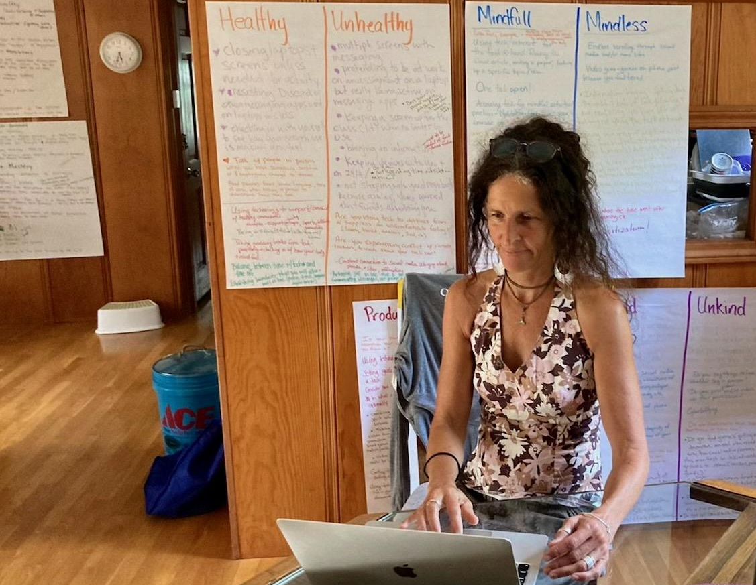
Inspired by what we learned, we then researched, wrote, created, and designed, all while developing a daily flow that held us beautifully for the intensity of the work. Our mindfulness practices included daily yoga, meditation, walk and talks, alone time, and preparing delicious shared meals.
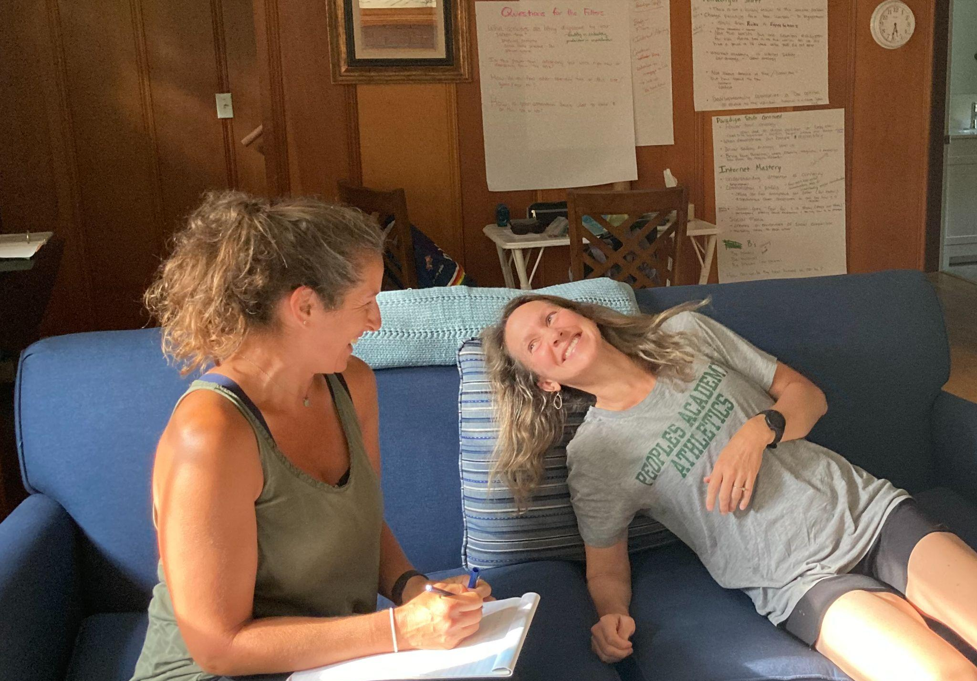
We will be bringing together colleagues from our four schools in mid-August for a feedback protocol to assist us as we continue to develop, share, and fine-tune our work in the year to come.”
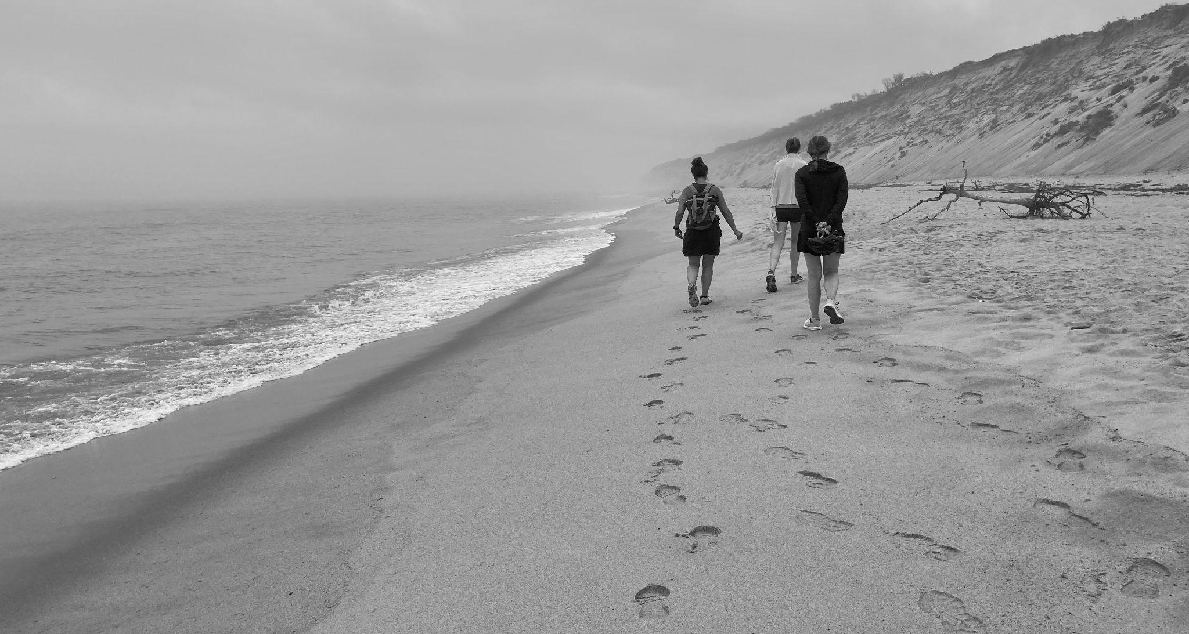

Celebrations

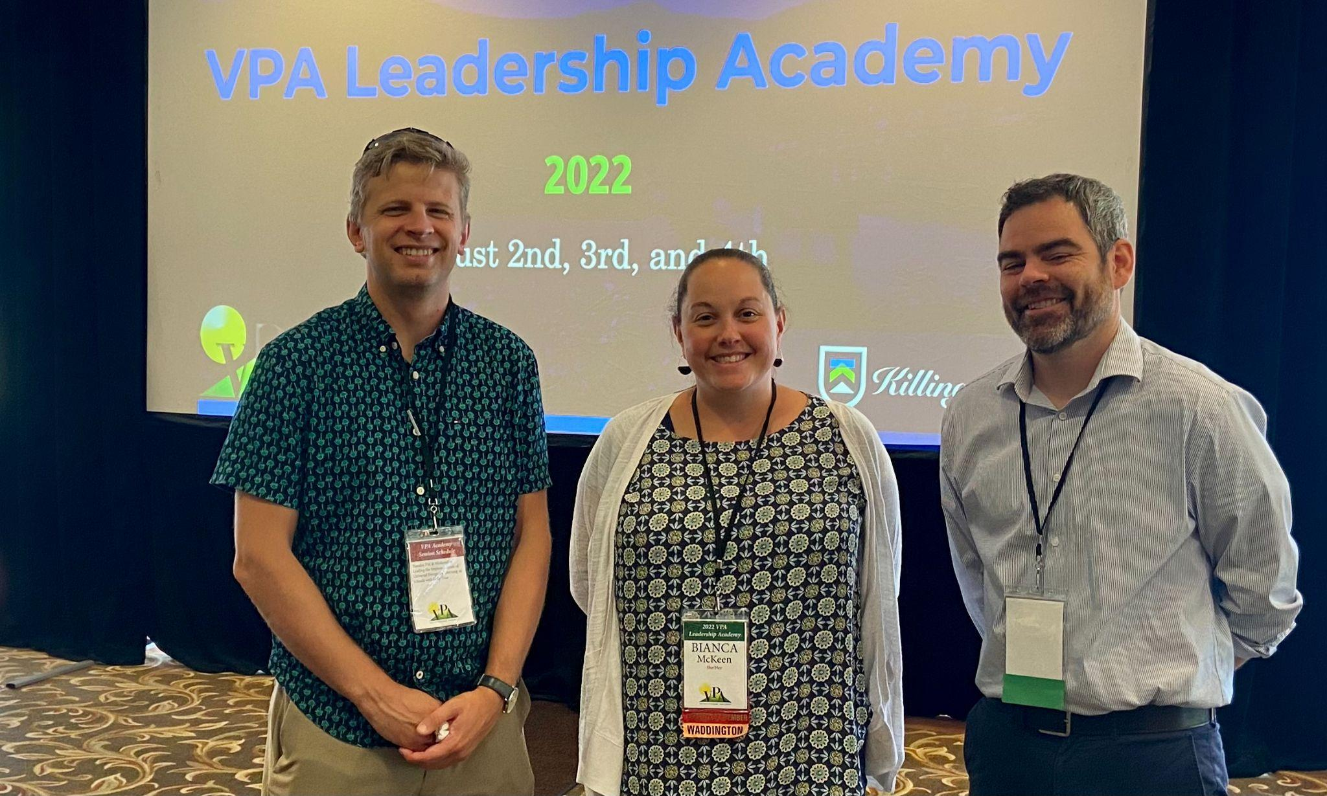
Principals Michael Ruppel (RF17) and Bianca McKeen (RF16) joined VPA Assistant Executive Director Mike McRaith (RF13) at the annual VPA Leadership Academy in Killington.

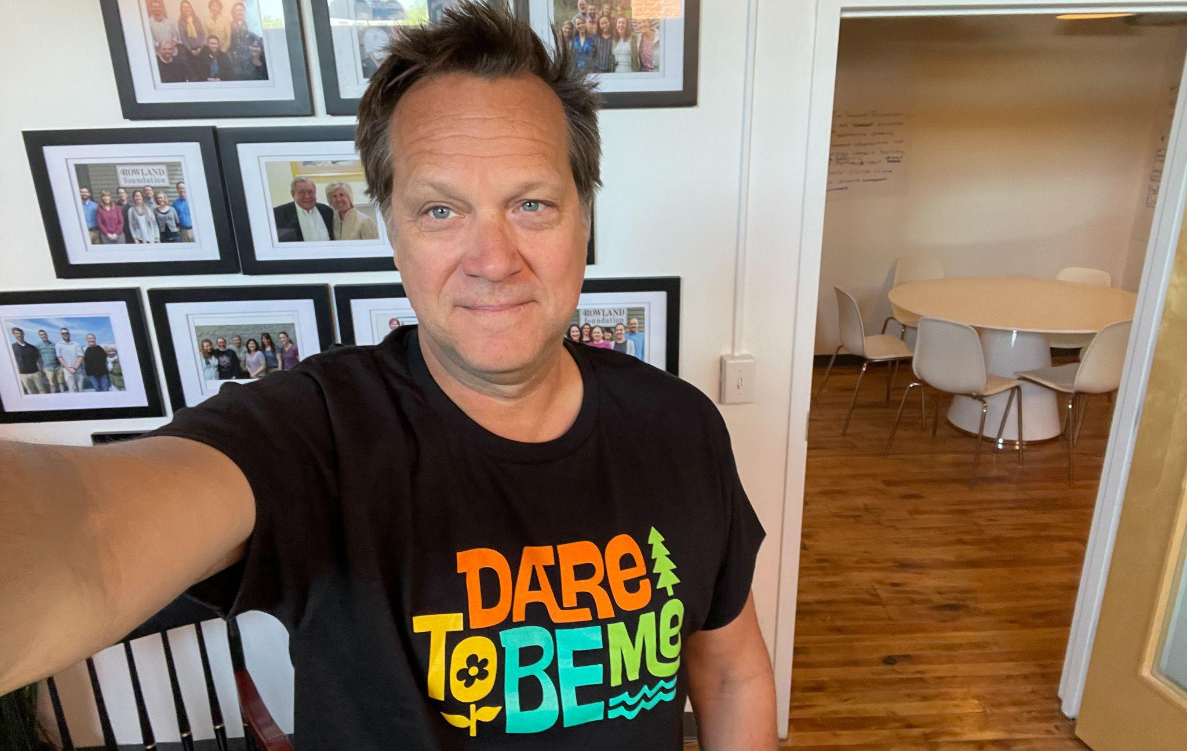
Executive Director Mike Martin (RF09) seen here at the Rowland Foundation’s Burlington office proudly wearing his new Dare to Be Me t-shirt from Anja Pfeffer’s (RF21) Rowland fellowship work.

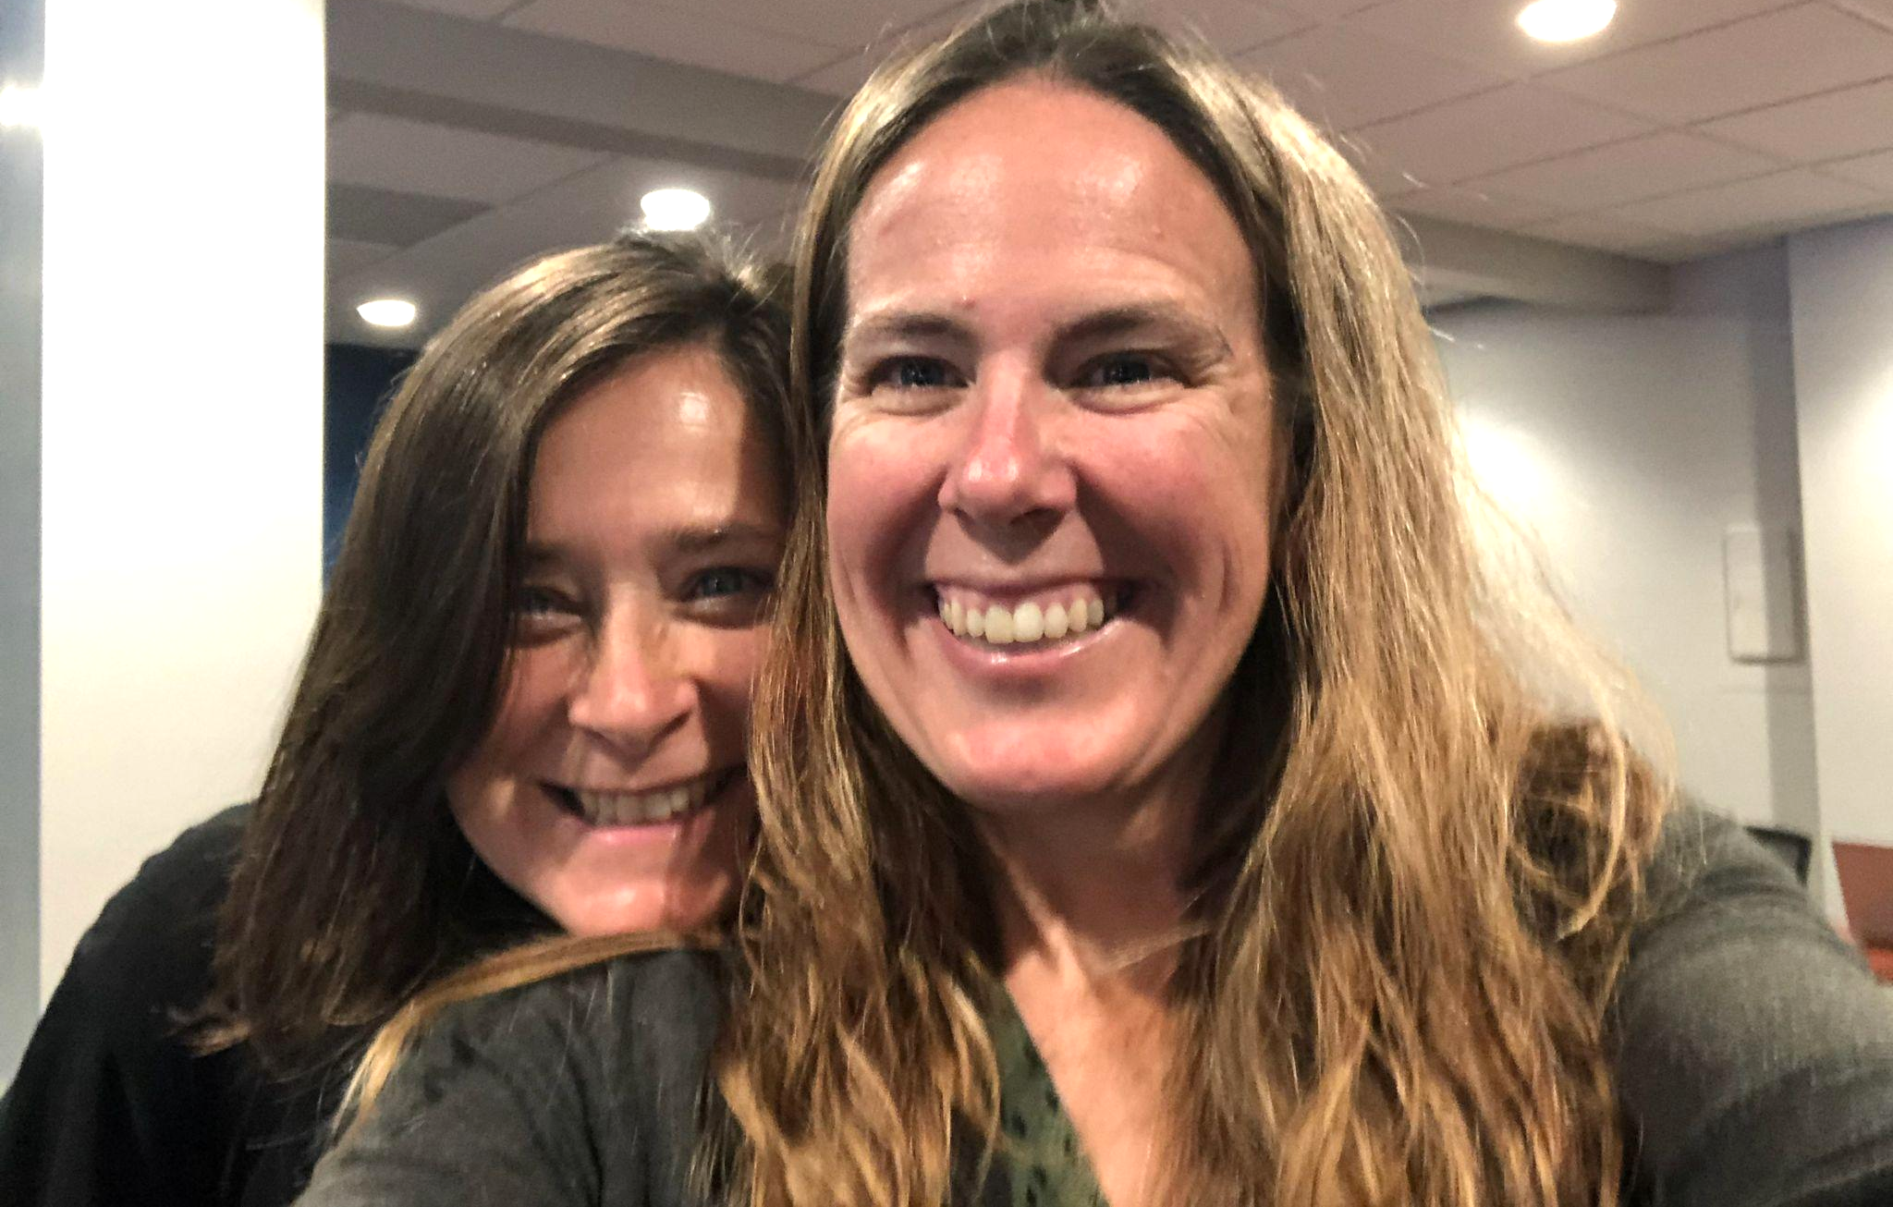
Senior Associate Jeanie Phillips (RF14) & Trustee Erica Wallstrom (RF14) started in their new positions as Senior Associates for the Great Schools Partnership, seen here during their onboarding in Portland, ME.

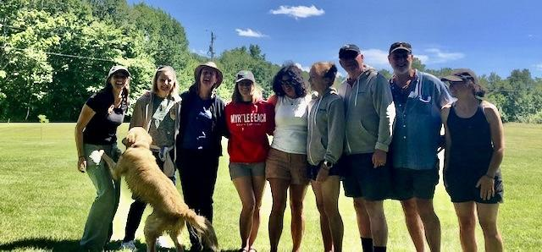
From Kat Robbins (RF21) & Janis Boulbol (RF21), “In June, a dozen teachers from Woodstock Union High School, representing every discipline, retreated to the Blueberry Hill Inn to refine the newly launched CRAFT pathway. Students this fall will take a deep dive into Community and Climate Resilience through Agriculture, Forestry, and Technology through the lenses of everything from Wellness to Statistics! Teachers are inspired, connected, and pumped!”

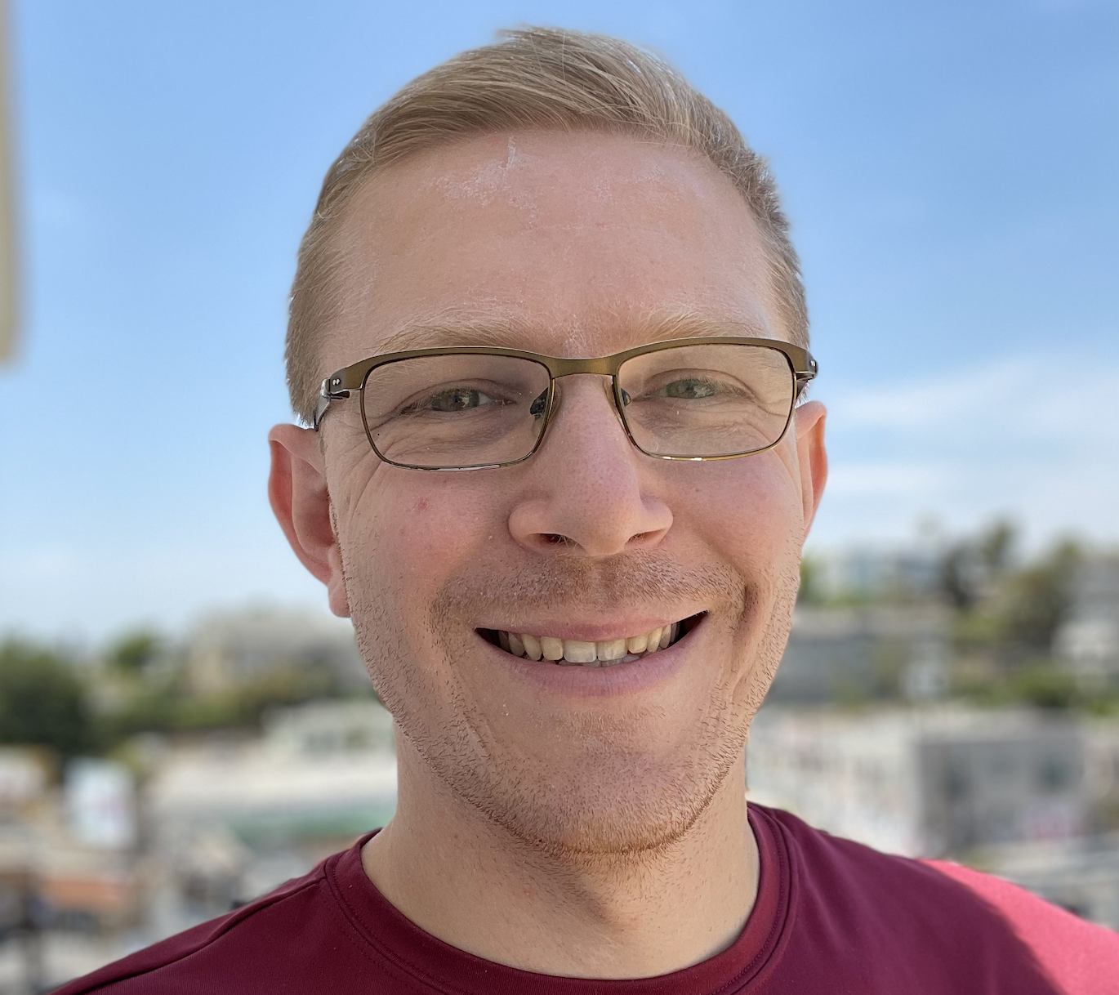
Luke Dorfman (RF19) is pleased to announce that he’s accepted a math teaching position at South Burlington High School for the coming school year.

Gratitude

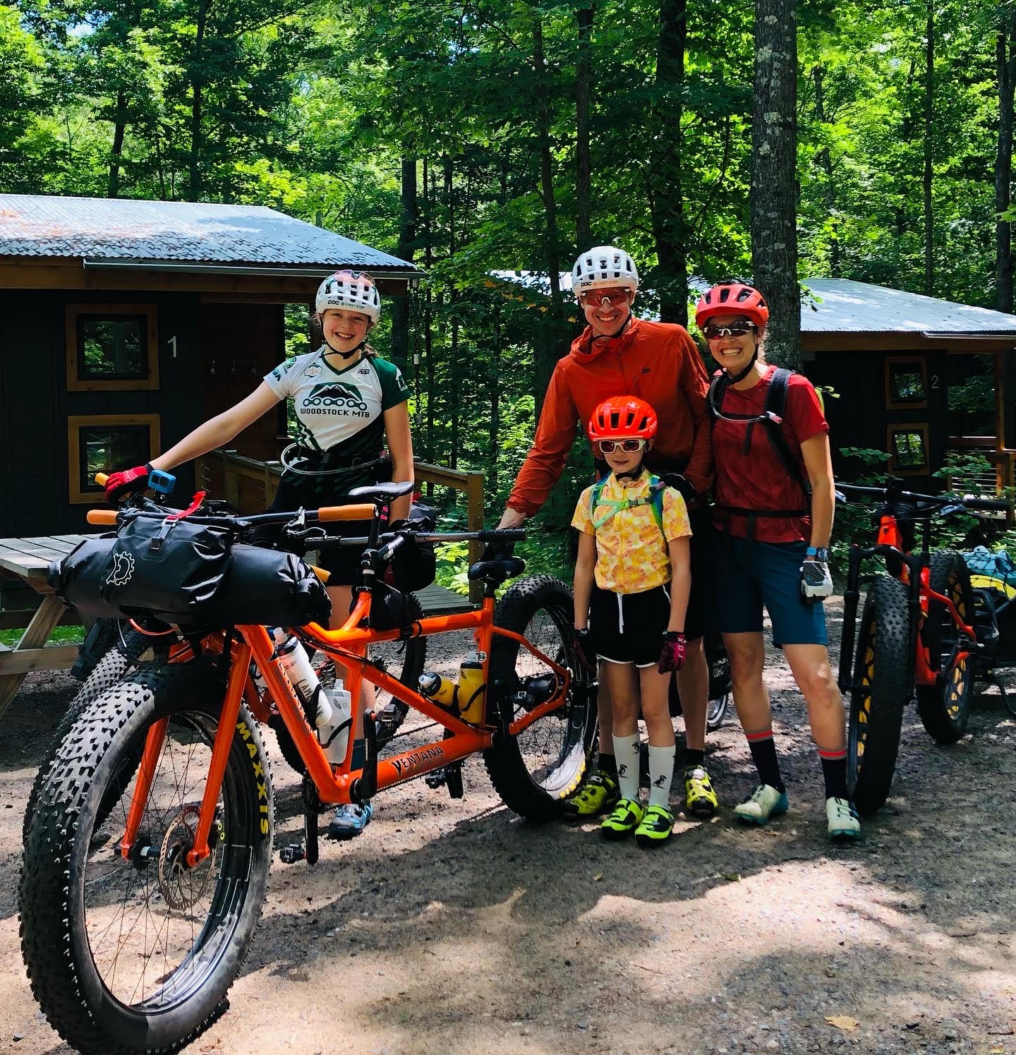
Sarah Hagge (RF16) and family bike packed in northern Wisconsin!

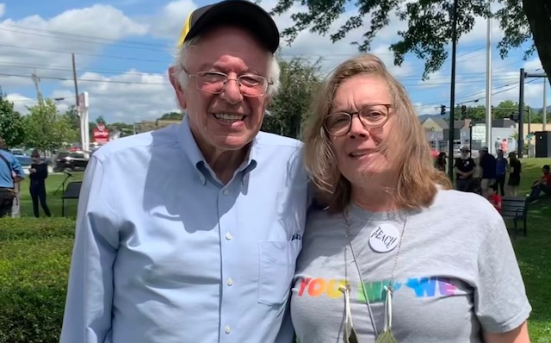
Marsha Cassel (RF14) met with Senator Bernie Sanders.

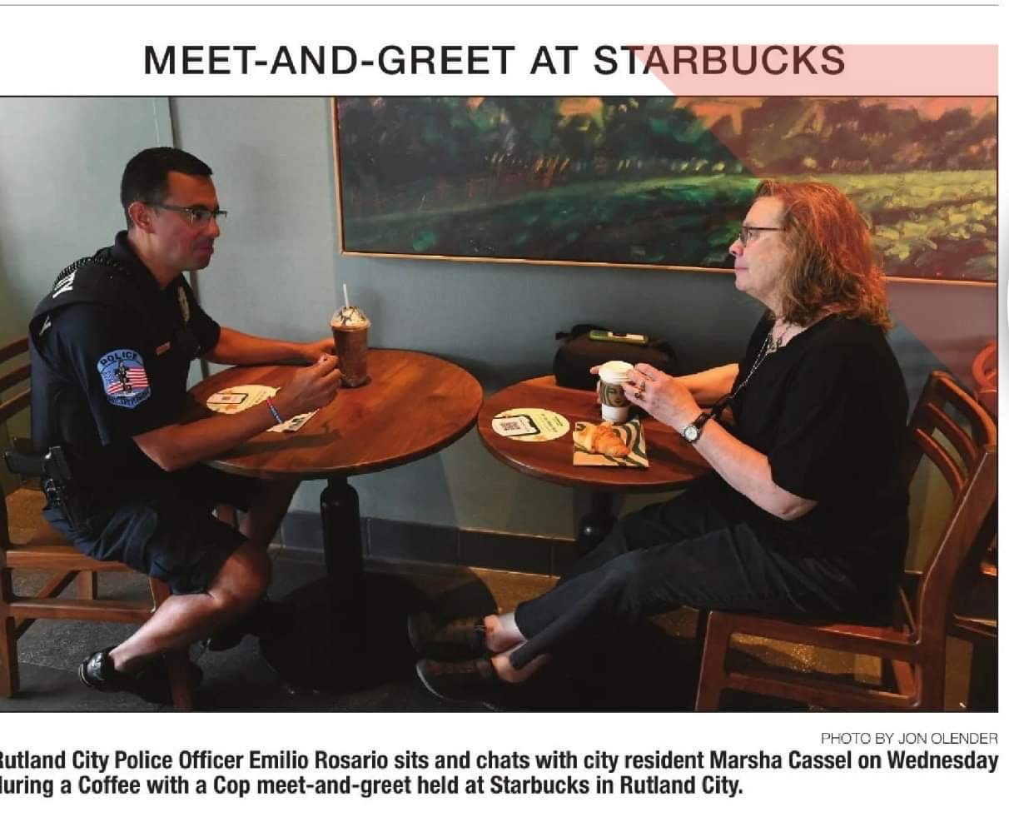

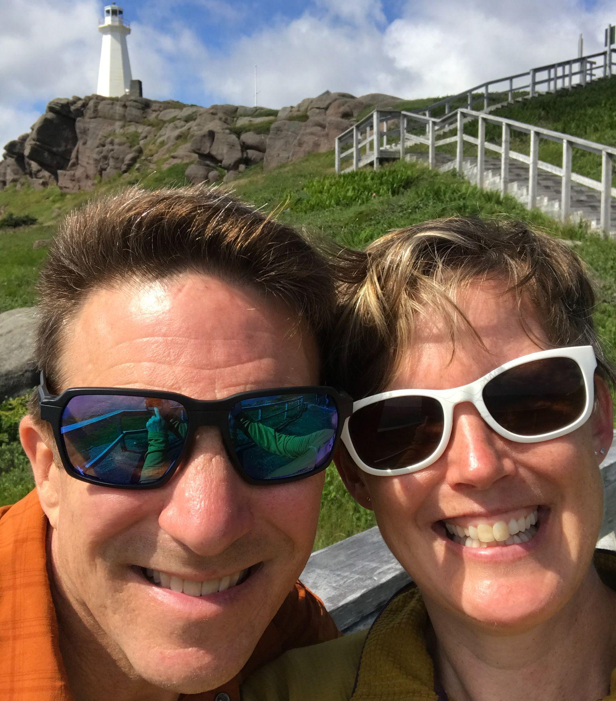
Abbie Bowker (RF17) & husband Eric at the Cape Spear lighthouse, easternmost point in North America.

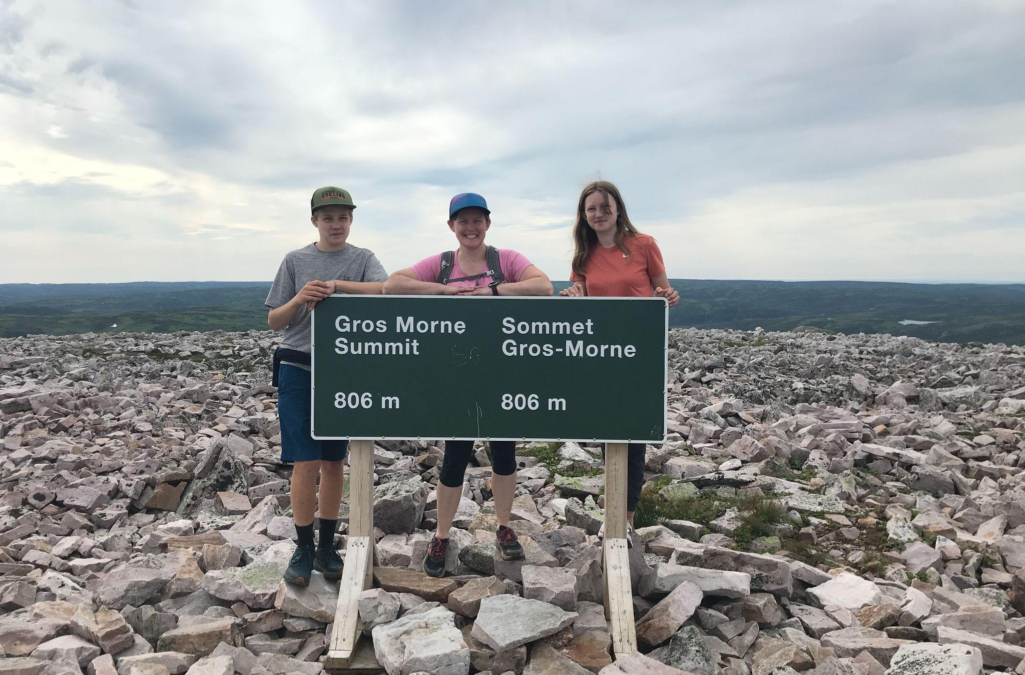
Newt, Clover, and their mom Abbie at the summit of Gros Morne mountain.

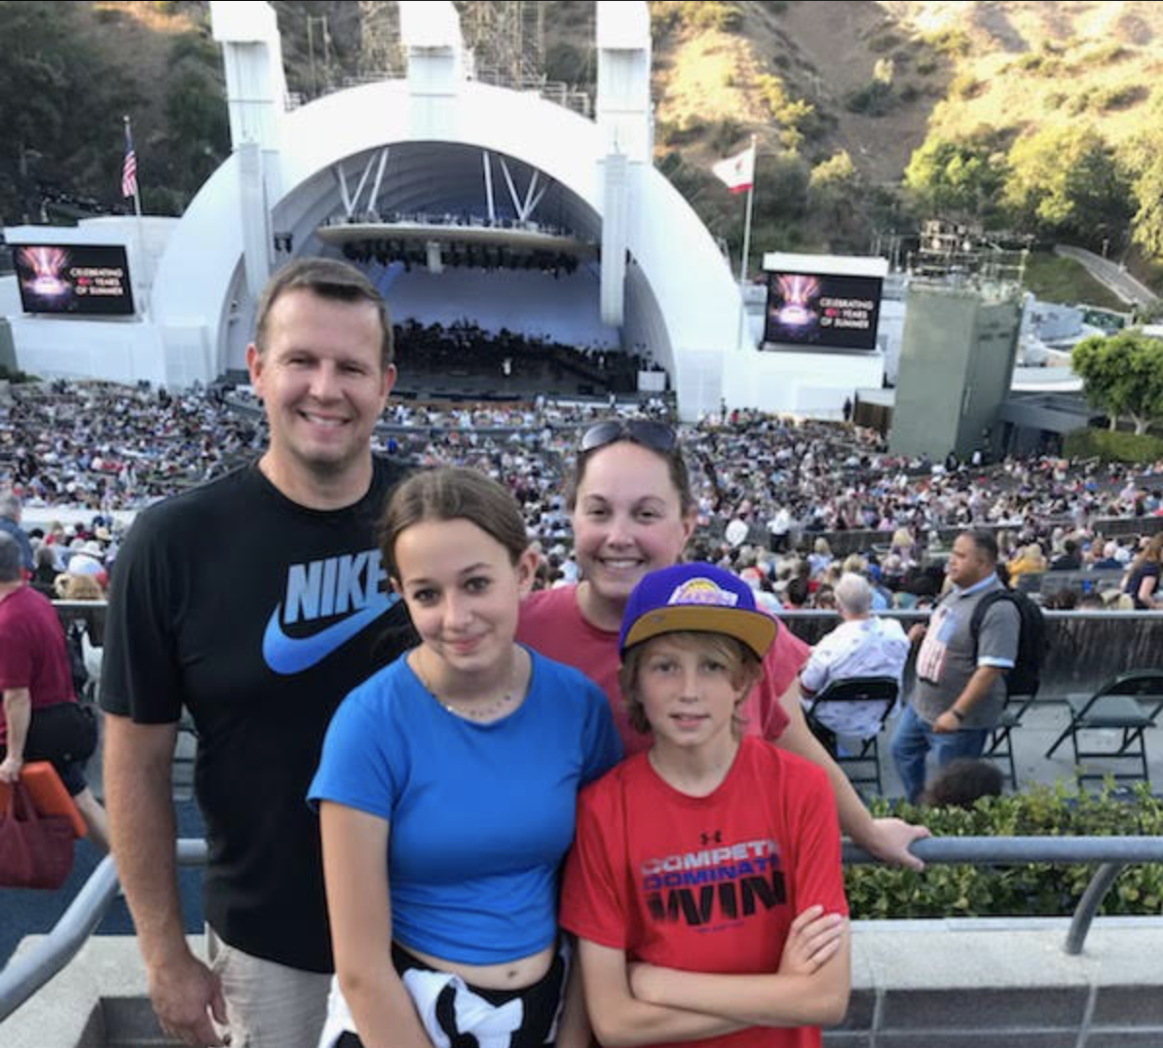
Bianca McKeen (RF16) was at the Hollywood Bowl on the 4th of July with husband, Jason, daughter Keira (13) and son Kipten (11) where they saw the LA Philharmonic Orchestra, Steve Martin, and Martin Short, and, of course, fireworks.

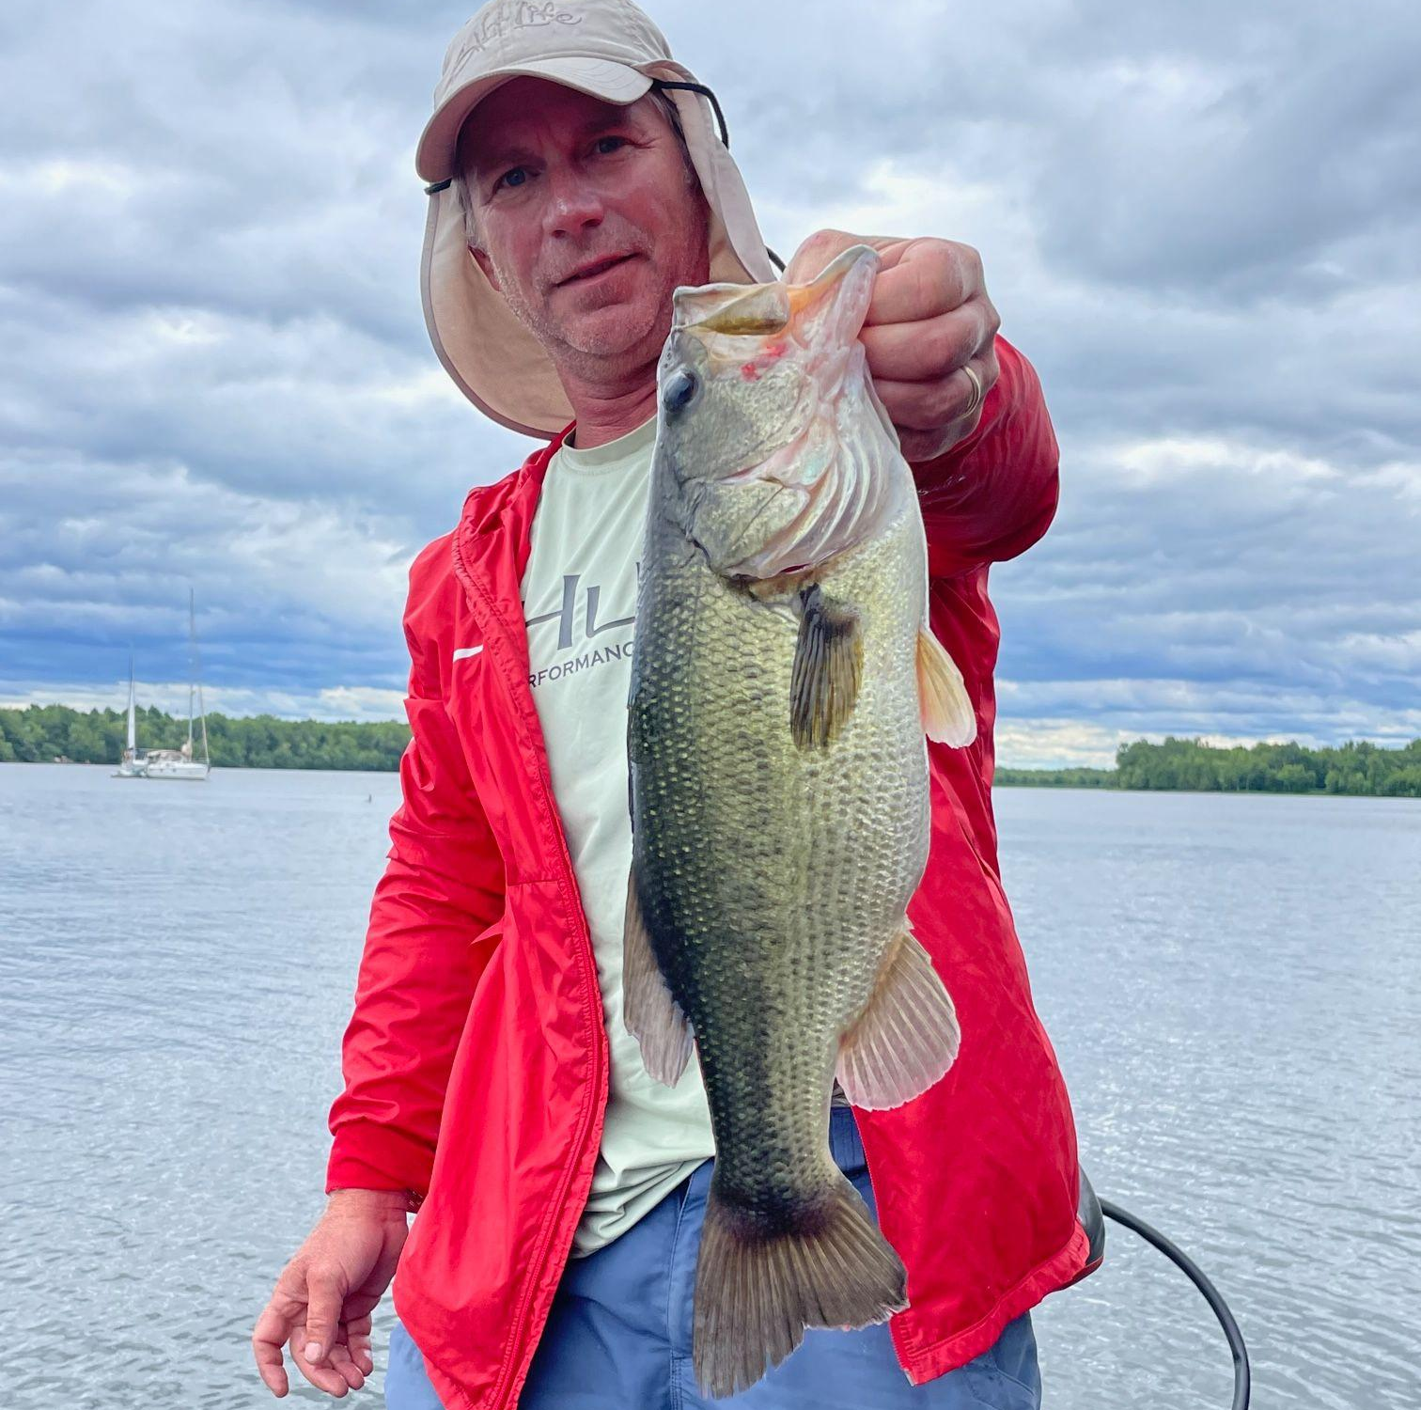
Tom Sabo (RF11) fished on Lake Champlain, seen here with a largemouth bass.

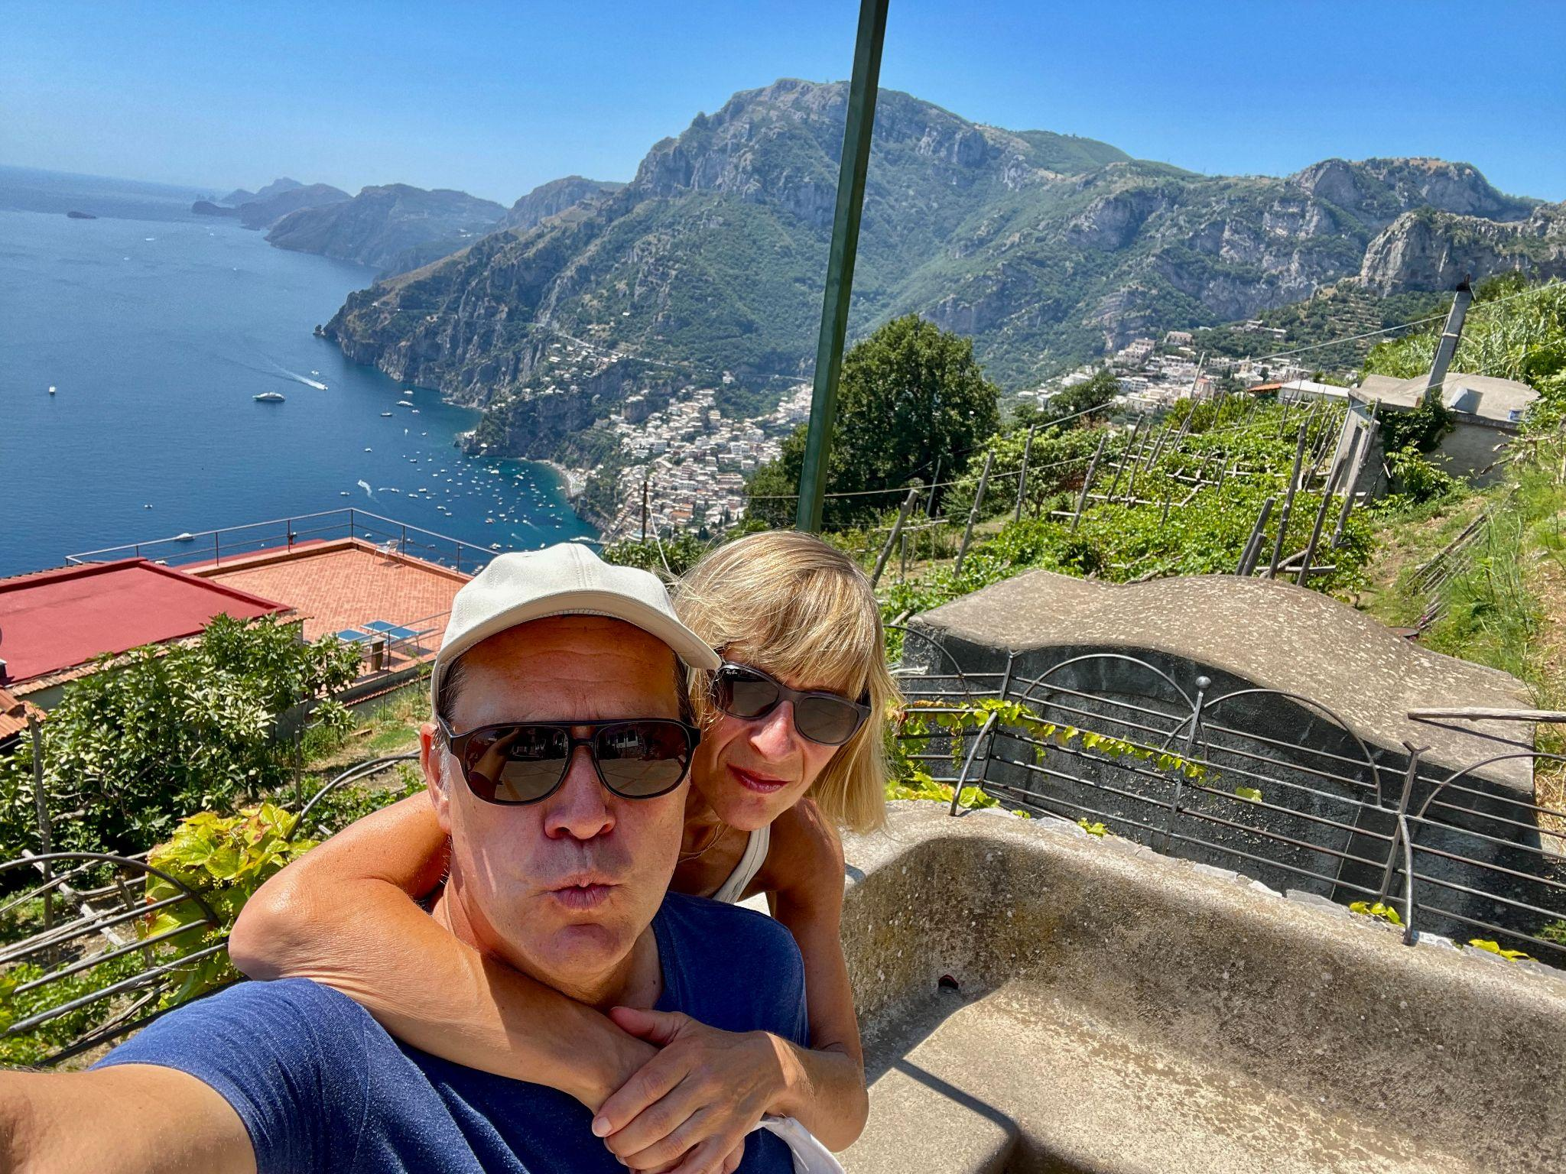
Executive Director Mike Martin (RF09) and wife Magali hiked on the Amalfi Coast in Italy, seen here in Nocelle, a small village that overlooks Positano.

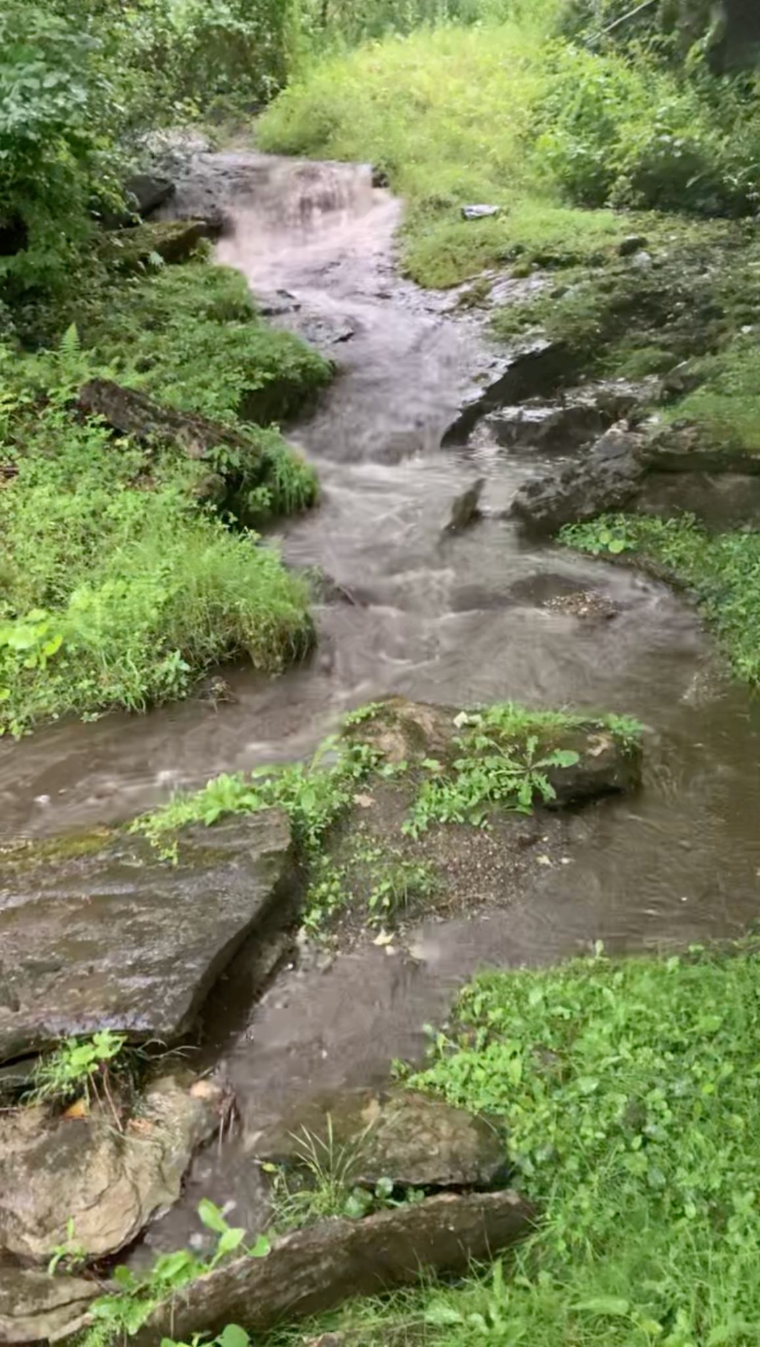 | Rowland Foundation Founder & Past Executive Director Chuck Scranton and wife Arden are grateful for their beautiful new home in Dorset, VT…and the lively brook that runs along their property. (Click on the image for video.)

Courtesy Postings

The Rowland Foundation is pleased to announce a unique learning opportunity that has been specifically designed for Rowland Fellows. With support from the Great Schools Partnership, Shelburne Farms, and the Rowland Foundation, starting this fall, Senior Associate Jeanie Phillips (RF14) will be teaching Collaborative Practices for Equity (Sept. 21-23). You’ll want to click on the link to register right away because we believe this course will fill quickly. Jeanie has also arranged for overnight lodgings at Orchard Cove as an option for course participants. Shelburne Farms is generously offering two nights at Orchard Cove for $100 for September 21 & 22. Limited rooms are available, so if you are interested, please contact Jeanie right away: jeanie@therowlandfoundation.org

