 | Letter to Fellows  Send Us Your Content!  August 2023

Dear Rowland Fellows,

I hope that you and your loved ones are all happy, safe & sound after this summer’s heat, humidity, and flooding around our state.

As you already know, Senior Associate Lori Lisai (RF15) has been leading our work to develop a new website for the Rowland Foundation. She worked with a design team of Rowland Fellows last school year and is now collaborating with a consultant to build out the new site’s architecture.

We would like to feature more media on our new website. Now that Elon’s killed Twitter, and with many of us stepping back from the anger and noise of social media, we are pivoting towards new ways to curate Rowland Foundation work. Our new website will have a Fellows-only section with content that is relevant to Rowland Fellows. Our newer cohorts are also using Google Drive on our Rowland Google domain to store and share Fellowship work internally.

Of course, we will be developing outward-facing media too, with the primary goals of 1) encouraging prospective Rowland Fellows to apply, and 2) sharing more of our story with the Vermont educational community.

To this end we will be putting out a request for proposals in the coming months to filmmakers interested in and capable of producing a series of short films about the Rowland Foundation, likely focused on themes such as Shared Leadership, Student Voice & Choice, Collaborative Practices for Equity, Systemwide Change, Sharing Innovation, or The Power of Climate and Culture. We would love for these films about The Rowland Approach to take inspiration from Tom Sabo’s (RF11) edutopia video and Anja Pfeffer’s (RF21) Dare to Be Me video.

As a Rowland Fellow, here are some ways you can contribute to our ambitious projects of developing a new website and producing short films about the Rowland Approach:
- Send us high-quality still photography of you, your students, your Steering Committee, and your school community! Please make sure to include your name and school in the filenames, so images can be traced back to their sources, and upload images to this folder.
- Send us video footage of you, your students, your Steering Committee, and your school community. Even if we are not able to use the video with sound, we may be able to use it as “B Roll” (i.e., moving background images). Please upload video files to this folder, and include your name and school in the filenames, so content can be traced back to its source.
- Let us know if you would like a film crew to come to your school to interview you, your colleagues, and your students about your Rowland Fellowship work and its impact! Please fill out this form with your name and contact information so we can be in touch as we move forward with this project.

Thanks in advance for contributing content to our new Rowland Foundation website and short films. Your contributions will help Vermont communities better understand our work and ethos as a foundation. Please feel free to check in with Lori Lisai (lori@therowlandfoundation.org), Abby Paige (abby@therowalndfoundation.org), or me if you have any questions or suggestions about this exciting opportunity.

Wishing you an excellent end to summer,

Mike

Rowland Foundation Updates

The 12th Annual Rowland Conference
Growing Community: Making Space for Joy & Creativity in School
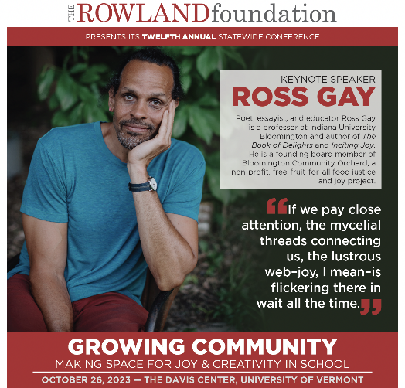
Rowland Conference registration will open on September 5th! If you pre-registered one or more school teams, you’ll receive an early-bird code for a reduced rate. You will then just need to enter your team information (team members, workshop choices, dietary restrictions, etc.) with UVM Event Registration and you’ll be all set. The excitement about Ross Gay is palpable, and this year’s early-bird spots filled faster than ever. Make sure you get your team registered first thing once you’re back at school.

Digital Wellness Resource Guide
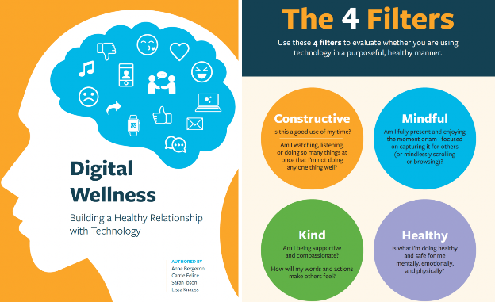
The Rowland Foundation is pleased to announce the publication of Digital Wellness: Building a Healthy Relationship with Technology, authored by our 2022 Rowland Encore Grant Team: Anne Bergeron (RF11), Carrie Felice (RF13), Sarah Ibson (RF13) & Lissa Knauss (RF18). We are proud of our Rowland Fellow authors’ approach, which is pragmatic and positive instead of shaming and blaming young people about their tech use. Instead of solely thinking in terms of “screen time”, the authors propose four filters to better understand the nature of our technology use, namely, asking, Is it Constructive? Mindful? Healthy? Kind?

Please share this timely resource guide with your students, colleagues, and families! This publication couldn’t come at a better time, as we realize the challenge of managing our technology use — adults and children alike! The authors have field-tested this resource guide in Vermont schools and thoughtfully curated relevant and useful classroom activities combined with helpful resources.

The Rowland Women’s Leadership Retreat
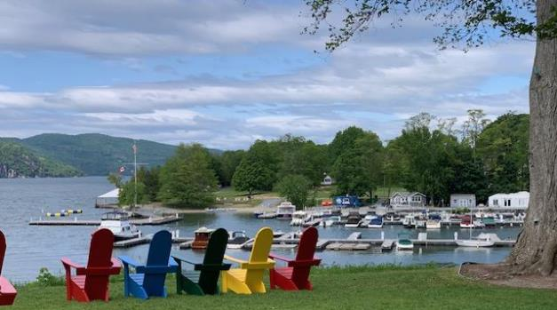
The 2023 Rowland Women Leadership Retreat was held at Basin Harbor Club this year. It was a deeply appreciated opportunity for Rowland Fellows to connect and think about what it means to be women educational leaders.

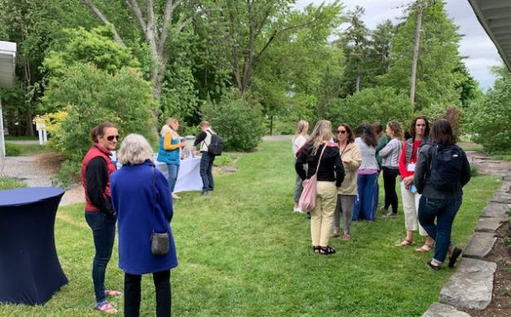

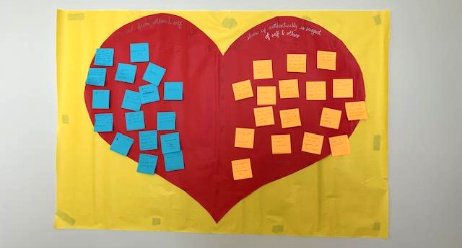
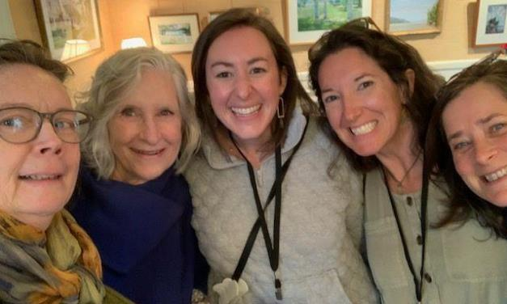
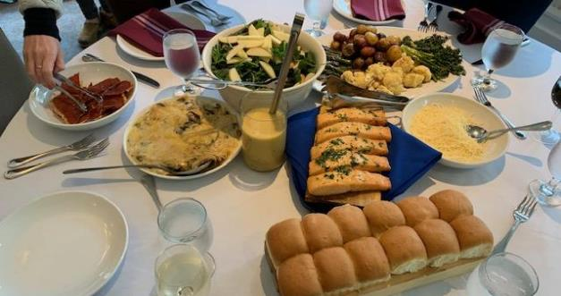
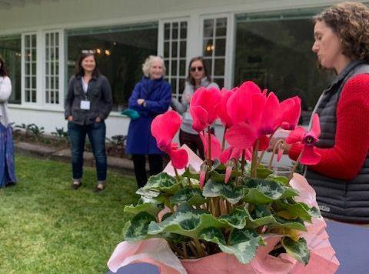
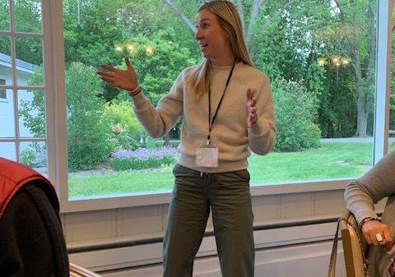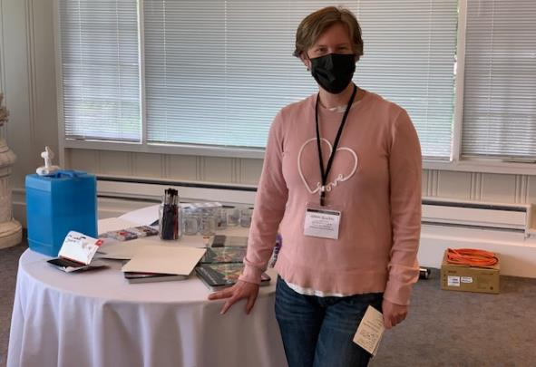
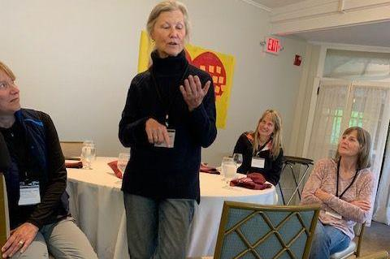
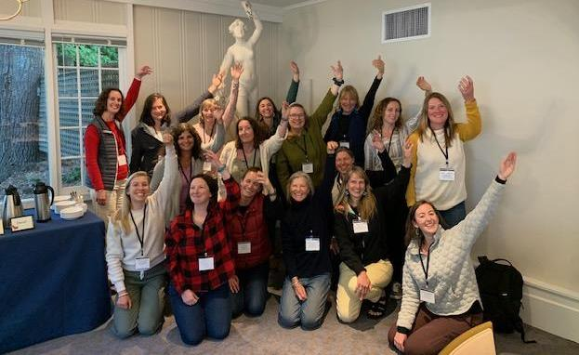
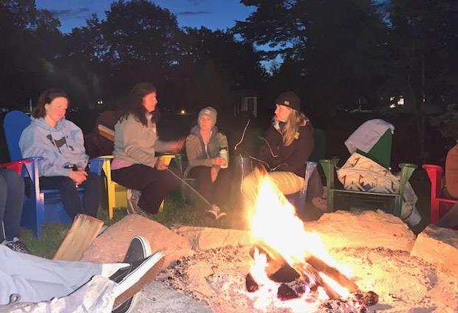

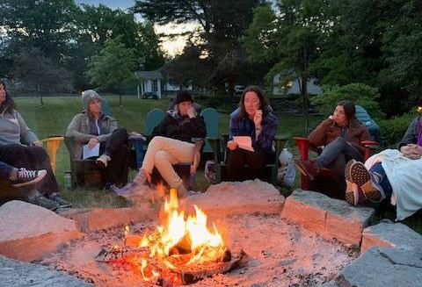

2023 Rowland Encore Grant Team
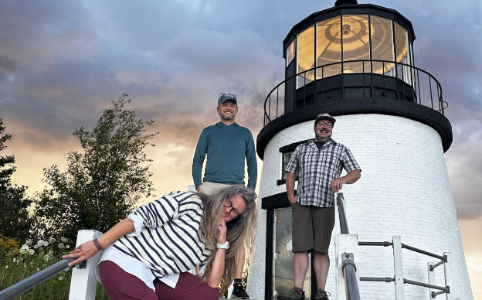
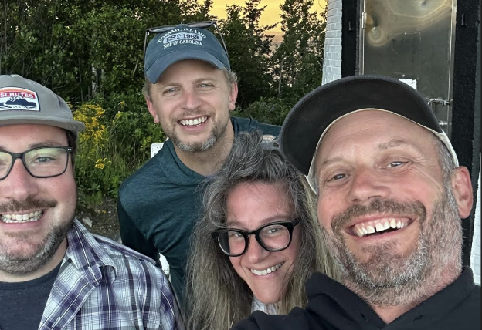
The 2023 Rowland Encore Grant Team convened in Rockwell, Maine this summer for their writing retreat as they work to develop a white paper focused on deeper learning for Vermont schools. Seen here: Andrew Jones (RF15), Michael Ruppel (RF17), Jess DeCarolis (RF09) & Gabe Hamilton (RF15).

The Rowland Foundation Staff
This summer Executive Director Mike Martin (RF09) and Executive Assistant Abby Paige met with Senior Rowland Associates Jean Berthiaume (RF09), Jeanie Phillips (RF14), & Lori Lisai (RF15) to take stock of the year’s work and do some initial planning for the year ahead.
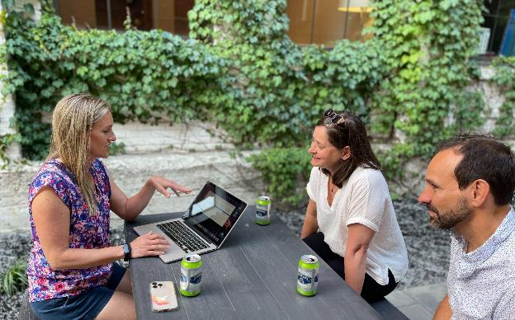
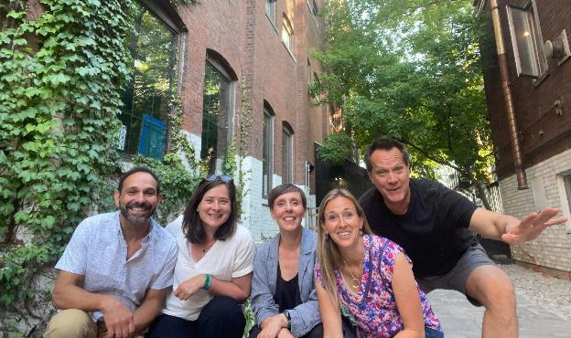

Celebrations
Warmest congratulations to Marsha Cassel (RF14)! We want to wish Marsha a very happy next chapter as she retires from teaching at Rutland High School. We are grateful for Marsha’s brilliant career as a world language teacher, a statewide leader, and an advocate for democracy and equity in Vermont education. Marsha co-founded Rutland’s annual GIN (Global Initiatives Network) Conference and recently served on Vermont’s Diversifying the Educator Workforce Taskforce. Marsha enjoys the love and respect of her colleagues, students, families, and administrators because of her sharp intellect, warm sense of humor, and generosity of spirit.
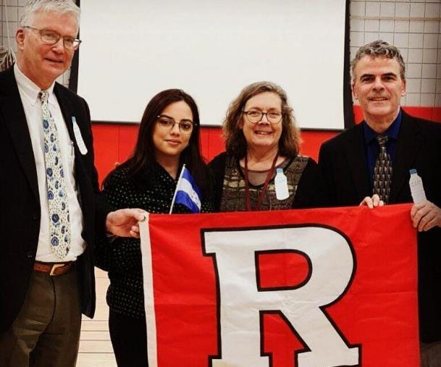
Marsha Cassel seen here with Rutland Superintendent Bill Olsen and Principal Greg Schillinger welcoming a GIN keynote speaker.

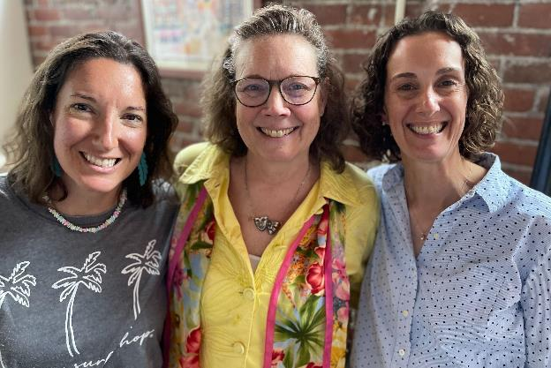
Marsha Cassel seen here at the Rowland Foundation Office with her fellow Rowland Women’s Leadership Retreat planners Tara Cariano (RF18) and Gretchen Muller (RF17).

Here is an appreciation from Marsha’s Rutland colleague Bianca McKeen (RF16):

Marsha Casell has been so much for so many people at Rutland High School and in the Rutland community. I have had the great privilege of working with Marsha at both Rutland Middle School and RHS. Marsha is a true professional. Her advocacy for all students, especially those underrepresented, runs deep and never stops. Marsha has brought many global connections to Rutland High School and the state. She has spearheaded the Global Issues Network conference in Vermont since its inception. Marsha has coordinated exchanges, changes in programming, community dialogues, and new courses and extracurricular activities to help change the world in which we live for the better. She is a mentor and teacher and will always be so. I am proud to call her a friend and wish her all the best.

Here is a tribute to Marsha from Trustee Erica Wallstrom (RF14) who was her Rowland Fellowship partner at RHS:

At her core, Marsha is a fighter, a defender, an advocate. Her dogged determination is for displaced people, marginalized voices, our abused planet, and always, always for her students. The result of her consistent willingness to step in and step up is intertwined throughout Rutland High School as well as the greater Rutland community.

While not her most noteworthy or influential action, I want to share a story that demonstrates her grit and commitment. On the eve of our 2016 GIN Conference, we received a reluctant email from our keynote speaker’s agent informing us that somehow there was a double booking where the speaker was going to be presenting the night before in Buffalo; and therefore, he was not going to be able to attend our conference. While I immediately started thinking about alternatives for that time slot, Marsha began laying out her counter argument and plotting her plan. Ultimately, she ended up communicating directly with the keynote and convinced him that he could in fact speak at both events if we were able to provide him transportation from upstate New York to Rutland. This transportation entailed Marsha jumping in her Subaru armed with caffeine and snacks for an 8 hour drive after a full day of teaching only to pick him up and drive through the night back to Rutland. The end result was a moving keynote where most people attended unaware of the logistics required to make it a reality.

Marsha was and remains the quiet warrior - making the inconceivable a reality. Marsha congratulations on your retirement - think of the road trip possibilities that await you!

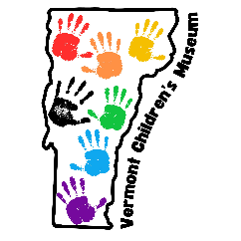
Congratulations to Kerianne Severy (RF17) on the success of the Vermont Children’s Museum! Kerianne launched this new non-profit which is now putting together a full year calendar of traveling pop-up events throughout Addison County. For more information please visit: www.vermontchildrensmuseum.org Kerianne also just completed Dave Melnick’s Level 2 train-the-trainers trauma course and would love to get feedback on presentations, workshops, and/or consultations by working with fellows and their schools. You can contact Kerianne at: kerianne.severy@mausd.org

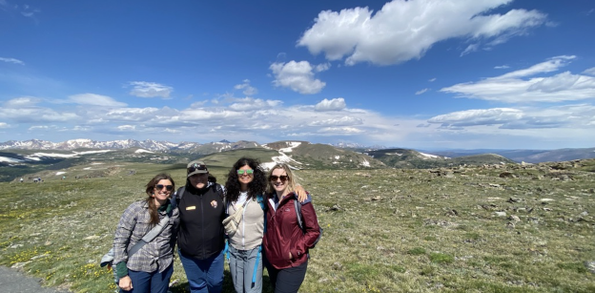
Janis Boulbol (RF21) & Kat Robbins (RF21) participated in the National Park for Every Classroom workshop in Estes Park, Colorado this summer with staff and partners from Marsh-Billings-Rockefeller National Historical Park and the Billings Farm and Museum. They met with parks from across the nation as well as the NPS Climate Change Response Program to explore how and why the NPS is supporting education and advocacy around climate action and environmental justice. Together, Janis & Kat co-created a year-long plan for teacher professional development sessions that they will facilitate. Stay tuned for this schedule later this fall! They also explored the alpine tundra on many early morning and late evening hikes to waterfalls, lakes, and ridgelines.

This year several Rowland Fellows were invited to lead workshops for superintendents, special education directors, and curriculum leaders at Connecting the Dots: Inclusion, Belonging & Wellness in Vermont Schools, the annual conference co- sponsored by the VSA, VCSEA & VTCLA. Andrew Jones (RF15), Mike Martin (RF09), Mike McRaith (RF13) & Jeanie Phillips (RF14) presented to this statewide audience on topics such as: Universal Design for Learning, Social Justice Standards, Portrait of a Graduate, and The Rowland Approach to School Change.

At this fall’s Annual Rowland Conference, Growing Community: Making Space for Joy & Creativity in School, we’re pleased to announce that nearly half of the workshop presenters are Rowland Fellows, including: Anne Bergeron (RF11) Janis Boulbol (RF21), Abbie Bowker (RF17), Carrie Felice (RF13), Emily Gilmore (RF17), Sarah Ibson (RF13), Lissa Knauss (RF18), Anja Pfeffer (RF21), Kat Robbins (RF21). Look for the complete conference program in next month’s Letter to Fellows!

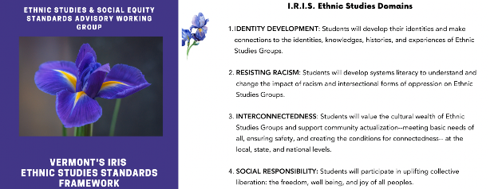
Act 1 of 2019 created a diverse statewide working group to 1) “review standards for student performance adopted by the State Board of Education”, and 2) “recommend to the State Board updates and additional standards to recognize fully the history, contributions, and perspectives of ethnic groups and social groups.” Both of these charges have now been completed. Act 1 Working Group revisions to Vermont’s Educational Quality Standards were adopted by the State Board of Education earlier this year. Most recently, the Act 1 Working Group worked with national consultants to develop Vermont’s IRIS Ethnic Studies Framework, which has been submitted to the State Board for adoption. Rowland Fellows Mike McRaith (RF13) and Mike Martin (RF09) both served on the Act 1 Working Group, and Jess DeCarolis (RF09) provided expert guidance to the group’s work in her role as an AOE Division Director.

Gratitude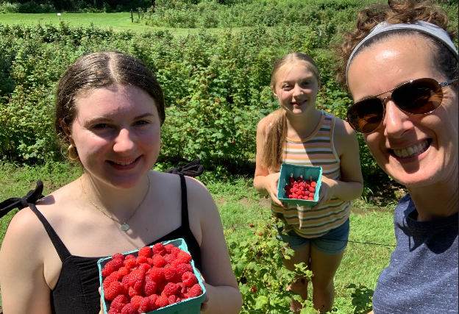
Gretchen Muller (RF17), seen here with daughters Anya and Nadia, honored their yearly tradition of berry picking on a visit to the Culinary Institute of America in Hyde Park, NY to celebrate Gretchen’s mom's 80th birthday.

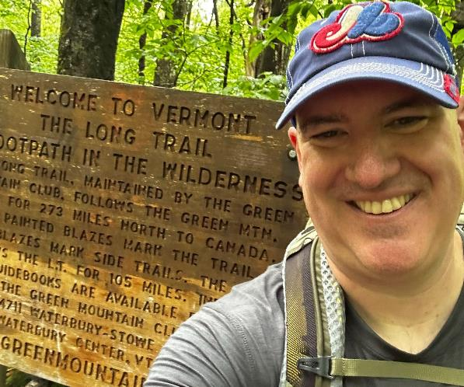
Before the flooding, Chris Sheehan (RF23) set out with some friends and did 100 miles on the Long Trail! Chris said it was a great adventure to kick off the summer.

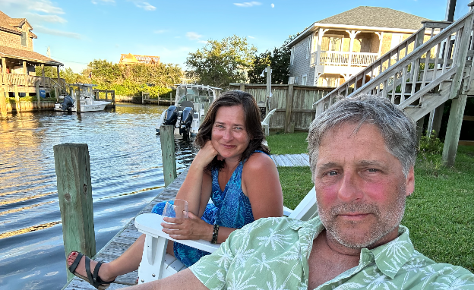
Jeanie Phillips (RF14), seen here with husband Michael Eppolito, recently enjoyed swimming in the ocean, kayaking with dolphins, and reading lots of books in Ocracoke, North Carolina.

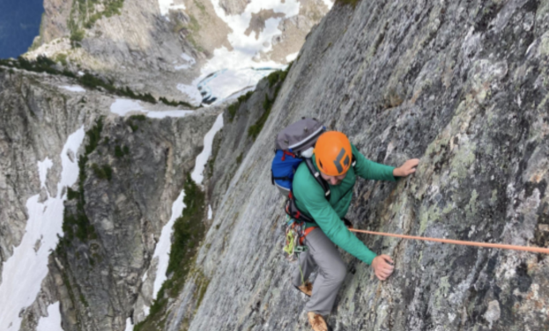
Alpinist Andrew Jones (RF15) did some serious mountain climbing in Washington this summer. Seen here climbing the route "True Grit" (5.8) On Vesper Peak in the Central Cascades.

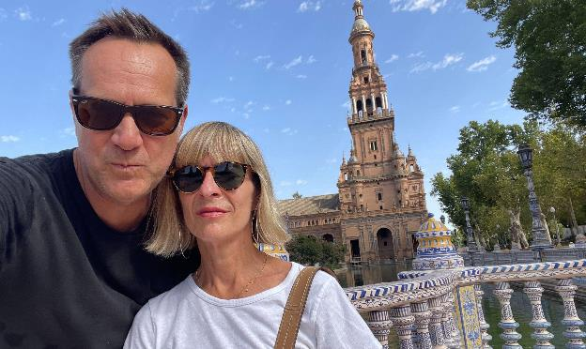
Michael Martin (RF09), seen here with his wife Magali in Seville, recently visited Andalusia.

Courtesy Postings


The Collaborative Practices for Equity course is starting Aug. 16th and still has a few spots open! This highly participatory course, taught by Jeanie Phillips (RF14) and co-sponsored by Great Schools Partnership & The Rowland Foundation, is designed for teachers and administrators interested in developing the skills necessary for designing and engaging in effective collaboration. Participants will actively build a culture that supports collaboration and will reflect on the process of sustaining a collaborative culture in their own settings. They will explore and practice structures that encourage collaborative inquiry and consider how those structures might work in their schools. Participants will engage in work on questioning, developing skills that will create opportunities for growth, both for themselves and for colleagues. A fierce commitment to educational equity and excellence will be at the core of all the learning participants will do.
- Dates: August 16, 17, 18; September 25; November 10, 2023 from 9am-4pm
- Location: face-to-face in Shelburne, VT
- Cost: $1,350 for 45 hours of recertification credit, 3 credits from Castleton University available for an additional $435
- Registration Here!

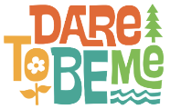
The Dare to Be Me graduate course registration is now open for the fall semester! Educators interested in teaching & learning with the heart, body, and mind will want to enroll in this experiential Castleton graduate course taught by Anja Pfeffer (RF21). To learn more, check out the new Dare to Be Me website.
- Location: In-person at Hazen Union School
- Dates and Times: October 14, 2023 – May 18, 2024. One Saturday a month (see dates below) spread across the school year from October 2023 to May 2024.Oct. 14, 2023, Nov. 4, 2023, Dec. 2, 2023, Jan. 6, 2024, Feb. 3, 2024, March 9, 2024, April 6, 2024, May 18, 2024, Times: 10am - 3:30pm
- Credits: 3 graduate
- Tuition: $1,195


VPA Professional Learning & Support, Fall 2023 Offerings Check out the many offerings for this school year from the VPA, including the first-ever Women in Leadership Conference, Examining Race in VT Schools, and much more.

