 | Letter to Fellows  August 2021
Dear Rowland Fellows,

I hope you are having a beautiful summer with your loved ones.

It’s usually healthy for educators to not think about school during the summer, but the current Critical Race Theory (CRT) controversy is making that hard to do. As you probably already know, what right-wing political activists are currently calling “Critical Race Theory” is nothing of the sort; they are using CRT as a catch-all term to oppose everything from antiracism work to a critical examination of United States history. Since it's hard to stand for racist schools or against critical thinking, the somewhat obscure graduate school framework of CRT has been conjured up as a new culture wars bogeyman. Critics of what is being called “CRT” claim that it is divisive and that it hurts white children when schools have honest discussions of racism, power, and privilege.

Unfortunately, the fake CRT polemic is now being used by some state legislatures to do real harm to curriculum. For example, a recent bill in the Texas State Senate purged Dr. Martin Luther King, Susan B. Anthony, and César Chávez from the required curriculum, and also removed the requirement for schools to teach that the Ku Klux Klan is morally wrong. Given the oversized influence Texas has on the national textbook market, this alone is cause for concern.

Closer to home in New Hampshire, this past month Governor Chris Sununu signed into law language banning all state employees, including teachers, from using “divisive language” on the job. Superintendent James Morse said the amendment would have the effect of “curtailing freedom of speech, freedom of expression and academic freedom in New Hampshire.” New Hampshire teachers found in violation of this new law —ironically titled “Prohibition on Teaching Discrimination”— will face professional sanctions by their State Board, including the potential loss of their teaching license.

Following the controversy surrounding the removal of confederate statues and the writing of the 1776 Report—a publication which was condemned by the American Historical Association—these new curriculum battles seem to evoke George Orwell’s formula from 1984, “Who controls the past controls the future. Who controls the present controls the past.”

This June, before leaving my position as South Burlington School District Director of Learning, I took a call from a calm and polite community member who was very concerned about “CRT”. He said that it would “send white students to the back of the bus” and make our next generations of young people into communists. I tried to make the case that it’s healthy for students to learn the history that was hidden from me back when I was a student. After all, “The advancement and diffusion of knowledge is the only guardian of true liberty,” as James Madison said. Our conversation did not end with any consensus, but it was a good reminder that I couldn’t take for granted community support for antiracism work in schools, even in supposedly progressive Vermont.

All that to say, my fellow Rowland Fellows, that our work to “positively affect student achievement and the culture and climate” of Vermont schools lies at the heart of the democratic mission of public school. Our work to provide equitable opportunities for all students and to cultivate citizenship is more critical than ever. And perhaps even more important than any given historical figure or event is the type of questions we ask of students in school. For example, I find useful the following guiding questions from historian Joanne Freeman:

- What stories do we tell in schools?
- Who gets talked about?
- Who doesn't get talked about?
- What's allowed to be talked about?
- What gets crossed out and not talked about?
- What is the story of America that we want our children to learn?

In a moment where bad ideas “go viral” on social media—leading to more Americans actually getting a deadly virus—how we know what we know is of the utmost importance, and so is critical thinking. Schools play an essential role in giving our future citizens the tools and knowledge to construct understanding. And, of course, grand narratives matter too, whether they are for an ever-improving democracy or for a desire to return to the past. When President Obama drew a line from Seneca Falls to Selma to Stonewall in his second inaugural speech, it told a story of who we are as a country and who we aspire to be.

As usual, nobody puts it better than James Baldwin, “...the great force of history comes from the fact that we carry it within us, are unconsciously controlled by it in many ways, and history is literally present in all that we do. It could scarcely be otherwise, since it is to history that we owe our frames of reference, our identities, and our aspirations.”

For some time now, the narrative around U.S. public schools is that they are failing. However, public school educators should take this latest controversy as an extreme compliment. Underlying the current debate is actually a tacit admission that how and what teachers teach really stays with our young people, that teachers do, in fact, make a difference.

Thank you, dear Rowland Fellows, for elevating the voices of students in our schools and modeling democracy in your work. Your hard work and courage make all the difference.

See you soon,

Mike

P.S. I’m trying out a new monthly newsletter here to help keep us all connected, so please send me your news! Each month, I’ll be bundling courtesy posts for courses & events, and also celebrating new jobs, family vacations, and other news from our extended Rowland Family of Fellows. So please email whatever you’d like to share to rowland.foundation@gmail.com

P.P.S. For more on the “CRT” controversy:

We Need to Teach the Truth About Systemic Racism, Say Educators (NEA)

The Two Big Lies of WSJ’s Attack on Critical Race Theory (Fairness & Accuracy in Reporting)
- Now & Then: Culture Wars (Heather Cox Richardson & Joanne Freeman podcast)
- Ibram X. Kendi on What Conservatives—and Liberals—Get Wrong About Antiracism
The Ezra Klein Show

Rowland Foundation Updates
The 10th Annual Rowland Conference with keynote Dr. Carla Shalaby and the theme of Teaching Love & Learning Freedom: Practicing Community in the Classroom at the University of Vermont’s Davis Center on October 27th is going to be amazing. Special thanks to all of the Rowland Fellows who submitted workshop proposals. Registration will open in September, at which time team members will be able to select workshops. We are excited about our conference theme of. Carla is the author of Troublemakers, which is a book that will change the way you think about school.

Mark your calendars for this year’s All Fellows Retreat which will be at the Hilton Burlington on October 26th, followed by our traditional All Fellows Social at the Farmhouse immediately afterwards. In addition to the usual RF cohort cross-pollination, this year’s edition will explore ideas for Rowland Encore grant proposals. Stay tuned for more details in the months to come.
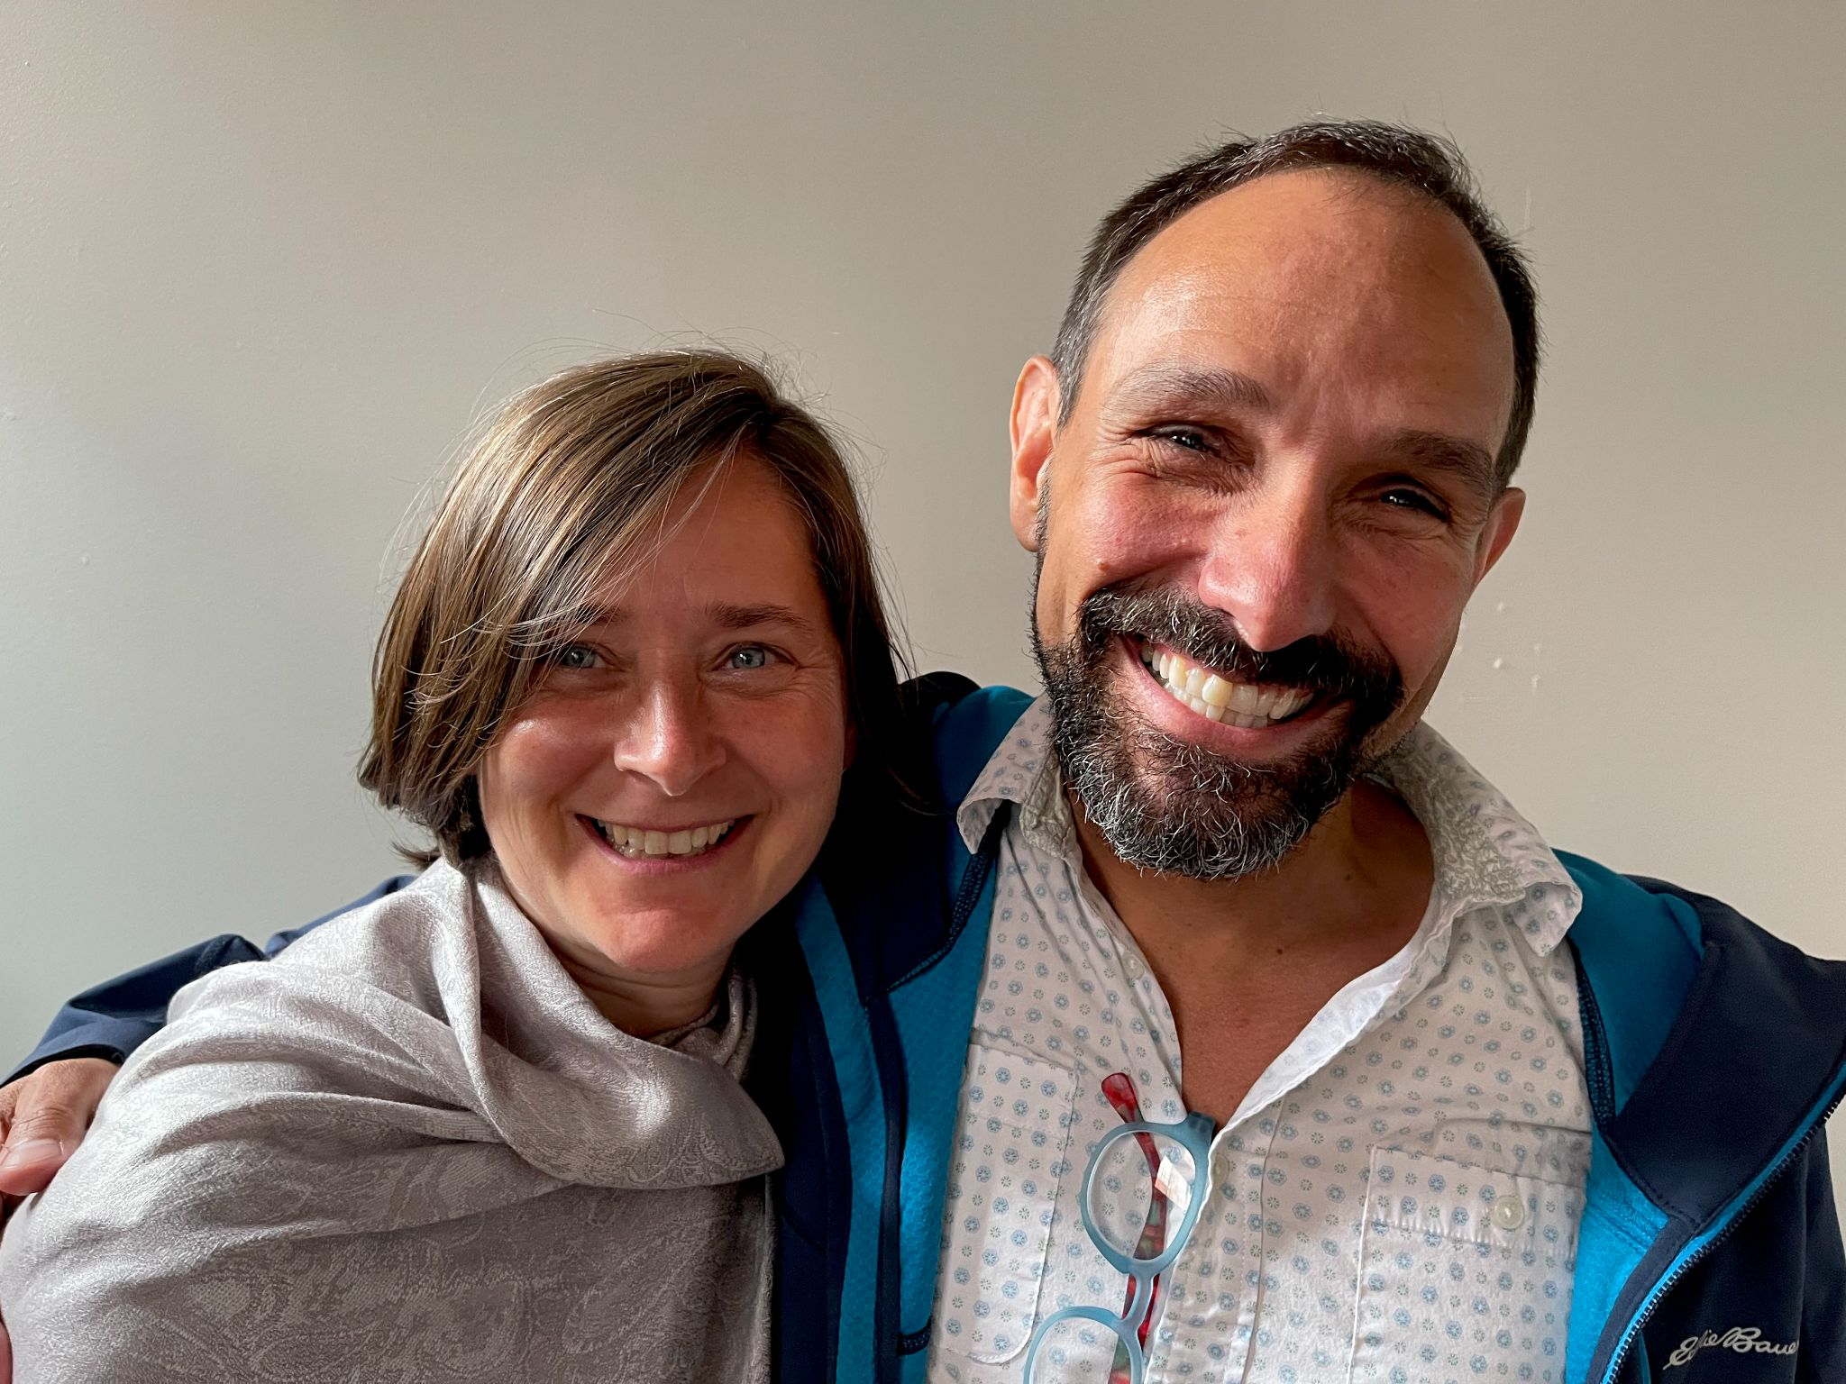

Rowland Foundation Senior Associates Jeanie Phillips (RF14) & Jean Berthiaume (RF09) met at the new Rowland Foundation offices in Burlington with Mike Martin (RF09) to plan for work with Rowland Foundation cohorts this year.

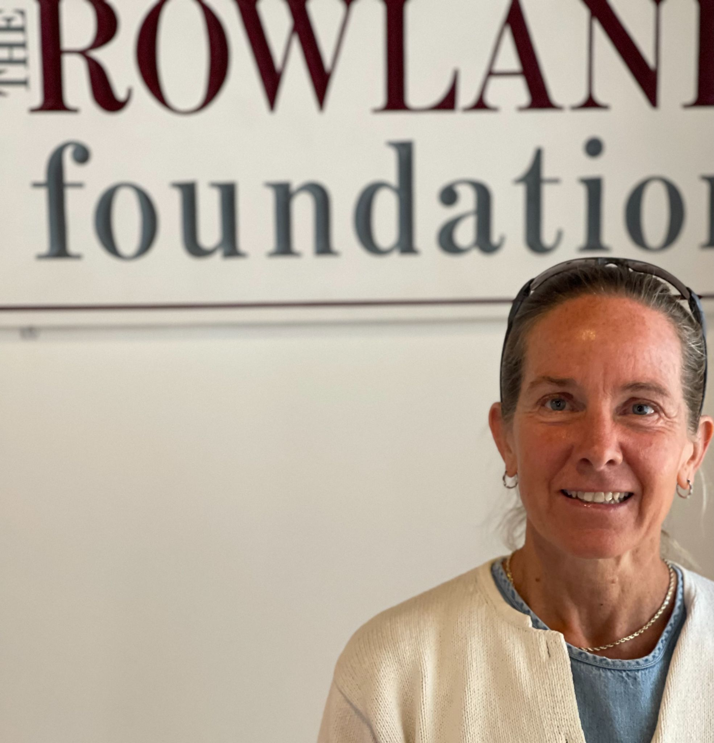
Rowland Foundation Board Chair Heidi Rowland Lynn met at the new Rowland Foundation offices in Burlington with Mike Martin (RF09) to plan for the coming year.

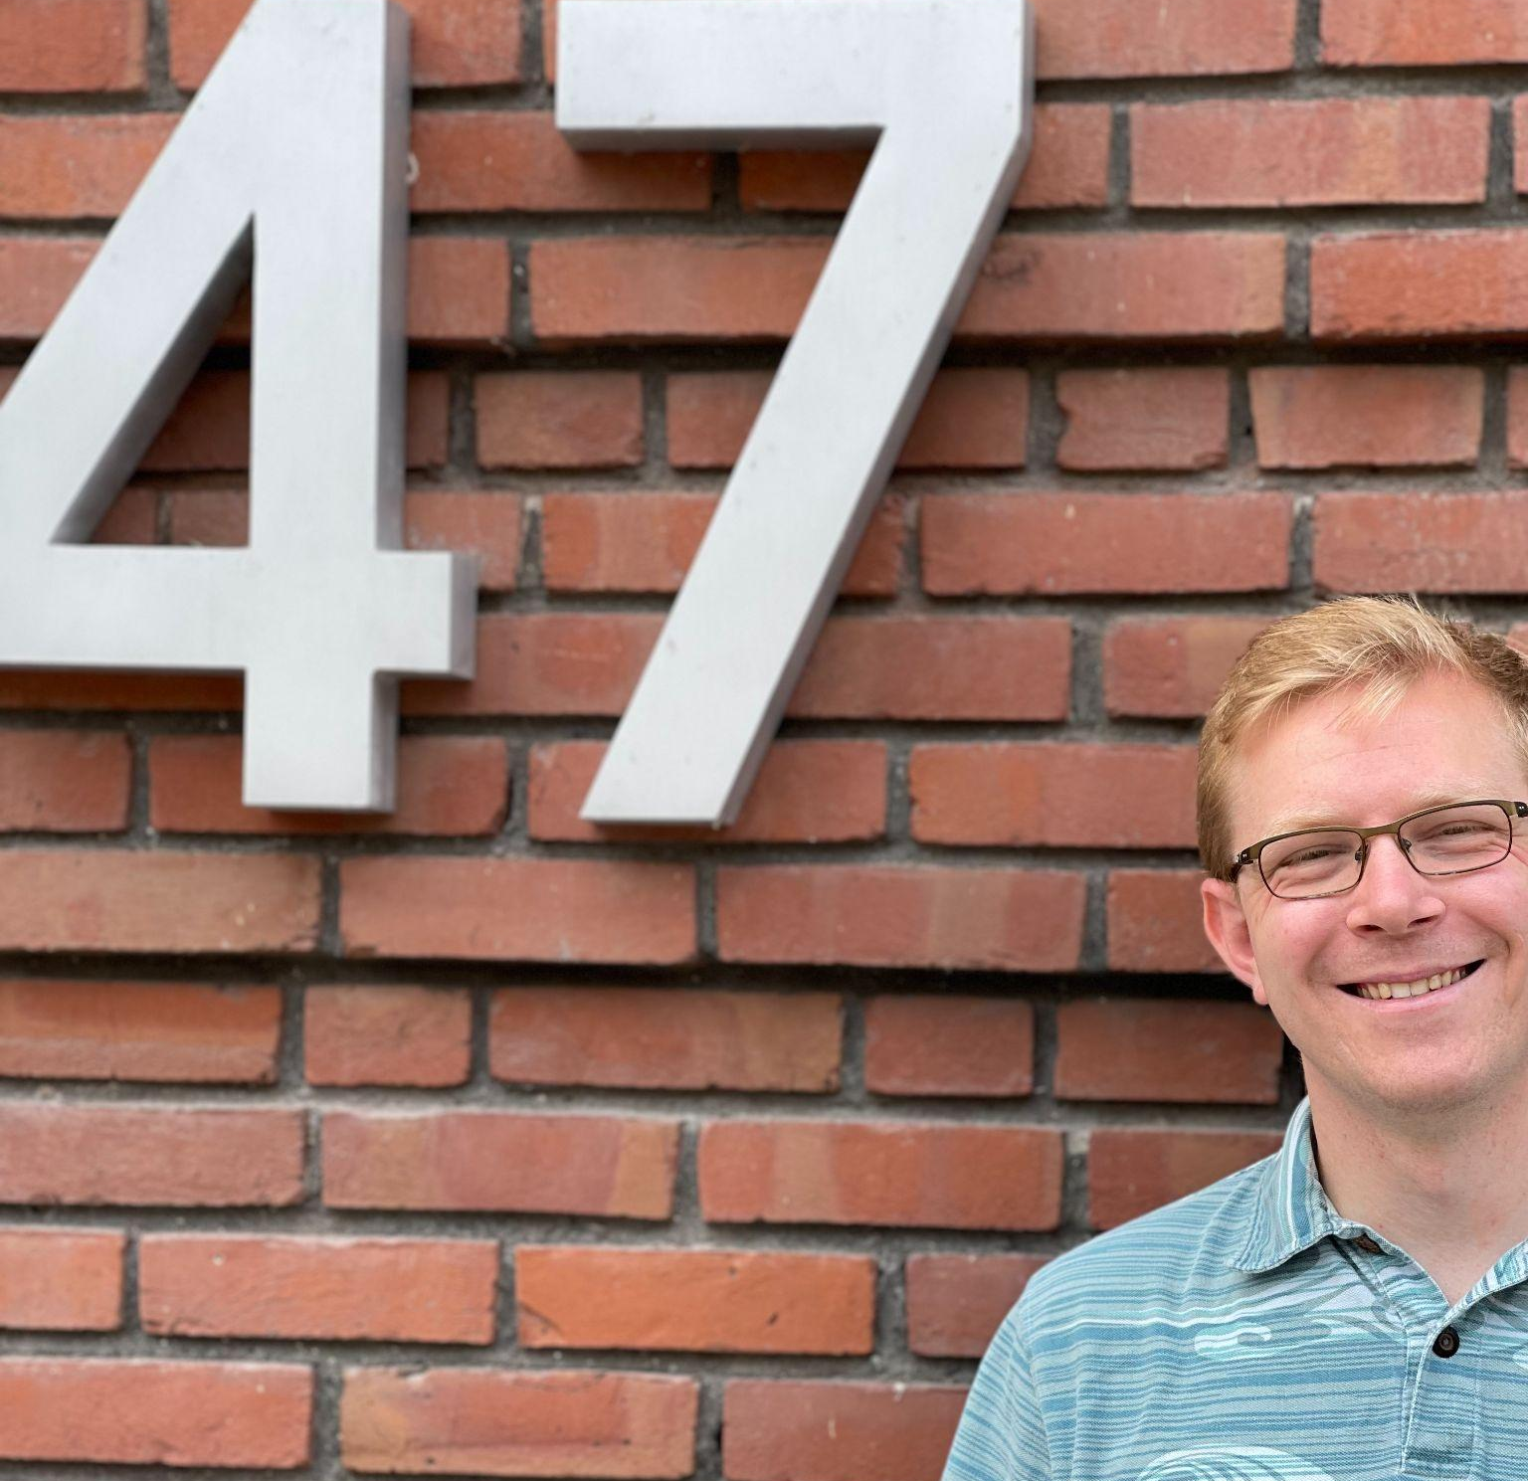
Luke Dorfman (RF19) met at the new Rowland Foundation offices at 47 Maple St., Burlington with Mike Martin (RF09) to discuss educational podcasts.

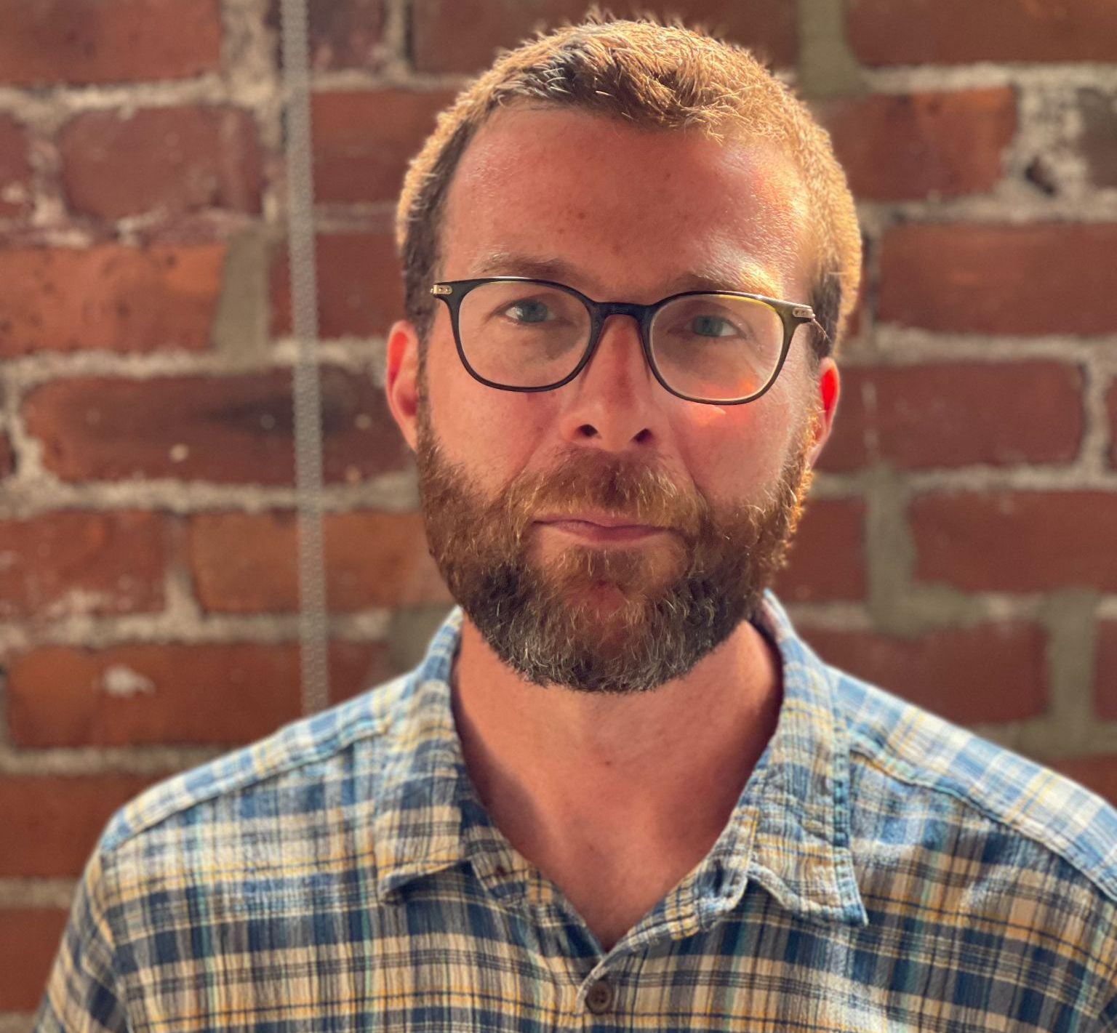
Peter McConville (RF11) met at the new Rowland Foundation offices in Burlington with Mike Martin (RF09) to catch up and discuss place-based education.

Gratitude

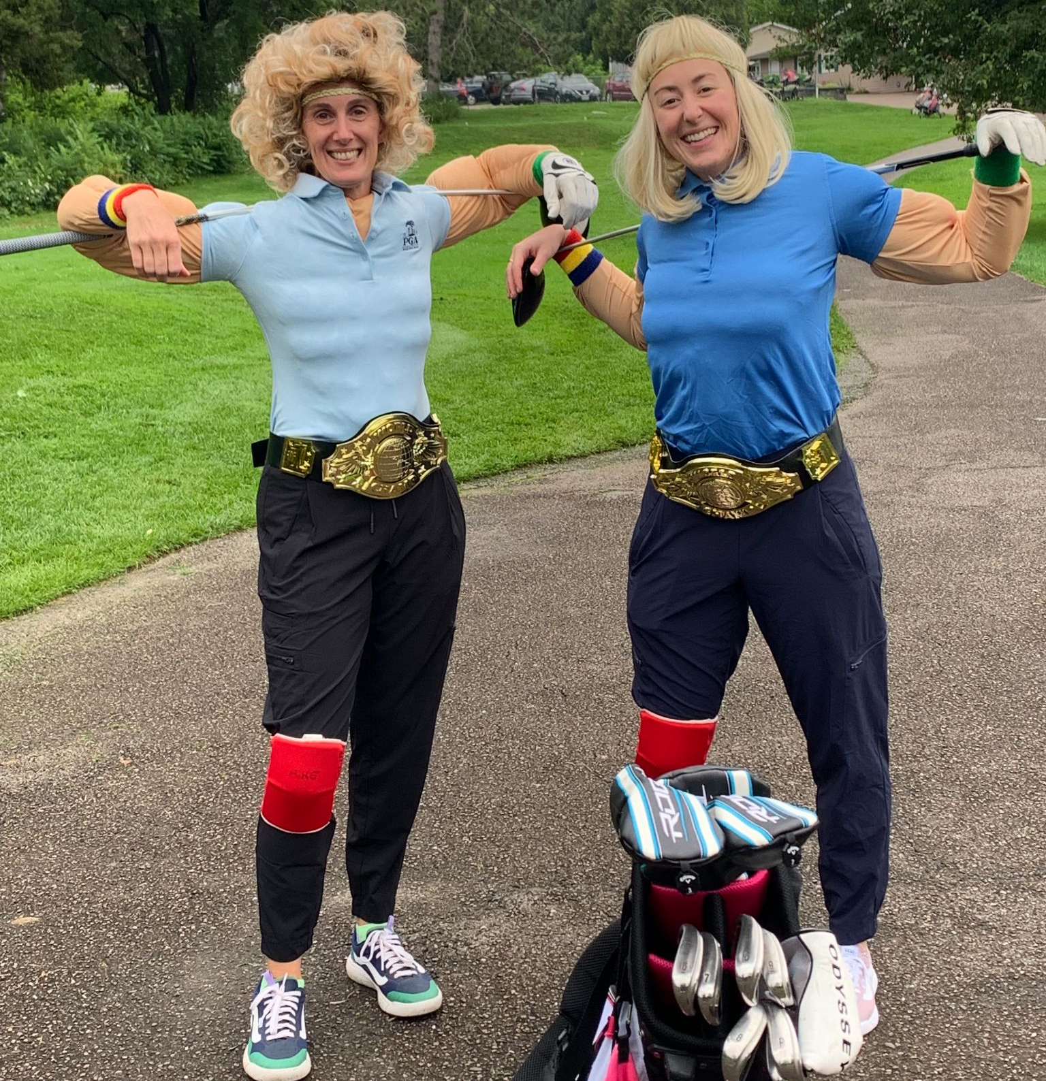
The Wonderful Women of Wrestling, AKA Gretchen Muller (RF17) and Emily Gilmore (RF17), hit the links in Williston.

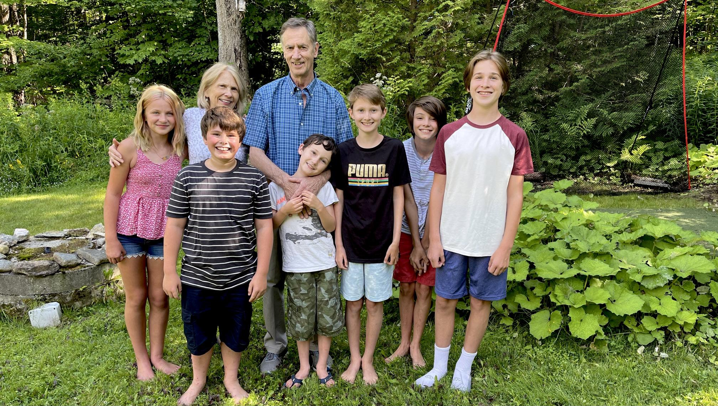
Arden & Chuck Scranton enjoyed time with their grandchildren (left to right) Hannah, Reece, Sawyer, Cole, Declan, and Ben in Winhall.

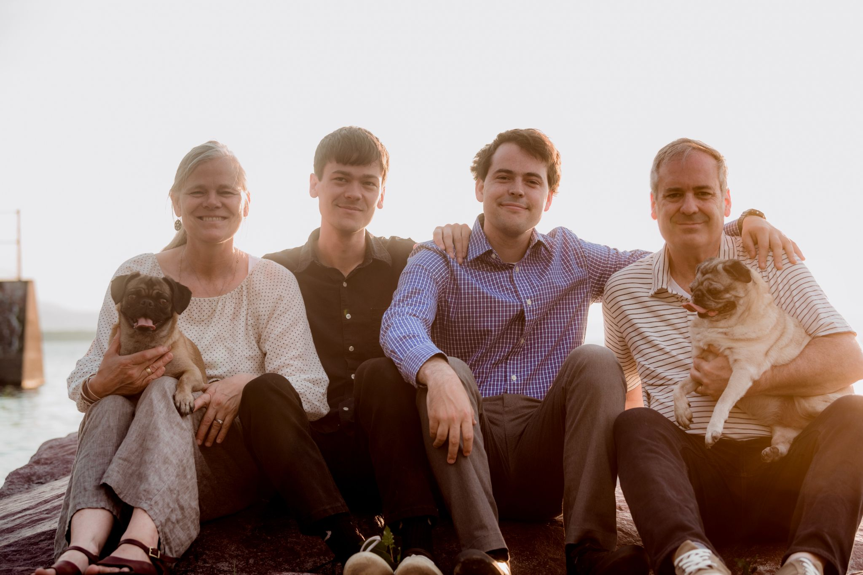Sally & Charlie MacFadyen (RF20) were grateful to have Brian and Owen back home this spring, after a challenging pandemic experience. Seen here at Burlington’s Oakledge Park, a place that has always been special to their family.

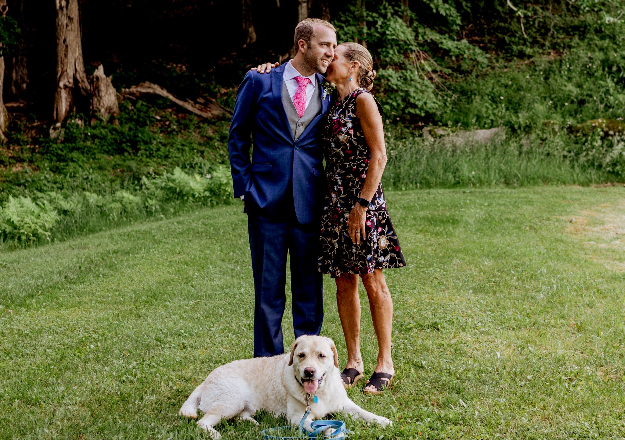
Carter Rawson and Heidi Lynn at Carter’s wedding to Leeanne, seen here with Milo in Dorset.
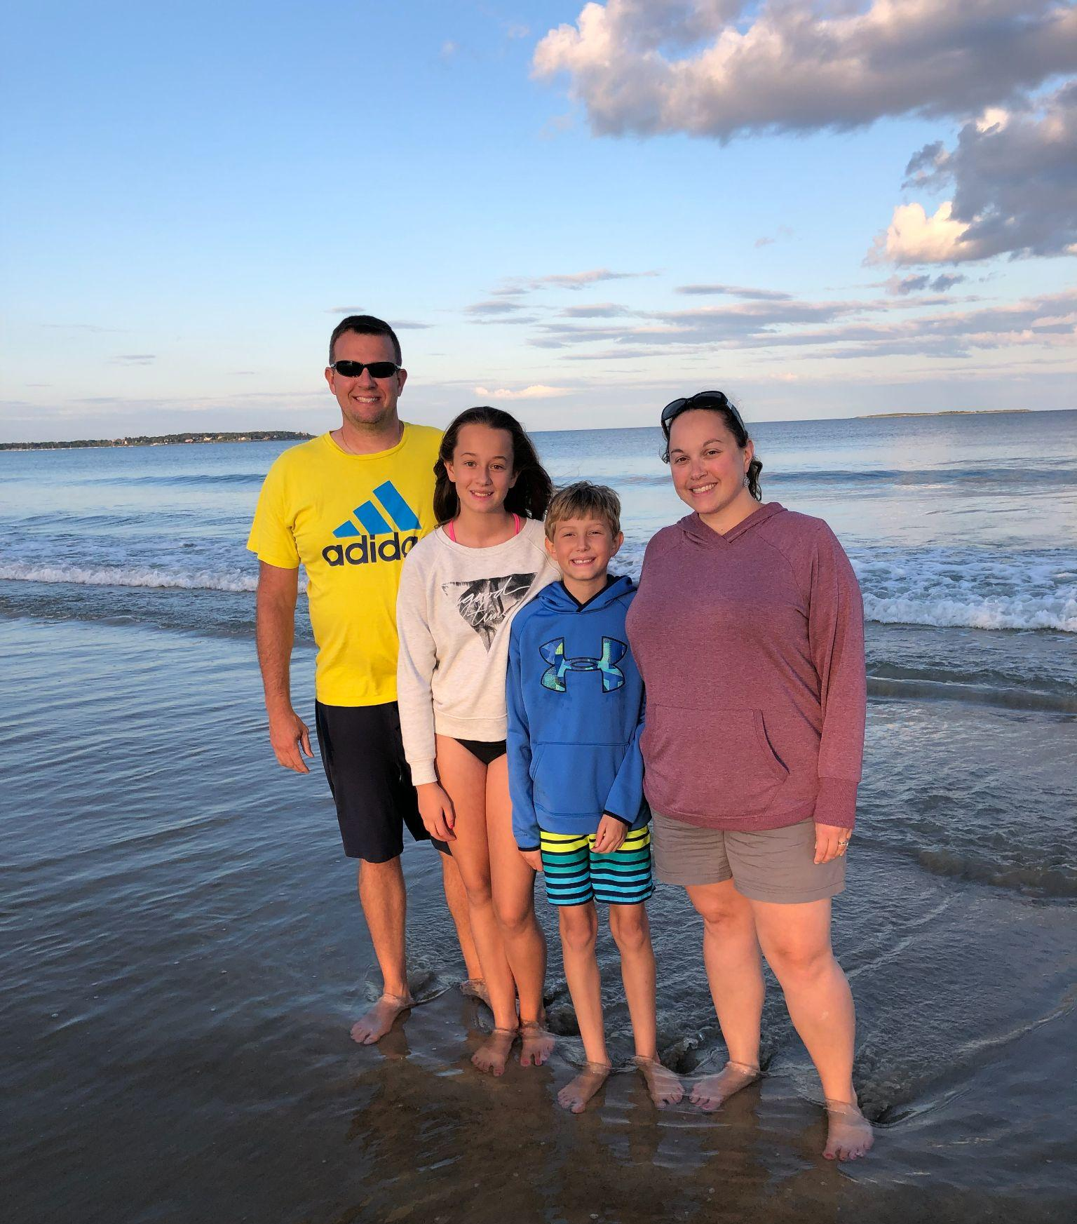
Bianca McKeen and family enjoyed Old Orchard Beach, Maine this summer. Bianca is seen here with her husband Jason and kids Keira and Kipten.
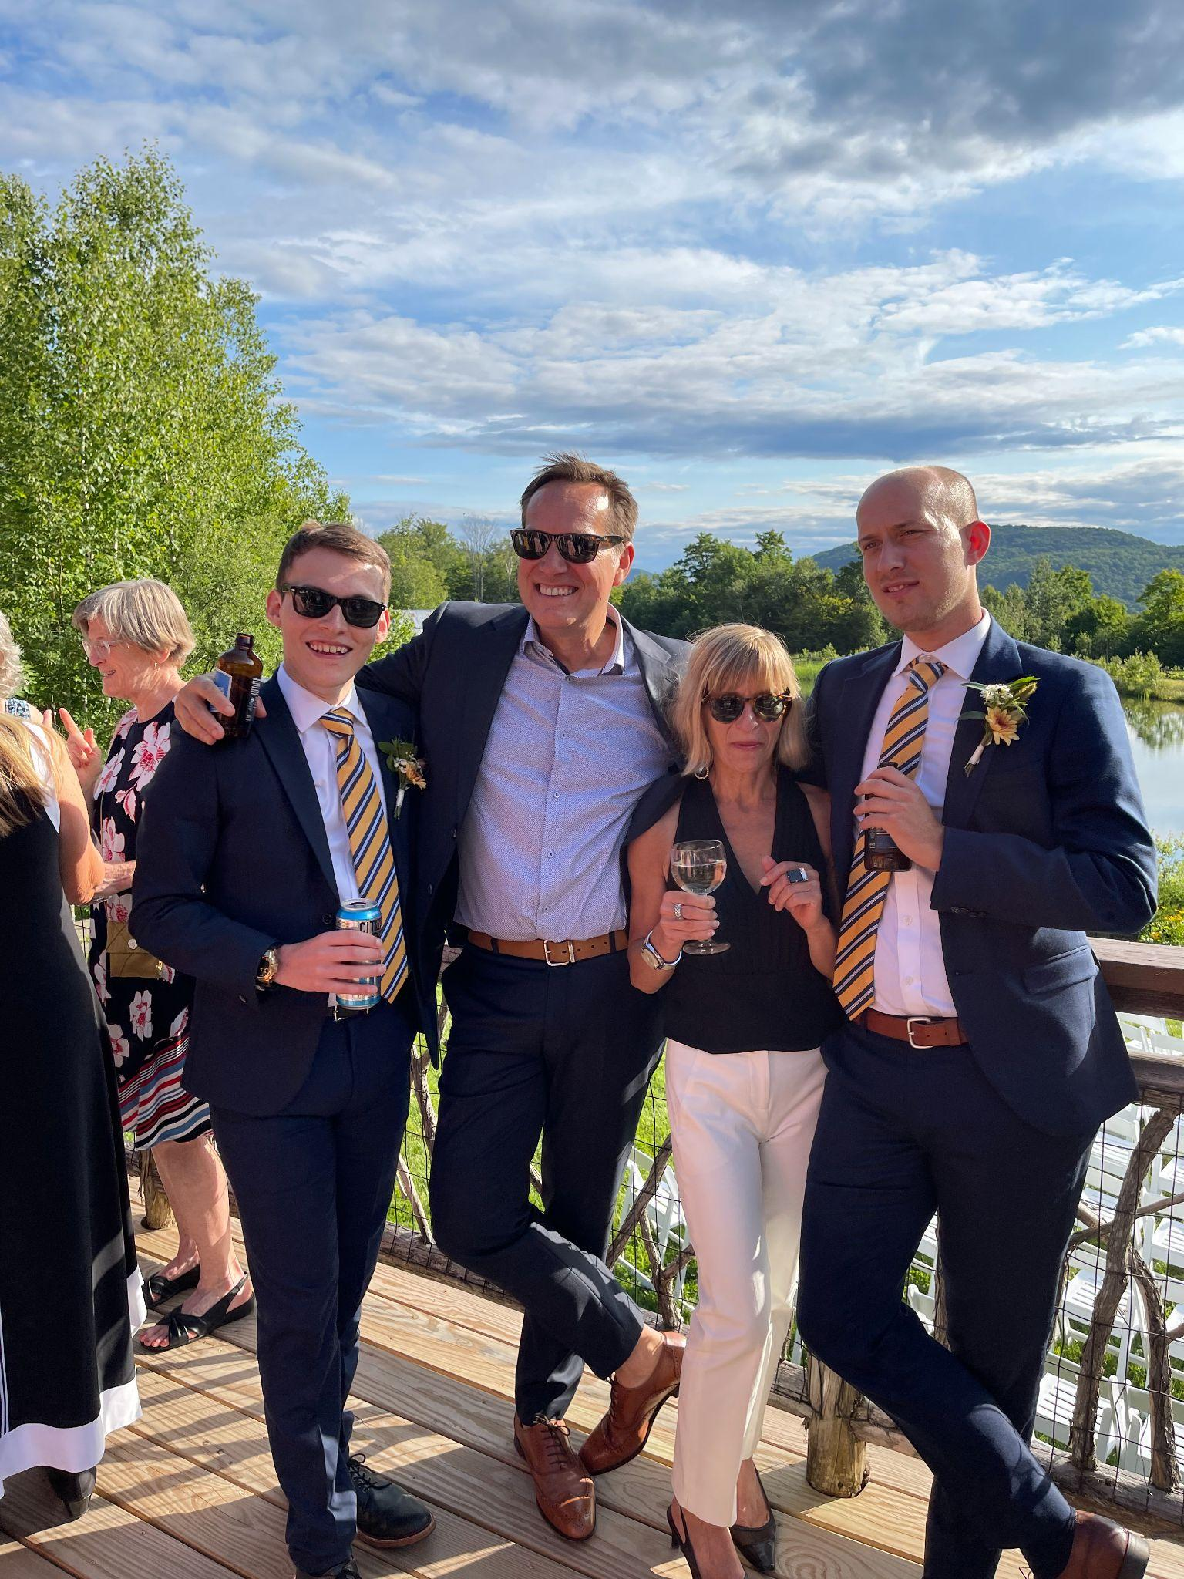
Magali & Mike Martin (RF09) got to see their sons Joshua & Theo in person for the first time since January. Seen here at a wedding in Bolton.

Celebrations
Peter Langella (RF17) has been accepted into the Reimagining Education for a Racially Just Society Advanced Certificate Program at Teachers College, Columbia University.

Courtesy Postings
NEASC is calling for workshop proposals for the NEASC Annual Conference and Showcase (virtual): December 8-9, 2021. Proposal deadline: Monday, August 16, 2021.
Contact: Jim Mooney, jcmooney07@gmail.com

Community Schools Act Grant Request for Applications Application deadline: September 1, 2021 Contact: Jess DeCarolis, Student Pathways Division, jess.decarolis@vermont.gov

