 | Letter to Fellows  December 2021
Dear Rowland Fellows,

I hope this message finds you and your loved ones doing well.

It seems to me that the holidays bring a focus on wellness each year, which then fades away faster than a New Year’s resolution in January. Of course, this year as the pandemic drags on, many of us are struggling—especially our young people, who have borne the brunt of the crisis, from cancelled rites of passage, to loneliness, to a patchwork school experience that has brought glaring inequities to the fore.

We know that our students are hurting right now. So it’s only natural that schools would be increasingly turning to wellbeing, not as an add-on, but as the foundation for healthy kids, teachers, schools, and communities. After years of digging out from the NCLB accountability regime, it’s almost as if it took the current crisis to remind us that schools are a place for humans to come together and learn to live together in community.

“You can tell a school with a great culture & climate as soon as you walk in the door,” Chuck Scranton often says, and I couldn’t agree more. I’m grateful to be serving the Rowland Foundation’s school culture & climate mission in my work. If we want to see our students thrive, we need to start with these critical elements instead of treating them as after-thoughts, or only focusing on how school culture & climate affect student wellbeing after a critical incident or tragedy.

As you may already know, Tara Cariano (RF18) and Lissa Knauss (RF18) are helping to lead the Vermont Advisory Council on Wellness and Comprehensive Health, which was created by Act 66 of 2021. They are collaborating with Jess DeCarolis (RF09) at the AOE, and the committee recently connected with Mike McRaith (RF13) at the VPA as well. It is my hope that this work will raise awareness and perhaps even change some of our measures for school success. For example, imagine how budget and policy discussions would change if the Annual Snapshot included climate survey results from every Vermont school, alongside more traditional measures of school success.

There is great opportunity here. At a time when public schools are under pressure from not just the pandemic but also privatization and politics, we need to redefine what in-person learning communities should look and feel like. Fortunately, there are already models to help support this work, for example, the CDC’s Whole School, Whole Community, Whole Child and British Columbia’s Well-Being BC. Of course, some critics will say that wellbeing work will come at the expense of academic rigor, but I don’t think they are mutually exclusive. In fact, I believe the current levels of anxiety and depression that we’re seeing in young people may be the most significant obstacle on the whole to their being college- or career-ready.

On a related note, Janis Boulbol (RF21), Kat Robbins (RF21), and I recently completed a four-day training on the Compassionate Systems Framework with Peter Senge. We all agreed the training could be very helpful for Rowland Fellows, and also that the framework & practices reflected an updated systems approach that really centered wellbeing and community. If you’re interested, the next training is scheduled for January and, thanks to a collaboration with the Tarrant Institute for Innovative Education, Peter Senge has generously granted us a special Vermont Educator rate of $750 per person (compared to $1,250 pp) for the virtual format. See details below in “Courtesy Listings”.

In closing, I wish you and your families much happiness this holiday season. Even in the rush of things, I hope you find space to take stock of your own wellbeing and that of your loved ones too.

Take care and see you soon,

Mike

P.S. Please send me your news! Each month, I’m sharing courtesy posts for courses & events, and also celebrating new jobs, family vacations, and other news from our extended Rowland Family of Fellows. So please email whatever you’d like to share to rowland.foundation@gmail.com

Rowland Foundation Updates

The Rowland Encore Grant proposal deadline is December 31st.
This is an exciting new opportunity to do something big with a team of veteran Rowland Fellows. There is only one Encore Grant awarded each year to support a team of Rowland Fellows leading a regional or statewide project. Always feel free to contact Mike Martin with your questions and ideas.

Thanks to everyone who took a minute to share their good ideas with us after the Annual Conference and the All Fellows Retreat. Many of you said that the World Café discussion was particularly productive. You can consult here the World Café notes transcribed from the chart paper—Thank You, Jeanie! I also made wordles from two survey questions to see which themes came up the most often in your responses. You can see unedited versions of those below.

What would you most like to see Rowland Encore Grants focus on in the next few years?
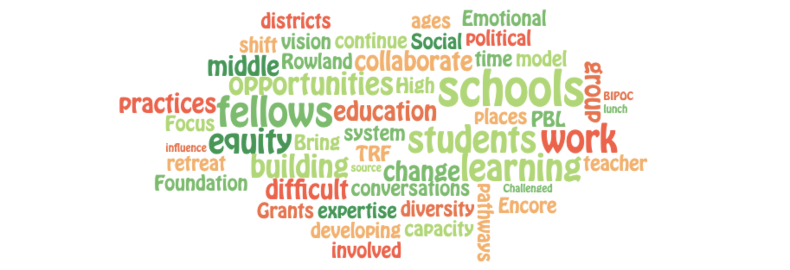

What types of activities would you like to see come from Rowland Leadership Grants in the next few years?
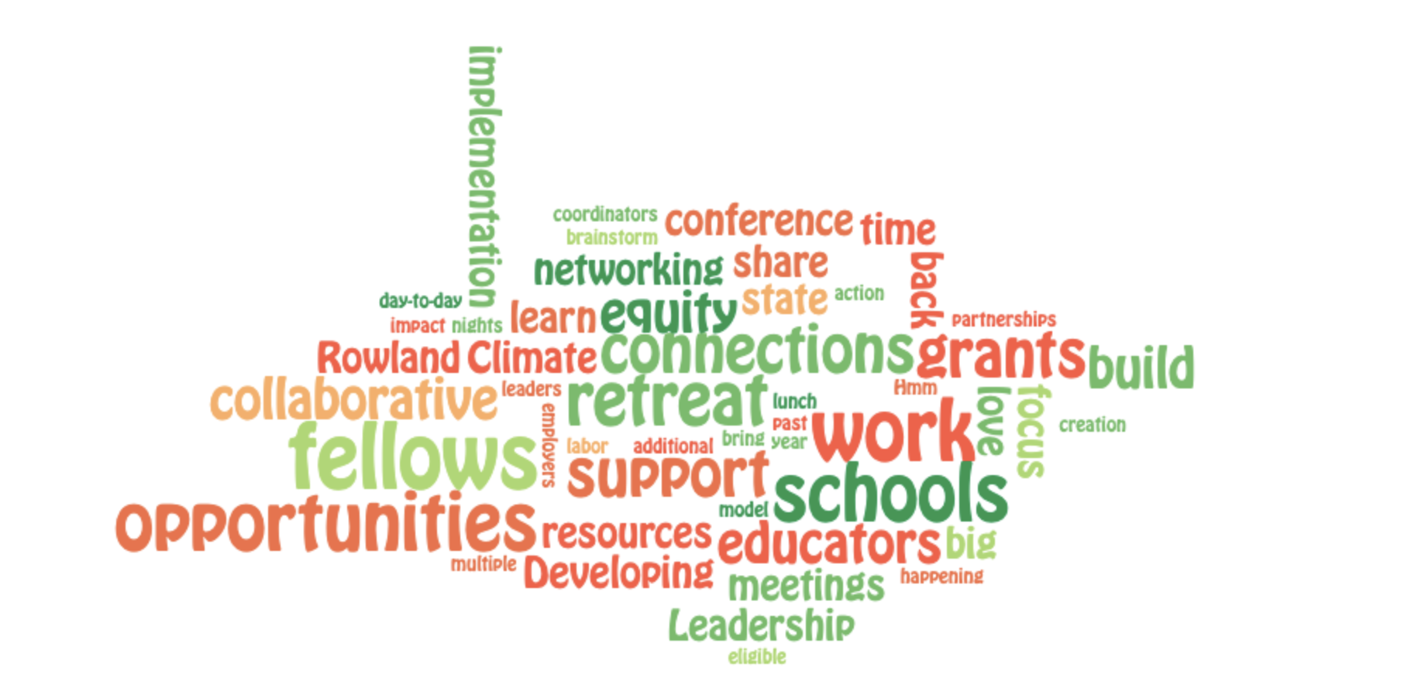

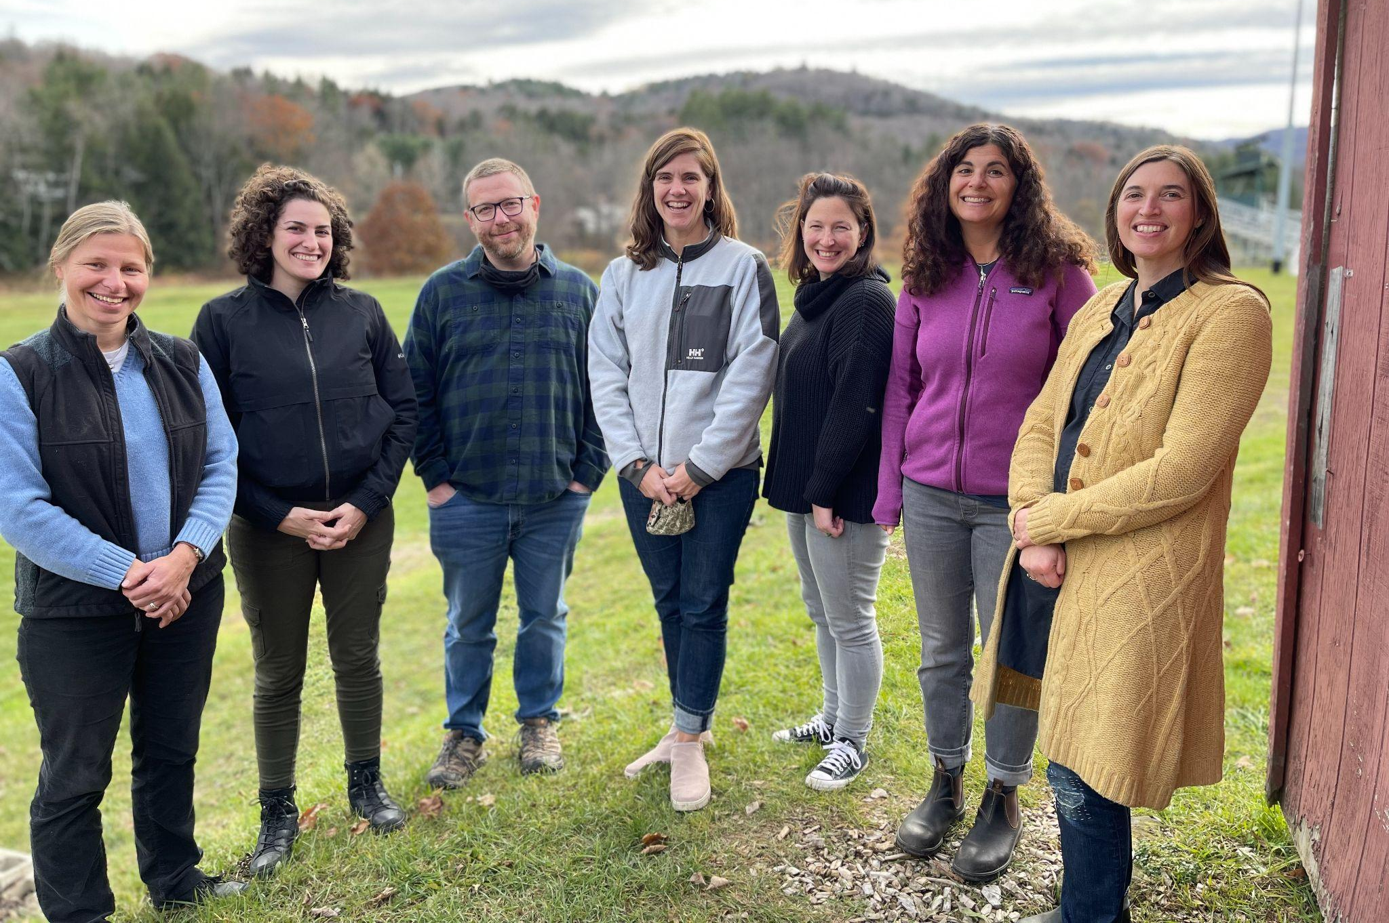
The 2021 Rowland Fellows Cohort met at Woodstock Middle/High School in November. Seen here (left to right) Anja Pfeffer, Nicole Awwad, Brent Litterer, Rachel Howes, Samantha Mundt, Janis Boulbol & Kat Robbins.

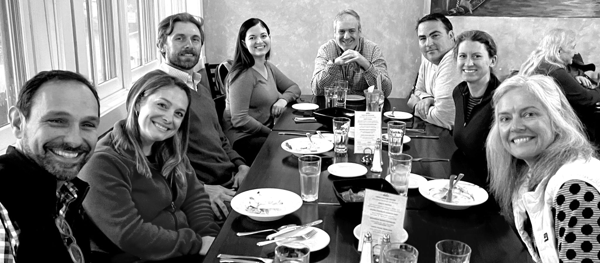
The 2020 Rowland Fellows Cohort met in Montpelier in November, seen here with Senior Associate Jean Berthiaume (RF09) at Sarducci’s (left to right) Kristin Cimonetti, Ben Heintz, Ali Vega, Charlie MacFadyen, Tim O’Leary, Jillian Joyce & Stacy Shortle

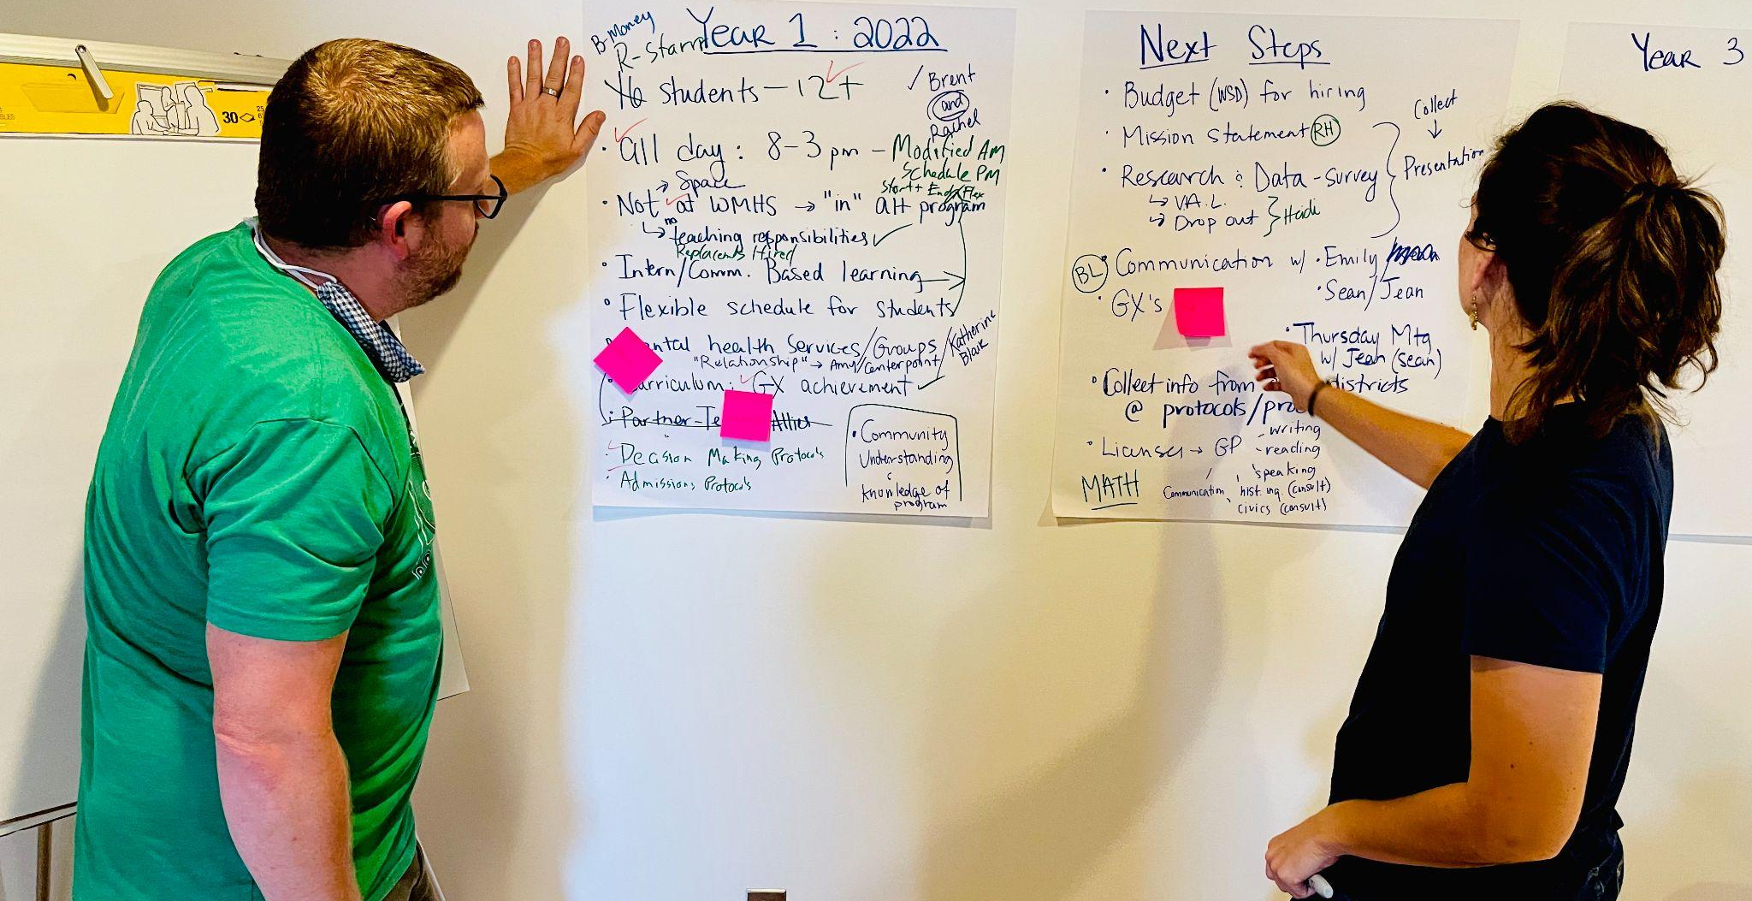
Brent Litterer (RF21) & Rachel Howes (RF21) used the work space in the new Rowland Offices for some Fellowship planning this fall. Fellows should feel free to contact Mike Martin anytime to make an appointment to use our new space for Rowland work!

Celebrations
Congratulations to Janis Boulbol for being named as a Shelburne Farms Learning for a Sustainable Future Changemaker along with her Rowland Fellowship partner Kat Robbins. You can learn more about their great work in this feature article.

Courtesy Postings
This January 18-21, Peter Senge & Mette Boll will be offering a four-day virtual training called Introduction to Compassionate Systems Framework, as mentioned above. To access the discounted rate we’ve obtained for Vermont educators, under “Tuition” on the registration form please select “Other” and write in “VT Group Rate $750”. You should repeat that information, and any other pertinent invoice information, on the “Any Special Invoice instructions?” line. If you have any questions or concerns, please contact Miho Kito at mkito@systemsawareness.org

This summer Andrew Jones (RF15) is teaching Leading School Innovation, a 3-credit UVM graduate course that is specifically designed for teachers & administrators leading change in their schools (e.g., Rowland Fellows). If you’re interested in picking up some new change strategies with a colleague or two, this 2-week seminar may be just what you’re looking for this summer.

