 | Letter to Fellows  Stewardship  December 2022

Dear Rowland Fellows,

I hope you had an excellent Thanksgiving and are enjoying the holiday season.

The FIFA World Cup is holding sway over televisions around the world right now, and it hasn’t lacked for controversies: accusations of rampant corruption in Qatar’s winning bid to host the event; inhumane and deadly working conditions for the migrant workers who built metro lines, neighborhoods, and seven stadiums in a few short years; the ecological disaster of air-conditioned stadiums; the first-ever dry World Cup for fans (Sorry, Hooligans!); and the ruthless suppression of any team or player support for LGBTQ+ rights in Qatar where homosexuality is banned by law. That’s a lot to take in of course, but then again, the last World Cup was held in Russia–after its invasion of Crimea in Ukraine–so we shouldn’t be too surprised at how big money and human rights often collide in major world sporting events.

As depressing as that all seems, I’ve been thinking about one World Cup news report a lot lately, and if you’re looking for something inspiring, you should check it out. It’s a New York Times article about Japanese soccer fans and how they are cleaning up stadiums after cheering on their team at the World Cup. Not only that, but their national team has left its dressing room impeccable with a thank you note after each match, which is not a common thing for pro athletes to do, evidently. To understand the source of this civic-mindedness, it may help to look at schools in Japan. Students in Japan practice gakko soji (school cleansing), which teaches them the importance of keeping their surroundings and body clean, as well as how to be a productive member of society. And it’s not uncommon for the Japanese to bring this civic spirit to other public places in their country…and now to the World Cup.

Reading about these civic-minded Japanese fans & players got me thinking about parallels in Vermont. After all, back in the 1970’s, our state passed an innovative bottle deposit law, imposed high fines for littering, celebrated its first Green-Up Day, and enacted Act 250 to prevent environmental damage from overdevelopment in Vermont. This combination of strong policy and civic pride has spurred generations of Vermonters to care about the environment on a local, national, and global level–starting with their own town squares, public parks, and outdoor trails. And this, even as public spaces have been increasingly neglected, abandoned, and closed in many parts of the United States (e.g., public parks and libraries).

Vermonters also care about their local schools, of course, and have persistently defended public education, which has been a constitutional right in our state since 1777. However, even as we’ve protected our green spaces, we haven’t done a good job of maintaining our schools. Our state stopped all support for capital improvements in 2007, leaving it to local towns and cities to raise bonds for aging school buildings that need much more than a clean sweep and a new coat of paint.* Even as school communities negotiate and litigate their way through Act 46 to keep their local schools open, we’re ignoring the fact that our schools across the state are crumbling. Even as we’ve protected the Green Mountains for our children, we have not been keeping up their school buildings. We have not been good stewards.

In my hometown of Burlington last month, 76% of voters approved a $165 million bond to build a new high school, since our current building has been closed since 2020 due to PCB contamination. While this strong local support for a new school is good news, it should never have come to this. By the time a new school is built, an entire generation of Burlington High School students will have only taken classes in a repurposed department store with temporary dividers for classroom walls. This at a school in Vermont’s largest city–John Dewey’s hometown– and one with the largest population of students of color in our state. This is poor stewardship of the public assets that our young people rely on the most.

When we take care of our public assets, pick up litter on Green Up Day, or just leave a space better than we found it like the Japanese, we are engaging in stewardship. This is at odds with the hyper-individualism and voracious consumerism that seem to dominate our society today. Stewardship is an outlook that recognizes that we are in fact all connected, that we shouldn’t burn up our planet, and that we should look out for each other.

When it comes to educating our young people, the same thing applies. Education is not a product to consume, not a competition, but rather a shared endeavor–and one we must nurture with the greatest care. Whether we want to accept it or not, we are, in fact, in this together. If this is what we believe, our investment in our local schools should reflect it.

Take care and see you soon,

Mike

P.S. Japan produces some good players but is not considered an international soccer power. In the past week their national team defeated both Germany and Spain to finish #1 in their group going into the playoffs. Many commentators chalk it up to Japanese players’ selfless, collective style of play, which is so different from the style of the self-centered stars of the European teams.

*As a point of comparison, the Massachusetts School Building Authority has disbursed over $16.1 billion to local districts since 2004, on the basis of periodic statewide Needs Surveys that assess the condition of all public schools.

Rowland Foundation Updates

The Rowland Women Leadership Retreat
Congratulations to Marsha Cassel (RF14), Gretchen Muller (RF17), and Tara Cariano (RF18)! Their proposal to plan and coordinate the 2023 Rowland Women Leadership Retreat has been formally accepted. The Rowland Women Leadership Retreat is now an annual event, funded by our operating budget and organized by a Planning Team of Rowland Women each year. This grew out of Lauren Parren’s (RF12) “Weston Women” writers group and builds on a past Rowland Leadership Grant which funded a retreat for Rowland Women. In her original grant proposal, Lauren wrote,
Women in Vermont who aspire to leadership positions face serious challenges due in large part to bias, whether it is conscious or unconscious. Schools across the state are losing out on the huge potential hidden in those who need encouragement and tools to affect real change within their organizations.
With this annual investment, the Rowland Foundation Board of Trustees recognizes that women leaders face unique challenges, including in the field of education. Stay tuned for more information coming soon from Marsha, Gretchen & Tara, the 2023 RWLR Planning Team!

Our new Diversifying the Educator Workforce Grant (DEW) was formally approved by the Rowland Foundation Board of Trustees in September. This grant is intended to remove barriers to licensure for aspiring educators of color in Vermont and builds on regional and statewide work led by Jess DeCarolis (RF09), Caitlin Steele (RF09), and Marsha Cassel (RF14). Executive Director Mike Martin has been meeting with community leaders, educators, and aspiring educators of color over the past months. We are currently finalizing the selection process and mentor guidelines in order to open DEW Grant applications in January 2023. Stay tuned for updates and feel free to connect Mike with aspiring educators of color you know in Vermont! You can read more about the Rowland DEW Grant here.

Rowland Fellowship Information Nights
With middle grades and high school teachers now eligible to apply for Rowland Fellowships, Executive Director Mike Martin has been hosting a series of Rowland Fellowship Information Nights for Vermont teachers interested in submitting a Rowland Fellowship proposal this year. With help from Senior Associate for Media & Technology Lori Lisai, Mike has hosted a Google Meet session and Twitter Chat for prospective Rowland Fellows so far. Each Fellowship Info Night offers general information about our mission, our Fellowships, our Cohort Model, and our application process, with time for Q & A too.

Please help us recruit new Rowland Fellows! Spread the word at your school and beyond! Please tell your colleagues about our mission and our work, and encourage them to attend our last Rowland Fellowship Info Night of the year:

Wed., Dec. 7 | 4:00 - 6:00 pm | In-Person Discussion with Refreshments at the KBH Gallery Space (Kestrel) at 47 Maple St. in Burlington

On the Rowland Foundation website, your colleagues can find a link to the Rowland Fellowship application, a list of grants awarded, a Rowland Fellowship timeline, and a FAQ page. Interested teachers are also encouraged to contact Rowland Fellows–there are now 93 around Vermont–in order to learn more about this amazing professional development opportunity.

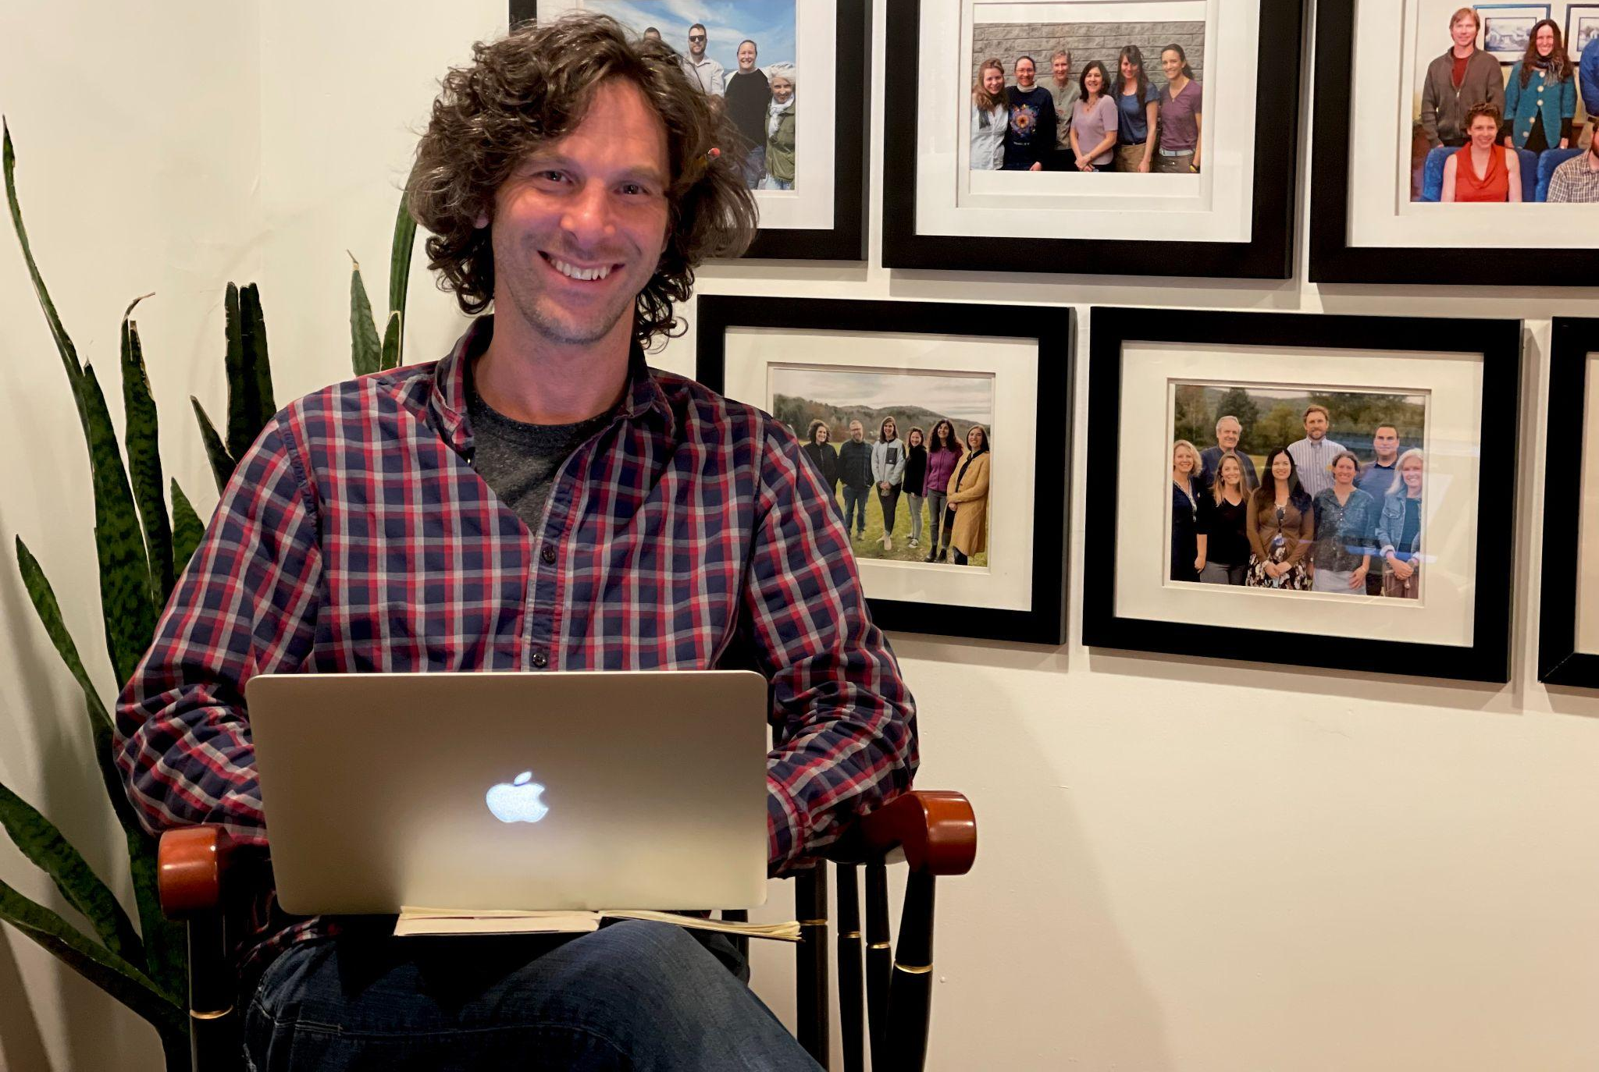
Brian Boyes (RF14) met with Mike at the Rowland Office to discuss his Rowland Leadership Grant work with Vermont teachers on popular music education.
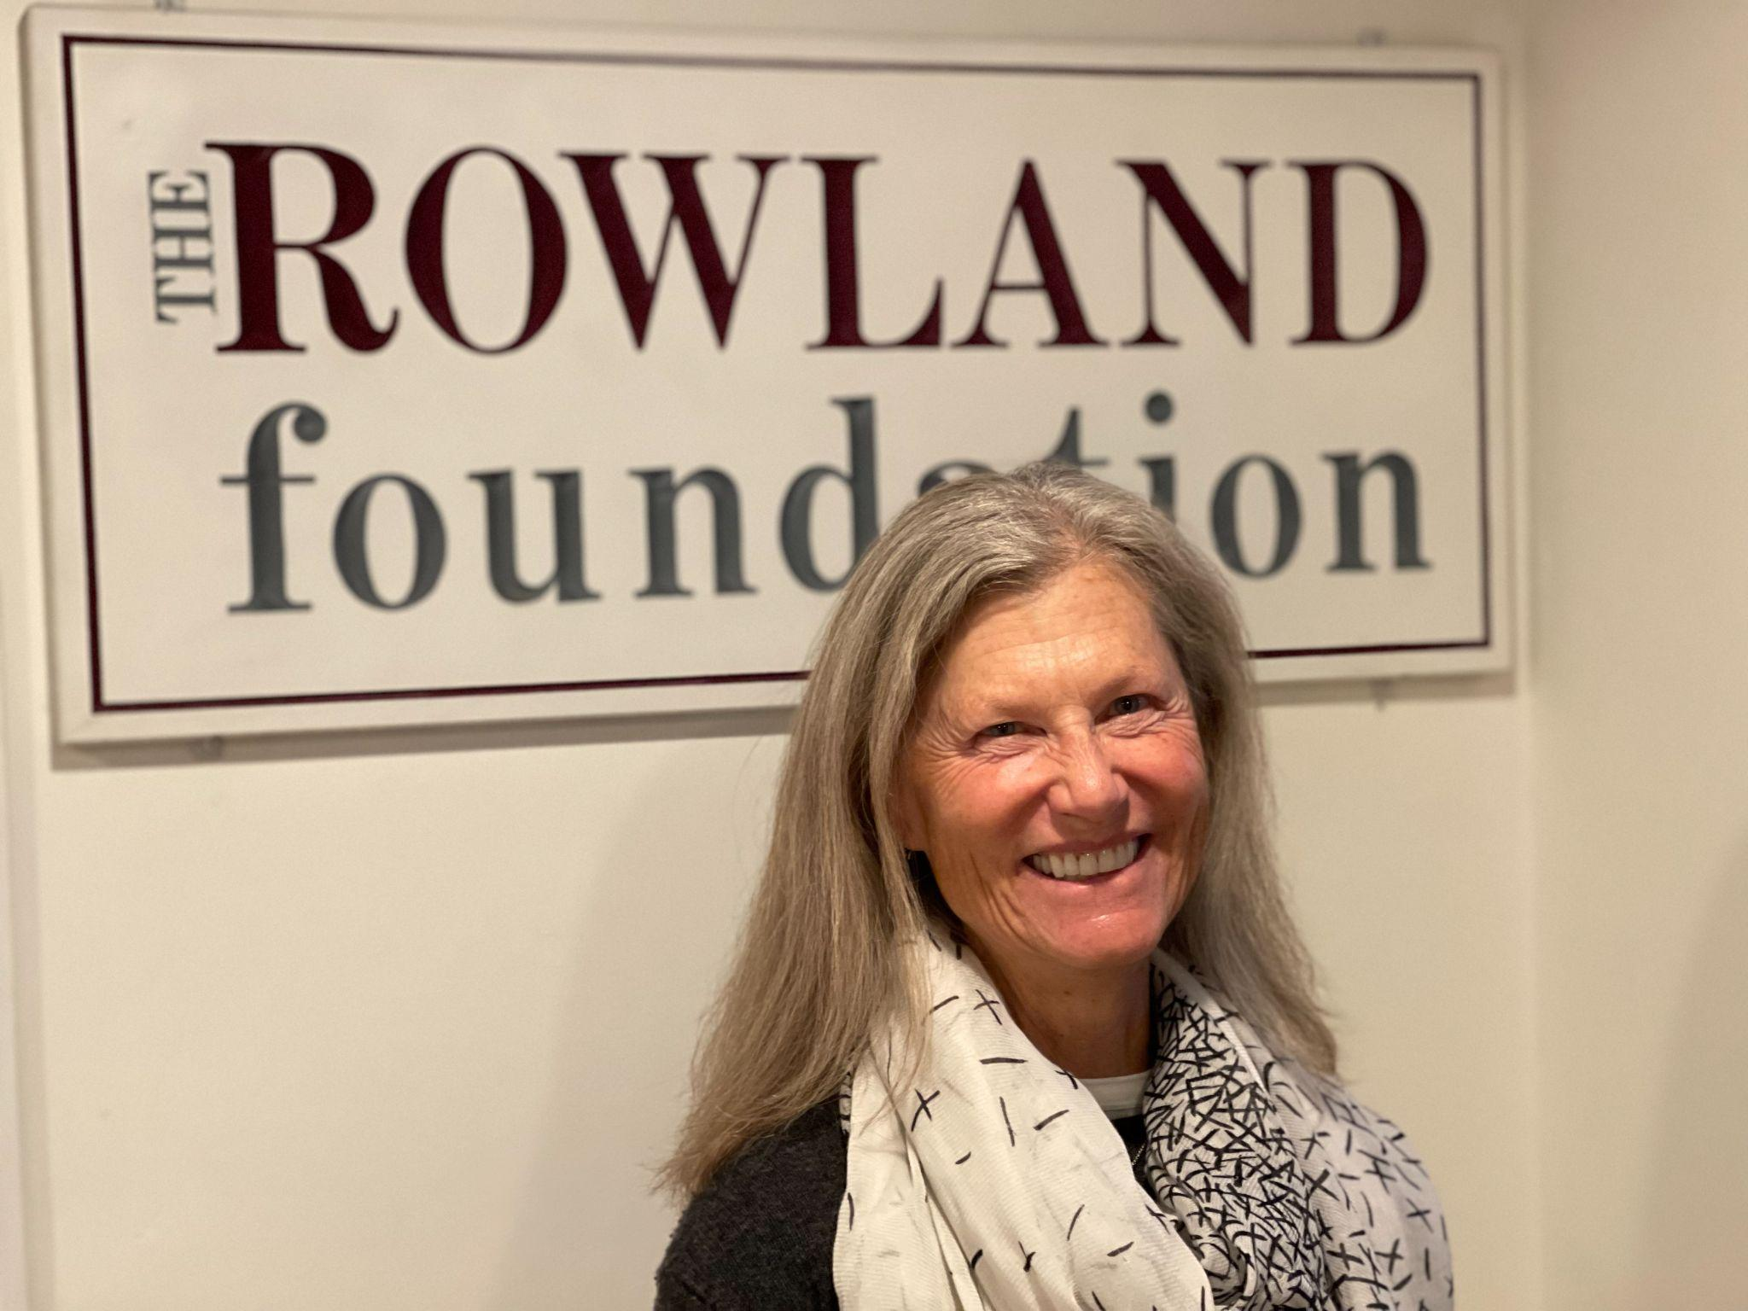
Kathy Cadwell (RF16) visited Mike in the office in November to discuss an award nomination for the National School Board Association’s MAGNA Award for the Harwood Harkness Initiative.

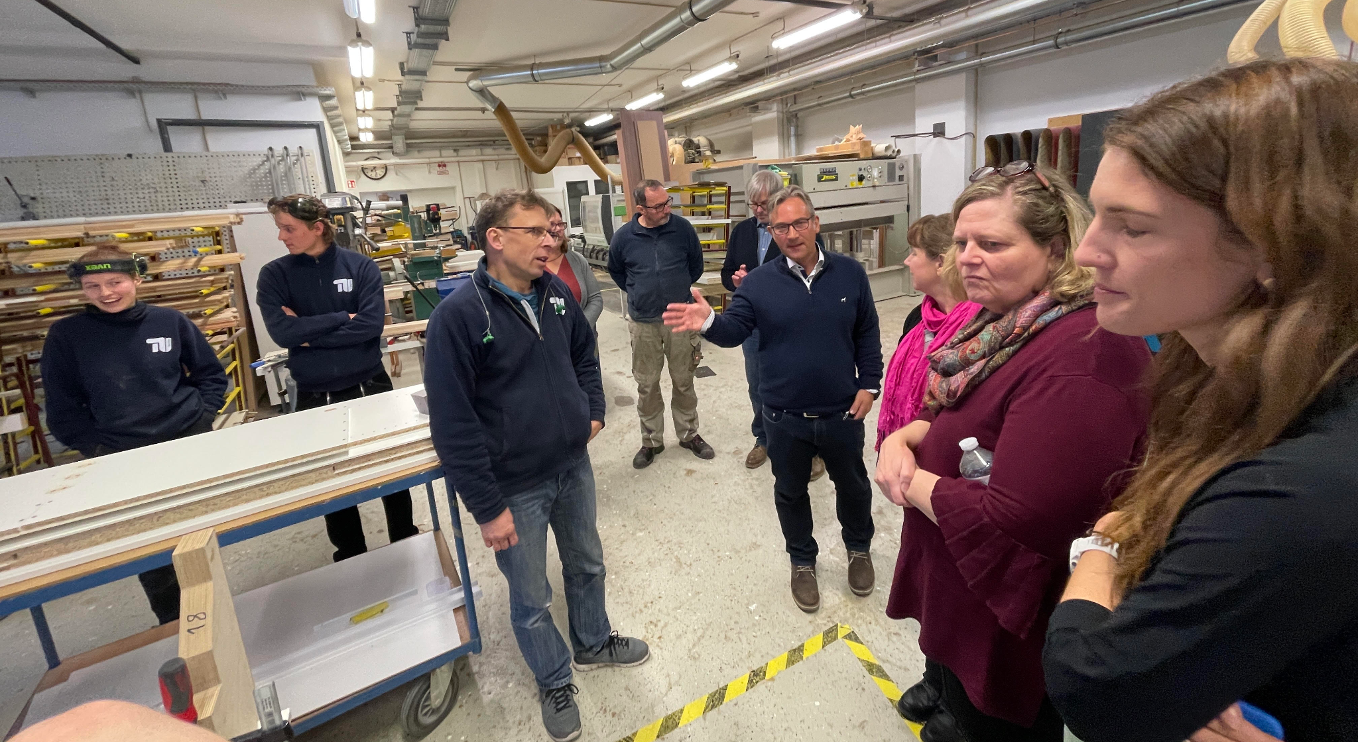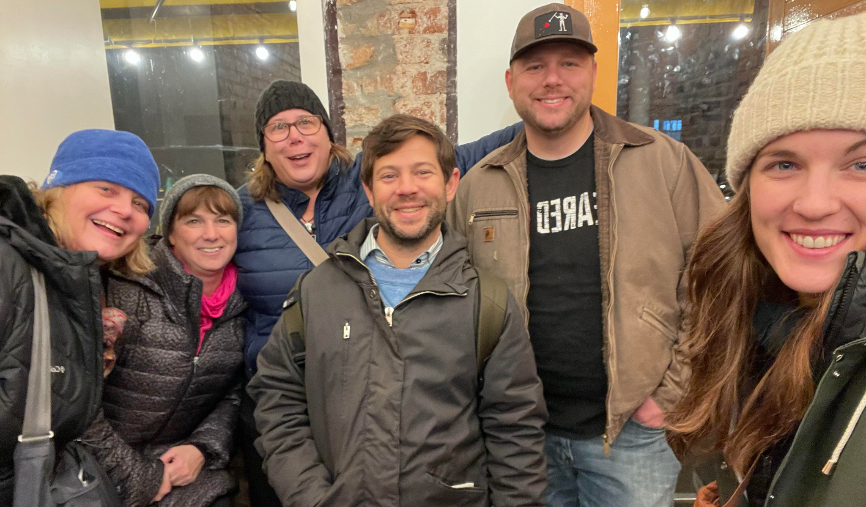
For his Rowland Fellowship, Devon Karpak (RF22) is focusing on changes to Otter Valley's (OV) tech ed program which will give students more opportunities to explore potential careers and help them better prepare for the world of work. This will take the form of a career pathway program that will assist them in their decisions for further training and connections to local companies. Part of the research for this program was looking at other models that currently exist and the one that is held up as the standard on a global scale is the dual system in Germany. On November 18th, five staff members from OV set out to learn first hand about the relationships between industry and schools in Germany. The group consisted of two counselors, two teachers and the OV registrar/scheduling expert. They visited ABB ( a global corporation with expertise in automation,robotics and welding), TU Berlin ( a technical university with a wood shop that builds custom items for the school), Lippe Berufskolleg Lünen ( a school that focuses on training individuals in human services and business) and Hase Bikes ( a company that produces custom recumbent and adaptive bicycles). Each school/company supports students in apprenticeships and training. Not only did Devon’s group have the opportunity to do the work, but they also had the pleasure of brainstorming ideas, discussing struggles and triumphs, and taking in the culture of Germany.

The Rowland Foundation’s first-ever Collaborative Practices for Equity course concluded this week with an in-person gathering at Orchard Cove and Indian cuisine for lunch. The course was taught by Senior Rowland Associate Jeanie Phillips, with support from the Great Schools Partnership and Shelburne Farms. Moving forward, the course will be a foundational experience for all new Rowland Fellows. Veteran Rowland Fellows are warmly invited to join our new Fellows for some shared learning when this course runs again in the fall. In the meantime, stay tuned! Jeanie will be teaching a Facilitative Leadership course this spring. More information coming soon.

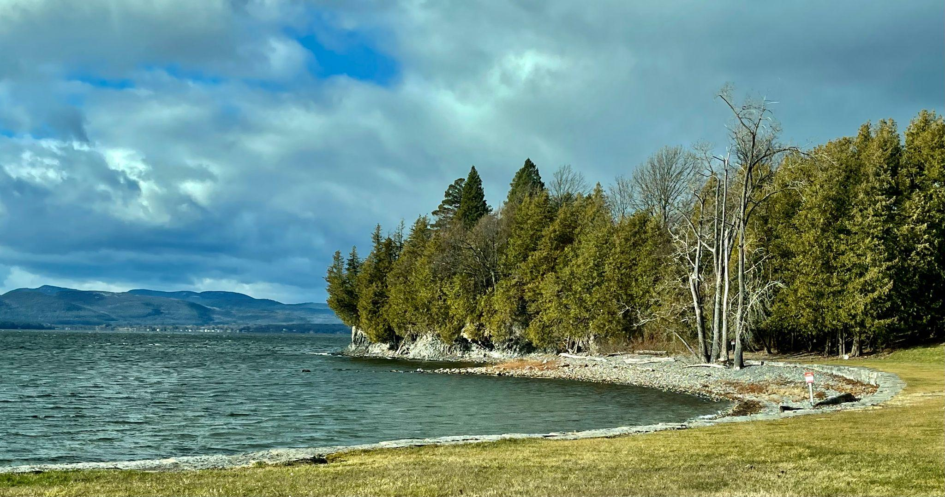
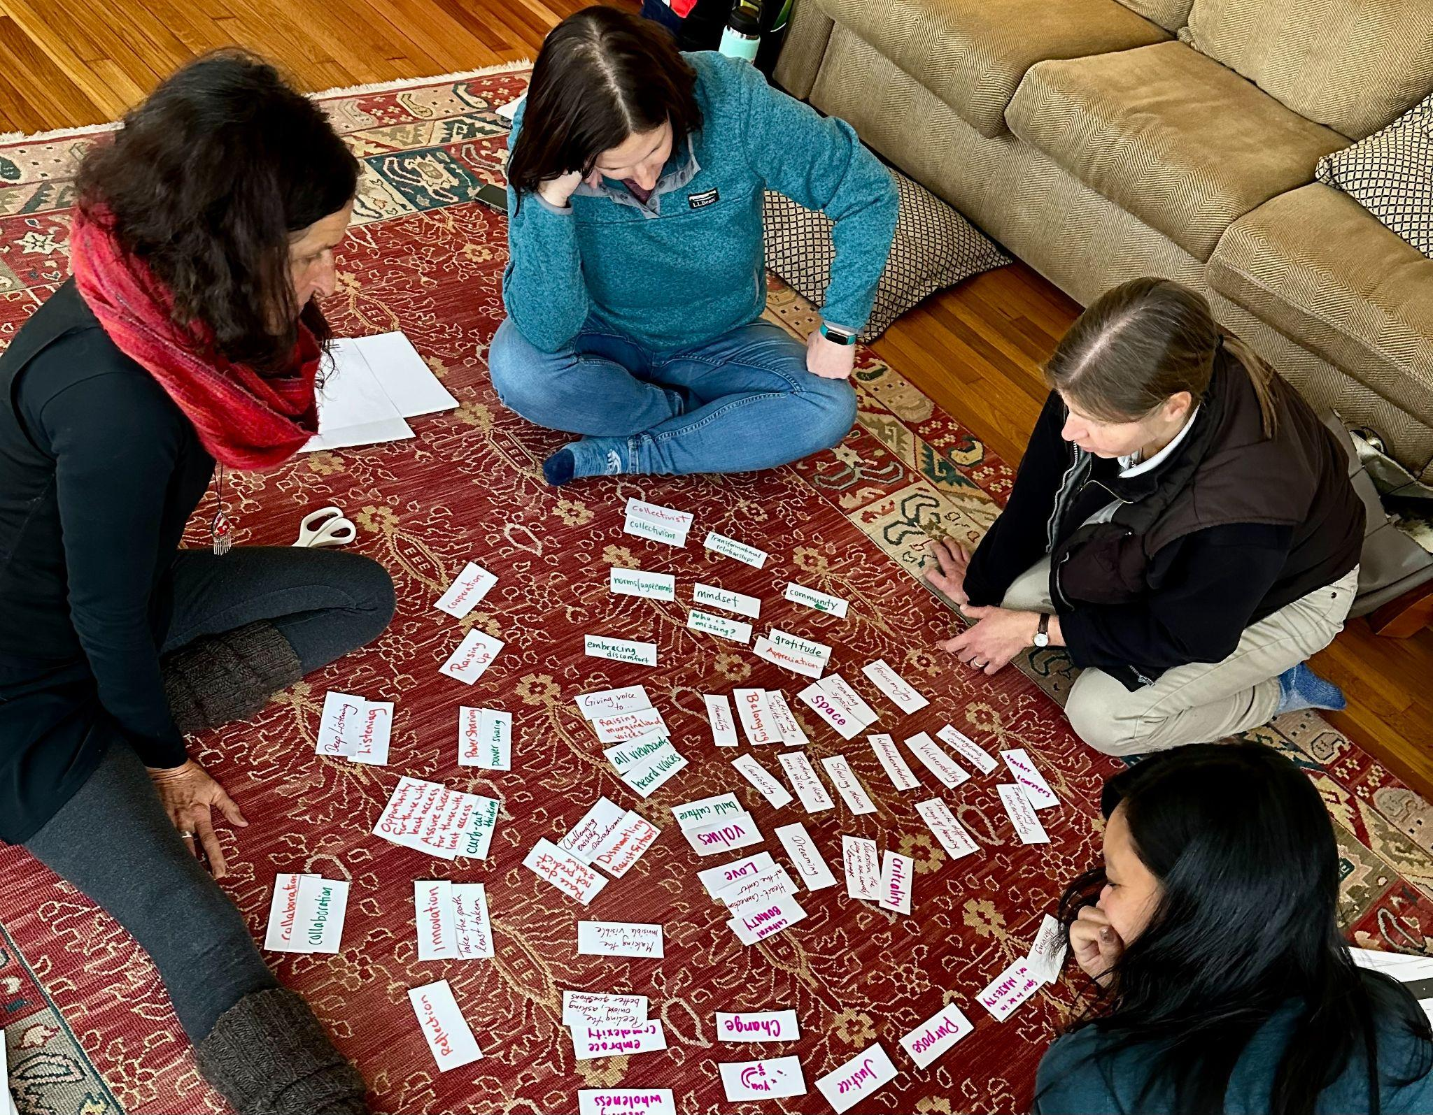
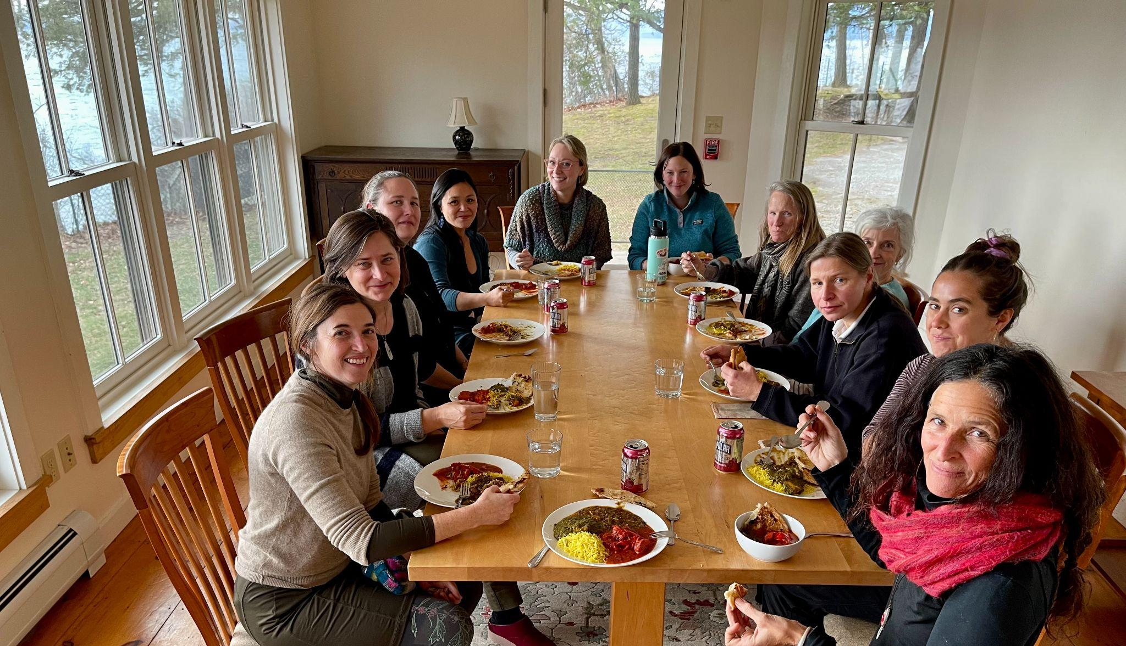
Seen here sharing a meal in community with Collaborative Practices for Equity coursemates at Orchard Cove, Shelburne Farms, Kat Robbins (RF21), Jeanie Phillips (RF14), Becky Ebel (RF22), Aimee Arandia-Østensen, Kerianne Severy (RF17), Samantha Mundt (RF21), Deb Levesque, Patti Tomashot (RF22), Anja Pfeffer (RF22), Hannah Corbin & Anne Bergeron (RF11).

Gratitude
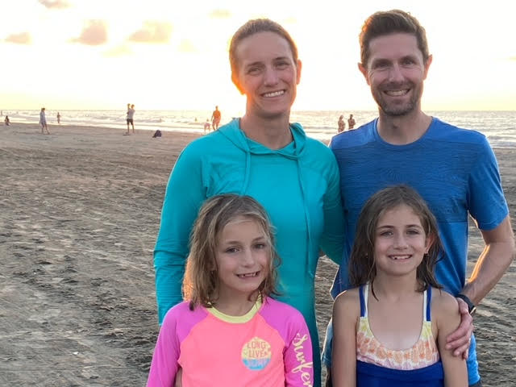
Jen Kravitz (RF12) and her family seen here in Cartagena, Colombia.
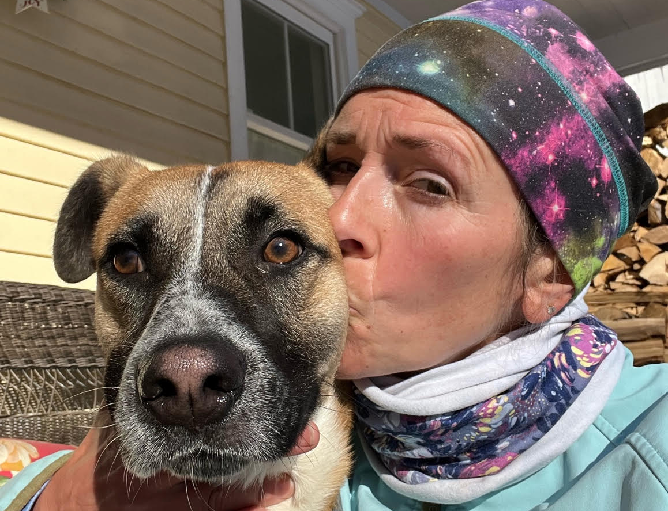
Lori Lisai (RF15) seen here with Rico “after a run to ward off the holiday calories”.
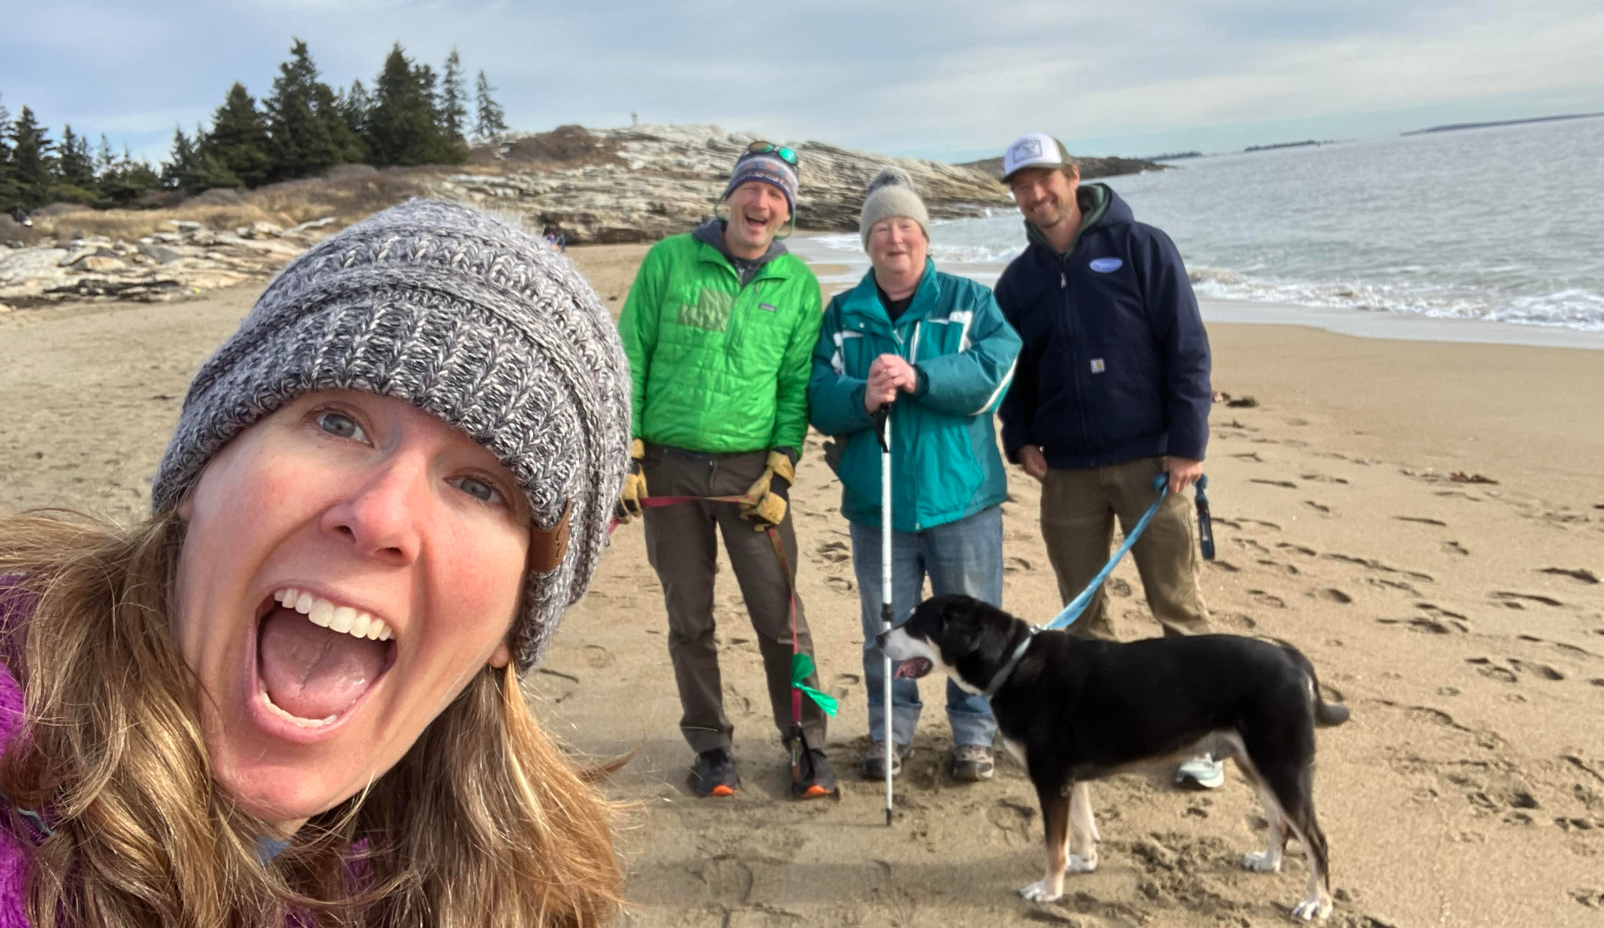
Erica Wallstrom (RF14) seen here with family at the Reid State Park beach in Maine “working off the indulgences”

Celebrations
Check out this excellent video! Anja Pfeffer (RF21) worked with Seven Days to create this beautifully produced short film about her Rowland Fellowship work Dare To Be Me at Hazen Union. Anja is also teaching a course through Castleton University to share the model with other schools. If you’d like to learn more, feel free to contact her at: anja.pfeffer@therowlandfoundation.org

Big news for VT school counselors! Patti Tomashot (RF22) served as the committee project lead for a new Vermont Comprehensive School Counselor Framework which was released at the Vermont School Counseling Conference in October. With support from the Vermont School Counselor Association (VTSCA), the Vermont Agency of Education, and the American School Counseling Association, Patti led a formal ad hoc committee of school counselors, representative of K-12 schools across the state, to develop this new model. In developing this resource for educators, counselors and administrators, the committee reviewed frameworks from several states, and actively solicited feedback through surveys, including via the Agency of Education, and focus groups with school counselors across Vermont to hear their stories, incorporate their feedback, and learn of the successes and challenges in school counseling. Patti is grateful for the important support provided by Rowland Fellows in this work: Gretchen Muller (RF17), former Stowe High School principal instrumental in advocating for VT school counselors; Tara Cariano (RF18), former Vermont School Counselor Association President, for making this work a priority for all Vermont school counselors; and Jess DeCarolis (RF09) who helped support this model as the VT AOE liaison to VTSCA.

Jill Prado (RF12) has received a Fulbright Teachers for Global Classrooms Grant! This year-long professional learning opportunity, sponsored by the U.S. Department of State and the Fulbright Finland Foundation, is capped by an international field experience. Jill conducted 16 school visits in Eastern Finland, and guest taught at Joensuu, which is only 43 miles from the Finnish-Russian border. At the Internationalization Conference, she attended a briefing on U.S. foreign policy and international education priorities in Finland by the U.S. Embassy in Helsinki, including a discussion of the Ukrainian education system and how Finnish schools incorporate new Ukrainian arrivals. The Fulbright cohort of teachers also hosted one of the conference sessions: Applying Transversal Competencies to Facilitate Virtual Classroom to Classroom Collaboration with U.S. Teachers. Jill’s Fulbright experience in Finland has yielded wonderful, formative, and tangible opportunities for Essex High School, the Global Leadership Program, and potentially other district or state-level initiatives as well.

Courtesy Postings
The Education Justice Coalition Education Organizing Committee is hosting an event called Inclusive Education Quality Standards: Putting Teaching Practices into Action on December 8th from 5:00-7:00. This event is a hybrid online/in person event in Montpelier and on Zoom. “We will lift up your work and the work of educators in Vermont.” More info here.

Teachers: #1 Highest Demand Promising Job in Vermont's 10 Year Outlook
On October 25th, Governor Scott held a joint press conference with the Department of Labor and the McClure Foundation to announce Vermont’s Highest Demand Promising Jobs, the 2023-2024 edition. This annual report shares a list of the 50 most promising jobs in Vermont over the next 10 years. In this edition, the #1 most promising job in Vermont for the next 10 years is–by quite a large margin, teacher.
The VPA issued this Statement on the Vermont Education Workforce Shortage (11-4-22) as a follow up to the report and the press conference.


Winter in Vermont is so beautiful, but nothing compares to Winter at the Woodstock Inn. All educators are welcome to join the Vermont Principals' Association and the Center for Creative Leadership for rejuvenating, engaging, and meaningful professional learning at the first annual Winter Symposium on Jan. 29, and Jan. 30 2023. For questions contact Mike McRaith at mmcraith@vpaonline.org

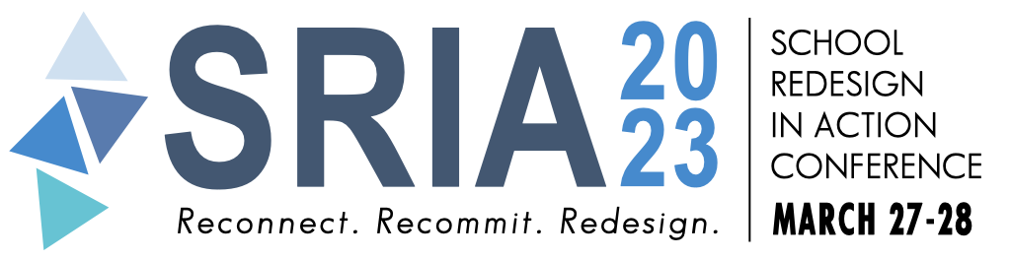
Save the date! The School Redesign In Action Conference will take place in Newport, Rhode Island on March 27-28, 2023. Just contact our Great Schools Partnership (GSP) Senior Associates if you’d like to learn more: Emily Gilmore (RF17), Erica Wallstrom (RF14) & Jeanie Phillips (RF14)

