 | Letter to Fellows  February 2022
Dear Rowland Fellows,

I hope this message finds you and your loved ones doing well.

With New Hampshire’s “teacher loyalty” bill, Black History Month seems more important than ever this year. Of course, since black history is so fundamental to understanding American history, it’s hard to understand why it would ever be relegated to a single month. In fact, the history of Black History month, as well as the ongoing efforts to extinguish any counter-narratives that question white supremacy help us understand where we are as a country and where we come from.

I’ve been thinking a lot about love lately. Not the Hallmark, candy heart, cheap chocolate kind of love, but the loving-kindness kind of love. Thich Nhat Hanh, who is one of my heroes, passed away last week, and for him loving-kindness was a rigorous discipline, which demands great concentration and will power. Loving-kindness meditation is a demanding practice which helps us focus benevolent energy on ourselves and others. It is not an easy kind of love.

You may already know that Dr. Martin Luther King, Jr. nominated Thich Nhat Hanh for the Nobel Peace Prize in 1967, and that the recently departed, well loved teacher and writer bell hooks took inspiration from Thich Nhat Hanh too. The great civil rights leader John Lewis called the art of nonviolence “love in action”. Similarly, bell hooks wrote, “Love is an action, never simply a feeling.” She also taught us, “When we choose to love, we choose to move against fear, against alienation and separation. The choice to love is a choice to connect to find ourselves in the other.” This courageous form of love may be the kind we need most right now.

For bell hooks, radical love is a key part of the struggle for liberation. In her essay “Love as the Practice of Freedom”, she wrote “The moment we choose to love, we begin to move against domination, against oppression. The moment we choose to love we begin to move towards freedom, to act in ways that liberate ourselves and others. That action is the testimony of love as the practice of freedom.” bell hooks reminded us that moving towards love is a willful, radical act, and it makes me think of how much this is needed in our schools and communities right now.

Unfortunately, given our current political climate, we’re probably going to need a lot more radical love and loving-kindnesss—perhaps more than usual—in the years to come. As educators, we have a unique responsibility to take care of our young people (and each other), and that starts with showing grace towards ourselves. I know I will be working on it.

If all this talk about love seems out of place to you here, or if you find yourself thinking, “Sure, nice idea, but what does that look like in the classroom?”, please recall that our friend Dr. Carla Shalaby has given us specific, concrete examples of what this looks like. In her Rowland Conference keynote, she gave us these actionable strategies to move “toward a loving way”. Carla challenges each of us to take action within our locus of control to positively change our classroom and school cultures.

By now, we’re all familiar with the oxygen mask analogy for how teachers need to practice self-care in order to be able to care for their students. To go a little deeper, I think we will all need to work on ourselves in order to do the work we need in schools. As Thich Nhat Hanh wrote in How to Love, “The essence of loving kindness is being able to offer happiness. You can be the sunshine for another person. You can’t offer happiness until you have it for yourself. So build a home inside by accepting yourself and learning to love and heal yourself.”

As we come through the pandemic, we have an opportunity to think deeply about the schools we need for our young people now. Time and again, we will make choices that will lead to one kind of school community or another. Will our schools be shaped by anger or radical love? Will school be seen as a commodity or a community? Will we choose competition or an ethic of care?

Take care and see you soon,

Mike

P.S. Special thanks to Jeanie Phillips (RF14) & Nicole Awwad (RF21) who both shared some important ideas & helpful sources with me for this letter

P.P.S. Please send me your news! Each month, I’m sharing courtesy posts for upcoming courses & events, and also celebrating new jobs, family vacations, and other news from our extended Rowland Family of Fellows. So please email whatever you’d like to share to michael@therowlandfoundation.org

Rowland Foundation Updates
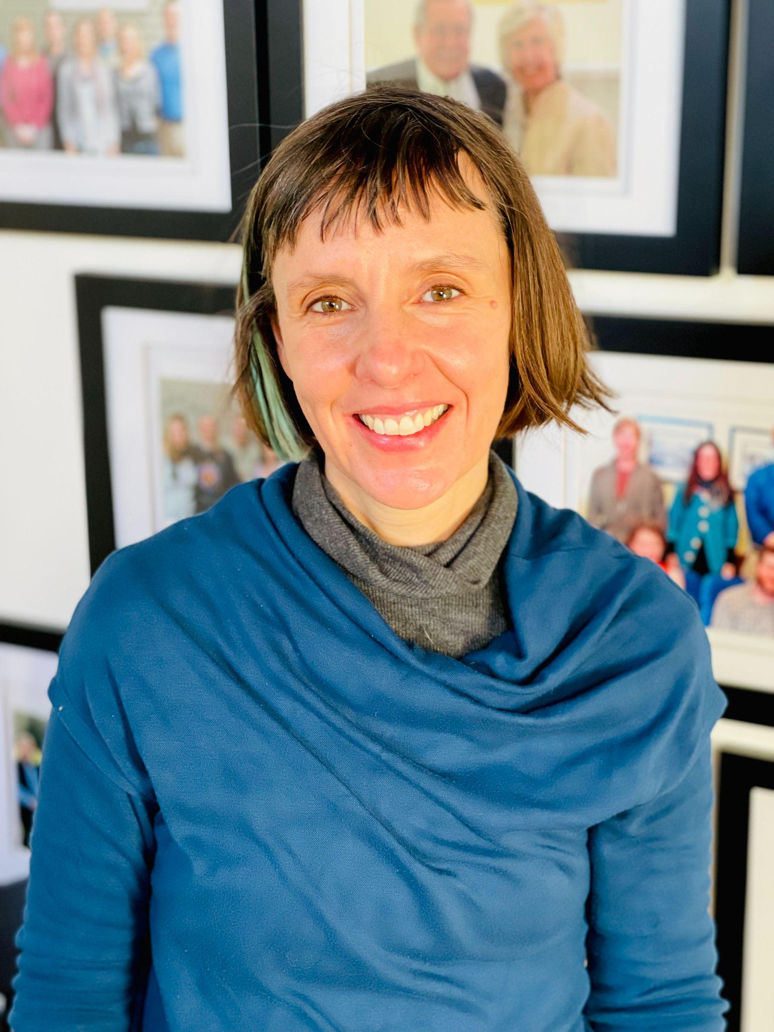
We are thrilled to welcome our new Executive Administrative Assistant Abby Paige to the Rowland Foundation! Abby writes for a literary magazine, has a theater background, and is a Burlington School District mom. She grew up in Vermont and lived in Canada until recently moving back home to be closer to family. When you have a moment, please send her a welcome message at: abby@therowlandfoundation.org

Next week, the Rowland Foundation Board of Trustees will review the finalist proposals for this year’s Rowland Fellowships. The Board of Trustees will also be reviewing our first-ever received Rowland Encore Grant proposals. Please stay tuned for some big announcements at the end of the month, and please join us in welcoming our 2022 Cohort of Rowland Fellows!

The Omicron wave has put a damper on our in-person meetings, but the work continues and we are staying connected as a Rowland Foundation network! Even via videoconference, Rowland Fellows are continuing to connect, collaborate, and even share some laughs.

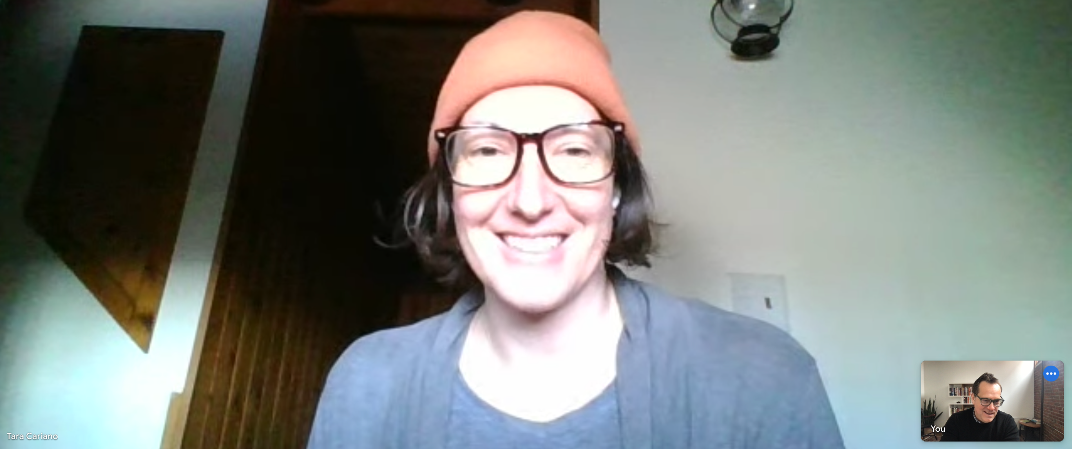
Tara Cariano (RF18) met with Mike to discuss how we can help schools center wellbeing.

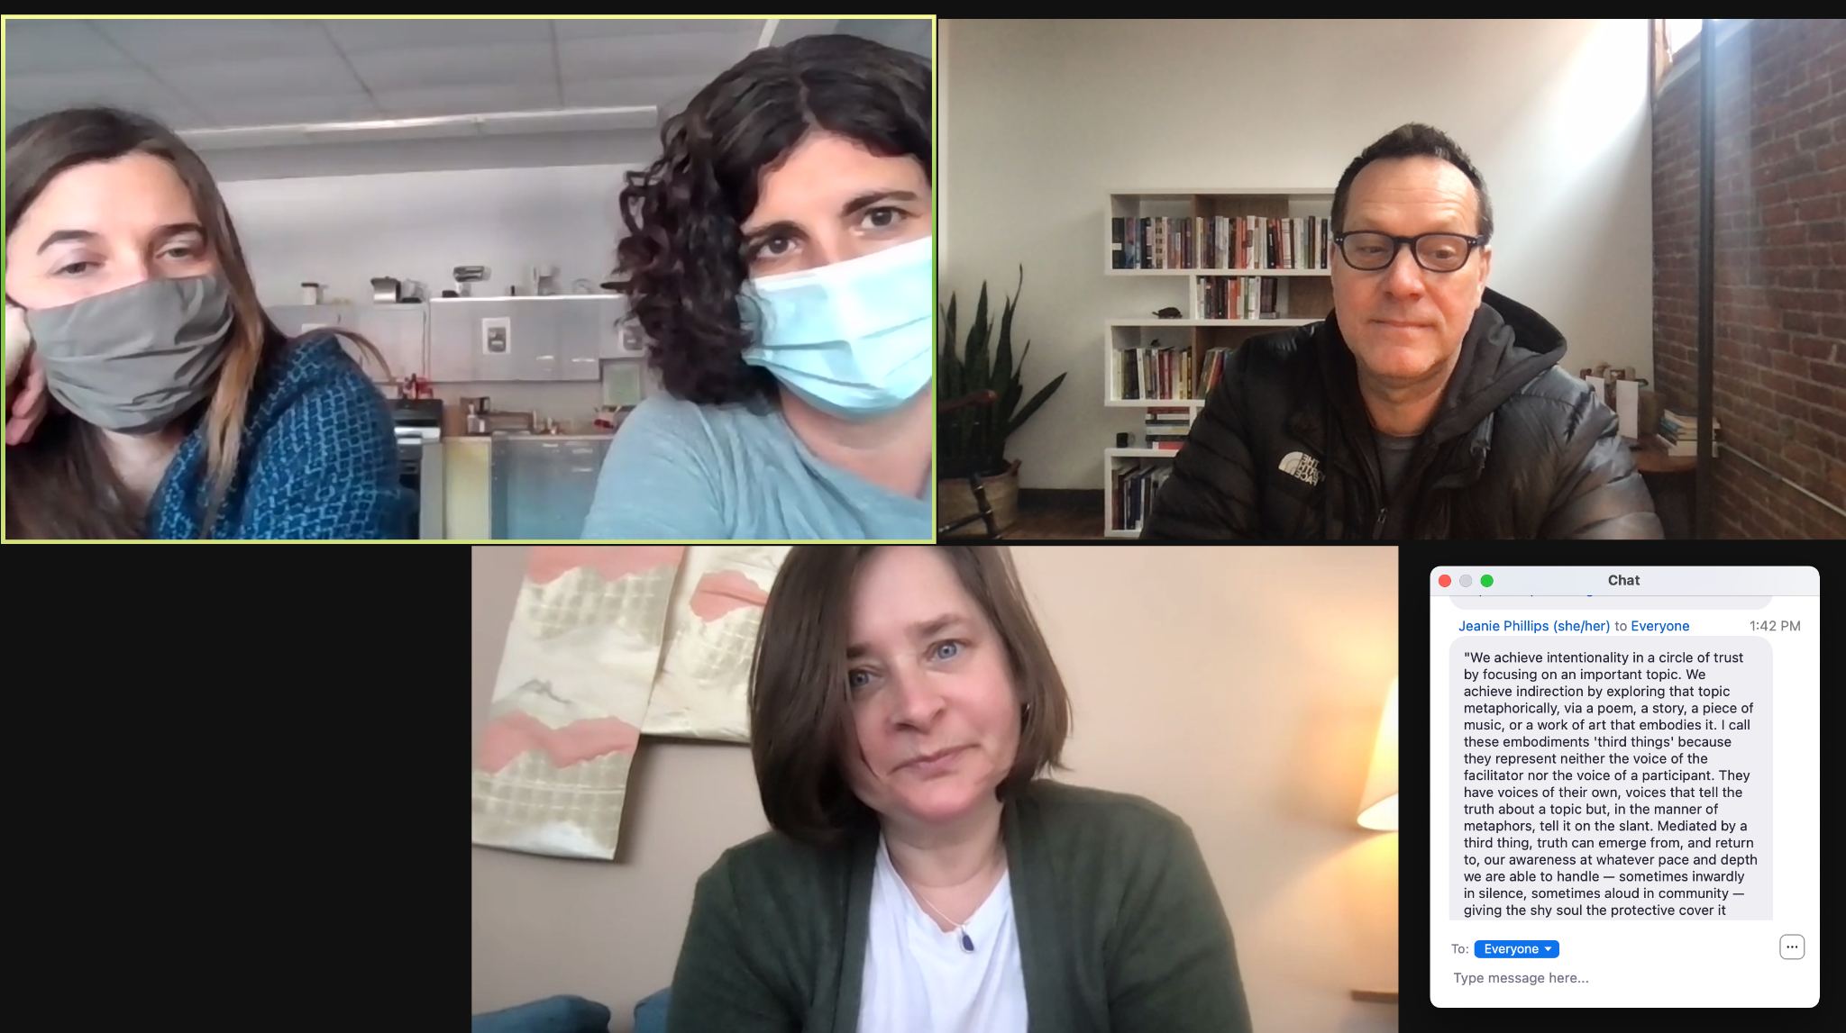
Kat Robbins (RF21) & Janis Boulbol (RF21) met with Senior Associate Jeanie Phillips (RF14) & Mike to discuss strategies for shared learning with steering committees.

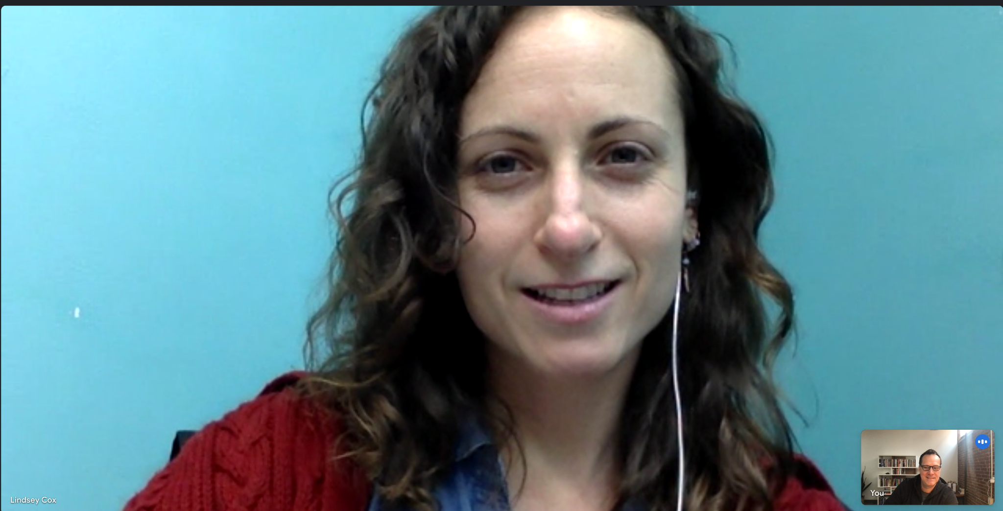
Lindsey Cox (RF17) met with Mike to discuss new approaches for shared leadership in schools.

Gratitude
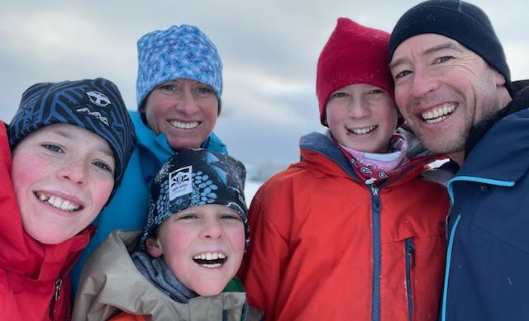
Jillian Joyce (RF20) is seen here with Thomas, Gus, Micah & Ben after a full day of skiing and sledding at Targhee near the Wyoming/Idaho border.

Morgan Manley & Annika Heintz of Mill River Union High School expressed gratitude for their school’s amazing music teacher Kristin Cimonetti (RF20) in this beautiful article from the Underground Workshop, which is edited by Ben Heintz (RF20)

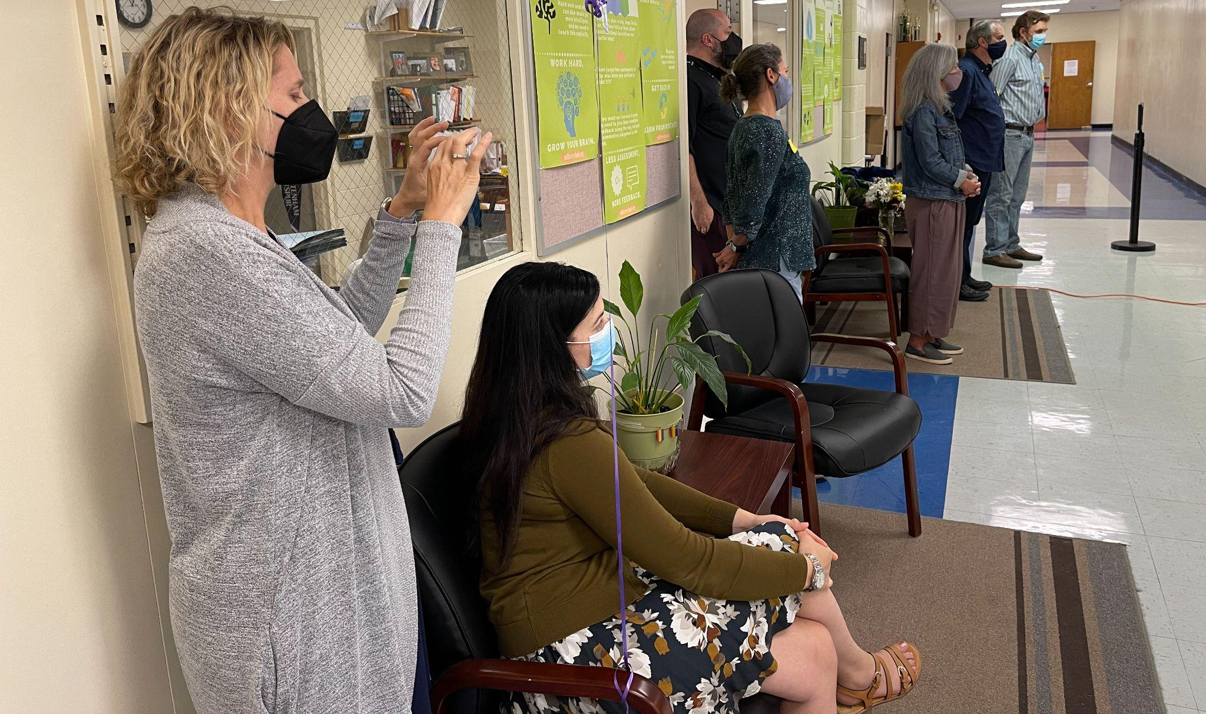
The 2020 Rowland Cohort, totally moved & inspired, as they attend a special (masked) performance from Kristin's choral students (September 2021)

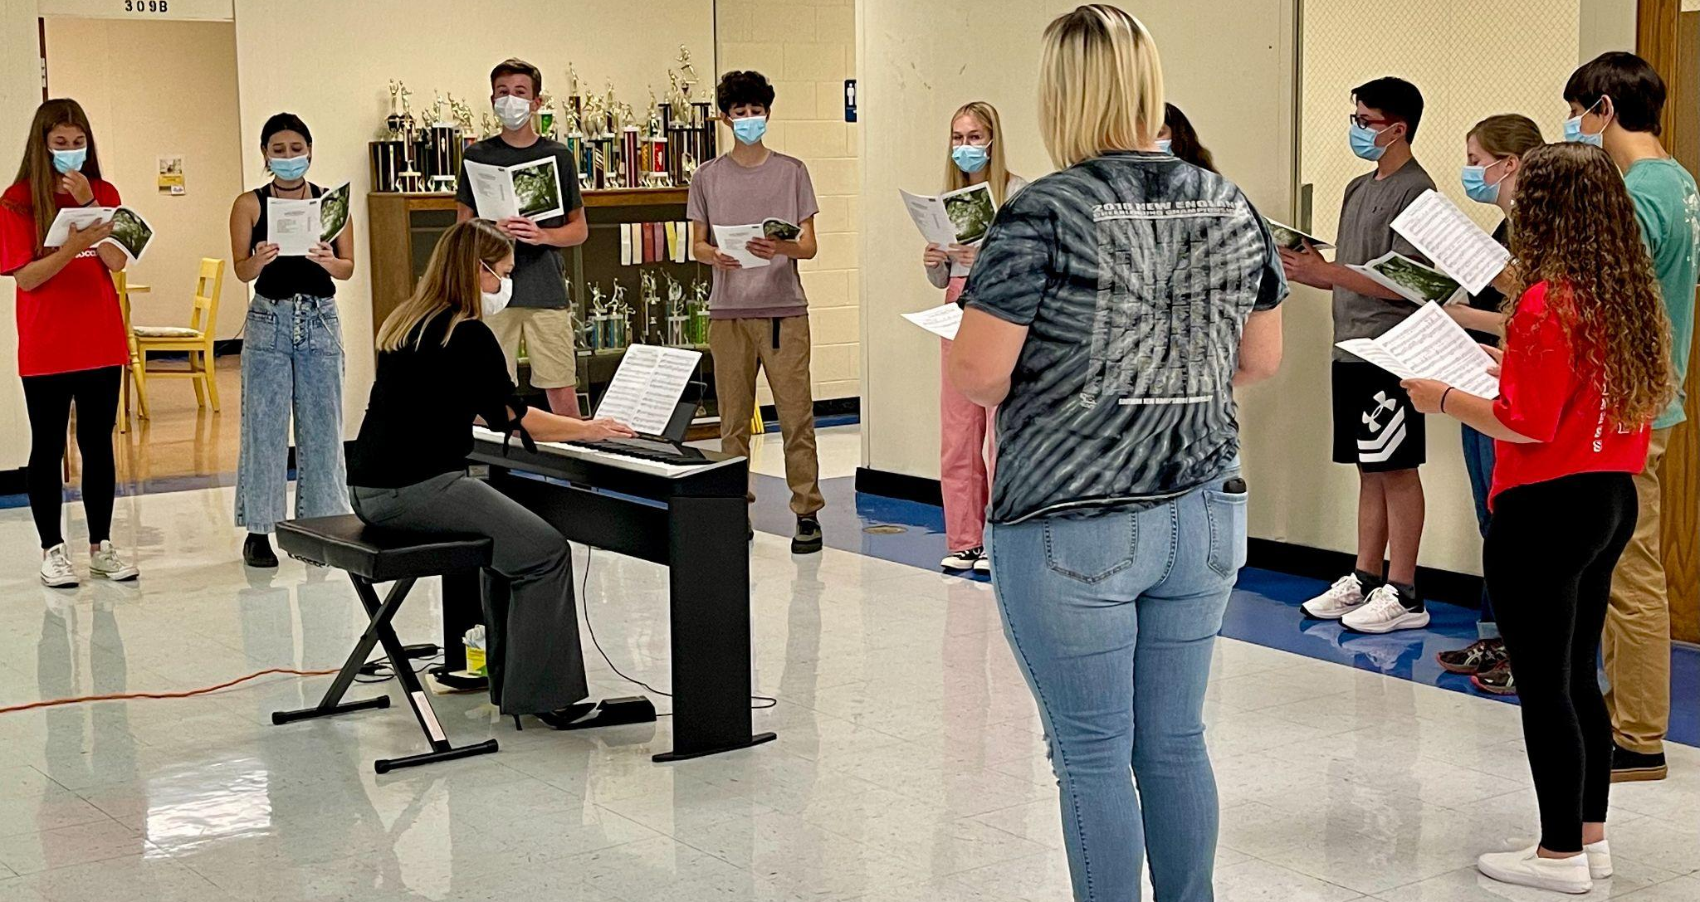Kristin & her amazing singers performing for the 2020 Cohort in the fall at Mill River.
Celebrations
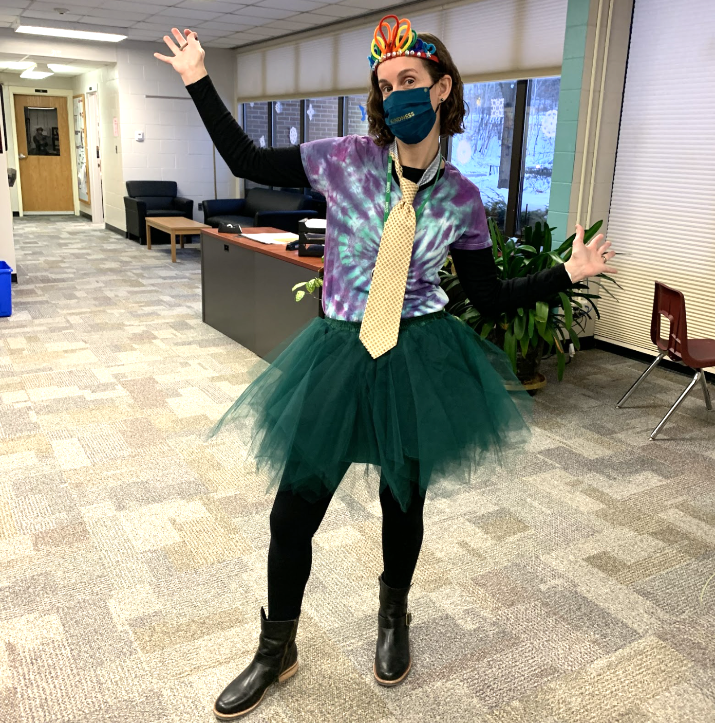
Camel’s Hump Middle School Principal Gretchen Muller (RF17), seen here wearing a tutu, tie & tiara, is bringing joy to her school community with the Ultimate Two Two’s Celebration, which took place on February 2, 2022.

Belated congratulations to Global Leadership Program (GLP) Director Jill Prado (RF12) who has received a Fulbright Award for her innovation, leadership, and hard work. The GLP Speaker Series recently welcomed award-winning National Public Radio journalist and author Aarti Shahani. You can follow GLP on Twitter: @viavenues

Congratulations to Michael Ruppel (RF17) who will succeed Jim Avery as the next Principal of Otter Valley Union High School! You can read more here about Michael’s move to this new position.

Warmest congratulations to Superintendent Adam Rosenberg (RF10) who will be retiring after serving in a variety of roles in education since 1988 and in Vermont schools since 1995. Adam is looking forward to spending more time with his wife, his kids…and his Telecaster.

Courtesy Postings
AOE Division Director Jess DeCarolis (RF09) would like Rowland Fellows to know that the position of Post-Secondary Programs Coordinator on the Personalized Learning team has been posted. You can find more information about this opportunity here.

Elijah Hawkes, former VT principal and long-time ally of the Rowland Foundation, is now Director of Leadership Programs at the Upper Valley Educators Institute (UVEI). Elijah writes, "Rowland Fellows who are considering a career in school administration should consider UVEI as an option for your certification path. UVEI's learning by doing approach has a lot of parallels to leadership development that's part of the Rowland Fellowship. I'd love to talk with anyone who might have questions about our program. And we've got info sessions coming up. Hoping to hear from you!"

This summer Andrew Jones (RF15) is teaching Leading School Innovation, a 3-credit UVM graduate course that is specifically designed for teachers & administrators leading change in their schools (e.g., Rowland Fellows). If you’re interested in picking up some new change strategies with a colleague or two, this 2-week seminar may be just what you’re looking for this summer. UVM registration for summer courses opens on February 17th.

