 | Letter to Fellows  Chat GPT  February 2023

Dear Rowland Fellows,

I hope you and your loved ones are doing well and staying warm!

Since the company OpenAI released it for free public use last November, it seems like bloggers, pundits, podcasters, journalists, educators, and commentators of all stripes can barely talk about anything else: Chat GPT-3 is here and it’s really shaking things up.

What is Chat GPT-3?
Chat GPT-3 is a very powerful machine learning chatbot based on a natural language processing system. GPT stands for “Generative Pre-Trained Transformer” and the 3 indicates the third generation. There are different kinds of chatbots, but this one is getting a lot of attention because it produces surprisingly good results, even for the casual user. If you’re huddled inside from the cold this weekend, you can go here to mess around with Chat GPT and see what you think.

Right now, a lot of people are talking about Chat GPT because they’ve tried it and are scared at how good it is. It even scared Google, to give you an idea.

Of course, teachers and college professors are worried about academic honesty because Chat GPT is immune to anti-plagiarism tools like turnitin, so schools are trying to take “preventive measures” to get ahead of this disruptive technology, this new essay killer. A computer science student at Princeton even created an app to detect Chat GPT generated text, presumably as a new plagiarism-buster (and OpenAI just announced their own “AI Classifier” for this same purpose), but, as with all things tech, we can imagine that might be a losing game…

Is this just the next thing?
Probably. Learning technology has a long history of freaking people out, and then being quickly adopted as legitimate. Remember when Microsoft Word gave us spell & grammar checks, and how we were worried nobody would learn how to spell? Now teachers not only use those tools, but voice-to-text too. Remember how kids weren’t going to learn how to do bibliographies when EasyBib came out? Well, now teachers encourage students to learn how to do bibliographies by sending them to EasyBib first (and personally, I’m not sure I would have finished my doctoral dissertation without my Zotero plug-in). Remember when the graphing calculator panicked Trigonometry teachers? Now most syllabi tell you which Texas Instruments model # you need for your math course. Going further back, my engineer dad actually used a slide rule pretty often until the “pocket calculator” got big in the mid-1970’s. It makes you wonder if our ancestors were worried that the abacus would stunt mathematical reasoning for future generations...

And it’s good to remember that, if you go back far enough, written text itself was a learning technology, even before Gutenberg’s printing press. Plato was not an early adopter. Amongst other things, he was worried that written language would weaken our ability to memorize, famously saying, “It will implant forgetfulness in their souls. They will cease to exercise memory because they rely on that which is written, calling things to remembrance no longer from within themselves, but by means of external marks.”

But this feels different somehow. When IBM’s Deeper Blue defeated chessmaster Gary Kasparov back in 1997 it was a turning point for deep learning models predicated on neural networks. But AI is now accelerating at a pace that’s hard to understand–and across many fields of knowledge. Now generative chatbot tools seem to be creating original work, even in the style you request, from Shakespeare to Elon Musk, from Aristotle to Trump, in the voice of an eighth grader or in the voice of Preet Bharara.

Even scarier, chatbots and other artificial intelligence (AI) tools are doing more than homework these days. They are roiling up a range of professions. Architects are using AI to develop new designs. Coders are using it to write and debug code. Marketers are using it to generate ad copy and marketing strategies. The AI start-up DoNotPay was launched to help make legal arguments by a chatbot to help clients get out of traffic fines, but the California Bar Association forced its owner to stop. Teachers are even using AI to create lesson plans (God forbid!) AI-generated art has raised some serious questions about intellectual property and even a class-action lawsuit. CNET recently ran into trouble when it started outsourcing articles to AI instead of writers.

How trustworthy is Chat GPT-3?
It depends. OpenAI names some of their product’s limitations here, and this short introductory video includes the list below. It’s also good to understand that Chat GPT is not a search engine, but a predictive language model, and so some users report that it doesn’t admit to not knowing the answer and will provide bogus explanations and even invent sources as needed instead of admitting to not knowing. Chat GPT-3 is also often bad at complex math problems, so students are quickly learning to turn to tools like AI:R Math instead. Finally, from a style standpoint, some writers are finding that Chat GPT-3 lacks panache, originality, pizazz, verve…you know, that human spark.

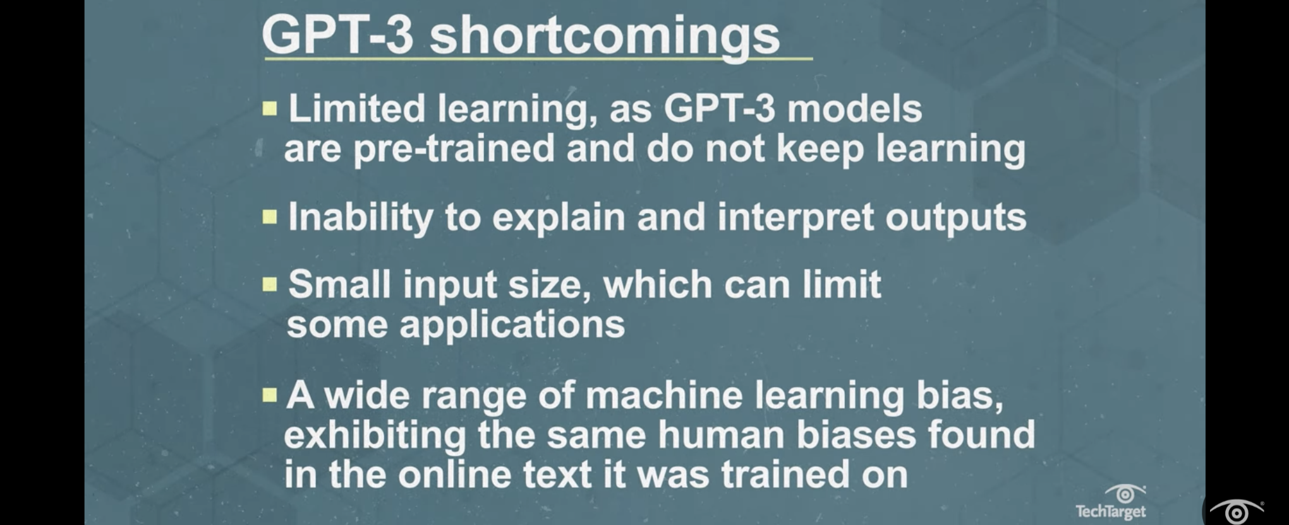

If you’re reading these limitations and are thinking, “Phew! It’s not that great yet!” you might want to think again. GPT-4 is coming soon, and will no doubt improve exponentially on this version’s capabilities.

Will most teachers and students all be using Chat GPT and other AI by this time next year? Yes. I mean, we’re already using AI all the time (for example, those auto-complete suggestions in your email). “The future is already here, it's just unevenly distributed,” as William Gibson famously said. So while some schools are freaking out about how to police AI in learning, many educators are looking at how to incorporate it into teaching & learning in a way that makes sense.

Many professional writers are experimenting with different “AI writers” to help generate rough first drafts, rote communication, or simple summaries. Obviously, using AI to break the ice, and then teaching young writers how to keep refining and iterating from there, could be a useful new approach to process writing…provided students don’t stop at the first draft.

“ChatGPT is the tip of the iceberg,”educator & technologist Ivy Xu recently tweeted, adding a list of Seven AI websites that will change education forever, according to her predictions.

Oregon high school English teacher Cherie Shields is an early adopter, and I love the way she describes how she’s incorporating it into her teaching practice and learning from experimentation.

So what can we do as educators?
Well, one simple first step would be to talk about it. A common sense approach would be to create some time and space for teachers to develop some shared understanding about these new technologies and to explore possible approaches–before leaping to schoolwide bans or trying to shoehorn this new challenge into old academic honesty policies.

For example, Charlie MacFadyen (RF20) is helping to lead an AI focus group with his CVU colleagues, with full support from the administration. After getting questions about ChatGPT from faculty members, Charlie sees the need to start the conversation in an intentional way, and hopes the new group will help staff to “come to some common understandings and practices about the use of AI in teaching and learning”. Charlie is interested in finding innovative ways for AI to be effectively incorporated into teaching and learning at CVU, while at the same time addressing concerns about academic honesty.

What do all these AI tools mean for our assessment practices?
It means we need to keep learning and get creative. Some teachers are already shifting to more in-class writing to neutralize the problem of authorship, while others are asking students to bring in their Chat GPT first draft as a starting point. When it comes to responding to text, in the past teachers only had to surpass a Cliff’s Notes level of textual analysis– now we’re going to have to dig a little deeper.

Still others are thinking of how to play with Chat GPT’s limitations in order to investigate the creative process with students. Personally, I found Chat GPT’s Shakespearean style over relies on inversion (which makes it sound like Yoda), and its poetry and short fiction tend to pump out threadbare clichés. Let’s have some fun with that and see if we can do better!

“Our students need to learn skills that a computer can’t do,” former Vermont Secretary of Education Rebecca Holcombe used to say. Well, I guess this all shows she was right.

At a much broader level, these AI tools provide us with an opportunity to really rethink our assessment principles. When we think about how much time we spend on assessment of learning (evaluation) vs. assessment for learning (formative feedback), we can see that we’re still operating within a ranking & sorting accountability regime. What if we used this AI “probortunity” to lean more deeply into authentic assessment? In that case, we could see students spending more time building and creating than reporting and summarizing. We might also see more real-life work products, designed and created by collaborative teams of classmates, than procedural learning done individually.

The bottom line here is that Chat GBT and other AI writers are surprisingly generative and increasingly creative. This means that we will need to revamp our teaching & assessment practices to be more generative, creative, original–in a word, human–than these powerful new tools.

Let’s start messing with it!

Take care and see you soon,

Mike

P.S. Tyre Nichols was a hard-working father, a skateboarder, and an avid photographer. He was more than the victim of the police brutality that ended his life too soon. You can see his photographs here.

P.P.S. Have you listened to Fela Kuti yet today? Why not? #joy

P.P.S. The 1619 Project is now available on Hulu! Check out the powerful trailer here.

P.P.P.S. I send this letter out to all Rowland Fellows & Trustees every first Friday of the month. Please consider sending me your news, photos, courtesy postings, and anything else you would like to share with our vibrant network of Rowland Fellows.

Rowland Foundation Updates
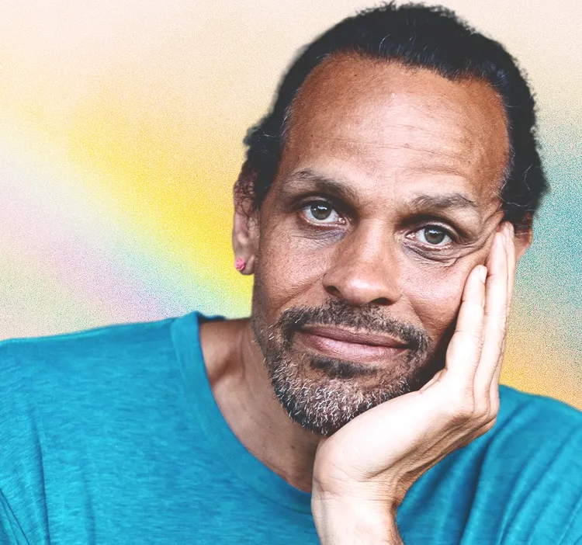
12th Annual Rowland Conference Keynote: Ross Gay!
Great news! The essayist, poet, and educator Ross Gay will be our next keynote speaker for the Annual Rowland Conference to take place at UVM on Thursday, October 26, 2023. Dr. Gay is a professor at Indiana University Bloomington and the author of the New York Times best-seller The Book of Delights. His new book of essays is Inciting Joy.

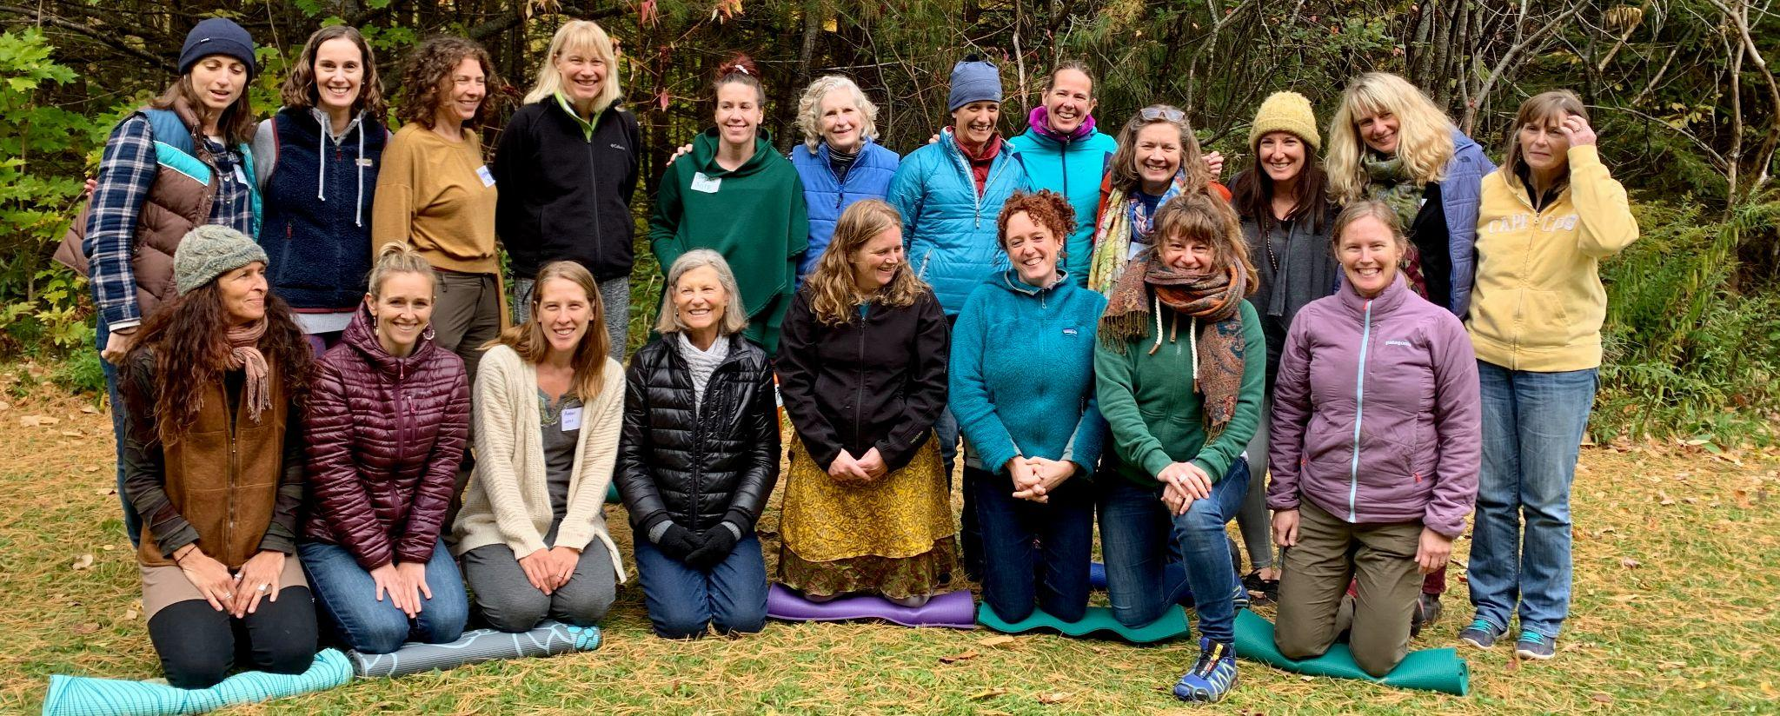
The Rowland Women Leadership Retreat
Save the date announcement coming soon! This year’s Rowland Women’s Leadership Retreat Planning Team have been organizing and are planning for this year’s retreat to take place in early June. Thanks to all of you who gave input via the planning survey, and feel free to contact Marsha Cassel (RF14), Gretchen Muller (RF17), and Tara Cariano (RF18) with your questions & suggestions as they get things in place.

The Rowland Diversifying the Educator Workforce (DEW) Grant
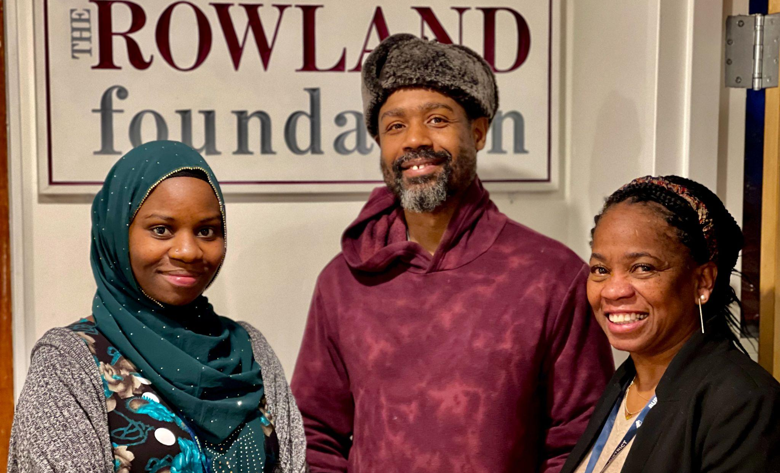
Safia Haji, Infinite Culcleasure & Bonnie Johnson-Aten met with Executive Director Mike Martin recently at the Rowland Foundation’s Burlington office for DEW Grant Orientation.

Excellent news! The Rowland Foundation has already awarded its first two DEW Grants to two amazing aspiring educators of color: Safia Haji and Infinite Culcleasure. Safia is a mother of three beautiful children, worked until recently for Winooski school district, and is now doing her teacher practicum at Essex High School. Infinite is a father, worked recently for the nonprofit Voices for Vermont’s Children, and has served as a community organizer and youth mentor for several years. Both Safia & Infinite are enrolled in the Spark Teacher Institute, where Nicole Awwad (RF21) serves on the faculty.

In other good news, Bonnie Johnson-Aten will be serving as DEW Grant Mentor for this year’s aspiring educators of color who received Rowland DEW Grants. Bonnie is an incredible educational Vermont leader who has served as a teacher and administrator in several districts around the state. She has mentored countless Vermont educators of color (on her own time) and most recently served as facilitator for the VPA’s A Place of Our Own, an affinity group for Vermont administrators of color. Bonnie is currently supporting 12 administrators as District Principal for Burlington School District. Bonnie will be meeting with Safia & Infinite, and up to two more DEW Grant recipients this year, as a mini-cohort to support them on their pathways to licensure. The Rowland Foundation is fortunate to have Bonnie serving in this important role.

Winooski’s New School Renovations
Rachel Howes (RF21) & Brent Litterer (RF21) hosted the 2021 Rowland Fellows for a cohort meeting in Winooski and gave us a school tour! Winooski’s new school renovations are truly remarkable.

Senior Rowland Associate Jean Berthiaume (RF09) and Rachel Howes giving the 2021 Cohort a tour of Winooski’s new renovations, seen here in the main lobby.
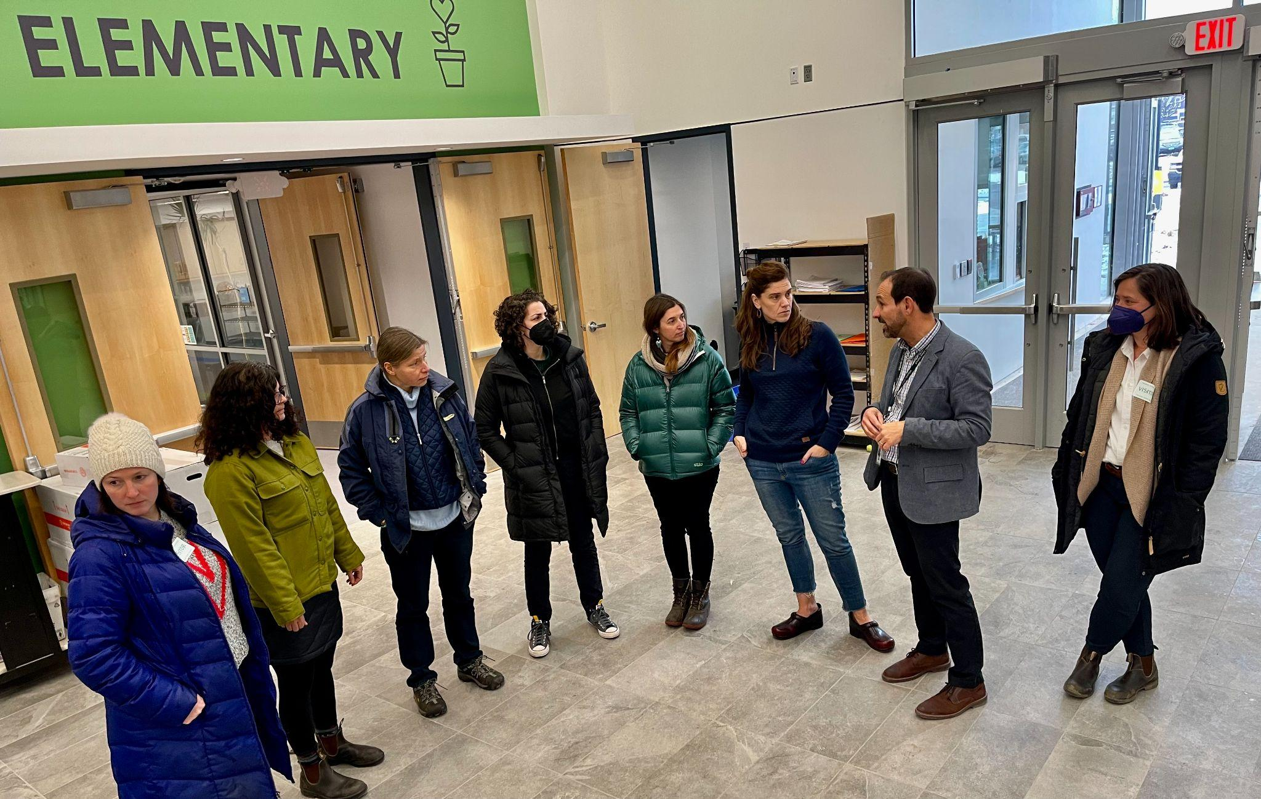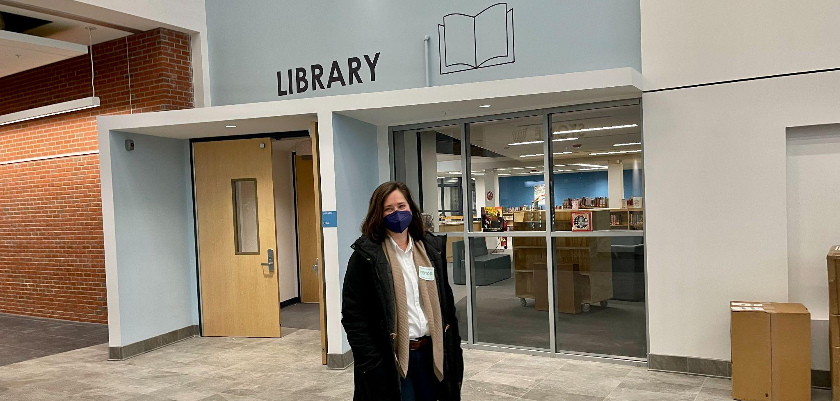
Senior Associate (and former librarian) Jeanie Phillips checking out Winooski’s new library.
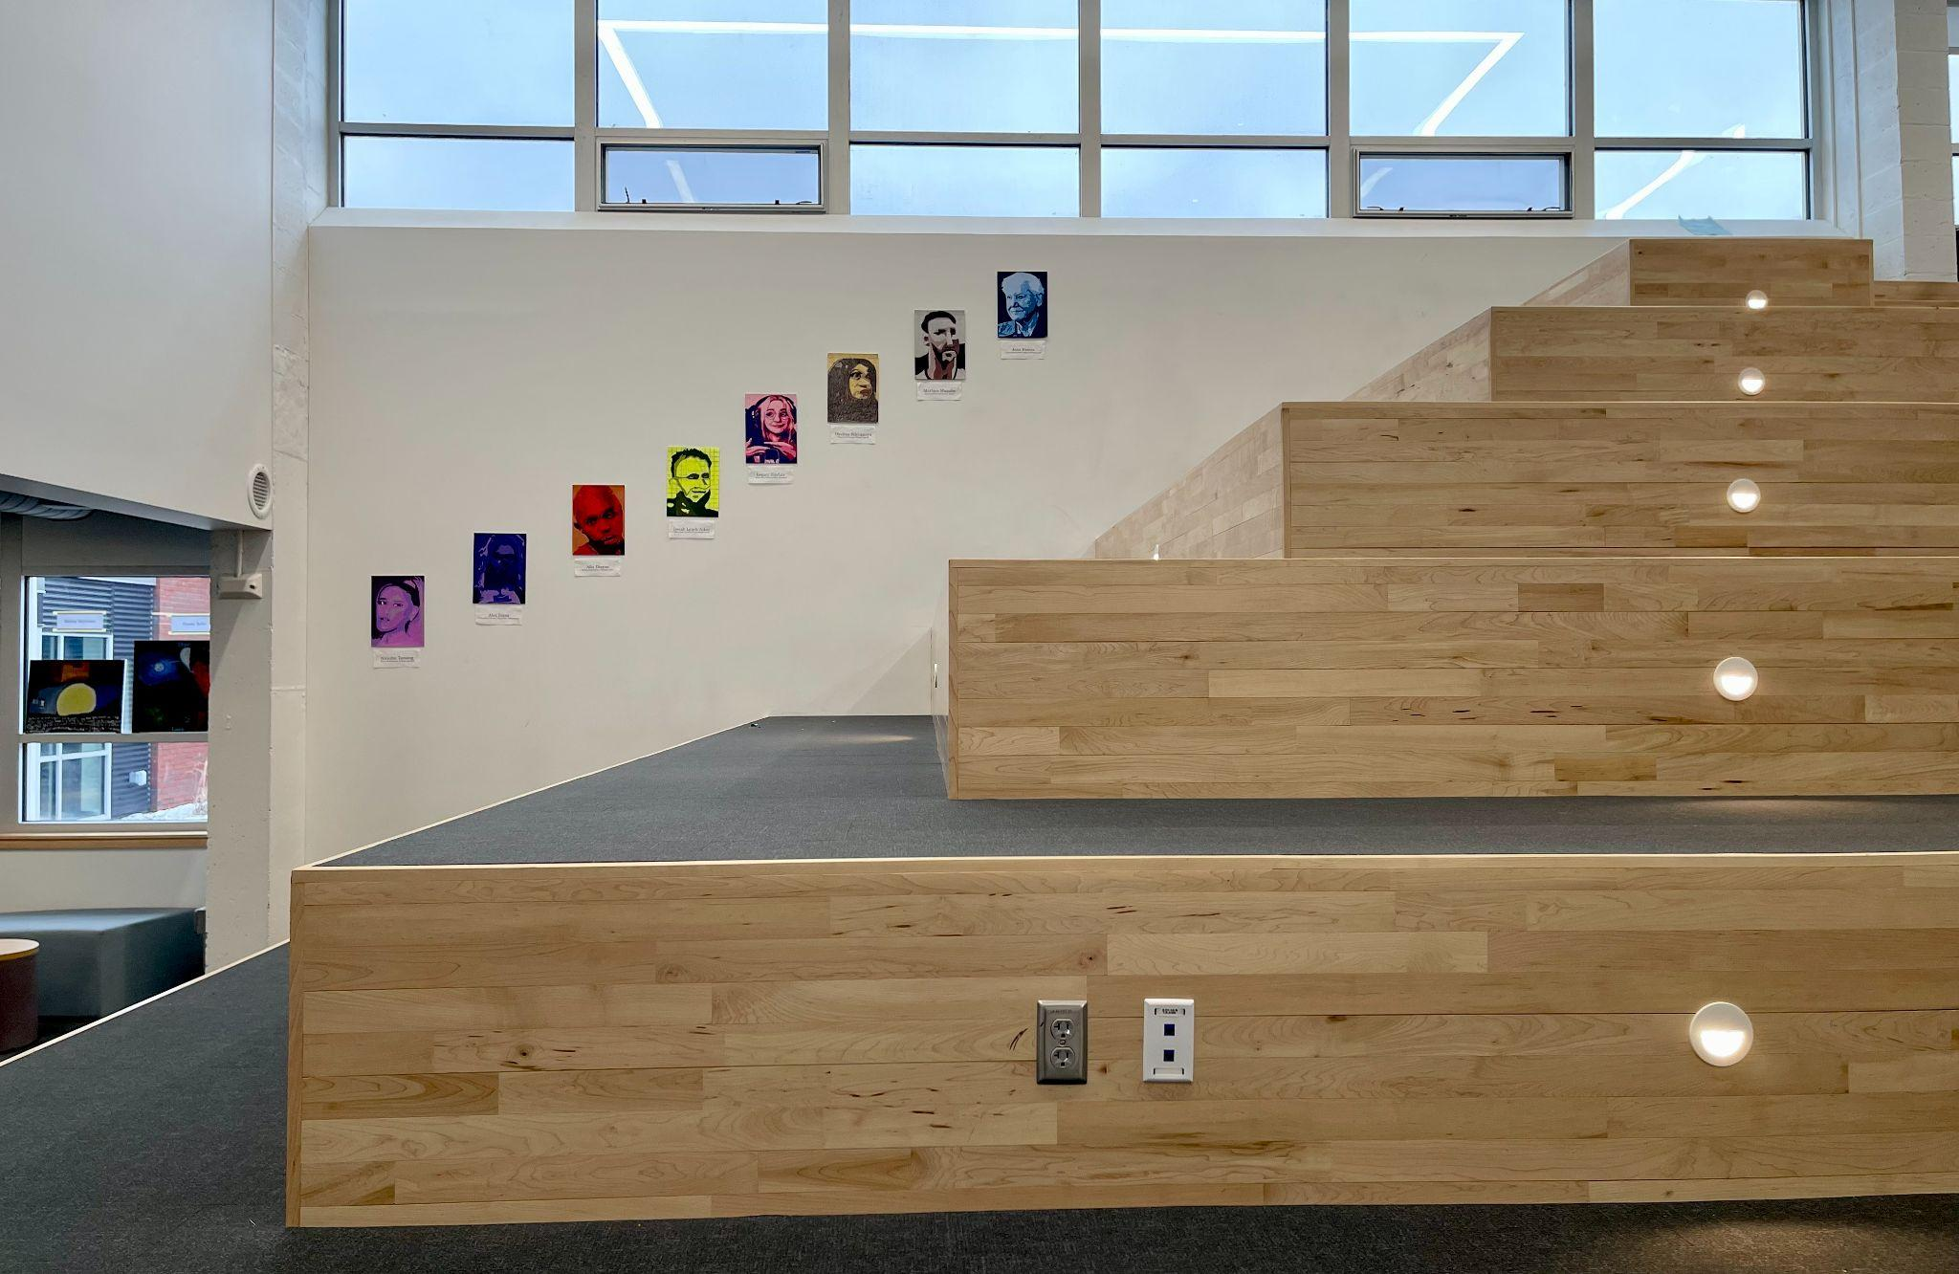
One of Winooski’s new commons areas, full of natural light and space for students to meet.
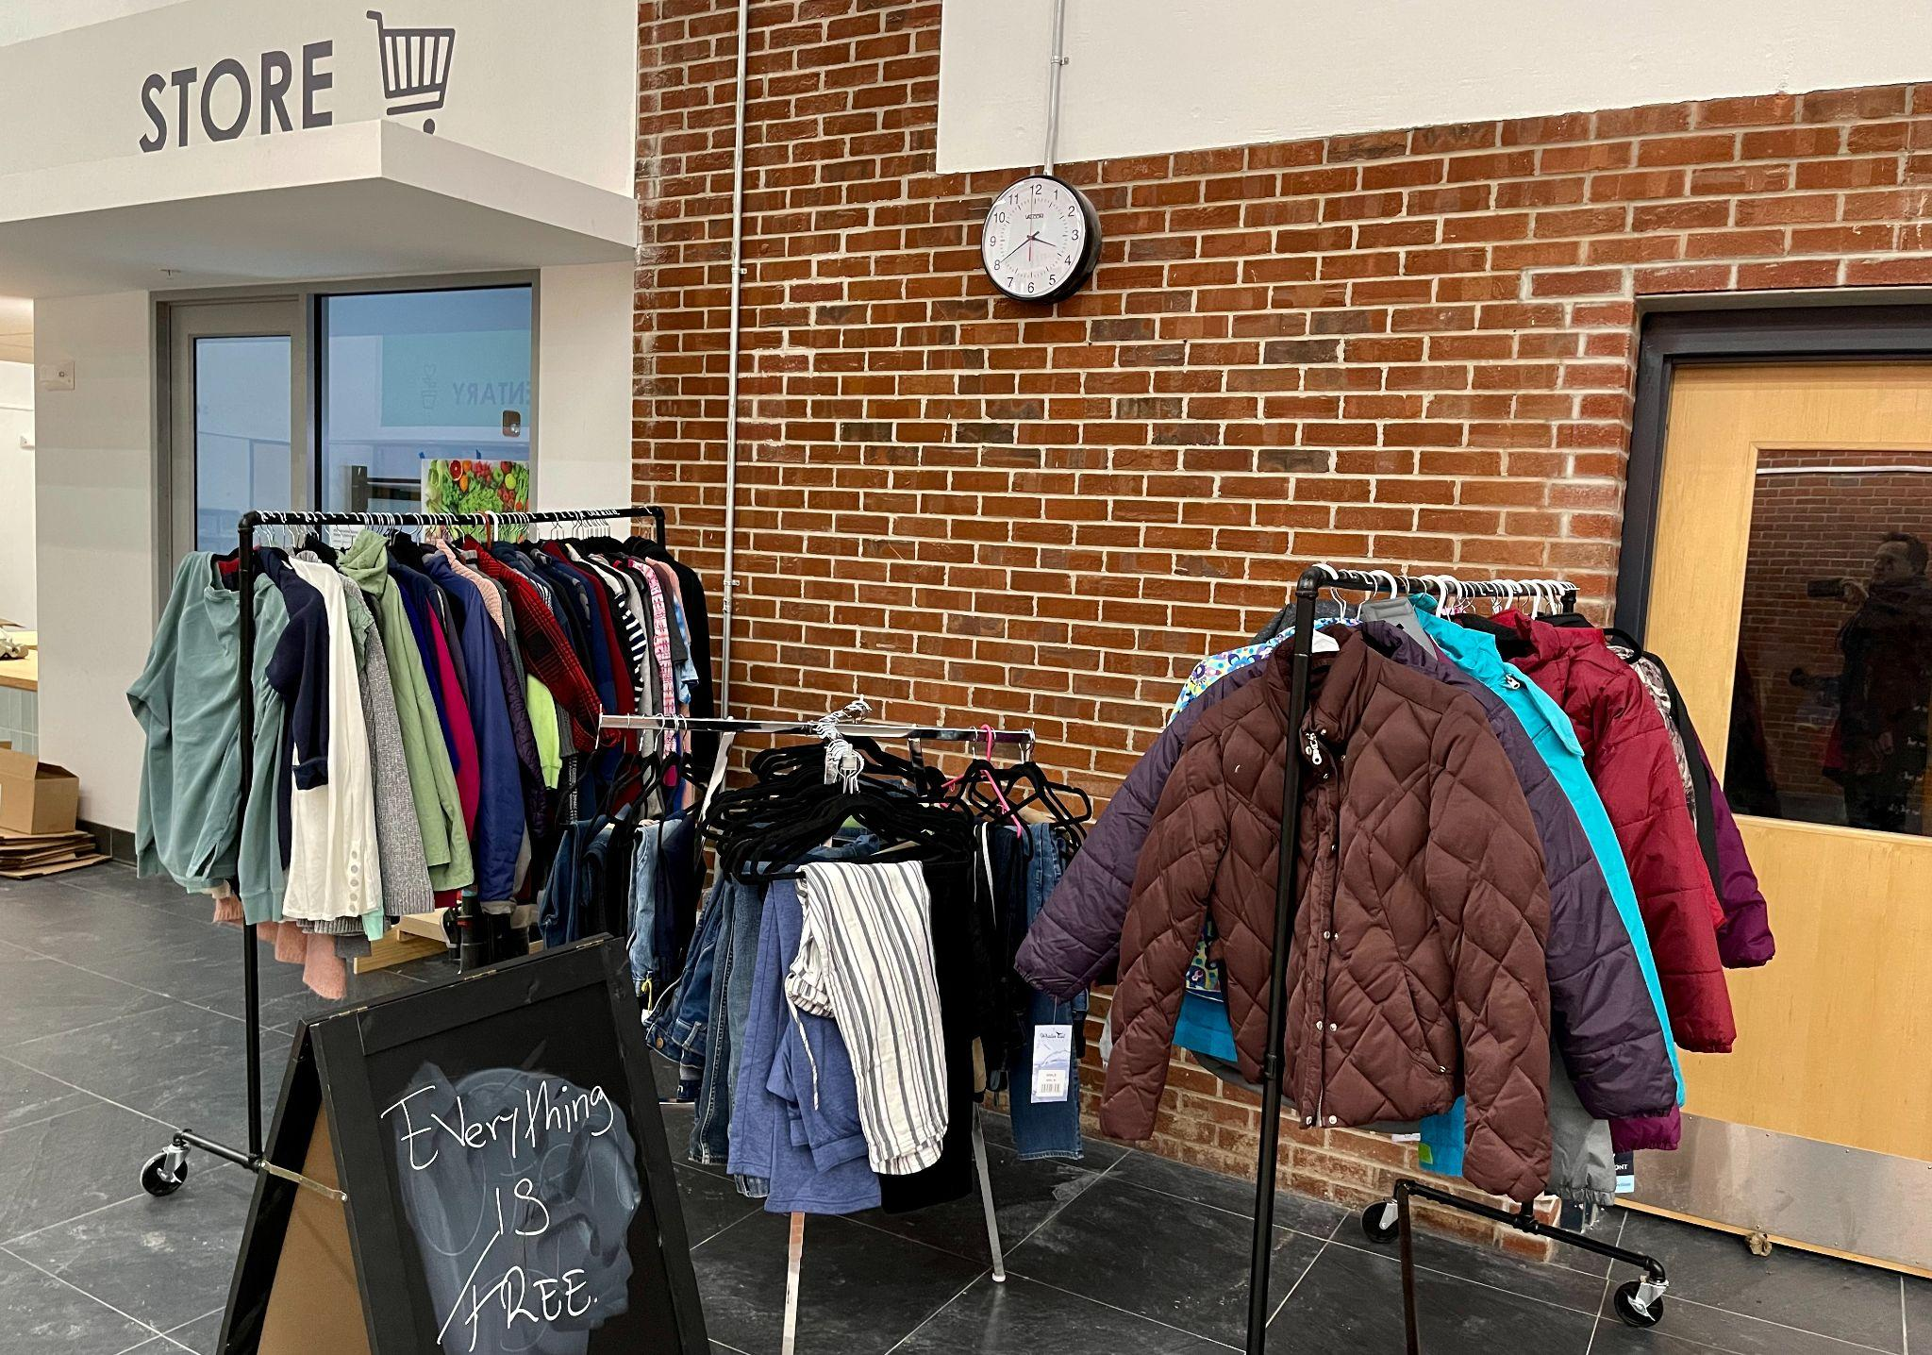
Winooski School District’s new “Free Store”. Learn more about the Winooski School District’s Necessity Store here.

Collaboration for Innovation
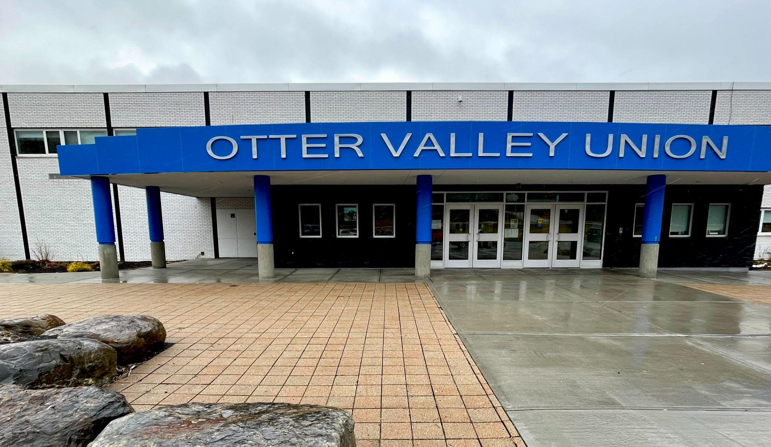
Devon Karpak (RF22) & Otter Valley Union HS Principal Michael Ruppel (RF17) recently hosted the 2022 Rowland Fellows at Otter Valley. Tough weather, but a great day with Rowland Fellows.

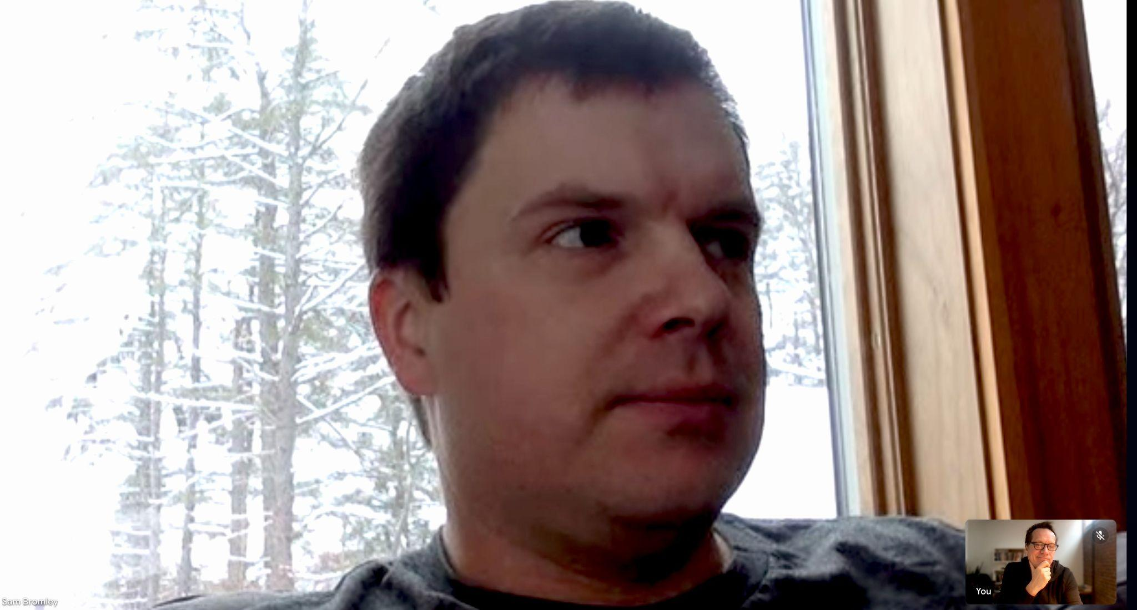
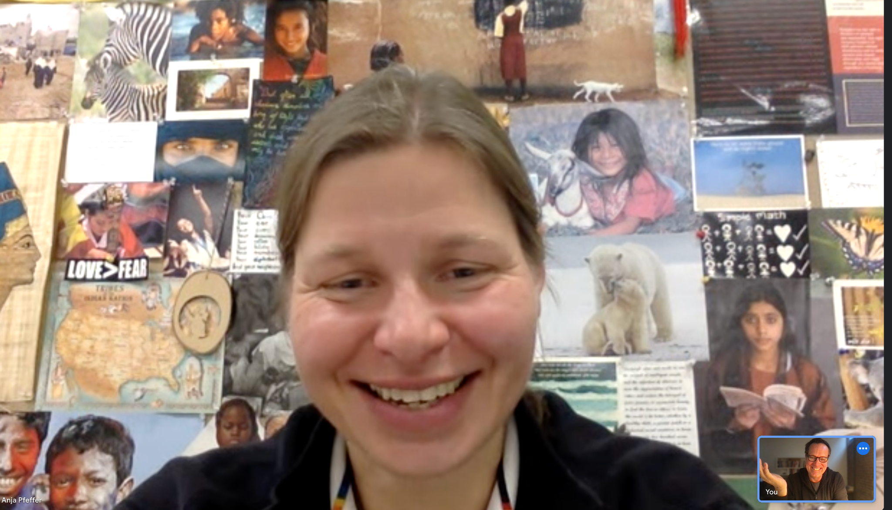
Even as we’re grateful to return to more in-person meetings, it’s nice to be able to jump on a video call on short notice without worrying about icy roads. Executive Director Mike Martin seen here Google Meeting with Sam Bromley (RF22) & Anja Pfeffer (RF21) this January.

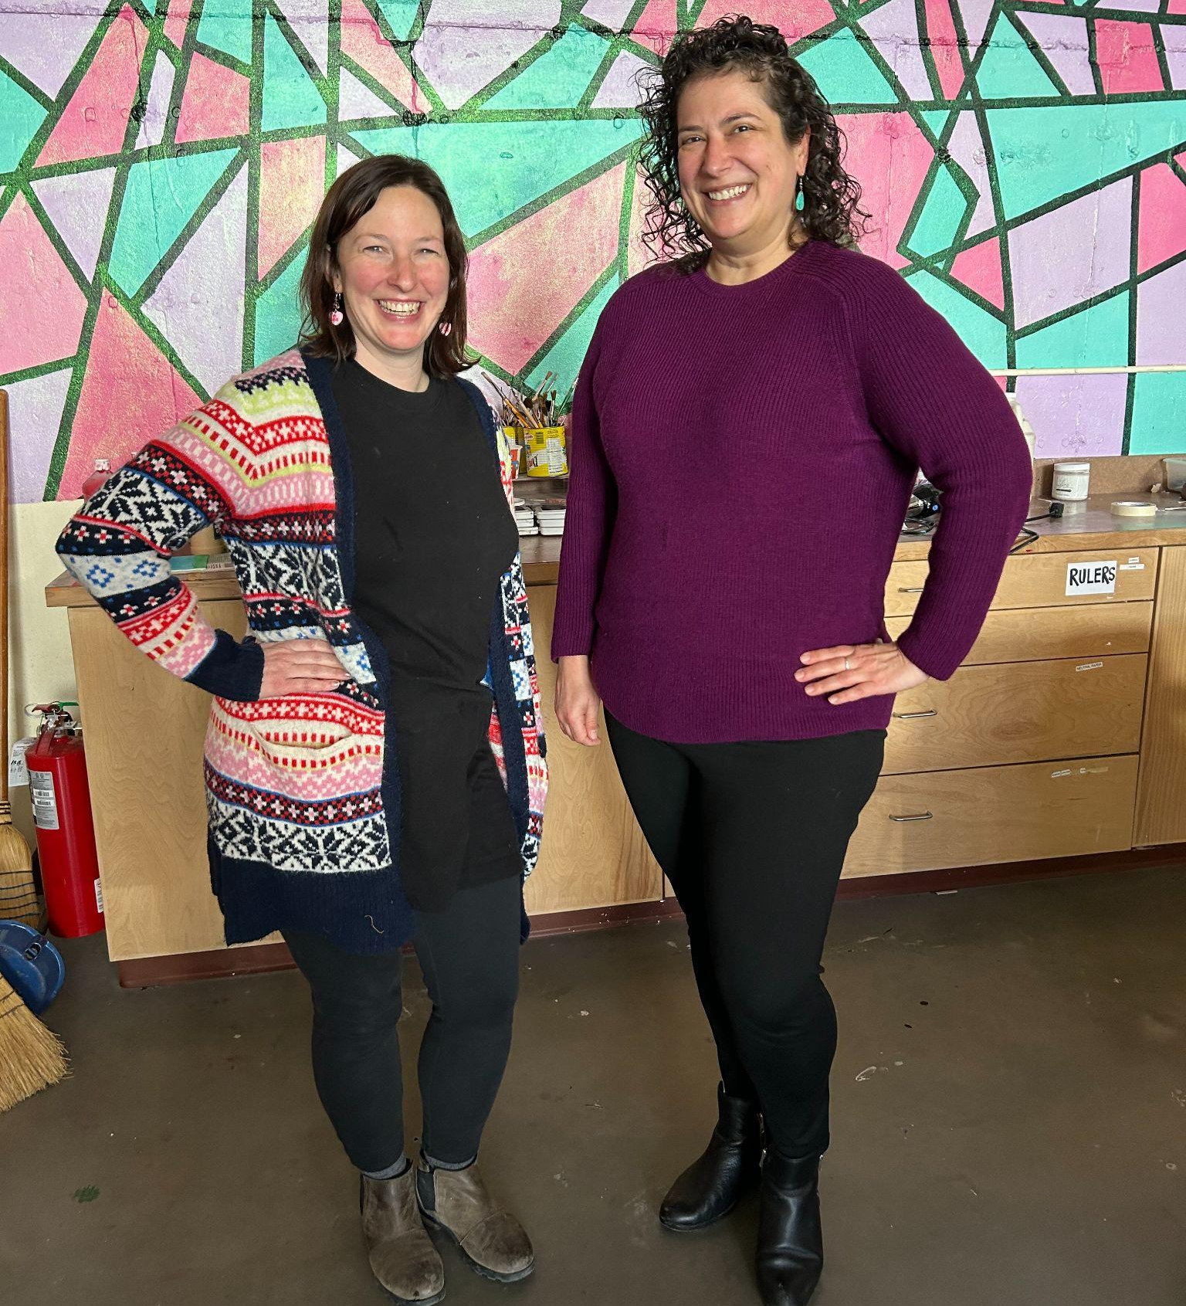
Samantha Mundt (RF21) recently worked with SRI Facilitator and Vermont educator Marissa Barbieri to organize and lead a faculty-wide conversation on project-based learning at Twin Valley Middle High School. No surprise–it was a smashing success.

Gratitude
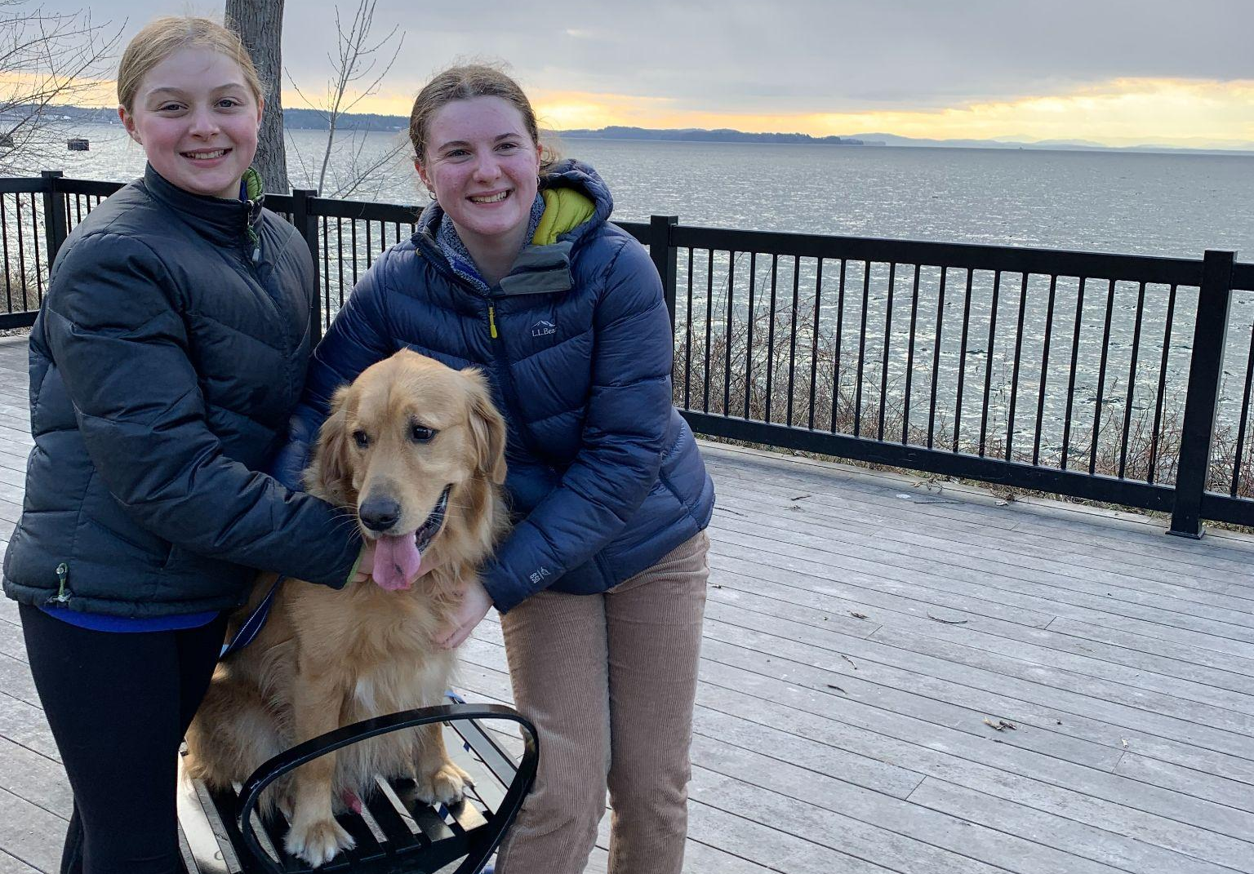
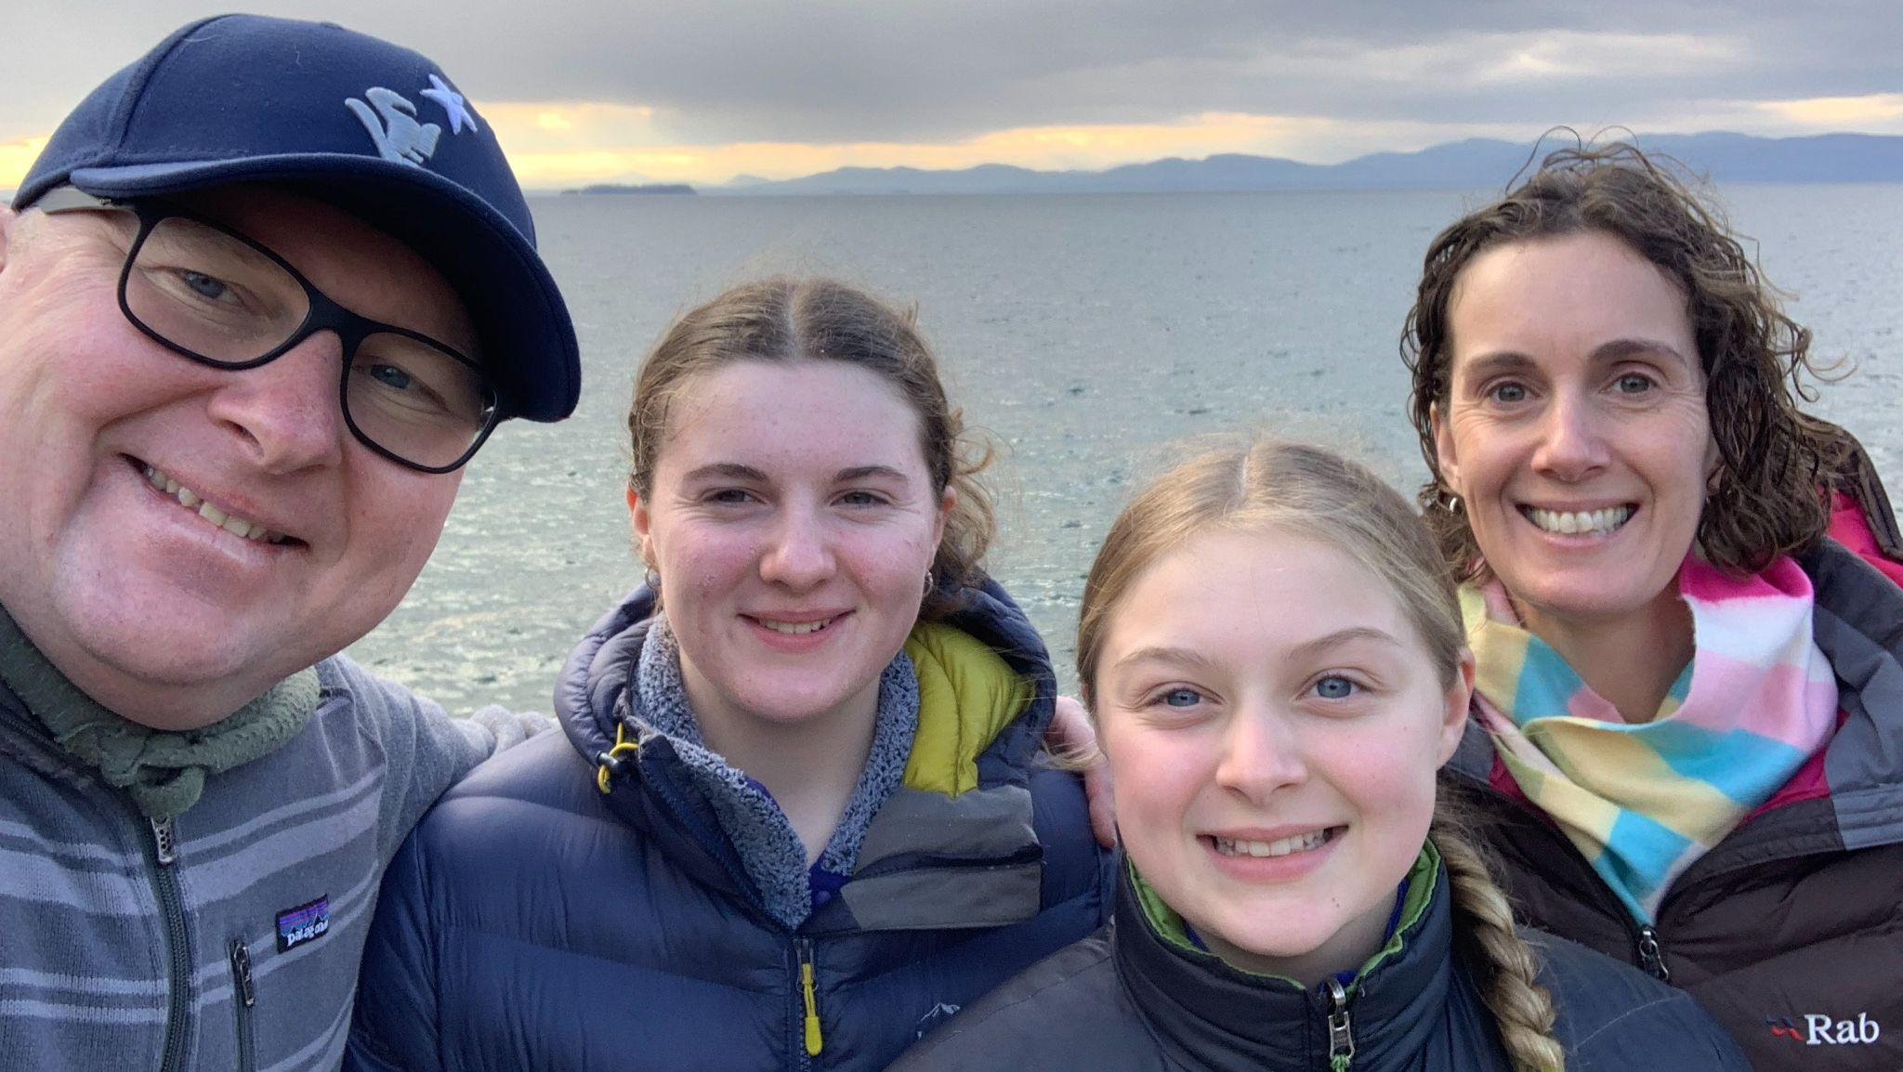
Gretchen Muller (RF17) is grateful for a recent walk with her husband, daughter, and dog along Burlington’s Waterfront to celebrate her birthday. Happy 30th Birthday, Gretchen!

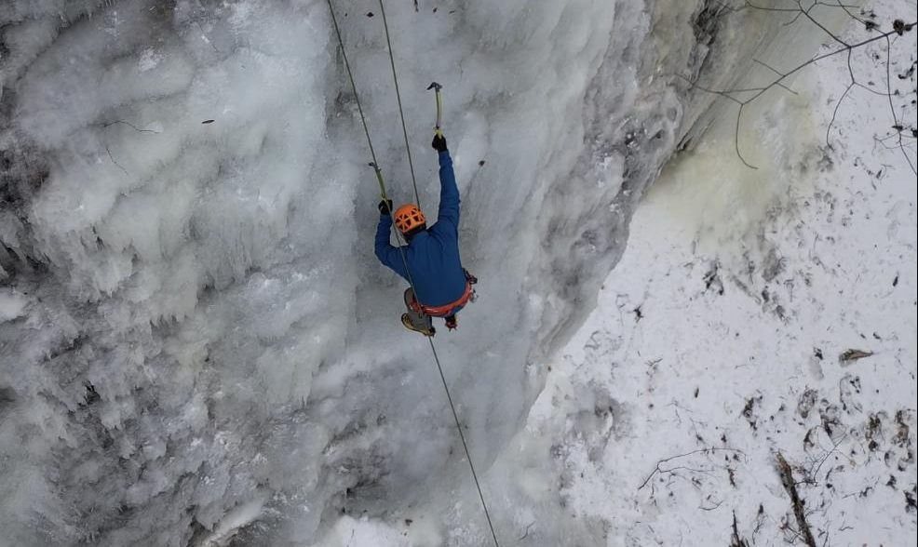
Alpinist Andrew Jones (RF15) is grateful for some recent ice climbing at Snake Mountain with friend & Fellowship partner Gabe Hamilton (RF15). Photo & drone credit: Gabe’s son Liam.

Celebrations
Senator Bernie Sanders recently awarded St. Johnsbury Academy Adult Education $473,000 in Congressionally Directed Spending funds to build a flexible pathway for adult learners in the field of nursing. Sandra Mings Lamar (RF16) worked with a coalition of NEK community leaders in adult education, workforce development and health care to envision the program. Using the work of the committee she submitted a proposal to Senator Sanders' office and recently learned that it was part of the Omnibus Bill. For more on Senator Sanders' bill visit: Senator Sanders Secures More Than 42 Million For Vermont

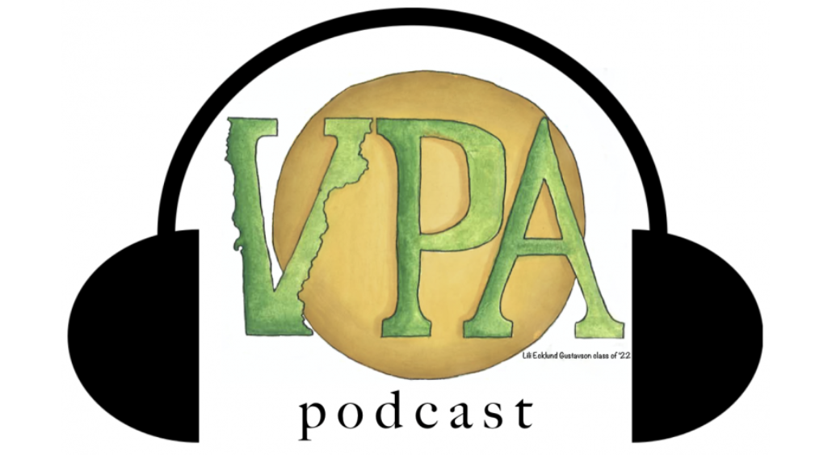
Mike McRaith (RF13) has helped launch a new VPA podcast! If you haven’t listened to it yet, be sure to check out his recent series on diversifying the educator workforce.

Courtesy Postings
Connecting the Dots, the VSA/VTCLA/VCSEA 2023 Spring Conference will be held on May 18-19 at Burlington’s Hilton lake Champlain. Do you have an idea for a great workshop to share with Vermont colleagues? Submit your long- or short-format session proposal here by February 17, 2023.

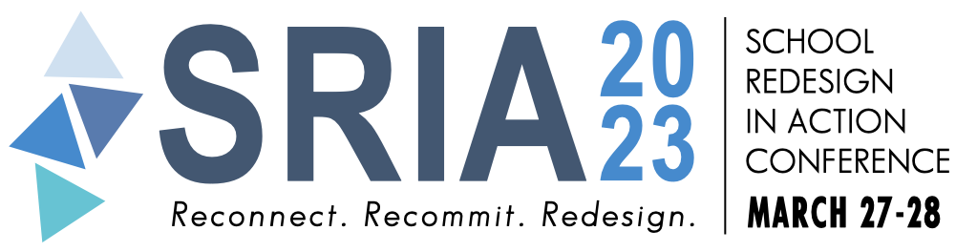
Registration is open! The School Redesign In Action Conference will take place in Newport, Rhode Island on March 27-28, 2023. Just contact our Great Schools Partnership (GSP) Senior Associates if you’d like to learn more: Emily Gilmore (RF17), Erica Wallstrom (RF14) & Jeanie Phillips (RF14)
Save the date for the Education for Social Justice Conference: Reimagining Schools, Connecting Communities sponsored by the Vermont Education Justice Coalition and led by Vermont educators of color in South Royalton on April 1st, 2023. Feel free to contact Nicole Awwad (RF21) if you’d like to learn more about this new conference!
If you missed our new Collaborative Practices for Equity course last fall, mark your calendars for the next time it will run with our 2023 Cohort and other Vermont educators: August 16-18, Sept. 25, and Nov. 10. Senior Associate Jeanie Phillips (RF14) will be teaching the course at Shelburne Farms again, sharing wonderful food and a beautiful setting each day. The course is co-sponsored by the Rowland Foundation, Great Schools Partnership, and Shelburne Farms. If you’d like to learn more about this amazing professional learning opportunity, feel free to contact Rowland Fellows from this year’s alumni: Anne Bergeron (RF11), Sam Bromley (RF22), Bryan Dickinson (RF22), Devon Karpak (RF22), Becky Ebel (RF22), Gretchen Muller (RF17), Samantha Mundt (RF21), Anja Pfeffer (RF21), Kat Robbins (RF21), Kerianne Severy (RF17) & Patti Tomashot (RF22).

