 | Letter to Fellows  January 2022
Dear Rowland Fellows,

I hope you’re staying healthy, keeping warm, and finding fun with your friends & family whenever you can.

This is a tough school year. Any teacher will tell you that it’s much harder than last year. Looking back, many of us would gladly trade our current exhaustion for the “COVID fatigue” we were talking about in the Summer of 2020. If we only knew then what lay ahead... Since then, health care workers and educators have faithfully sustained their communities through unbelievably arduous working conditions—mostly without the support they need from political figures and community members. When New Yorkers and others banged pots & pans from their windows to cheer on health care workers in the early days of the pandemic, it was moving. That said, I hope our society finds other ways to thank its unsung heroes as we come through this. We owe a debt of gratitude to our teachers who continue to show up every day to take care of kids and families, come what may.

On a personal note, Omicron crashed my family’s Christmas celebrations this year. Fortunately, we’re all fully vaccinated, but my mom has had some serious symptoms even though she’s “boosted.”

On a hopeful note, many experts are saying that Omicron may be a double-edged sword. Since it appears that the new variant offers excellent immunity against the previous one, that its symptoms tend to be milder (especially if you’re vaccinated and younger), and that it’s extremely contagious, it may actually get us to something like the elusive “herd immunity” faster than expected. So I’m choosing to be hopeful, and hanging onto the idea that we could be at a very different place later this spring.

I’ll also be hanging onto the following lessons from the pandemic. Children need vibrant, caring, in-person learning communities. We need to stop treating our essential workers like disposable workers. Democracy cannot survive in a post-fact-based society.

Thank you, Rowland Fellows, for your ongoing efforts to support the democratic mission of public school. Your hard work and leadership make all the difference.

Take care and see you soon,

Mike

P.S. Please send me your news! Each month, I’m sharing courtesy posts for upcoming courses & events, and also celebrating new jobs, family vacations, and other news from our extended Rowland Family of Fellows. So please email whatever you’d like to share to michael@therowlandfoundation.org

Rowland Foundation Updates
Last month, we received 11 Rowland Fellowship Applications for our 2022 cohort, which is a little lower than the number we receive most years. Unfortunately, we won’t be able to conduct interviews in our new Burlington offices as planned, but our video conference interviews will start next week to give our Board of Trustees the time to review finalists before selecting 2022 Rowland Fellows at their next meeting in February. It’s inspiring to see Vermont educators still putting forward serious school change proposals despite the current circumstances.

We also received two different team proposals from Rowland Fellows for our first year of Rowland Encore Grants. Our Board of Trustees will review these proposals in February with an eye to funding one of them this year. In addition, we’ve received three applications for Rowland Leadership Grants so far this school year with great ideas ranging from a Rowland Fellows podcast series, to a sustainable leadership book club, to popular music education. Our new Executive Director Mike Martin will be working directly with these Rowland Fellows to finalize plans and funding levels.

There will never be another Marge Malko! However, we’ve received an overwhelming response to our Rowland Foundation Administrative Assistant job posting—over 50 applications in under three weeks. This week, Mike conducted interviews of qualified candidates with lots of help from Senior Associate for Media & Technology Lori Lisai. We have a target date of Feb. 1st for the newly hired Rowland Foundation Administrative Assistant to start in this important role.

Gratitude
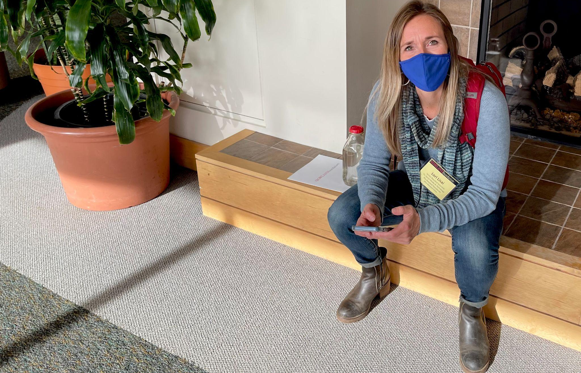
In her newly expanded role as Senior Associate for Media & Technology, Lori Lisai (RF15) has been working closely with Mike to build out the Rowland Foundation’s tech infrastructure in our new Google Workspace for Nonprofits domain, as well as trying out new social media strategies & tools. Lori is seen here (re)tweeting like crazy during the 11th Annual Rowland Conference.

This January, Lori has taken on additional responsibilities to help Mike with admin assistant hiring, new Fellows interviews, and some important mailings. We’re lucky to have Lori give back to the Rowland Foundation by chipping in at this important moment. Thank you, Lori, for jumping in and sharing your incredible skill set, collaborative spirit, and great sense of humor when they were most needed!

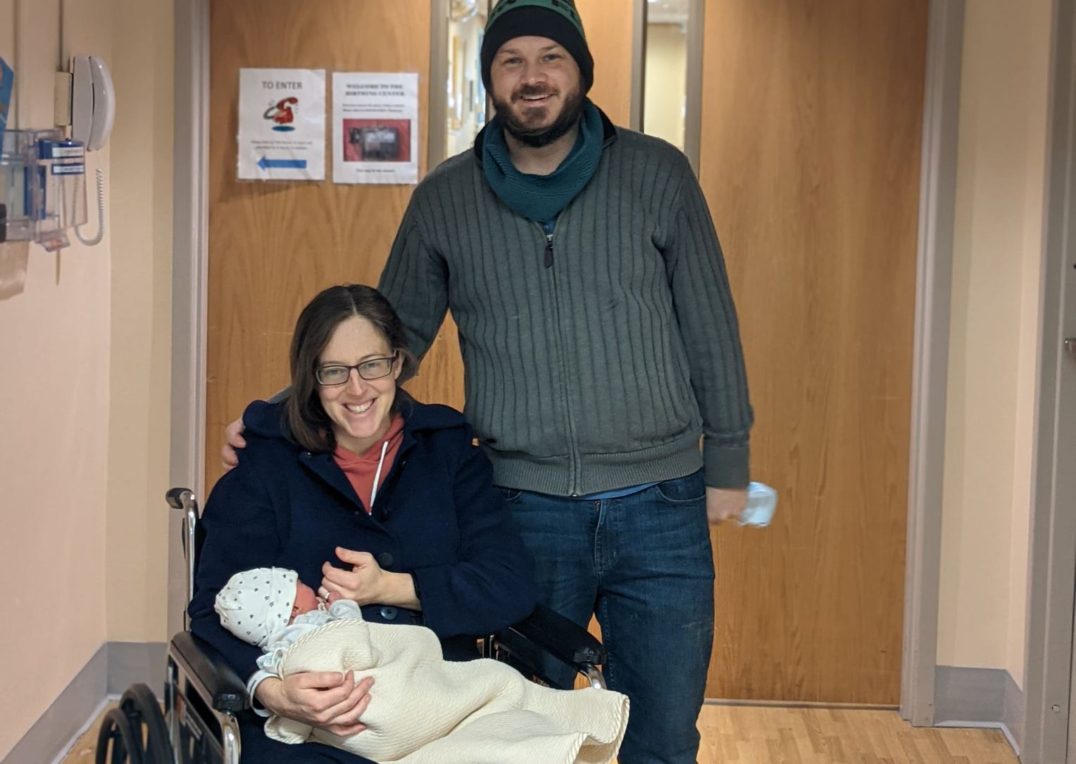
Heartfelt congratulations to Anne Watson (RF15) and her husband Zach Watson seen here with their brand-new baby Peter Watson at Copley Birthing Center.
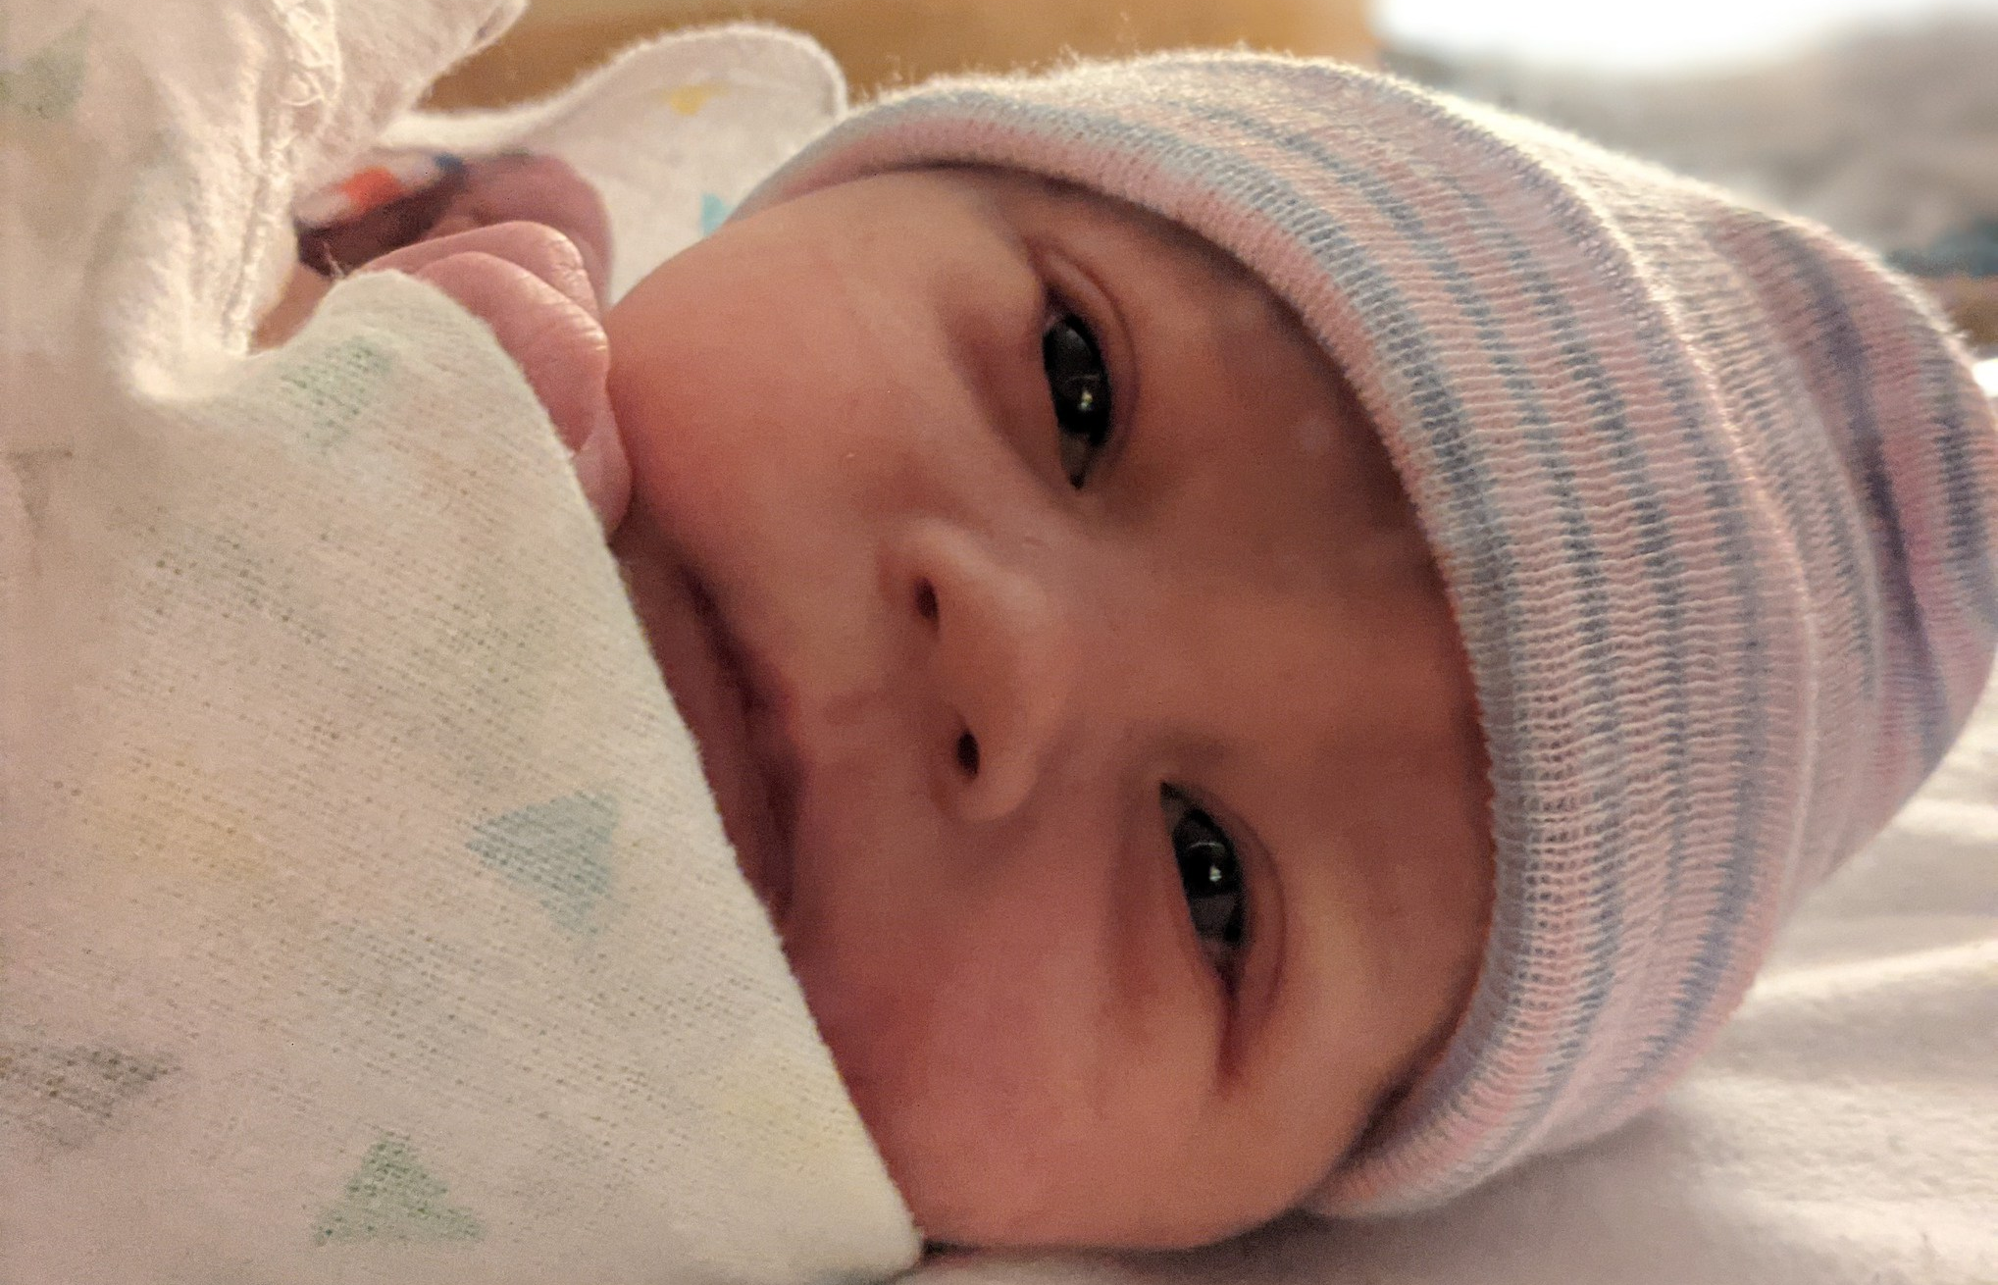
Peter Alexander Watson was born in Morrisville, VT on December 28th, 2021.

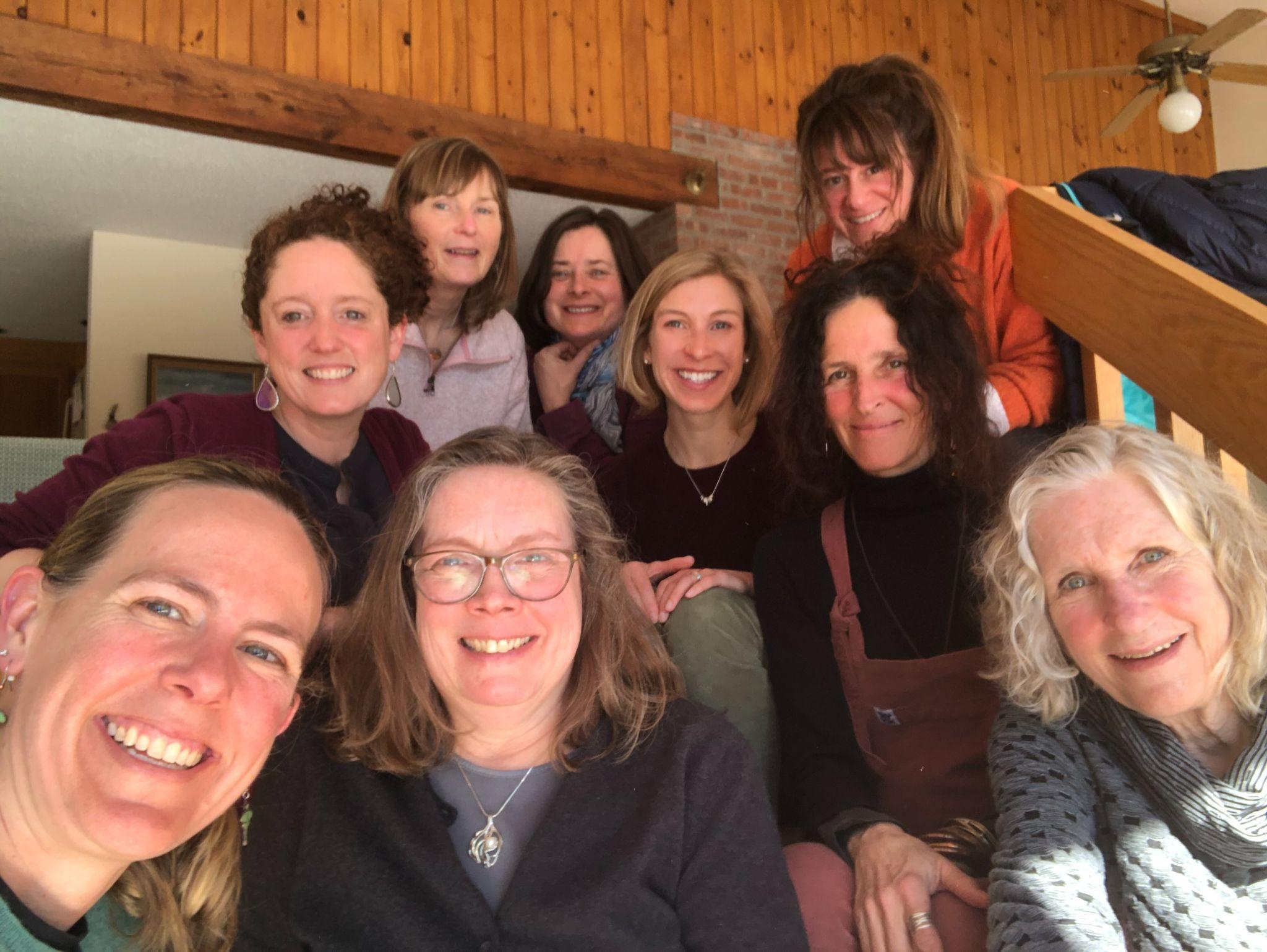Special thanks to Lauren Parren (RF12) for sharing this beautiful memory of a Weston Women gathering from March 2020 just before the lockdown. This group portrait of Vermont educational rock stars is a great reminder of the power of connecting and supporting each other in good times and bad. When we recently discussed future gatherings of Rowland Women with Kathy Cadwell (RF16), Lauren said, “Maybe spring will be a season of renewal…” Pictured here (clockwise from left front) Erica Wallstrom (RF14), Caitlin Steele (RF09), Ellen Berrings (RF13), Jeanie Phillips (RF14), Rachel Cohen (RF19), Jess DeCarolis (RF09), Anne Bergeron (RF11), Lauren Parren (RF12), Marsha Cassel (RF14)

Celebrations
Congratulations to Mary Schell (RF10) who is the new Community Schools Coordinator for the White River Valley Unified District. WRUD/WRVMS was recently awarded the Community Schools ACT 67 Grant. Check out the Community Schools Blue Print guiding this innovative work and partnerships between the school and community.

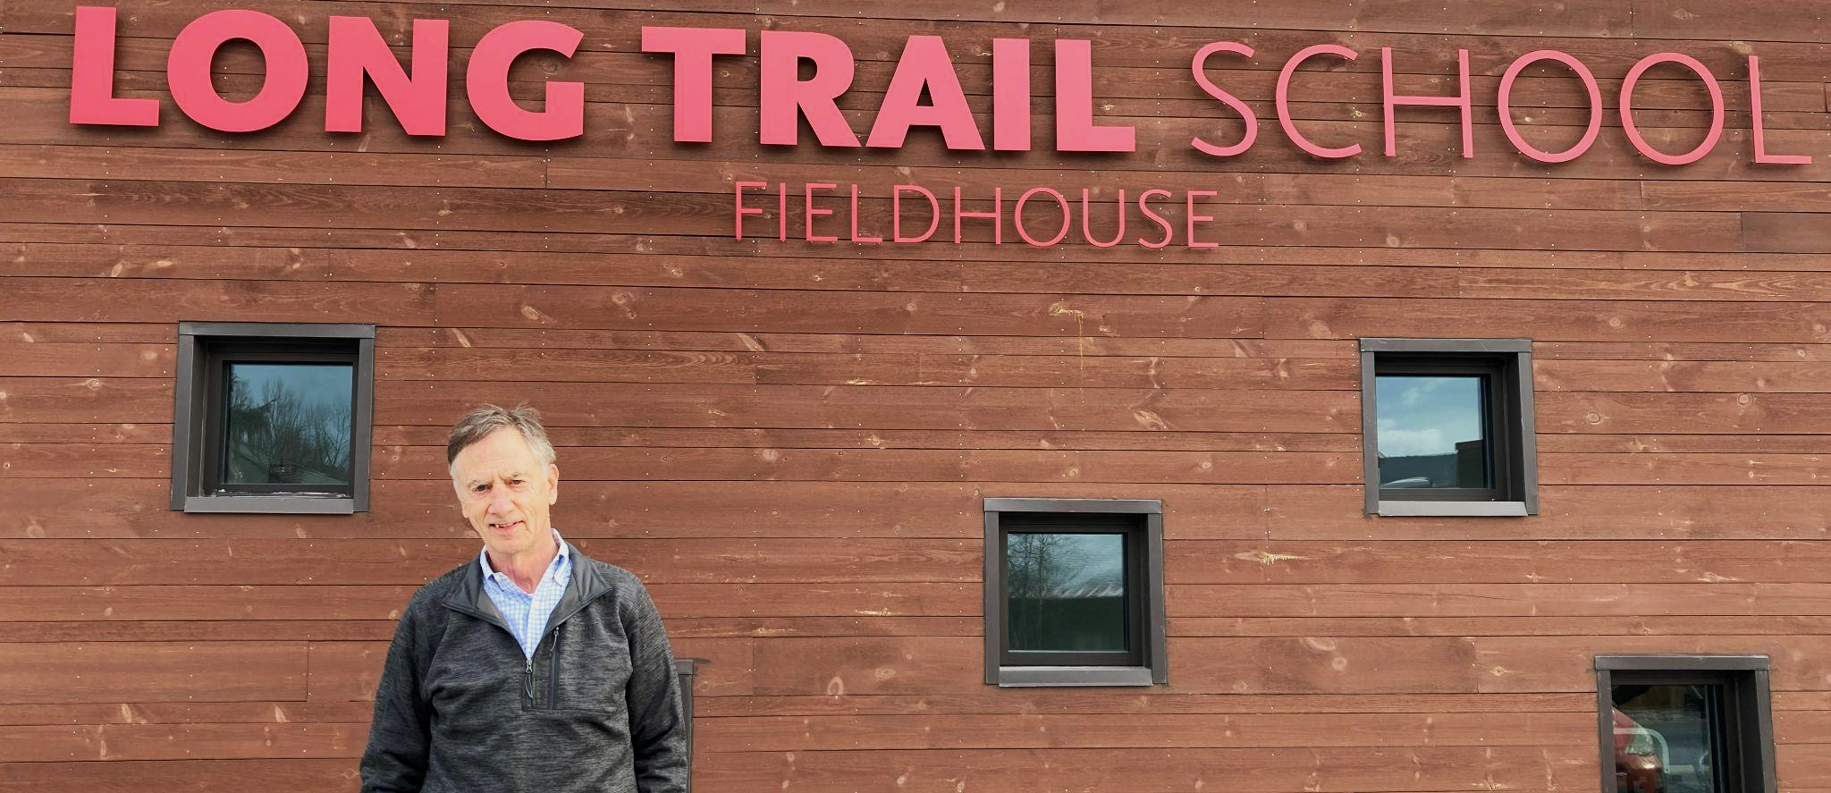
Congratulations to our Founder & Past Director Chuck Scranton on accepting a new position as Interim Head of the Long Trail School! Long Trail is fortunate to have Chuck's leadership in these trying times.

Courtesy Postings
This January 18-21, Peter Senge & Mette Boll will be offering a four-day virtual training called Introduction to Compassionate Systems Framework. To access the discounted rate we’ve obtained for Vermont educators, under “Tuition” on the registration form please select “Other” and write in “VT Group Rate $750”. You should repeat that information, and any other pertinent invoice information, on the “Any Special Invoice instructions?” line. If you have any questions or concerns, please contact Miho Kito at mkito@systemsawareness.org

Mike McRaith (RF13) shares the following for courtesy posts: the Vermont Principals' Association has several "no fee" learning events this winter that are open to all Vermont educators. Some of the topics include: Supporting Migrant Students, Leading Through Acute Stress Incidents, Drop-in for Aspiring School Leaders, Learning Sessions with Outright VT, and online courses (no fee) for the month of February: Beyond Bias and Burn Bright. View here for more information and registrations.

"A Climate Report Card for our Schools" will be the Underground Workshop's big collaborative reporting project for this spring, says Ben Heintz (RF20). Over the course of a semester, teams of students will collect data and interviews measuring their schools' progress toward sustainability in terms of 5 criteria: heat, electricity, transportation, food systems and curriculum. Tom Sabo (RF11) will serve as a teacher advisor, and student editors collect data from schools, organize reporting in a series of articles, and present VTDigger's readers with a statewide view of the issues, to be published in May and June. It's a great opportunity for students to collaborate across schools, with workshops offered along the way, it's structured to allow for different levels of involvement, and there's lots of support available, including a partnership with VEEP and with VTDigger's reporters available to support students' reporting. It's a great project for teachers to pursue with a class or for school environmental clubs to get involved with. Please get the word out by sharing this amazing opportunity with students here.

This summer Andrew Jones (RF15) is teaching Leading School Innovation, a 3-credit UVM graduate course that is specifically designed for teachers & administrators leading change in their schools (e.g., Rowland Fellows). If you’re interested in picking up some new change strategies with a colleague or two, this 2-week seminar may be just what you’re looking for this summer.

