 | Letter to Fellows  Joy  January 2023

Dear Rowland Fellows,

Happy New Year! I hope you found some quiet moments with friends & family during the hectic holiday season. Magali & I got to spend some time with our kids who came to stay with us, which was really wonderful…and already seems so long ago.

I’m looking forward to reading Unearthing Joy, Dr. Gholdy Muhammad’s next book which comes out on February 1st. If you attended last fall’s Rowland Conference, you’ll probably remember this slide from Gholdy’s keynote presentation:

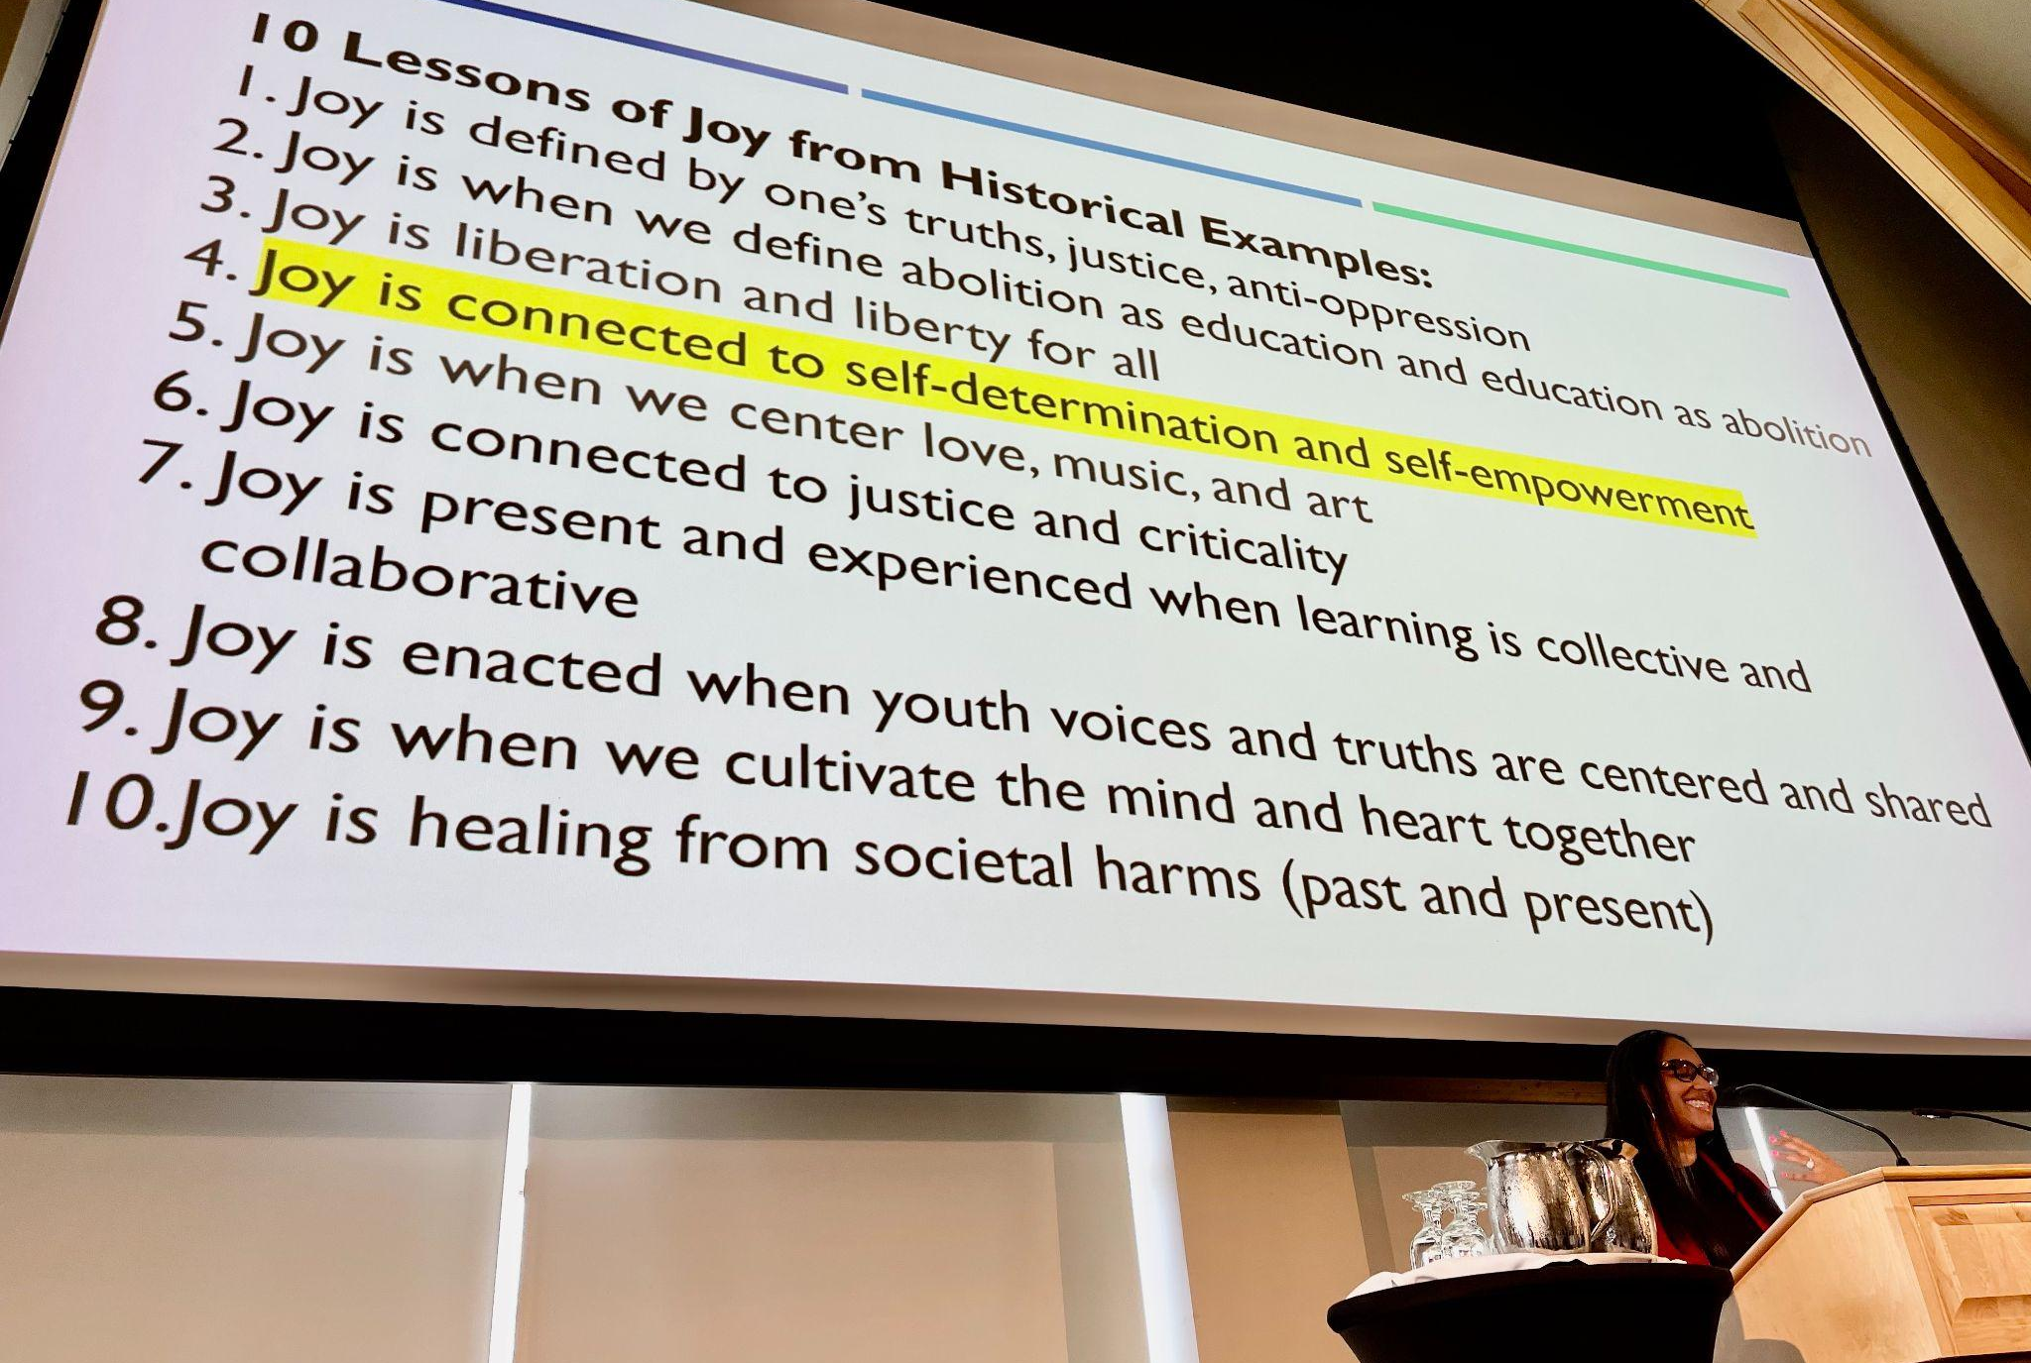

Obviously, there is a lot to think about when we examine Gholdy’s research findings about joy here, but to start, I’ll just point out that her ten lessons of joy overlap with—and also surpass—the deck-the-halls version of joy that prevails during the holidays. Nothing against ugly sweater contests, but Gholdy’s definition definitely goes a little deeper and broader than the Hallmark notion of joy we’re used to. Of course, it makes perfect sense that joy would flow from self-determination and self-empowerment, and that truth, justice, and liberty for all would be joyful, but how often do these things come to mind when we think of joy?

And come to think of it, isn’t it weird how we’ve stripped the J-word from all educational discourse? Apparently for many of us, joy is just too touchy-feely or too subjective for school. You can almost hear the haters asking how we would even assess it, right? Or demanding to know where joy would fit in the district’s strategic plan, right? Well, given the fact that the Rowland Foundation’s mission is to invest in Vermont teachers to positively change the culture & climate of school, I think that we might want to revisit joy as a driving force, and possibly even name it as a priority for schools, students, and teachers. Especially coming out of this pandemic, which, let’s be honest, sort of beat us up.

And for those who say that joy is too personal or too ethereal to be taken seriously in this context, I would just highlight Numbers 5-10 on Gholdy’s list above. I mean, imagine if we used those five as the criteria to evaluate our curriculum, our classroom walk-throughs, our teacher professional learning goals, or our school action plans… Wouldn’t you want to send your kid to a school that practiced those principles? Wouldn’t you want to teach there?

Looked at from this angle, we can see that joy is, in fact, something rigorous, hard to achieve, and obviously worth pursuing. This reminds me of our Rowland Board Retreat last May when Trustee Jim Mooney recommended we include “joy” or “joyfully” in our updated mission statement. Somewhat to my surprise, there was unanimous support for the idea. But when you stop and think about the generous, collaborative, creative, joyful vibe at nearly any gathering of Rowland Fellows, you can see how Jim’s great idea totally makes sense for the Rowland Foundation. In the end, our Board opted for mission wording that was succinct and direct, and so “joy” didn’t make the final cut. Nevertheless, I’m determined to look for ways to highlight joy in our Rowland work, and then act accordingly. For example, take a moment to apply Gholdy’s Numbers 5-10 to Rowland gatherings and Fellowship work now—I think it still works! Following our Rowland Foundation Board of Trustees’ discussion of joy, Senior Associate Lori Lisai (RF15) shared this terrific insight, “Wow, that would be awesome…and a really high standard for us to live up to.” Wiser words were never spoken.

Around Christmas time, a dear friend and colleague gave me wonderful present, namely, a book of essays entitled Inciting Joy by the poet Ross Gay, where he writes,

What if joy and pain are fundamentally tangled up with one another? Or even more to the point, what if joy is not only entangled with pain, or suffering, or sorrow, but is also what emerges from how we care for each other through those things? What if joy, instead of refuge or relief from heartbreak, is what effloresces from us as we help each other carry our heartbreak?

I love this quote. Nothing against Marie Kondō, but this Ross Gay version of joy seems to be a more three-dimensional, deeper, darker way to understand it. And perhaps most importantly, this way of thinking about joy leads us to reflect not just on the inevitability of suffering, but also to think about our interdependence. Joy is not for solo acts, only ensembles.

Along the same lines, in The Book of Joy by His Holiness the 14th Dalai Lama & the Archbishop Desmond Tutu, the two spiritual leaders agree that joy comes from being generous with others. The Archbishop explains,

The Dead Sea in the Middle East receives fresh water, but it has no outlet, so it doesn't pass the water out. It receives beautiful water from the rivers, and the water goes dank. I mean, it just goes bad. And that's why it is the Dead Sea. It receives and does not give. In the end generosity is the best way of becoming more, more, and more joyful.

I recommend The Book of Joy. Its discussion of human relationships, culture, spirituality, and freedom struggles by the Dalai Lama and Desmond Tutu is remarkable. Even more unique than their dialectic, however, is the love and admiration these two monumental figures clearly have for each other, even as they crack each other up and tease each other mischievously, joyfully. If you think I’m exaggerating, check out this three-minute trailer from the companion film Mission Joy: Finding Happiness in Troubled Times. When I recently attended a screening of the film, it made me laugh out loud and even cry a little (which I tried to do as discreetly as possible in the darkened theater). You can also learn more at the Mission Joy website, which includes information about the science of happiness.

Will “joy” be the word of the year in 2023? Nothing against “metaverse”, but I hope joy wins. Joy sure seems to be getting a lot of attention these days, including in this article from The Guardian about how to make spreading joy a weekly practice. Once again, the author emphasizes the idea that we rely on others to find joy, and usually by sharing some. I know, the idea that altruism makes us happy–or that it is by giving that we receive–is not a new idea. More of an old chestnut, truth be told. Just the same, in this age seemingly dominated by egotism, narcissism, greed, and loneliness, it couldn’t hurt to go back to basics.

I wish you & yours a joyful new year.

Take care and see you soon,

Mike

P.S. If you want to start spreading joy right away without doing any research…
1) Find a friend or family member to dance with.
2) Play Marvin Gaye’s Got to Give it Up really loud on your speakers.
3) Move your body.
4) Share as many new dance moves as you can.

P.P.S. I send this letter out to all Rowland Fellows & Trustees every first Friday of the month. Please send me your news, photos, courtesy postings, and anything else you would like to share with our vibrant Rowland network of Fellows.

Rowland Foundation Updates

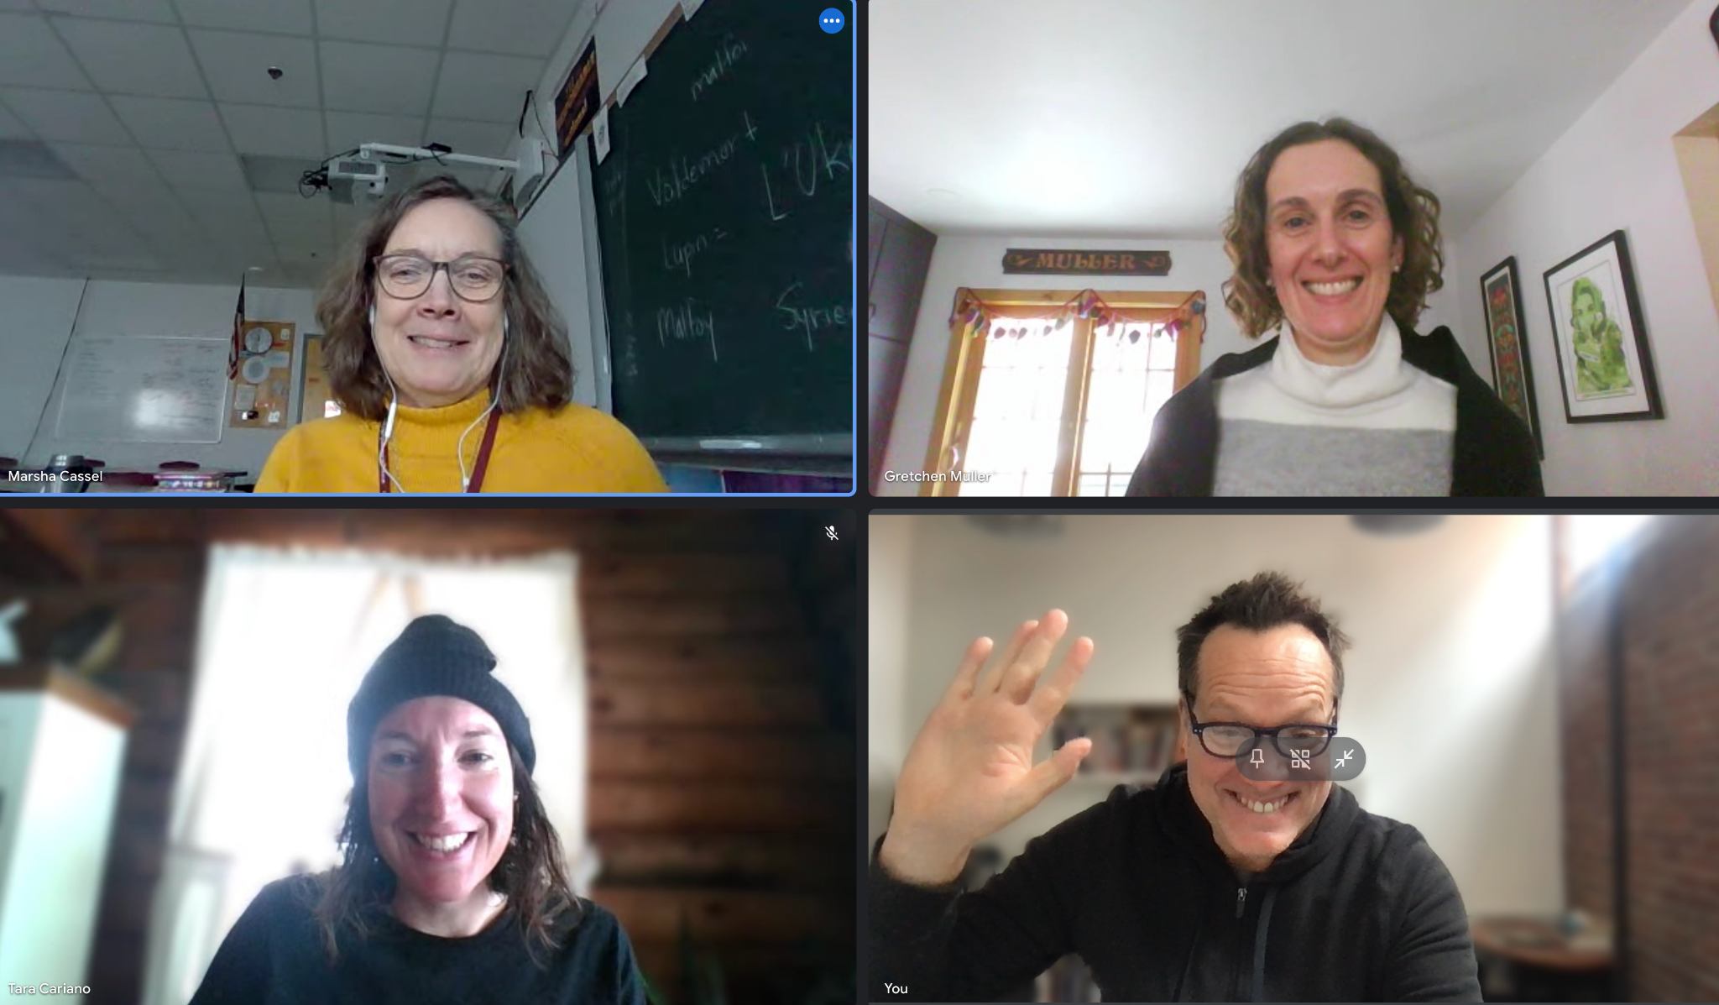
The Rowland Women Leadership Retreat
Congratulations to Marsha Cassel (RF14), Gretchen Muller (RF17), and Tara Cariano (RF18), who have begun work to plan and coordinate the 2023 Rowland Women Leadership Retreat! The Rowland Women Leadership Retreat is now an annual event, funded by our operating budget and organized by a Planning Team of Rowland Women each year. They have been consulting with Executive Director Mike Martin and are looking to hold this year’s retreat in late May 2023.

New Fellows Interviews
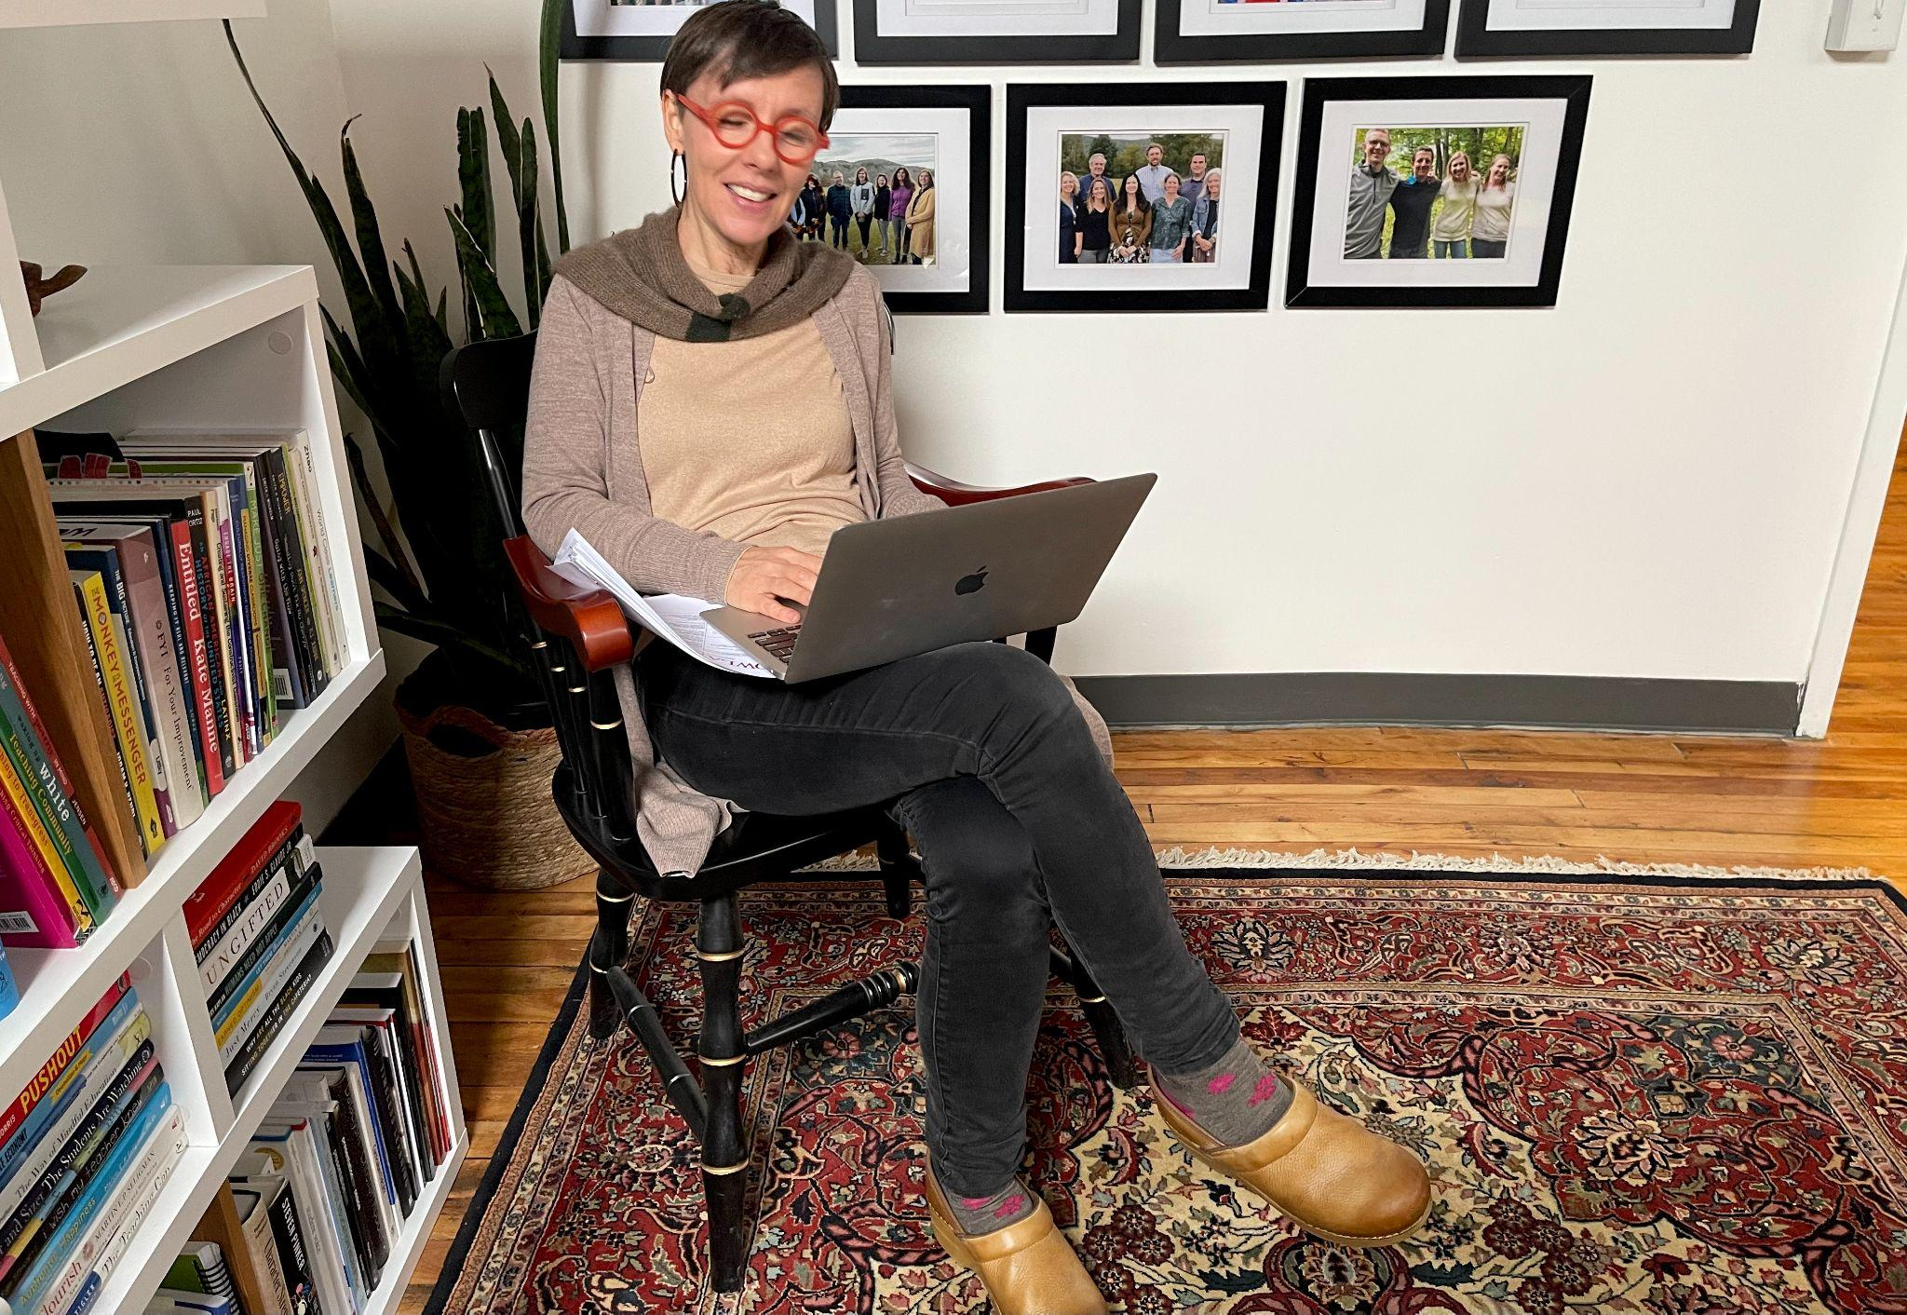
Executive Admin Assistant Abby Paige (seen here) has been assisting Mike with new Fellows interviews! This year is the first time we’ve had in-person interviews with candidates in the Rowland Foundation office since before the pandemic. To improve access, Fellowship candidates also have the opportunity to choose to interview by video-conference. Mike will be checking candidate references next week and sending finalist proposals on to the Board of Trustees for them to select the 2023 Cohort at their February meeting. Stay tuned for the annual new Fellows announcement at the end of next month.

Our new Diversifying the Educator Workforce (DEW) Grant launched this week and we are now accepting applications from aspiring educators of color in Vermont. This grant is intended to remove barriers to licensure, including costs associated with licensure (e.g., certification program fees, tuition, PRAXIS exam prep & fees) and builds on regional and statewide work led by Jess DeCarolis (RF09), Caitlin Steele (RF09), and Marsha Cassel (RF14). Executive Director Mike Martin has been meeting with community leaders, educators, and aspiring educators of color over the past months. Stay tuned for updates and feel free to connect Mike with aspiring educators of color you know in Vermont! You can find the application for the Rowland DEW Grant here.

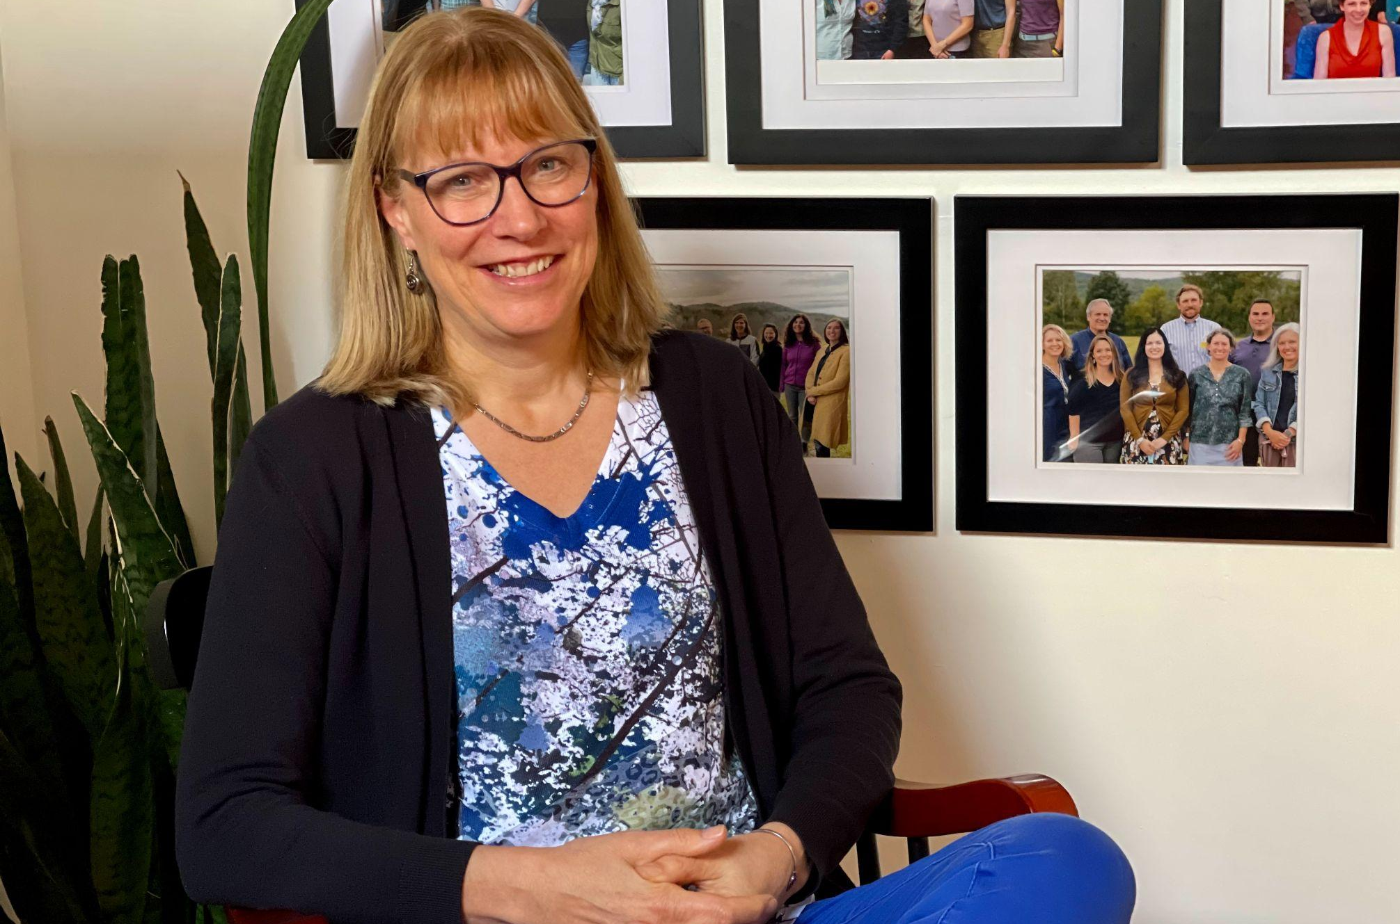
Sandra Mings-Lamar (RF17) seen here visiting the Rowland Offices in Burlington this month. Among other topics, Sandra offered to help Mike find a site for a Rowland Foundation NEK recruiting event in November 2023.

Gratitude
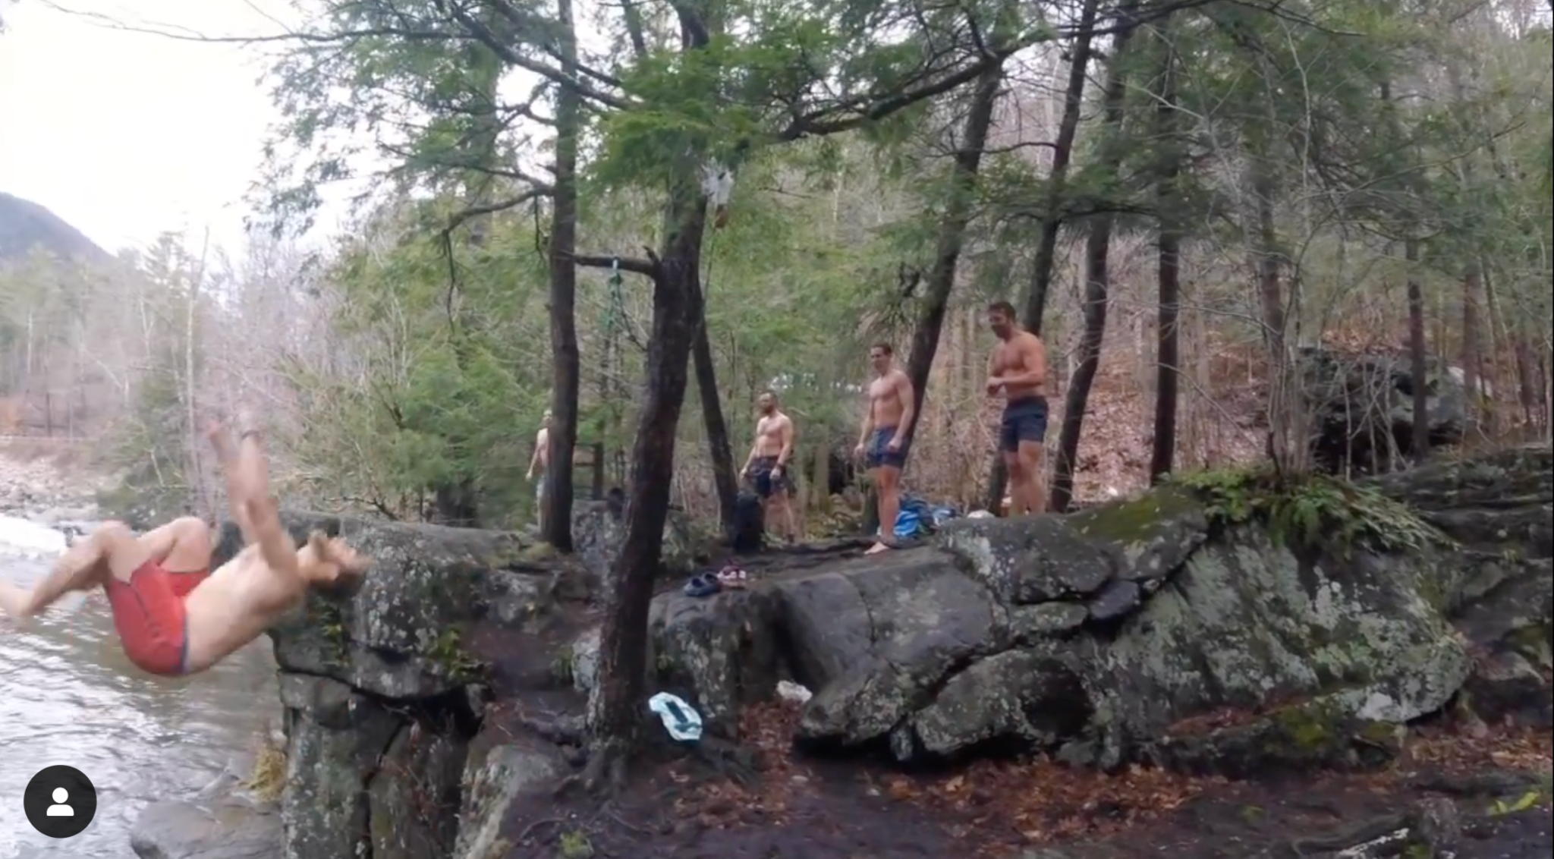
John Painter (RF14), seen here at Bartlett’s Falls in Bristol, has been doing a monthly cold water plunge with friends and his son, Lincoln. You can see them in action in this joyful video.

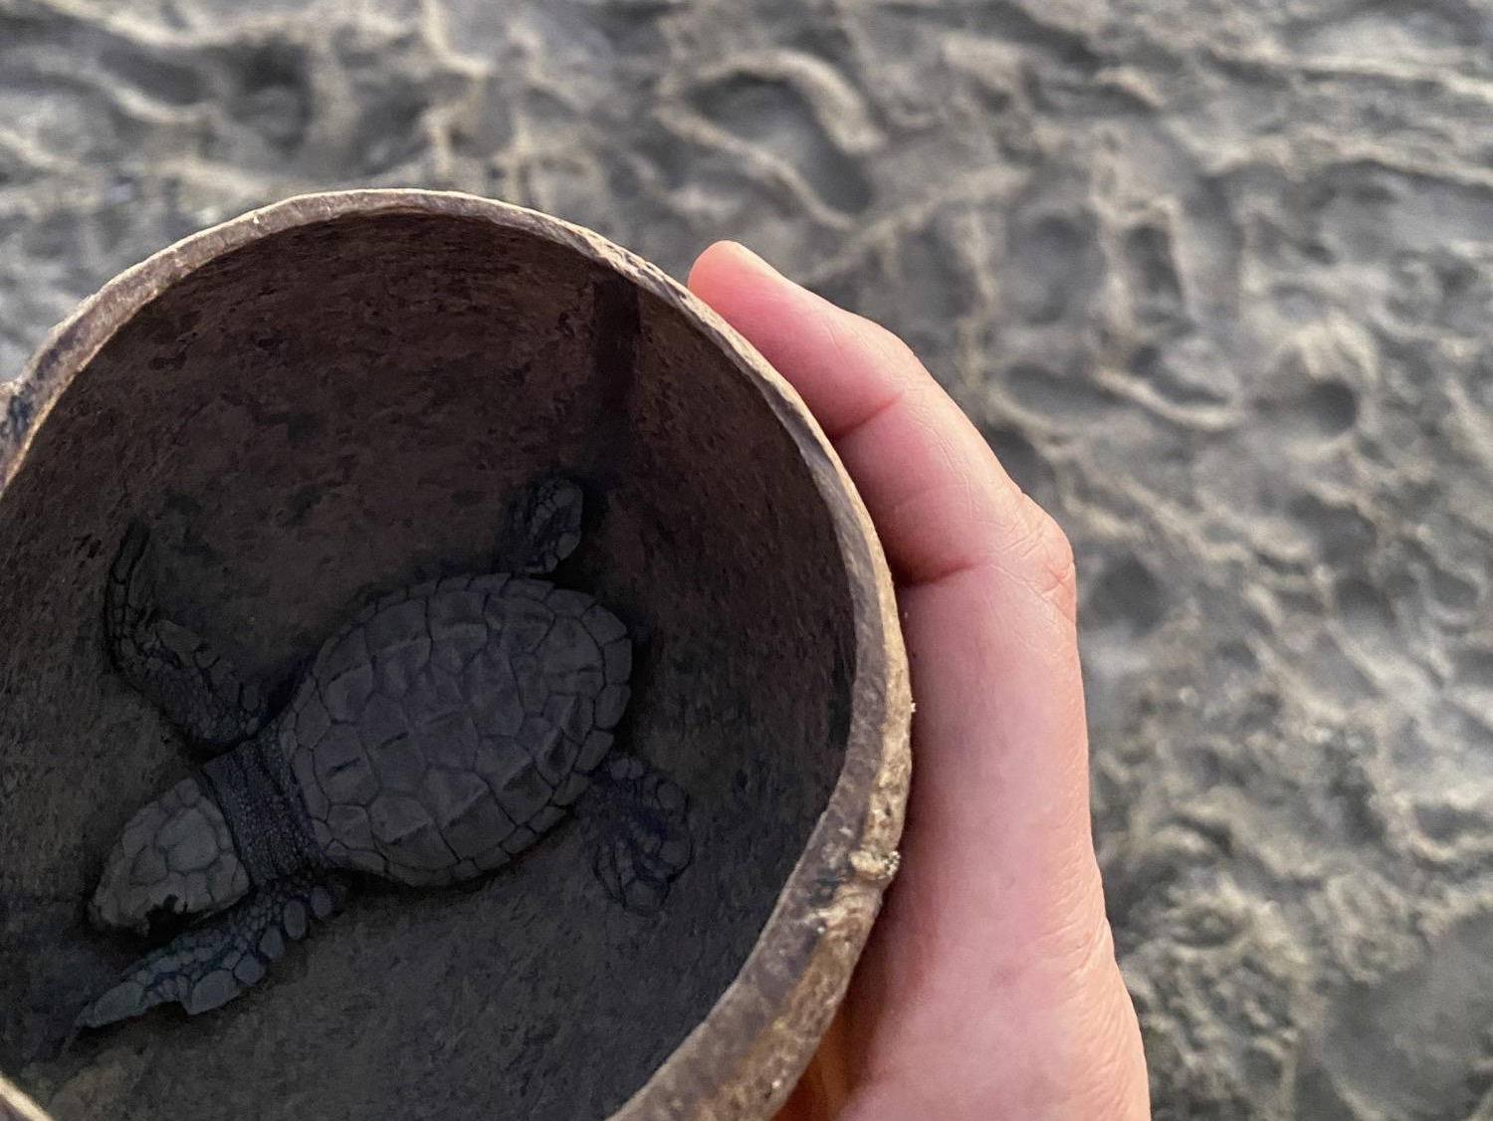
On a recent vacation to Mexico, Sandra Mings-Lamar’s (RF17) family volunteered at a turtle sanctuary where they rescue baby sea turtles. Sandra and her family helped release the baby turtles back into the ocean. #joy

Celebrations
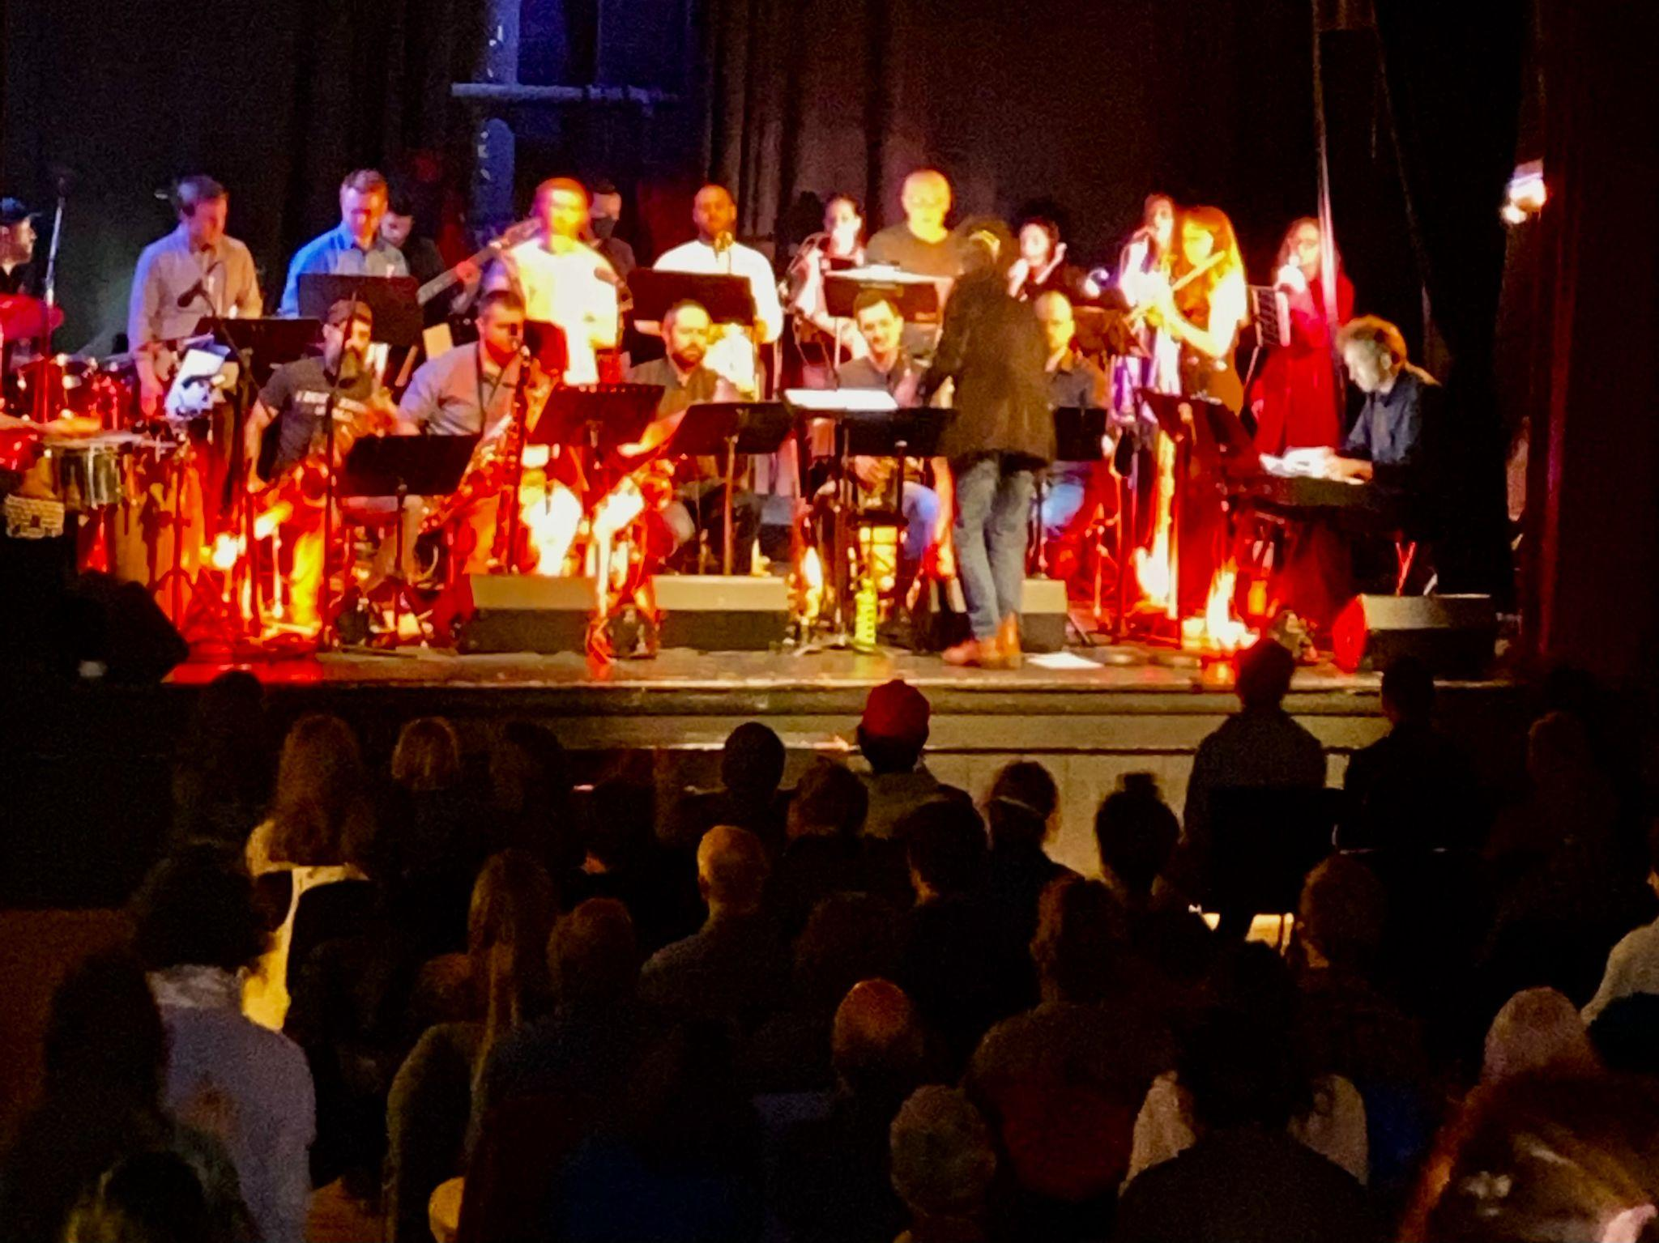
Brian Boyes (RF14), seen here joyfully leading the Saturn People’s Sound Collective at Goddard College’s Haybarn Theatre, has just released a critically acclaimed album with this 22-piece band. The album features Brian’s original music and arrangements, and was listed by The Rutland Herald/Times Argus as one of the best Vermont albums of 2022. Resonating at the intersection of post-rock and jazz, the album is streaming on all platforms and is accompanied by several high quality videos from the live studio recording. You can find an excellent review of the album here (Thanks, Marsha!).
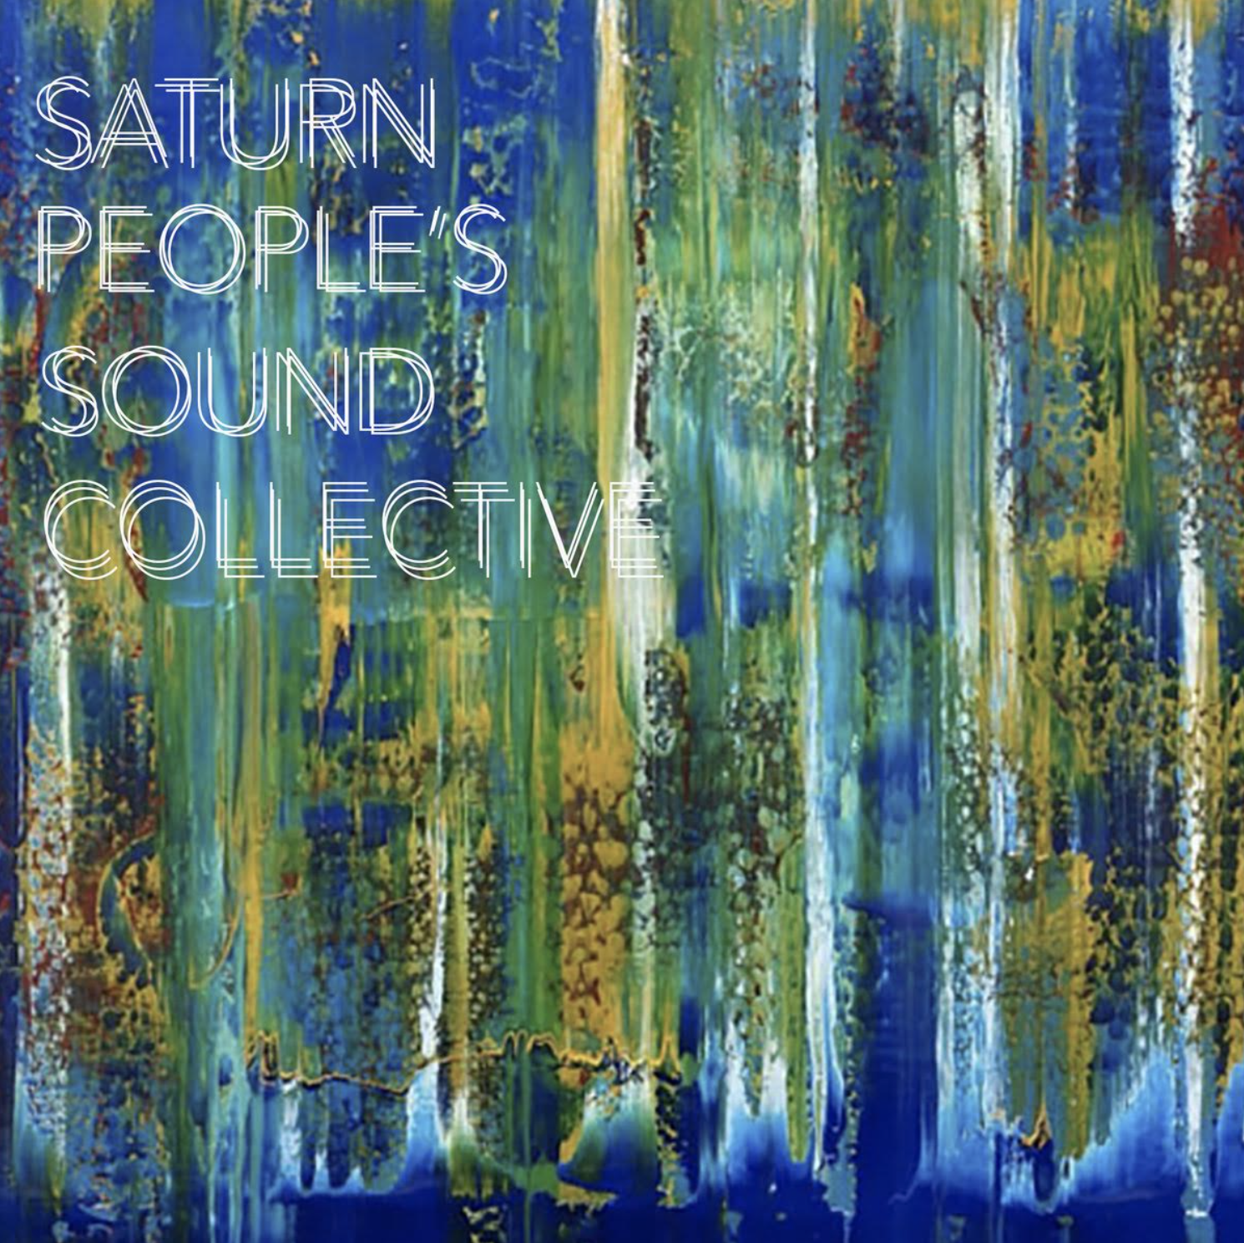

Courtesy Postings
If you missed our new Collaborative Practices for Equity course last fall, mark your calendars for the next time it will run with our 2023 Cohort and other Vermont educators: August 16-18, Sept. 25, and Nov. 10. Senior Associate Jeanie Phillips (RF14) will be teaching the course at Shelburne Farms again, sharing wonderful food and a beautiful setting each day. The course is co-sponsored by the Rowland Foundation, Great Schools Partnership, and Shelburne Farms. If you’d like to learn more about this amazing professional learning opportunity, feel free to contact Rowland Fellows from this year’s alumni: Anne Bergeron (RF11), Sam Bromley (RF22), Bryan Dickinson (RF22), Devon Karpak (RF22), Becky Ebel (RF22), Gretchen Muller (RF17), Samantha Mundt (RF21), Anja Pfeffer (RF21), Kat Robbins (RF21), Kerianne Severy (RF17) & Patti Tomashot (RF22)
Save the date for the Education for Social Justice Conference: Reimagining Schools, Connecting Communities sponsored by the Vermont Education Justice Coalition and led by Vermont educators of color in South Royalton on April 1st, 2023. Feel free to contact Nicole Awwad (RF21) if you’d like to learn more about this new conference!
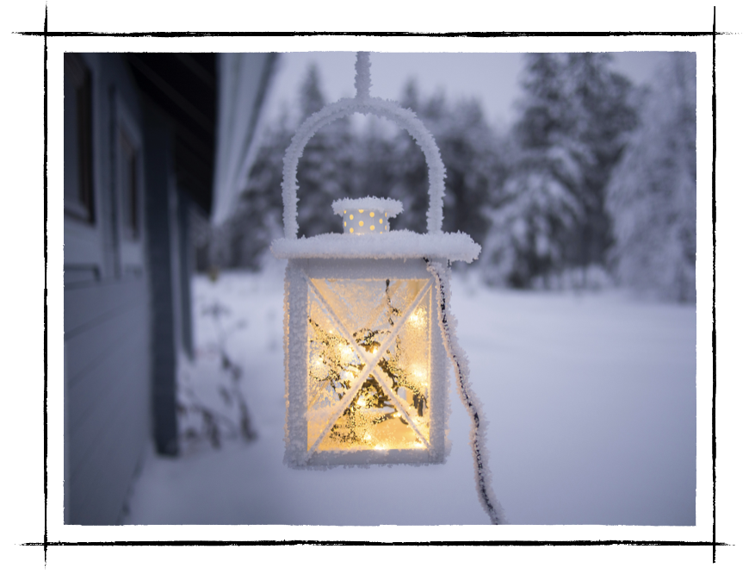
Mike McRaith (RF13) is passing along here the VPA's recent Winter Update on Professional Learning & Support Offerings. Many of the options are open to all educators and their communities.

Jill Prado (RF12) shares this update from the Global Leadership Program (GLP) that she leads at Essex High School. Jill’s Rowland Fellowship work led to the creation of GLP.

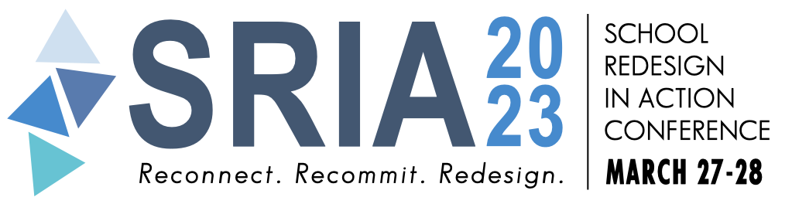
Save the date! The School Redesign In Action Conference will take place in Newport, Rhode Island on March 27-28, 2023. Just contact our Great Schools Partnership (GSP) Senior Associates if you’d like to learn more: Emily Gilmore (RF17), Erica Wallstrom (RF14) & Jeanie Phillips (RF14)

