 | Letter to Fellows  July 2021
Dear Rowland Fellows,

I hope this message finds you & your loved ones doing well. When I was a classroom teacher, I remember July being my favorite month, when I could feel the weight of the school year leaving my body and the space of summer opening up before me. I wish you that feeling right now, in this weird moment between the pandemic and the After Times.

I just rewatched Chuck’s TEDx talk That Immovable Mountain, and found it more relevant than ever. “How can we foster creativity in students when we who are running the schools are so risk-averse?” Chuck asks us. In this moment of Educational Recovery, unfortunately, I think there is a failure of imagination. In the past few months, I’ve been disappointed to see a sort of scramble back to the status quo in schools instead of seizing the opportunity to do school differently. Instead of critically examining the industrial model that’s still with us, there seems to be a rush to remediate through extended school day and extended school year models, without rethinking how we should be spending all that time with students. And of course there’s still too little thought of how we pathologize students by constantly labeling and sorting them for various interventions.

“The real reason we don’t change is because of fear,” Chuck says in his TED talk, which I think helps us understand the current inertia in schools. After the year we’ve just been through, and the recent attacks on our democracy, it’s easy to understand why we educators would just want some peace and stability. However, if our only pandemic takeaways are zoom proficiency and a little more SEL, then we will have missed the mark.

This is where you come in, my fellow Fellows. This summer, I think we need to rejuvenate in the etymological sense of the word—that we try to become young again. Only by stepping away from our screens, our jargon, and our inboxes can we truly refresh our thinking and reset our creativity. And this fall, schools will need our courageous innovation more than ever. So here’s a radical idea: let’s try to not think about school (at least as we know it) this summer. Instead, let’s simply try to remain open—to our loved ones, to new ideas, to the beauty all around us—in order to come back fresh in the fall.

See you soon,

Mike

P.S. I’m trying out a new monthly newsletter here to help keep us all connected, so please send me your news! Each month, I’ll be bundling courtesy posts for courses & events, and also celebrating new jobs, family vacations, and other news from our extended Rowland Family of Fellows. So please email whatever you’d like to share to rowland.foundation@gmail.com

Rowland Foundation Updates
Pre-registration for the 10th Annual Rowland Conference filled up quickly! #RFC21 will take place at the University of Vermont’s Davis Center on October 27th. Registration will open in September, at which time team members will be able to select workshops. We are excited about our conference theme of Teaching Love & Learning Freedom: Practicing Community in the Classroom with keynote Dr. Carla Shalaby. Carla is the author of Troublemakers, which is a book that will change the way you think about school.

Mark your calendars for this year’s All Fellows Retreat which will be at the Hilton Burlington on October 26th, followed by our traditional All Fellows Social at the Farmhouse immediately afterwards. In addition to the usual RF cohort cross-pollination, this year’s edition will explore ideas for Rowland Encore grant proposals. Stay tuned for more details in the months to come.

The new offices for the Rowland Foundation are at 47 Maple Street, Suite 200 in Burlington. We’re still getting moved in but you can get a sneak preview of our new space here.

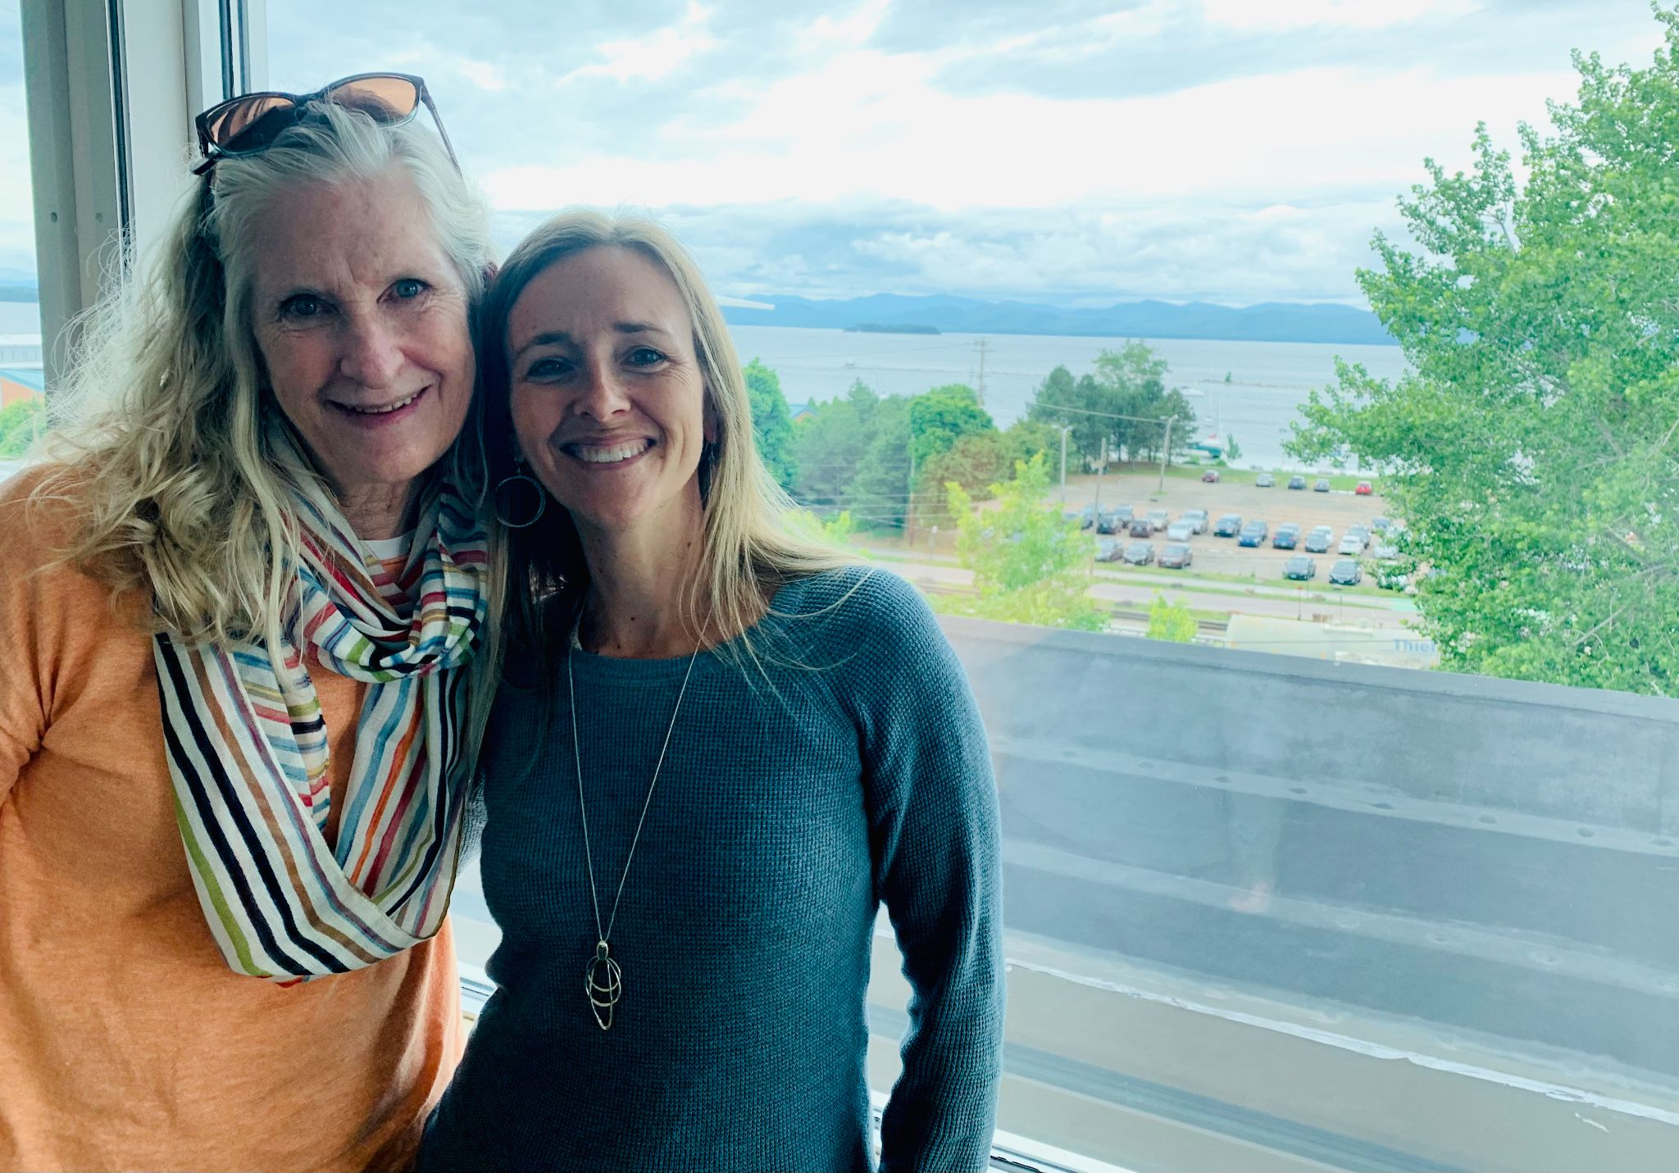
Lauren Parren (RF12) & Lori Lisai (RF15) met at the new Rowland Foundation offices in Burlington with Mike Martin (RF09) for transition work with Lori serving as the new Rowland Associate for Social Media & Technology. Deepest gratitude to Lauren for her dedicated work in this role, and to Jason Finley (RF09) for his work before her!

Due to the pandemic, this year we will be celebrating our 2020 and 2021 Fellows at a special annual dinner at the Reluctant Panther on September 18th. When you next see them, be sure to congratulate these amazing educators who led their school change projects during the crisis! The Annual Dinner will return to its usual time next May when we welcome aboard our 2022 Cohort of Rowland Fellows.

Gratitude
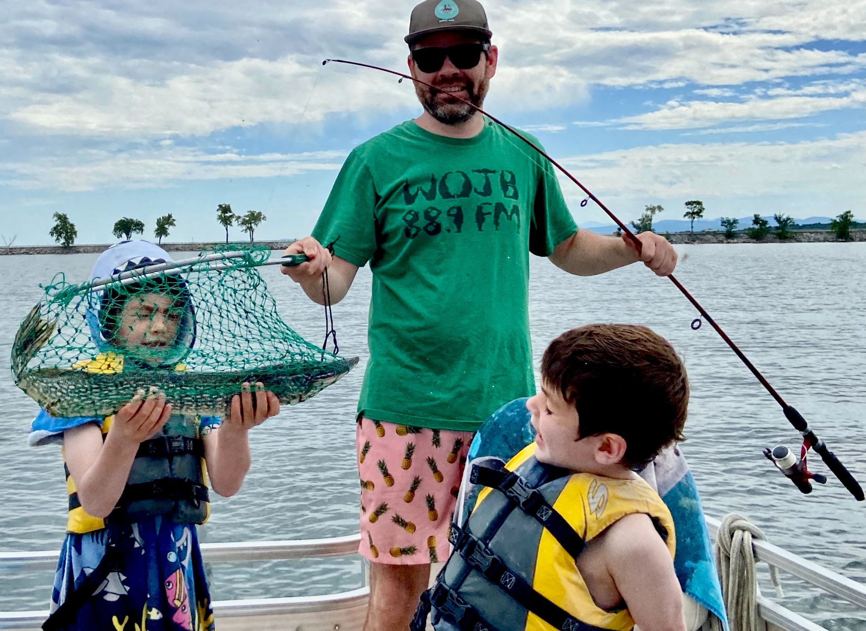
Mike McRaith (RF13) reeled in some hefty Lake Champlain pickerel this summer with sons Theodore & Freddy.

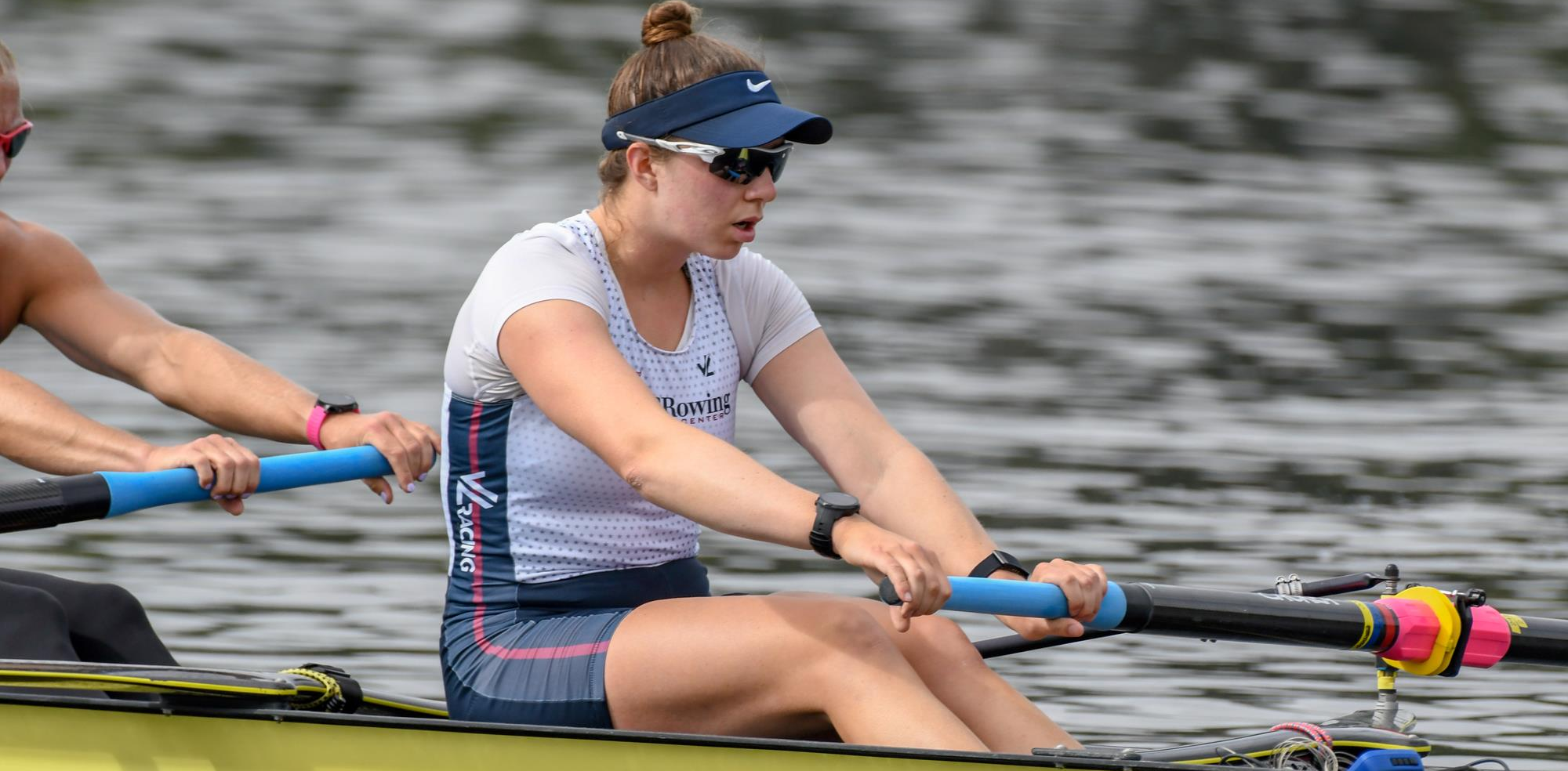
Jim & Tamra Mooney’s daughter Brooke has made the U.S. Olympic Rowing Team. Congratulations, Brooke!

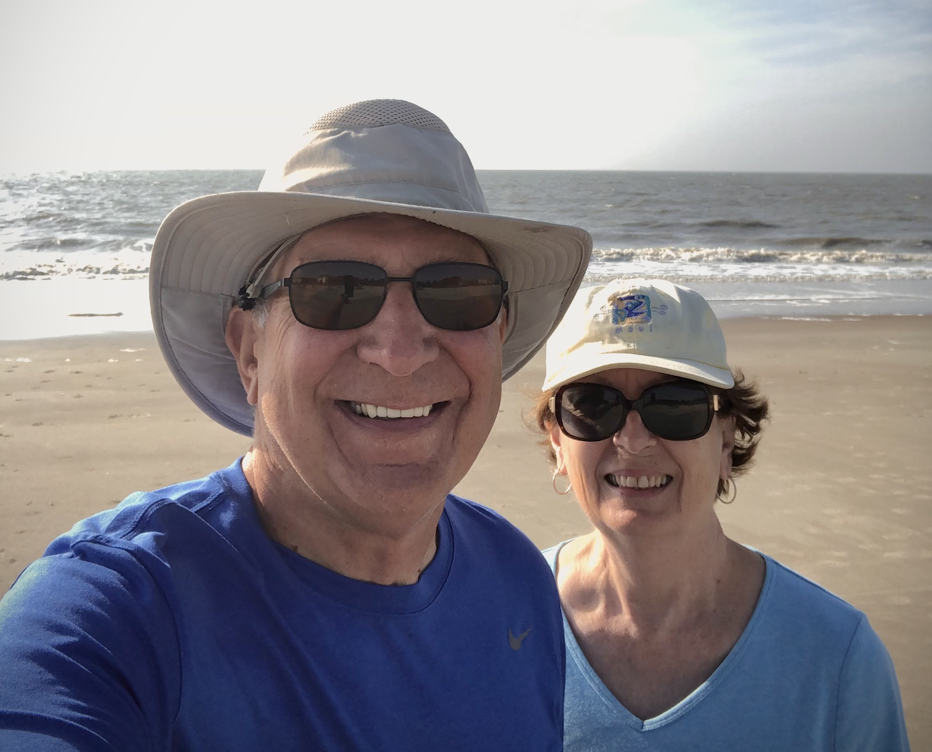
Marge & Rich Malko, seen here at Hilton Head Island, have been enjoying their life at the beach.

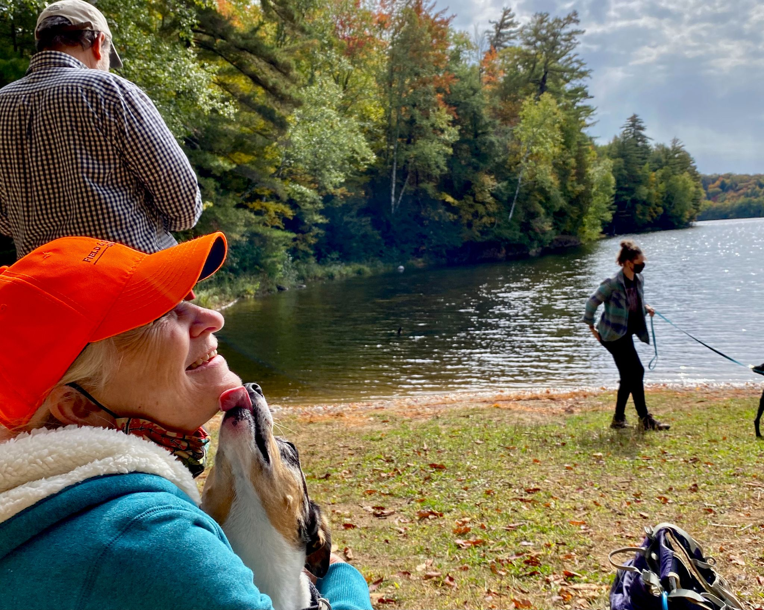
Lauren Parren (RF12) celebrated silver linings at Silver Lake with husband Steve and daughters Molly & Nora. Seen here having her face cleaned by Nora’s dog Zazie.

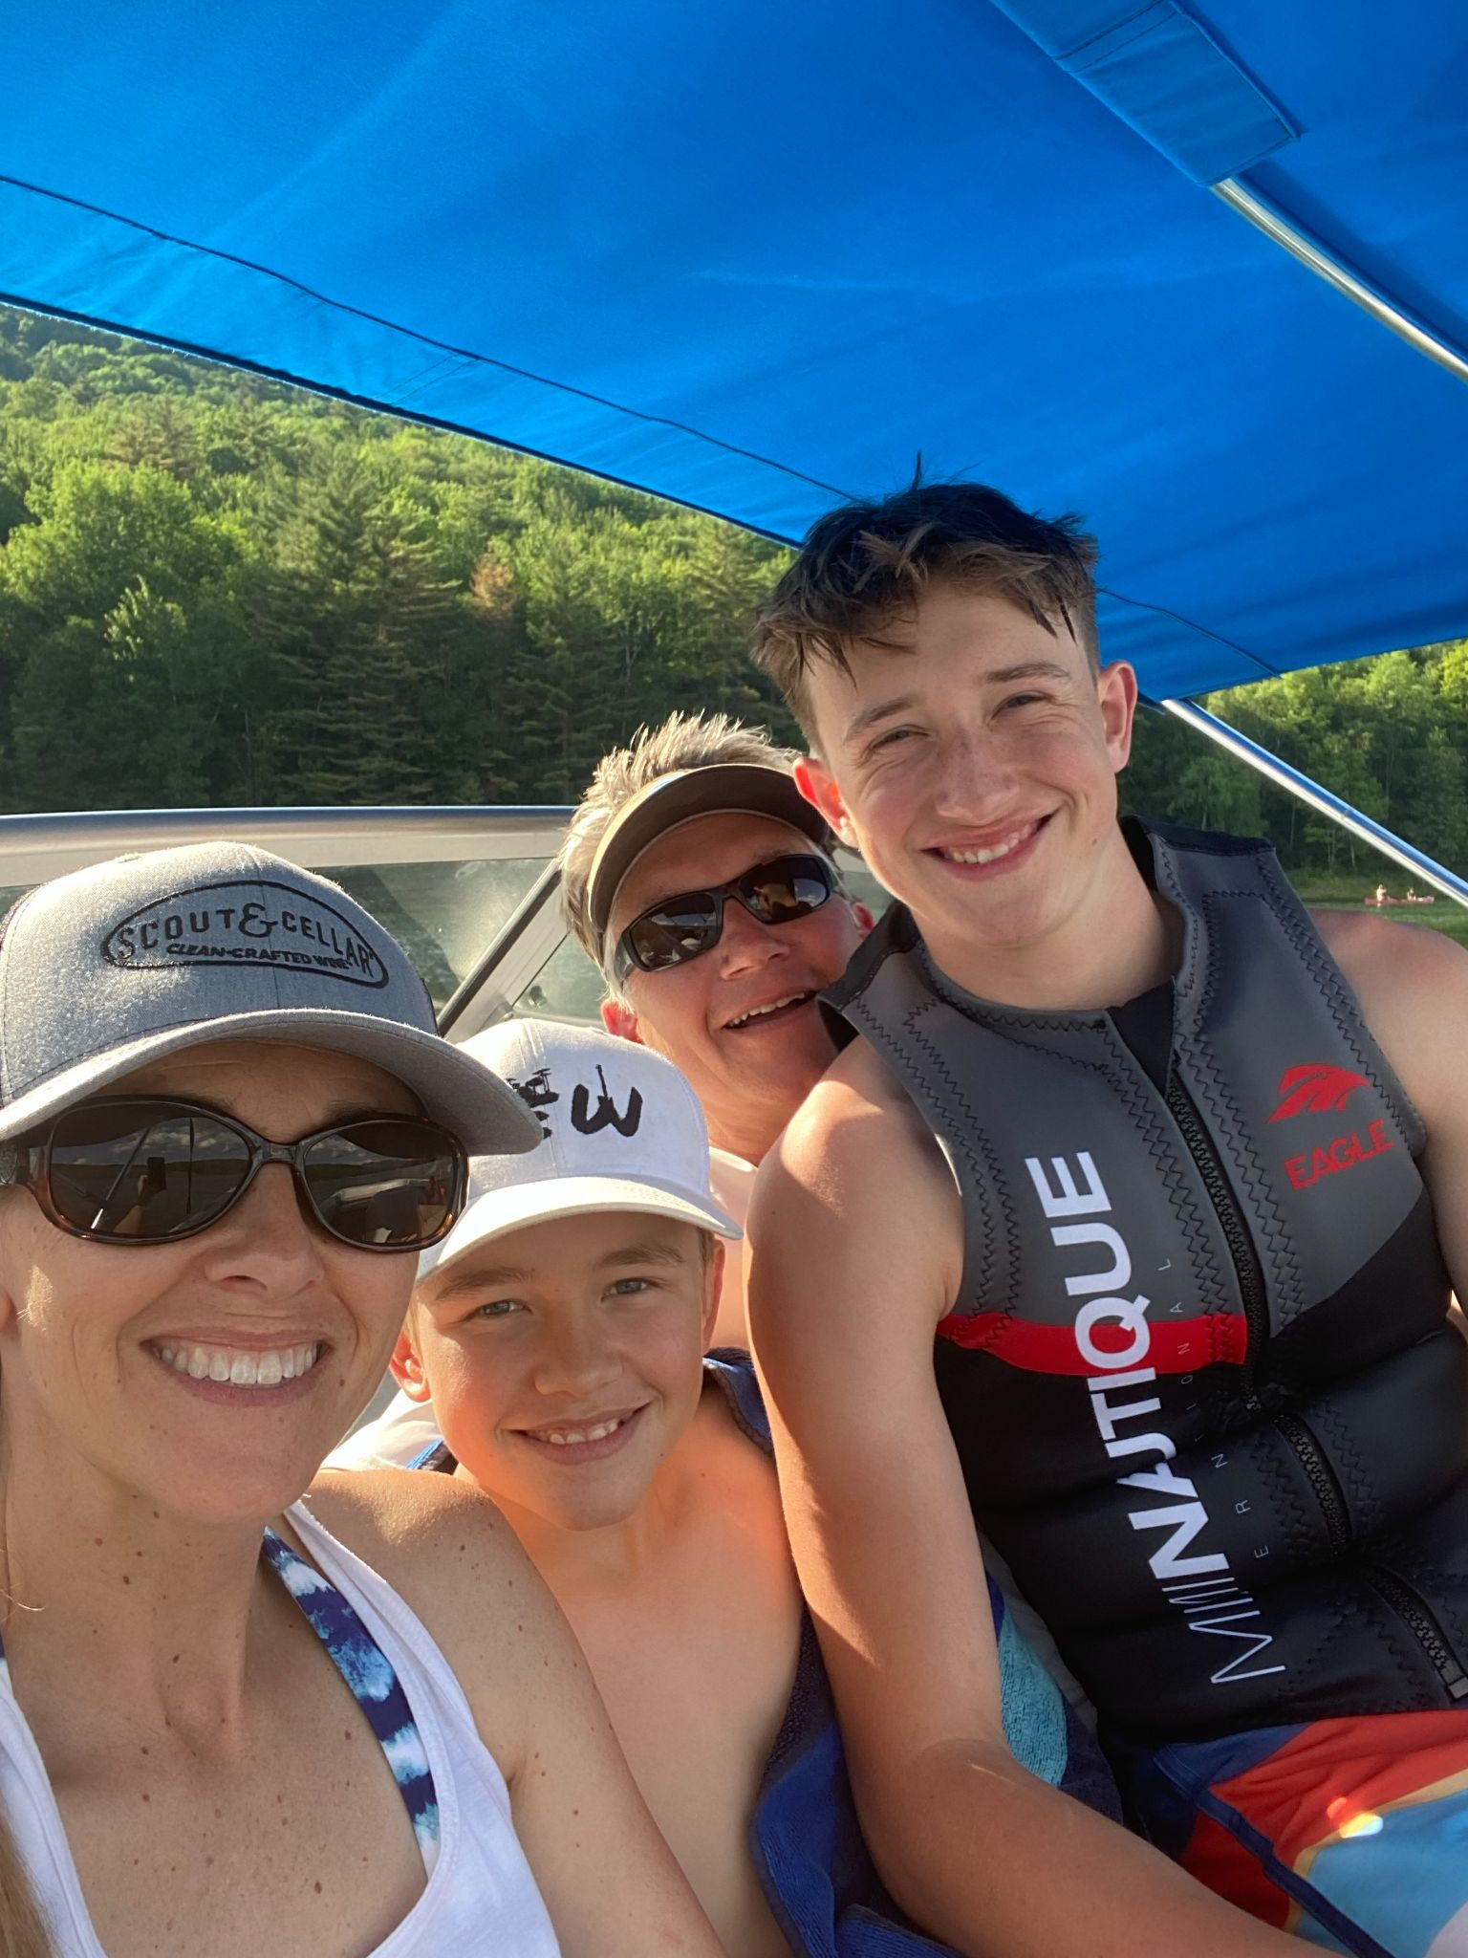
Lori Lisai (RF15) with her two boys Mac (12) and Emmett (14) and hubs, Jason grateful for time on the Waterbury Reservoir and living in such a gorgeous state.

Celebrations

Rachel Cohen (RF19) is the co-author of Place-based Education: Transforming Teaching and Learning Through Community Engagement with Amy Demarest.

Jess DeCarolis (RF09) is the co-chair and Caitlin Steele (RF09) a member of the New England Secondary School Consortium (NESSC) Task Force on Diversifying the Educator Workforce. You can read their important report here: Increasing the Racial, Ethnic, and Linguistic Diversity of the Educator Workforce: A Call to Action for Leaders.

Gabe Hamilton (RF14) will be the Director of Learning for the Addison Northwest Supervisory District.

Andrew Jones (RF14) served as Chair and primary author, with Jess DeCarolis (RF09), Jason Finley (RF09), Mike McRaith (RF13) and Chuck Scranton (RF Exec. Director & Co-Founder) serving as members of the Vermont Continuity of Learning Taskforce commissioned by Secretary French this year. You can read their report here: Making Revisions to the Grammar of Schooling: Education After COVID-19.

Andrew Jones (RF14) will be the Director of Curriculum & Innovation for the Mount Mansfield Unified Union School District.

Lori Lisai (RF15) will be a Vermont-based educational consultant and an independent consultant for Scout & Cellar Clean Crafted Wine, in addition to serving as the Rowland Foundation’s Associate for Social Media & Technology.

Gabrielle Lumbra (RF15) will be the Principal of the Flexible Pathways Academy for Franklin Northeast Supervisory Union.

Sandra Mings-Lamar (RF16) will be the Director of Adult Education at St. Johnsbury Academy.

Gretchen Muller (RF17) will be the Principal of Camel’s Hump Middle School.

Sabrina Westdijk (RF17) will be the Principal of Edmund’s Middle School.

Courtesy Postings
NEASC is calling for workshop proposals for the NEASC Annual Conference and Showcase (virtual): December 8-9, 2021. Proposal deadline: Monday, August 16, 2021.

We are looking forward to Alex Shevrin Venet presenting at RFC21! Here’s a link to her online Trauma-Informed Classroom series this summer.

