 | Letter to Fellows  The Next Chapter  June 2022

Dear Rowland Fellows,

I hope this message finds you and your loved ones doing well during these troubling times.

Many of our country’s democratic institutions seem wobbly in this moment, and the institution of public school is no exception. That’s one of the reasons I’m so proud of the Rowland Foundation’s ongoing commitment to improving Vermont schools through teacher innovation, collaboration, and leadership.

As we come to the end of the toughest school year in living memory, I’ve been taking inspiration from the ideas that you shared in the All Fellows Survey, especially those that underline the power of perseverance and optimism. If hope and hard work combined are a sort of super power, I believe that Rowland Fellows can truly make a difference, especially when we work together. As school and society continue to undergo great change in the years to come, the Rowland Foundation will continue to work for the kind of schools our young people deserve.

Looking ahead to the next chapter of the Rowland Foundation gives me great hope. Last month, our Board of Trustees had a daylong retreat to connect as a board, explore core values, revisit our mission statement, and identify investment priorities to support our mission in the coming years.

After carefully review of the All Fellows Survey results and thoughtful deliberation, I’m very pleased to report that the Rowland Foundation Board of Trustees identified the following important investment priorities for the next few years:
- Expand eligibility for Rowland Fellowships to include middle grades educators
- Support a diverse educator workforce in Vermont
- Sponsor an annual Rowland Women’s Leadership Retreat
- Expand the use of media to document and disseminate the work of the Rowland Foundation (e.g., new website, professionally produced short films, publishing Fellowship videos & podcasts, etc.)

The Board has charged me with developing strategies in these focus areas, and I’m excited to dive into the work. The Board also worked on updating the Rowland Foundation’s mission statement and will finalize the new draft language at their fall meeting–stay tuned! As we begin to write the next chapter of the Rowland Foundation, I will be reporting back to you here with updates and invitations to contribute to the work in whatever ways make sense.

Along these lines, we are beginning work on a new Rowland Foundation website! Senior Associate for Social Media & Technology Lori Lisai will be leading a design team and would love to hear your ideas. If you are interested, please let her know how you’d like to contribute by completing this short questionnaire.

After such a challenging year, I wish you the best summer ever with your family and friends. I’ll be visiting friends & family in France for a few weeks this July, so I won’t be sending out my Letter to Fellows next month. Feel free to send me photos of your summer adventures to include in my August letter!

Take care and see you soon,

Mike

P.S. In response to systemic racism in school, in 2019 the Legislature passed Act 1, a law to establish ethnic & social equity studies standards in Vermont schools. Act 1 established a working group to “review standards for student performance adopted by the State Board of Education and..., recommend to the State Board updates and additional standards to recognize fully the history, contributions, and perspectives of ethnic groups and social groups.” Mike McRaith (RF13) and I have been serving as members of the Act 1 Working Group for the past two years.

After compiling feedback on draft EQS revisions received from the VSBA, VSA, VPA, VTCLA, expert readers, and other stakeholders, the Act I Working Group submitted proposed revisions of the Educational Quality Standards (EQS) to the Vermont State Board of Education last month in order to meet its charge from the Legislature. Please take a moment to read the proposed changes to EQS here. Curriculum leaders will notice a new emphasis on Universal Design for Learning, Culturally Responsive Pedagogy, and Restorative Practices—none of which are included in the existing Vermont Educational Quality Standards (2013).

The State Board of Education has now formed an EQS Subcommittee chaired by Tammy Kolbe & Kim Gleason and asked the Act I Working Group to provide a brief rationale for each of the EQS sections with proposed revisions. The Act I Working Group has now submitted the rationale for all changes to the State Board for consideration.

If you would like to voice your support for these important changes to the EQS, our state’s educational quality standards, feel free to send a short note to the State Board’s EQS Subcommittee:
Jennifer.Samuelson@vermont.gov, Tammy.Kolbe@partner.vermont.gov, Patrick.Brown@partner.vermont.gov, Tom.Lovett@vermont.gov, Kimberly.g.gleason@vermont.gov
P.P.S. Please send me your news! Each month, I’m sharing courtesy posts for upcoming courses & events, and also celebrating new jobs, family vacations, and other news from our extended Rowland Family of Fellows. So please email whatever you’d like to share to michael@therowlandfoundation.org

Rowland Foundation Updates

The Annual Rowland Conference: Keynote Speaker Dr. Gholdy Muhammad

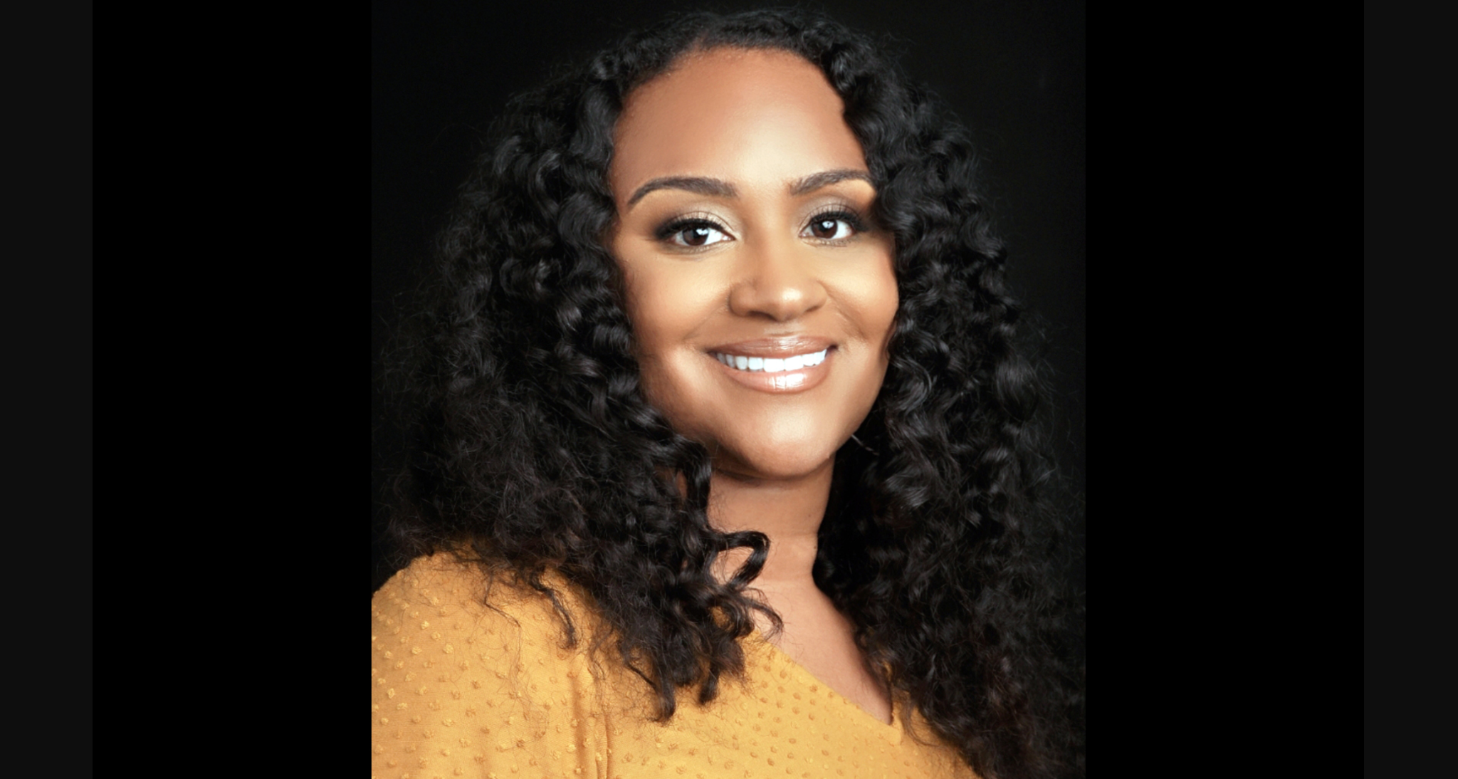
Pre-register your conference teams here! Our earlybird slots are nearly full already, so be sure to sign up soon. You will save 20% on the conference fee and don’t need to submit your participant names or payment information until UVM Events Registration opens in September. Earlybird registration expires at the end of June or when we run out of spots, whichever comes first.

Dr. Gholdy Muhammad will deliver our keynote for the 11th Annual Rowland Conference at UVM’s Davis Center on Wednesday, October 26, 2022 on the theme of Cultivating Genius: An Equity Model for Culturally & Historically Responsive Education. Feel free to submit a related workshop proposal or share the Rowland Conference Workshop Proposal Form with a colleague.

Dr. Muhammad’s book Cultivating Genius is a seminal work which seems more timely than ever with the recent passage of Act 28, “An act relating to improving prekindergarten through grade 12 literacy within the State,” and also Act 1, “An act relating to ethnic and social equity studies standards for public schools”. As you may already know, the Act 1 Ethnic & Social Equity Standards Advisory Working Group has just submitted proposed revisions to Vermont’s Educational Quality Standards to the State Board of Education.

The All Fellows Survey Results
If you still haven’t had the chance to, be sure to check out the Summary of Results from the All Fellows Survey for some excellent thinking and strategies relating to leading change in schools. You can also watch this short video for survey highlights in Rowland Fellows’ own words—the quotes are inspiring and also provide great insights on the joys and challenges of leading school change.

The All Fellows Retreat & Social
Save the date! The All Fellows Retreat will take place on Tuesday, October 25th (1:00-4:00pm) at a site to be determined. The traditional All Fellows Social will take place immediately afterwards at The Farmhouse Tap & Grill in Burlington.

The Annual Rowland Foundation Dinner on May 14th celebrated the first year’s work of our 2021 Cohort of Rowland Fellows and also the induction of our new fellows from the 2022 Cohort:

Sam Bromley, Montpelier High School (Science Teacher)
"provide opportunities for students to be active members in their local food systems and increase relevant engaging learning opportunities"

Bryan Dickinson, North Country Union High School (Math Teacher)
"showing the link between active lifestyles, academics, and future careers"

Becky Ebel, Vergennes Union Middle/High School (Special Educator)
"creating a holistically restorative system focused on the well-being of all school members"

Devon Karpak, Otter Valley Union High School (Technology Education Teacher)
"create an exemplar curriculum and program for a CTE connected pathway at OV for 7th-12th grade"

Patti Tomashot, Stowe High School (Guidance Director)
"create a comprehensive school counseling model for Grades 9-12...that includes personal, social & career domains"

Please don’t hesitate to contact our newer Rowland Fellows to connect! They may be working in a school just down the road from yours, or working on a Fellowship project that overlaps with your professional experience, skills, or expertise. Don’t be shy–there is no such thing as a “cold call” in the Rowland Fellows’ network.

Special thanks to Rowland Foundation Board Chair Heidi Lynn and Executive Administrative Assistant Abby Paige for their work with the Reluctant Panther to ensure a safe, happy, and successful Annual Dinner & Board Retreat. Deepest gratitude to Senior Rowland Associates Jean Berthiaume, Jeanie Phillips & Lori Lisai who did such an amazing job as the facilitators for our Board Retreat with the Rowland Foundation’s Board of Trustees.
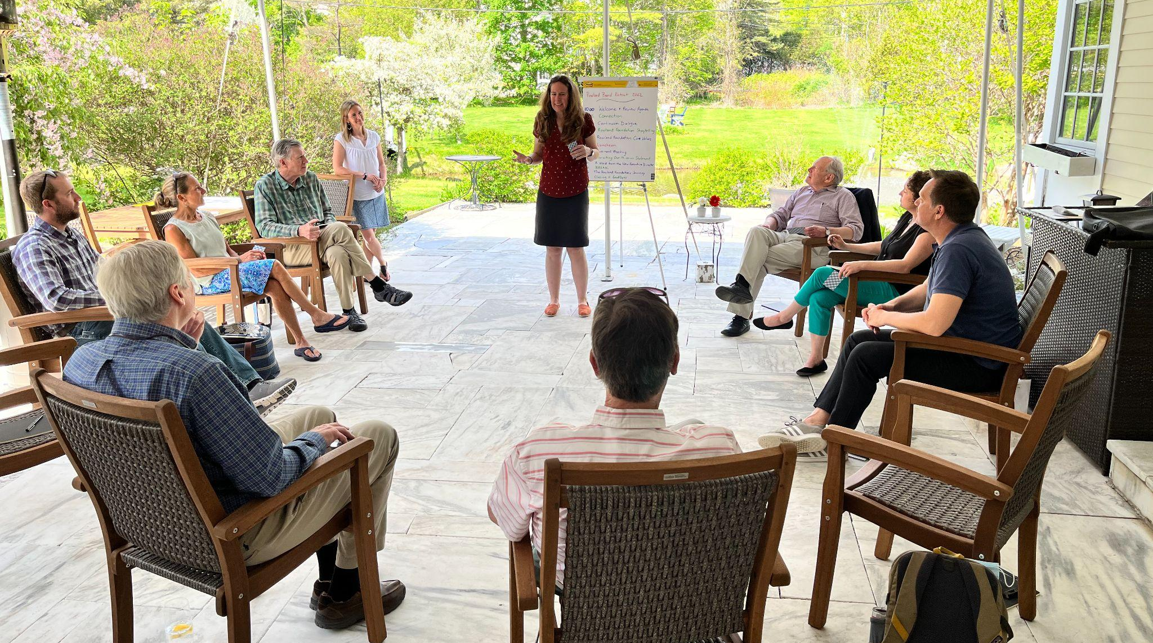
Rowland Foundation Trustee Erica Wallstrom (RF14) at the Board Retreat in Manchester.

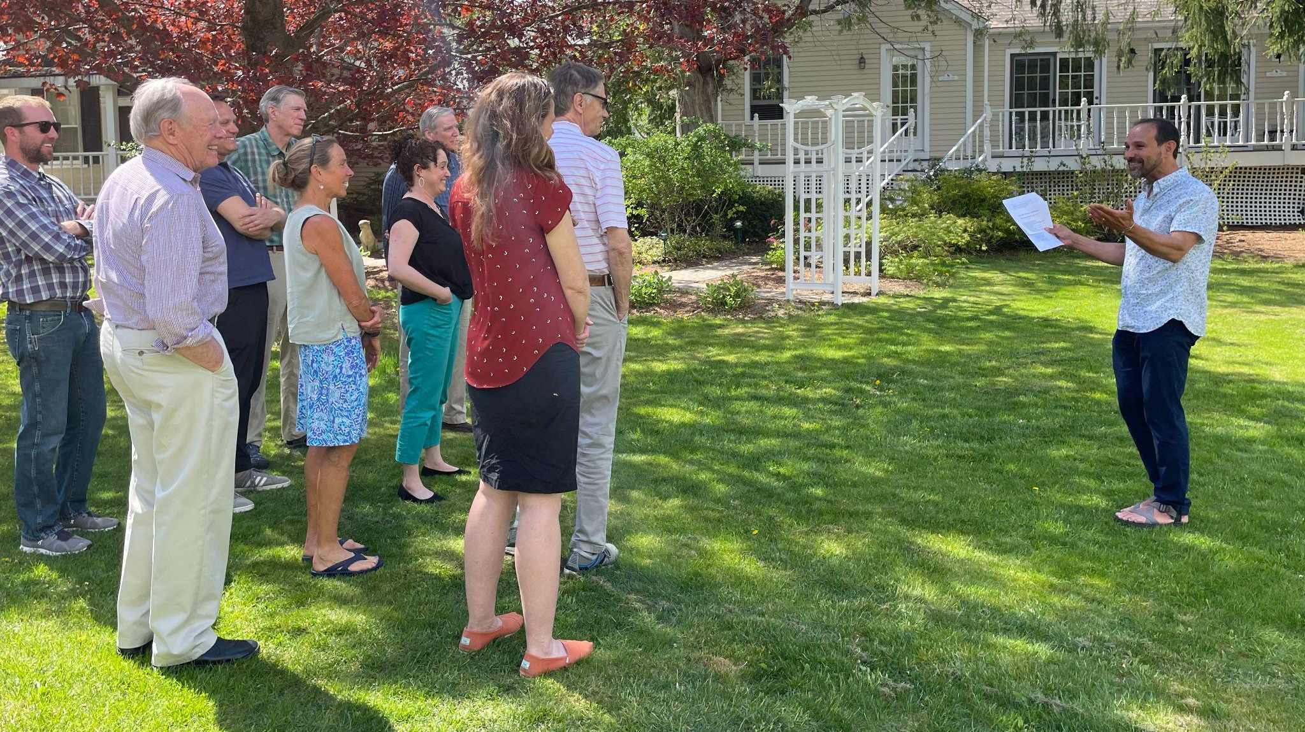
Senior Associate Jean Berthiaume (RF09) leading a Continuum Dialogue at the Board Retreat.
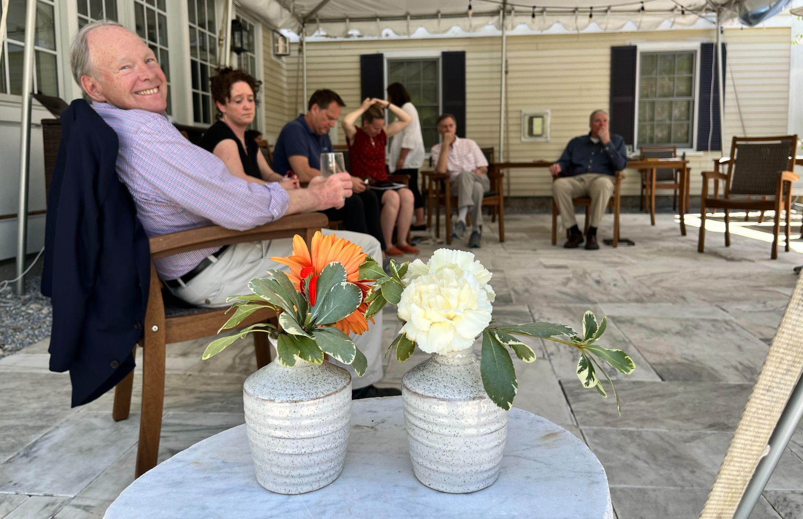
Rowland Foundation Trustee Dan Rowland seen here enjoying the day at the Board Retreat.
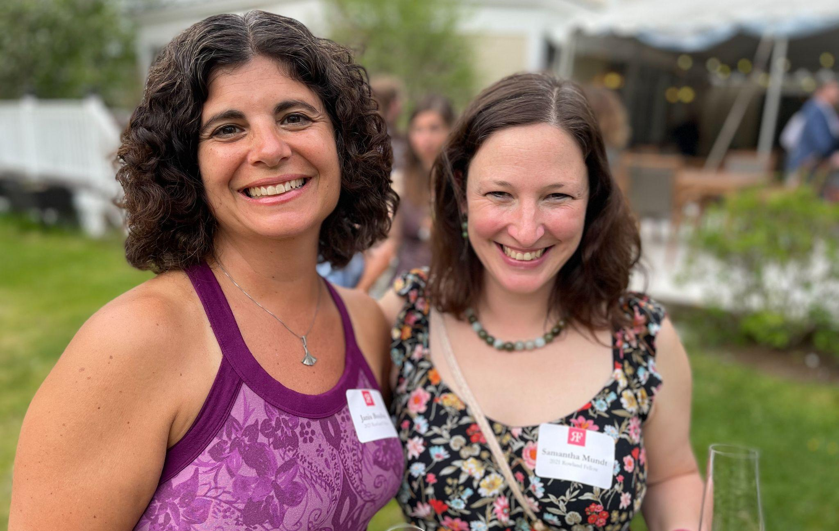
Janis Boulbol (RF21) & Samantha Mundt (RF21) at the Annual Dinner in Manchester.
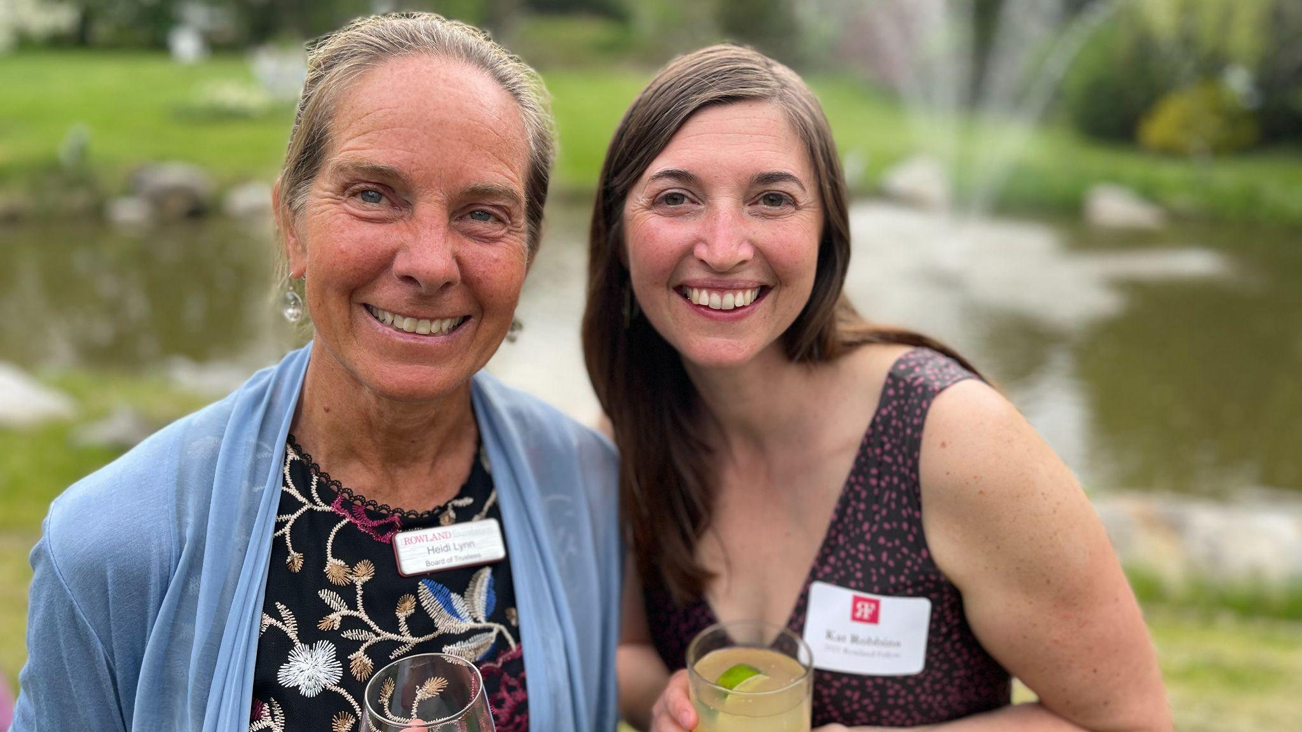
Board Chair Heidi Lynn & Kat Robbins (RF21) at the Annual Dinner.
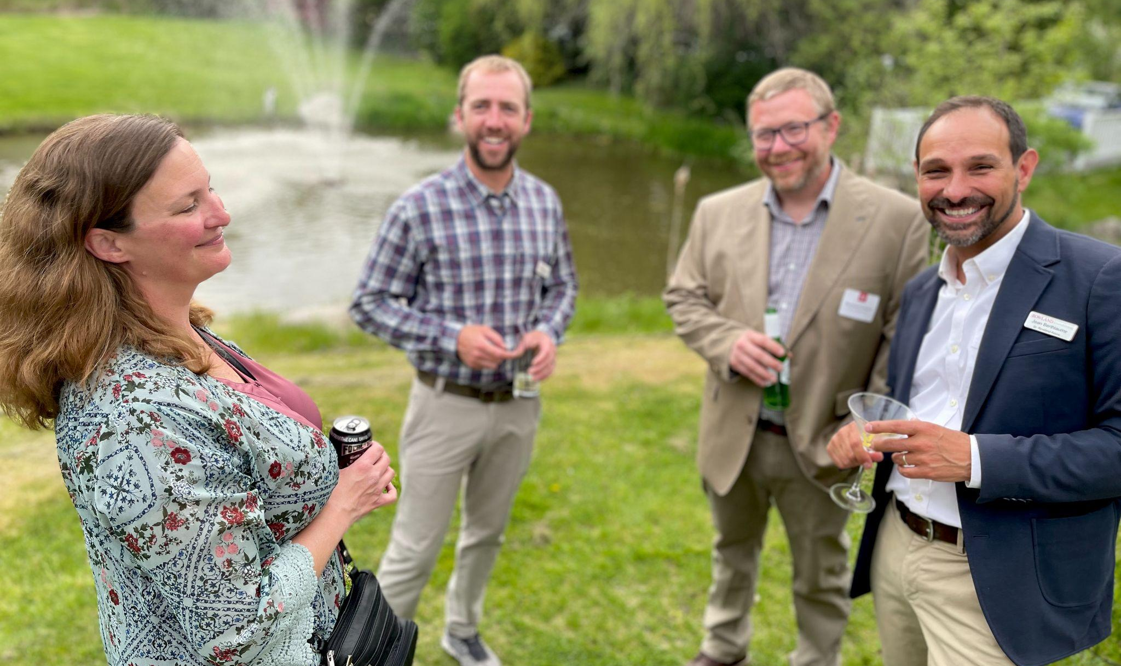
Angie Albeck, Trustee Carter Rawson, Brent Litterer (RF21) & Senior Associate Jean Berthiaume (RF09) seen here enjoying the Reluctant Panther.

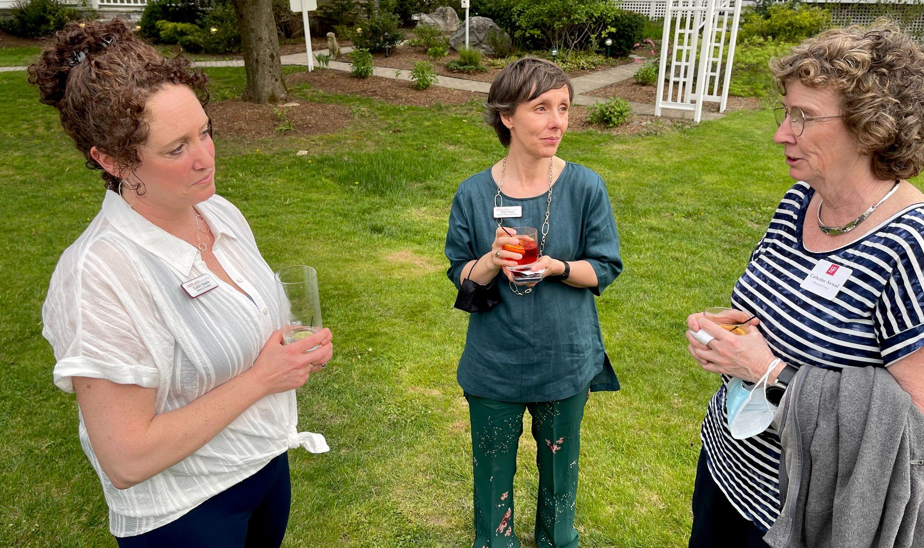
Trustee Caitlin Steele (RF09), Executive Administrative Assistant Abby Paige & Catherine Awwad at the Reluctant Panther.
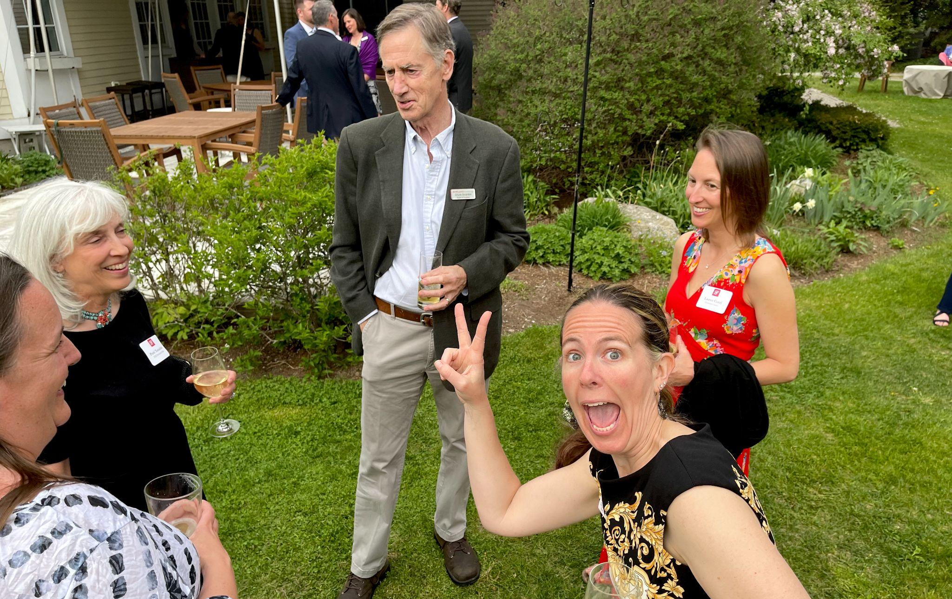
Becky Ebel (RF22), Patti Tomashot (RF22), and Trustees Chuck Scranton & Erica Wallstrom with guests at the Annual Dinner at the Reluctant Panther in Manchester.
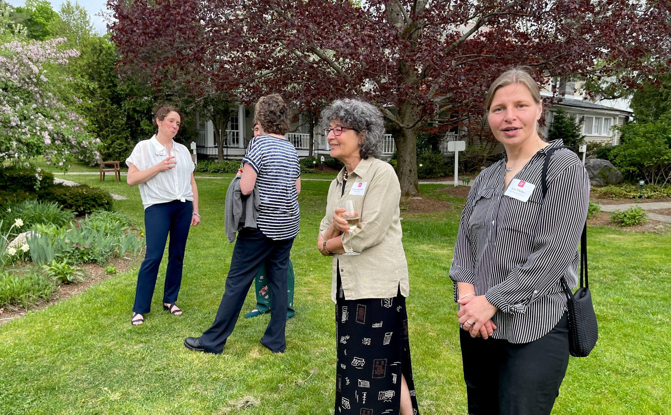
Laurie McBurnie & Anja Pfeffer (RF21) at the Rowland Foundation Annual Dinner.

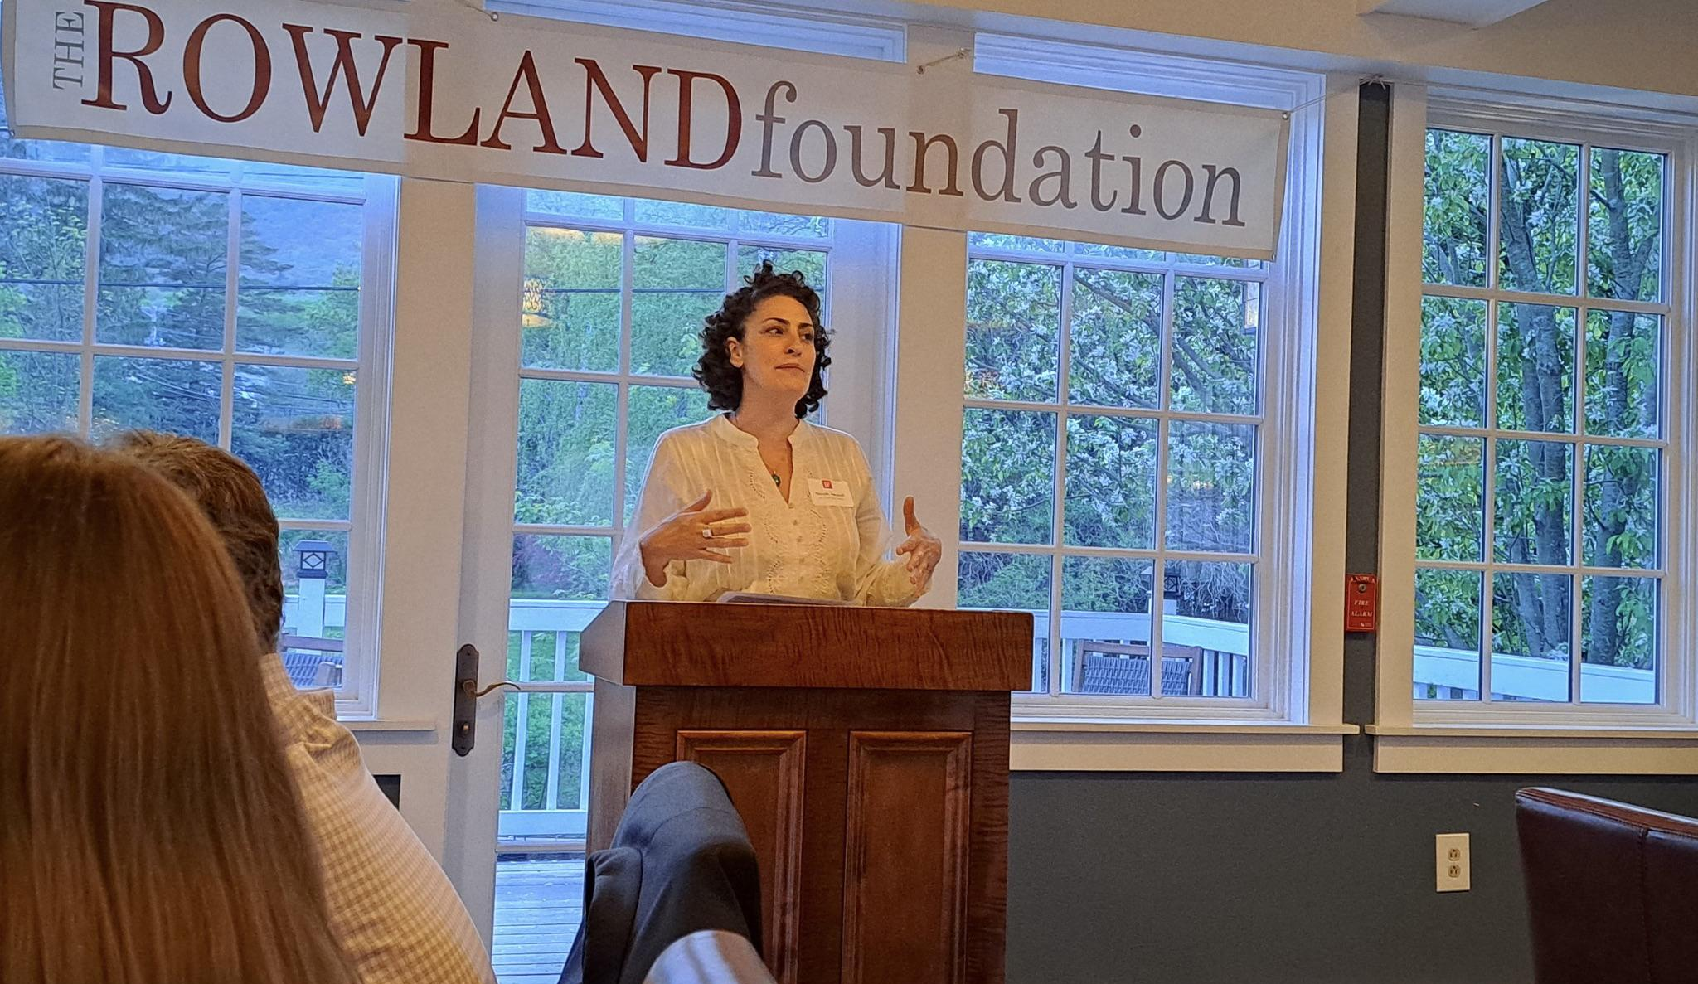
Nicole Awwad (RF21) speaking at the Annual Dinner at the Reluctant Panther in Manchester.

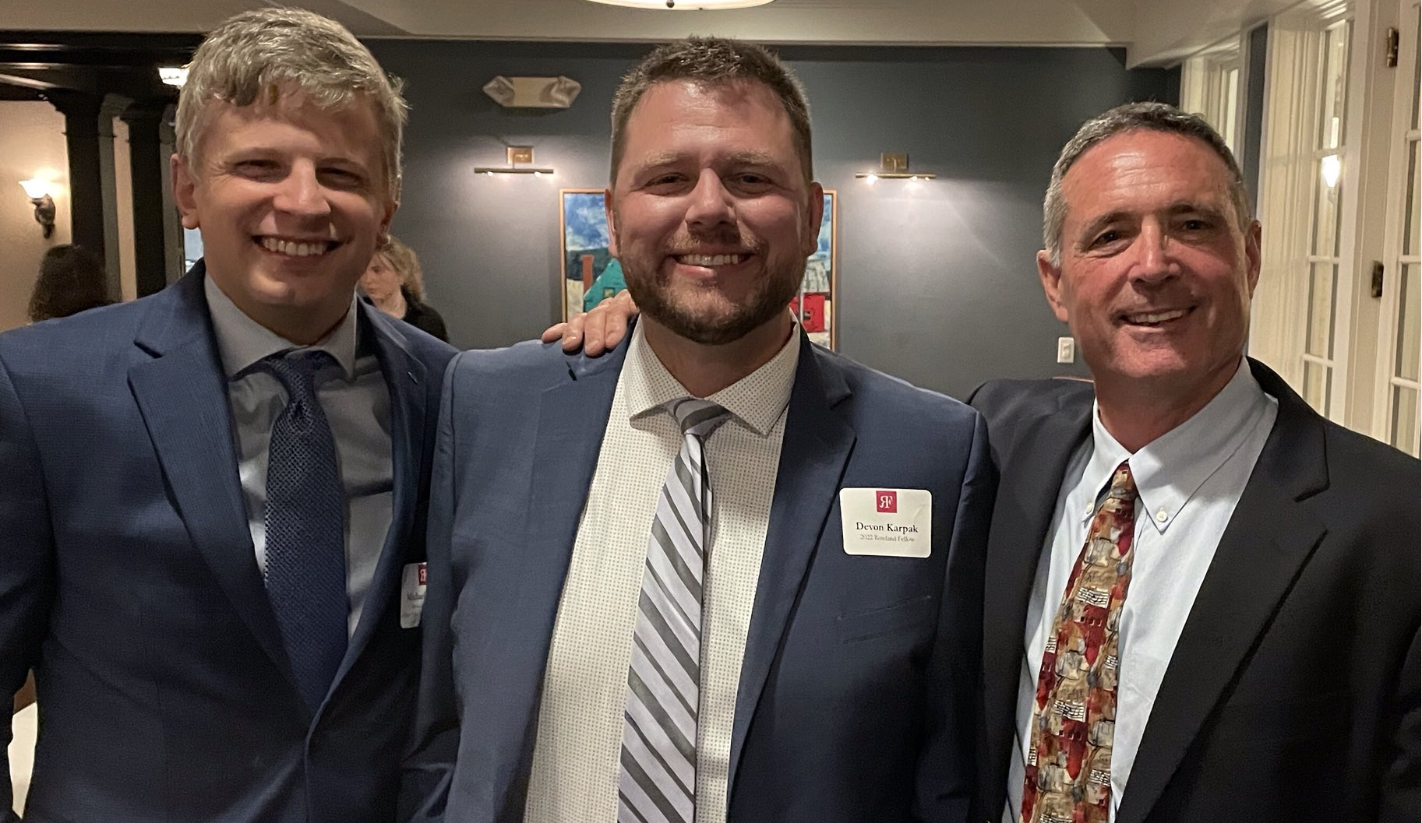
New Otter Valley Union HS Principal Michael Ruppel (RF17) and current Otter Valley Principal Jim Avery surround their Rowland Fellow Devon Karpak (RF22) at the Annual Dinner.
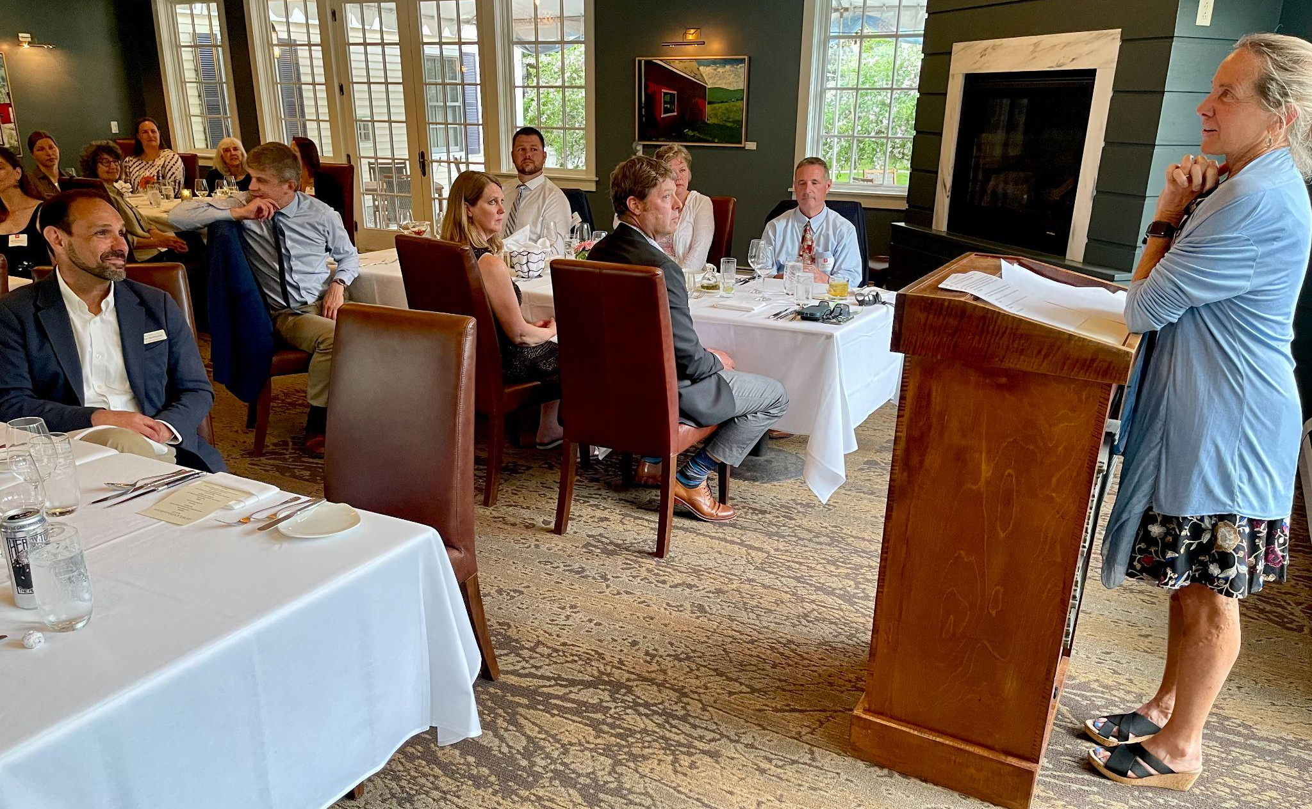Rowland Foundation Board Chair Heidi Lynn speaking at the Annual Dinner.
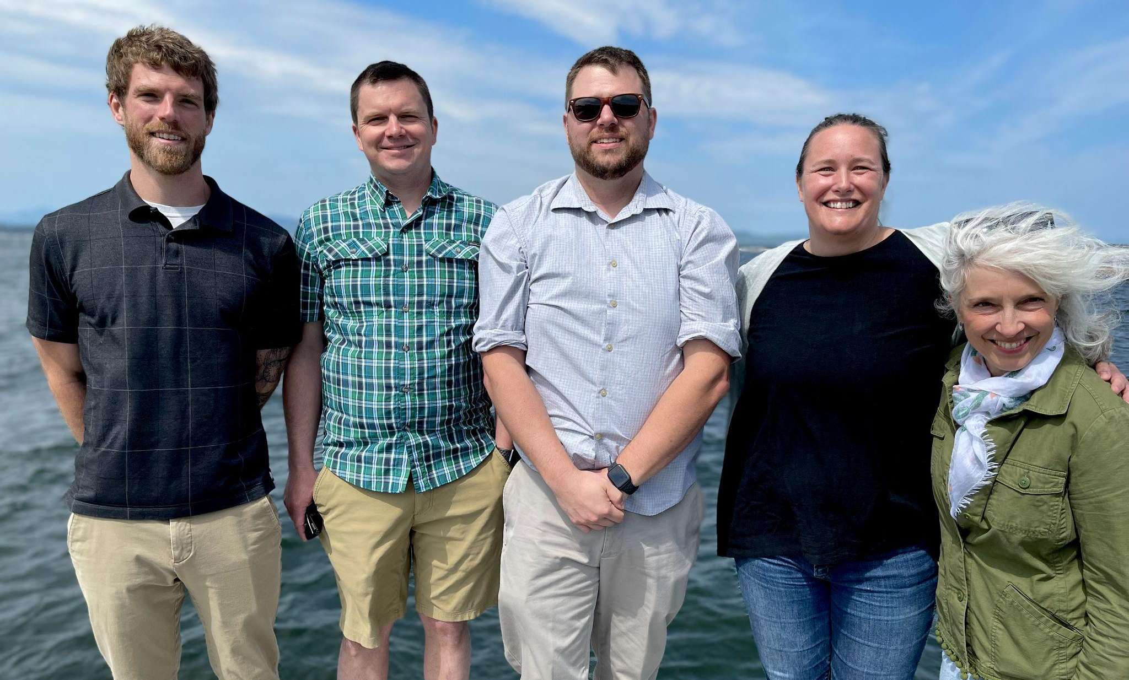
Presenting the Rowland Foundation’s fourteenth cohort of Rowland Fellows! The 2022 Cohort seen here in front of Lake Champlain near the new Rowland Offices (left to right): Bryan Dickinson, Sam Bromley, Devon Karpak, Becky Ebel & Patti Tomashot
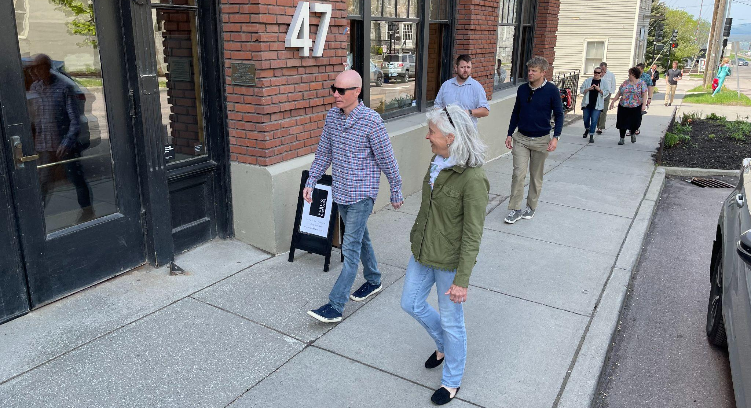
2022 Rowland Fellows doing some initial planning with their principals at the new Rowland Fellowship Launch, seen here in front of the Rowland Foundation offices in Burlington.
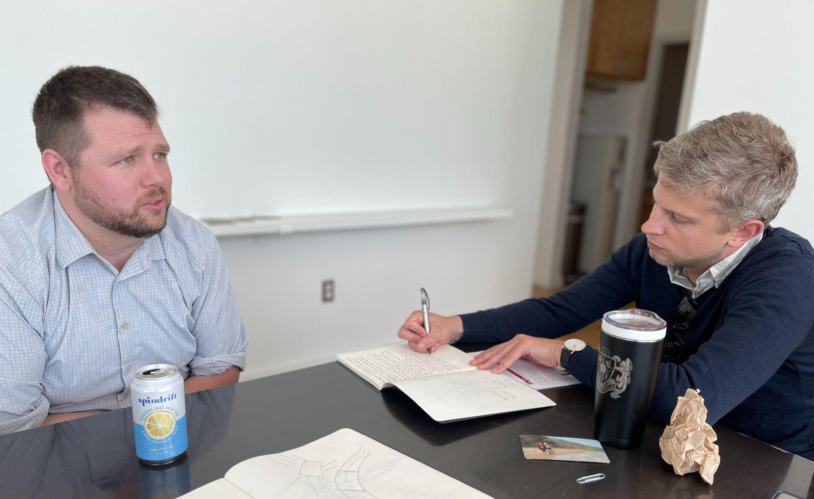
Devon Karpak (RF22) & Principal Michael Ruppel (RF17) talking about the Otter Valley school community at the Rowland Foundation offices in Burlington.
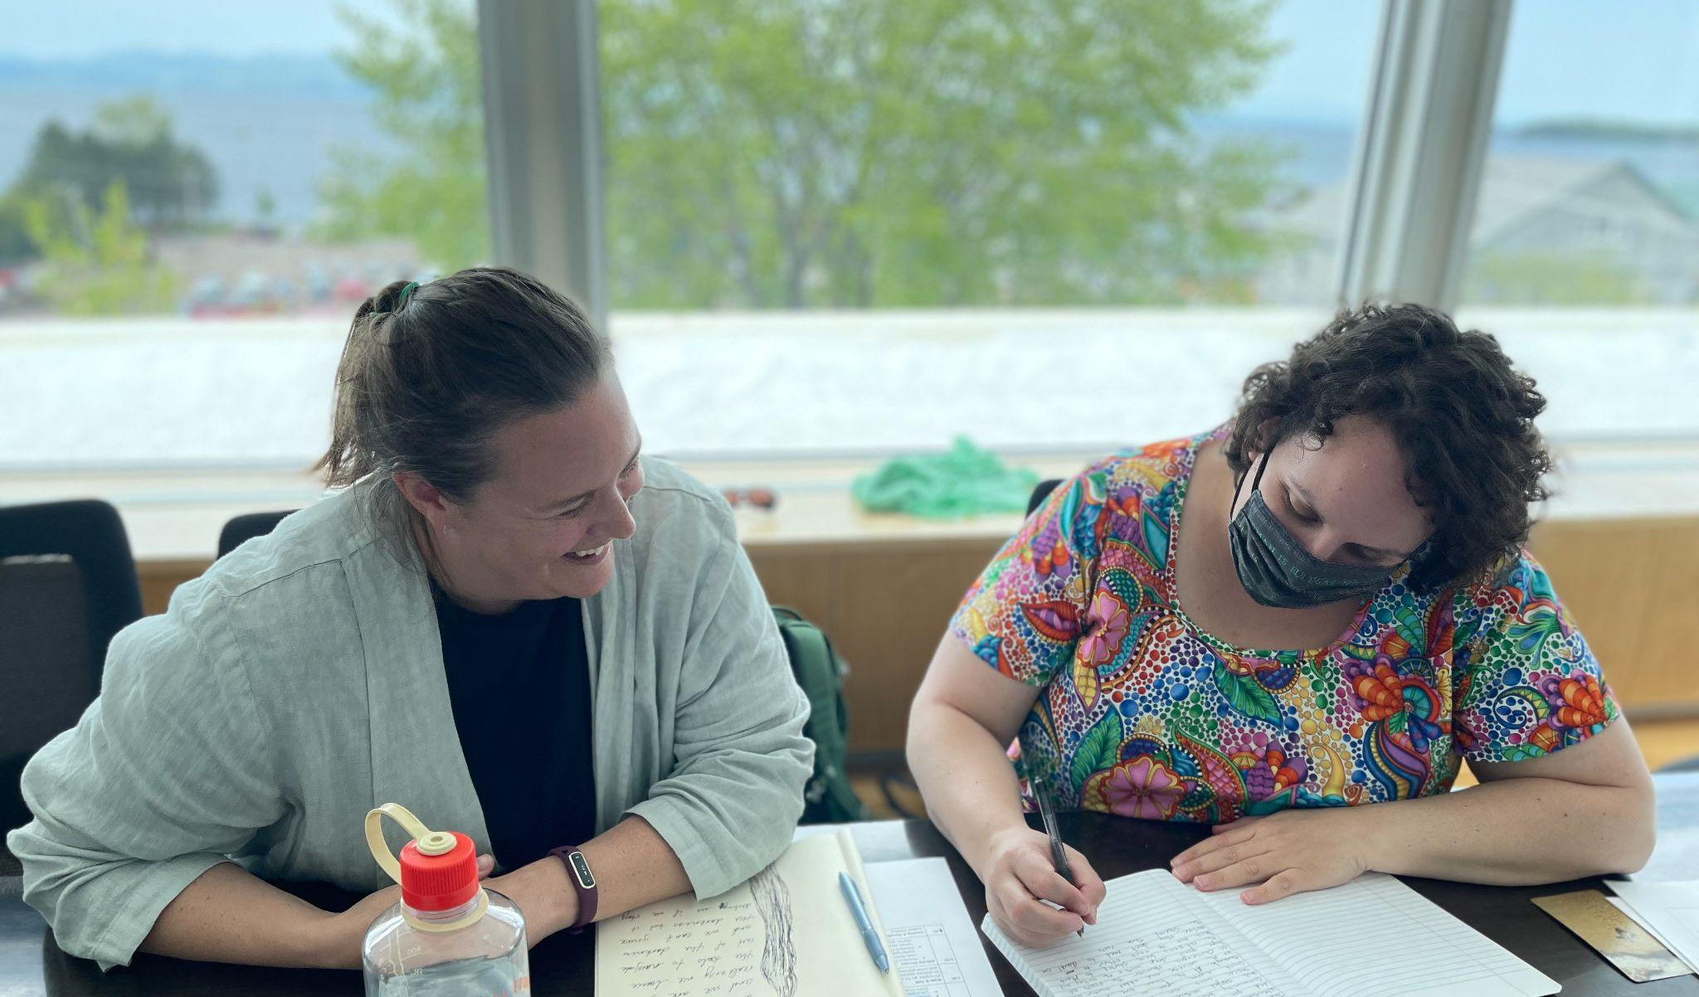
Becky Ebel (RF22) & Principal Jody Chamberlin talking about the Vergennes school community.
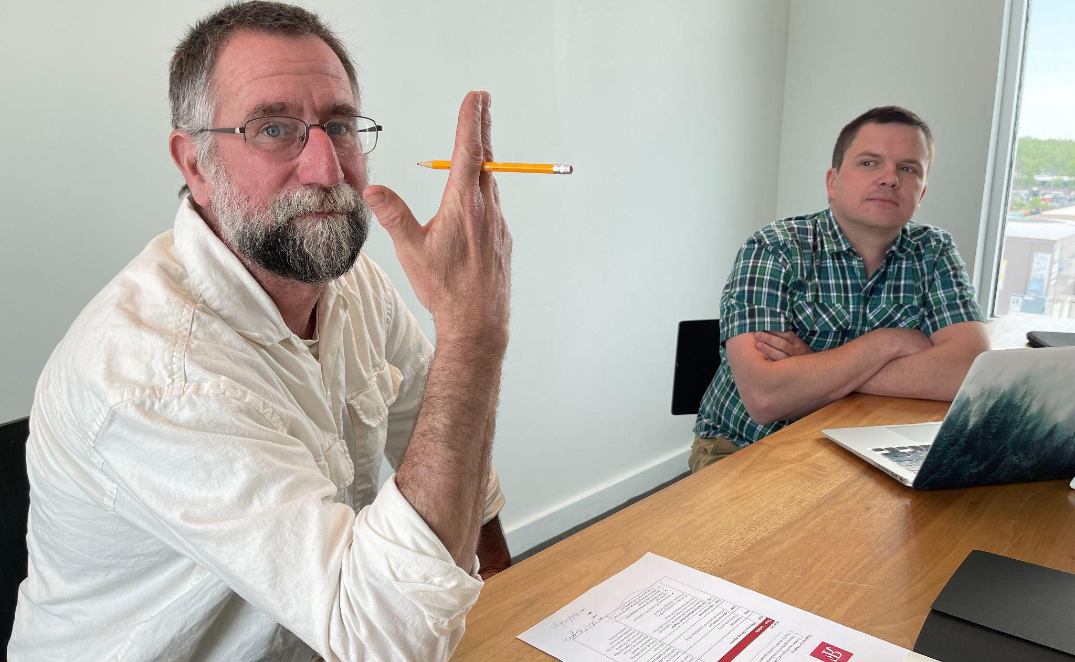
Montpelier High School Director of Flexible Pathways Matt McLane & Sam Bromley (RF22) at the Rowland Fellowship Launch in Burlington.
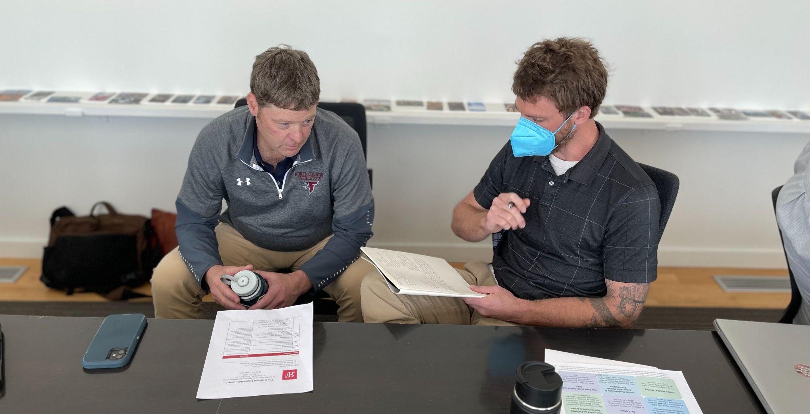
North Country Union High School Principal Chris Young working with Bryan Dickinson (RF22) at the Rowland Foundation offices in Burlington.

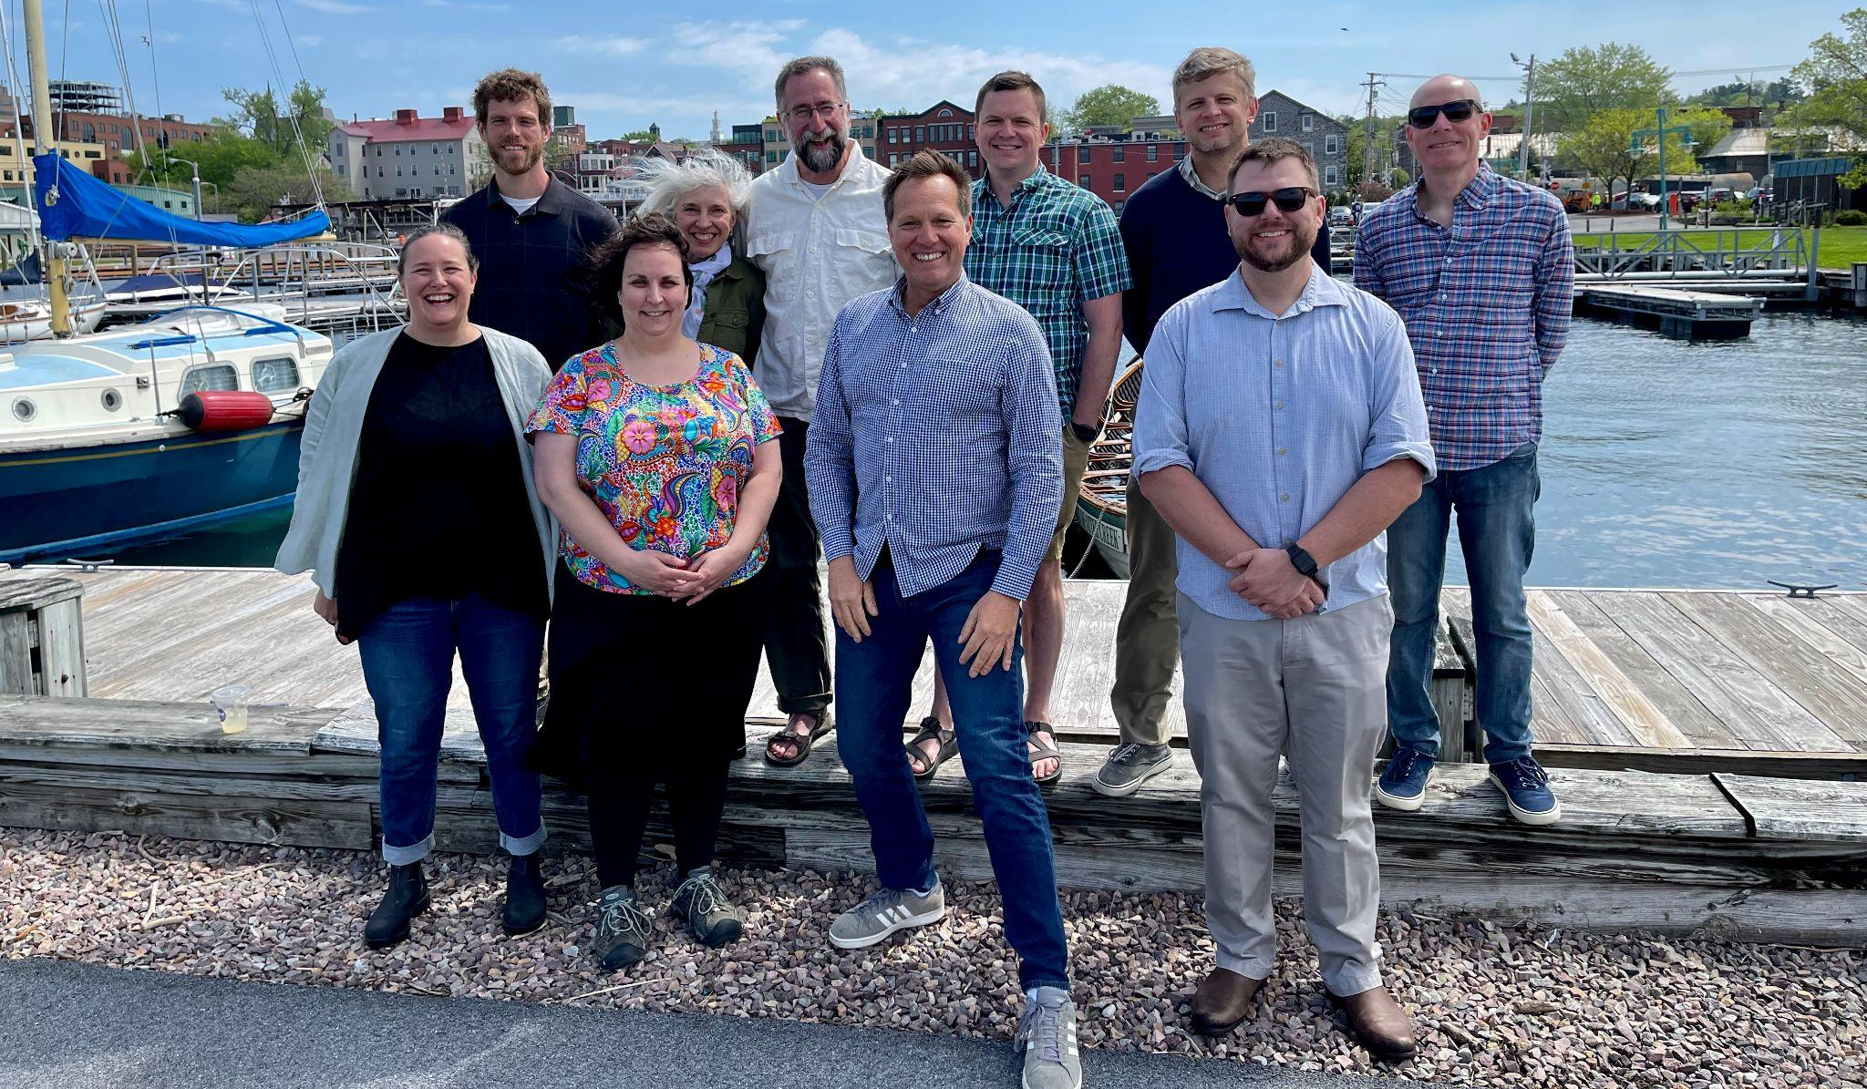
New Rowland Fellows and their principals gathered for the Rowland Fellowship Launch in Burlington. Seen here (left to right, back to front) Bryan Dickinson, Patti Tomashot, Matt McLane, Sam Bromley, Michael Ruppel, David Greenfield, Becky Ebel, Jody Chamberlin, Mike Martin & Devon Karpak.

Celebrations
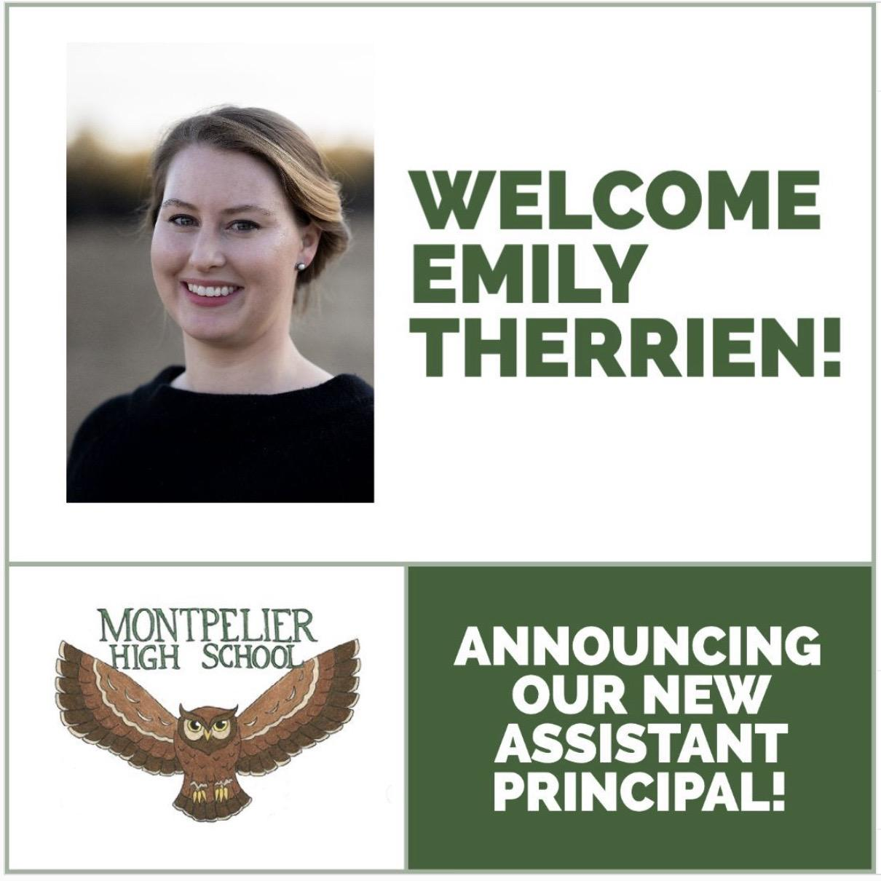
Congratulations to Emily Therrien (RF19) who will be serving as Montpelier High School’s Assistant Principal next year!
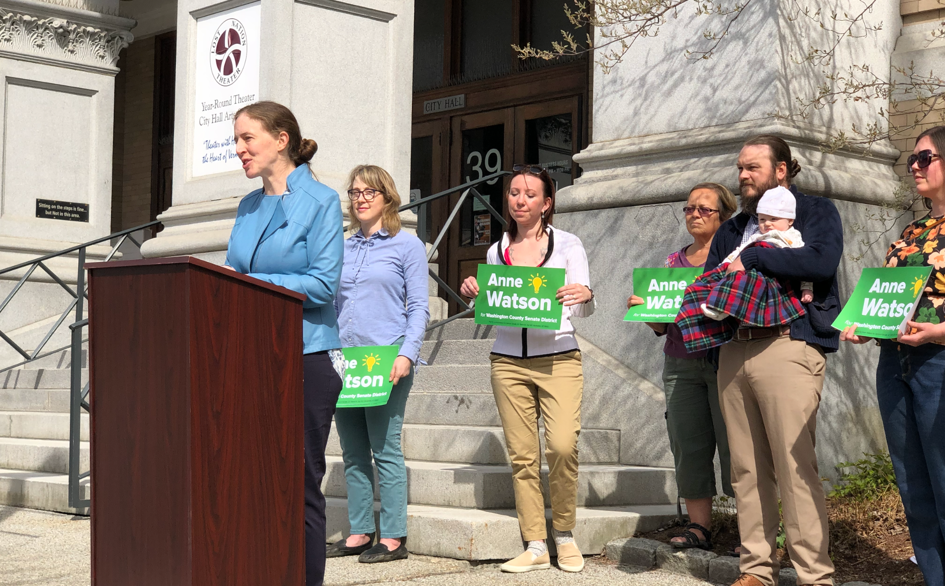
Much respect and kudos to the multi-talented Montpelier High School Teacher & Mayor of Montpelier Anne Watson (RF15) who is running for State Senate to represent the Washington County Senate District!

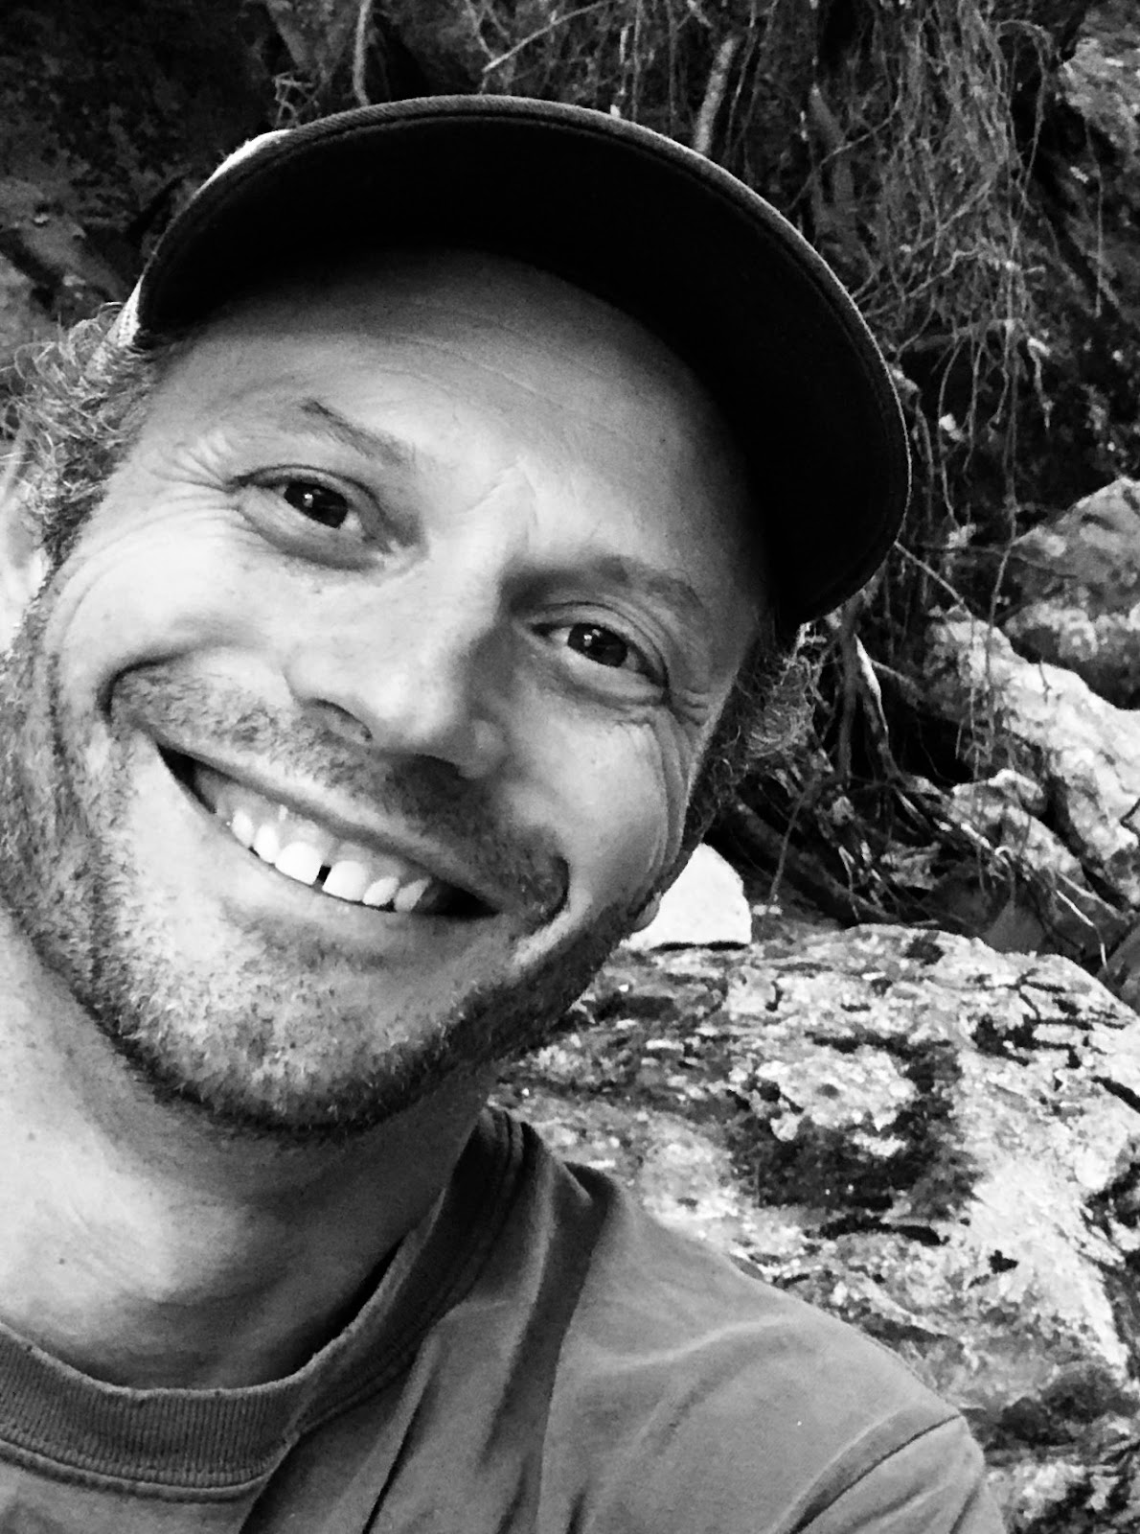 | Congratulations to Gabe Hamilton (RF15), the 2022 recipient of the Vermont Curriculum Leaders Association’s (VTCLA) Ned Kirsch Innovative Leadership Award! From his colleagues’ nomination: “Gabe is engaging with presentations, makes people think outside of their comfort zone, and challenges ‘the way it's always been.’… He was at the forefront of creating a system in which learners have access to varied academic opportunities such as independent and guided learning opportunities, enhanced targeted instruction, and the most recent design of extended-year learning opportunities in response to COVID-19.”

Congratulations to Kristin Cimonetti (RF20) who will be the next Principal of Shrewsbury Mountain School! She will continue to serve as Fine Arts Coordinator for the district and teach high school vocal classes at Mill River Union High School.

Congratulations to Andrew Jones (RF15) who will be serving as Assistant Superintendent for the Mount Mansfield Unified Union School District next year!

Congratulations to Jason Finley (RF09) who will be the Director of Career Pathways & Workforce Development at Randolph Union High School starting July 1st! His goal is to embed career education and pathway planning across the curriculum.

Congratulations to Sarah Hagge (RF16) who will be teaching 10th & 12th grade English at Woodstock Union Middle and High School next year!

Congratulations to Abby Bowker (RF17) on her new job! She is happy to announce that after working as an art teacher at Champlain Valley Union High Schools for 18 years, she has decided to change gears and move to teaching 3rd-8th graders Visual Art at Williston Central School.

Congratulations to Rowland Foundation Trustee Dan Rowland who has been awarded the Dot Crutcher Award for lifetime achievement in Historic Preservation from The Blue Grass Trust for Historic Preservation, in Lexington, Kentucky!

Congratulations to Kat Robbins (RF21) & Janis Boulbol (RF21) whose Rowland Fellowship work was featured in the most recent Vermont Land Trust Newsletter! (And thanks, Heidi, for sending this my way!)

Gratitude
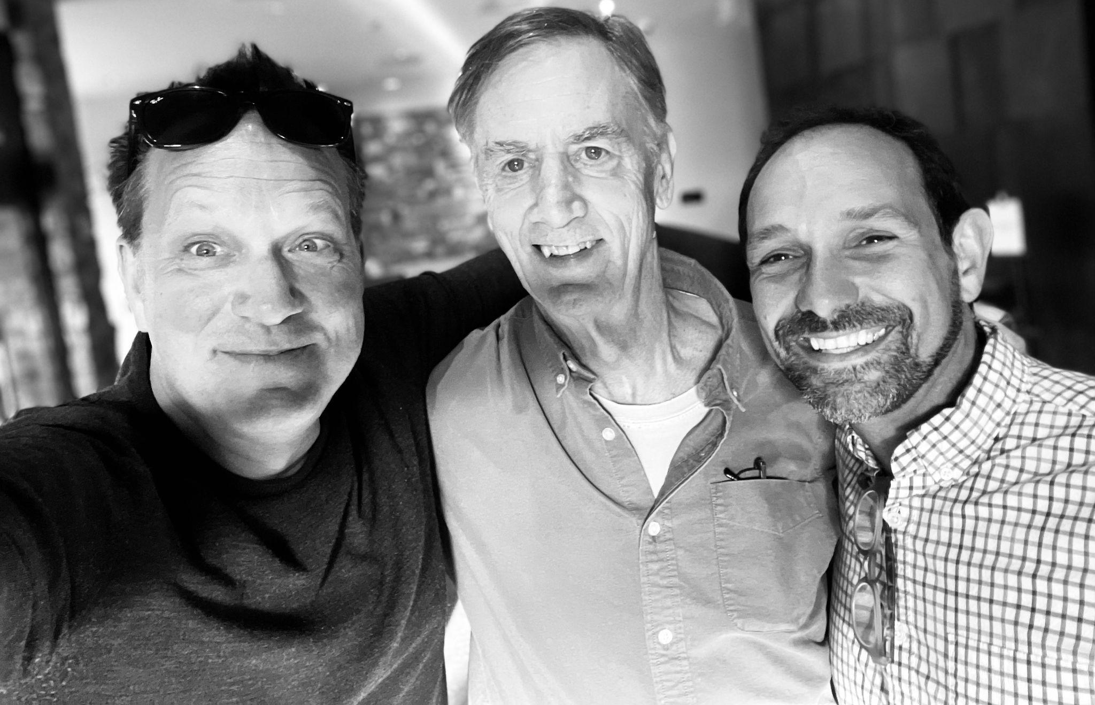
Old friends Mike Martin, Chuck Scranton & Jean Berthiaume met in Burlington recently to enjoy a meal together and catch up.
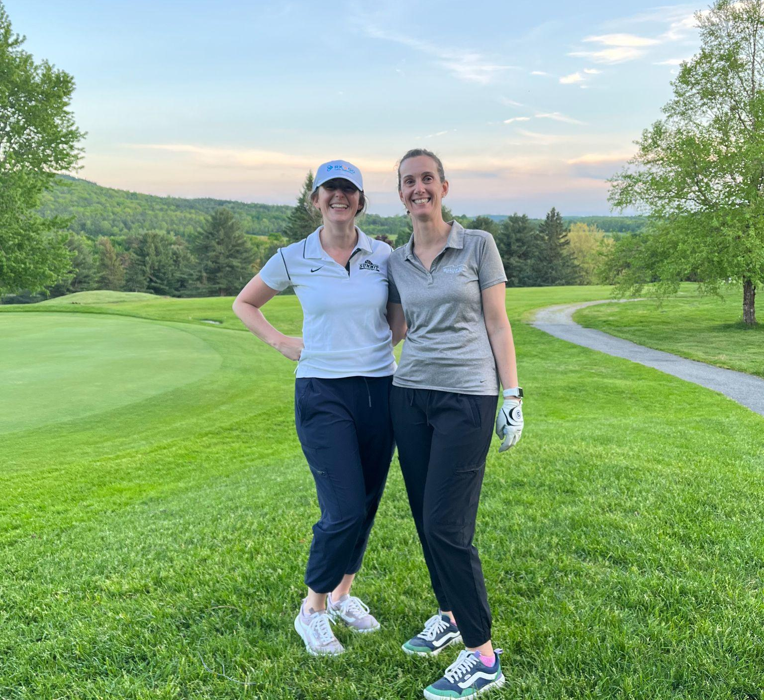
The best place for reconnecting with your Rowland cohort twin! Emily Gilmore (RF17) & Gretchen Muller (RF17) seen here at Williston Golf Club.

Courtesy Postings
Sabrina Westdijk (RF17) shares that Edmunds Middle School in Burlington is seeking a new Assistant Principal who will be a dynamic, invested thought partner who is commited to restorative justice practices and anti-racist education. Edmunds has a lot to offer, including a YPAR program supporting young people in advocacy and equity work, a newly-founded peer mediation program, and a new district-wide strategic plan focused on deeper learning, community engagement, and equity. If you know someone who you think would be interested, please pass on this opportunity. You can find the posting here.

Gabrielle Lumbra (RF15) will be teaching Rethinking Instruction & Assessment in a Proficiency-Based Classroom at Castleton University, July 3 - August 13, 2022. Click here for more information and a link to registration. Also from Gabrielle, “I am looking for people who would be willing to pose real problems to students and partner with teachers as they develop learning experiences. You may be an engineer, a gardener, a politician, a beekeeper, or a chemist; you have an expertise that offers a real world application to otherwise disconnected school topics. We are looking to answer the persistent question, “when would I ever use this?”. If you would be willing to participate, or know someone who would be, please use this form to tell us about your expertise.”

Looking for some great professional development over the summer? Great Schools Partnership is hosting 3-day virtual institutes on equitable advisory systems, creating and facilitating Professional Learning Groups, racial equity in education, and grading for educational equity. To learn more, visit the Great Schools Partnership Events page! If you have questions, please reach out to Emily Gilmore (RF17) (egilmore@greatschoolspartnership.org).

Associate Principal Bianca McKeen (RF16) shares that Rutland High School is hiring a Work-Based Learning Coordinator. This position has grown out of a 2016 Rowland Fellowship. Please consider applying to join our dynamic team. School Spring Job ID: 3896527

