 | Letter to Fellows  March 2022
Dear Rowland Fellows,

I hope this message finds you and your loved ones doing well.

Our hearts go out to the Ukrainian people in this moment. Their courage and unity in the face of the horrors of war has been unbelievable. We don’t know what lies ahead, but there will likely be much more human suffering. It’s also clear that the effects of this war will be far-reaching and will continue to reshape the global economy and “post-Cold War order”. As it becomes evident that market economies don’t necessarily foster democratic societies, the future of autocrats like Russian President Vladimir Putin hangs in the balance.

In an Atlantic magazine article that Dan Rowland shared with me, Anne Applebaum describes Putin and his ilk this way, “Instead of democracy, they promote autocracy; instead of unity, they try constantly to create division; instead of open societies, they promote xenophobia. Instead of letting people hope for something better, they promote nihilism and cynicism.” It’s important to note that this same war of ideas is taking place in our own country right now.

Of course, as we think about the future of our own country, our thoughts turn to the future of our children. As some of our schools began to drop mask mandates this week, we’re finally able to see our students' smiles again. Chuck told me this week that some of his teachers were seeing their students' faces for the first time—even though they’d known them for two years! Now is the time for us to consider the culture & climate we want for schools in the months and years to come.

Along these lines, many of you know that Peter McConville (RF11) was one of the lead architects of Burlington’s City & Lake Semester. One design challenge City & Lake students grapple with is the following:

- What if school were designed for wellbeing?
- What if school were designed for learner interest?
- What if school were designed for belonging & connection?

Too often, we think of school culture and climate as ethereal or extras, when in fact they are something that profoundly change a school when we intentionally design for them. What if we actually designed school for in-person learning? How would our learning spaces look if we designed them for collaboration? What would it feel like to incorporate movement into academic classes? How would advisory or morning circles need to change for students to feel ownership of these daily rituals? How could we better model democratic values in the daily life of school?

In order to strengthen democratic values in Vermont public schools, in 2019 the Legislature passed Act 1, an act relating to ethnic and social equity studies standards for public schools. At the time, the prime sponsor of the legislation Rep. Kevin “Coach” Christie said, “This is about Vermont, and what we really stand for.”

Act 1 created an advisory work group to recommend changes in academic standards to the Vermont State Board of Education. It has been my honor to serve on the Act 1 Ethnic & Social Equity Standards Advisory Working Group for the past two years on behalf of the Vermont Curriculum Leaders Association (VTCLA). Similarly, Mike McRaith (RF13) represents the Vermont Principals Association on the Act 1 Advisory Work Group, and Jess DeCarolis (RF09) has been actively involved given her important statewide leadership at the AOE for equity in Vermont schools. Many Rowland Fellows have contributed to this work in various capacities, and if you’re interested, you can learn more about the work in this report.

After an extensive, yearlong process with Vermont education associations, expert readers, community leaders, public comment, and input from various stakeholder groups, I’m pleased to share that the Act 1 Advisory Work Group has completed a draft of proposed changes to the Vermont Educational Quality Standards (EQS). After a committee vote on March 17th, these proposed changes will be submitted to the Vermont State Board of Education for approval.

When the current Educational Quality Standards (EQS) came out in 2014, many of us were thrilled to see the clear mandate for proficiency-based learning (PBL) and personalized learning plans (PLPs). With the passage of Act 173 and a much greater awareness of how systemic racism and inequities show up in Vermont schools—and having learned a great deal from the challenges of implementing PBL & PLPs—we are ready for a clear policy mandate for the work ahead.

The struggle for democracy starts in the classroom, not in the street. As the Vermont-born social philosopher John Dewey wrote, “There cannot be two sets of ethical principles, one for life in school, and the other for life outside the school.”

Take care and see you soon,

Mike

P.S. Please send me your news! Each month, I’m sharing courtesy posts for upcoming courses & events, and also celebrating new jobs, family vacations, and other news from our extended Rowland Family of Fellows. So please email whatever you’d like to share to michael@therowlandfoundation.org
Rowland Foundation Updates
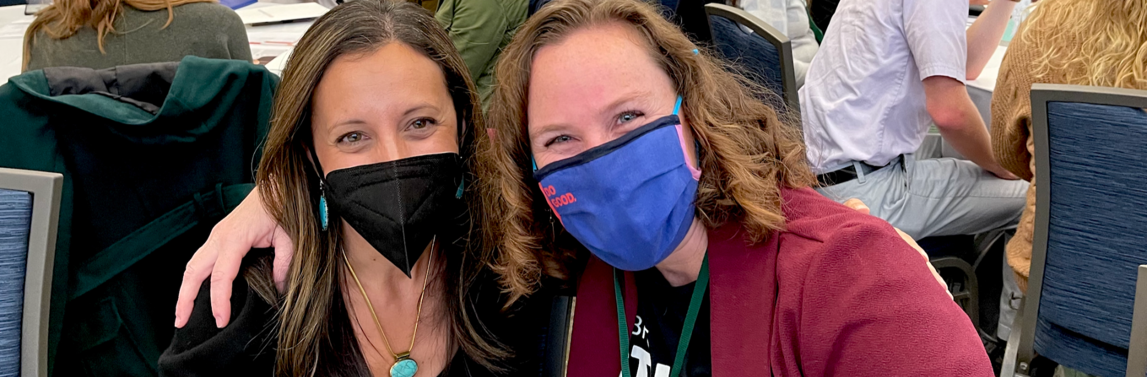
Preparation for the 11th Annual Rowland Conference is underway! We are currently working on confirming a keynote speaker…but we’re still waiting on her reply. As we begin to explore other options, please let us know your keynote speaker recommendations. You can tell us your top keynote choices in this short survey. For multiple recommendations, simply complete the survey as many times as you want. Please remember that we’re looking for speakers who will resonate with Vermont’s classroom teachers and push their thinking. The keynote also provides the conference theme that the workshops are built around, so that’s an important consideration too.

Mike, Lori & Abby worked with our new 2022 Rowland Fellows at our new Burlington office for New Fellows Orientation this week. Remember how excited you were to be a new Fellow?

Please note: Missing from photos is Patti Tomashot (RF22) who was out of state taking care of her 87-year old mom after surgery.

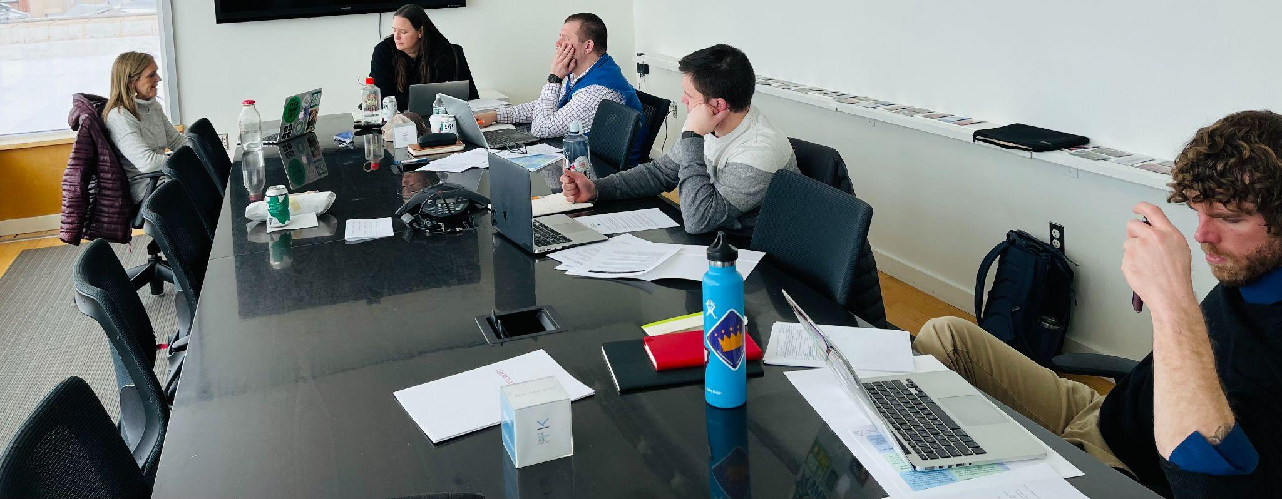
Seen here at the Karma Bird House Conference Room in Burlington (left to right) Rowland Senior Associate for Social Media & Technology Lori Lisai (RF15), Becky Ebel (RF22), Devon Karpak (RF22), Sam Bromley (RF22), Bryan Dickinson (RF22)

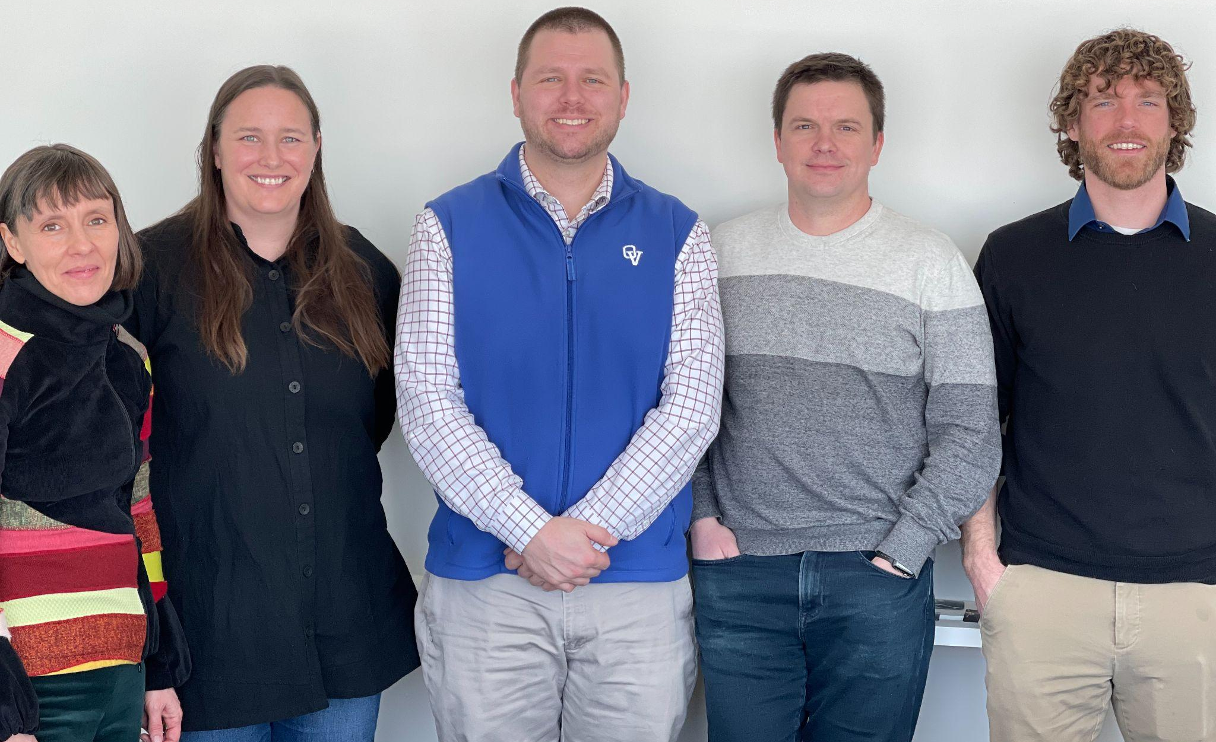
Seen here (left to right) Rowland Foundation Executive Administrative Assistant Abby Paige, Becky Ebel (RF22), Devon Karpak (RF22), Sam Bromley (RF22), Bryan Dickinson (RF22).

Gratitude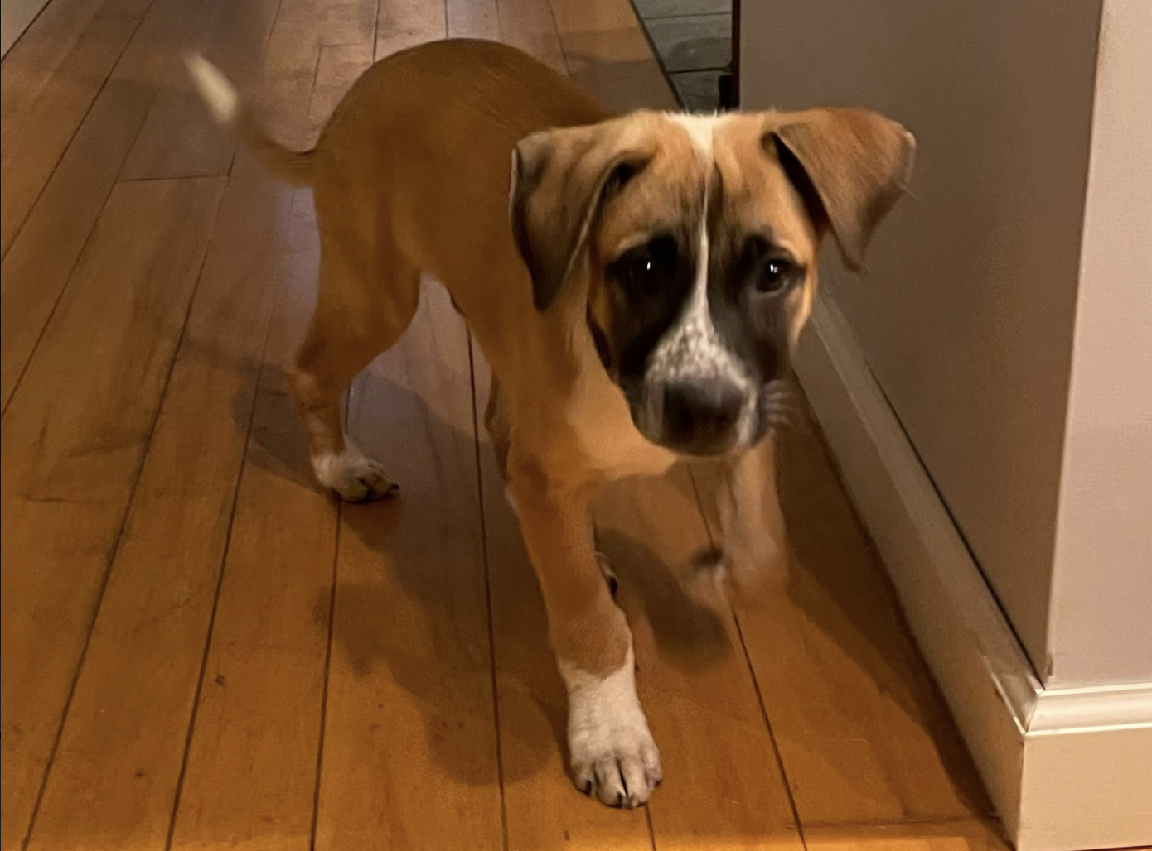
Lori Lisai (RF15) & family welcomed Rico (Puerto Rican street dog aka Sato) last Friday.

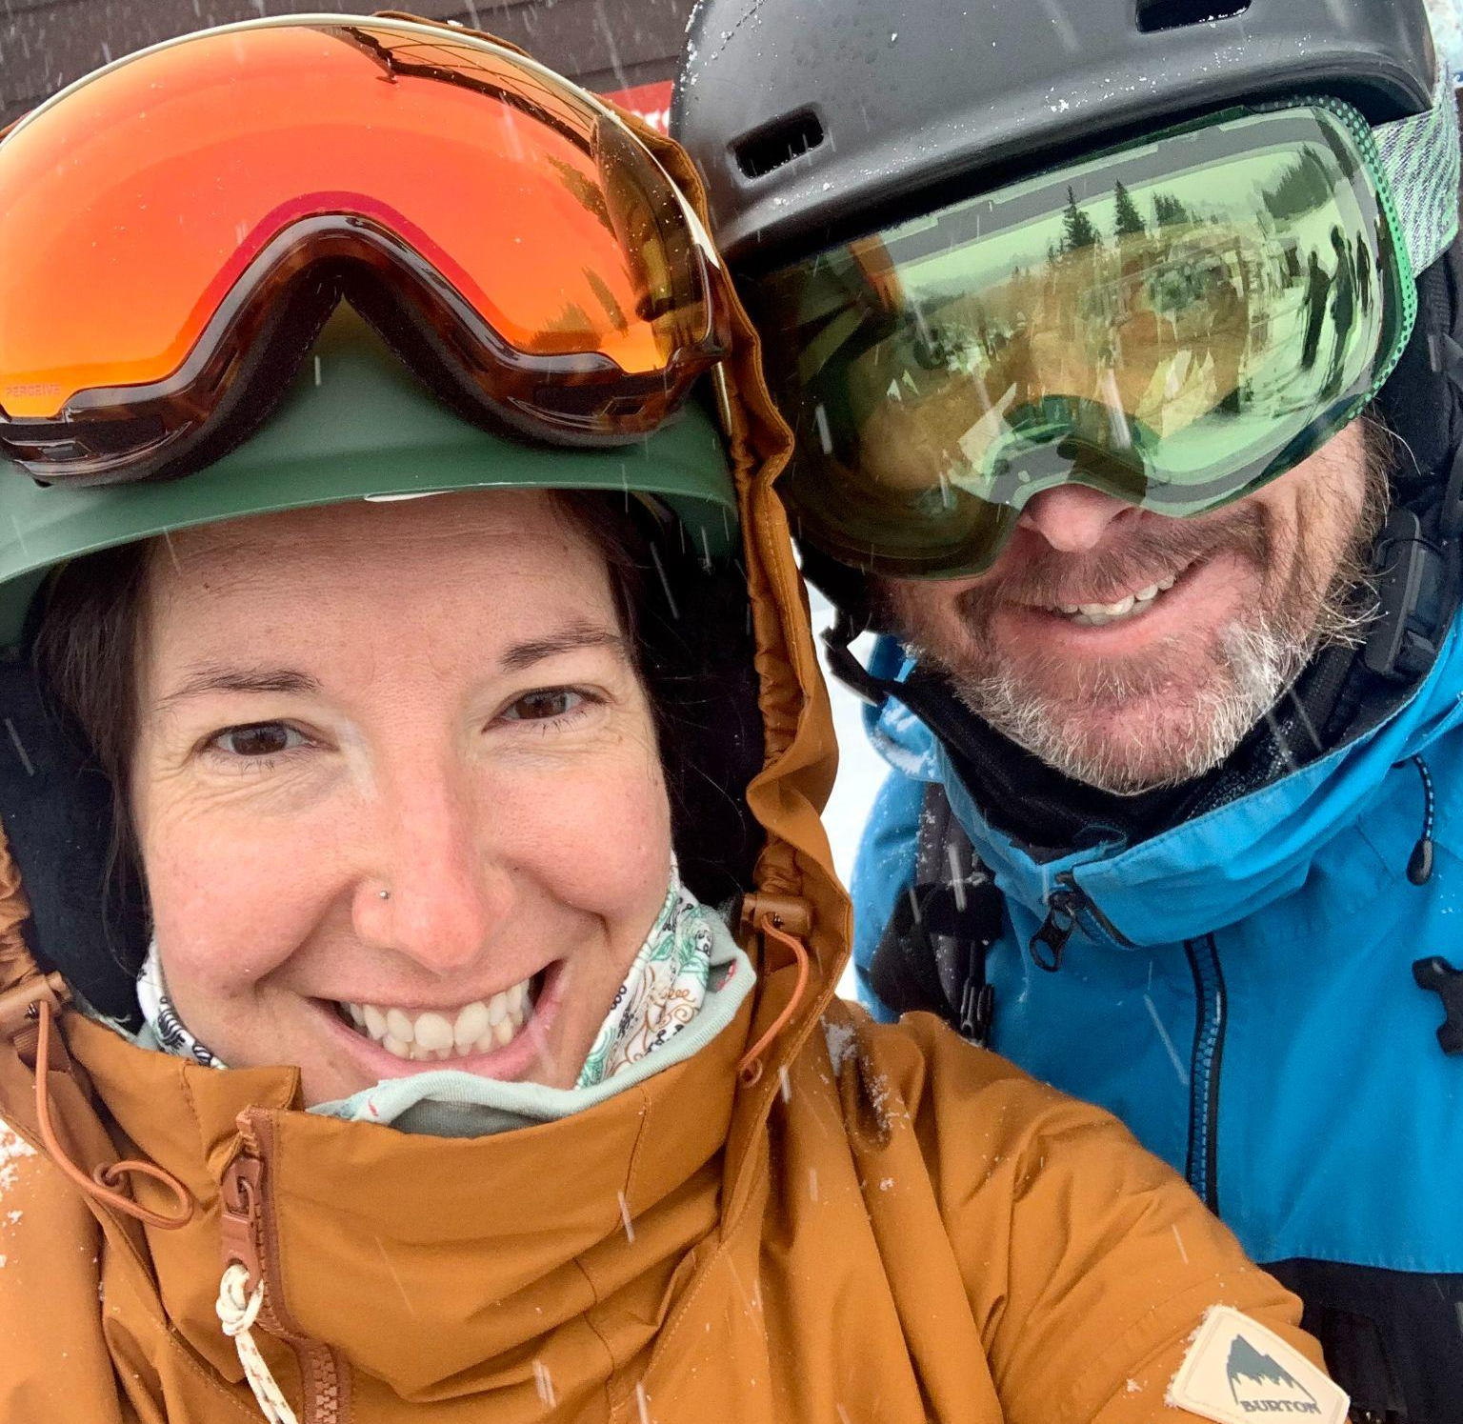Tara Cariano (RF18) & husband Jeremy had a wonderful time riding fresh POW in Utah over February break. Seen here at Brighton, they also visited Solitude and Snowbird.


John Painter (RF14) is seen here with good friends and fellow adventurers on their annual expedition to the Chic Chocs in Gaspesie National Park.
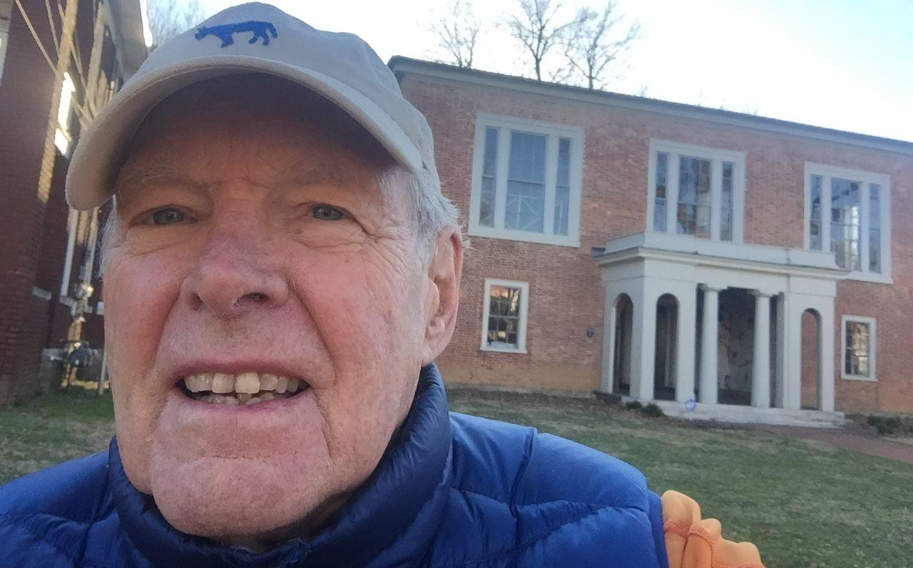
From Dan Rowland, seen here in front of the future home of Civic Lex, the Lexington, Kentucky-based non-profit of which Dan is President Emeritus, “Working with the Rowland Foundation has been one of the great pleasures of my life. Rowland Fellows are some of the most inspiring, impressive people I have met in my 80+ years. I am very, very grateful for the chance to know many of you!”

Celebrations
Sandra Mings-Lamar (RF16) is celebrating a new home for SJA Adult Education. The program will be focusing more on community partnerships. You can read more about her work here (pp. 18-19).

John Painter (RF14), who is South Burlington High School’s Math Curriculum Area Supervisor, has been working hard with his department colleagues to develop heterogeneously grouped math classes. He recently took a team of math teachers to Stanford University for a conference led by the influential author Jo Boaler and also Cathy Williams, who co-founded youcubed with Professor Boaler. “Based on that work, we are well on our way to developing a single, heterogeneously grouped math course for all first year students that will begin with the 2022-2023 school year,” John said.

On the front of civic education, Randolph High School Co-Principals Lisa Floyd (RF15) & Caty Sutton are hosting the next meeting of the Strong Schools Dialogue Series which seeks to foster solidarity among educators committed to strong school communities in a time of polarization. Participants will leave with strategies for increasing 1) trust and mutual understanding among community members, and 2) accountability to healthy, democratic community norms.

Courtesy Postings
From AOE Division Director Jess DeCarolis (RF09):
“While proficiency-based graduation requirements, coordinated curricula, and local comprehensive assessment systems are determined at the local level, state-level support for these local endeavors can help all systems make progress toward our collective goal of educational equity. In service to this goal, the AOE put out for public comment in November of 2021 a set of Equity Spotlight tools across all content areas to provide support and foster coherence statewide, while providing ample space for local input and design. We heard from special educators and directors, curriculum leaders and coaches, students and parents, interventionists and classroom teachers, principals, and librarians. We reworked our drafts based on that feedback and published them in January. You can find the new equity-driven proficiency resources here.

There’s always room for improvement and these are not static documents; they’re kick-starters that can be built upon. Feel free to contact jess.decarolis@vermont.gov if you’ve got some ideas, improvements, resources to share.”

This summer Andrew Jones (RF15) is teaching Leading School Innovation, a 3-credit UVM graduate course that is specifically designed for teachers & administrators leading change in their schools (e.g., Rowland Fellows). If you’re interested in picking up some new change strategies with a colleague or two, this 2-week seminar may be just what you’re looking for this summer. UVM registration is now open! To register, click here.

Brian Boyes (RF 14) will be leading an action-based seminar on Popular Music Educators, June 28-30. This 3 day session will take place at the beautiful Sugarhouse Soundworks recording studio in the Mad River Valley. Co-taught with vocal educator Stefanie Weigand, the seminar is designed to support Vermont K-12 music educators unfamiliar to popular music pedagogy but eager to build their toolkit + expand the offerings for students in their schools. Popular Music Education is an equity-based approach to music learning that leverages authentic learning experiences in which students take the lead with the teacher supporting as coach/facilitator. Thanks to support from the Rowland Foundation, this special no-cost opportunity is open to all Vermont music educators. More info and applications can be found here.

Camel’s Hump Middle School Principal Gretchen Mueller is wondering if there are any Rowland fellows that are in a middle or high school setting willing to share their class schedule outline. You can reach her at: gretchen.muller@mmuusd.org

On a personal note, our son Theo was a student in an early “field test” of the City & Lake experience thanks to Burlington High School’s Year End Studies (YES) program…which was made possible by Gretchen Mueller’s (RF17) Rowland Fellowship work.

