 | Letter to Fellows  Transferable Skills  March 2023

Dear Rowland Fellows,

I hope that your school vacation has been restful and rewarding.

When you ask parents, teachers, employers, and community members what they want for our students they often say the same thing – they want our young people to be strong communicators, problem solvers, collaborators, and critical thinkers. They also want our students to be engaged citizens and lifelong learners.

These learning goals are commonly referred to as transferable skills. There is broad consensus that these skills & dispositions are among the most important and enduring things we learn in school. Transferable skills are applicable across school subjects and across years of school. They are the skills that help you learn. They also transfer across various contexts in school, at work, or in life in general. In many ways, transferable skills are the secret sauce of a successful education.

That’s why I’m so happy that many Vermont school districts are thinking about transferable skills as they update or develop their Portrait of a Graduate this spring. With support from the Great Schools Partnership (GSP) and the leadership of Erica Wallstrom (RF14) & Jeanie Phillips (RF14), many Vermont educators are revisiting their top learning priorities, in other words, the essential skills we want all students to leave school with. This shared examination of the student outcomes we value most –and which skills best serve our students– is critically important, especially in our rapidly changing world.

On a related note, I’m glad that our new 2023 Rowland Encore Grant Team of Andrew Jones (RF15), Jess DeCarolis (RF09), Gabe Hamilton (RF15) & Michael Ruppel (RF17) is looking at ways to strengthen transferable skills in school with their focus on deeper learning. I also admire this transferable skills framework (English & Spanish versions) that Gabe has developed in collaboration with colleagues across school districts, drawing on earlier work from ISTE, CASEL, and Learning for Justice’s Social Justice Standards.

Meanwhile, I’m pleased to share that after presenting at several schools and field-testing some of their strategies, our 2022 Rowland Encore Grant Team (Disconnect/Reconnect) of Carrie Felice (RF13), Anne Bergeron (RF11), Sarah Ibson (RF13) & Lissa Knauss (RF18) will soon publish their findings on digital wellness with support from nationally-recognized researchers and the Boston’s Children’s Hospital. When I think of the challenges that we all share –yes, even grownups!– in regulating our engagement with social media and technology, I tend to think of this team’s work as investigating a sort of super-transferable skill, perhaps the most important metacognitive skill of our time.

I’ve been harping on the importance of transferable skills for a long time now, but don’t get me wrong – I also value rigorous content-based learning that is subject-specific, especially as a longtime French teacher! It’s just that we don’t often teach for transfer in a systemic way in schools, and this makes learning that much more disjointed for students. Here’s a related VPR commentary I wrote back in 2015. Also, Slides 7-33 from this GSP series I did with Mike McRaith (RF13) back in 2018 make some arguments for transferable skills…even if the slidedeck doesn’t include our hilarious dad jokes and banging music samples.

“We need to teach our students skills that computers can’t do,” former AOE Secretary Rebecca Holcombe used to say pretty often. At a time when chatbots are (seemingly) falling in love with journalists and artificial general intelligence (AGI) looms large on the horizon, Rebecca’s challenge seems more complicated –and more important– than ever.

If you think about it, transferable skills are a way to rehumanize school at a time when we need it most. To borrow a phrase, a curriculum driven by transferable skills is a “curriculum with a human face”.

Take care and see you soon,

Mike

P.S. I send this letter out to all Rowland Fellows & Trustees every first Friday of the month. Please consider sending me your news, photos, courtesy postings, and anything else you would like to share with our vibrant network of Rowland Fellows.

Rowland Foundation Updates

12th Annual Rowland Conference Keynote Ross Gay
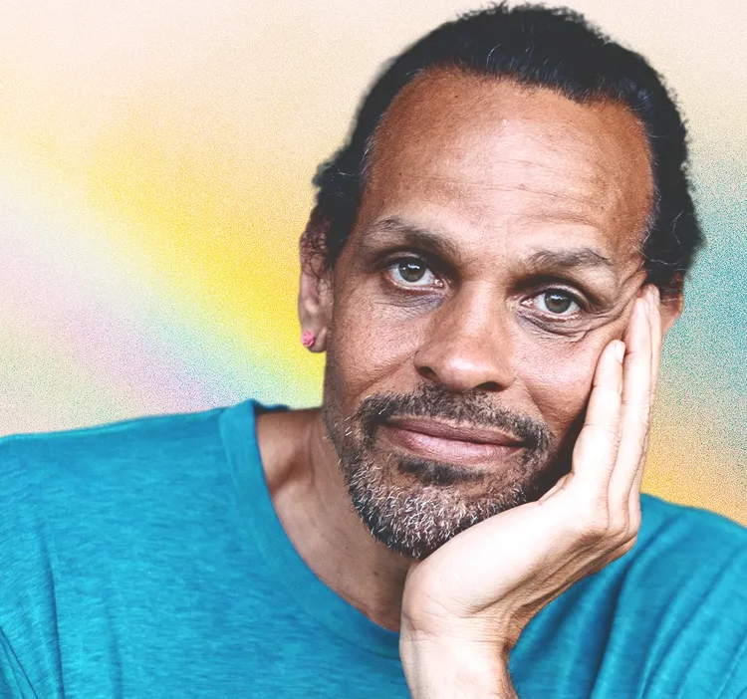
Great news! The essayist, poet, and educator Ross Gay will be our next keynote speaker for the Annual Rowland Conference, to take place at UVM on Thursday, October 26, 2023. Dr. Gay is a professor at Indiana University Bloomington and the author of the New York Times best-seller The Book of Delights. His new book of essays is Inciting Joy. Stay tuned for our upcoming call for workshop proposals on the working conference theme of Growing Community: Making Space for Joy & Creativity in School.

Introducing the 2023 Rowland Fellows!
The following Vermont educators have been selected by the Rowland Foundation Board of Trustees to make up the 2023 Cohort of Rowland Fellows:

Carrie Gilman Northfield Middle High School (Grade 7-8 ELA Teacher)
"create a youth panel to ensure student voice in inclusive and equitable response to harm, working in tandem with current discipline procedures"

Jessica Kessler Green Mountain Union High School (Grades 7-12 School Based Clinician)
"researching and implementing a schoolwide mental health literacy program"

Lindsay McQueen Edmunds Middle School (Grades 6-8 Health Teacher)
"#1: Design and implement a two-year framework for Community Time that is sustainable, equitable and flexible. #2: Reimagine a Wednesday schedule to maximize student choice and agency."

Adam Murray Essex High School (Grades 9-12 English Teacher)
"interview a large number of my school’s most disengaged and disenfranchised students about what they want school to be...form a student/faculty design team to propose changes to our school and teaching based on the interview data"

Elizabeth Placencia Middlebury Union Middle School (Grades 6-7 Language & Literature Teacher)
"create a mentoring program...that fully supports and sustains new teaching staff"

Christopher Sheehan Twinfield Union School (Grades 9-12 Social Studies Teacher)
"create a program at Twinfield that will help foster increased participation in our democracy by all Twinfield students"

The Rowland Diversifying the Educator Workforce (DEW) Grant
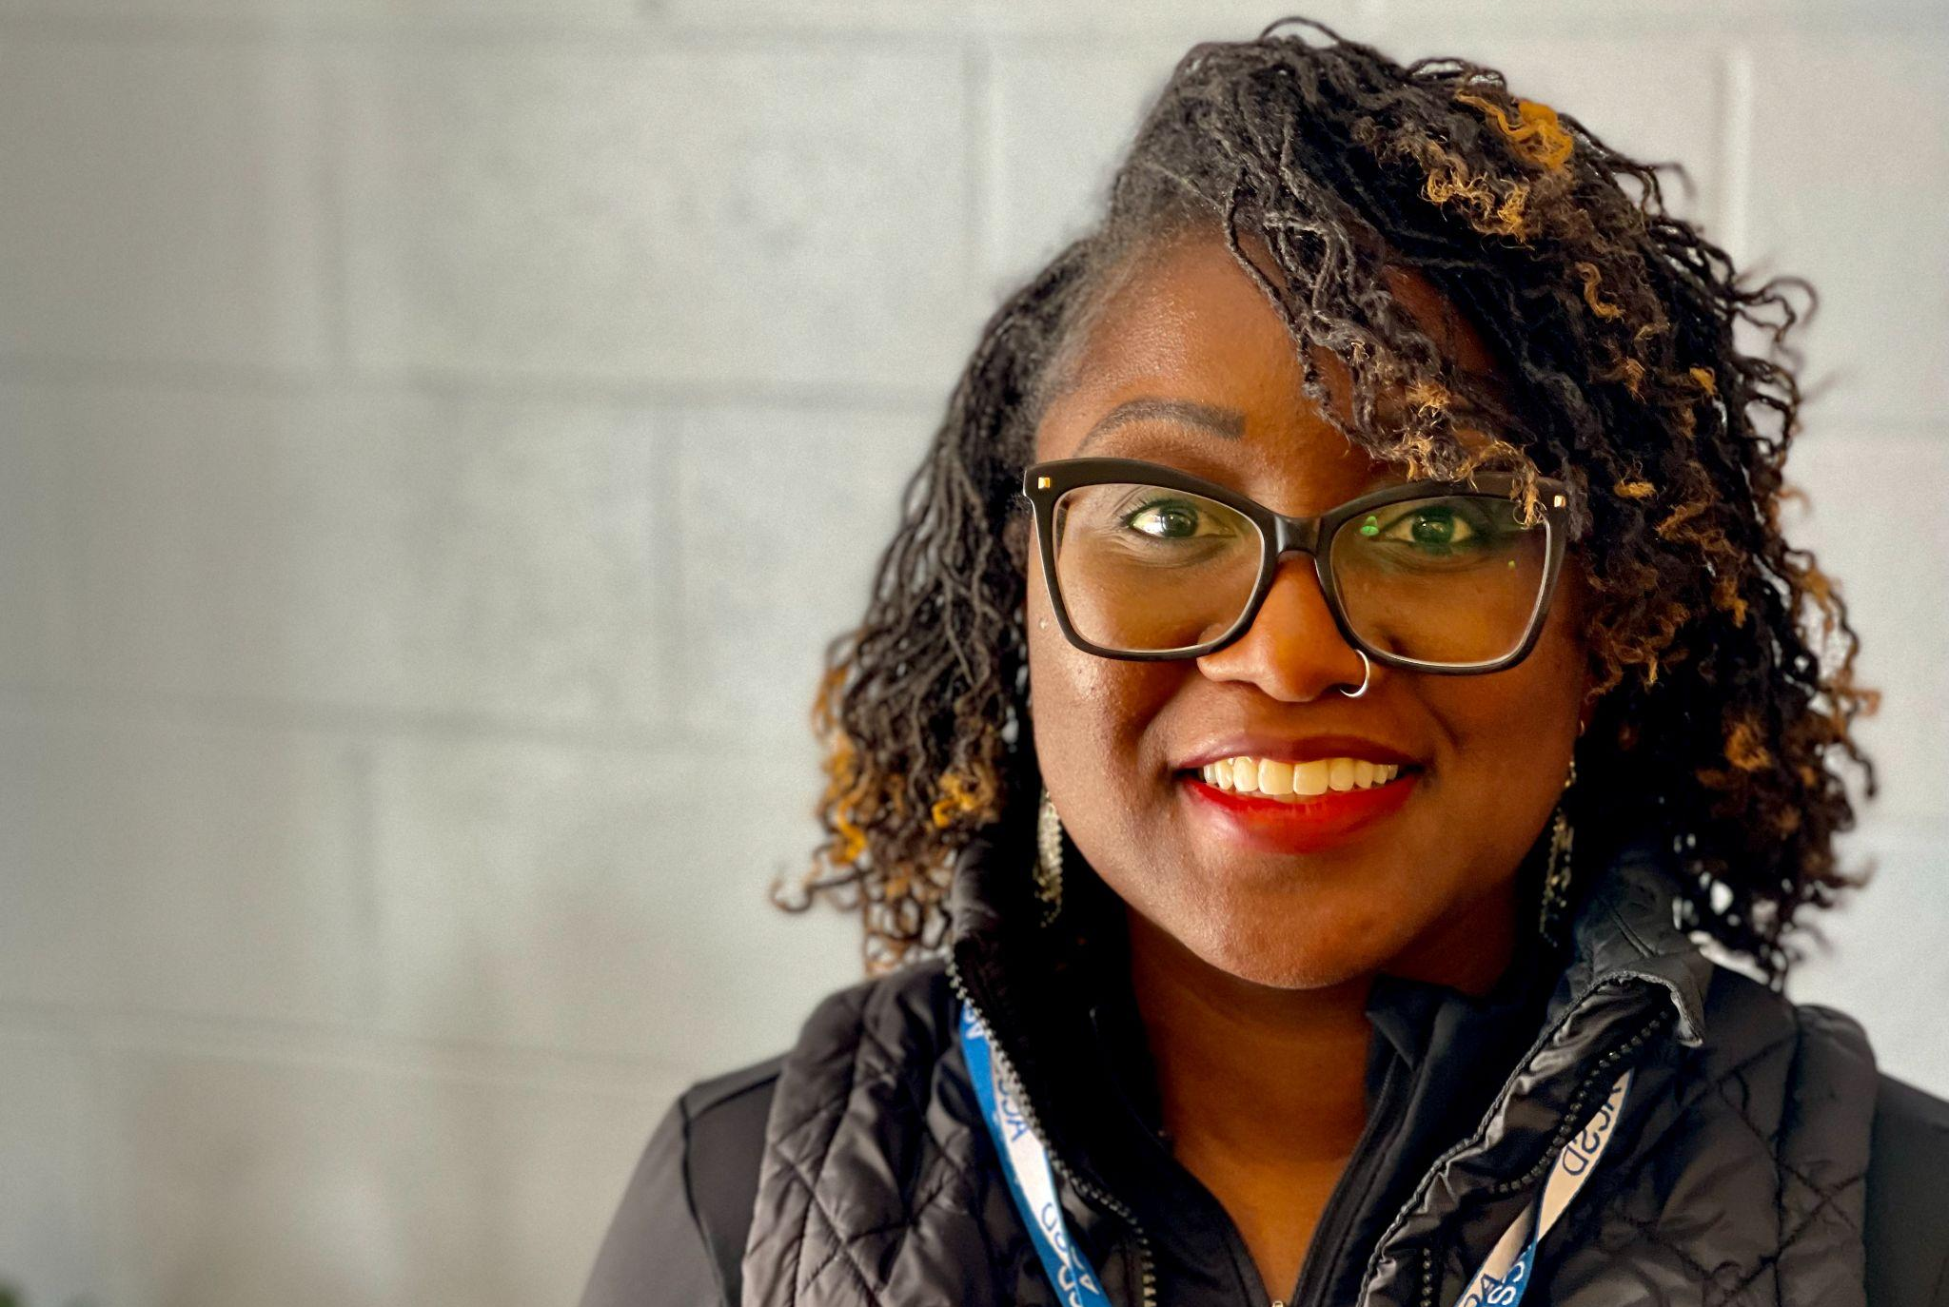
Congratulations to Esther Charlestin, the Dean of Climate & Culture at Middlebury Union Middle School! Esther is a recipient of our Rowland DEW Grant to support aspiring educators of color on their pathways to educator licensure in Vermont. Esther has a background in higher education and is currently serving her school on a provisional license. She joins our other DEW Grant recipients, Safia Haji & Infinite Culcleasure, in mini-cohort meetings this year with our DEW Mentor Bonnie Johnson-Aten.

The Rowland Women Leadership Retreat
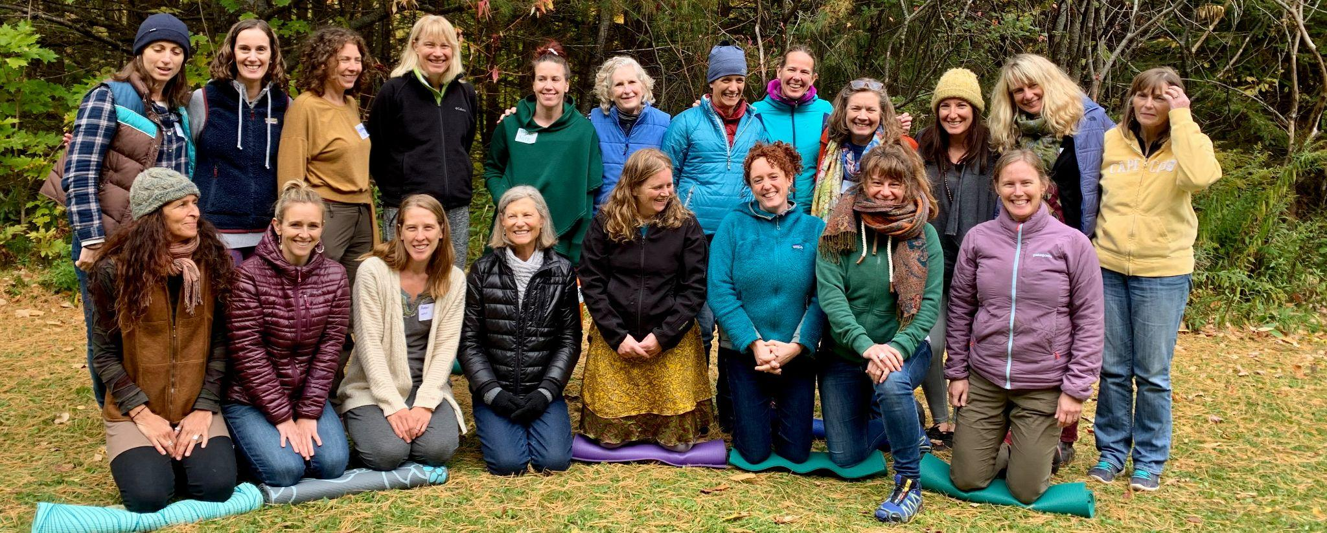
Save the Date! The Rowland Women Leadership Retreat will take place at Basin Harbor on Sunday, June 4 through Monday, June 5. We will be sending out a registration form in March. We hope you can make it! Thanks to all of you who gave input via the planning survey, and feel free to contact Marsha Cassel (RF14), Gretchen Muller (RF17), and Tara Cariano (RF18) with any questions.

New Rowland Encore Grant Team
Congratulations to our 2023 Rowland Encore Grant Team! As mentioned above, Andrew Jones (RF15), Jess DeCarolis (RF09), Gabe Hamilton (RF15) & Michael Ruppel (RF17) will be focusing on deeper learning approaches in their work together. Here is an excerpt from their REG Team proposal:

“Our project supports the philosophy and mission of the Rowland Foundation by focusing on both the technical and cultural aspects of educational change. The concept of deeper learning includes shifts in classroom practice, but more importantly, emphasizes a cultural sea change in how we think about teaching and learning. High schools have historically been siloed by department, with content being taught as isolated domains. This curricular climate not only inhibits the collaboration of teachers across departments, but also restricts how students experience school. Rather than a coherent arc of learning, students experience content in a disconnected manner. A deeper learning perspective focuses not just on content knowledge, but also on transferable skills that transcend any one subject area, creating a more connected learning experience. This can help students see the intersection of different subjects, instead of a fragmented collection of content domains. Simply put, transferable skills can act as a bridge between classrooms and
departments.

As schools begin to intentionally teach and assess transferable skills, students will become more engaged and will undoubtedly experience increased joy in their learning. Rather than perpetuate what Paulo Freire refers to as the “banking” model of education that prioritizes rote memorization of facts and dates, a deeper learning model provides students with opportunities to investigate concepts in-depth. Ultimately, students can exercise more agency in their learning journey, allowing them to pursue topics of interest that are also culturally relevant.”

Gratitude

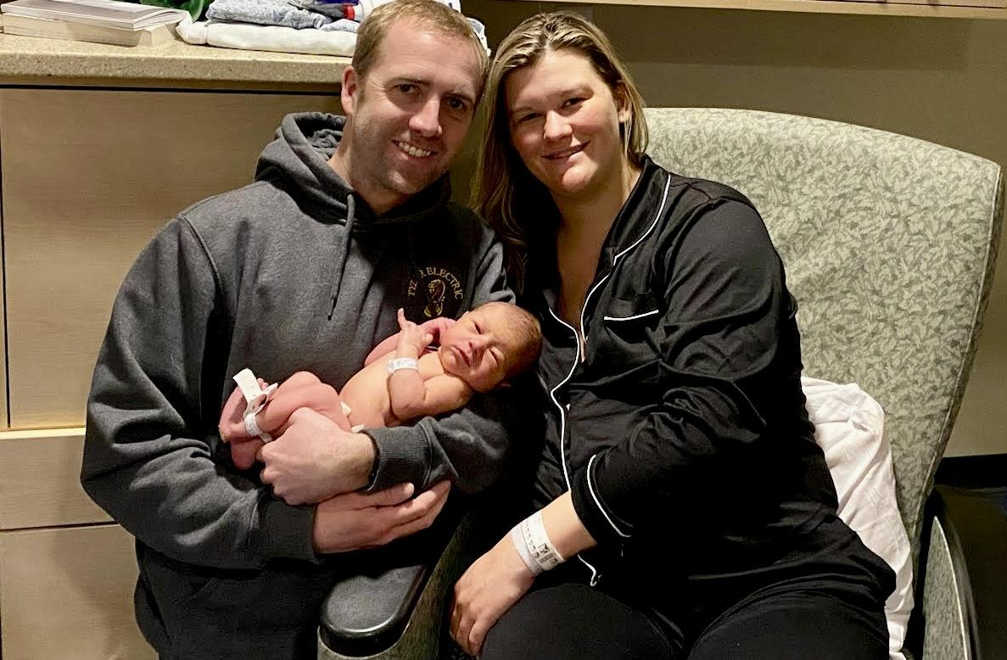
On February 22nd at 8:24 am, Rowland Foundation Trustee & Secretary Carter Rawson and his wife Leanne joyfully welcomed their first child, Ryker Gartner Rawson (7 lbs 11 oz, 20”) into the world.

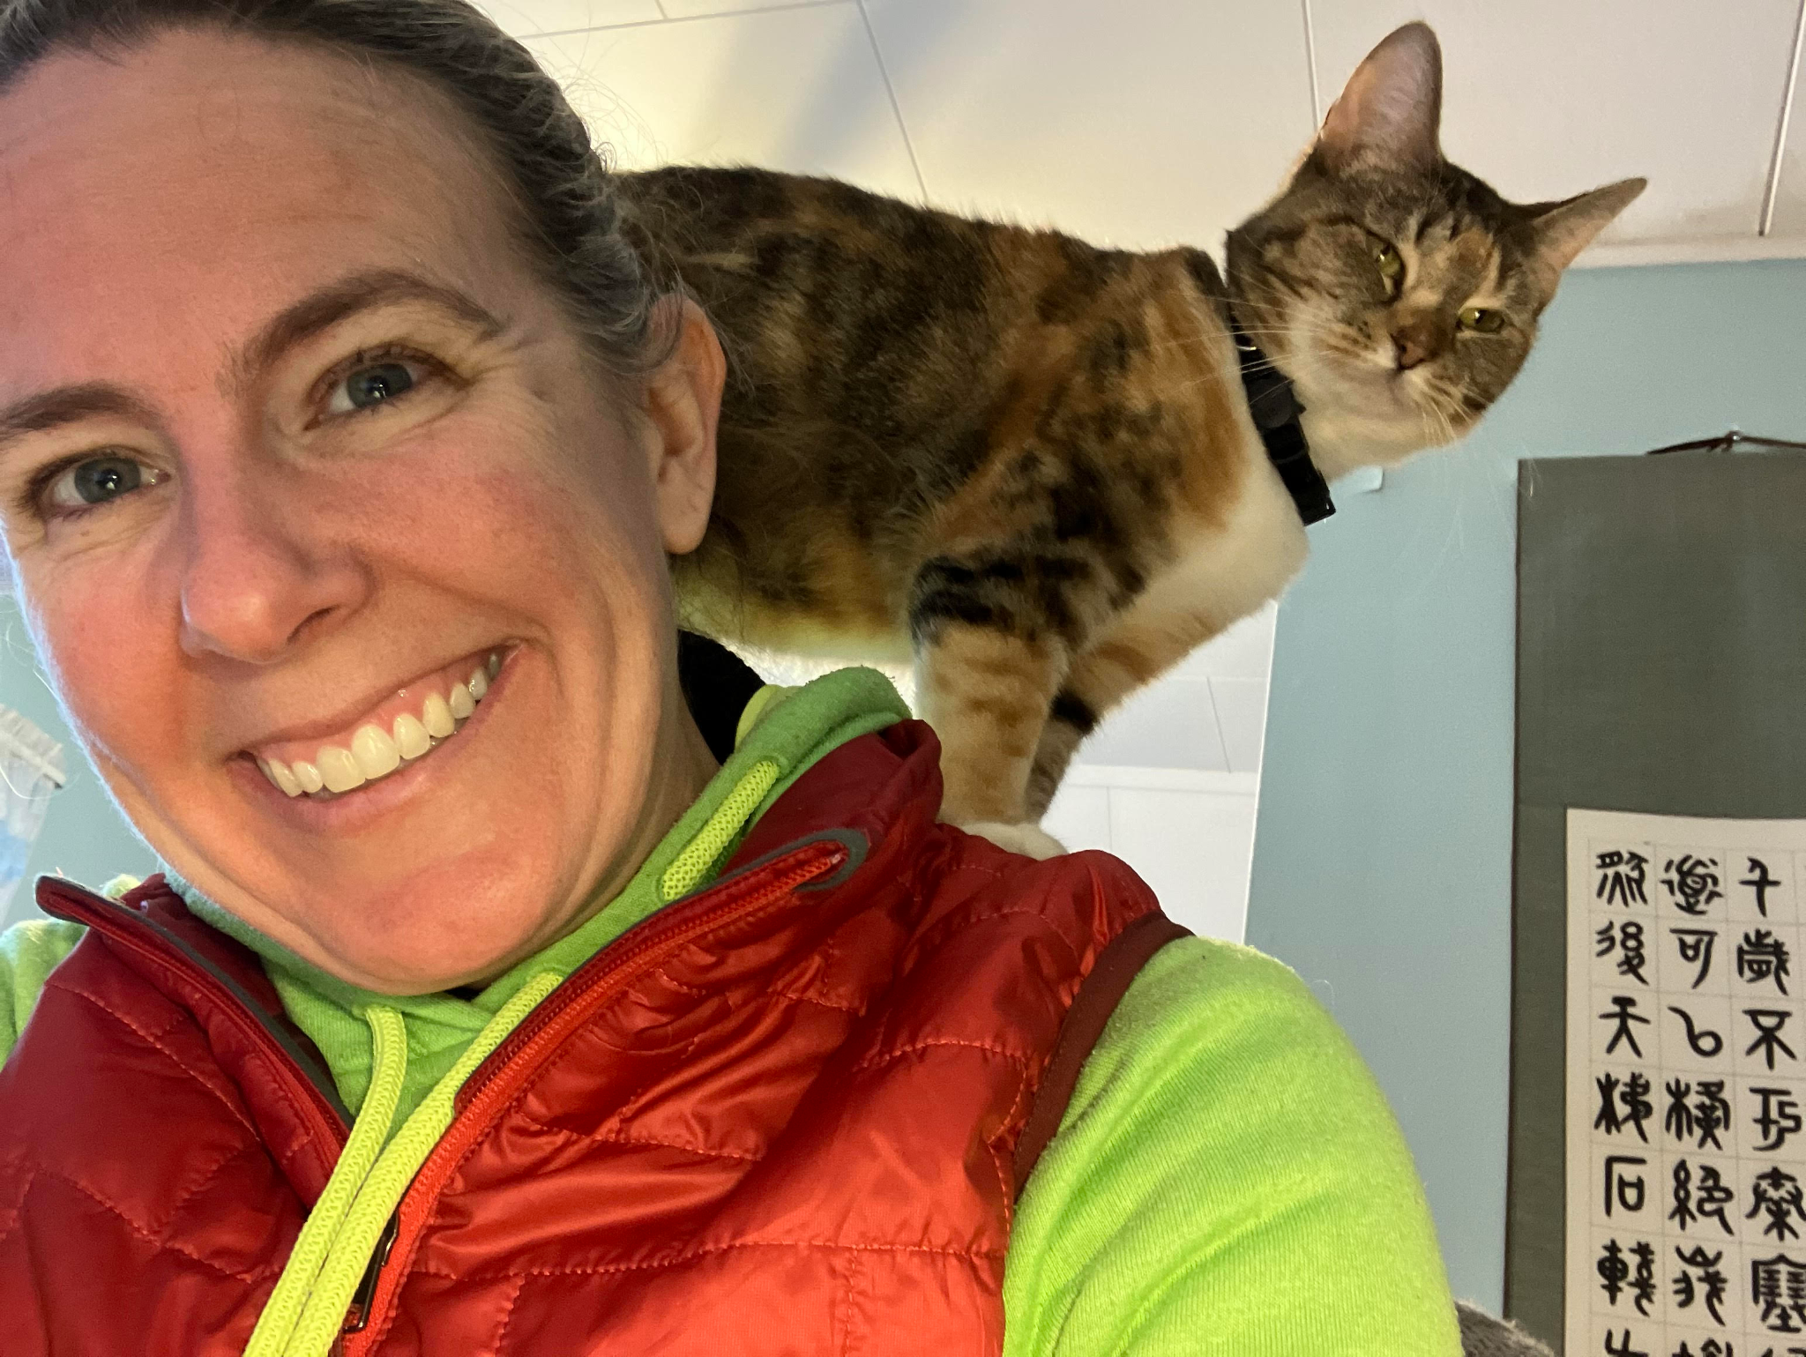
Rowland Foundation Trustee Erica Wallstrom (RF14) brought home the sweet and curious Wren (seen here joining Erica on a zoom call) from the Humane Society during last Friday’s snow day.

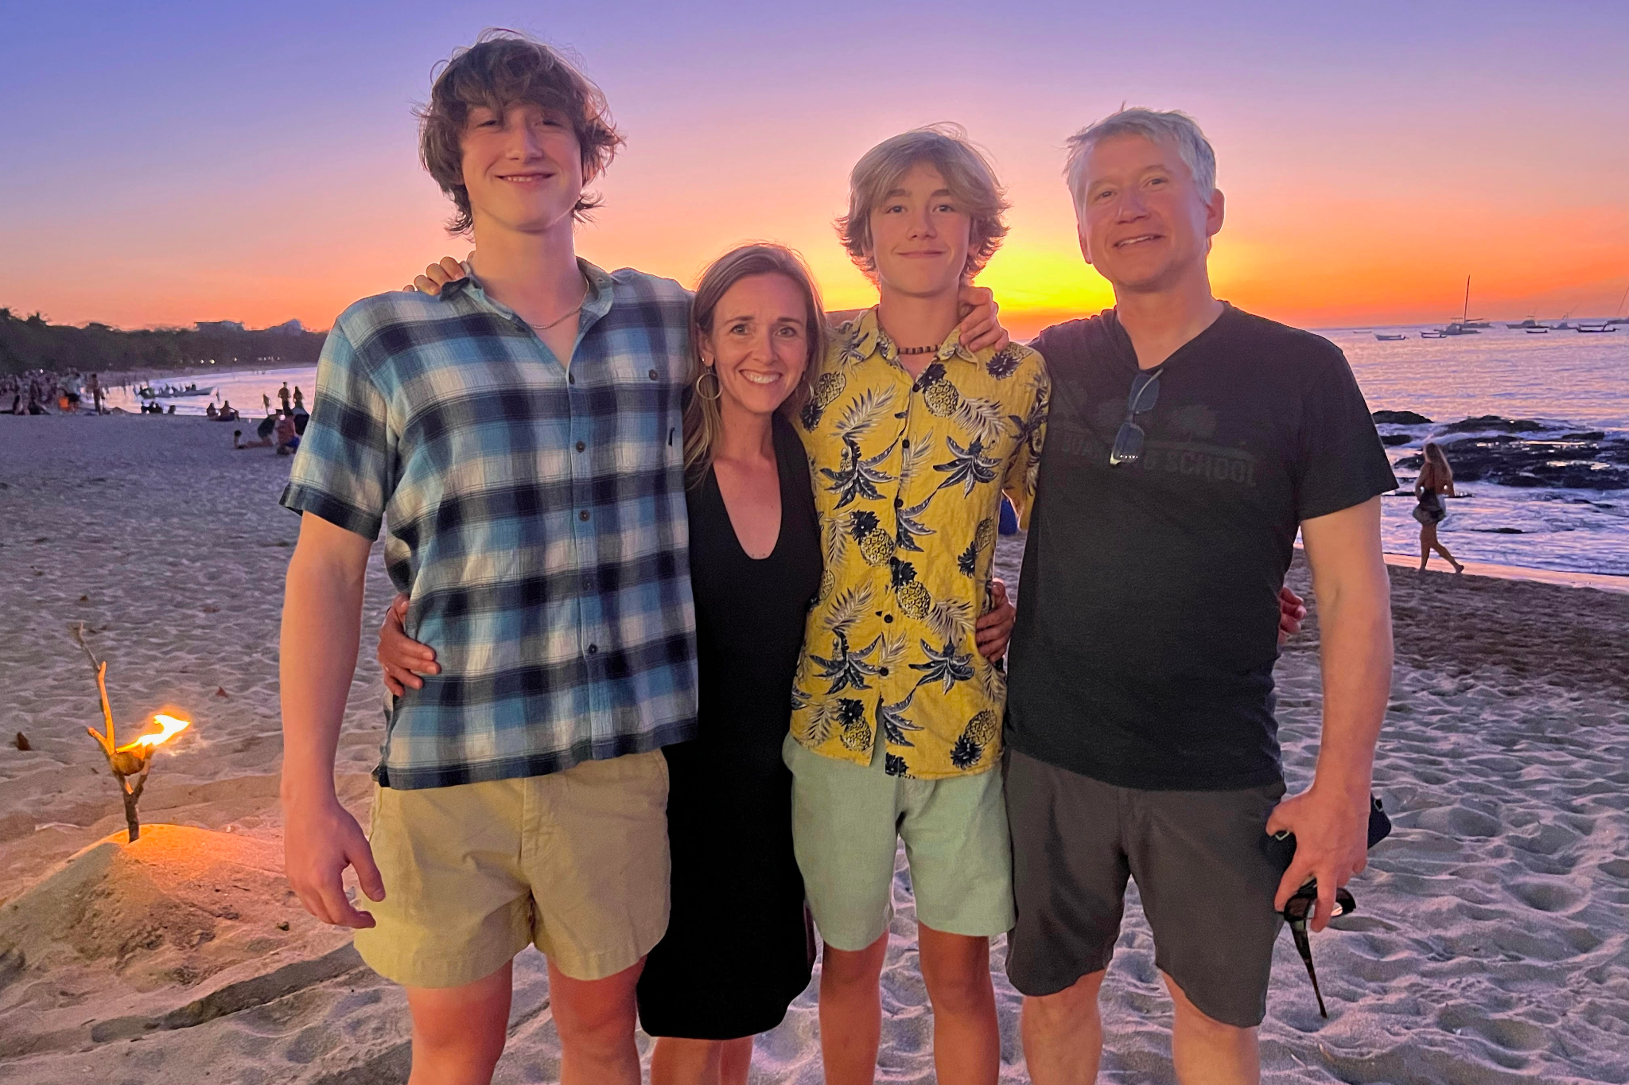
Senior Rowland Associate Lori Lisai (RF15) sends cheer and warmest regards from sunny Costa Rica, seen here with her husband Jason and sons Emmett & Mac.

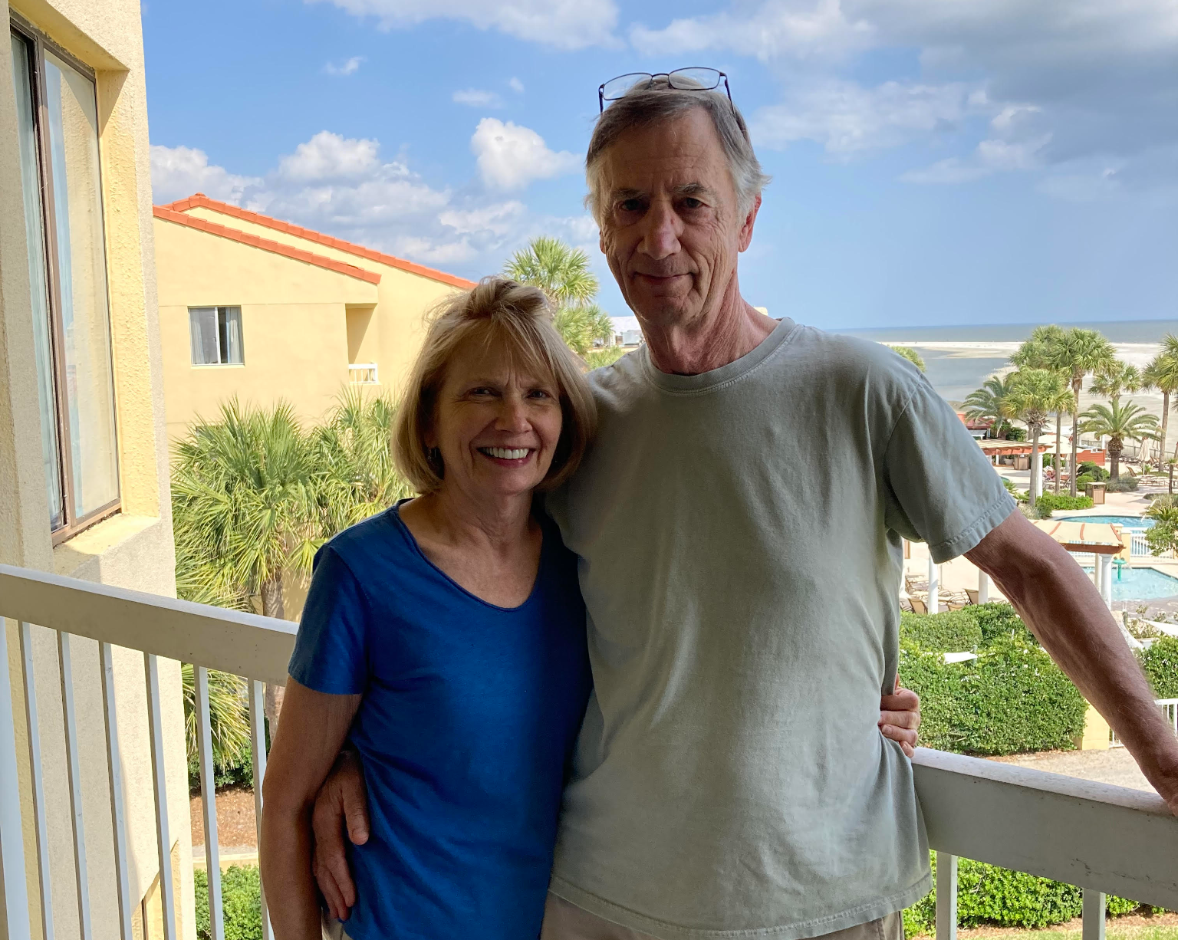
Rowland Foundation Trustee & Past Executive Director Chuck Scranton and his wife Arden, send their love from St. Simon’s Island in Georgia.

Celebrations

Sincere congratulations to Brian Boyes (RF14) who has just accepted the Grades 7-12 position of Instrumental Music & Performing Arts Teacher at Harwood Union Middle & High School.

Congratulations to Kathy Cadwell (RF16)! Her work with the Harkness Pedagogy has earned Harwood Union School District a Magna Award from the National School Board Association.

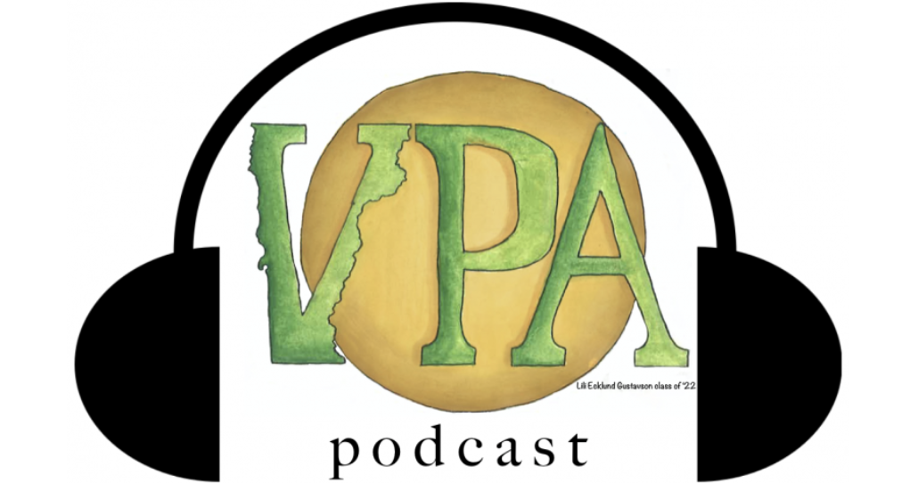
Mike McRaith (RF13) has helped launch a new VPA podcast! If you haven’t listened to it yet, be sure to check out his recent series on diversifying the educator workforce. You can find his latest interview here with Glennys Sánchez, Director of Coaching for Great Schools Partnership.

In a worrisome time of library censorship and attacks on public schools, Jeanie Phillips (RF14) has just written this important and useful blog piece in her work for Great Schools Partnership.

Courtesy Postings

The State of Vermont is hiring for three Truth & Reconciliation Commissioners to serve in this statewide position until June 30, 2026.

The Education for Social Justice Conference: Reimagining Schools, Connecting Communities will take place in South Royalton on Saturday, April 1st, 2023. You can register to save your spot here. Feel free to contact Nicole Awwad (RF21) if you’d like to learn more about this new conference!

If you missed our new Collaborative Practices for Equity course last fall, mark your calendars for the next time it will run with our 2023 Cohort and other Vermont educators: August 16-18, Sept. 25, and Nov. 10. Senior Associate Jeanie Phillips (RF14) will be teaching the course at Shelburne Farms again, sharing wonderful food and a beautiful setting each day. The course is co-sponsored by the Rowland Foundation, Great Schools Partnership, and Shelburne Farms. If you’d like to learn more about this amazing professional learning opportunity, feel free to contact Rowland Fellows from this year’s alumni: Anne Bergeron (RF11), Sam Bromley (RF22), Bryan Dickinson (RF22), Devon Karpak (RF22), Becky Ebel (RF22), Gretchen Muller (RF17), Samantha Mundt (RF21), Anja Pfeffer (RF21), Kat Robbins (RF21), Kerianne Severy (RF17) & Patti Tomashot (RF22).

Dr. Dorinne Dorfman, a former Vermont principal, shares this unique professional learning experience and hopes many Vermont educators will join here to see Literacy Transformation in Mississippi. You can learn more about the work here. Dorinne also shares a detailed itinerary and cost estimate for each participant. You can contact Dorinne at: dorinnedorfman@gmail.com

