 | Letter to Fellows  Stronger Together  May 2022

Dear Rowland Fellows,

I hope this message finds you and your loved ones doing well. In a moment where so much seems to be going wrong, I wish you strength, serenity, and excellent summer plans as this slow Vermont spring warms up.

After some considerable work combing through the data, coding, analyzing, and summarizing, I’m pleased to share with you here a Summary of Results from the All Fellows Survey. I am so grateful for the amazing response rate of 88.6% from Rowland Fellows and for the eloquent and powerful ideas they shared on the survey. Fellows’ ideas about the future of the Rowland Foundation will inform our Board of Trustees’ work at their retreat next week. I would recommend that all Rowland Fellows take a moment to read through the big ideas that surfaced in the data.

While many important themes emerged from the survey data, I’m going to hang on to one big, simple idea that seemed to come up everywhere: we are stronger together. Nearly all Rowland Fellows responding to the survey said that their cohort experience was invaluable and that the network of Rowland Fellows is a vibrant learning community that creates unique opportunities for learning across districts around Vermont. A large majority of Rowland Fellows also stressed the importance of shared leadership in order to succeed, including effective collaboration with administrators, colleagues, students, and other stakeholders–and ensuring that diverse perspectives are always part of the work, that all voices are heard.

Many Rowland Fellows emphasized the importance of developing a culture of collaboration. Fellows underlined the importance of collaborative and reflective practice as an important discipline, including the use of protocols, and many also said they learned that active listening is an essential leadership skill. Time and again, Fellows repeated the belief that the “smartest person in the room is the room” and described how their Fellowship deepened their beliefs and skills in the area of collaborative practice.

Many Rowland Fellows said that they learned that developing trust and strong relationships were critical to the success of their Fellowship work, both in order to motivate colleagues and also in order to enable the risk-taking needed for true innovation. Several Fellows said they learned the importance of humility and vulnerability in order to be open to constructive feedback and foster authentic connections with collaborators.
Many Rowland Fellows also described how hard it is to lead sustainable, systemic change in schools–especially as a teacher leader. And especially when Rowland Fellows find themselves balancing ongoing Fellowship work with teaching duties. And especially in the middle of a pandemic. Please take the time to read responding Rowland Fellows’ terrific thinking about leading change, in their own words, in the qualitative section Summary of Results from the All Fellows Survey. Many Rowland Fellows fully acknowledged the difficulty of systemic change and also had brilliant ideas for facing up to the challenge. Paraphrasing below, here’s a sneak preview of some the strategies that Fellows found to be most helpful in their Rowland Fellowship work:

- Embrace the journey. The outcomes will always be different from the original vision.
- Bring people into the work early. Stakeholders need to own the work with you.
- Celebrate successes along the way. It sustains change efforts.
- Communication is key. Tell your story widely and often.
- Including diverse perspectives and centering students always strengthens the work.
- Only a culture of collaboration can ensure the work’s longevity. Sometimes the process is also the product.

Thanks again, dear Rowland Fellows, for sharing your honesty, optimism, and incredible insights on the All Fellows Survey. In a time of divisiveness, it was inspiring to read Rowland Fellows’ ideas for building vibrant and equitable school communities through shared leadership.

Take care and see you soon,

Mike

P.S. Please send me your news! Each month, I’m sharing courtesy posts for upcoming courses & events, and also celebrating new jobs, family vacations, and other news from our extended Rowland Family of Fellows. So please email whatever you’d like to share to michael@therowlandfoundation.org

Rowland Foundation Updates

The Annual Rowland Conference: Keynote Speaker Dr. Gholdy Muhammad

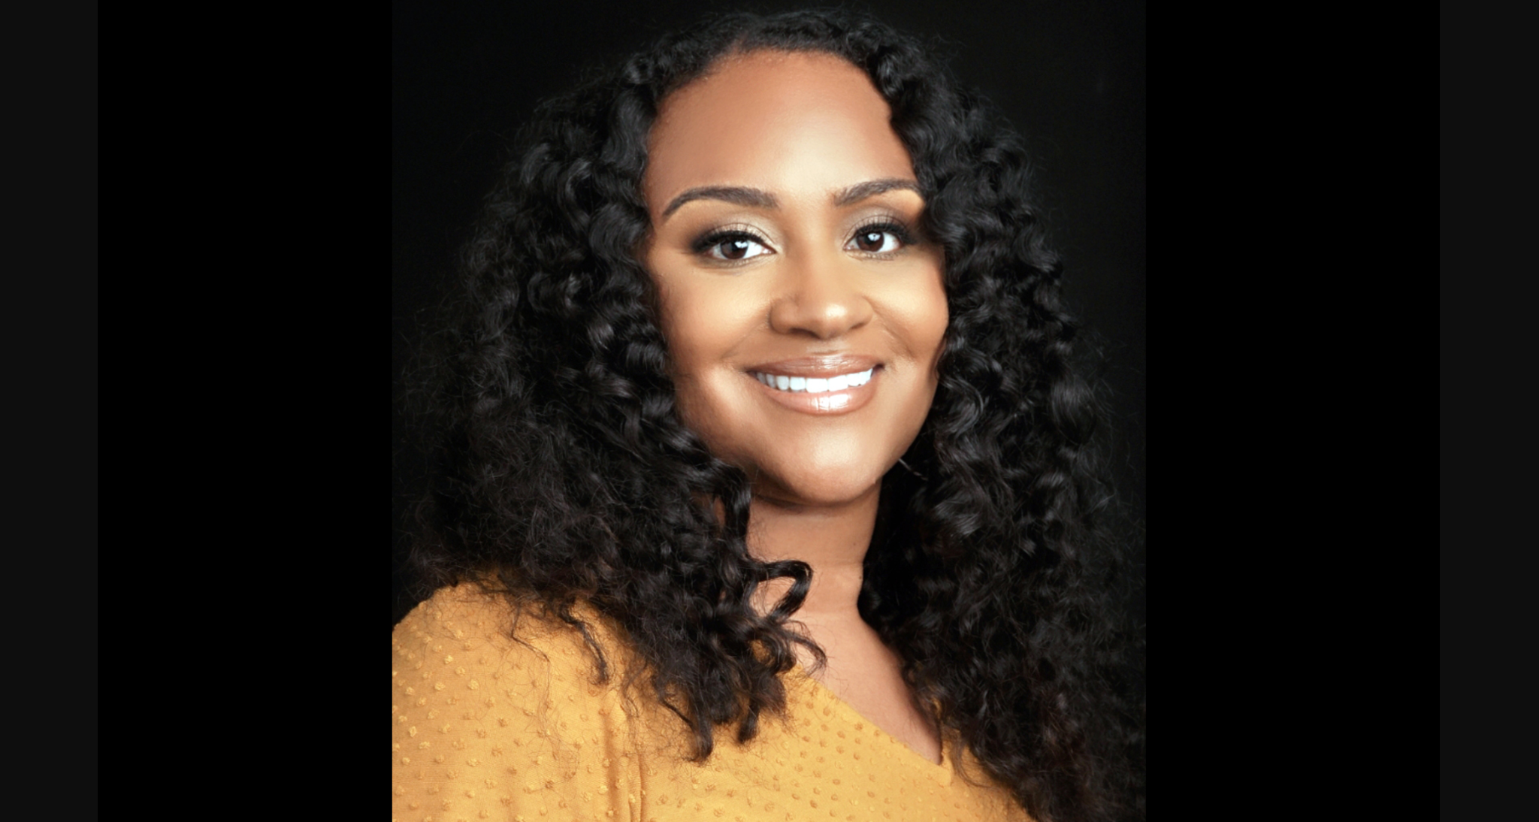

Due to unforeseen circumstances, Dr. Luvelle Brown will regrettably not be our keynote speaker this year as previously announced. However, we are thrilled to share that Dr. Gholdy Muhammad will be! She is a nationally recognized leader in literacy and culturally responsive education.

Dr. Muhammad’s book Cultivating Genius is a seminal work which seems more timely than ever with the recent passage of Act 28, “An act relating to improving prekindergarten through grade 12 literacy within the State,” and also Act 1, “An act relating to ethnic and social equity studies standards for public schools”. As you may already know, the Act 1 Ethnic & Social Equity Standards Advisory Working Group has just submitted proposed revisions to Vermont’s Educational Quality Standards to the State Board of Education.

With Dr. Muhammad as keynote speaker for our 11th Annual Rowland Conference at UVM’s Davis Center on Wednesday, October 26, 2022, we will be looking for Rowland Conference workshops for the conference theme of Cultivating Genius: Culturally Responsive Education. Feel free to submit a related workshop proposal or share the Rowland Conference Workshop Proposal Form with a colleague. Proposals submitted to Mike Martin by June 1st will be given priority for consideration.

Finally, stay tuned for an announcement that early-bird registration is open for RFC22! To make sure there’s room, we will first open registration to Rowland Fellows’ schools for two days before sending the pre-registration link out statewide. No funds are required to pre-register, so be sure to grab a spot for your school/district’s team(s) as soon as early-bird opens!

The All Fellows Survey Results

As mentioned above, the All Fellows Survey provided a wealth of wisdom from Rowland Fellows who generously and candidly shared their ideas and experiences. If you are a new Rowland Fellow, please be sure to read through the qualitative section Summary of Results from the All Fellows Survey for some excellent thinking and strategies relating to leading change in schools. If you are a veteran Rowland Fellow, you should do the same! This is a short compendium of significant learning from a remarkable group of teacher leaders who share an ethos of collaboration, innovation, and shared leadership.

So, you’ll definitely want to read the Summary of Results from the All Fellows Survey, but in the meantime here are a few more highlights…

The top three words Rowland Fellows used to describe their experience were:

- transformative (or transformational) 20 responses
- inspiring (or inspired) 14 responses
- empowering (or empowered) 12 responses

The top three types of gatherings Rowland Fellows would most like to see happen in the coming years were:

- An additional All Fellows Retreat in the spring (42 responses, 54.5%)
- An annual Rowland Women’s Retreat (40 responses, 51.9%)
- Rowland Foundation events designed for Fellows to bring a colleague to expand the network (38 responses, 49.4%)

The top four types of strategies Rowland Fellows would most like to see happen in the coming years in order to meet our mission were:

- Support a diverse educator workforce in Vermont (53 responses, 67.9%)
- Expand the number of grade-levels we serve through Fellowships (e.g., 5-12, pk-12) (49 responses, 62.8%)
- Sponsor research regarding school change initiatives in Vermont (45 responses, 57.7%)
- Produce podcasts, video, or other media to document the work of Fellowships in schools (43 responses, 55.1%)

Upcoming Annual Dinner & Board Retreat


Senior Associates Jean Berthiaume (RF09) & Jeanie Phillips (RF14) at the 2021 Annual Rowland Dinner at the Reluctant Panther in Manchester last fall.

The Annual Rowland Foundation Dinner will be held at the Reluctant Panther next week on May 14th for the induction of our new fellows from the 2022 Cohort:

Sam Bromley, Montpelier High School (Science Teacher)
"provide opportunities for students to be active members in their local food systems and increase relevant engaging learning opportunities"

Bryan Dickinson, North Country Union High School (Math Teacher)
"showing the link between active lifestyles, academics, and future careers"

Becky Ebel, Vergennes Union Middle/High School (Special Educator)
"creating a holistically restorative system focused on the well-being of all school members"

Devon Karpak, Otter Valley Union High School (Technology Education Teacher)
"create an exemplar curriculum and program for a CTE connected pathway at OV for 7th-12th grade"

Patti Tomashot, Stowe High School (Guidance Director)
"create a comprehensive school counseling model for Grades 9-12...that includes personal, social & career domains"

After their first year of Fellowship work, Rowland Fellows from the 2021 Cohort will be sharing their work with the evening’s distinguished guests:

Nicole Awwad, Springfield High School
“re-engage (at-risk students) in learning through a process of creating their own pathway to proficiency or graduation”

Samantha Mundt, Twin Valley Middle High School
“using creativity and design thinking to provide choice for students”

Rachel Howes & Brenton Litterer, Winooski Middle High School
“students have a consistent, caring adult, consistent rules, a consistent schedule, a soft beginning and end to the school day, and the chance to personalize their learning”

Anja Pfeffer, Hazen Union School

“Dare To Be Me: prioritizing wellbeing over academics by moving towards a trauma-responsive and whole person approach to teaching and learning”

Kathleen Robbins and Janis Boulbol, Woodstock Union Middle High School
“students are more likely to take lifelong action, and make personal choices that promote sustainable food, forest, and ecological systems, if they have a degree of ownership over their learning”

Please don’t hesitate to contact our newer Rowland Fellows to connect! They may be working in a school just down the road from yours, or working on a Fellowship project that overlaps with your professional experience, skills, or expertise. Don’t be shy–there is no such thing as a “cold call” in the Rowland Fellows’ network.

As previously announced, there will also be a Board Retreat for Rowland Foundation Trustees earlier in the day. Our Trustees’ discussions will be informed by the Summary of Results from the All Fellows Survey as they consider new strategies for the coming years, with our Senior Associates facilitating the day’s work. The retreat will be a unique opportunity for the Board of Trustees to connect as a group, discuss core values, revisit the mission statement, and identify priorities for the next chapter of the Rowland Foundation.

Special thanks to Chair Heidi Lynn for her work with the Reluctant Panther to ensure a safe, happy, and successful Annual Dinner & Board Retreat.

Celebrations


Please join me in congratulating our new Executive Admin Assistant Abby Paige on her upcoming show at Lost Nation Theater, Les filles du QUOI? If you are interested in cultural identities and the inherent conflicts therein, this comedic, bilingual, one-woman show is for you!

Gratitude

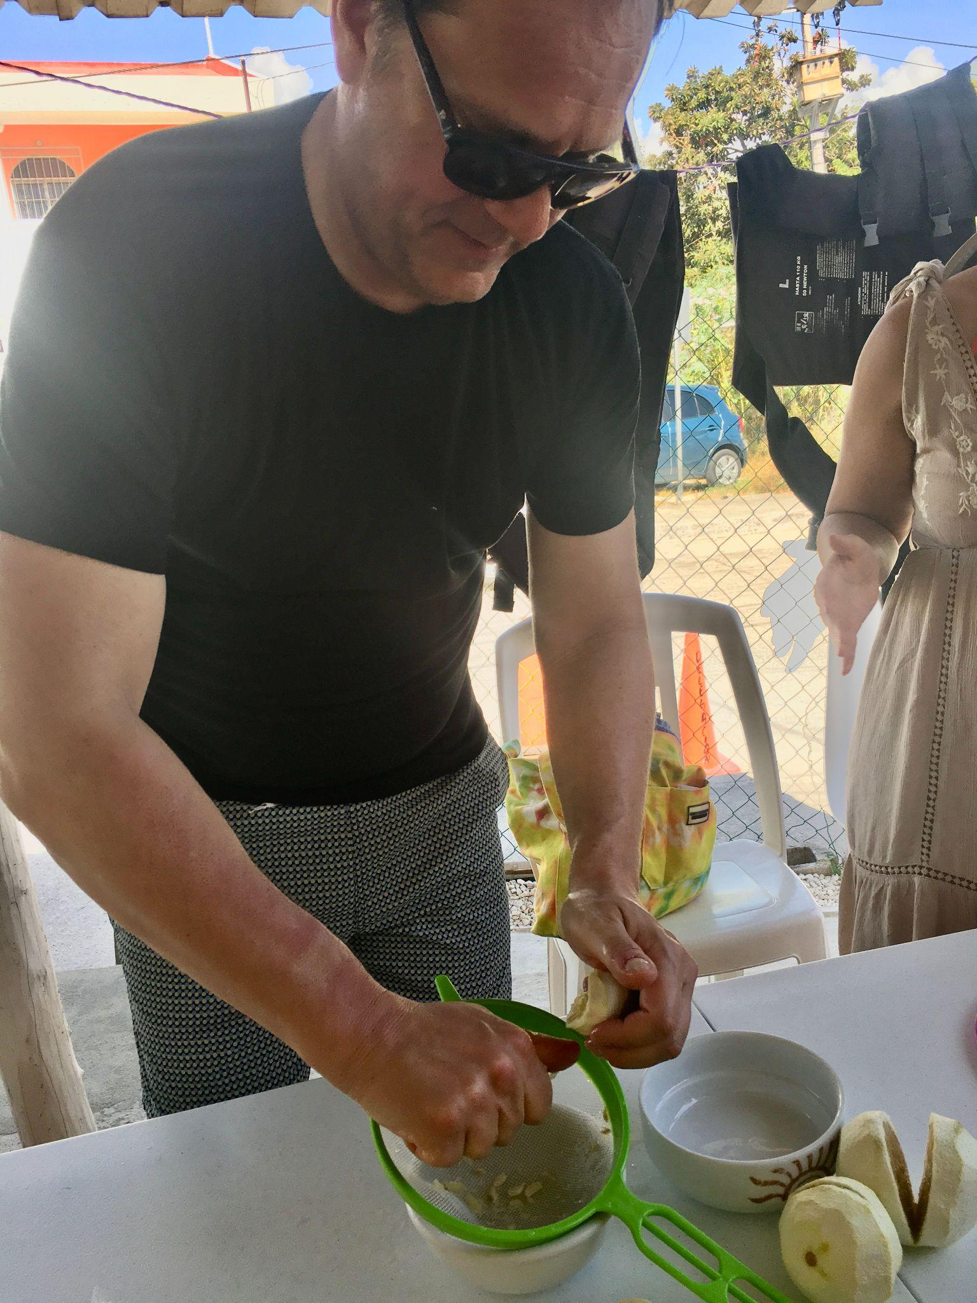
Rowland Foundation Executive Director Mike Martin (RF09) is grateful for a recent trip to Mexico where he attempted to speak Spanish. Seen here learning to make cochinita pibil.

Courtesy Postings

This summer Andrew Jones (RF15) is teaching Leading School Innovation, a 3-credit UVM graduate course that is specifically designed for teachers & administrators leading change in their schools (e.g., Rowland Fellows). If you’re interested in picking up some new change strategies with a colleague or two, this 2-week seminar may be just what you’re looking for this summer. Assuming several Rowland Fellows will take the course this year, it will also be a unique opportunity to connect and learn from each other across cohorts! UVM registration is now open. To register, click here.

