 | Letter to Fellows  November 2021
Dear Rowland Fellows,

I hope this message finds you and your loved ones doing well.

I have to admit that I’ve never been big on ceremony. Maybe it’s the association with pomp & pageantry, or maybe it’s just that I usually prefer casual & informal to serious & formal. After all, saying a role is “ceremonial” usually means that it lacks power or purpose. And “standing on ceremony” evokes a stiff, bloodless approach that’s not exactly creative or inviting. So I’ve never been a big fan of ceremony. Nevertheless, after this fall’s precious in-person gatherings at our rescheduled Annual Dinner, All Fellows Retreat, and Annual Rowland Conference, I think I'm getting a new understanding of the power of ceremony.

“Ceremony focuses attention so that attention becomes intention,” Robin Wall Kimmerer writes in Braiding Sweetgrass, a book first recommended to me by Senior Associate Jeanie Phillips (RF14). Our intention this fall was to warmly welcome our new Fellows into the extended Rowland Family of Fellows and to honor and thank Founder & Past Director Chuck Scranton. In my opinion, everything from the Reluctant Panther cuisine, to the beautiful Let it Grow video from Brian Boyes (RF14), to taking a moment to express gratitude to Barry & Wendy, to continuing Chuck’s Music Trivia Contest, to having Fellows stand up and be recognized in the Grand Maple Ballroom, to our annual photo together, to sharing drinks & toasts with our Trustees, to our habit of hugging instead of shaking hands—all of these traditions and customs help shape our group identity as the Rowland Foundation and define who we are.

In this moment of physical separation, I’m thankful for my new job where a lot of my work is about bringing people and ideas together...which is probably why I have a newfound appreciation for the importance of ceremony now. Looking back on this fall, I am so grateful for the ceremonies and annual traditions that brought us together to reconnect. Deepest thanks to the Rowland Fellows, Associates, Trustees, and friends of the Foundation who helped us convene with purpose and intention.

Unfortunately, we’re not able to create space for ceremony & celebrations together every month, so the question often comes up from Fellows—how can we stay connected during the months in between these events? In an attempt to answer that question, here’s my Top 10 List for Ways Rowland Fellows Can Lead & Stay Involved, delivered as a Letterman-style countdown for maximum effect…

Top 10 Ways Rowland Fellows Can Lead & Stay Involved!

#10 Complete the All Fellows Retreat & Annual Rowland Conference Surveys.
It just takes a minute and really helps us improve the next edition! Surveys will close Nov. 19th.

#9 Share some Twitter Love with Rowland Fellows & the Rowland Foundation.
We need positive vibration in public education right now! @RowFn #vted

#8 Cold call a fellow Rowland Fellow. (Actually, Rowland Fellows are warm.)
Joyscroll the Rowland Fellows dropdown by year, browse the fellowship ideas & schools, and contact a colleague for a consultation, walk, coffee, beer, or whatever.

#7 Hire or recommend a Rowland Fellow (and reference their work).
Proficiency-based or personalized learning? Culturally responsive pedagogy? Sustainability? Site-based learning? Collaborative practice? We have Rowland Fellows with chops.

#6 Use left-over Fellowship funds to inspire and connect Vermont educators.
Some good food at a nice off-campus venue can go a long way...

#5 Write a Rowland Blog entry!
Share your thinking & creativity! It doesn’t have to be a 5 paragraph essay, in prose, or even text! Think spoken word, video, or more images than text. Also, we will provide a thought partner and editing support as needed.

#4 Host a Cohort Reunion!
You know you miss those amazing people. Make a reservation at a restaurant or indoor/outdoor recreation spot and let the fun begin!

#3 Recruit a New Rowland Fellow!
Get a coffee and share ideas with a Vermont secondary educator you admire. Even if they don’t apply this year, you will have validated their work as an educator and get them thinking about innovation.

#2 Submit a Rowland Leadership Grant proposal!
Username: rowland Password: wendyandbarry

#1 Gather your team and submit a Rowland Encore Grant proposal!
Exciting new opportunity to do something big with a team of veteran Rowland Fellows. Only one awarded each year. Contact Mike Martin any time with questions and/or your ideas.

See you soon,

Mike

P.S. Please send me your news! Each month, I’m sharing courtesy posts for courses & events, and also celebrating new jobs, family vacations, and other news from our extended Rowland Family of Fellows. So please email whatever you’d like to share to rowland.foundation@gmail.com

Rowland Foundation Updates
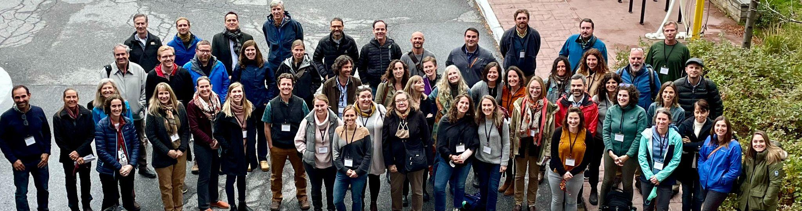
Special thanks to all the Rowland Foundation Fellows, Associates & Trustees who made this year’s All Fellows Retreat on October 26th a very special event

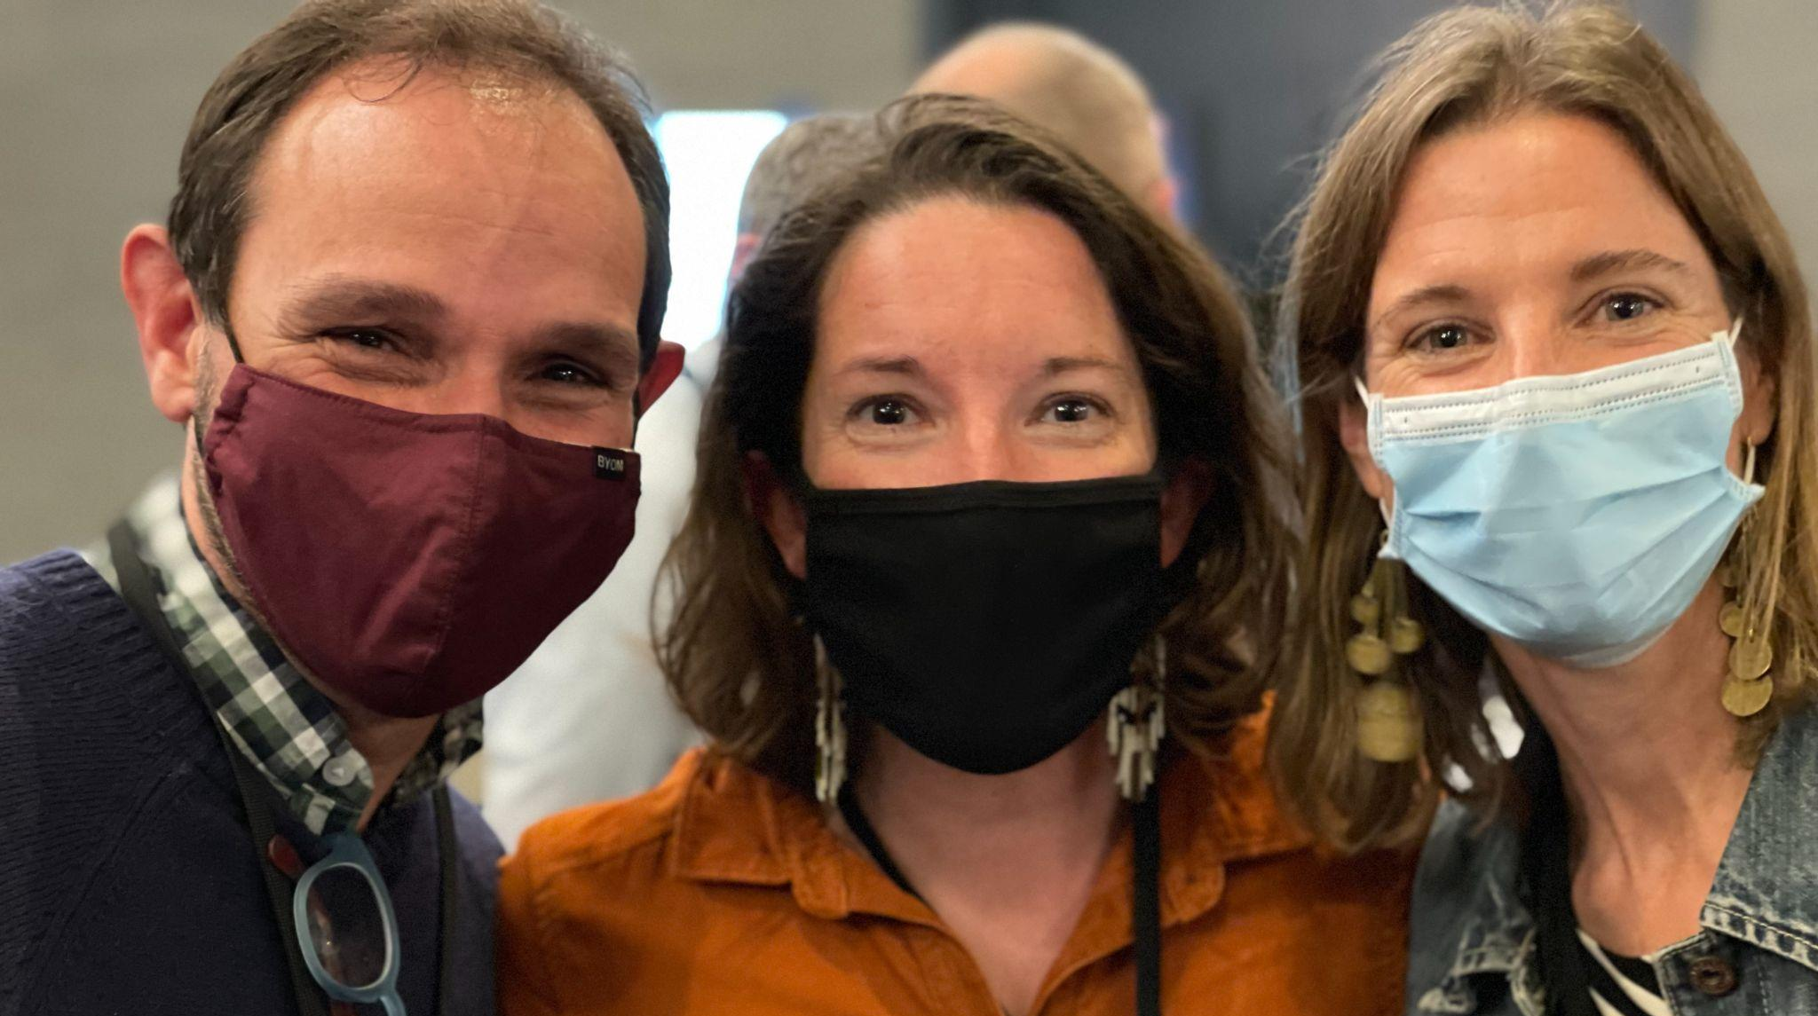
Senior Associate Jean Berthiaume (RF09) with Tara Cariano (RF18) & Lissa Knauss (RF18) at the All Fellows Retreat

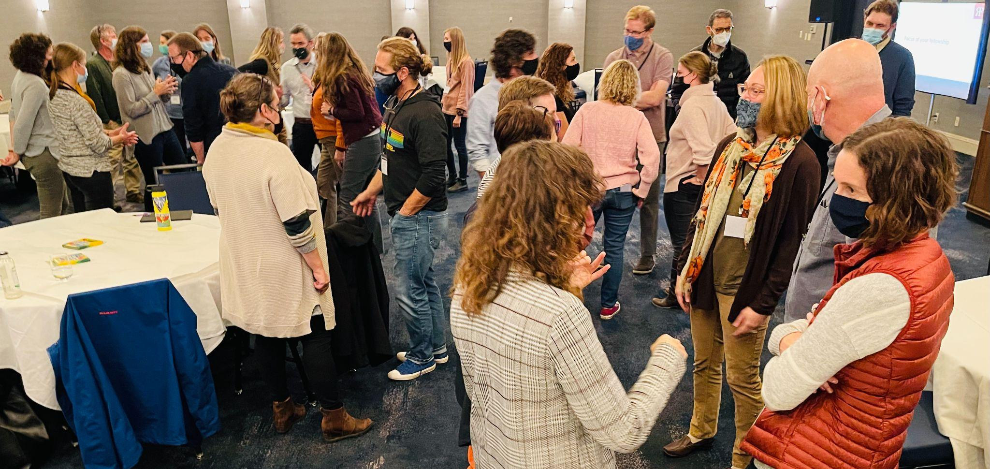
Inter-cohort mixer at the All Fellows Retreat at the Hilton Burlington

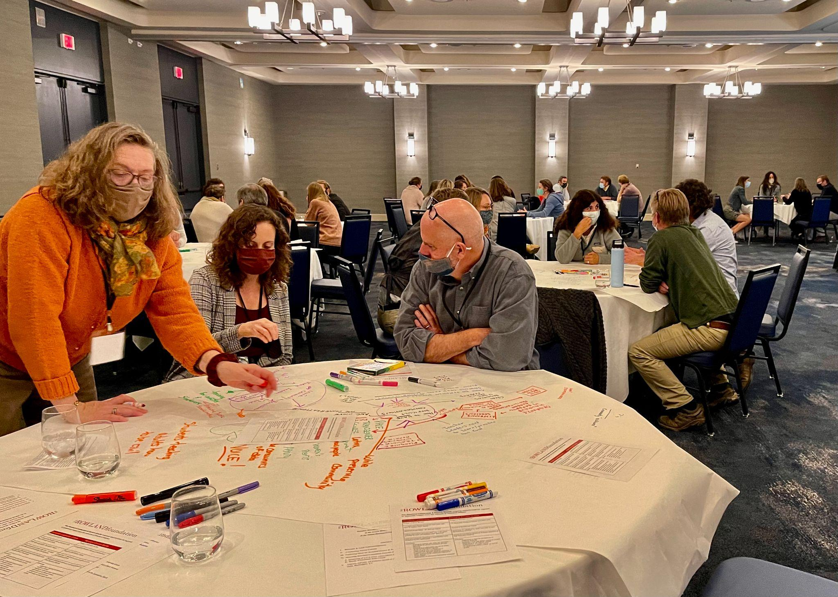
Marsha Cassel (RF14), Lindsey Cox (RF17) & Luis Bango (RF17) sharing ideas in World Café

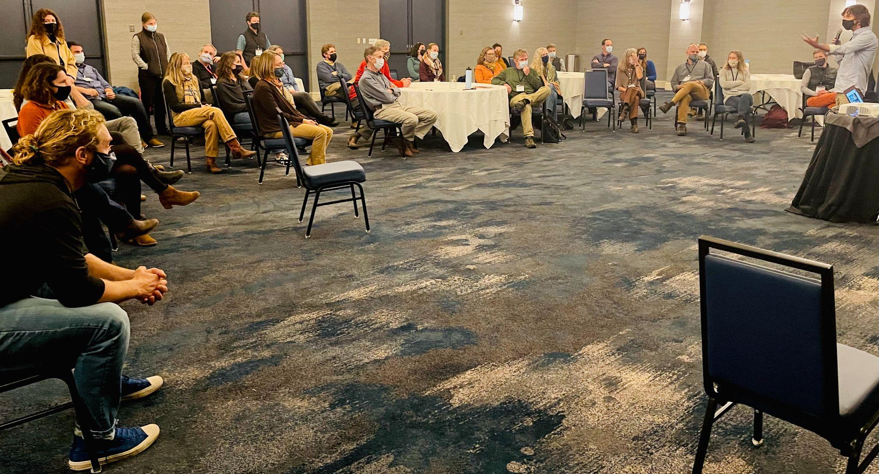
Brian Boyes (RF14) honoring beloved Rowland Foundation Founder & Past Executive Director Chuck Scranton at the All Fellows Retreat

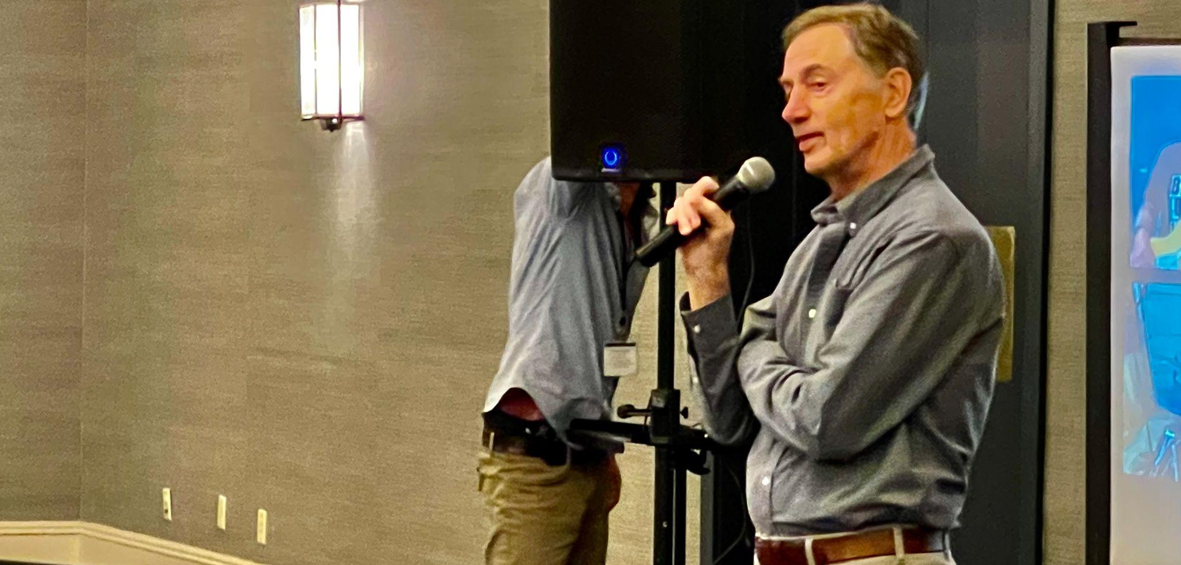
Rowland Foundation Founder & Past Executive Director Chuck Scranton sharing words of gratitude after the screening of the Let it Grow video

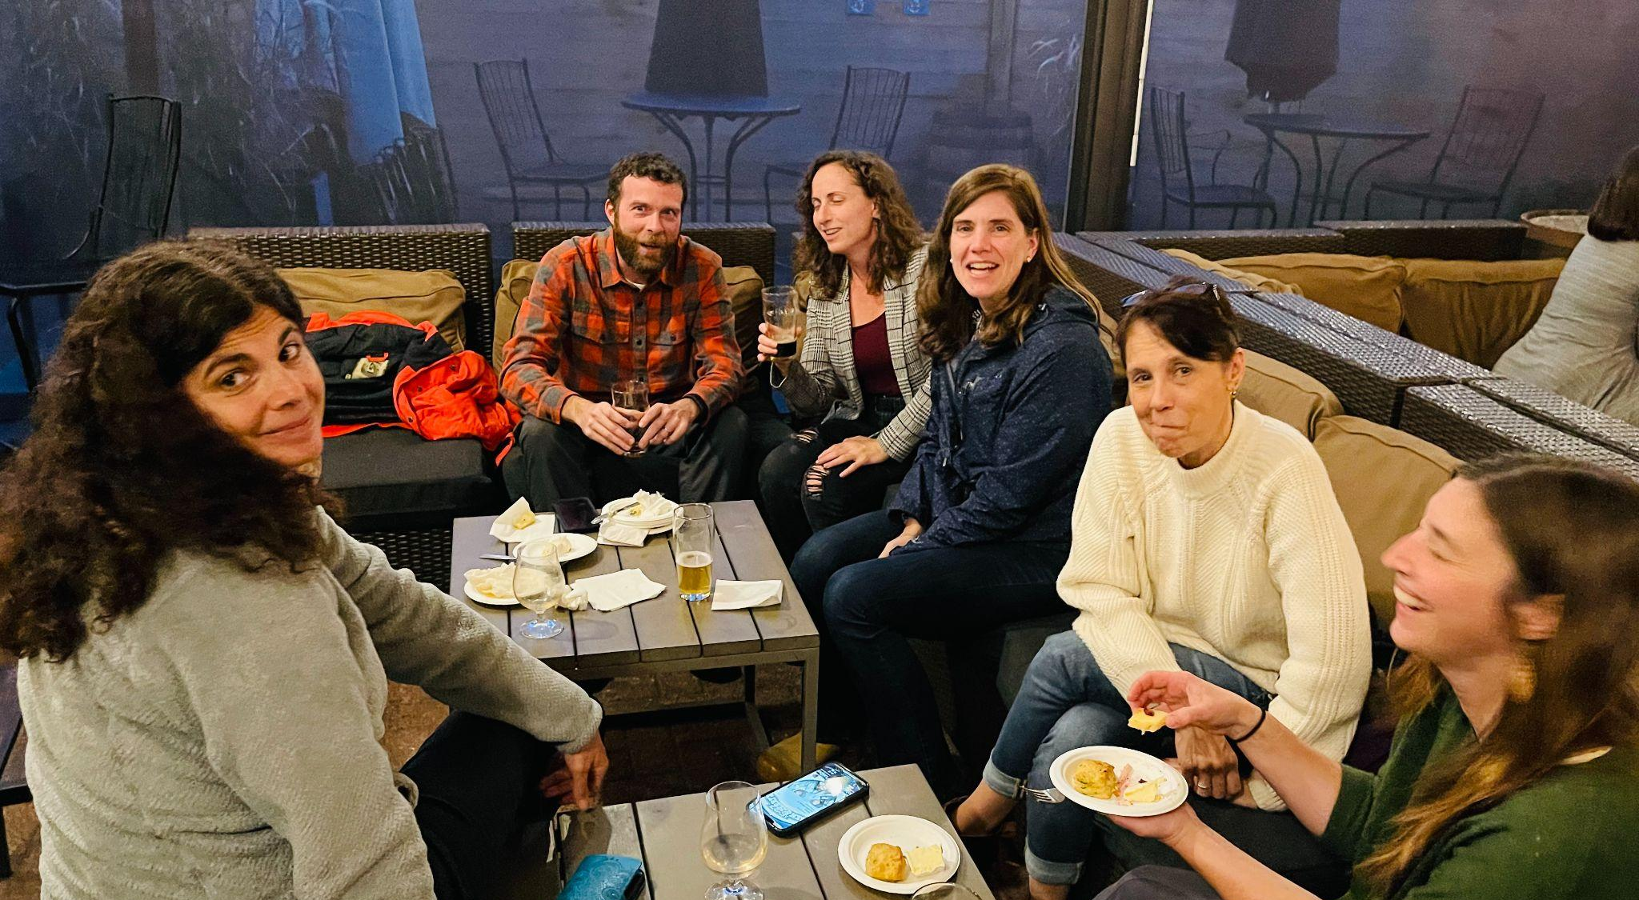
(left to right) Janis Boulbol (RF21), Peter McConville (RF11), Lindsey Cox (RF17), Rachel Howes (RF21), Nerissa Edwards (RF17) & Kat Robbins (RF21) at the Farmhouse Tap & Grill for the All Fellows Social

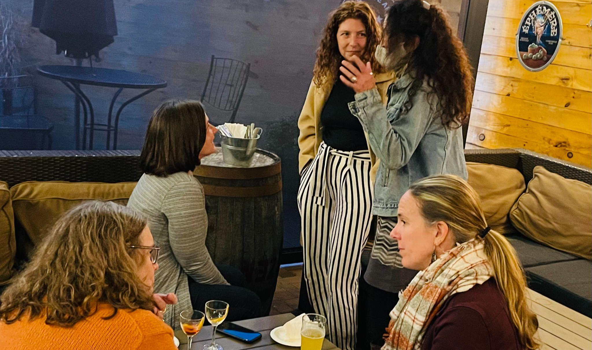
(left to right) Marsha Cassel (RF14), Senior Associate Jeanie Phillips (RF14), Kendra LaRoche (RF11), Anne Bergeron (RF11) & Trustee Erica Wallstrom (RF14) at the All Fellows Social

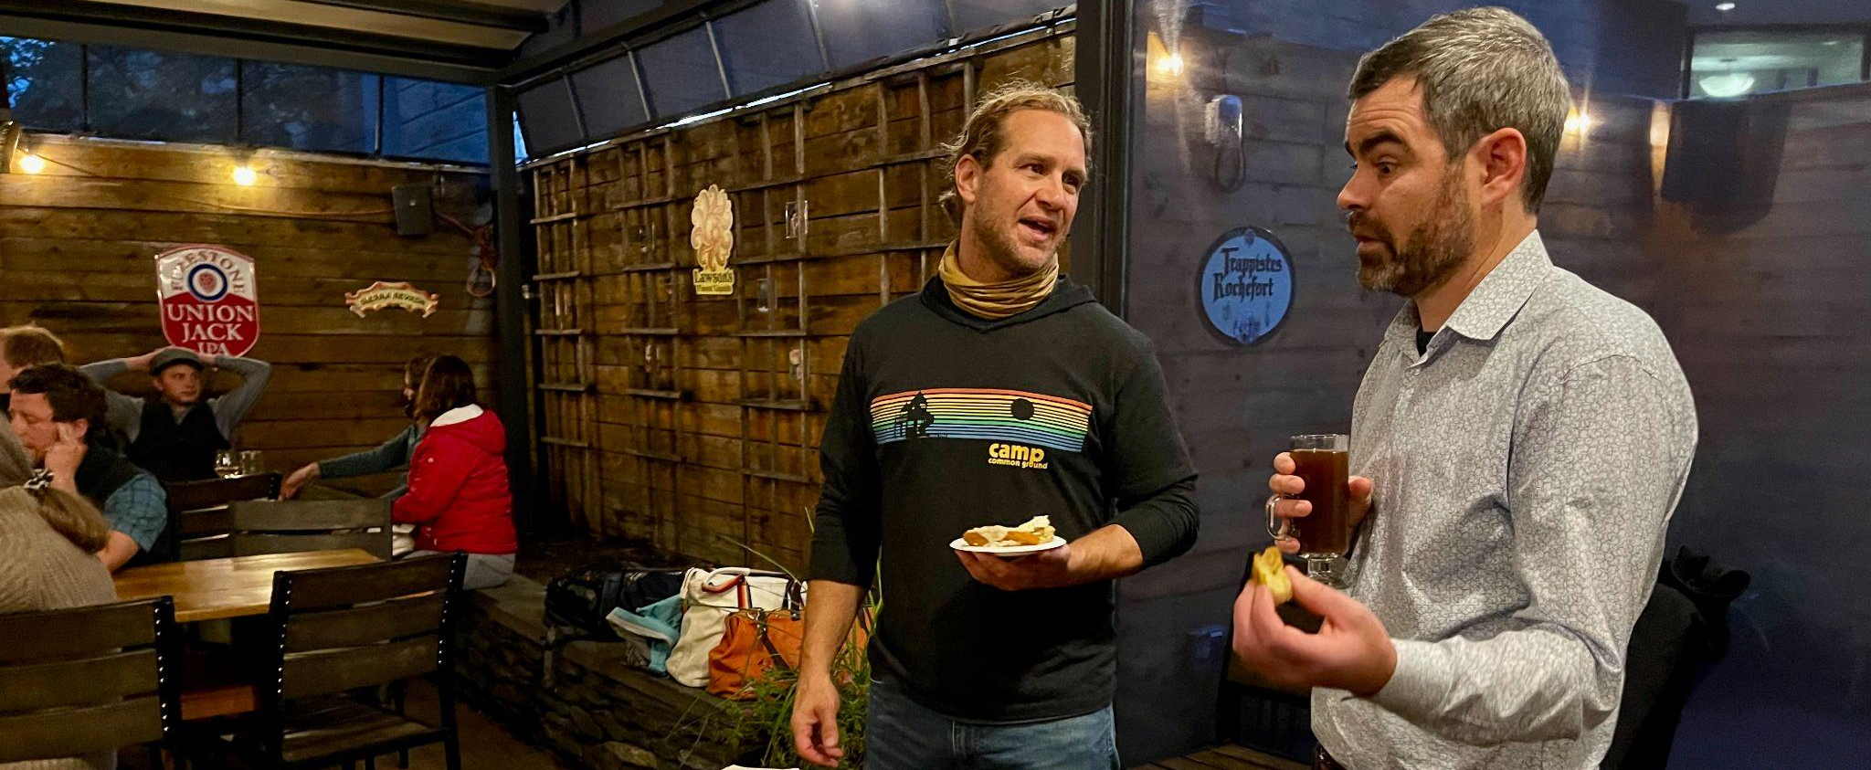
John Painter (Rf14) & Mike McRaith (RF13) in the newly weatherized Farmhouse Tap & Grill Beer Garden at the All Fellows Social

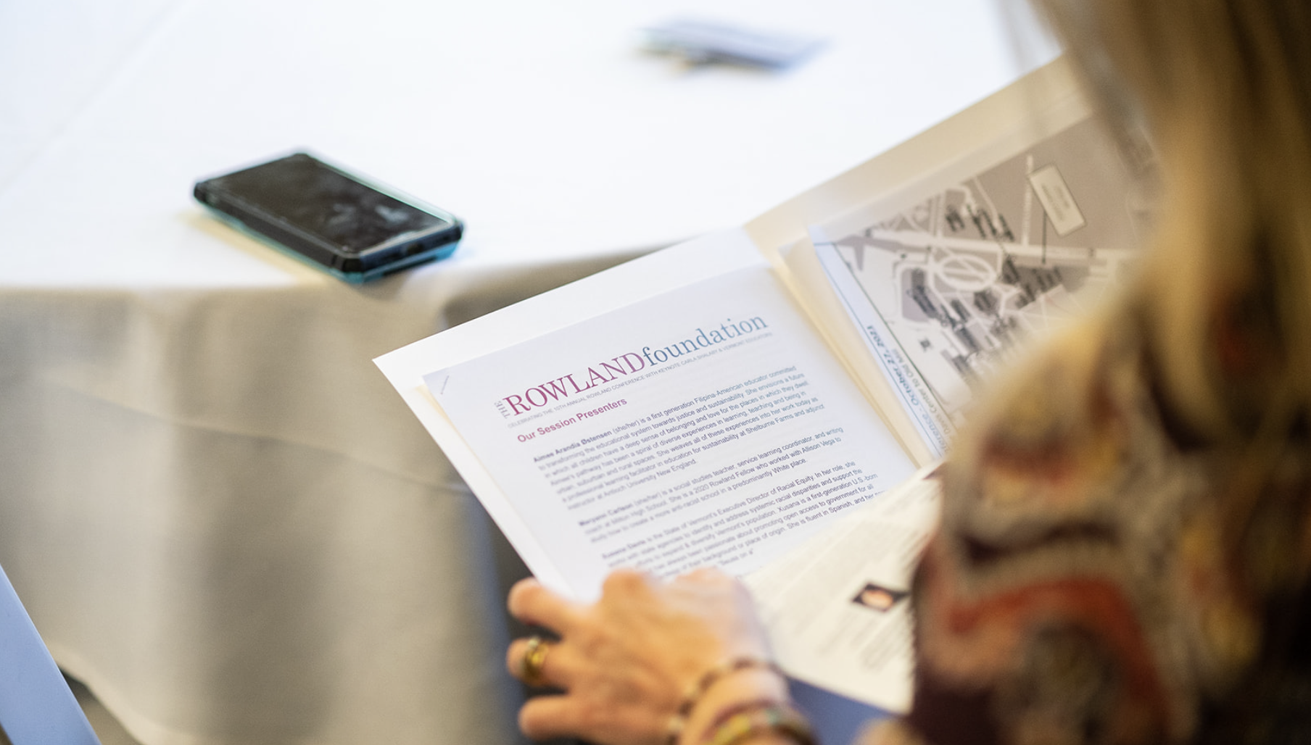Deepest thanks to all the teachers, students, principals, superintendents, administrators, coaches, board members, policymakers, academics, activists, and community members who made the 10th Annual Rowland Conference such a resounding success. : Isora Lithgow Productions

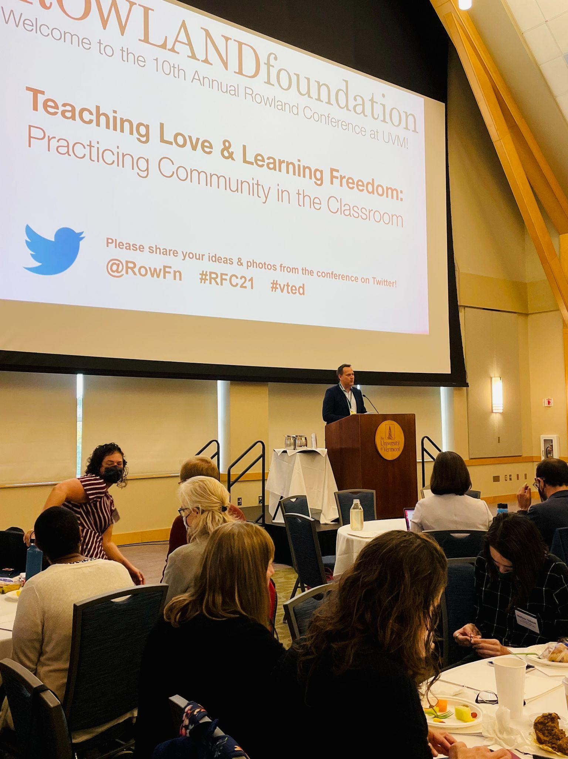
Rowland Foundation Executive Director Mike Martin (RF09) getting things started at the 10th Annual Rowland Conference at UVM’s Davis Center
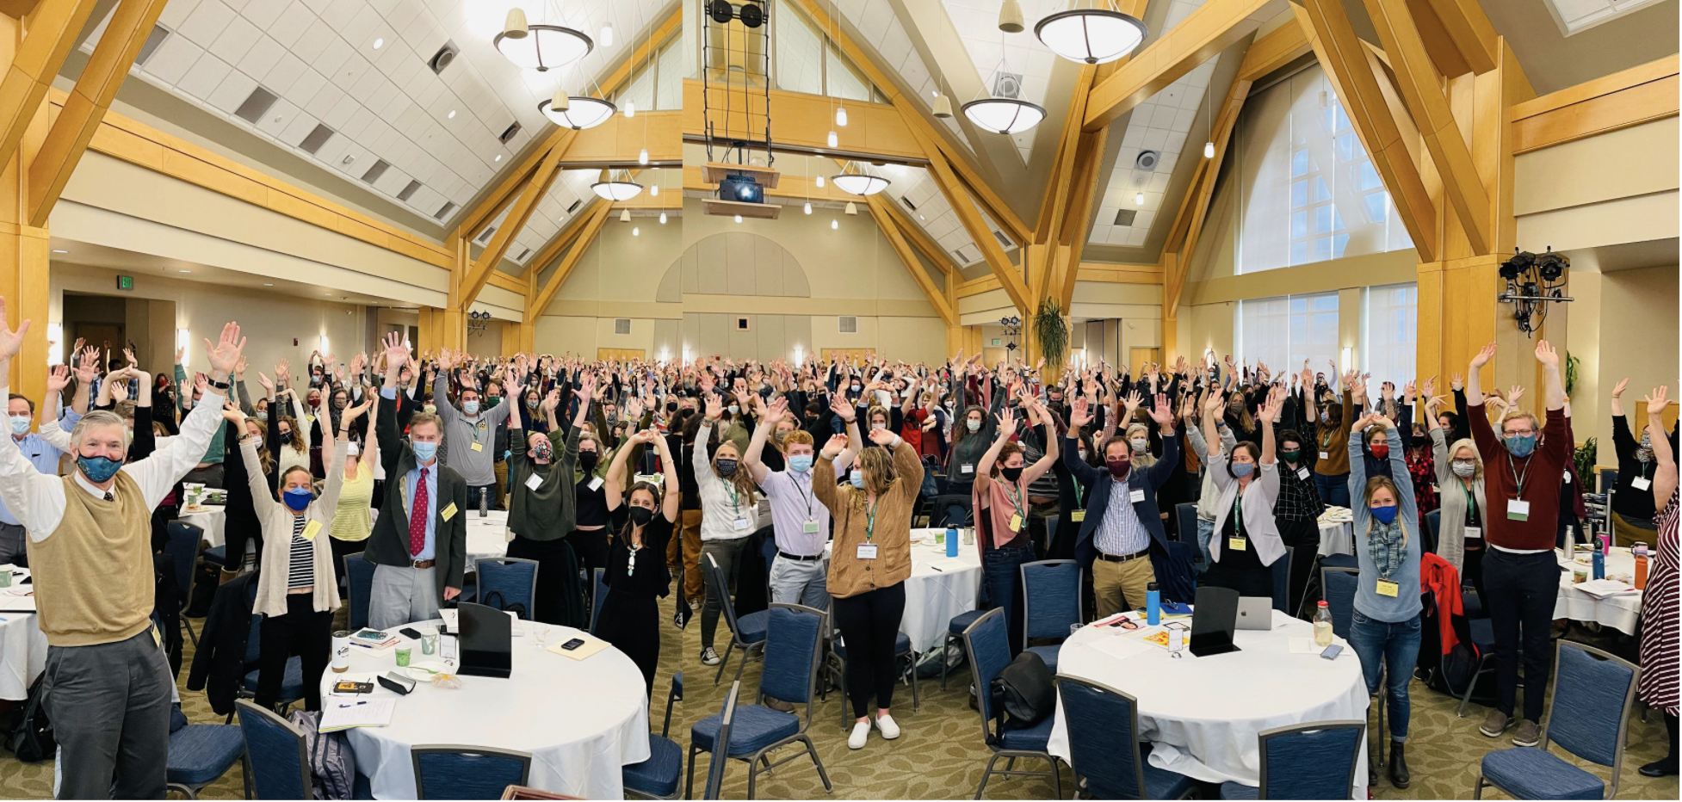
Thanks to our terrific participants, presenters, and Carla Shalaby’s inspiring message of love & liberation, our 10th Annual Rowland Conference was an amazing day. It was so good to get back together in person again! Along with Jeanie Phillips’ Land Acknowledgement and my tribute to Chuck, we will post the keynote video on the Rowland Foundation website for educational use. In the meantime, you can get a sneak preview of them here:

Carla Shalaby Keynote Jeanie’s Land Acknowledgement Mike’s Tribute to Chuck

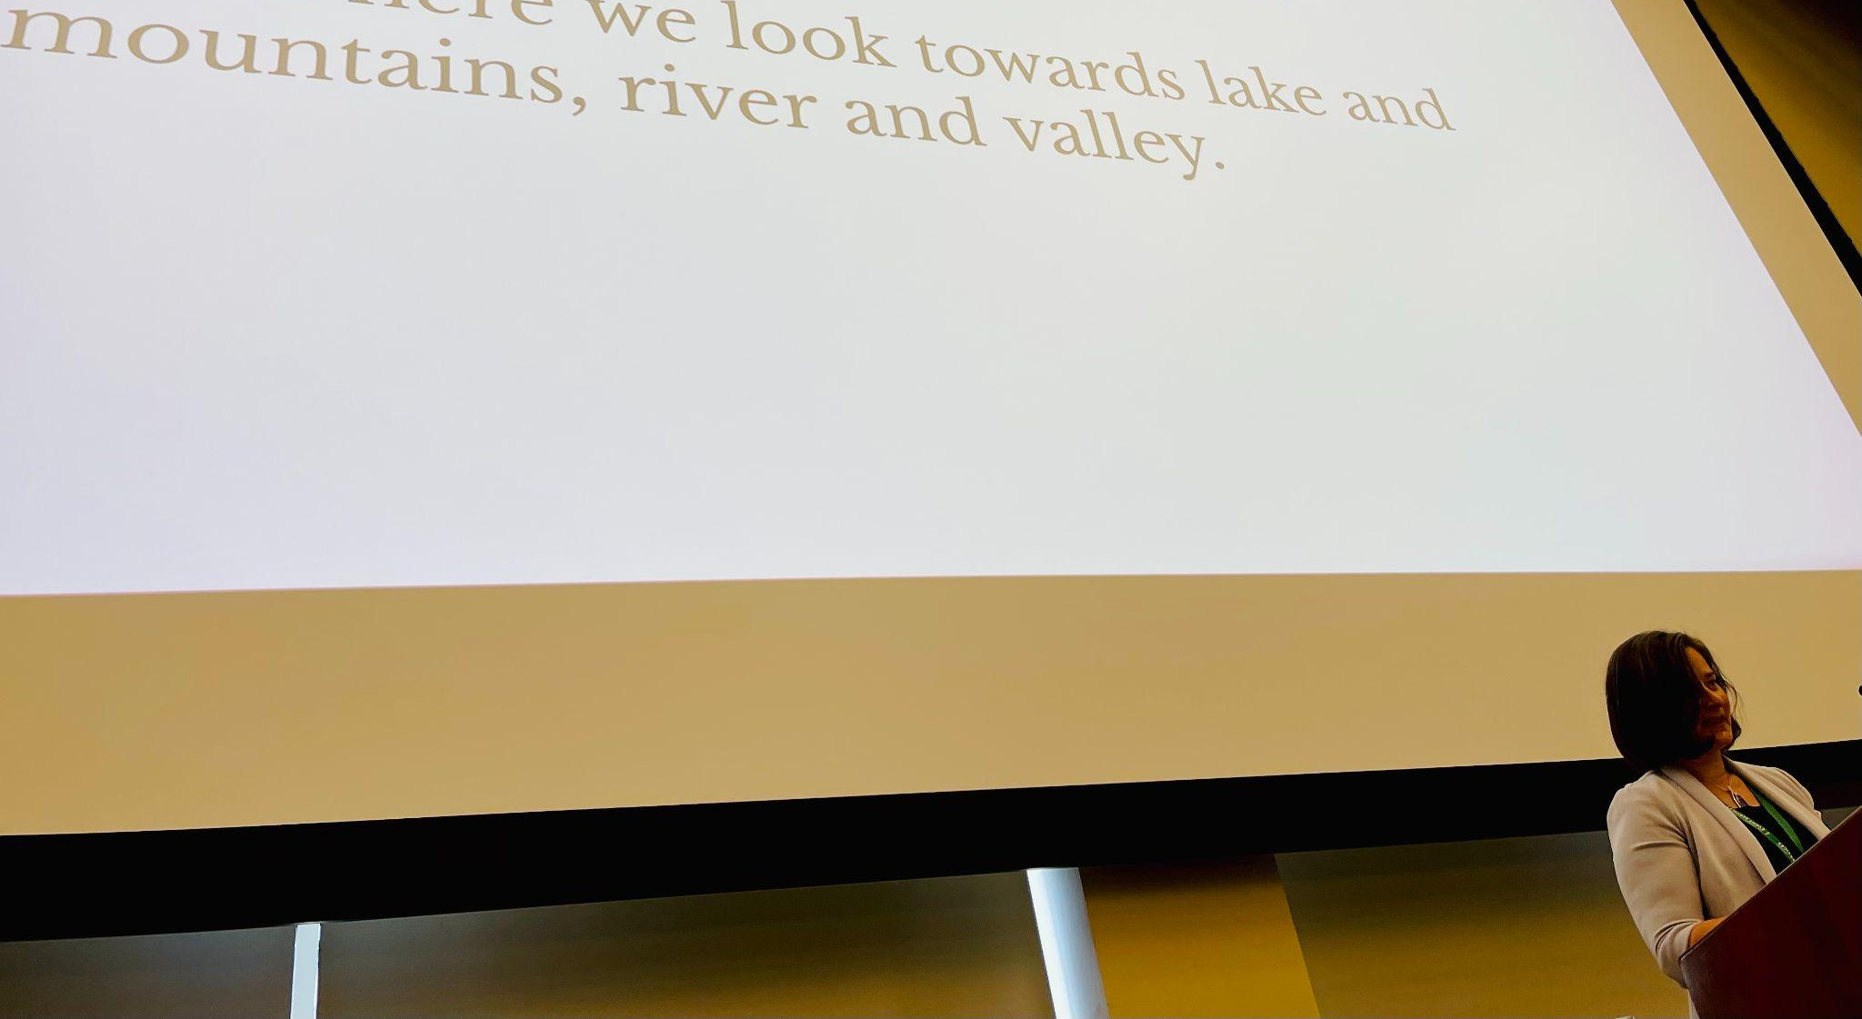
Senior Associate Jeanie Phillips (RF14) offering the Land Acknowledgement to open RFC21.

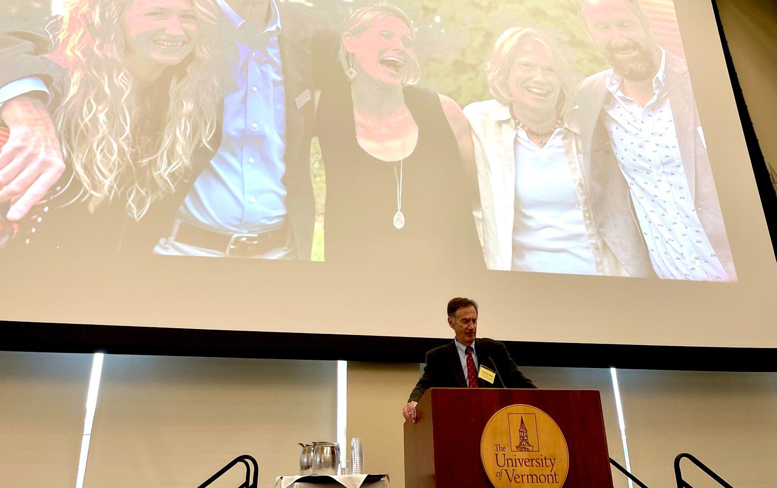
Founder & Past Executive Director Chuck Scranton offering words of gratitude in the Grand Maple Ballroom at RFC21.
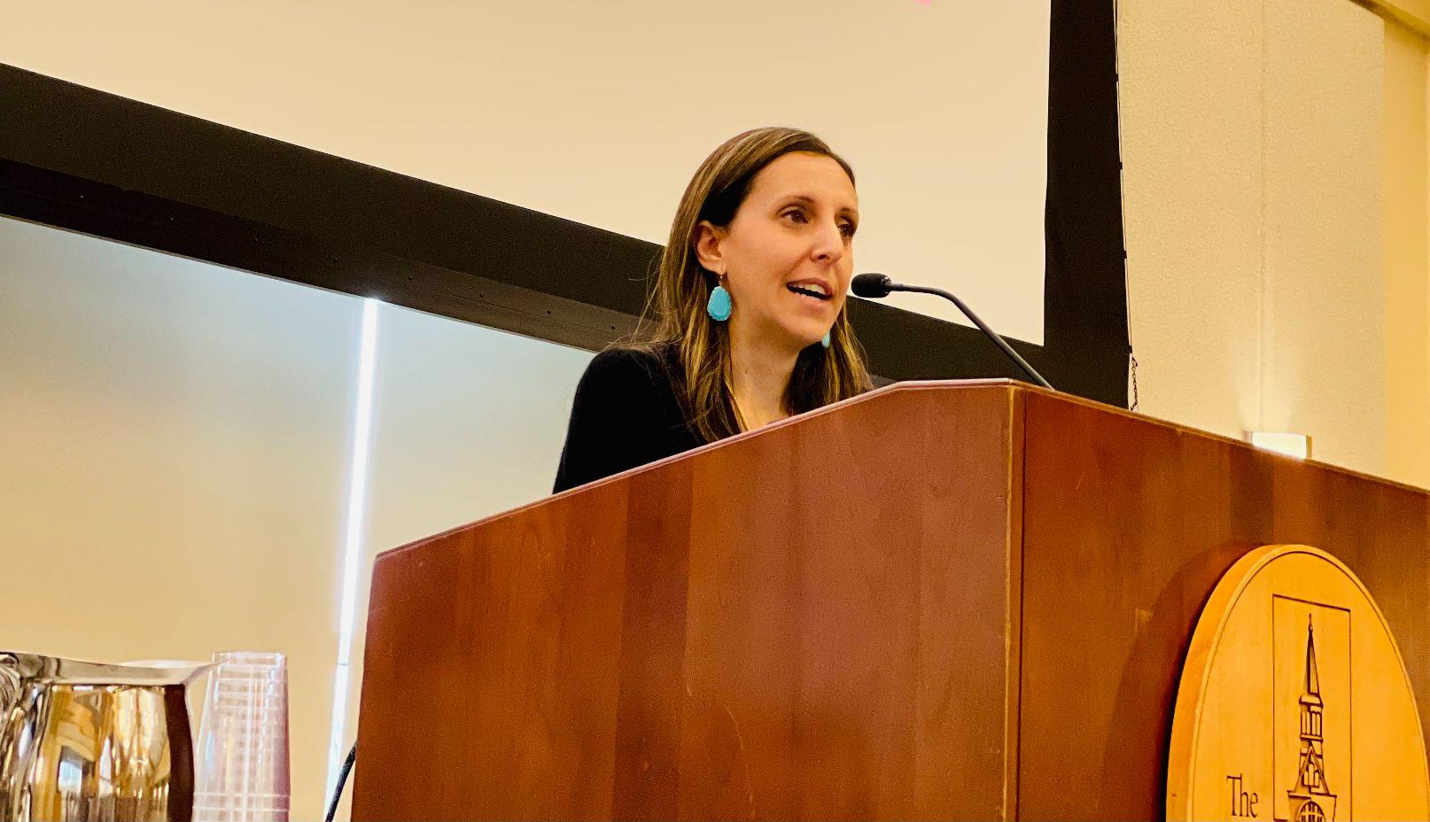
RFC21 Keynote Speaker Carla Shalaby, seen here closing her talk with a poetry recitation.
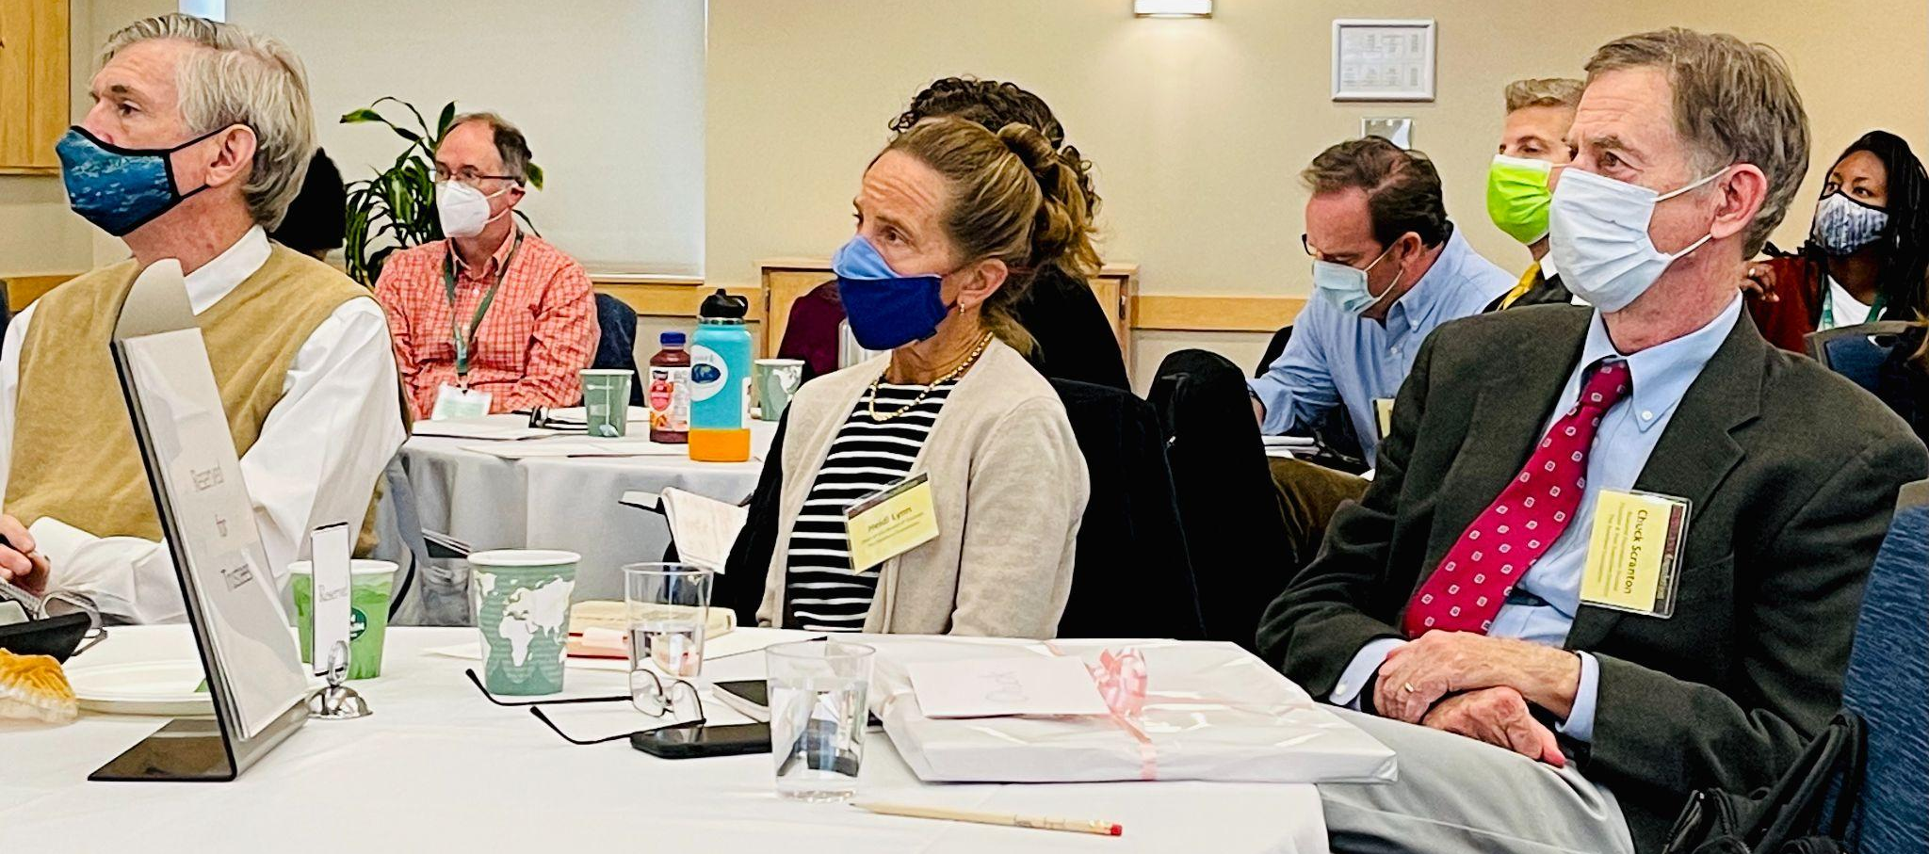
Rowland Foundation Trustees Jim Mooney, Board Chair Heidi Lynn & Chuck Scranton taking in Carla Shalaby’s keynote. Colin McKaig (RF13) & Michael Ruppel (RF17) seen in background.
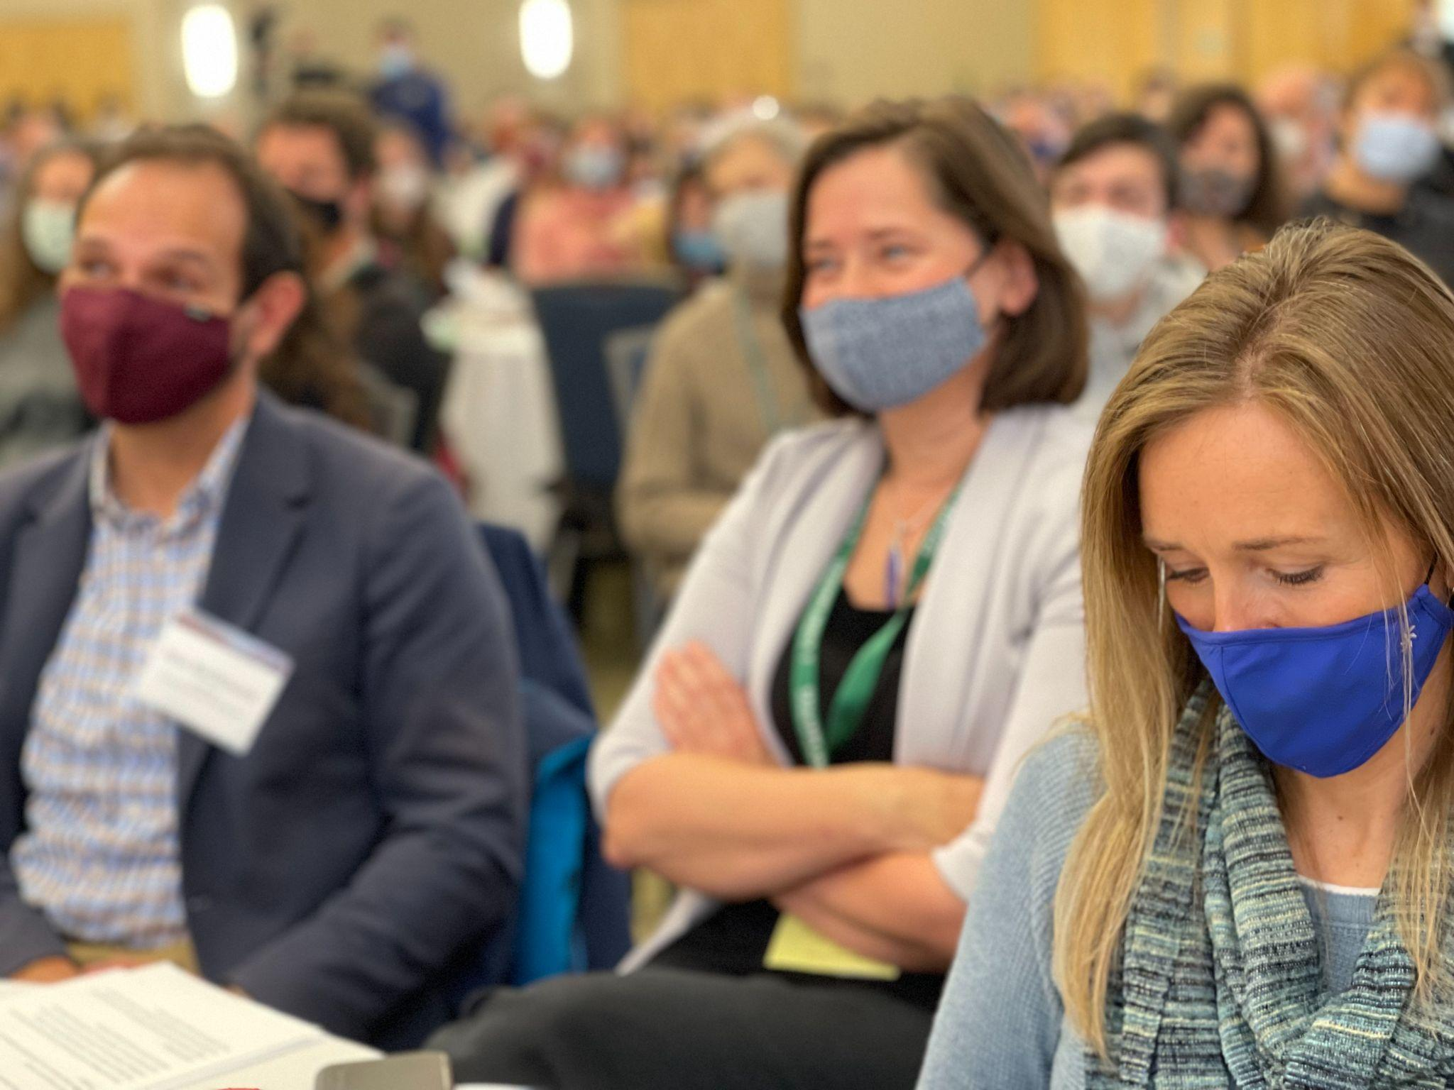
Senior Associates Jean Berthiaume (RF09), Jeanie Phillips (RF14) & Lori Lisai (RF15) seen here taking notes, tweeting, and reflecting on the Carla Shalaby keynote address.
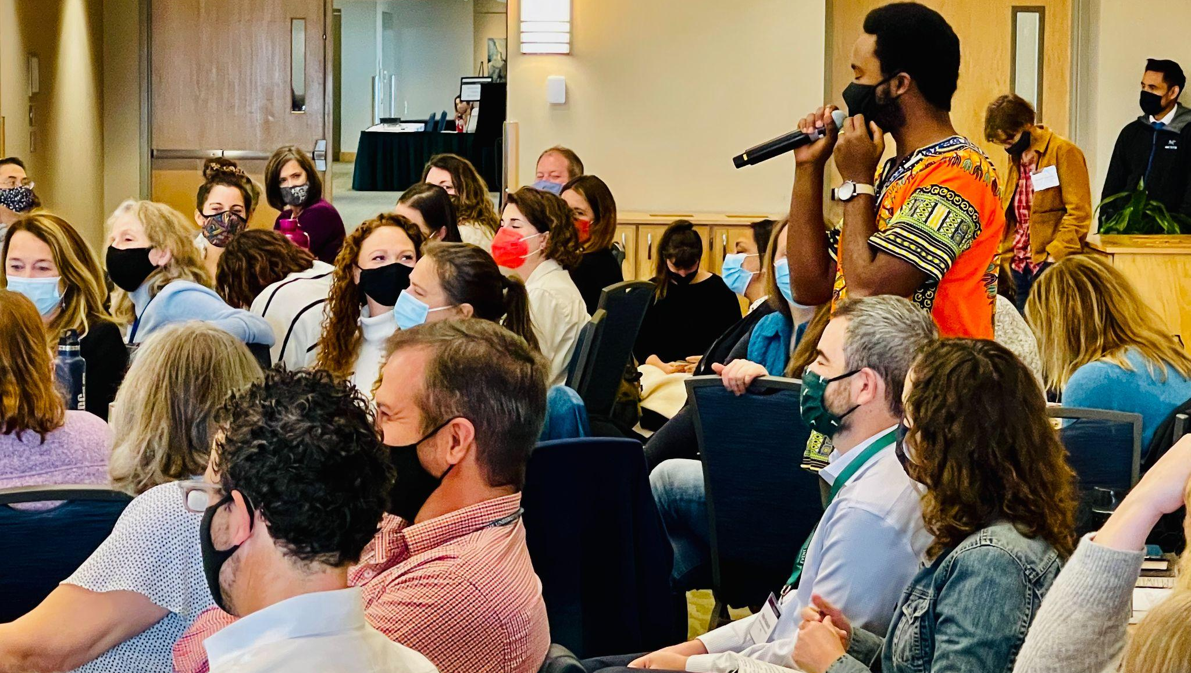Keynote Q&A with Mugabo W’Ishema Thierry Uwilingiyama asking a question here. Mike McRaith (RF13) & Lindsey Cox (RF17) seen in foreground.

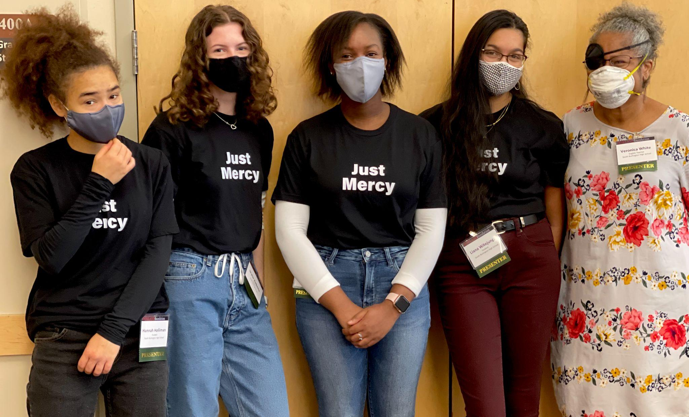
South Burlington Teacher Veronica White seen here with her student presenters.

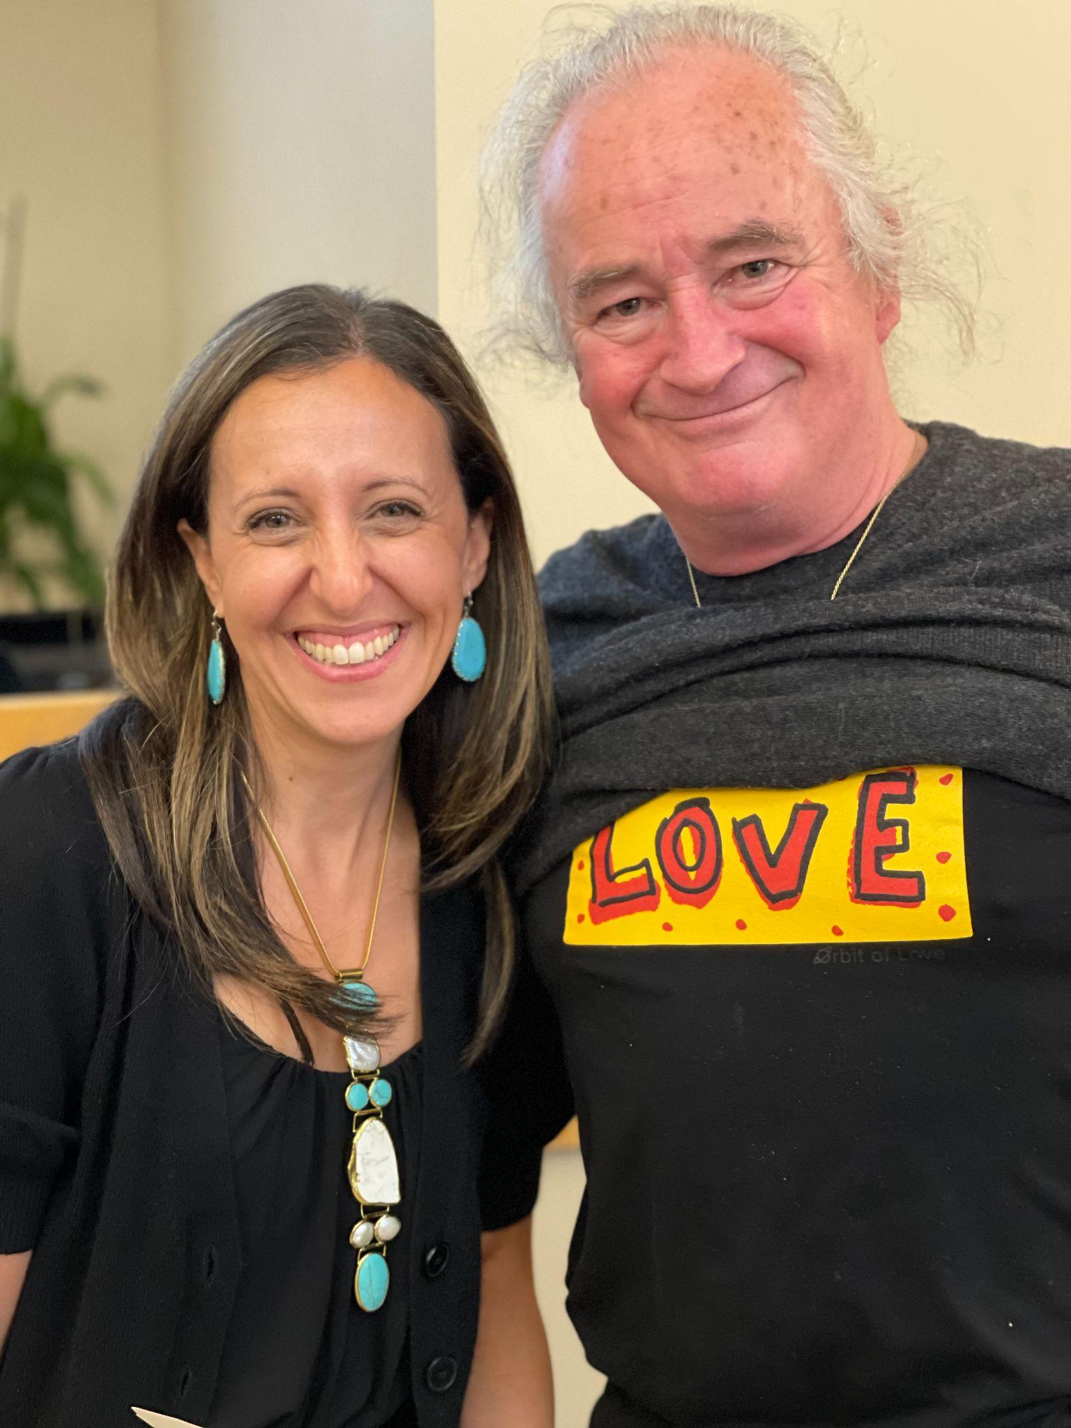
Principal Owen Bradley connecting with the keynote theme, seen here with Carla Shalaby.
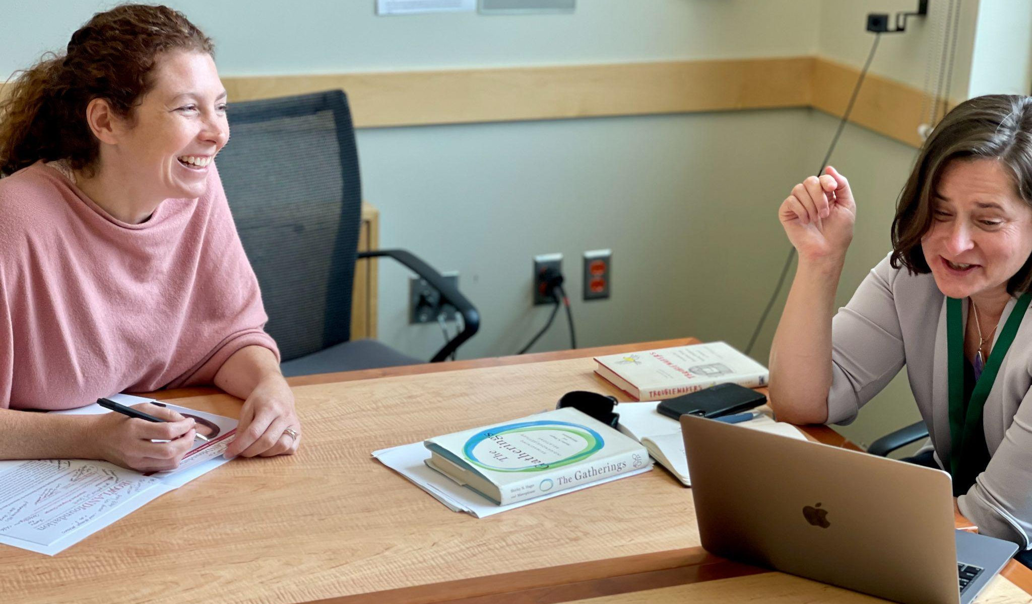
Kendra LaRoche (RF11) & Senior Associate Jeanie Phillips (RF14) catching up between sessions.

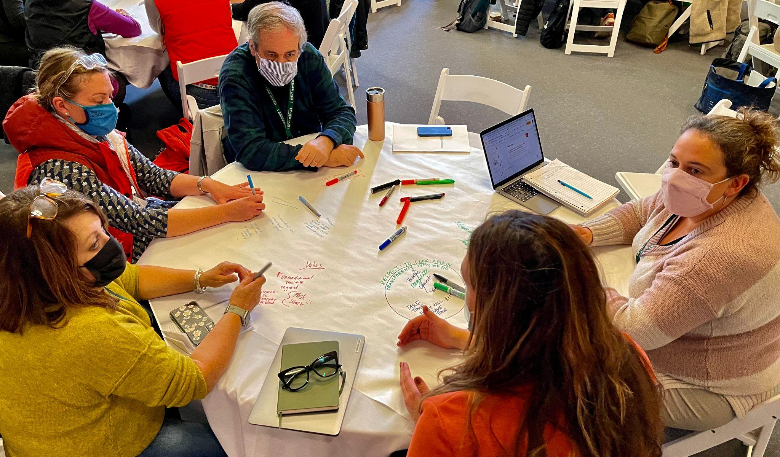
Rowland Foundation Trustee Erica Wallstrom (RF14) seen here in a Troublemakers workshop with Charlie MacFadyen (RF20).
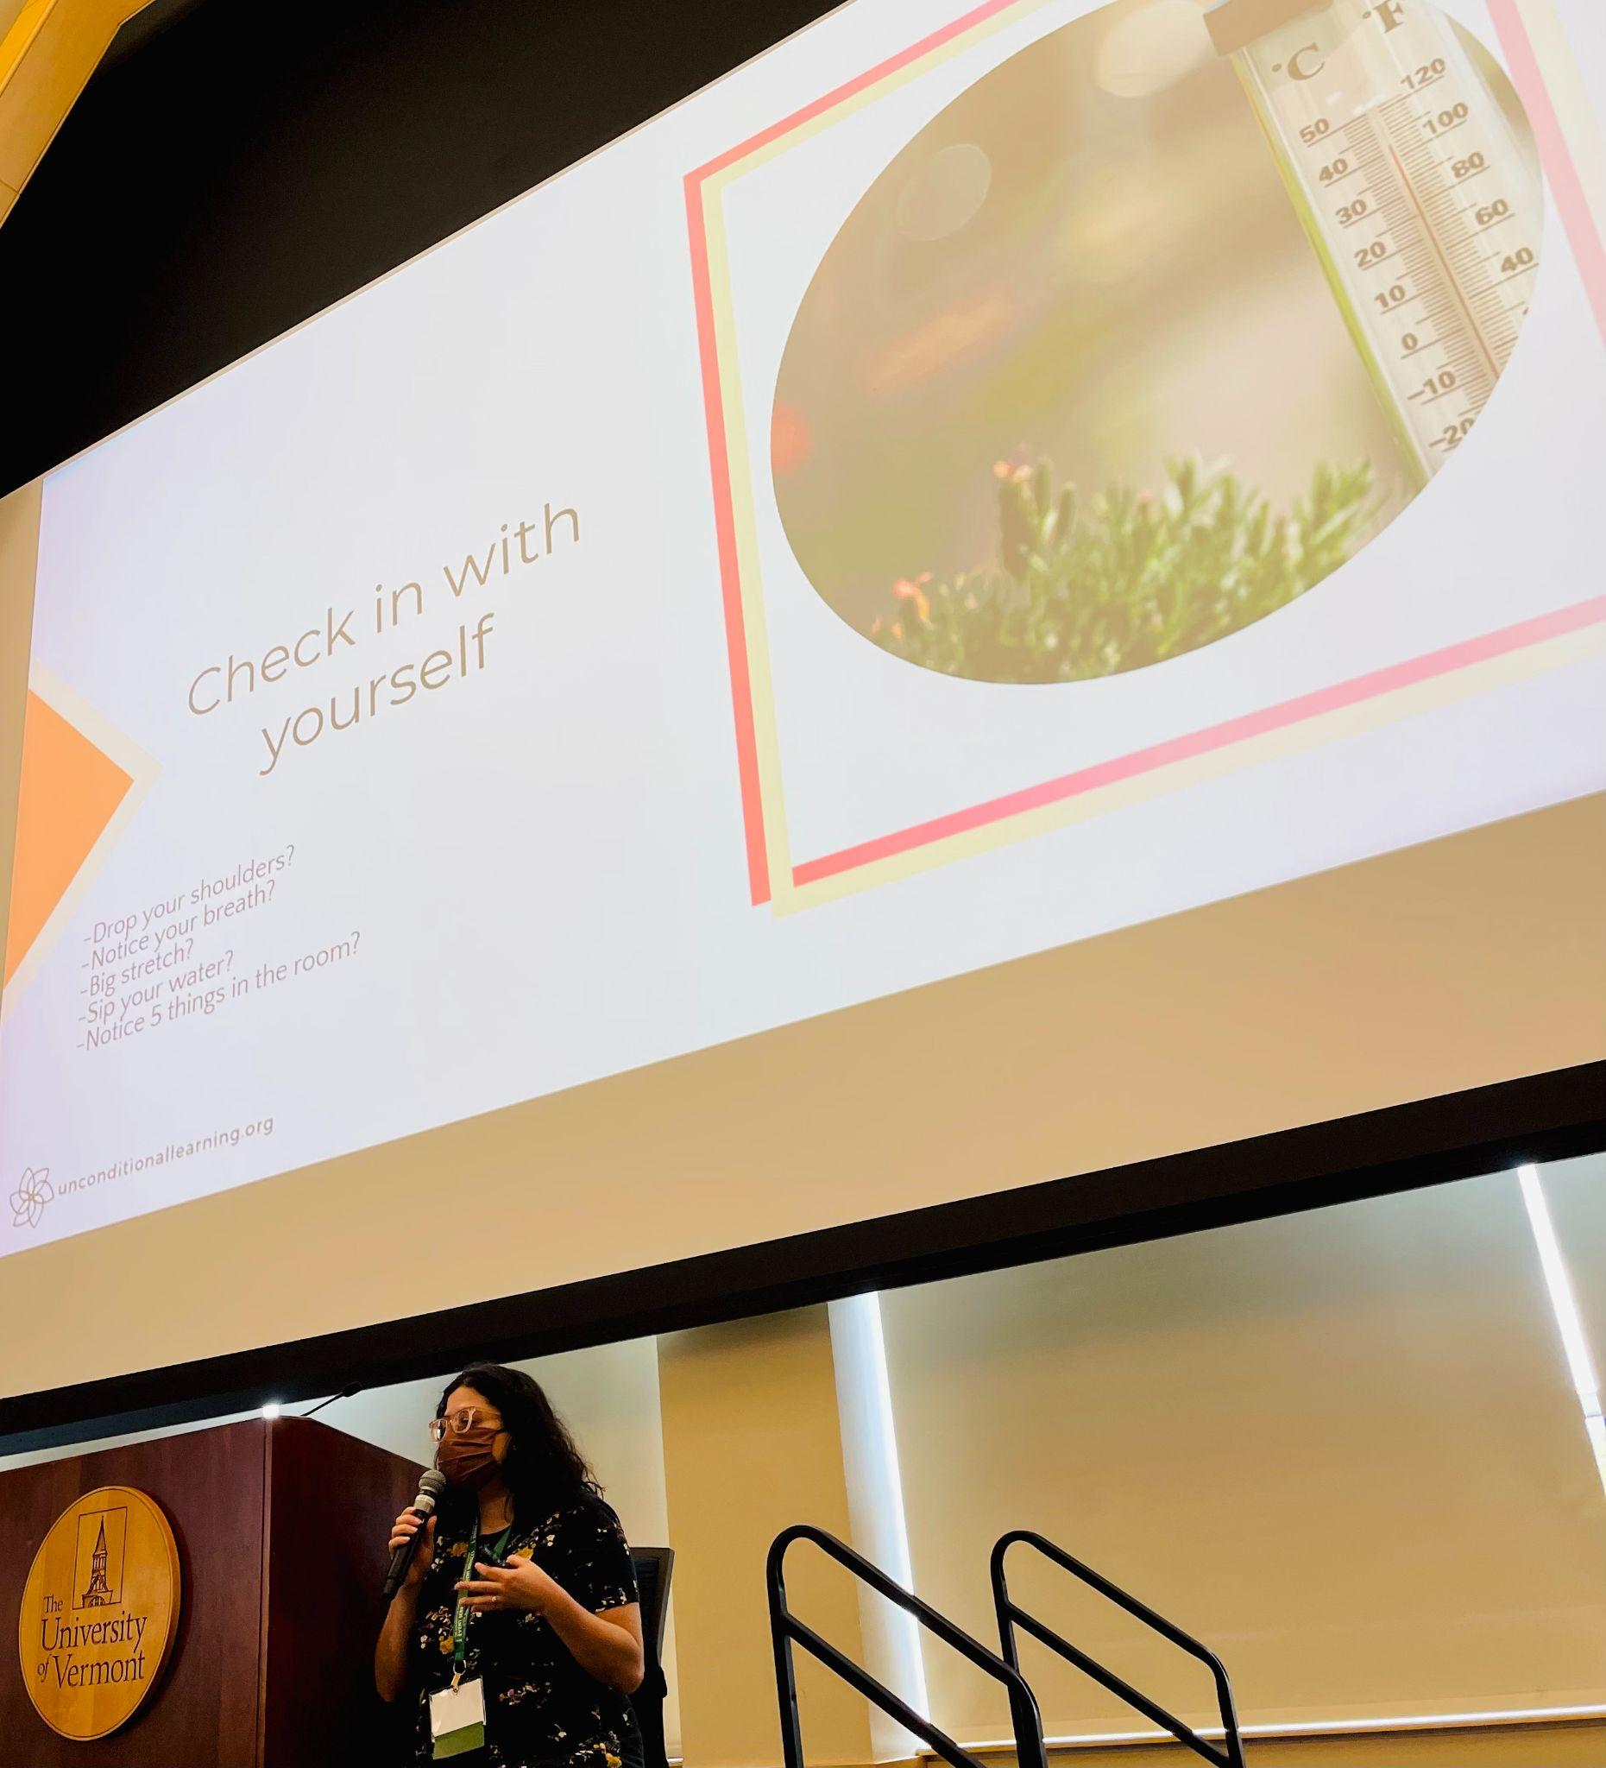
Author, Educator & Presenter Alex Shevrin Venet modeling her trauma-informed equity message in the Grand Maple Ballroom.

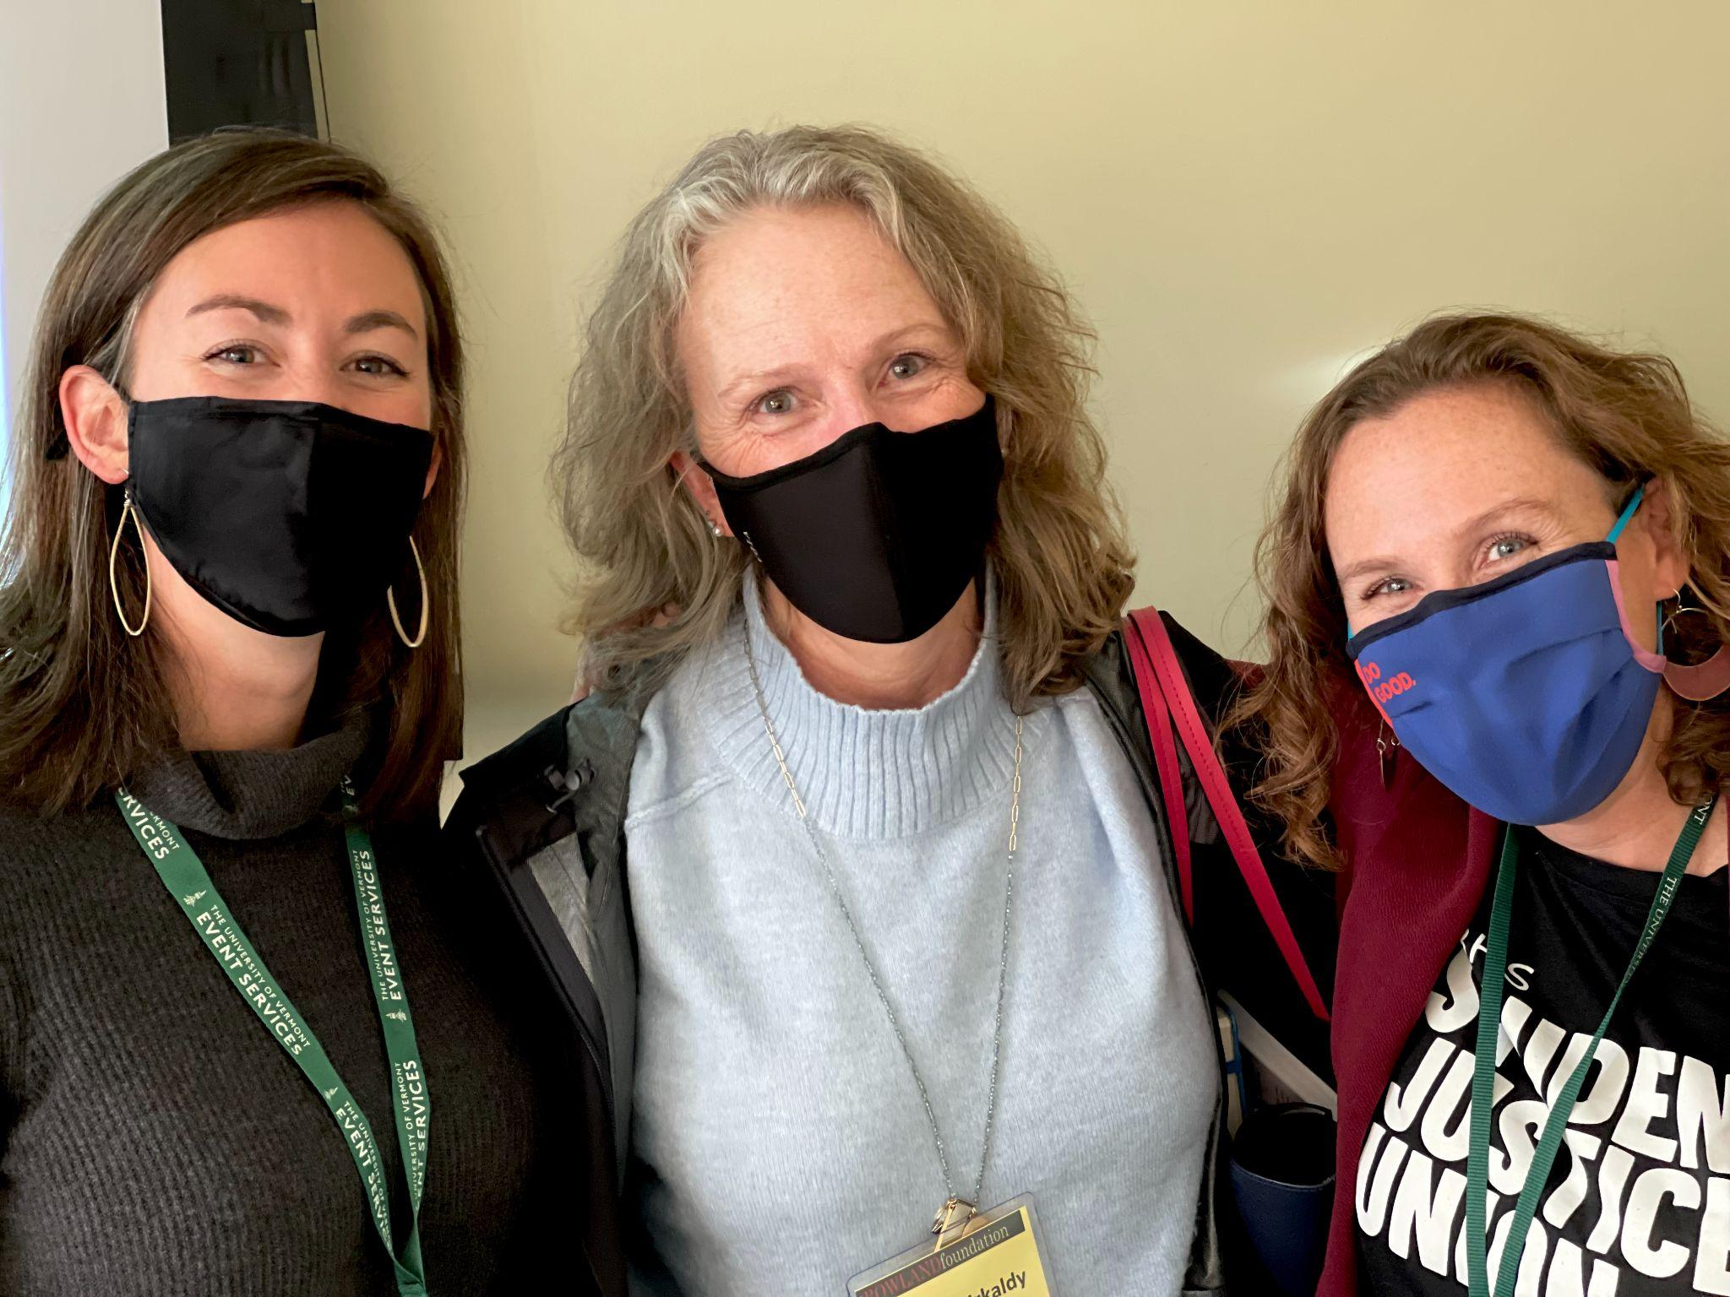
Emily Gilmore (RF17) & Kristine Kirkaldy (RF10)seen here with South Burlington teacher and RFC21 presenter Christie Nold.

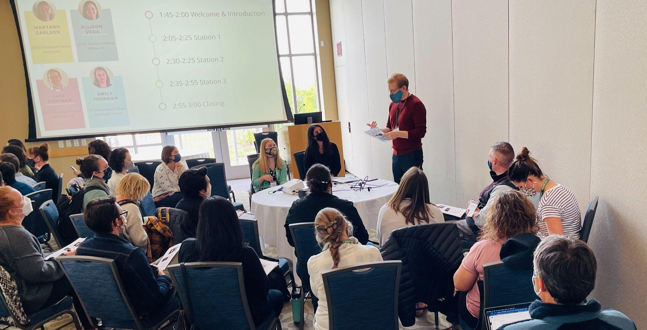
Luke Dorfman (Rf19) seen here presenting on equity work in Vermont schools

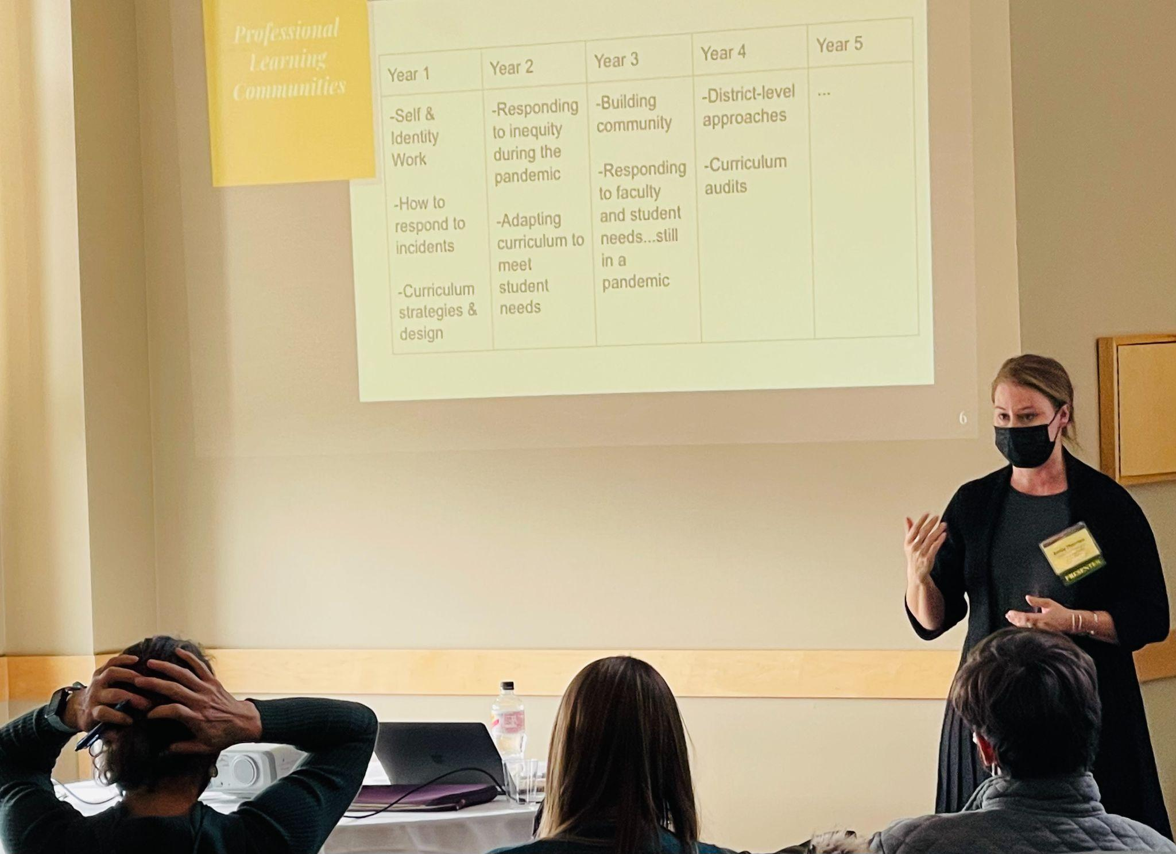
Emily Therrien (RF19) sharing strategies for equity transformations in Vermont schools

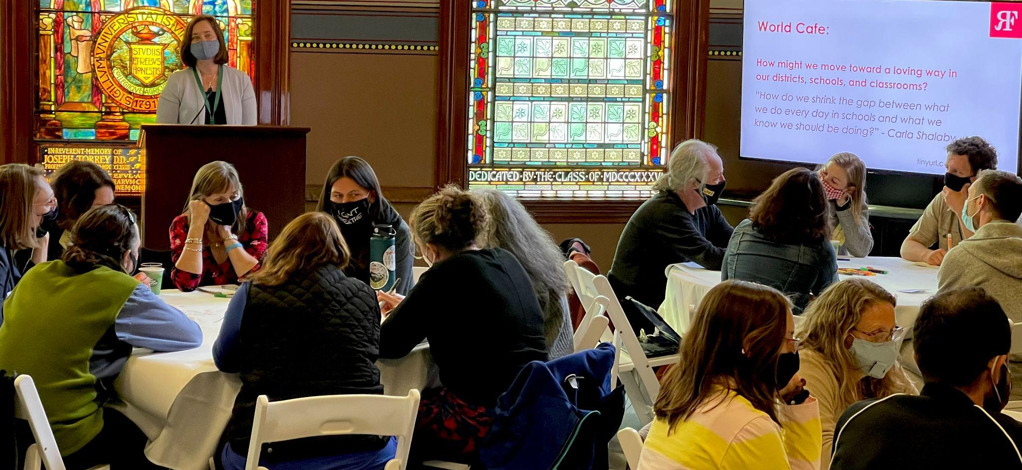
Senior Associate Jeanie Phillips (RF14) leading a call for action from Troublemakers with Kerianne Severy (RF17), Ellen Berrings (RF13), Lissa Knauss (RF18) & Luke Foley (RF19) visible in the foreground
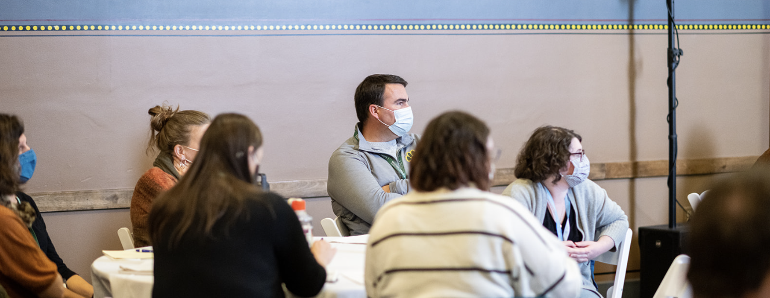
Tim O’Leary (RF20) learning about trauma-informed equity work. : Isora Lithgow Productions
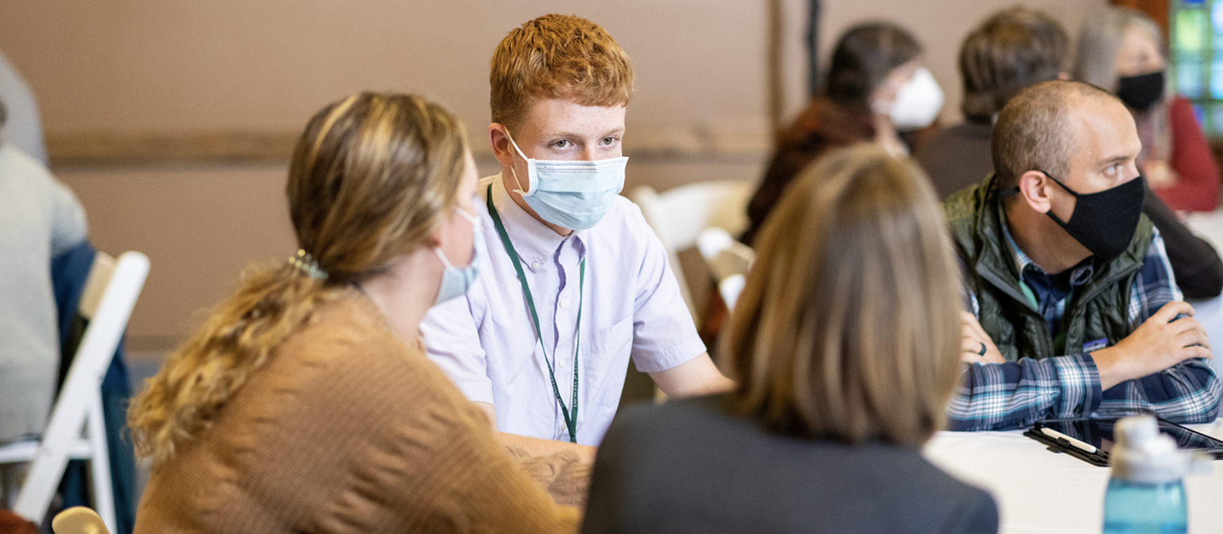
Students and teachers engaged in discussion at the 10th Annual Rowland Conference
: Isora Lithgow Productions

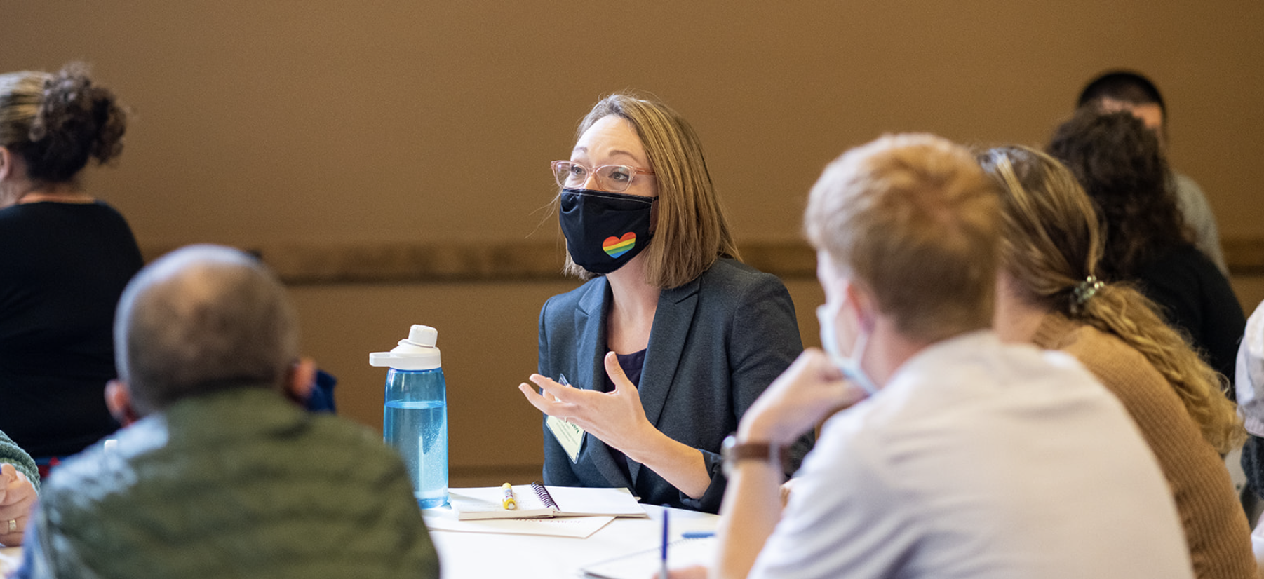
Kerianne Severy (RF17) sharing ideas at the 10th Annual Rowland Conference
: Isora Lithgow Productions

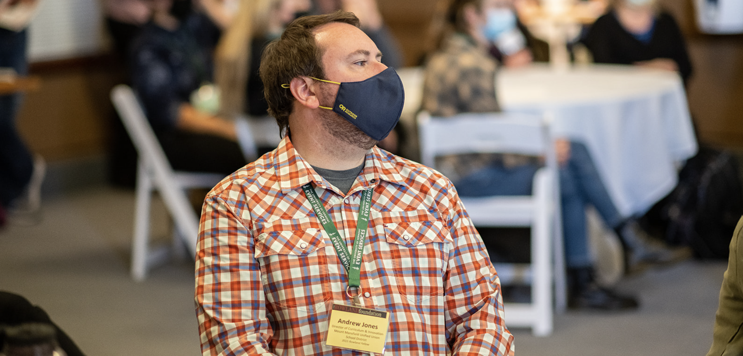
Andrew Jones (RF15) in John Dewey Lounge at the 10th Annual Rowland Conference
: Isora Lithgow Productions
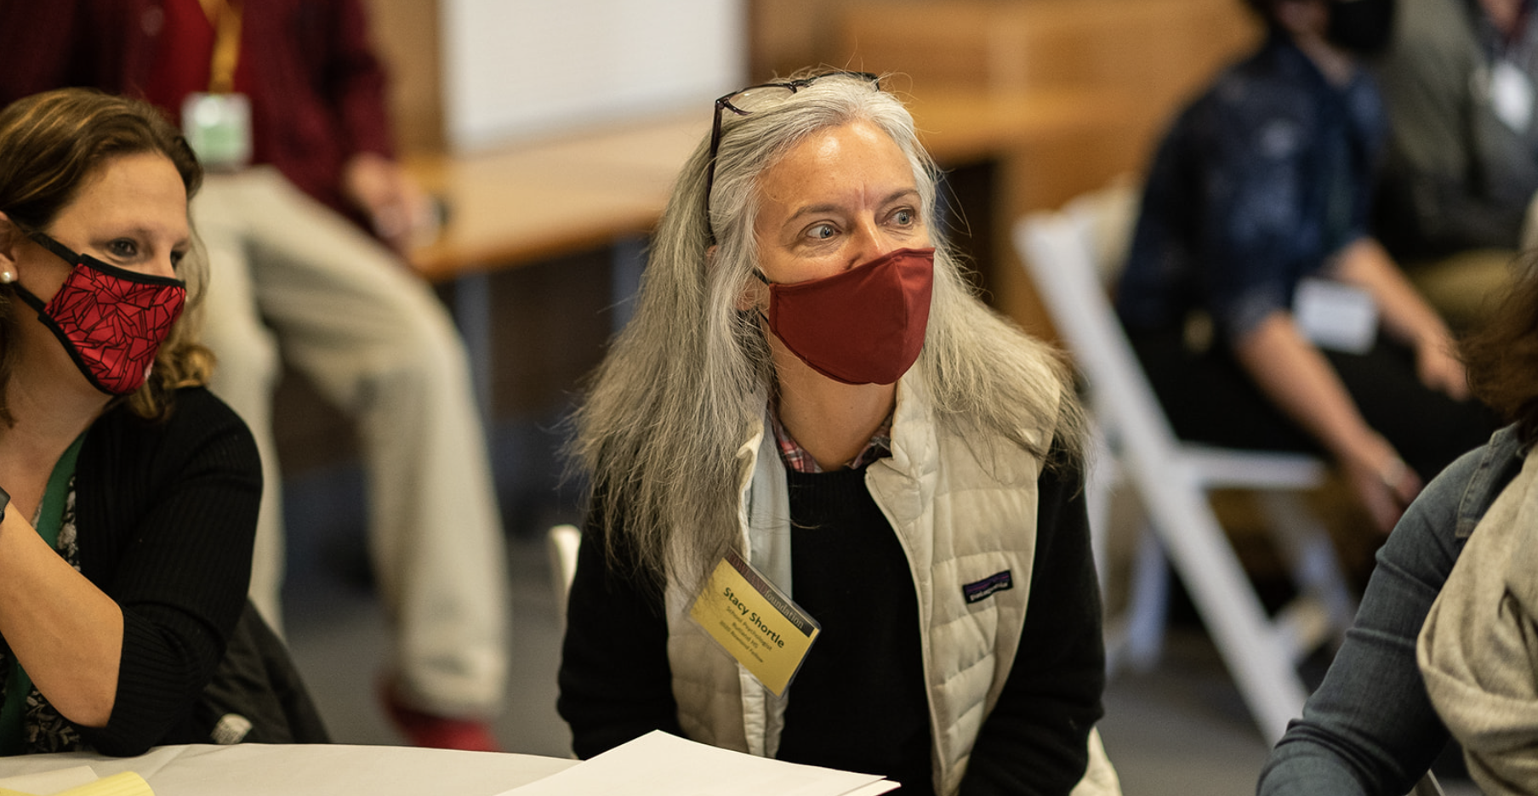
Stacy Shortle (RF20) at the 10th Annual Rowland Conference.
: Isora Lithgow Productions

Celebrations
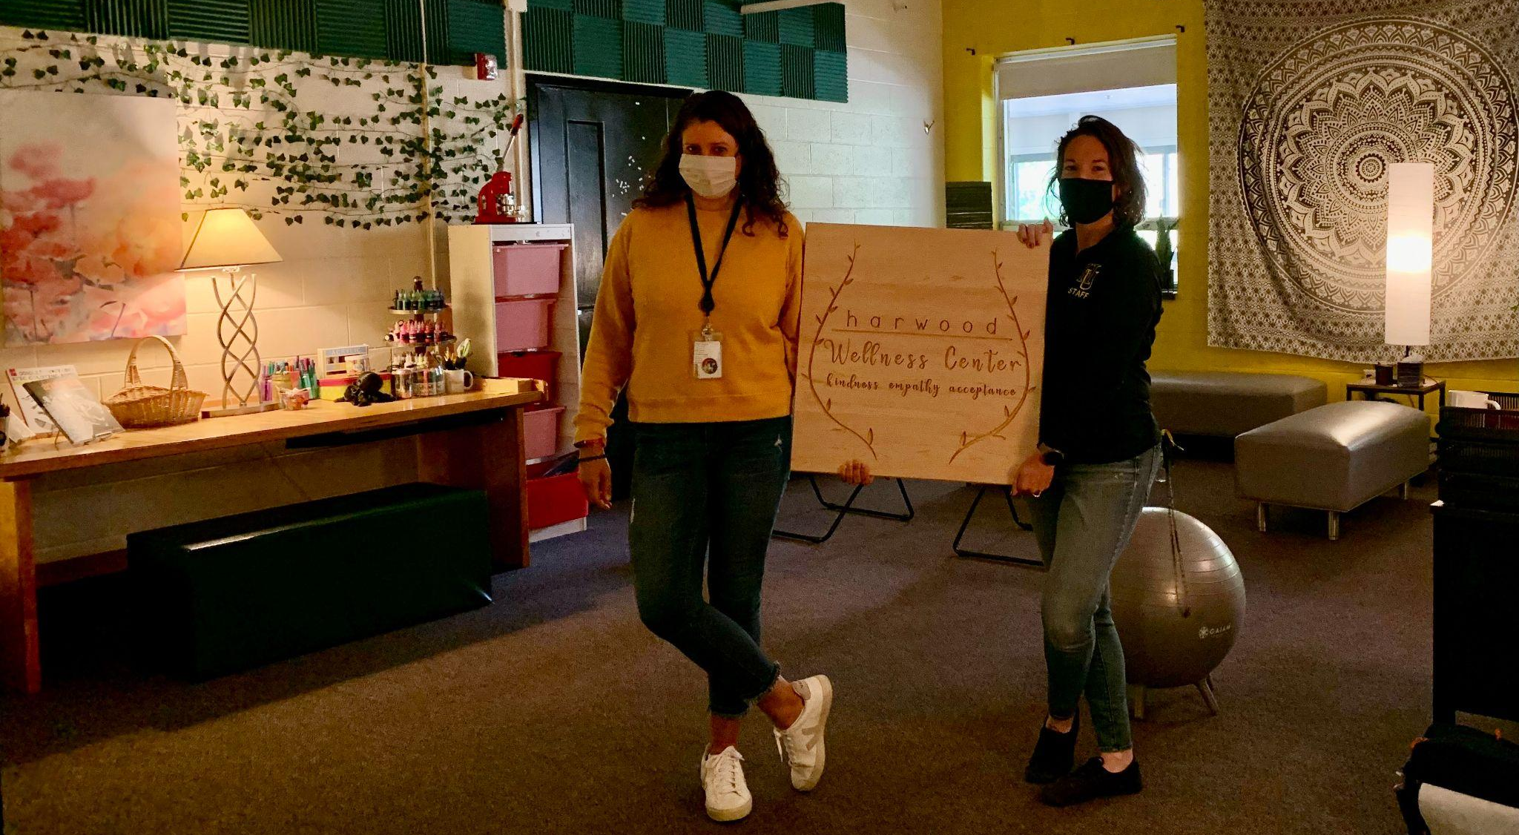Tara Cariano (RF18) is now teaching a new 9th grade course called Personal & Future Exploration, and also working to obtain additional licensure as a Health Educator. Seen here with Jen Dreimiller, Harwood Union Wellness Center Counselor in their new space.

Congratulations to Tara Cariano (RF18) & Lissa Knauss (RF18) who were recently named Chair & Vice Chair, respectively, of Secretary French's Advisory Council on Wellness & Comprehensive Health. Thank you for your state-level leadership, Dear Fellows!

Courtesy Postings
Kathy Cadwell (RF16) is available to consult with districts as a Harkness expert. She is currently teaching a related graduate-level contract course through St. Michael’s College for staff at Champlain Valley Union High School. Check out her resource-rich website Strategies in Classroom Dialogue and feel free to recommend her to school leaders looking to develop meaningful student voice, civic discourse, or collaborative practice for equity in the classroom.

Sandra Mings-Lamar (RF16) recommends in-person leadership courses offered through St. Johnsbury Academy’s adult school to be held in the media room of our campus library. From Sandra, “The series is taught by Dr. Martha Dubuque, a distinguished Vermont educator and administrator, who is also an award-winning consultant. These courses are great for new administrators and teacher leaders. They are great for any staff members. They are informative and practical courses that give participants tools for managing conflict, addressing the culture and climate of an organization and learning how to lead others to be their best selves.”

