 | Letter to Fellows  Cultivating  November 2022

Dear Rowland Fellows,

I hope you are enjoying these gorgeous days of late autumn!

Like many of you, my heart is full and my head is humming from the 11th Annual Rowland Conference last week. Dr. Gholdy Muhammad is a fantastic speaker and her message of Cultivating Genius really connected with Vermont educators. It seemed to come at the moment we need it most.

I’ve posted some high quality conference resources on our website, including Kat Robbins’s (RF21) powerful Land Acknowledgment, Jess DeCarolis’s (RF09) talk Centering Hope in School & Community, and some terrific workshop resources too. For a deeper dive, check out Dr. Muhammad’s amazing resource library and teaching videos. To protect her intellectual property, thank you for only using these resources internally in your school and not disseminating or publishing any of these docs online (e.g., Twitter, website, blog, etc.). Also, if you attended the conference, don’t forget to fill out the exit survey and download your PD certificate at the end!

Gholdy’s first name is actually “Gholnecsar” which means “to share beautiful flowers” in Persian, and she certainly shared many beautiful flowers with us last week with her keynote and workshop. One workshop highlight for some people was when she helped a driver’s ed teacher find ways to teach criticality in his course. Her response to his question showed that, just like the genius that is in every child, a deeper and more joyful curriculum is available to us if we look for it, create space for it, and cultivate it.

I also loved when Gholdy challenged us to think about what we do when a flower is not growing well. We don’t blame the flower, she said, instead, we change the environment–you know, give it more sun, water, and change the soil, for example. Obviously, this is what we need to do in schools too. Instead of lamenting “learning loss” and continuing to rank and sort students based on a very narrow definition of human genius, we should instead rethink the way we do school. The same way certain types of curricula lead to certain outcomes for students, the way we show up for our students & colleagues will produce a certain kind of school culture & climate. That unconditional positive regard is what makes all future growth possible.

Gholdy’s five pursuits make for a well rounded curriculum which is predicated on identity, skill, intellectualism, criticality, and joy. With “pursuits”, please notice her intentional language to emphasize aspirational endeavors and lifelong learning. This stands in contrast to our current “requirements”, “benchmarks”, “objectives”, and “competencies” to meet, complete, and check off. Gholdy is challenging us to deepen our work, and to think about a vibrant, rigorous approach to curriculum that will engage all students and honor them as learners at the same time.

As challenging as that may sound, I think Gholdy is also inviting us to step off the hamster wheel we’re on. We need to question the validity of this mad race to cover and assess, this linear march through learning targets that are unexamined and never-ending. Gholdy is asking us teachers to rethink the value of the narrow, normative-based assessments that reinforce an accountability regime and achievement ideology. Instead, she’s asking us teachers to return to the role of gardener where we can make room for nurturing, reflection, and growth.

After all, even in an orchard, the trees that grow together don’t all look the same. Couldn’t this be the same for our students’ learning activities and products? What if we created more opportunities for students to be more well rounded? And what would it look like for us to create space for students to be their beautiful, authentic selves in school?
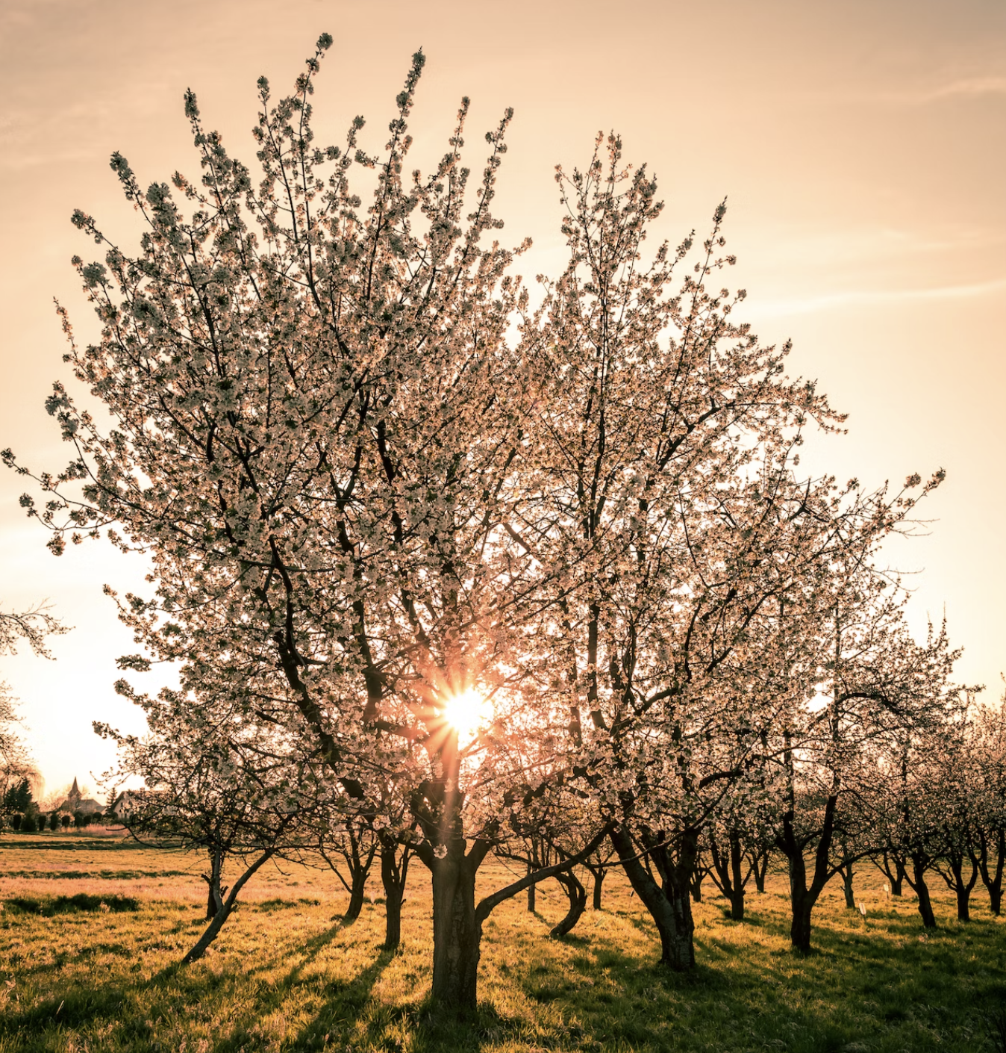

It seems to me that our current curriculum is more like the agricultural practice of espalier, where branches are radically cut back, trained, and tied to a flat surface so the tree is basically two-dimensional, all in the name of efficiency and increased production.
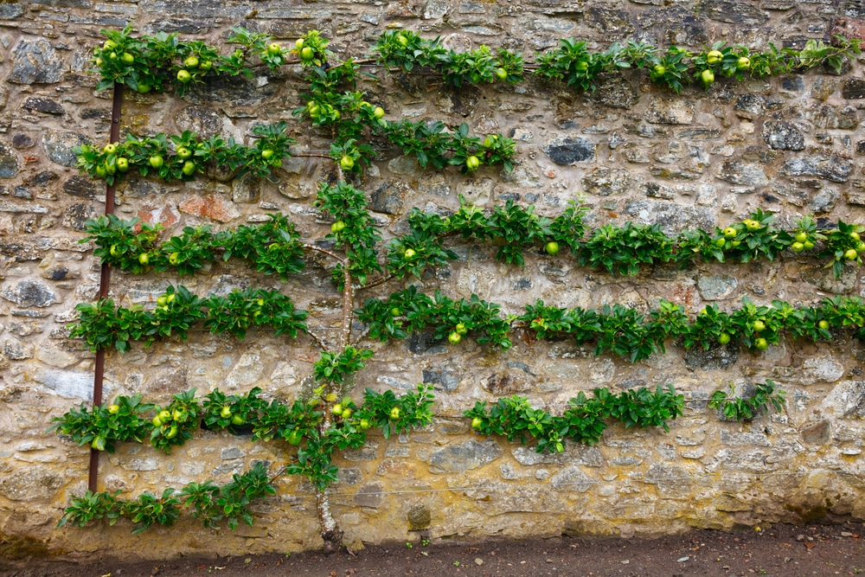

When you think about it, which of these two approaches seems better suited to cultivating joy? And if you’re thinking of joy as something you already do, something you’ve got covered in your practice, I invite you to take out a favorite unit or lesson plan and ask yourself where you’ve intentionally created space to cultivate joy. When we think about it in those terms, it becomes clear that this is something we need to pursue with more passion. Creating space for joy in school is going to be hard work! Think of Chuck’s Immovable Mountain. The pursuit of joy in school is more than pep rallies and birthday parties–it’s about reconnecting education with our humanity.

Check out Gholdy’s slide below for her thinking on what it means to cultivate joy in our practice. I can’t wait to buy Gholdy’s next book Unearthing Joy when it comes out in March 2023.
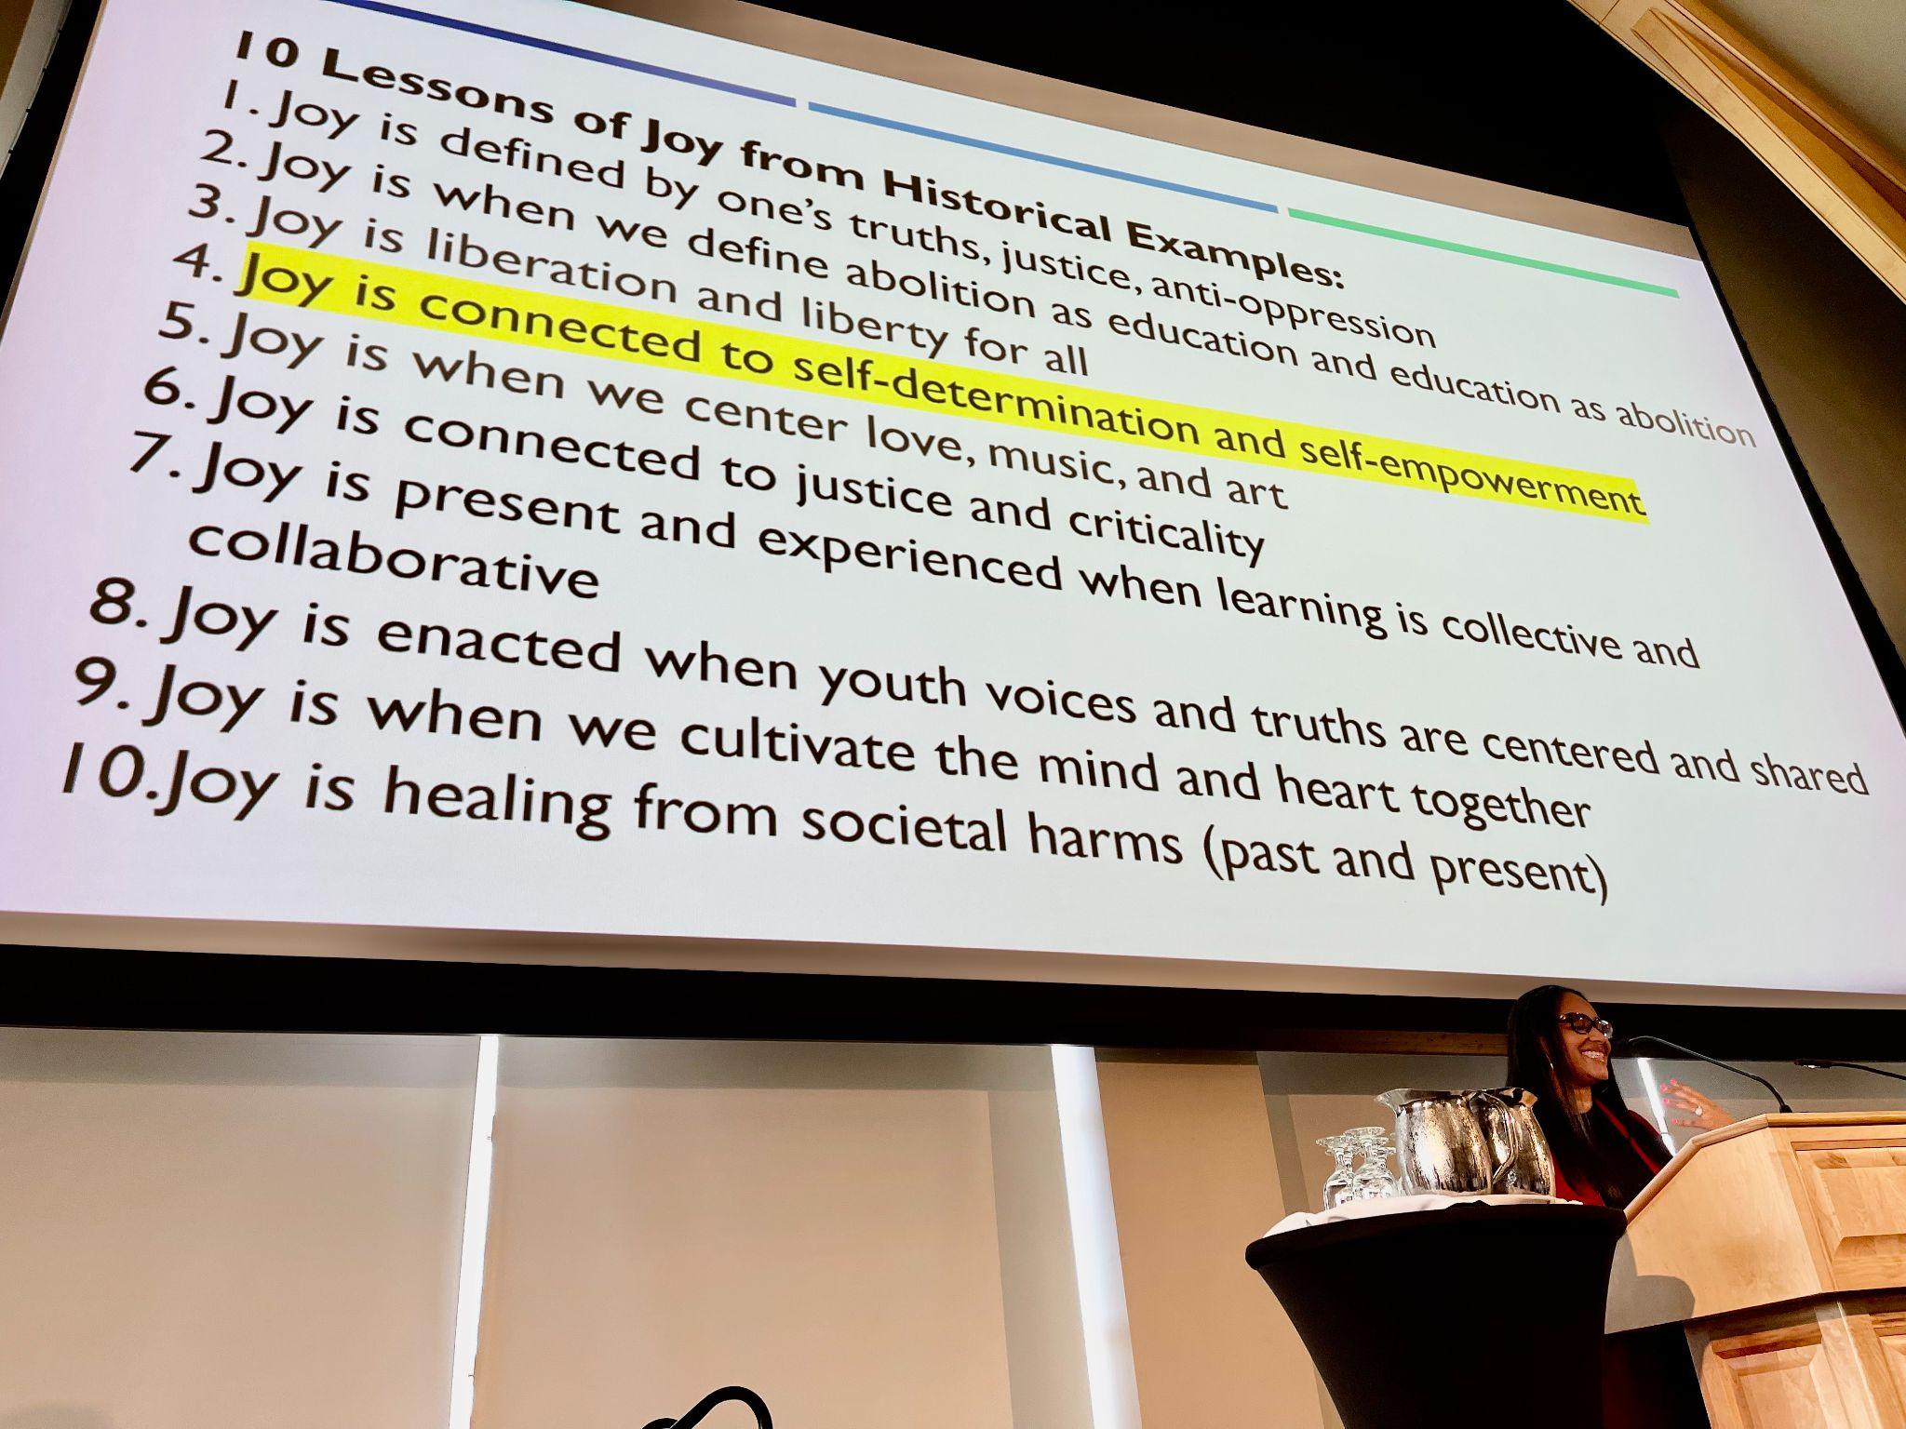

Gholdy teaches us that to cultivate genius in our students, we need to begin with ourselves. She writes, “You have to know yourself and your bias. You have to cultivate your own genius. In other words, cultivate your mind and your heart, and then move to your pedagogy.”

I’m sure that reexamining our curriculum and radically changing our teaching practice sounds like a lot of work. But if we’re honest, the status quo doesn’t really feel great right now either… so something has to change. And I think this hard work of cultivating can be joyful.

Take care and see you soon,

Mike

P.S. Please send me your news! Each month, I’m sharing courtesy posts for upcoming courses & events, and also celebrating new jobs, family vacations, and other news from our wonderful network of Rowland Fellows. So please email whatever you’d like to share to michael@therowlandfoundation.org

Rowland Foundation Updates

The Rowland Women Leadership Retreat is now an annual event which is funded by our operating budget and organized by Rowland Women. We are now accepting Planning Team applications and will prioritize those received by November 15th, 2022 in order to allow the time to make site reservations. You can find the Rowland Women Leadership Retreat (RWLR) grant guidelines & proposal form here. This grew out of Lauren Parren’s (RF12) “Weston Women” writers group and builds on a past Rowland Leadership Grant which funded a retreat for Rowland Women. In her original grant proposal, Lauren wrote,
Women in Vermont who aspire to leadership positions face serious challenges due in large part to bias, whether it is conscious or unconscious. Schools across the state are losing out on the huge potential hidden in those who need encouragement and tools to affect real change within their organizations.
With this annual investment, the Rowland Foundation Board of Trustees recognizes that women leaders face unique challenges, including in the field of education. If you would like to lead this year’s Planning Team, please find 1-2 co-conspirators and submit a proposal! As always, feel free to contact Mike with any questions or to find out more.

Our new Diversifying the Educator Workforce Grant (DEW) was formally approved by the Rowland Foundation Board of Trustees in September. This grant is intended to remove barriers to licensure for aspiring educators of color in Vermont. It builds on regional and statewide work led by Jess DeCarolis (RF09), Caitlin Steele (RF09), and Marsha Cassel (RF14). We are working to have the selection process and mentor guidelines in place in order to begin accepting applications in early 2023. Stay tuned for updates and feel free to connect Mike with aspiring educators of color you know in Vermont. You can read more about the Rowland DEW Grant here.

Rowland Fellowship Information Nights
With middle grades and high school teachers now eligible to apply for Rowland Fellowships, Executive Director Mike Martin will be hosting a series of Rowland Fellowship Information Nights for Vermont teachers interested in submitting a Rowland Fellowship proposal this year. Mike will offer general information about our mission, our Fellowships, our Cohort Model, and our application process, however, each meeting will mostly be question & answer format.

Please help us recruit new Rowland Fellows! Spread the word at your school and beyond! Please tell your colleagues about our mission and our work, and encourage them to attend one or more of these upcoming informational meetings:

Wed., Nov. 9 | 6:30 - 7:30 pm | Google Meet: meet.google.com/wvq-nozq-exz
Mon., Nov. 14 | 7:00 - 8:00 pm | Live Twitter Chat: #RowFn23
Wed., Dec. 7 | 4:00 - 6:00 pm | In-Person Discussion with Refreshments at the KBH Gallery Space (Kestrel) at 47 Maple St. in Burlington

Interested teachers should also consult our website for helpful information about the types of Rowland Fellowship proposals we’re looking for and our application process.

The All Fellows Retreat & Social
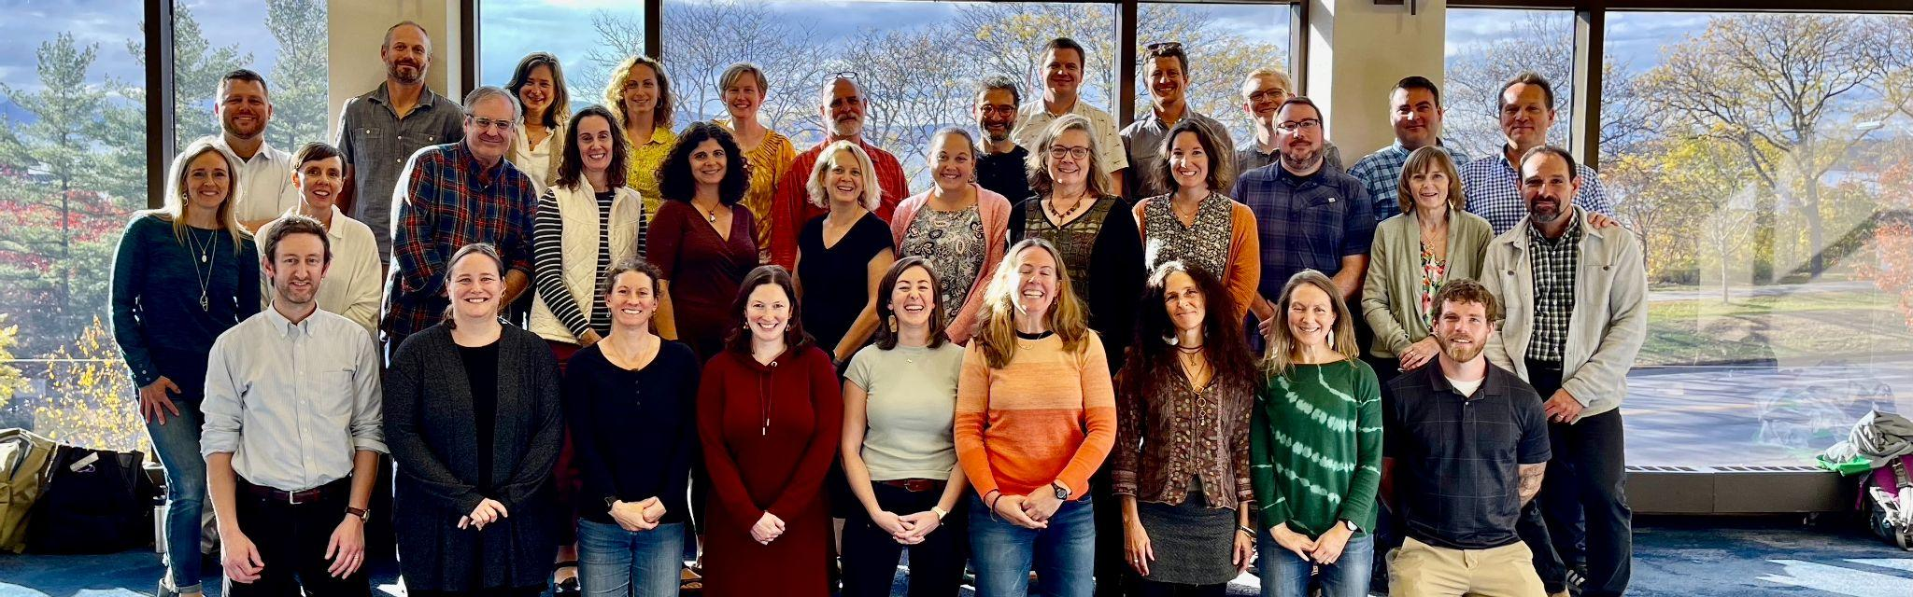Thanks to all the Rowland Fellows who joined us for the All Fellows Retreat this year! If you haven’t already done so, please give us ideas for next year’s edition here in the All Fellows Retreat Exit Survey. Warm congratulations to Charlie MacFadyen (RF20), Bryan Dickinson (RF22), Luis Bango (RF17), and Andrew Jones (RF15) for winning this year’s Music Trivia Contest: African SuperStars. You can see our All Fellows Retreat table discussions notes here. Thank you all Rowland Fellows for sharing your great thinking on many of our new Rowland Foundation initiatives!

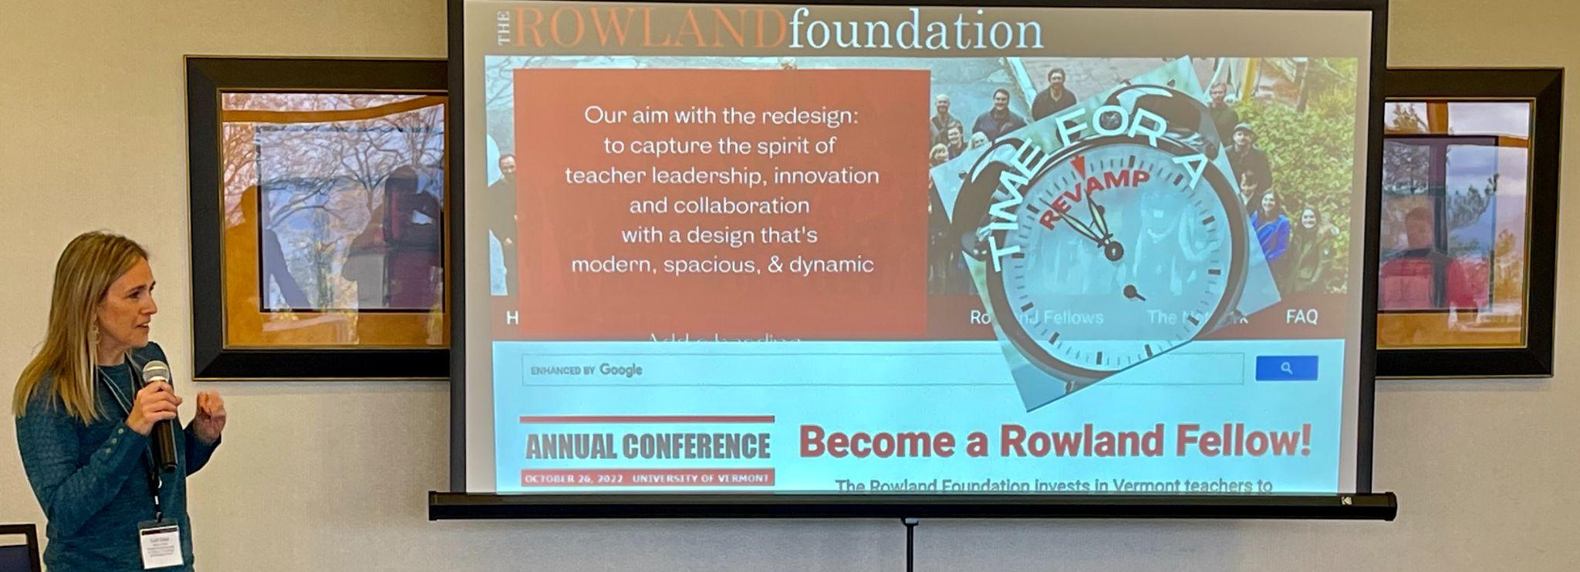
Thank you, Senior Associate Lori Lisai (RF15) for the update on the Rowland Foundation website work! All Rowland Fellows are invited to join the website design team discussions at their last scheduled meeting on Thursday, December 8th (3:30-4:30) at this zoom link: https://us02web.zoom.us/j/88003307849

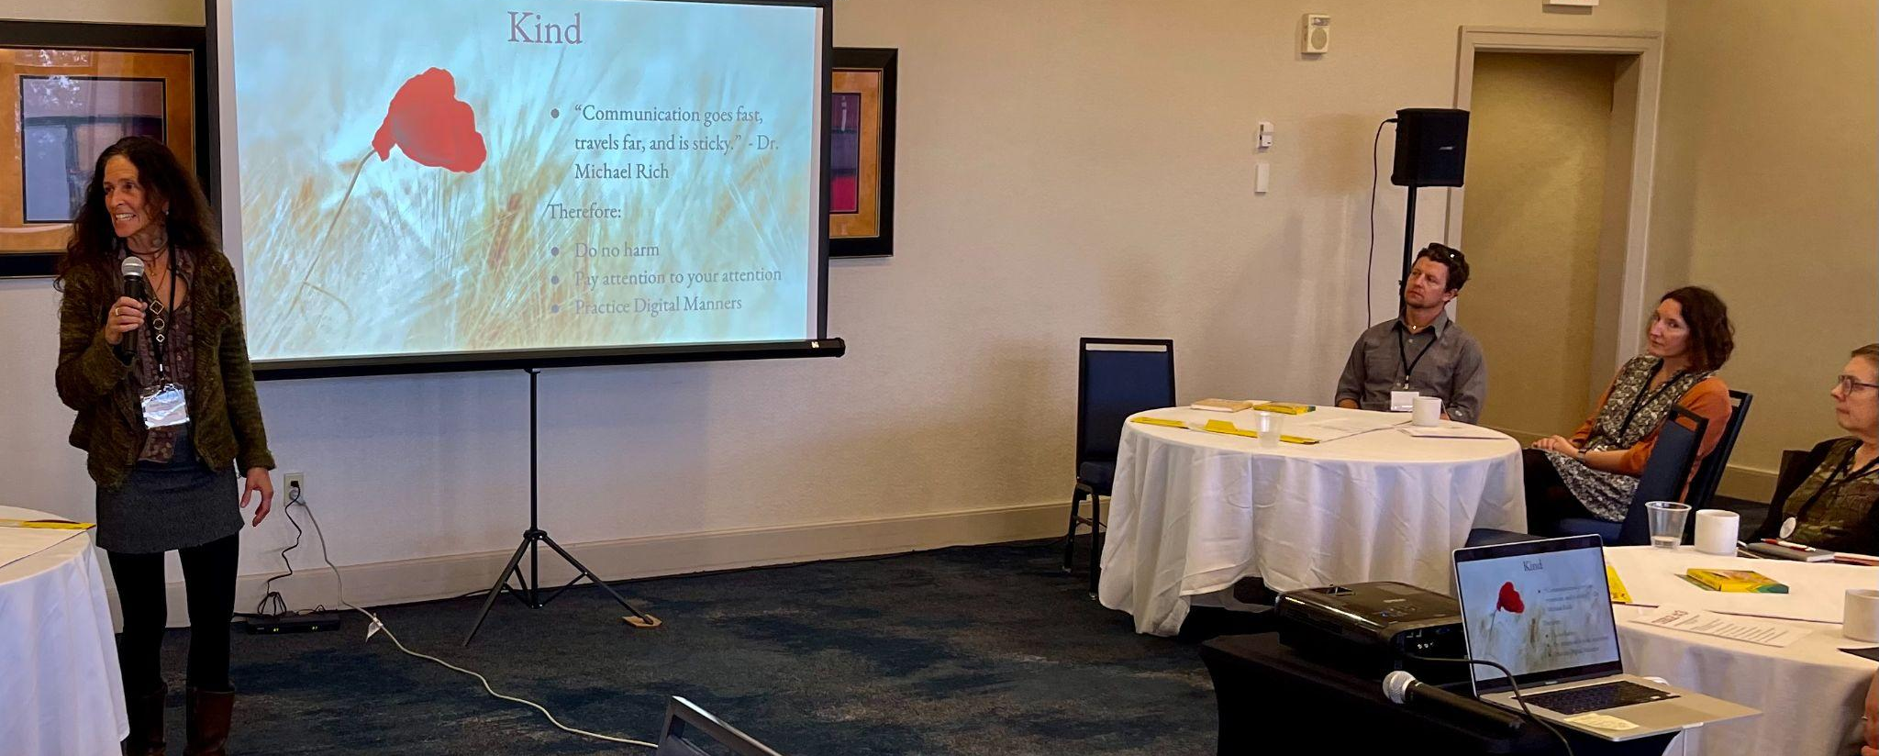
Thank you Carrie Felice (RF13) & Anne Bergeron (RF11) (seen here) for sharing an update on your Rowland Encore Grant work: Disconnect/Reconnect!

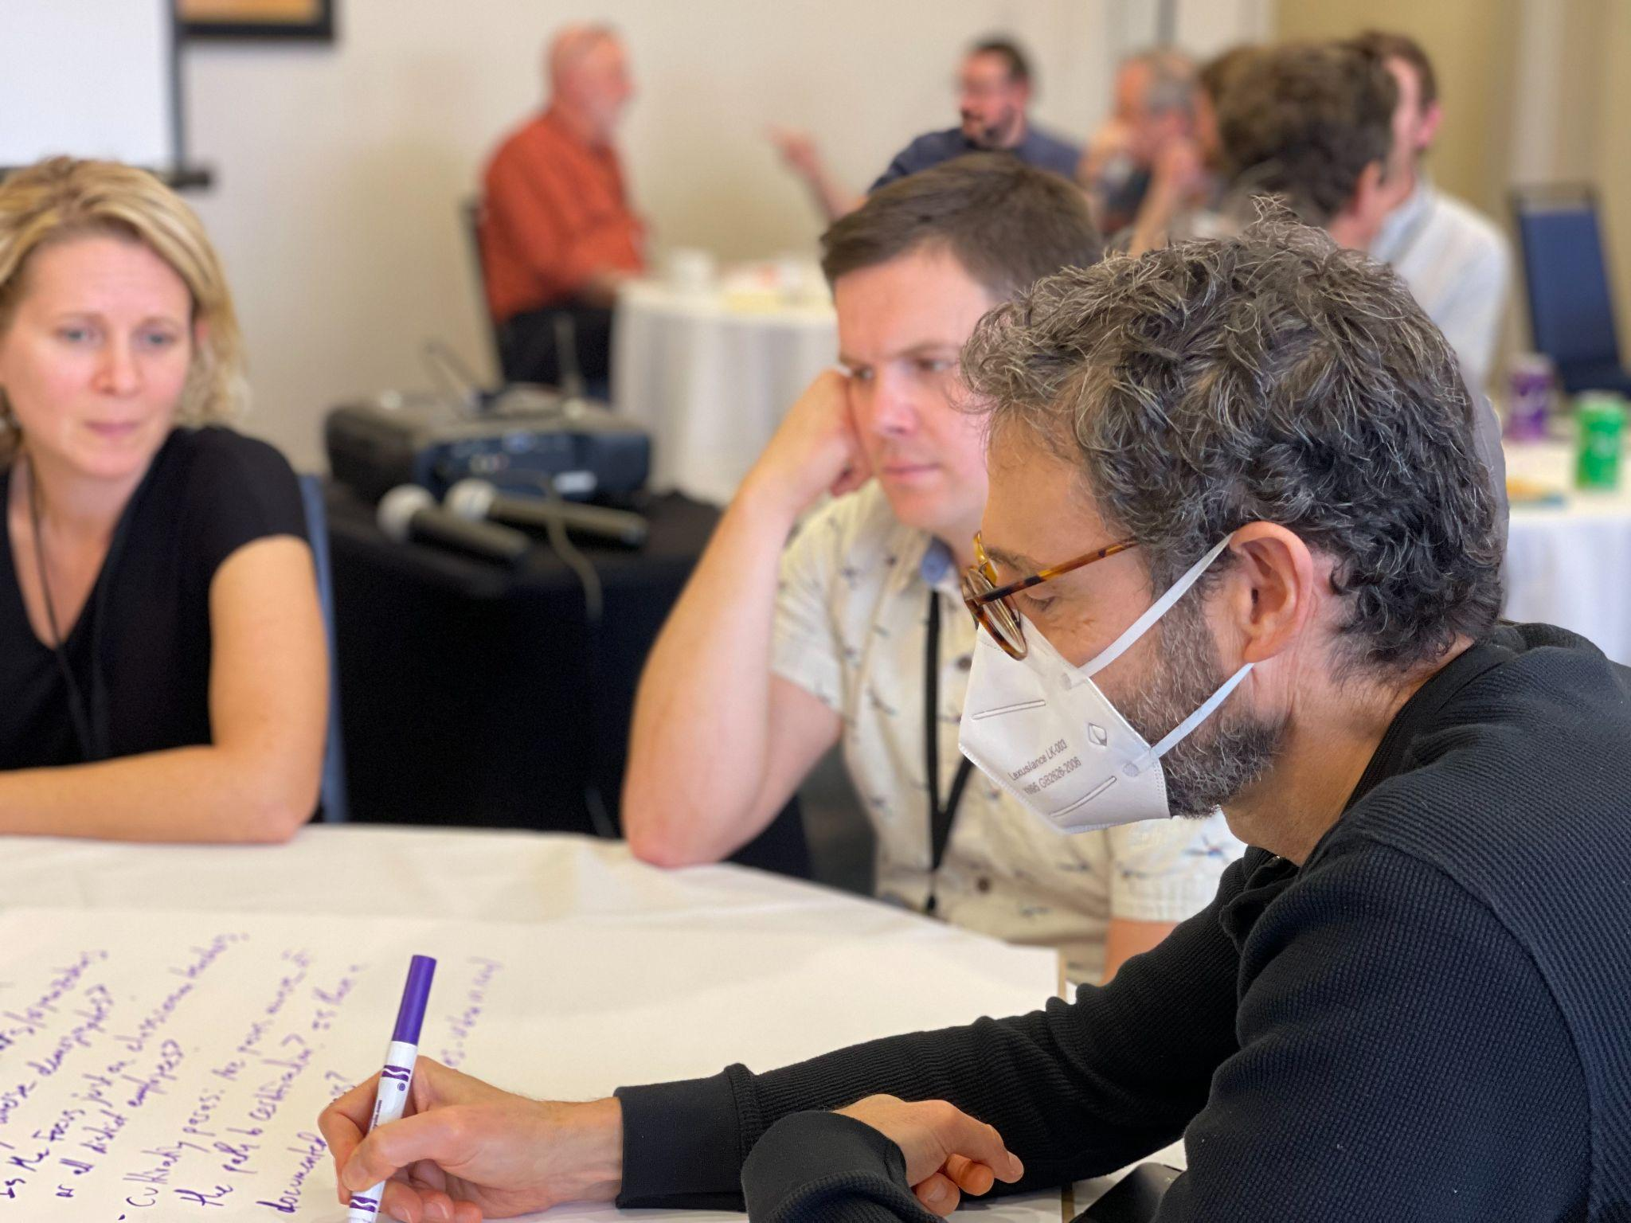
Maryann Carlson (RF20), Sam Bromley (RF22) & Adam Rosenberg (RF10) at the All Fellows Retreat

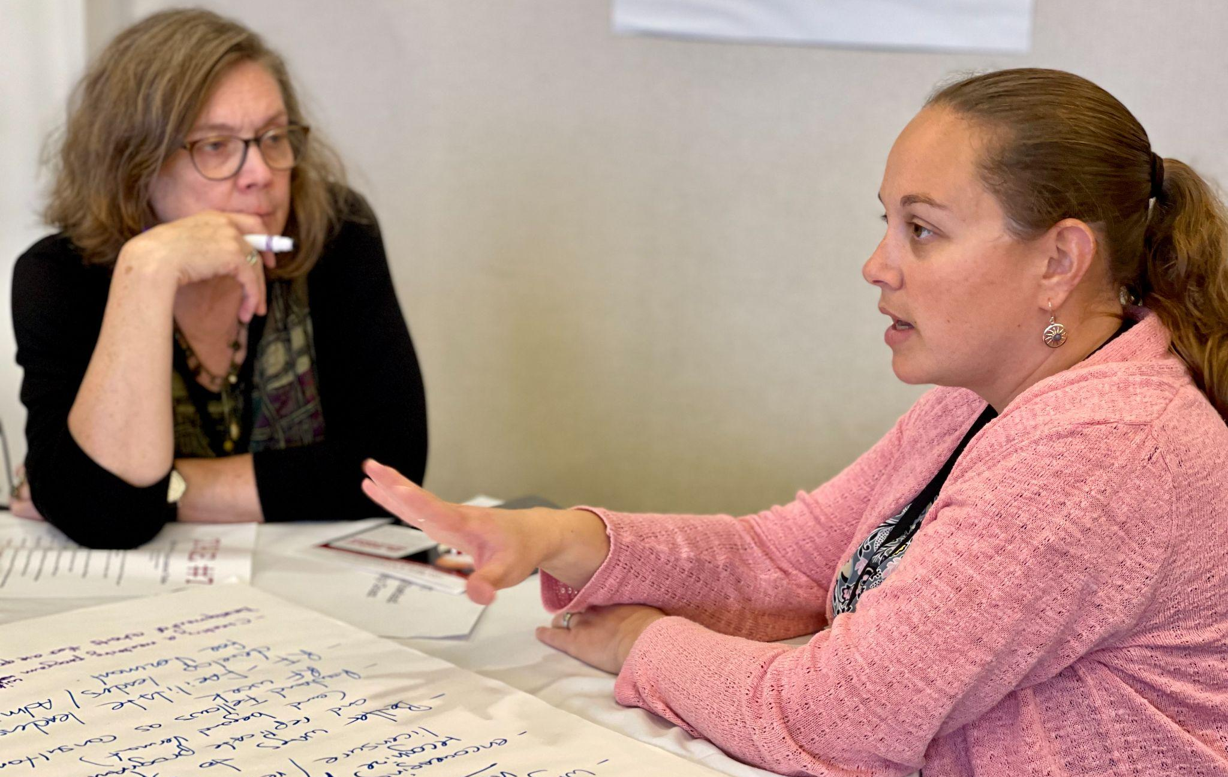
Marsha Cassel (RF14) & Bianca McKeen (RF16) at the All Fellows Retreat

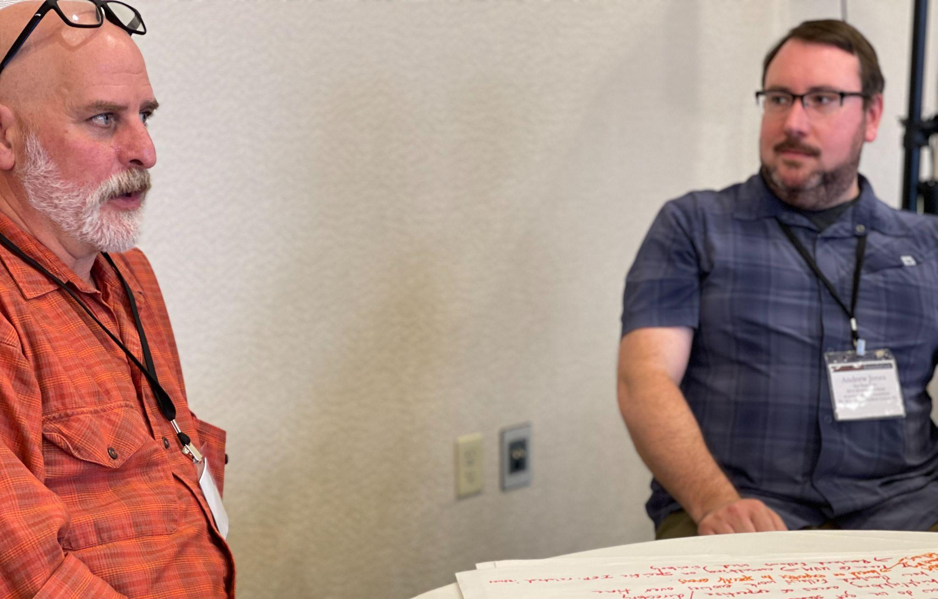
Luis Bango (RF17) & Andrew J0nes (RF15) at the All Fellows Retreat

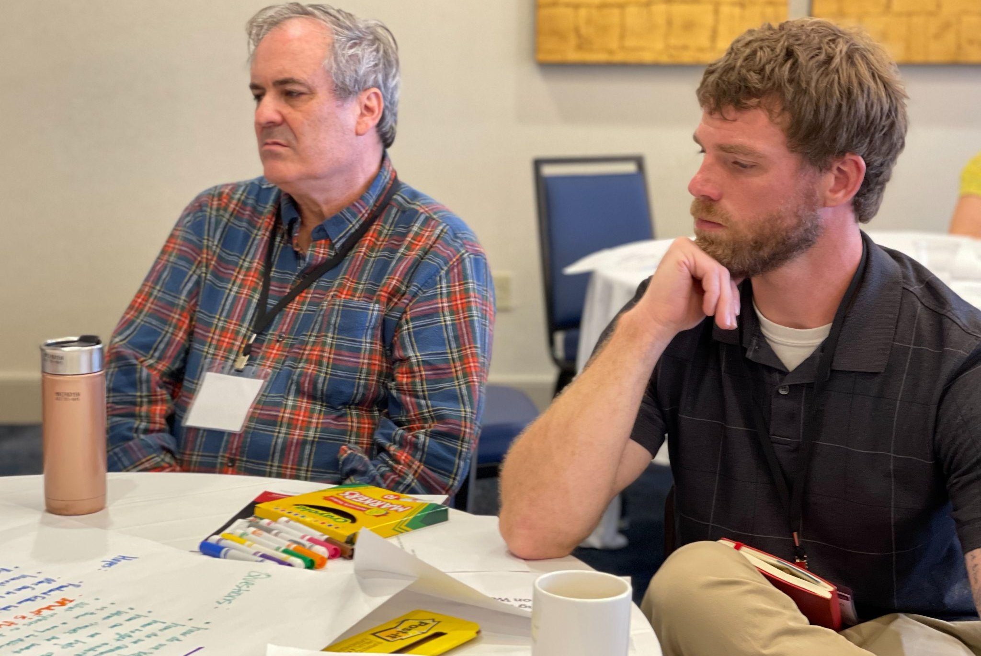
Charlie MacFadyen (RF20) & Bryan Dickinson (RF22) at the All Fellows Retreat

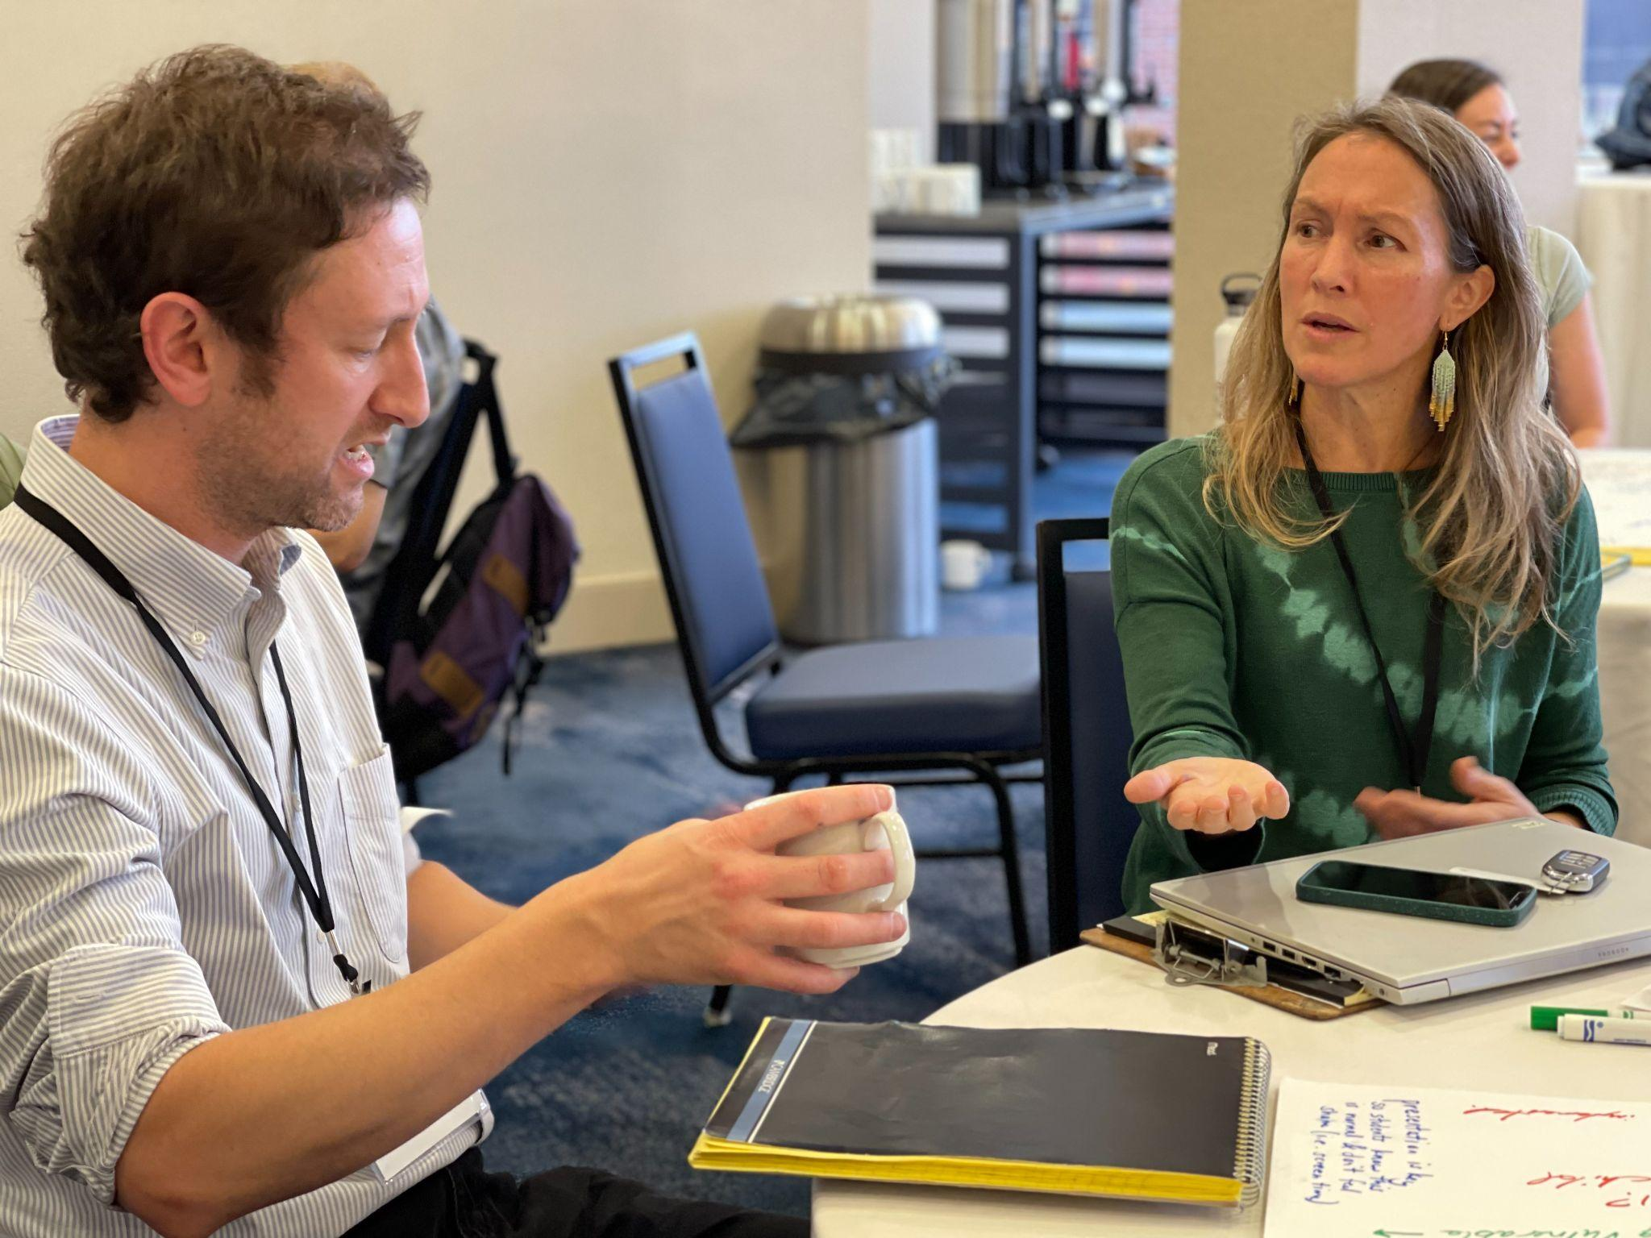
Alden Bird (RF18) & Carrie Felice (RF13) at the All Fellows Retreat

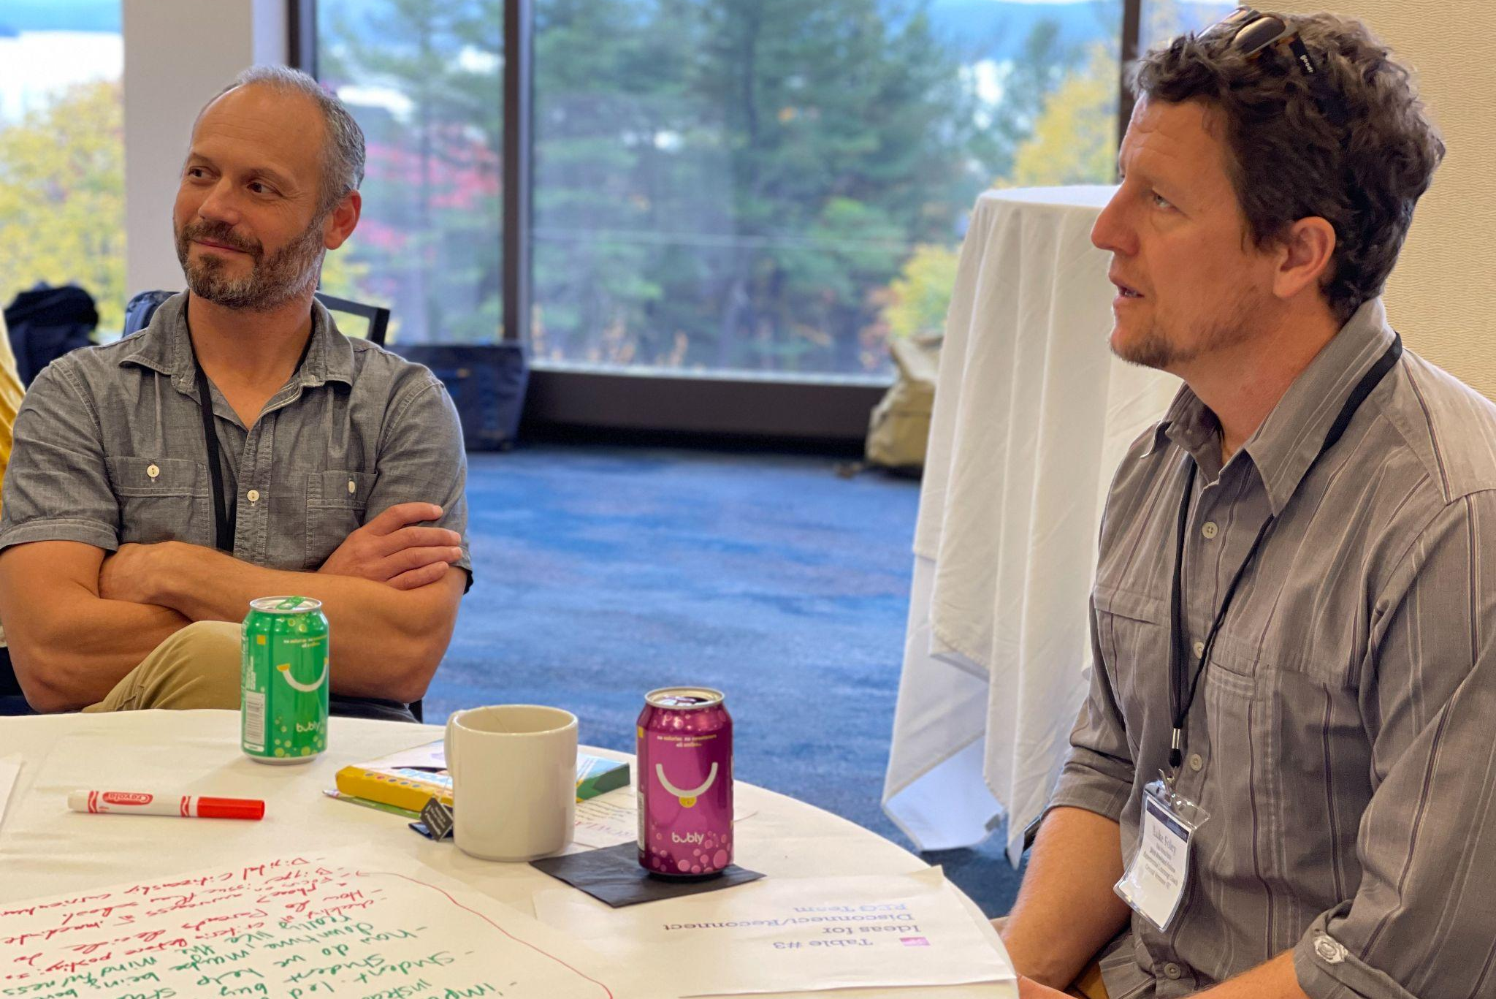
Gabe Hamilton (RF15) & Luke Foley (RF19) at the All Fellows Retreat

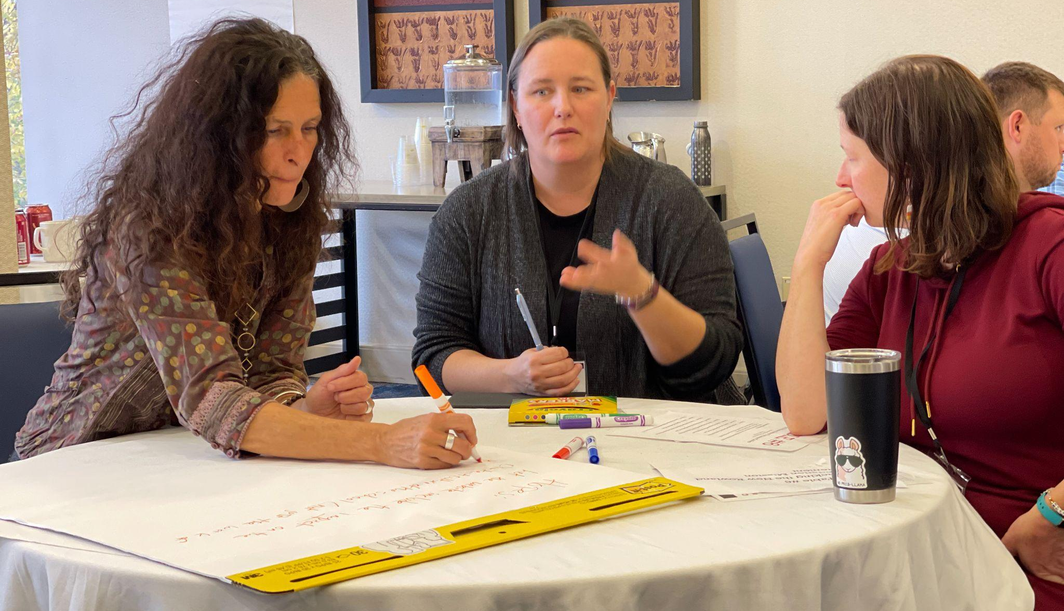
Anne Bergeron (RF11), Becky Ebel (RF22) & Samantha Mundt (RF21) at the All Fellows Retreat

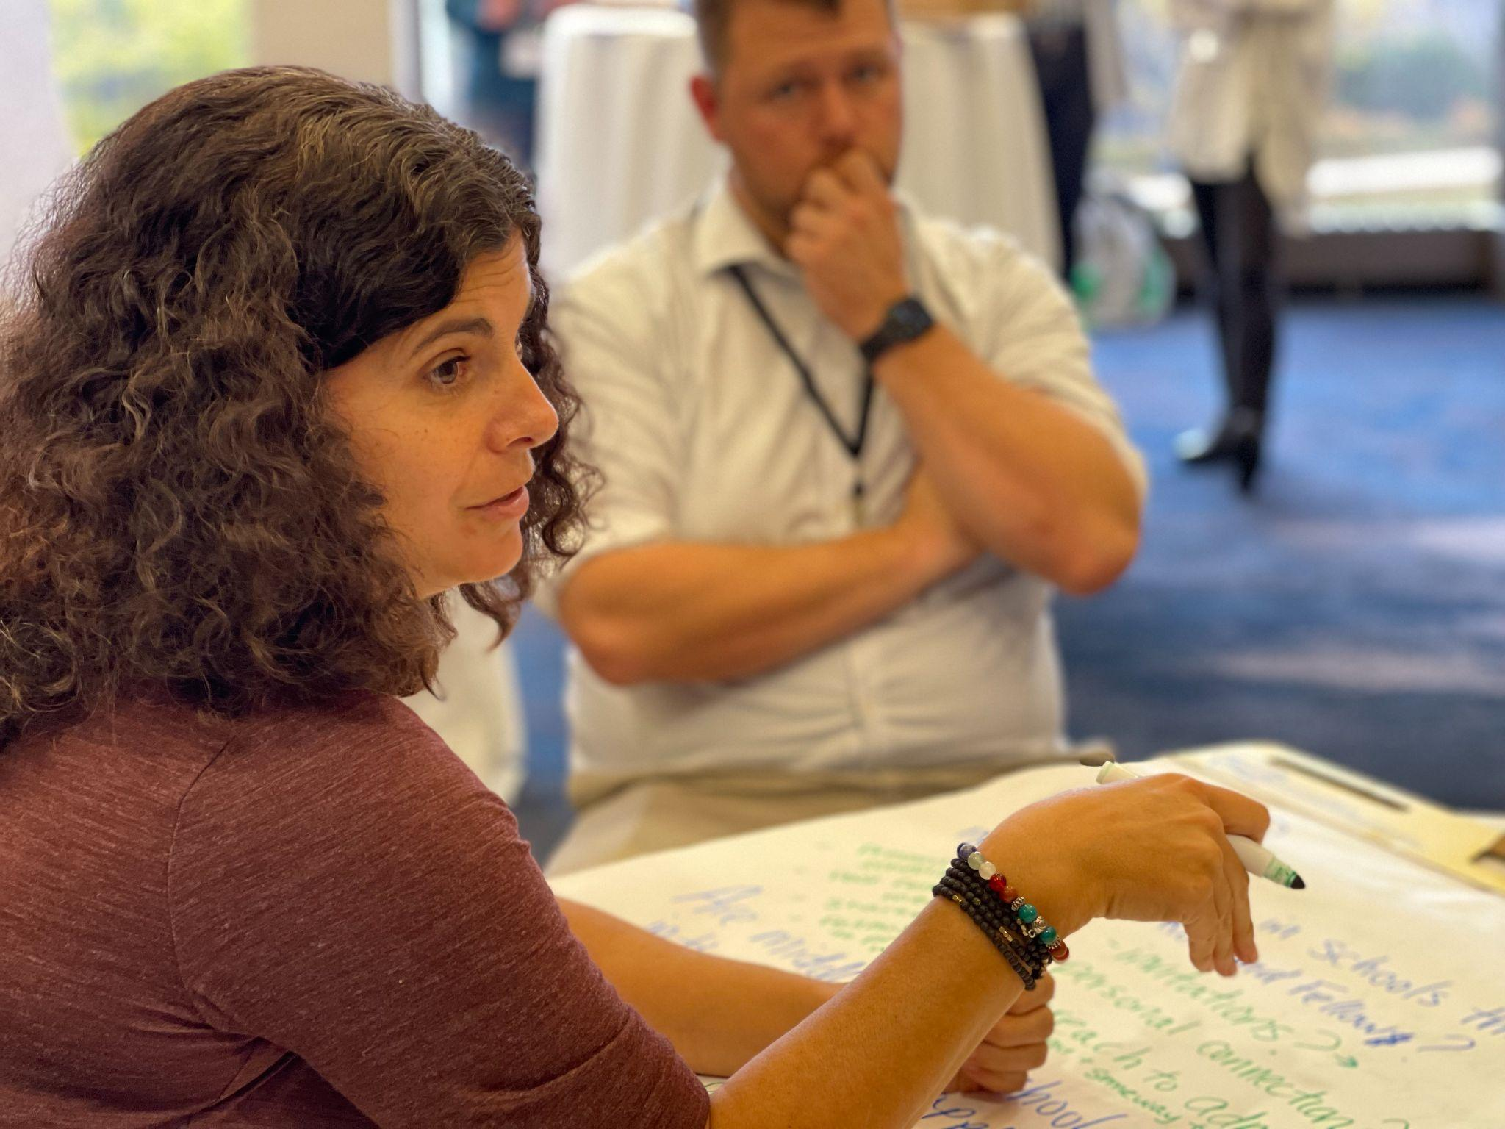
Janis Boulbol (RF21) & Devon Karpak (RF22) at the All Fellows Retreat

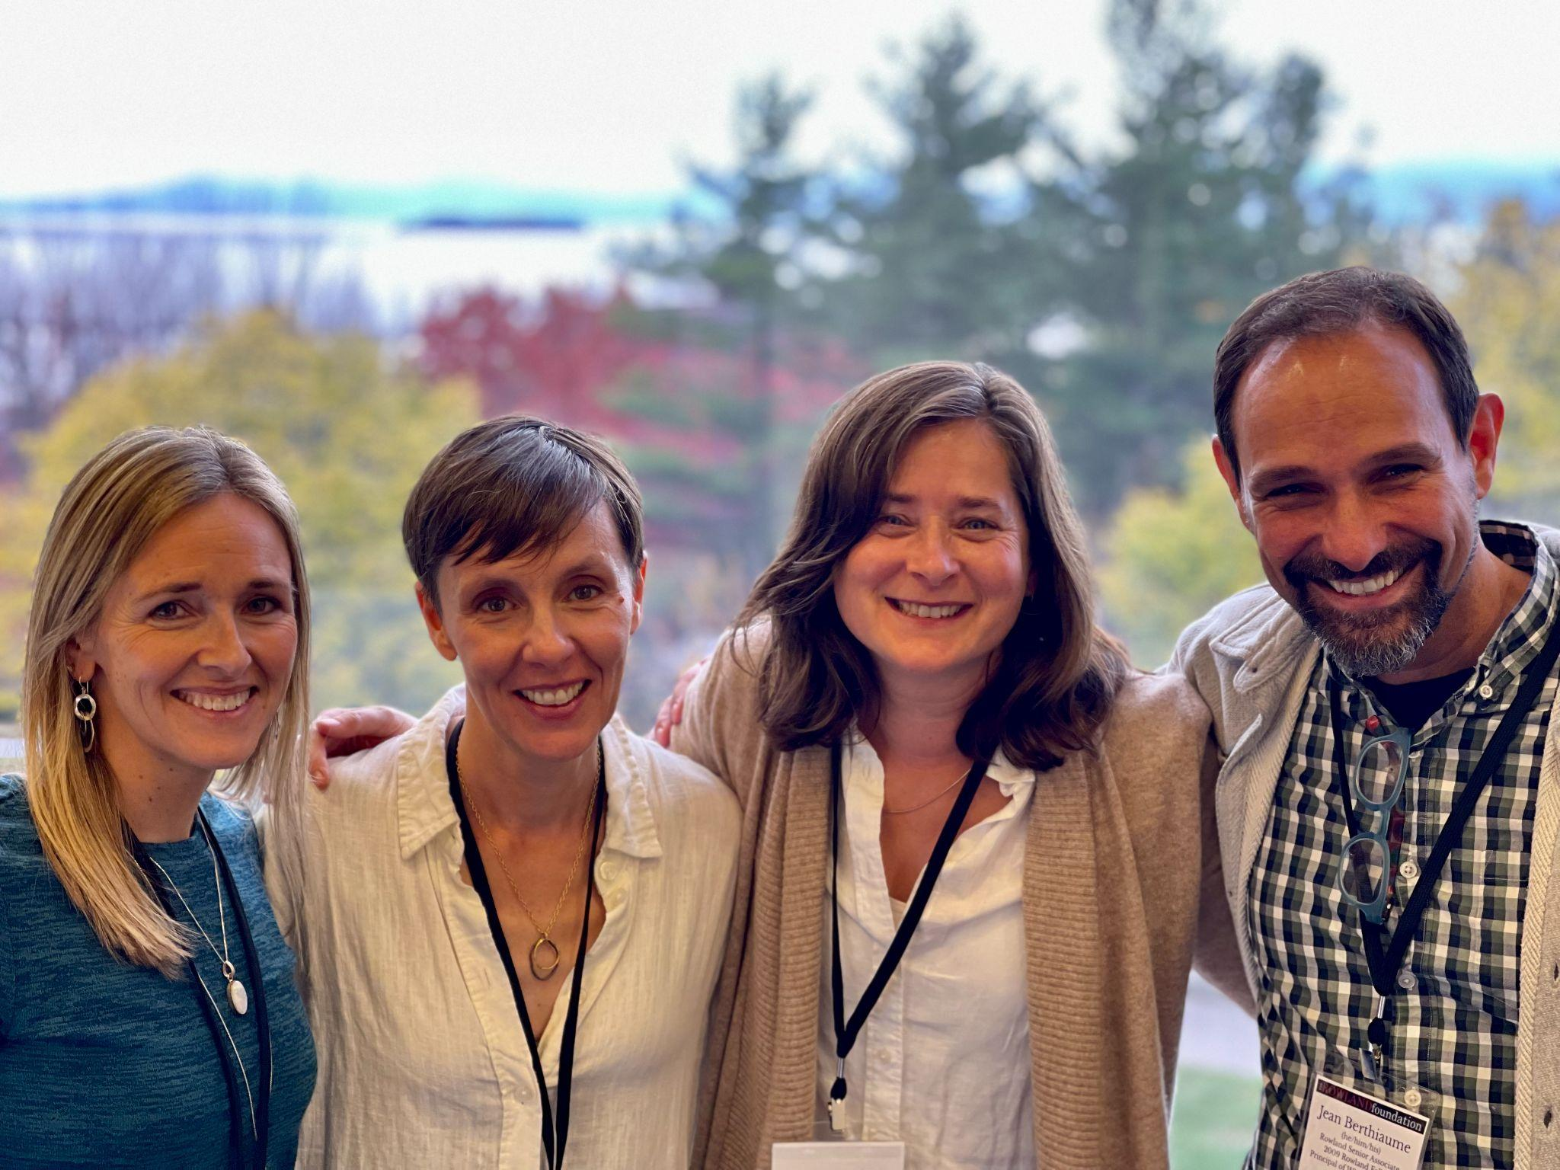
Special thanks to the Rowland Staff for making the All Fellows Retreat a success! Senior Associates Lori Lisai (RF15), Jeanie Phillips (RF14) & Jean Berthiaume (RF09) & Executive Administrative Assistant Abby Paige seen here at the Hilton Burlington/Lake Champlain.

The 11th Annual Rowland Conference
All Students Thriving: Rethinking School & Community
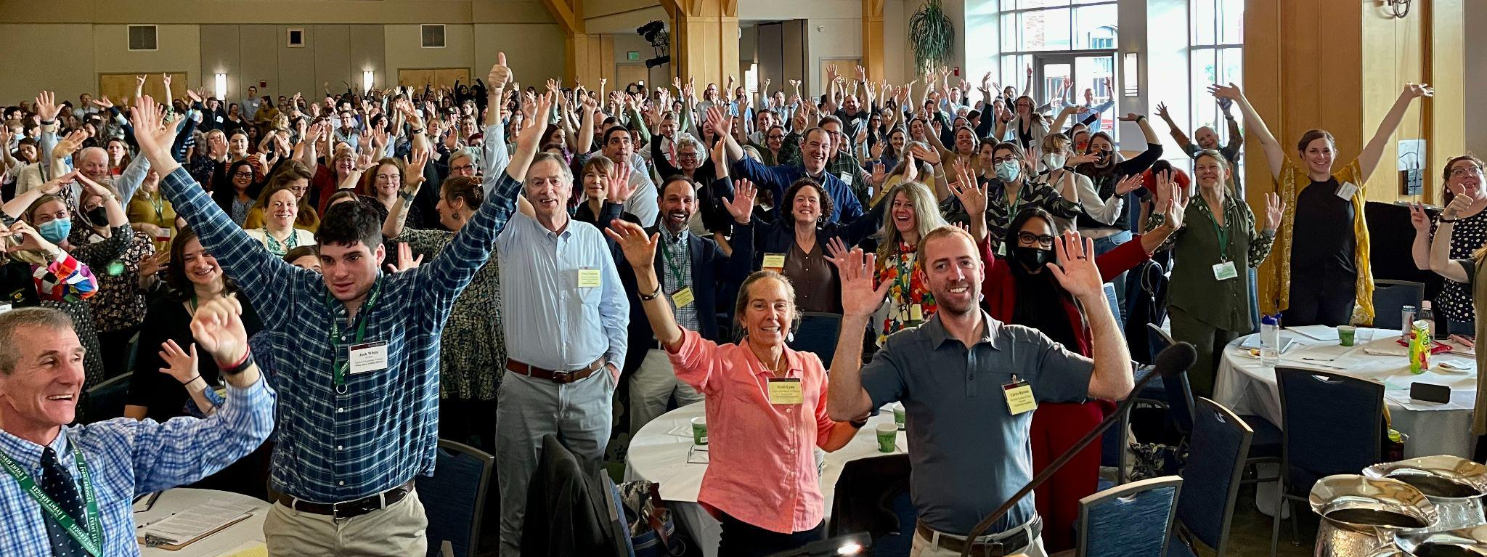

The 11th Annual Rowland Conference with keynote speaker Dr. Gholdy Muhammad was remarkable for the atmosphere of positive energy, innovation, and connection. Sincere thanks to Kat Robbins (RF21) for opening the day with such a beautiful land acknowledgment and to Jess DeCarolis (RF09) for her amazing address Centering Hope in School & Community in our opening remarks. Special thanks to our amazing workshop presenters–you can find many of their slidedecks & resources here.

Also, Gholdy Muhammad really connected with the Vermont Ed community and so she’s sharing these teaching videos and this incredible resource library with all conference attendees. To protect her intellectual property, please don’t share these online, but feel free to use them in your local school context to work with your colleagues and for your own professional practice. And remember to pick up a copy of her new book Unearthing Joy when it comes out in March 2023.

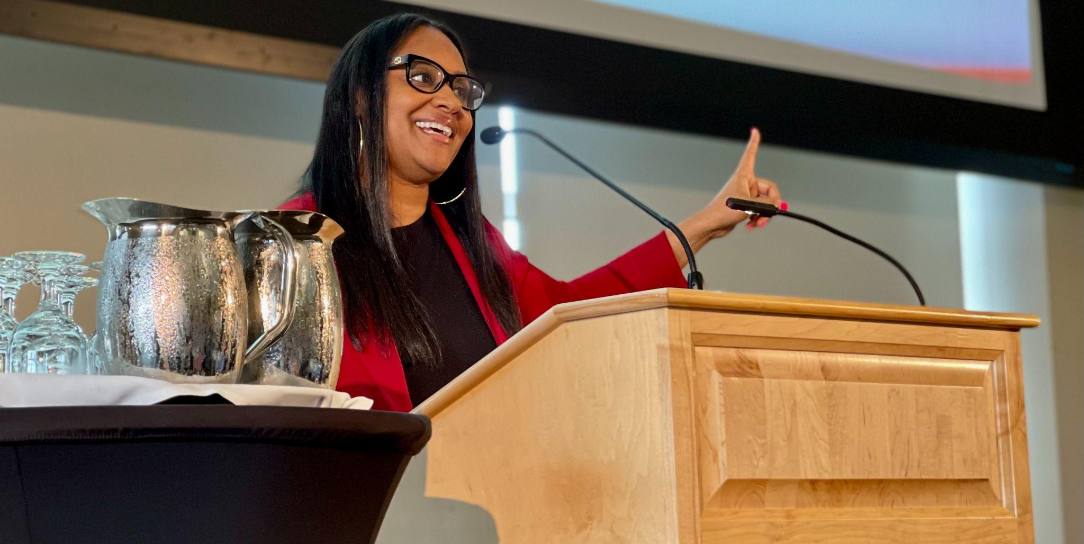
Keynote Dr. Gholdy Muhammad speaking at the 11th Annual Rowland Conference

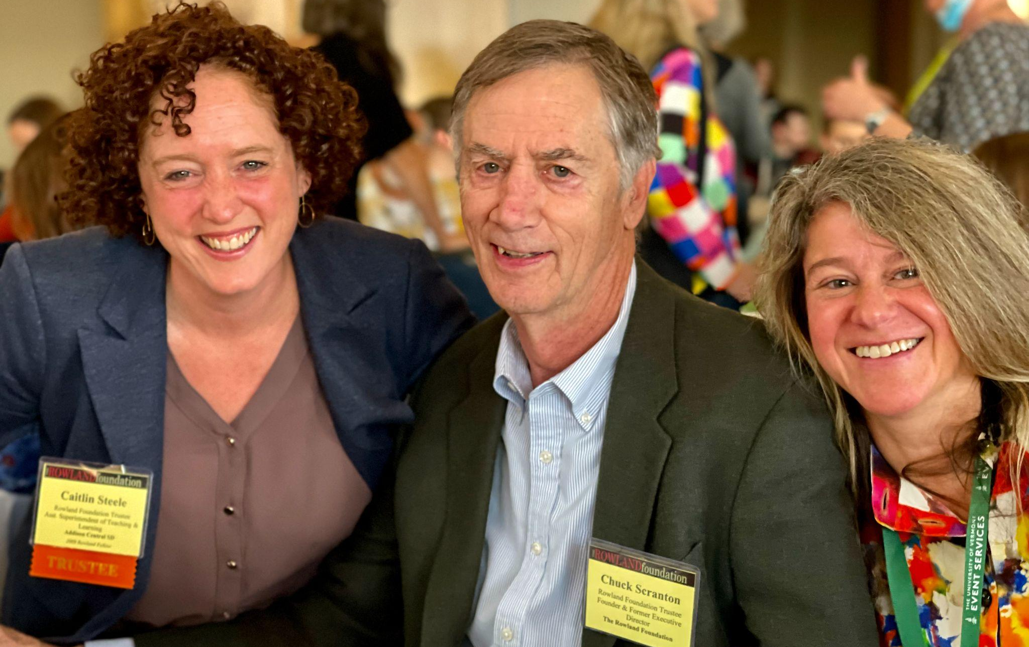
Trustees Dr. Caitlin Steele (RF09) & Chuck Scranton with Jess DeCarolis (RF09)

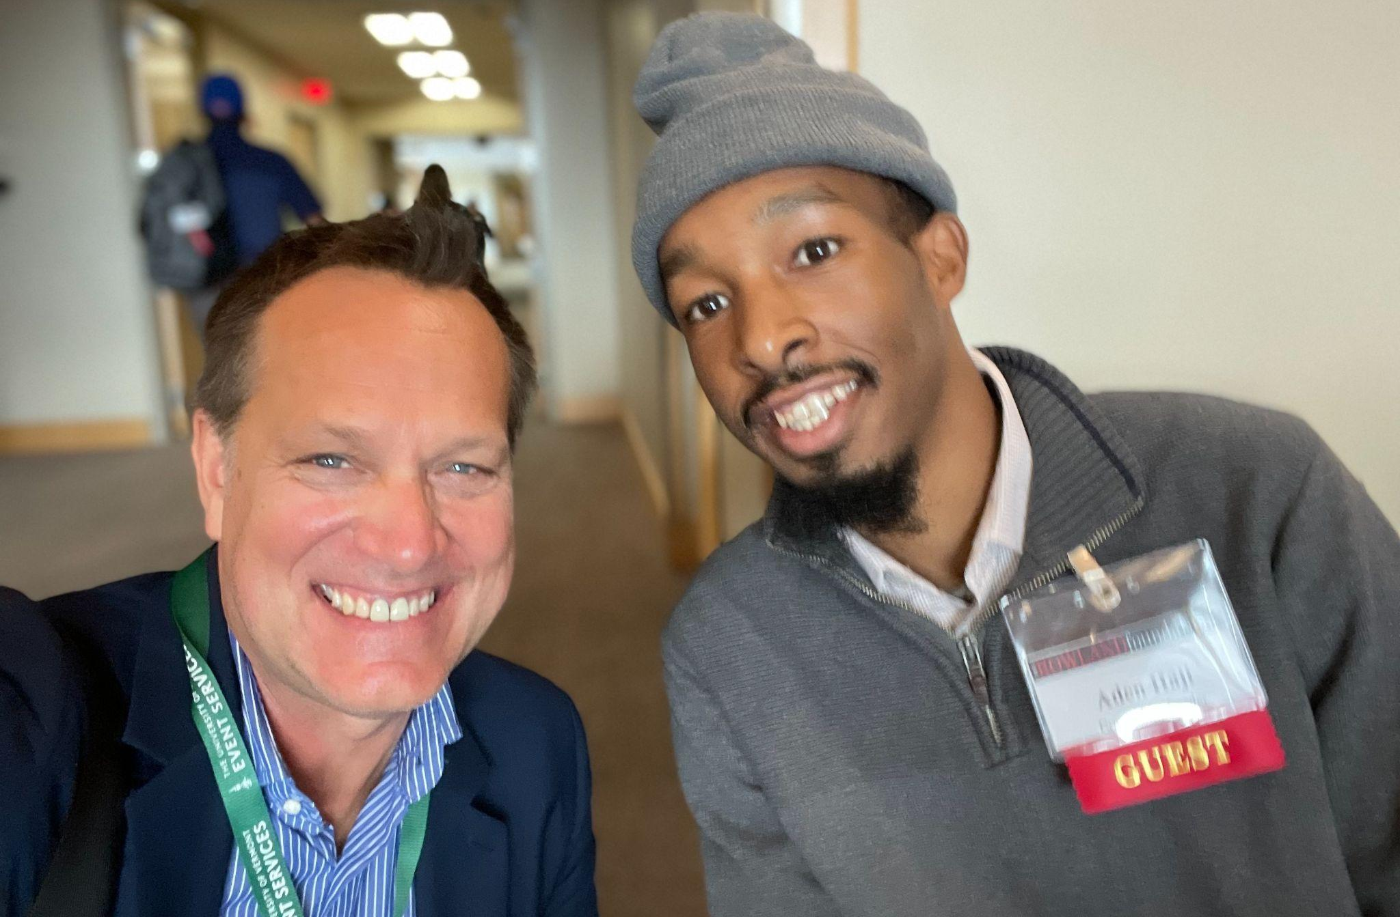
Executive Director Mike Martin (RF09) with Community Leader Aden Haji

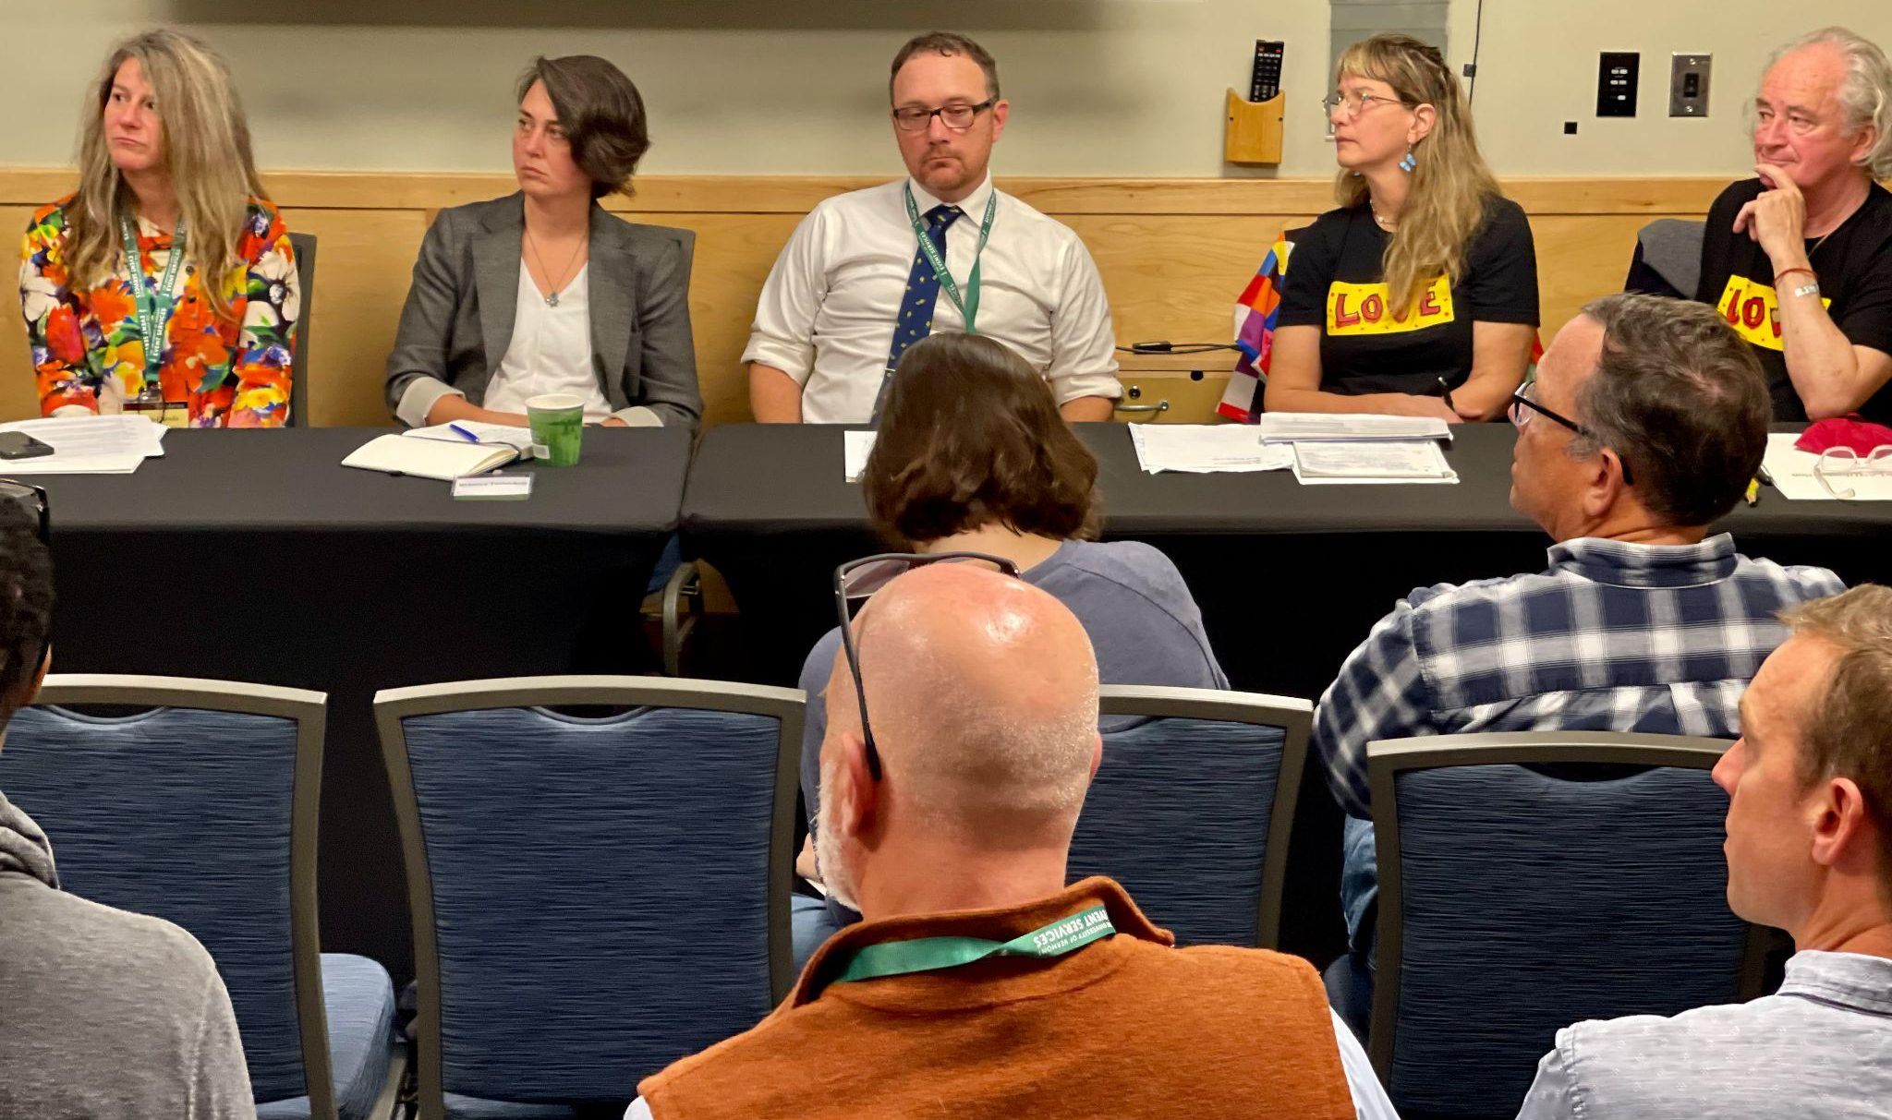
Jess DeCarolis (RF09), Matt DeBlois (RF09), and Mary Schell (RF10) seen here presenting on Community Schools in Vermont.

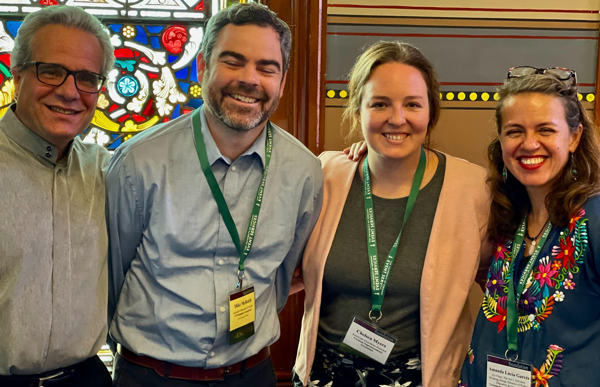
Mark Hage, Mike McRaith (RF13), Chelsea Myers & Amanda Garcés seen here presenting on the Act 1 proposed revisions to the Vermont Educational Quality Standards

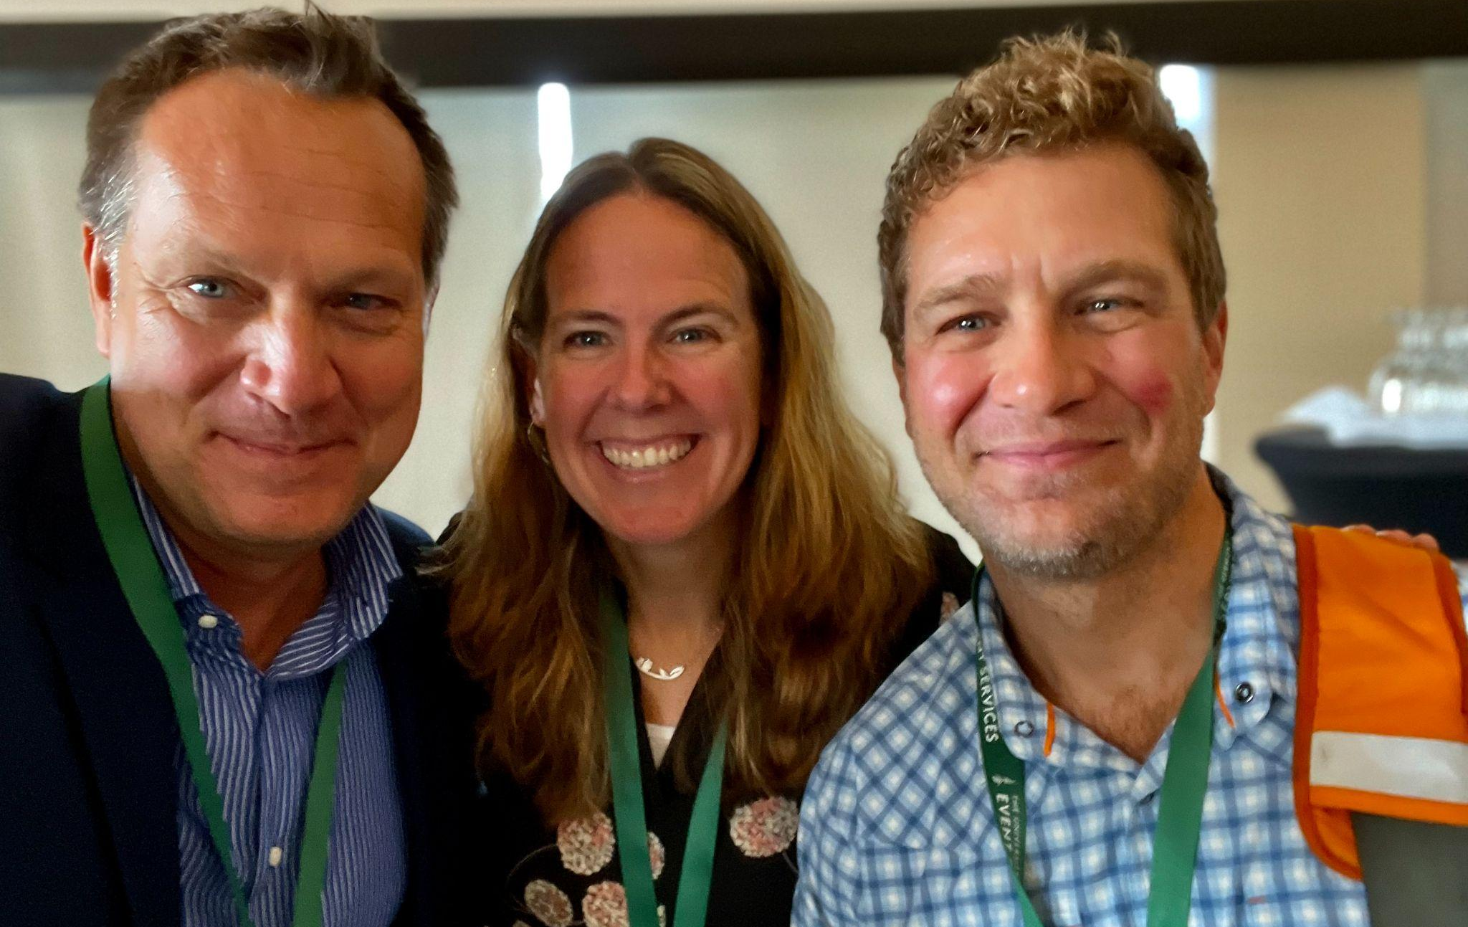
Executive Director Mike Martin (RF09), Trustee Erica Wallstrom (RF14) & John Painter (RF14) catching up at the Rowland Conference

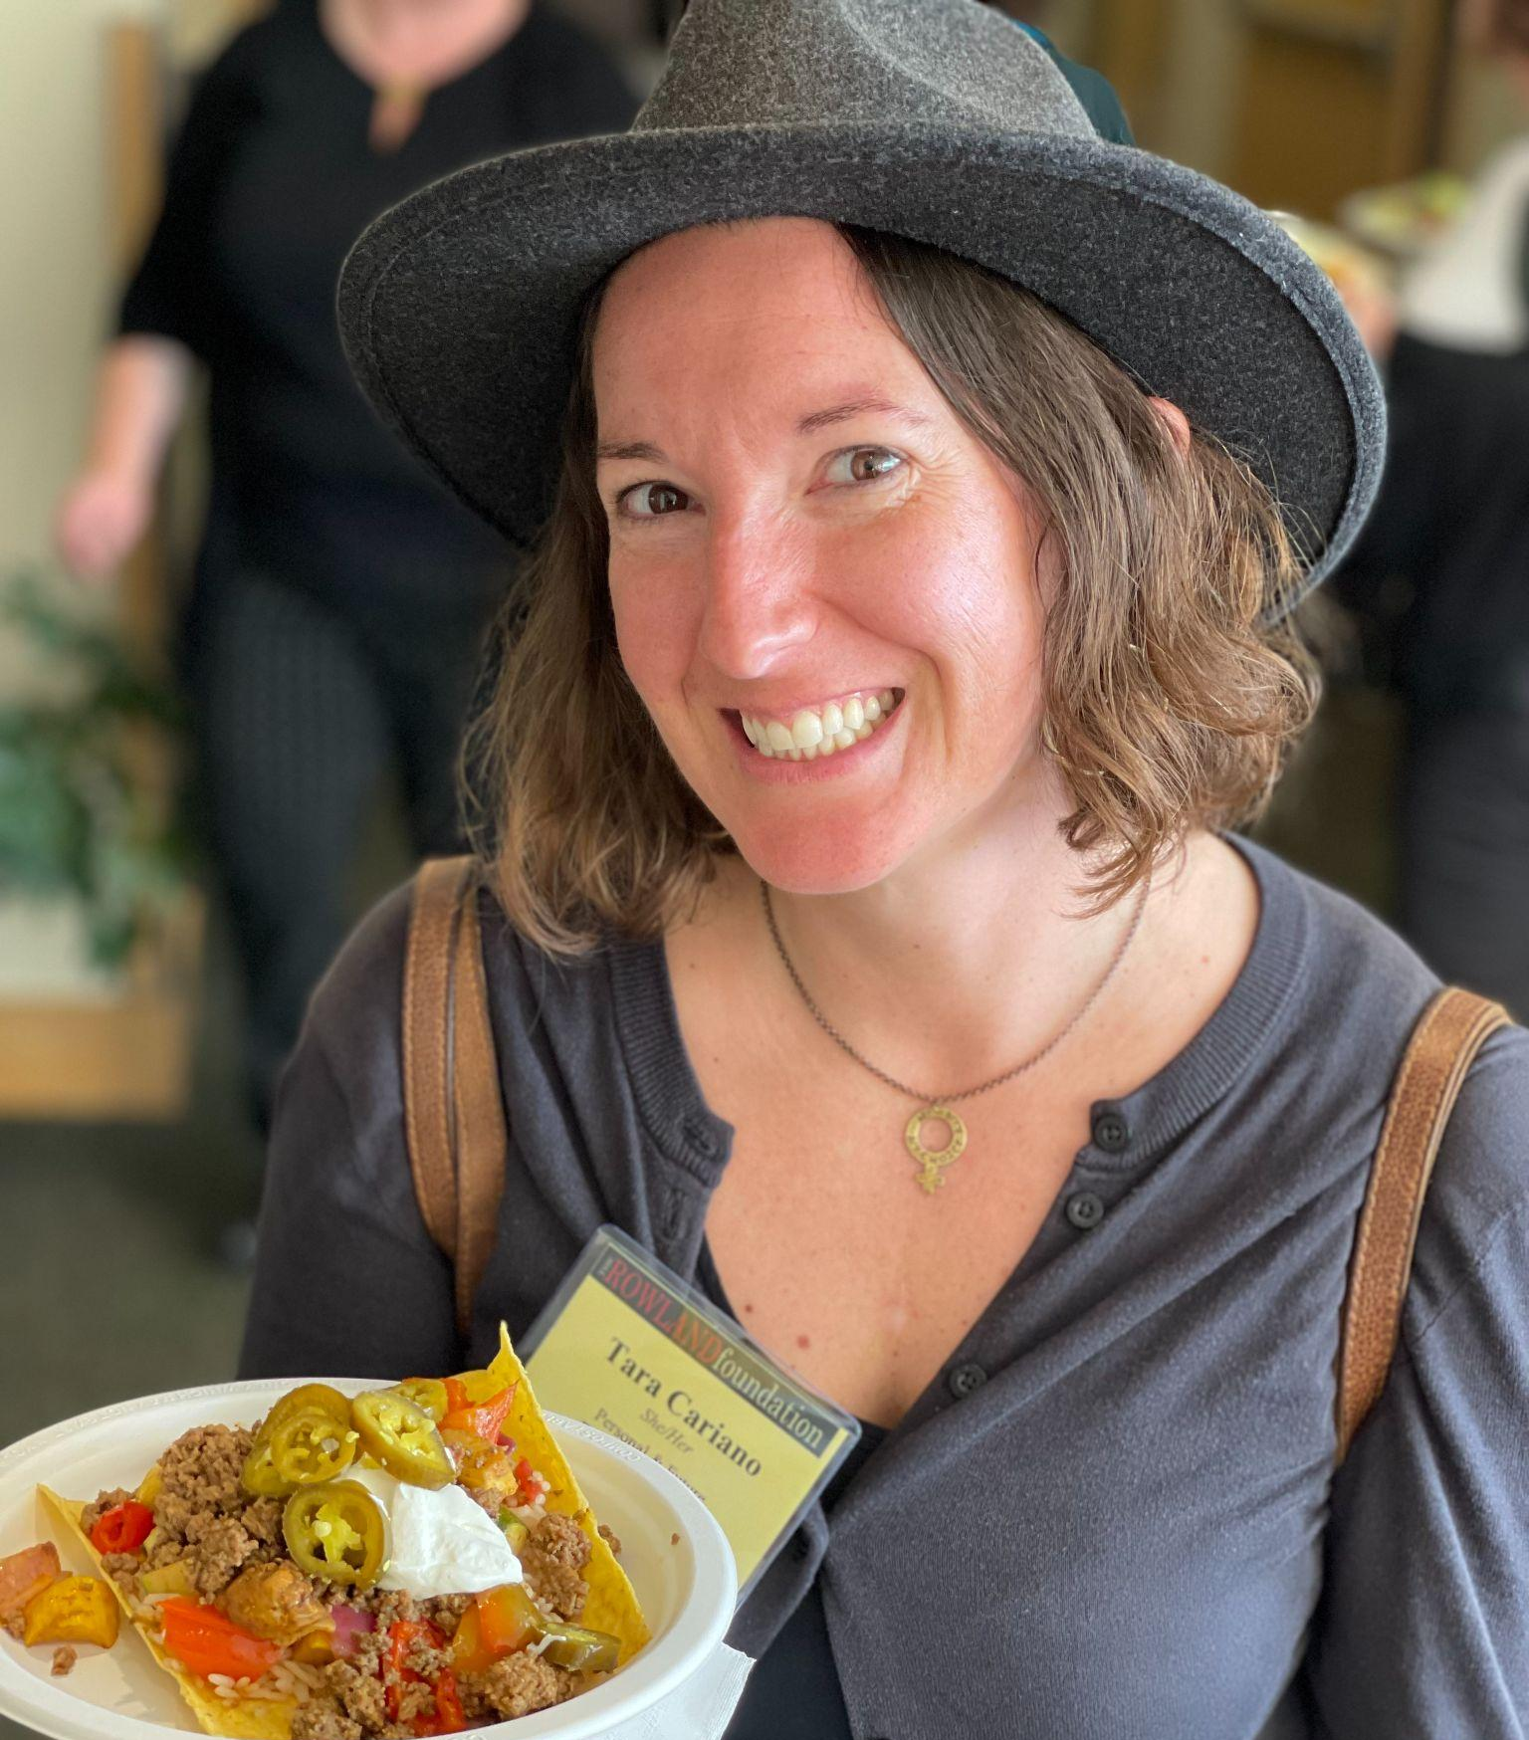
Tara Cariano (RF18) getting some delicious and spicy lunch at the Rowland Conference

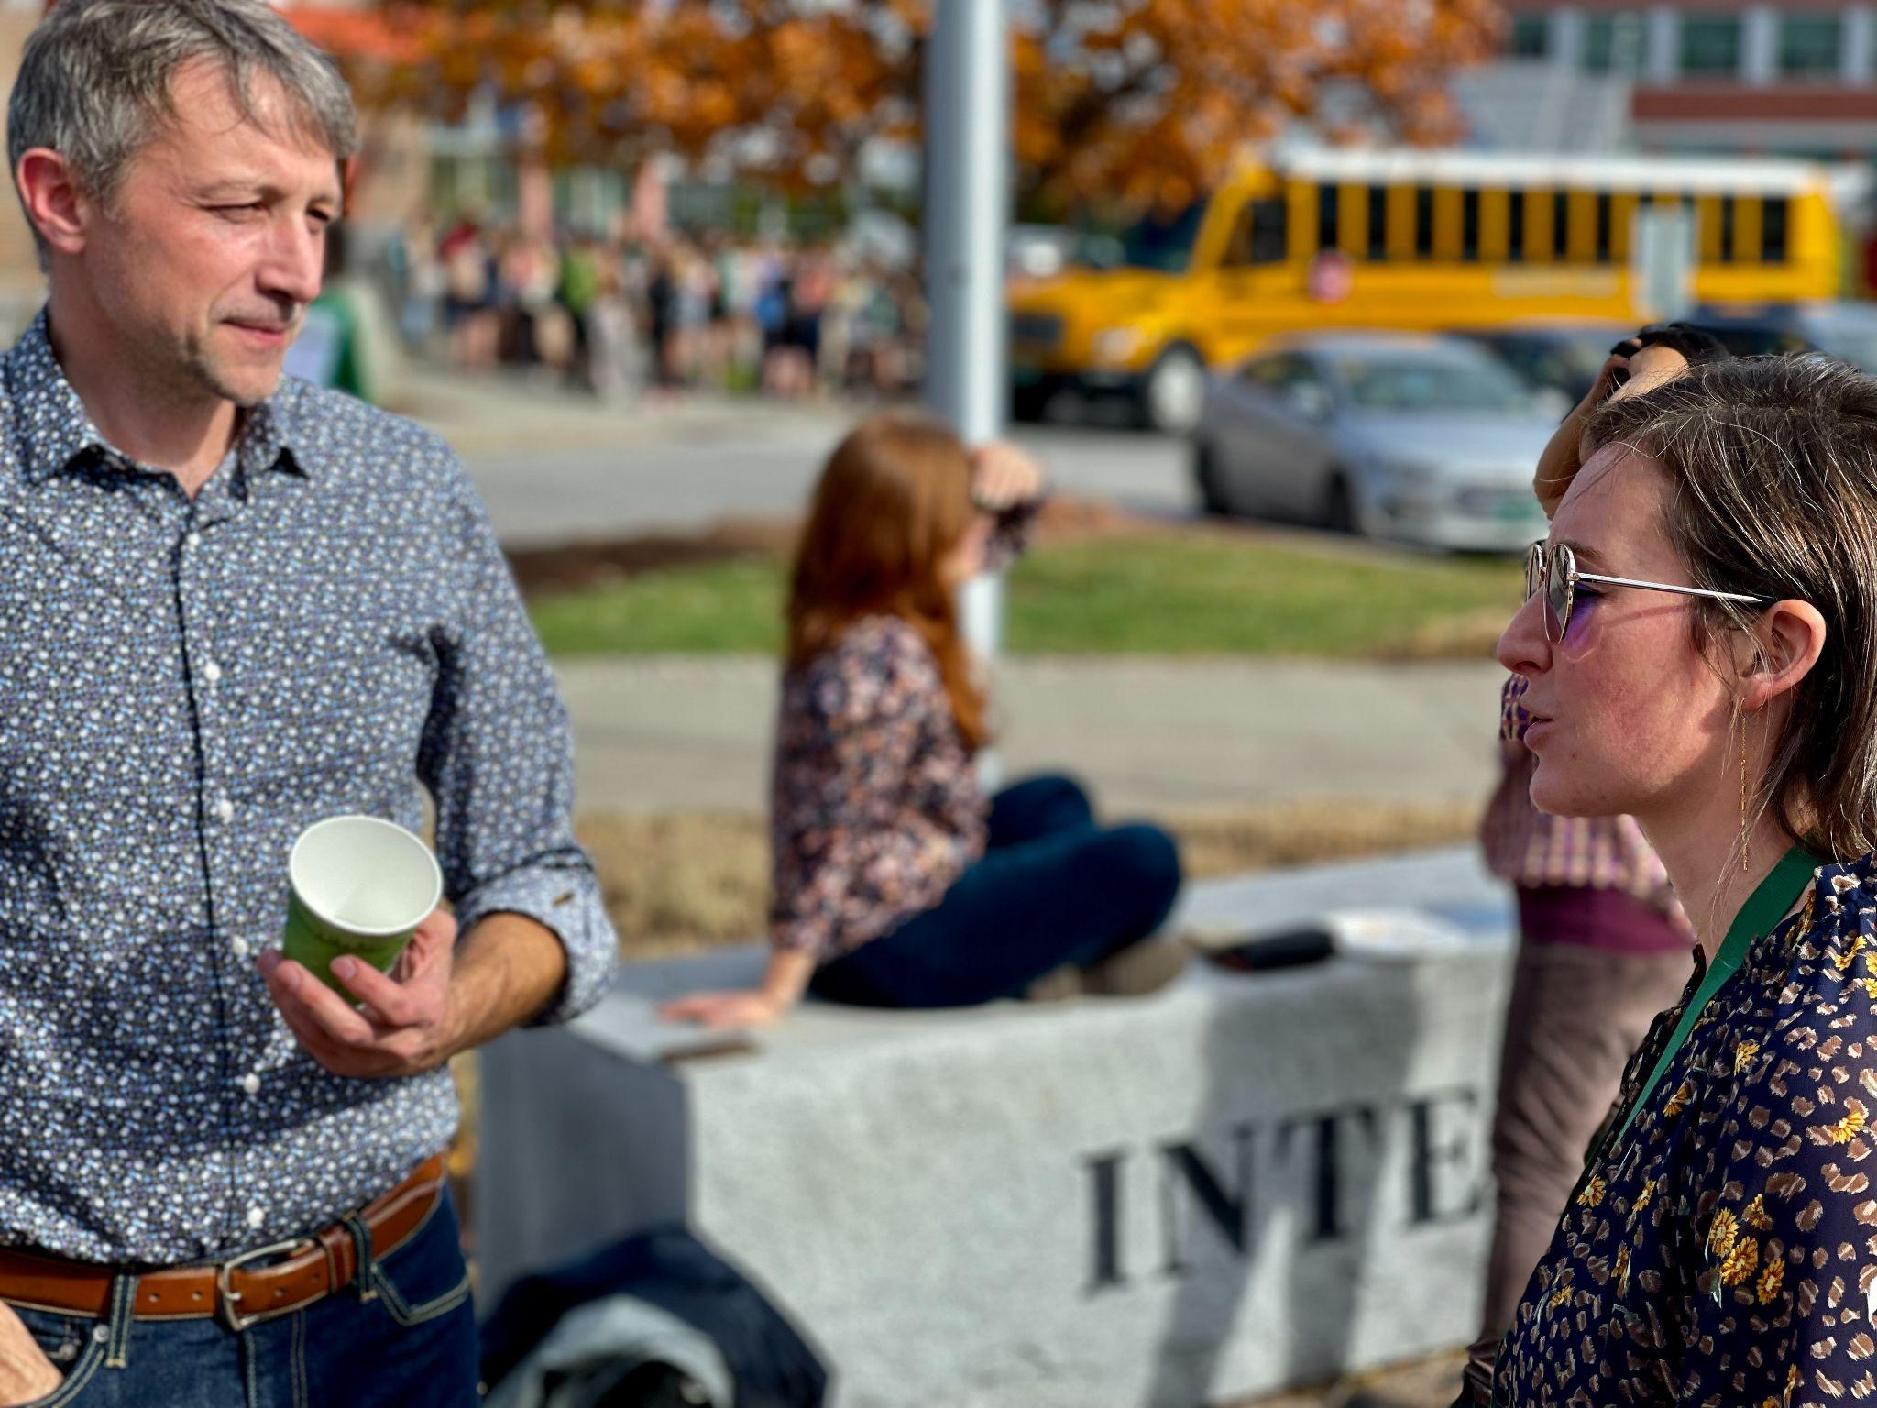
Workshop presenters Elijah Hawkes & Emily Gilmore (RF17) between sessions

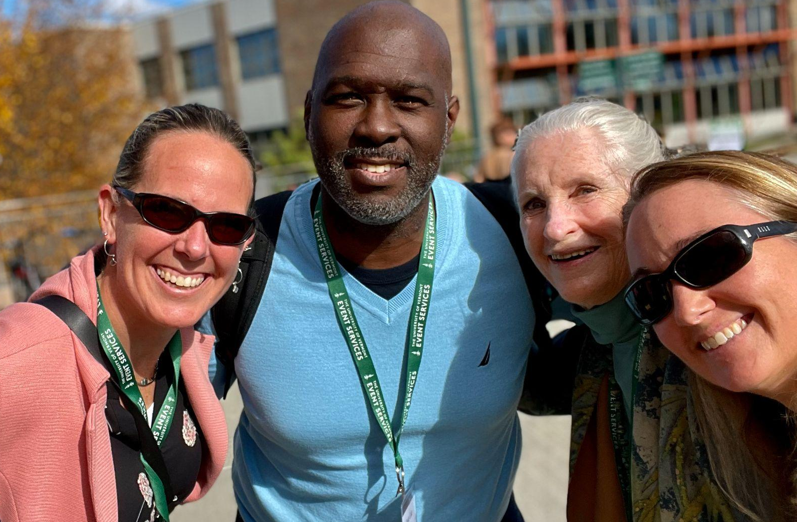
Trustee Erica Wallstrom (RF14) & Lauren Parren (RF12) seen here with staff from Great Schools Partnership at the Rowland Conference

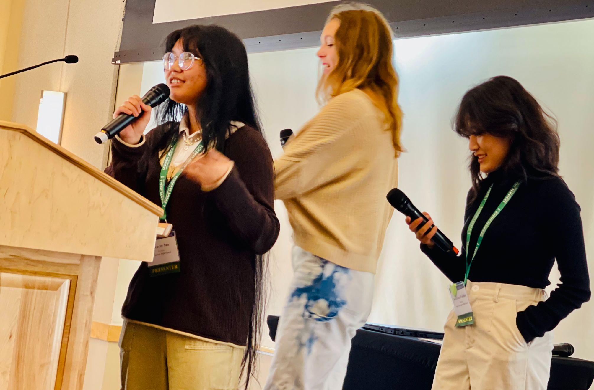
Students Mearee Jan, Eliza Willis & Auishma Pradhan presenting at the Rowland Conference

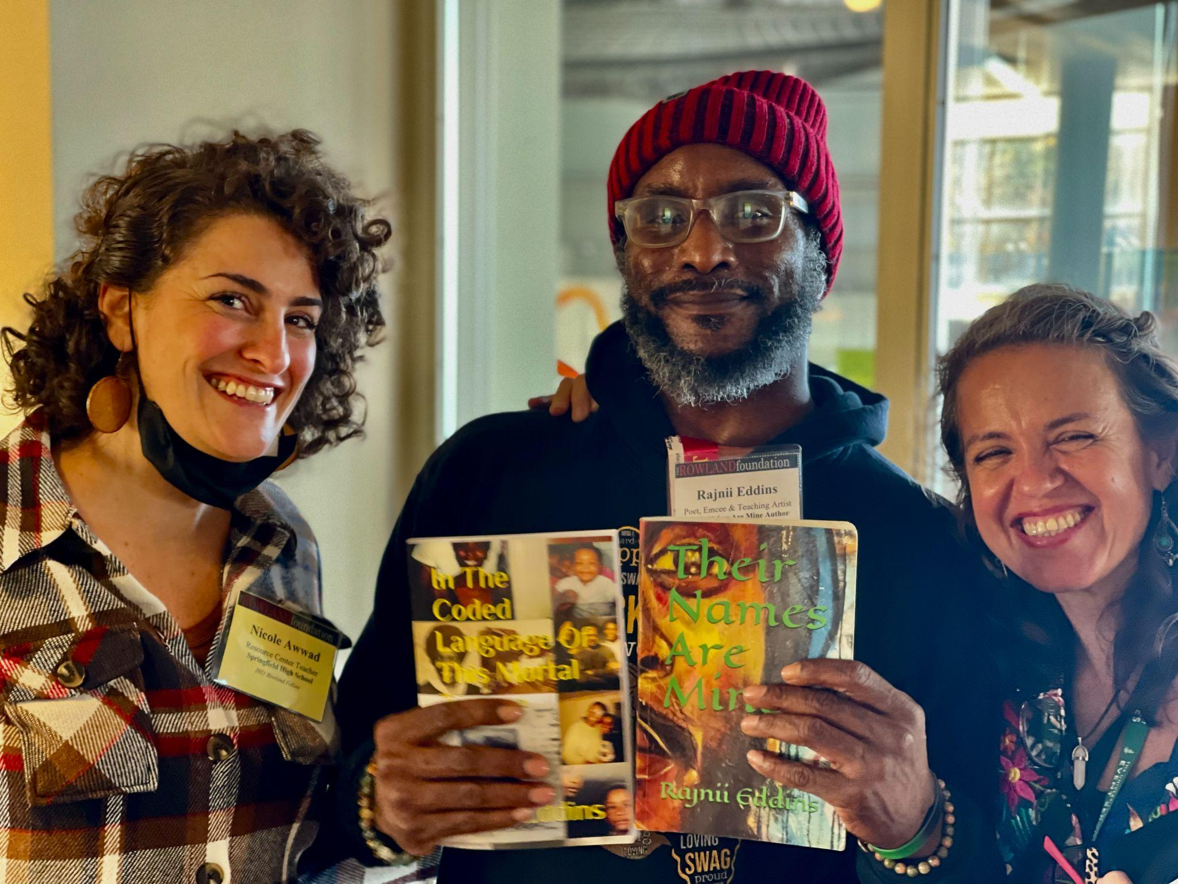
Nicole Awwad (RF21) seen here with poet & teaching artist Rajnii Eddins and Act 1 Working Group Chair Amanda Garcés.

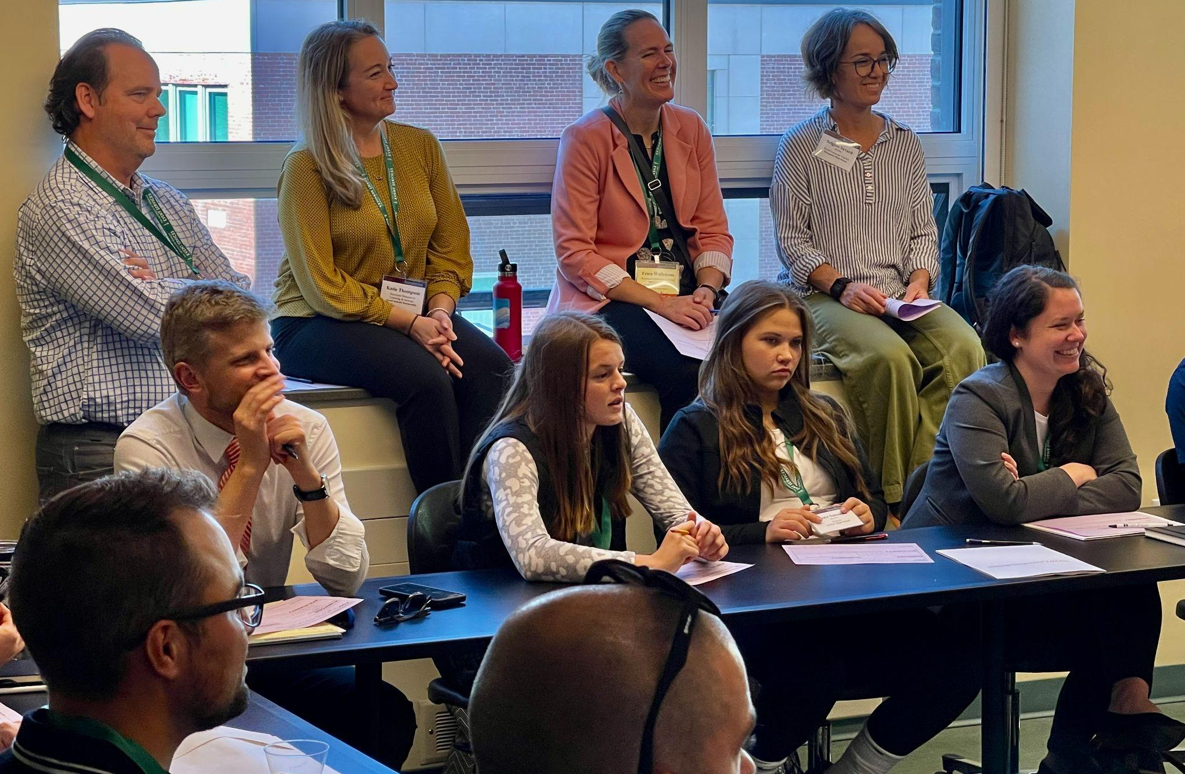
Colin McKaig (RF13), Michael Ruppel (RF17) & Trustee Erica Wallstrom (RF14) seen here at a workshop

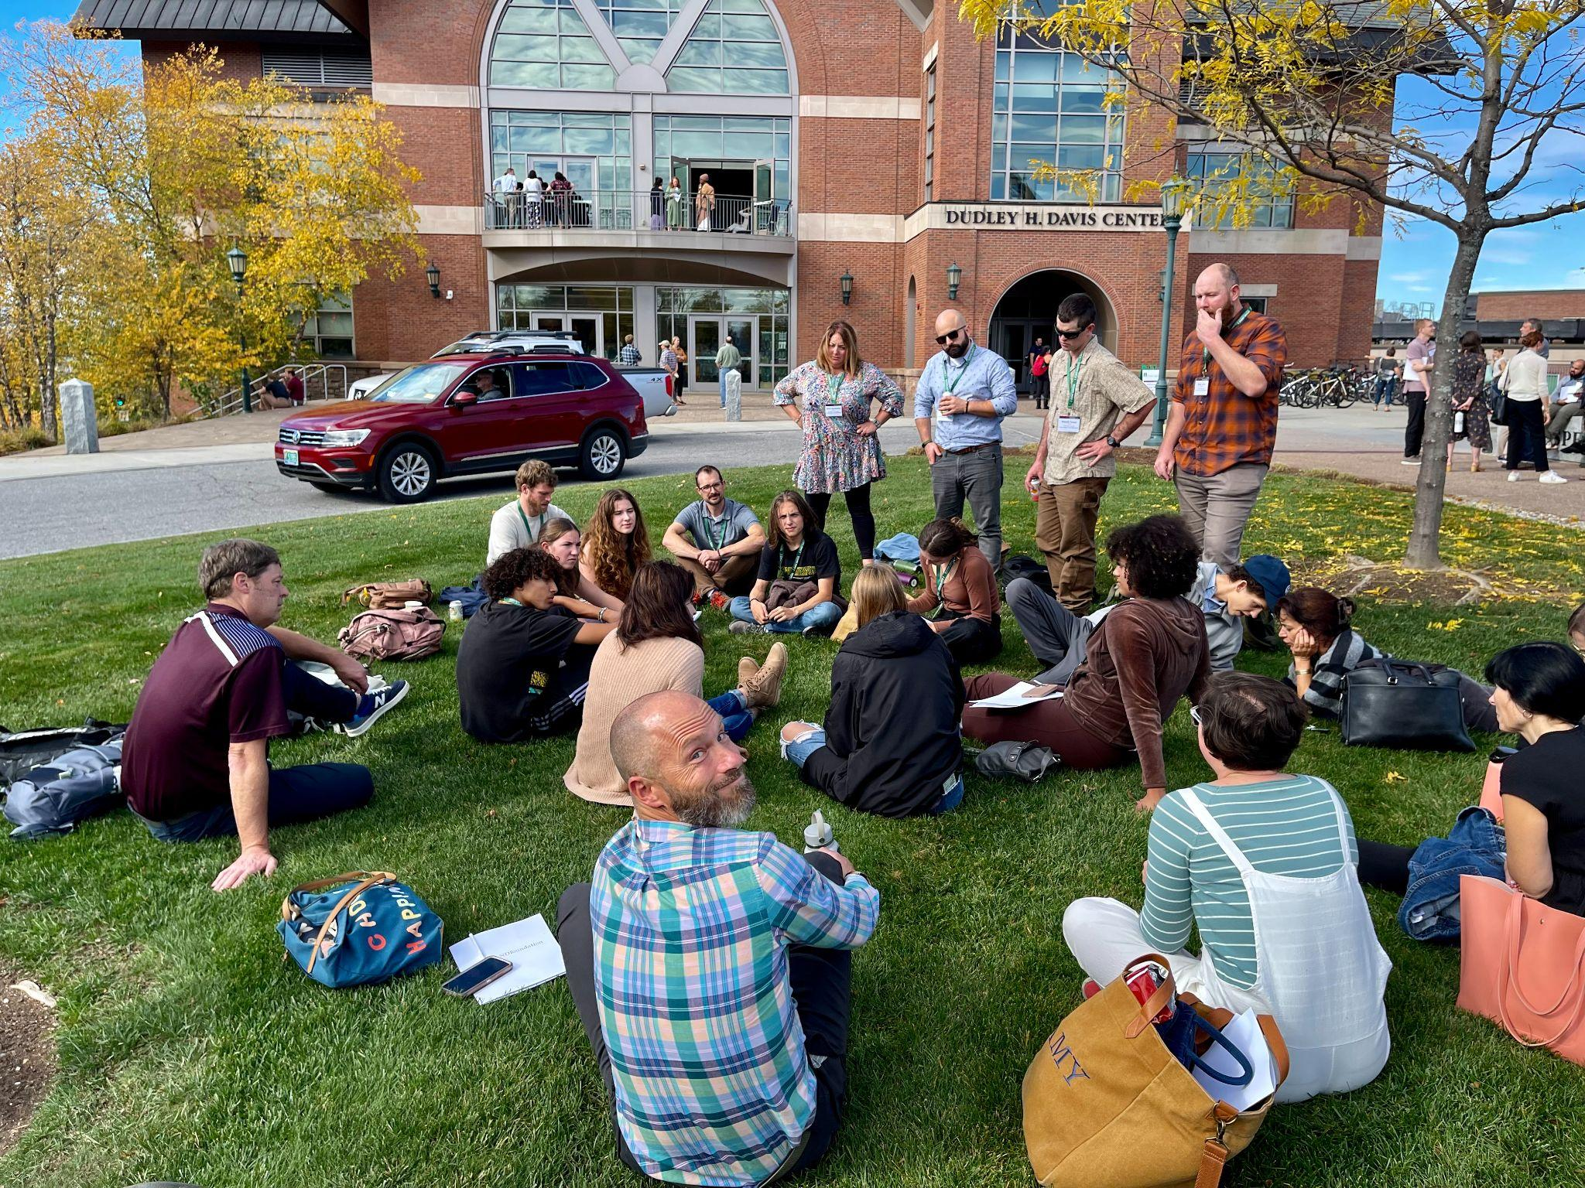
Students and staff discuss new learning during Team Time at the Rowland Conference

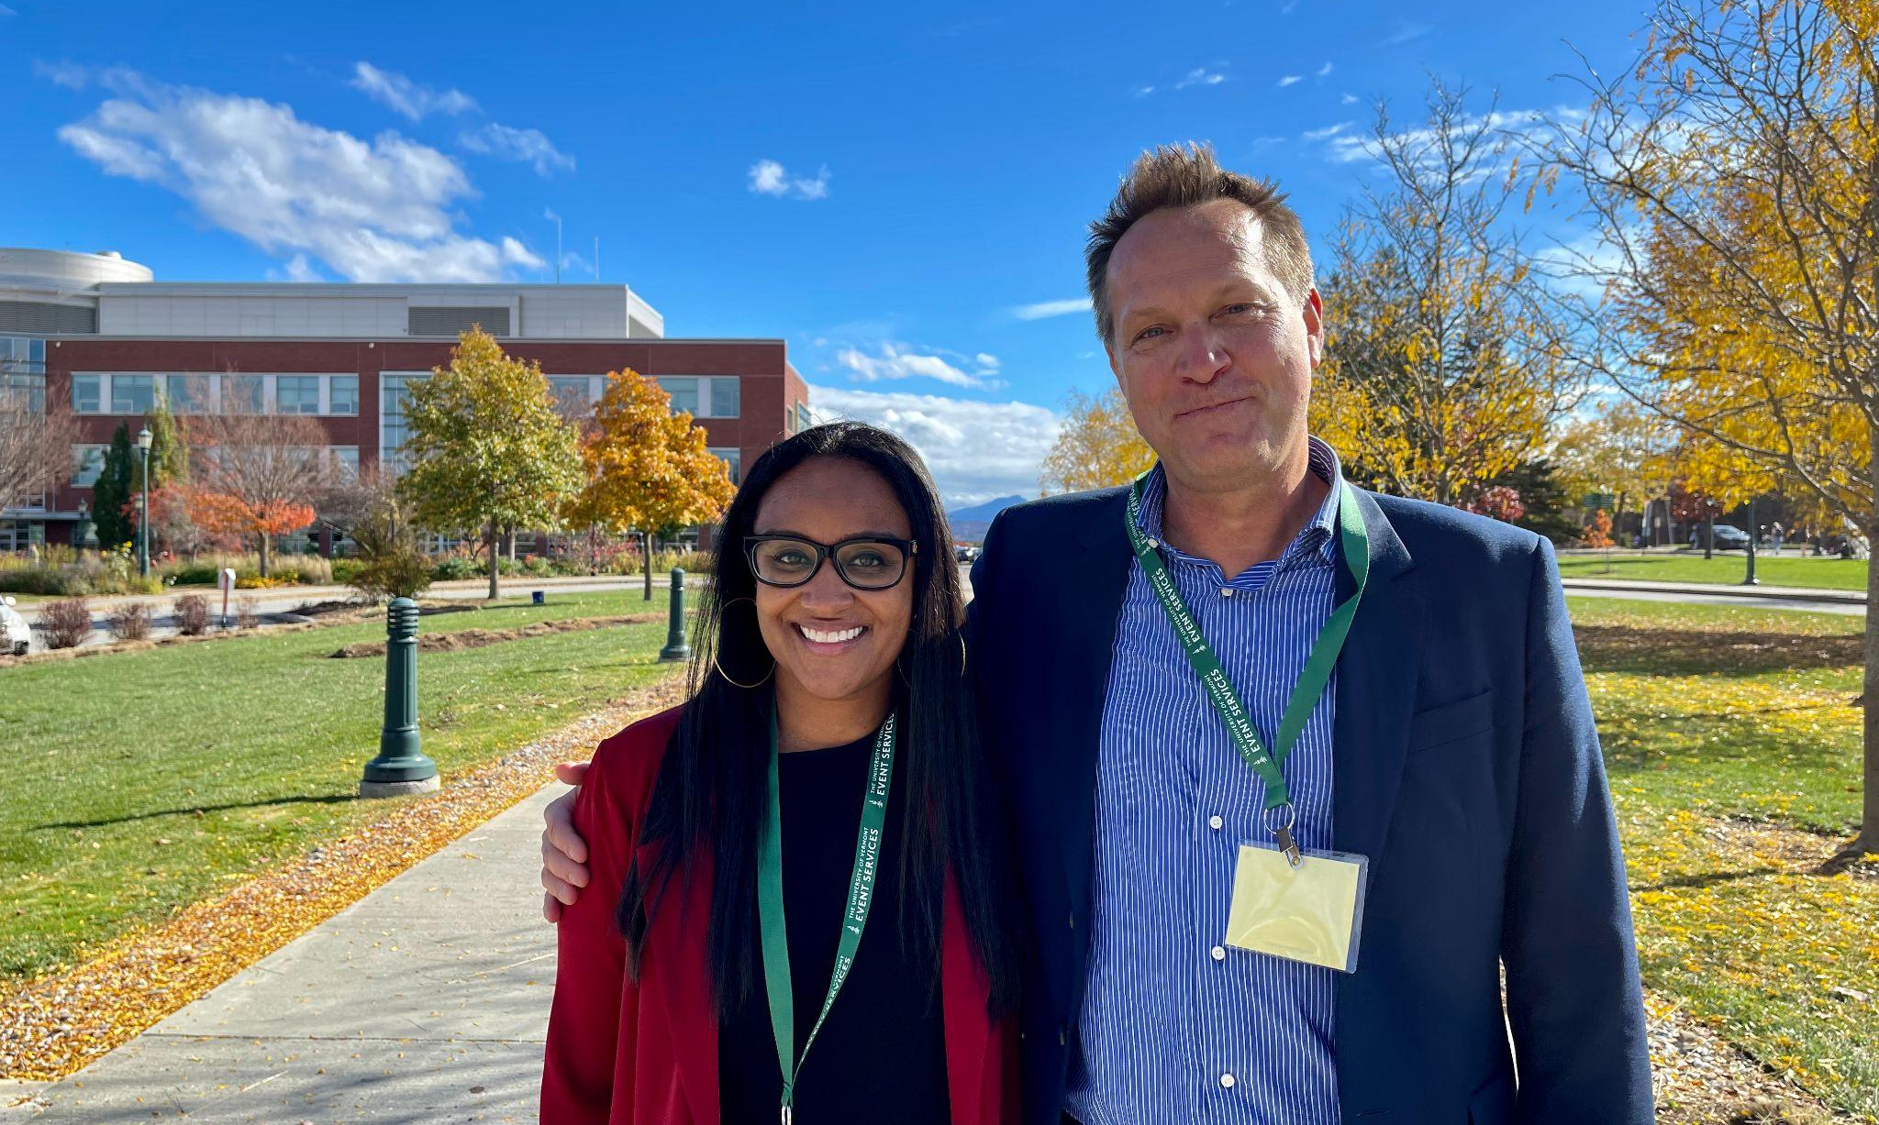
Thank you, Gholdy Muhammad!

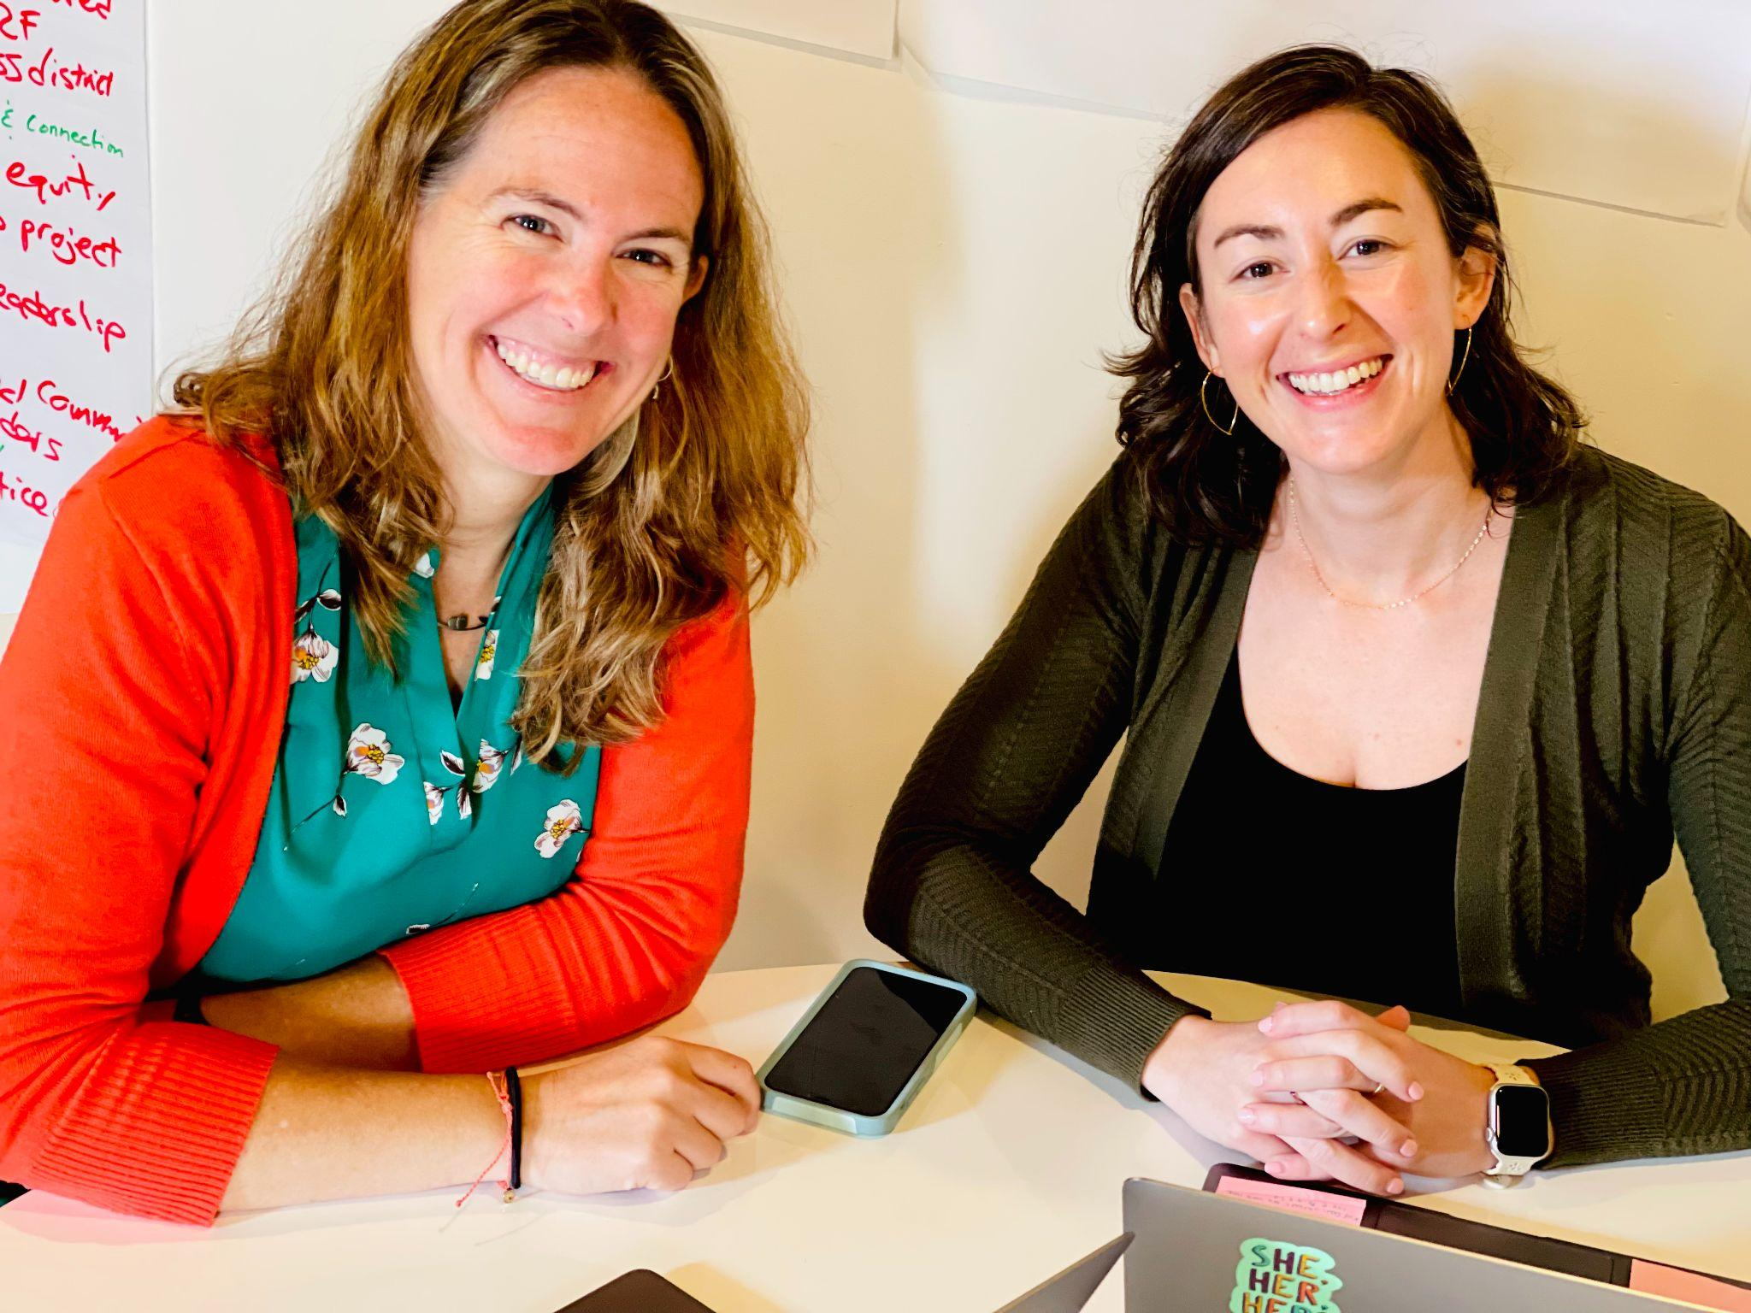
Great Schools Partnership Senior Associates Erica Wallstrom (RF14) & Emily Gilmore (RF17) came by the Rowland Office recently to do some work on strategies for equity-driven approaches to proficiency-based learning.

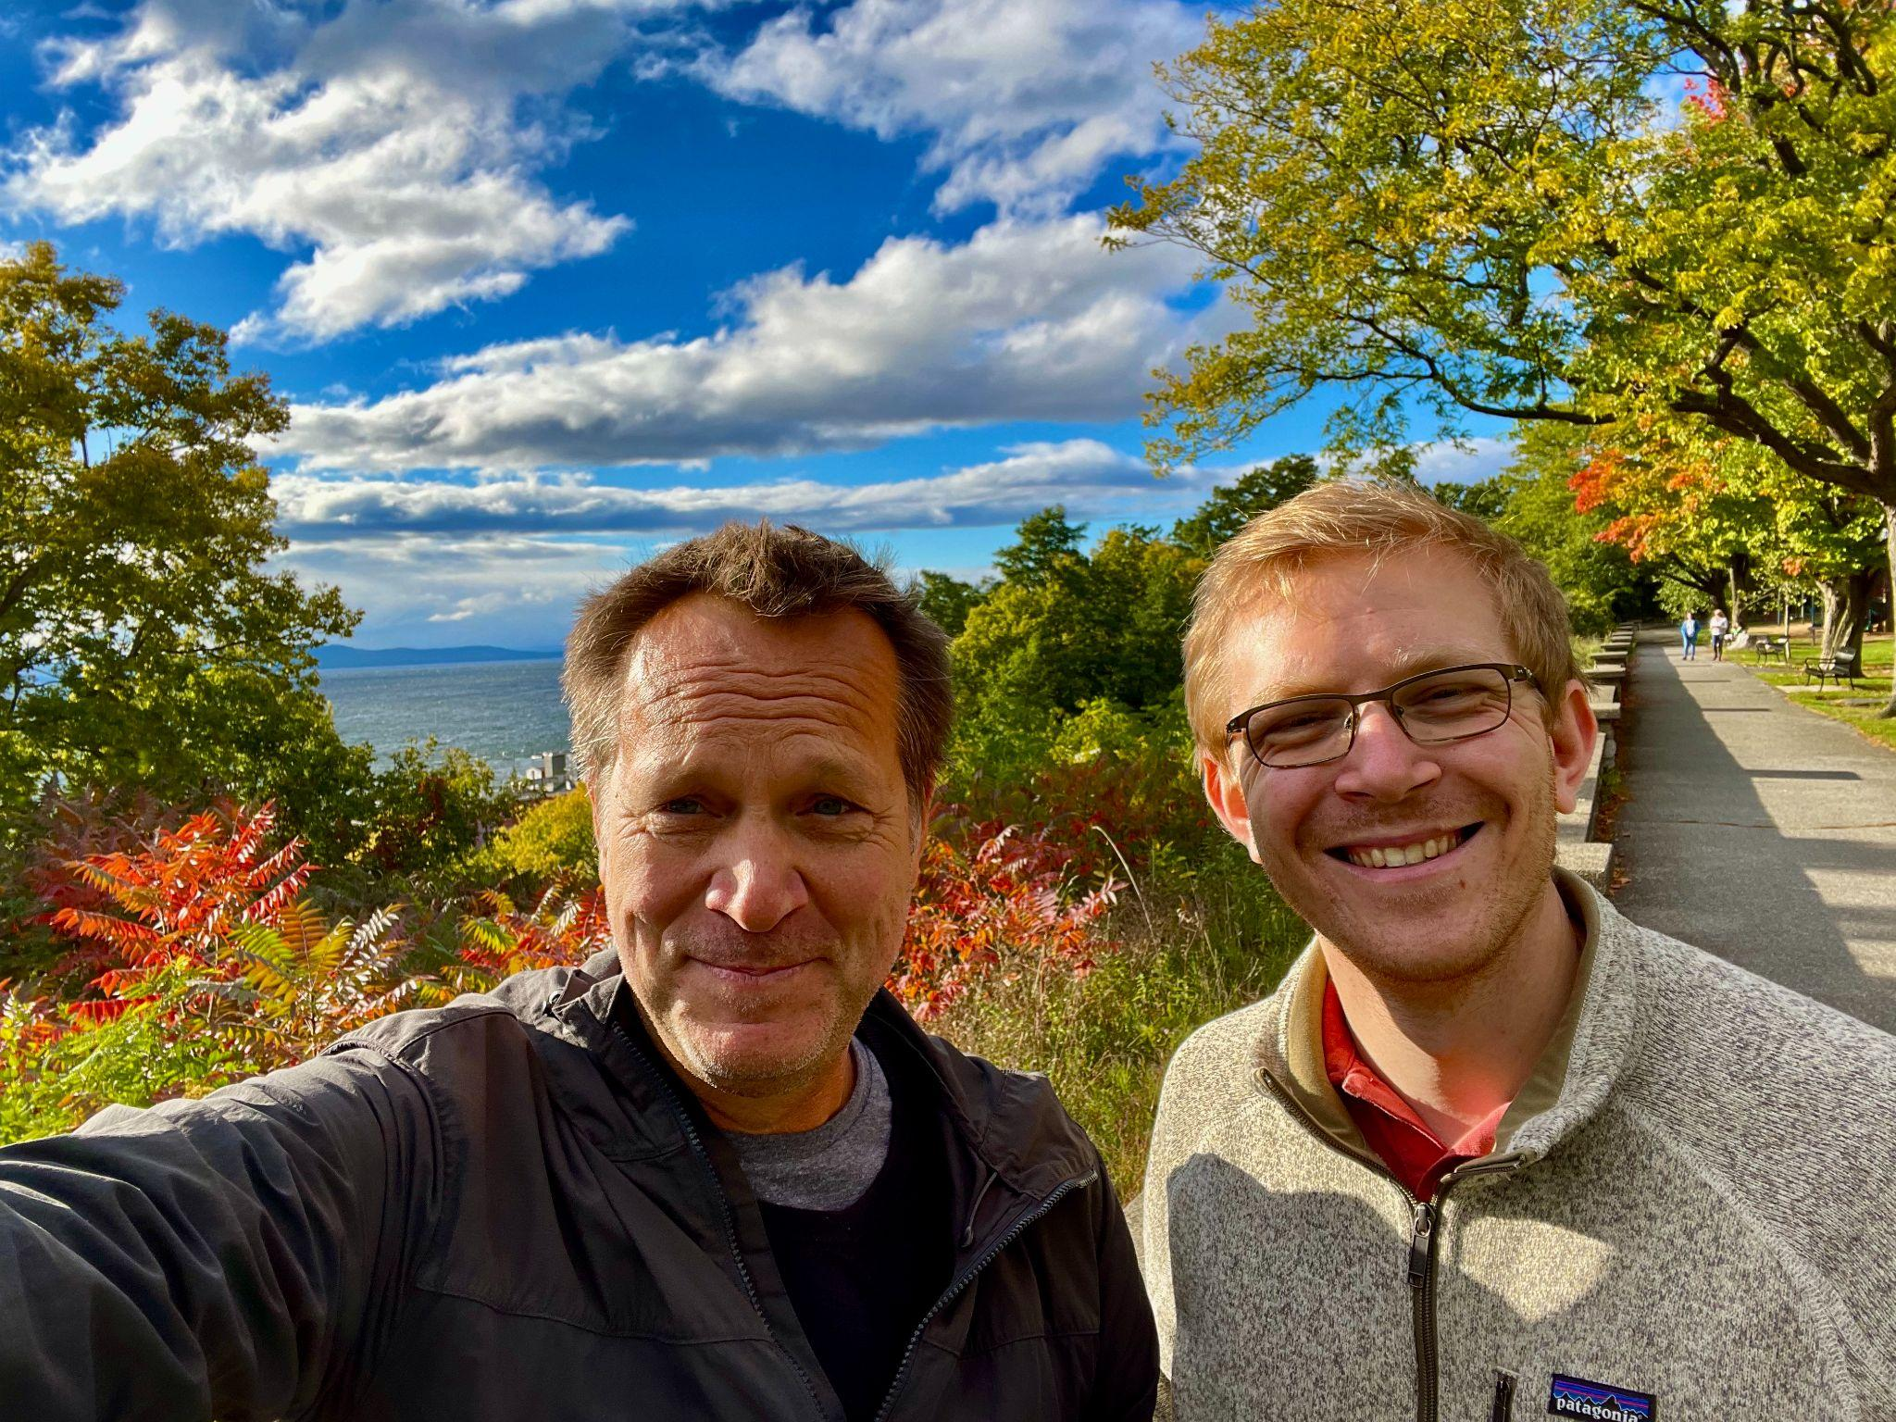
Mike Martin (RF09) & Luke Dorfman (RF19) had a walking meeting recently to discuss Luke’s Rowland Leadership Grant work on Rowland Fellow podcasts. If you’d like to learn more, feel free to contact Luke! lukedorfman@gmail.com

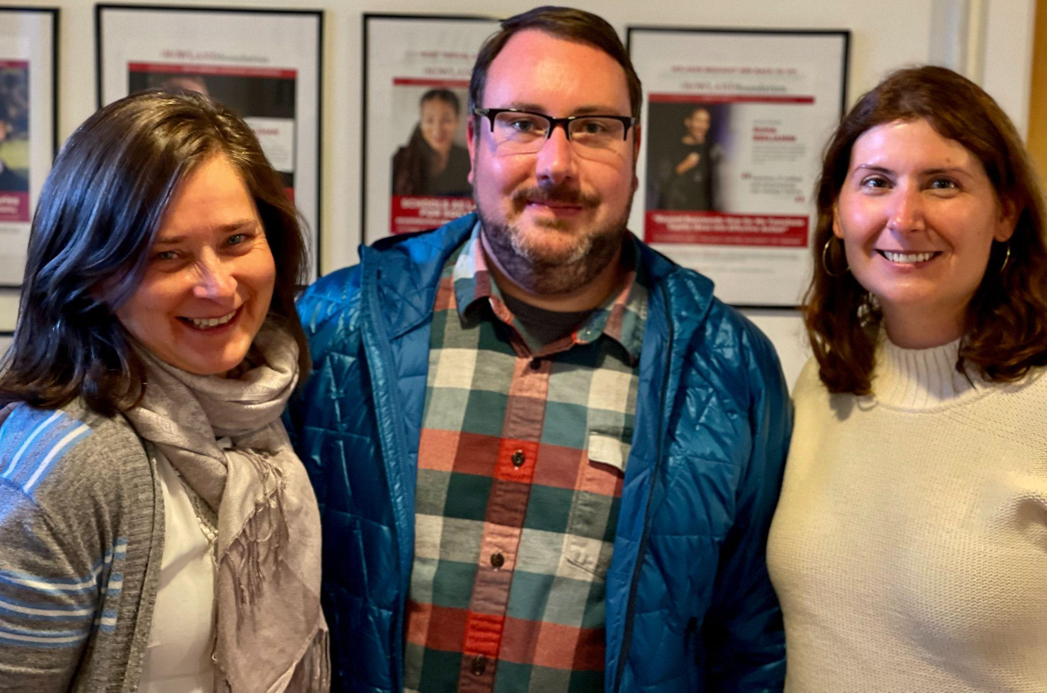
Senior Associate Jeanie Phillips (RF14) got to say hi to Andrew Jones (RF15) and Principal Jenn Cote when they were in the Rowland Office to meet with Mike the other day.

Gratitude
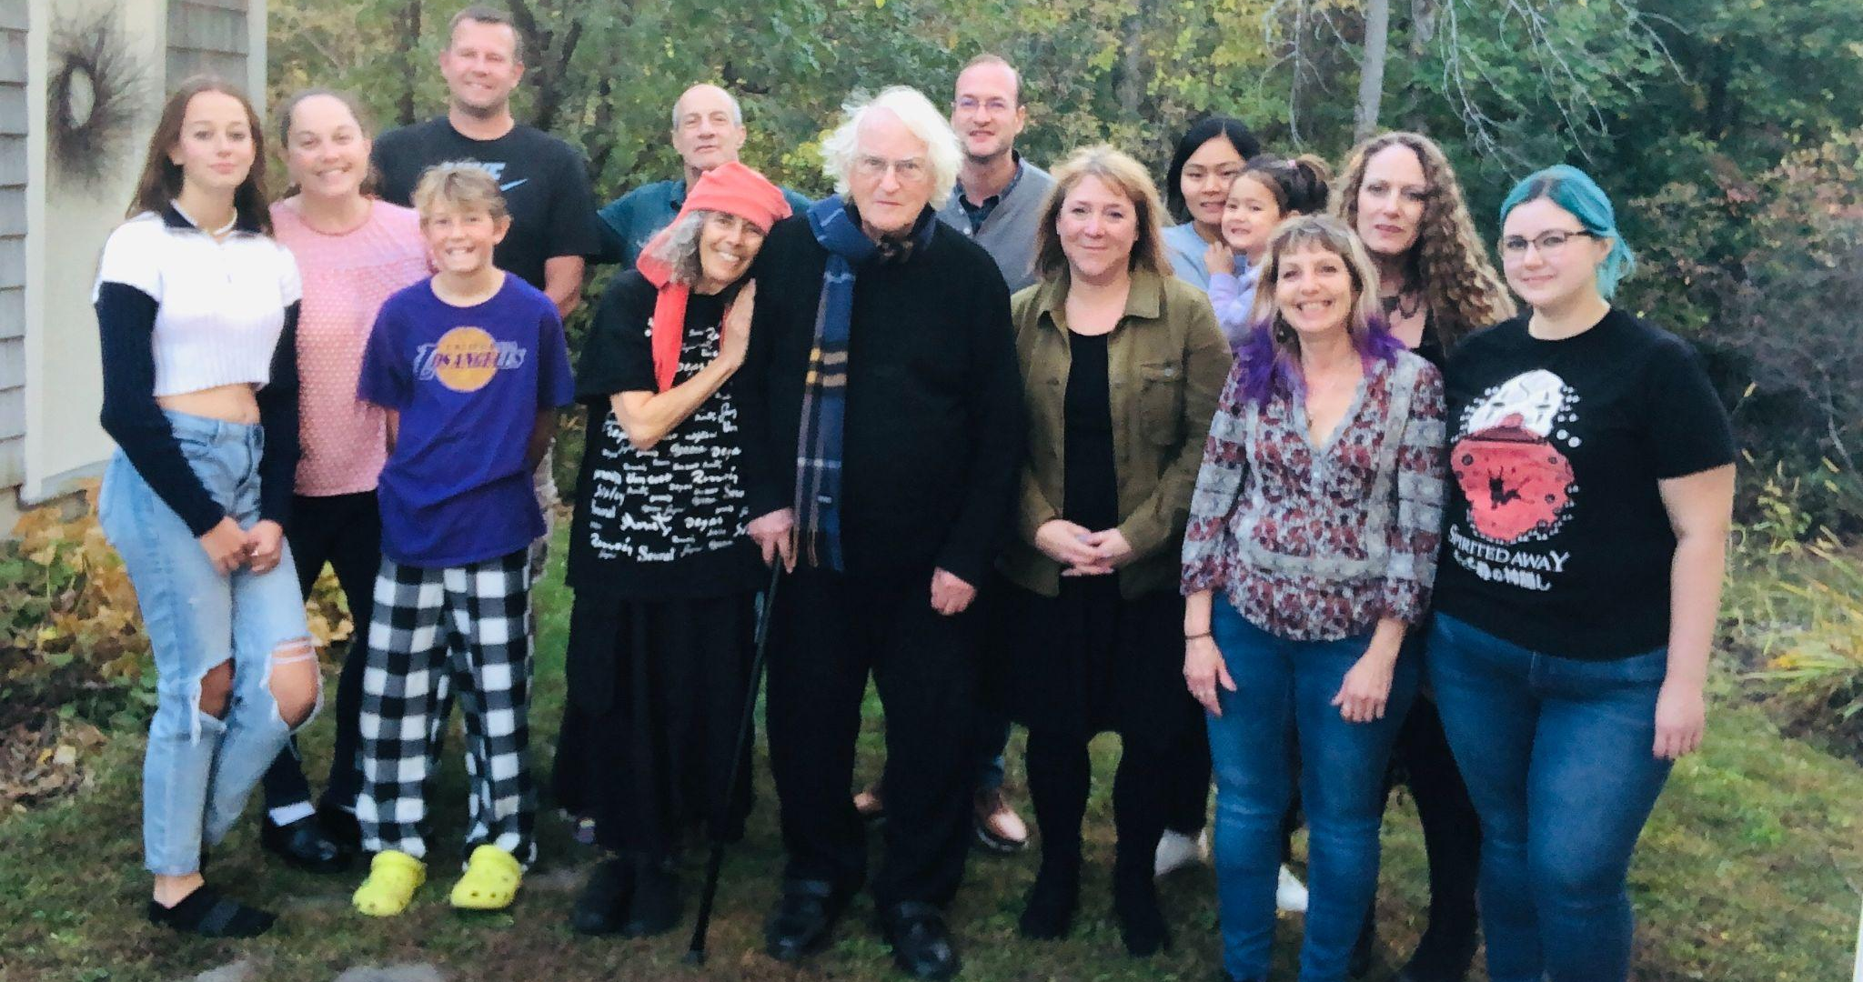
Bianca McKeen’s (RF16) family gathered last month to celebrate her grandfather, Charles Rotmil (a Holocaust survivor) for his 90th Birthday!

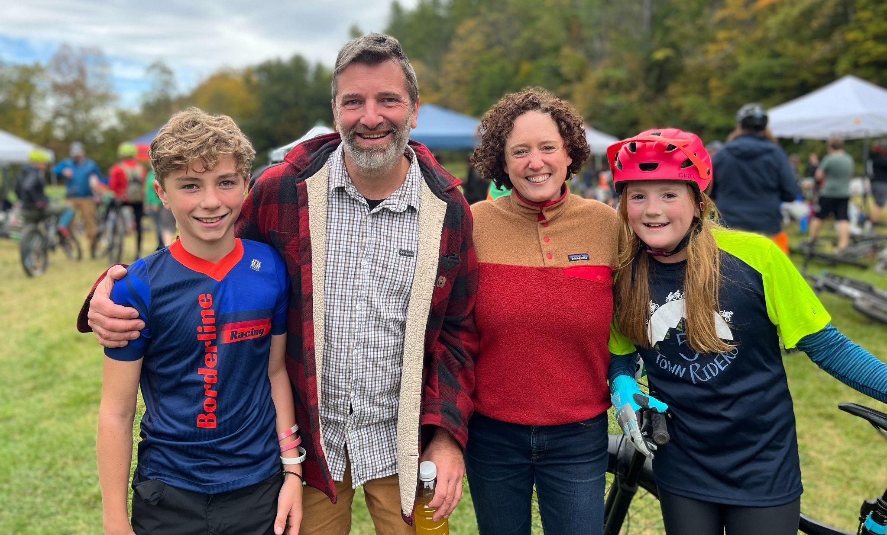
2009 Cohort mates and former Rowland Fellowship partners Jason Finley & Caitlin Steele are seen here with their bike-racing children, Luke & Una, at a race where Luke placed third! Fun fact–Rachel Cohen (RF19) is a founding member of Vermont Youth Cycling and currently serves as their Board Chair.

Celebrations
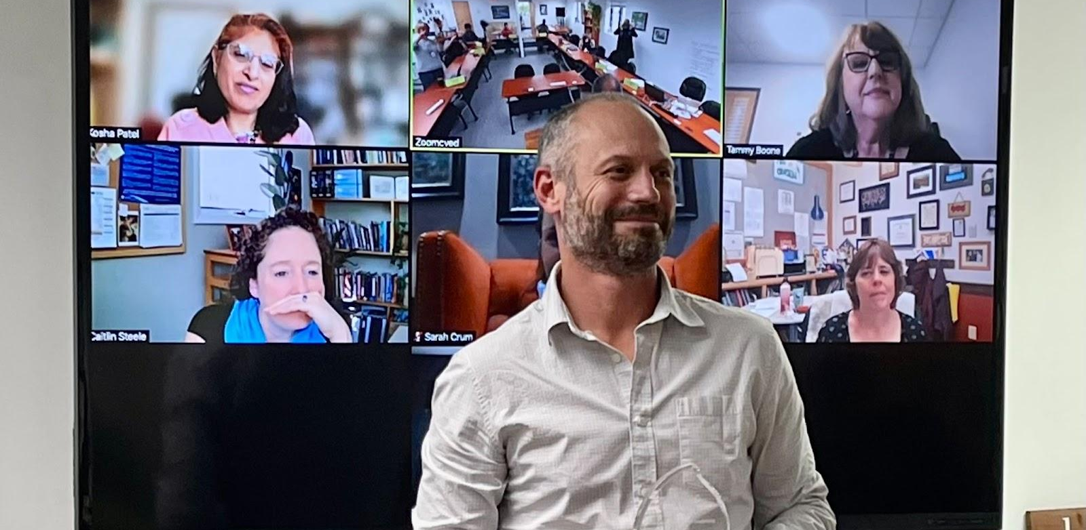
The Champlain Valley Educator Development Center (CVEDC) recently awarded the 2022 Ned Kirsch Innovative Leadership Award to Gabe Hamilton (RF15), Director of Learning in Addison Northwest School District. The Innovative Leadership Award is given to a Vermont educator who exemplifies outside of the box thinking, a courageous vision, strategic thinking & planning, collaborative work and networking across multiple groups, while always challenging the status quo.

Courtesy Postings

VPA Winter Symposium at the Woodstock Inn, Jan. 29-30

Winter in Vermont is so beautiful, but nothing compares to Winter at the Woodstock Inn. All educators are welcome to join the Vermont Principals' Association and the Center for Creative Leadership for rejuvenating, engaging, and meaningful professional learning at the first annual Winter Symposium on Jan. 29, and Jan. 30 2023. For questions contact Mike McRaith at mmcraith@vpaonline.org

SRIA Conference (Great Schools Partnership) March 27-28 in Newport, RI
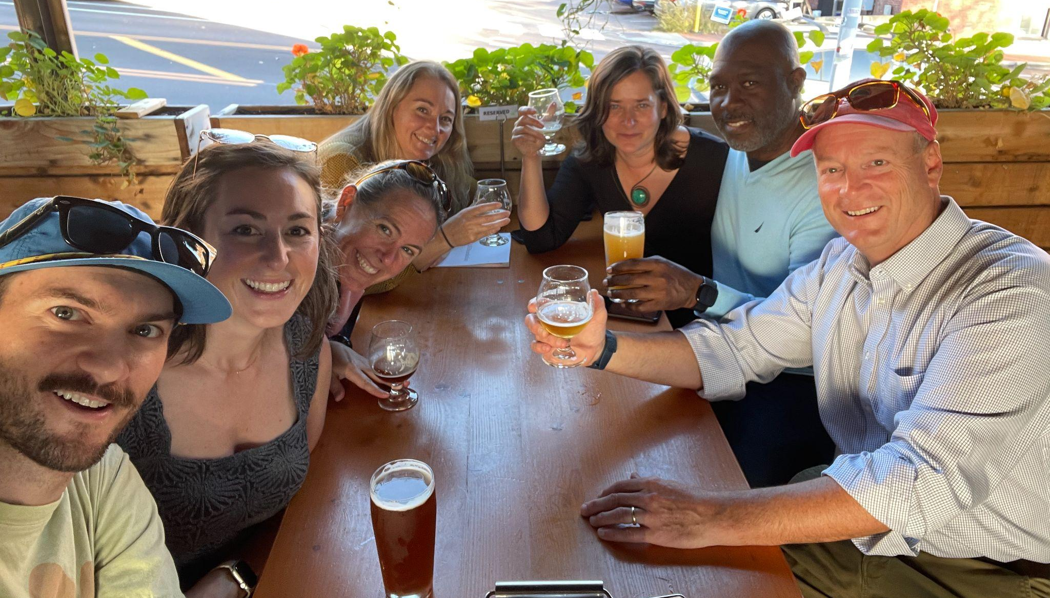
Save the date! The School Redesign In Action Conference will take place in Newport, Rhode Island on March 27-28, 2023. Great Schools Partnership (GSP) Senior Associates Emily Gilmore (RF17), Erica Wallstrom (RF14) & Jeanie Phillips (RF14) are seen here with friends & colleagues after this year’s Rowland Conference, including GSP Executive Director David Ruff & Associate Director Katie Thompson.

