 | Letter to Fellows  What is school for?  November 2023

Dear Rowland Fellows,

I hope your school year is going well. Last week it was wonderful to see 35 of you at the All Fellows Retreat and over 5o of you at the Annual Conference!

If you got to see Ross Gay’s keynote last week, you may still be reeling from it like I am. After all, it included: a fig tree in Philly, bees making honey in a wall, a swarm (or school) of kids hugging, the Enola Gay, critical thinking, “miserable shit”, mycelium, Bartleby, bombs, body shapes, bureaucratic email, and basketball camp. There was a lot to take in and a lot to think about for sure.

Throughout all of his talk–which was a tapestry of poetry, essays, emails, footnotes, and brackets–Ross Gay challenged us to ask the following about our teaching practice:
- How do we bring love into the classroom?
- How do we bring sorrow into the classroom?
- How do we bring gratitude into the classroom?

Above all, Ross Gay seemed to keep asking us, what is school for? Is it to train us to not listen to our bodies, nor each other? Is it to teach us to not ask the hard questions, in other words to be compliant? Is it to help us learn to tolerate misery, boredom, and discomfort so that we will be better prepared to take a job at Amazon, or Walmart, or a (bomb) factory?

Of course, it’s easy to scream no at this last series of questions, but, in fact, there is very little consensus about what school is for. You get very different answers when you ask people what school is for, even from like-minded friends and neighbors.

To think on this question, I often return to John Dewey, Paolo Freire, bell hooks, and Carla Shalaby. Texts like John Goodlad’s What School is For (1979) and The Vermont Design for Education (1971) are also valuable because they articulate important goals that we’re clearly still working on a half century later. They also harken back to a time before No Child Left Behind and Race to the Top totally poisoned how we think about public education in the U.S.

The lesser known author Michael Schiro is also helpful. In his book Curriculum Theory: Conflicting Visions and Enduring Concerns (2008), Schiro lays out curriculum ideologies that help us examine our assumptions about the purpose of school. To help clarify the half-hidden beliefs that undergird our conversations about school, Schiro describes four main ideologies: Scholar Academic, Learner Centered, Social Efficiency & Social Reconstruction.

As you can imagine, the Scholar Academic ideology is primarily concerned with conveying the skills, knowledge, and mental models of a particular discipline to the next generation, sort of like if each of our subject areas was a guild with our students apprenticing with masters of the trade. It’s easy to pick on this one, but also, subject area expertise is important! For example, I want my French teacher to be fluent and my math teacher to be proficient, please.

The Learner Centered ideology is familiar to progressive educators who believe we should always “start with the student” (cf. The Big Picture, Littky, 2004), keeping the whole person in mind and safeguarding autonomy as we flesh out the learning experiences accordingly in an organic fashion. We Vermonters all subscribe to this one, right? Except it leaves out one thing: community. Taken to an extreme, the learner-centered approach is the supreme expression of our individualistic culture where concepts like interdependence and reciprocity are often swept aside as we each pursue our personalized learning objectives. Flash forward a few years to all of our children learning exactly what and how they want from AI bots through VR goggles, and this seems decidedly less appealing…

The Social Efficiency ideology is predicated on what society needs (more doctors? more engineers? more elder-caregivers?) and aims for two things, “first, to perpetuate the functioning of society, and second, to prepare the individual to lead a meaningful adult life in society” (Schiro, 2008). It’s hard to argue against that combo, of course, because it seems to strike a balance somehow. However, this approach is also extremely market-driven, and not as concerned with personal aspirations. This approach encourages businesses to tell schools what sort of employees they need…and they’re not often asking for philosophy, religion, or fine arts majors. Also, there are no guarantees in the workplace if you followed the market demand that held sway during your years of studies. This model also fails to explain why roughly 40% of Harvard graduates go directly into finance or consulting, regardless of their course of studies.

The Social Reconstruction ideology is a tough sell in many countries because it implies that society is not quite there yet. If you like the status quo, this one is not for you. The idea here is that the role of school is not just to form up dutiful citizens, but rather leaders who will work to improve the country by changing it for the better. This ideology may open you up to critiques that you don’t love your country enough, however, true patriots are arguably always working for a “more perfect union” as described in the U.S. Constitution. This ideology tracks with the belief that democracy is always a work in progress.

Of course, most of us identify with more than one of Schiro’s ideologies, albeit to varying degrees. You can take the self-assessment here, and it’s also fun to take with colleagues, students, and school board members. Schiro’s curriculum ideologies help us examine the question of what school is for with a little more clarity about our own biases. They help us understand why so many conversations in schools– think of bitter department meetings, tense grade conferences, raucous school board debates, and feisty faculty meetings–seem to go nowhere. It’s because people are operating from different curriculum ideologies! In other words, we are often at odds not just because we don’t agree on what school is for, but also because we never stop to compare our competing priorities and underlying belief systems.

For example, maybe I want your student to love Pablo Neruda’s poetry (scholar academic), but you just want her to get that foreign language credit to get into the college of her choice (learner centered). Or maybe you really want to get into med school (social efficiency), and so you don’t care for teachers who keep asking you probing questions about social justice (social reconstruction). Or perhaps you really want the school to honor your child’s unique talents and needs (learner centered), but the teachers feel the need to cover the district’s curriculum (social efficiency)…You get the idea.

If you don’t believe me, just compare your school’s mission statement to what actually happens within its walls. You’ll probably find some competing sets of values–some explicit and some unspoken.

Lately, some people have been saying that school should just be about skills, and not social causes. This is often a response to moral panics regarding “CRT” or school bathroom access. Based on Schiro, at first glance, this could appear to be a conflict between the Social Reconstructionists and the Social Efficiency ideologues, who tend to think that school should be neutral and not political. However, when we consider that many of the “no-politics-please” people stripped our libraries of the Reverend Dr. Martin Luther King, Jr., Nobel Laureate Toni Morrison, and Pulitzer Prize Winner Alice Walker… and then proceeded to ban Margaret Atwood, JD Salinger, and John Steinbeck too for good measure, we can see a social agenda at work. So, as it turns out, and despite what they say, these modern day book-banners do, in fact, believe school is the place for some pretty major social reconstruction–just in a very specific direction.

In his book of essays Inciting Joy (2022), Ross Gay says he’s only got one rule for his university classroom which he has printed on a fancy poster: MAKE BEAUTIFUL SHIT TOGETHER! He also really emphasizes the last word “together” with his students because that’s how we learn best and thrive (cf. mycelial). Could it really be that simple? It makes you wonder.

If school is the place where citizens are made in our fragile democracy, maybe Ross Gay’s simple rules are a good start. Either way, we’ll probably need to have this discussion about what we think school is really for, and sooner rather than later. And not just by means of social media zingers, slams, and burns.

For critics worried that learning spaces that emphasize kindness–or even love if you agree with Shalaby–lack rigor, I would offer this final thought from Inciting Joy (The Eleventh Incitement):
…when class is not a site of evaluation, but one of mutual bewilderment, encouragement, support, and witness–i.e. unabashed being with; unabashed care–we learn better. And we learn together what we need to learn. One word for which is curiosity, a more loving and useful aspiration or acquisition or practice by far than mastery could ever be.

Take care and see you soon,

Mike

P.S. You can get early access to Ross Gay’s incredible keynote address here (coming soon to our website). And check out Becky Ebel’s (RF22) amazing land acknowledgement!

P.P.S. Here’s the conference exit survey in case you missed it in your conference folder. You’ll receive a PD certificate in your inbox after completing the survey, and you can also let us know in the survey if you want Ross Gay to return next year! Remember Ruha?

P.P.S. If you’ve been thinking about Digital Wellness lately, check out this Vermont lawsuit and this Florida school district!

Rowland Foundation Updates

Rowland Women’s Leadership Retreat
November 15th is the deadline for veteran Rowland Fellows to submit a Planning Team proposal for the next Rowland Women’s Leadership Retreat. The late fall deadline allows time for the Planning Team to reserve a location once their proposal is accepted. Two of last year’s planners, Gretchen Mueller (RF17) & Tara Cariano (RF18) led a table discussion at the All Fellows Retreat to share information about this annual event. Please consider contributing to this important Rowland Foundation tradition!

The Rowland Encore Grant (REG)
December 31st is the deadline for veteran Rowland Fellows to submit a Rowland Encore Grant Team proposal for a regional or statewide initiative. You can see the guidelines here. Members of our 2023 REG Team will lead a table discussion at the All Fellows Retreat to share information about their work to date on deeper learning. Members of our 2022 REG Team will be presenting their work on Digital Wellness in a workshop at the 12th Annual Rowland Conference.

Rowland Fellowship Info Nights
Please help spread the word about Rowland Fellowships! The December 31st deadline for this incredible opportunity for Vermont teachers will come up quickly. With a new round of spots we’re airing on Vermont Public from October 30th - November 17th, your friends and neighbors may be asking you about the Rowland Foundation and our work. You can also let prospective candidates know that our Senior Rowland Associates are available to help them with their applications since they are not part of the selection process:
Jean Berthiaume jean@therowlandfoundation.org
Jeannie Phillips jeanie@therowlandfoundation.org
Lori Lisai lori@therowlandfoundation.org

You can also let interested teachers know about these upcoming Rowland Fellowship Info Nights to be held around the state and online. Teachers will be able to meet with Executive Director Mike Martin and ask any questions they have over light refreshments. Directions and other details will be shared on our website.

Wednesday, November 8th (4:00 - 5:00pm) St. Johnsbury Academy
Thank you, Sandra Mings-Lamar!

Tuesday, November 14th (4:00 - 5:00pm) Google Meet
https://meet.google.com/ysp-tsns-tgu

Thursday, November 16th (4:00 - 5:00pm) Rutland High School
Thank you, Bianca McKeen!

Tuesday, November 28th (4:00 - 5:00pm) Kestrel Coffee Shop, Burlington
(just downstairs from our offices)

The All Fellows Retreat! (photos by Lori Lisai & Abby Paige)
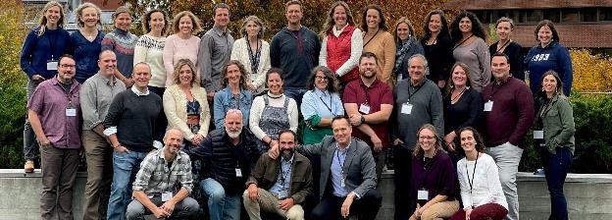
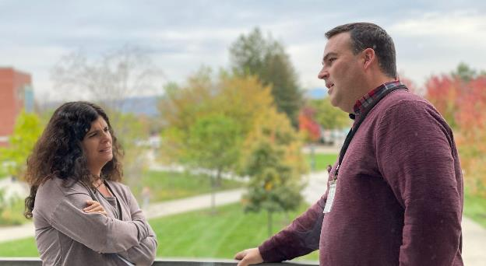
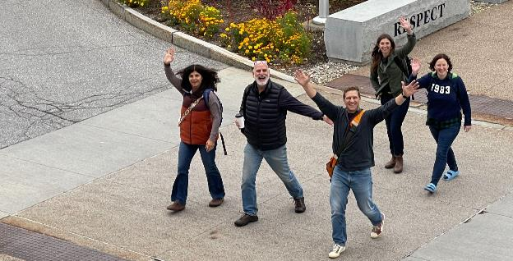
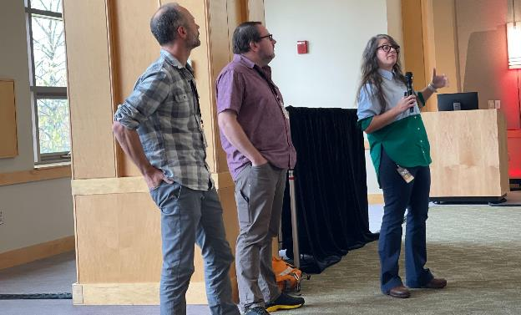
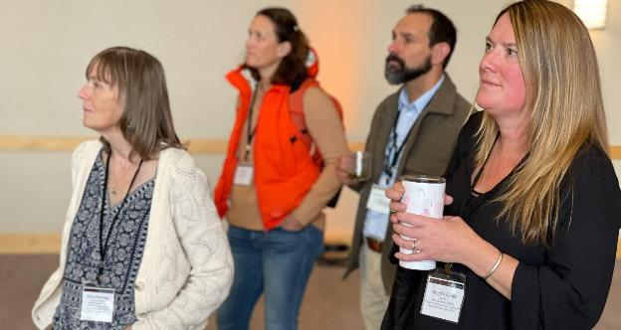
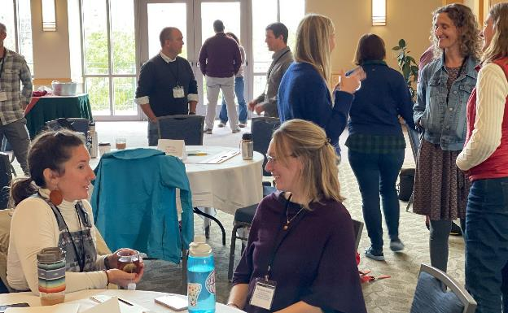
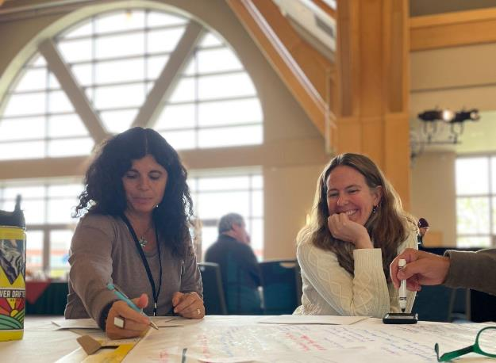

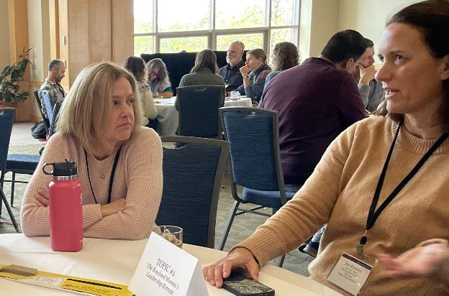
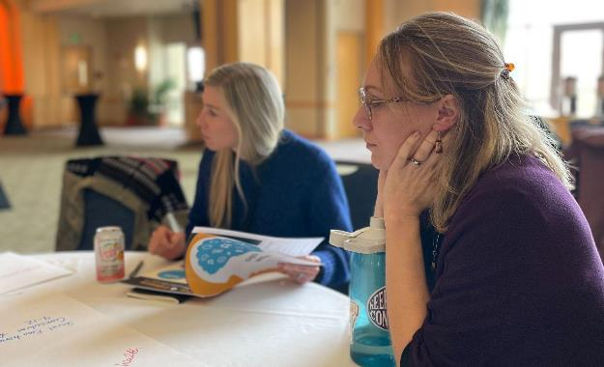
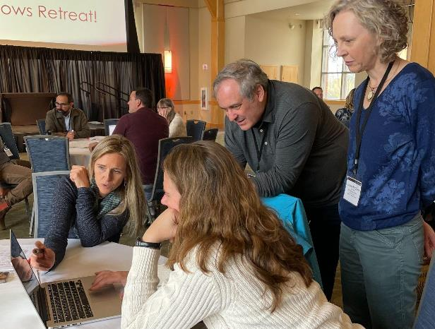
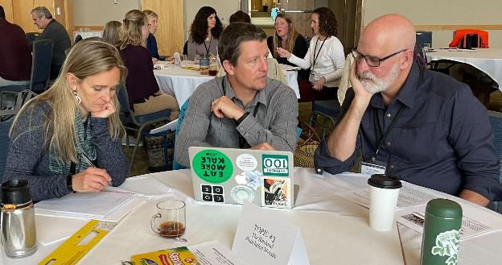
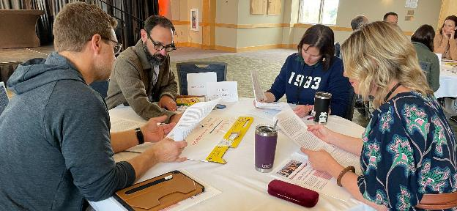
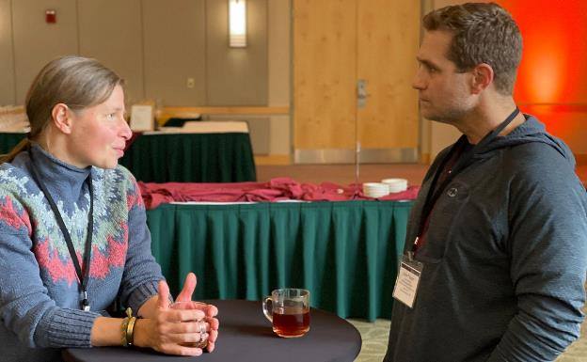
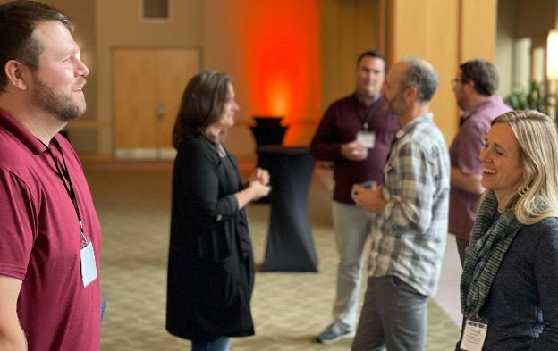
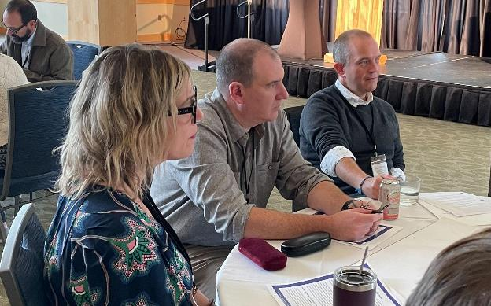
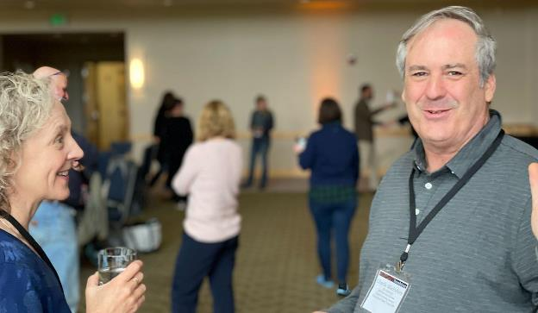

The 12th Annual Rowland Conference (photos by Lori Lisai)
Growing Community: Making Space for Joy & Creativity in School

“If we pay close attention, the mycelial threads connecting us, the lustrous web–joy, I mean–is flickering there in wait all the time.”
–Ross Gay, Inciting Joy (2022)

Ross Gay Keynote with Introduction by Kerrin McCadden
(coming soon to our website)

Land Acknowledgement from Becky Ebel (RF22)
(with generous behind the scenes support from Jeanie Phillips)

Conference Exit Survey (for PD Certificate)
(Let us know if you’d like to see Ross Gay return to the conference next year!)

A larger gallery of Conference photos
(We couldn’t fit all of our photos of this memorable day into this message! Please click through to see more.)
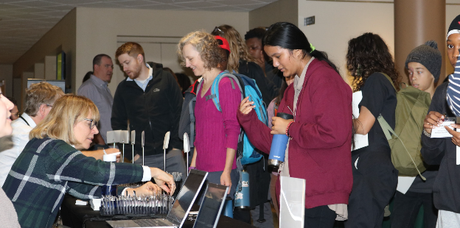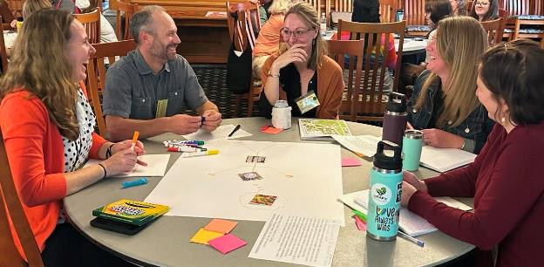

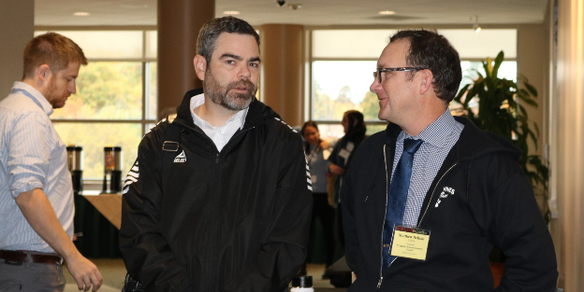
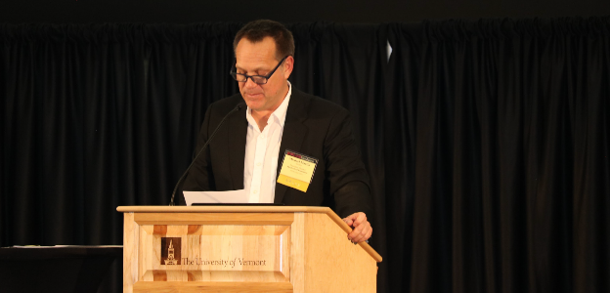
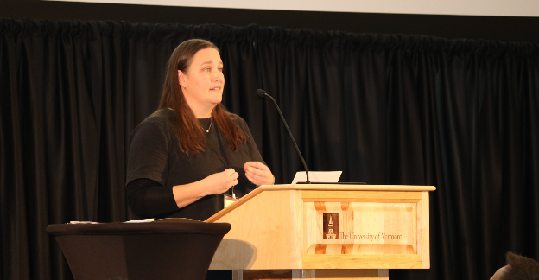
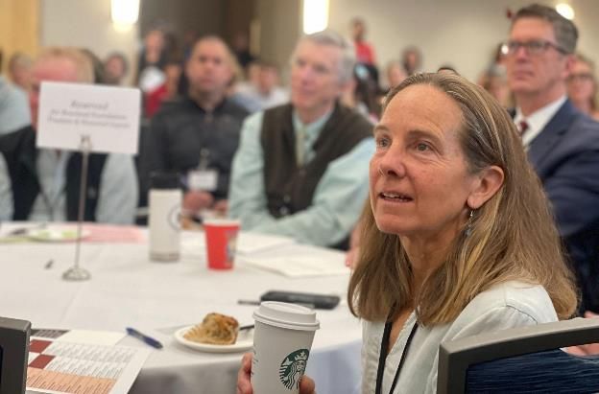
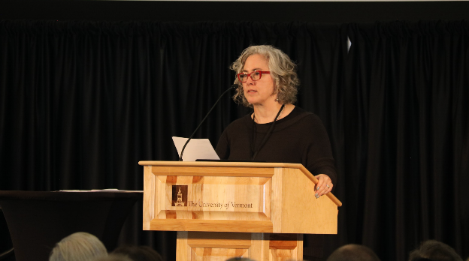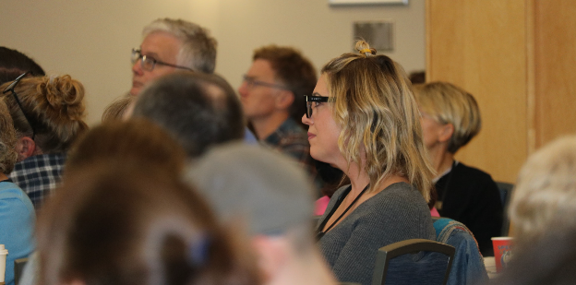
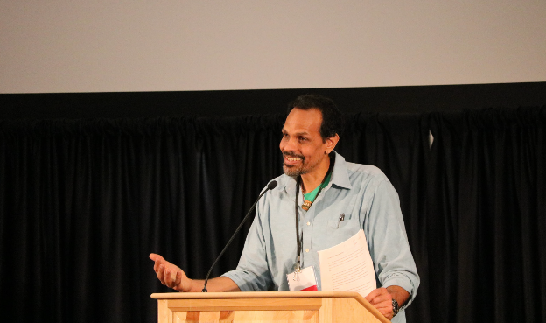
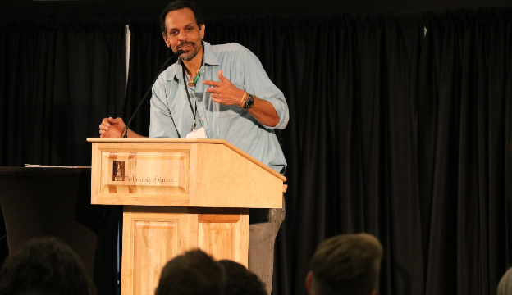
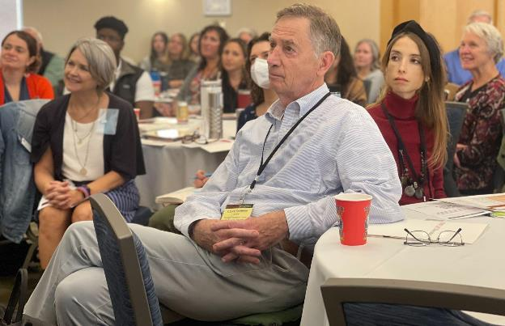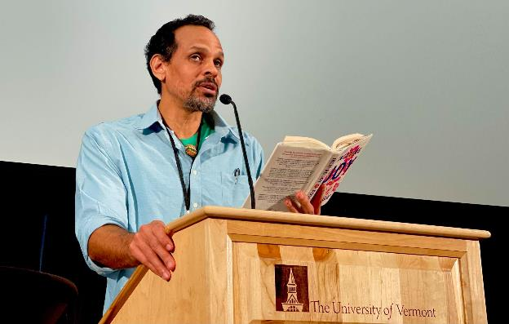
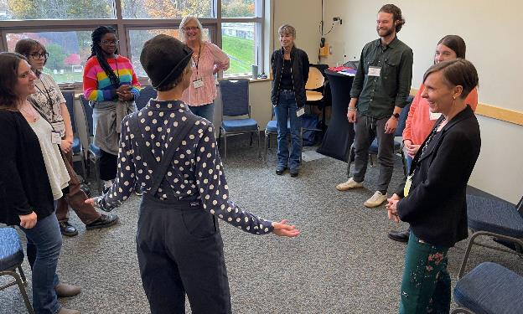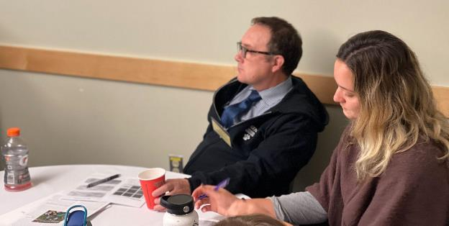
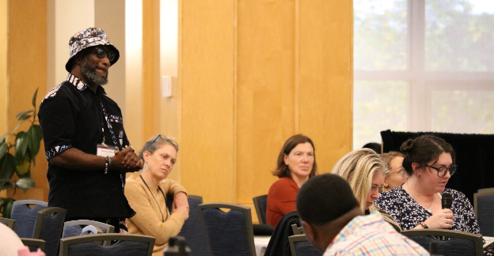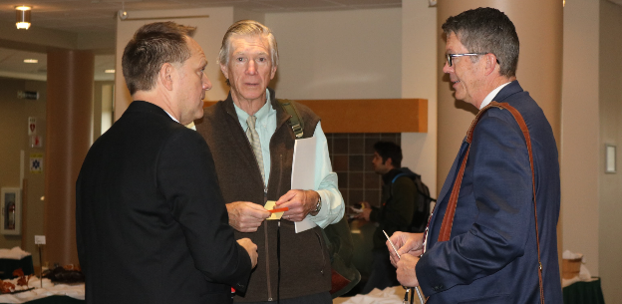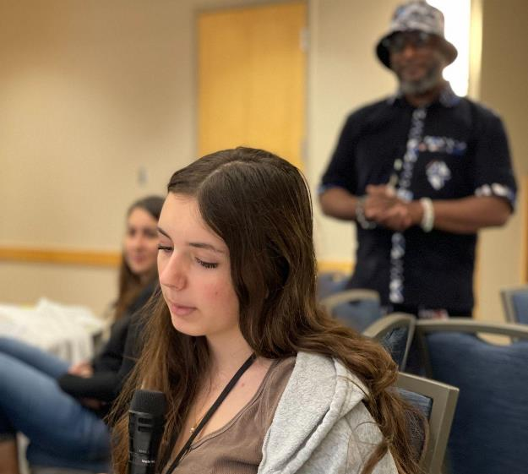
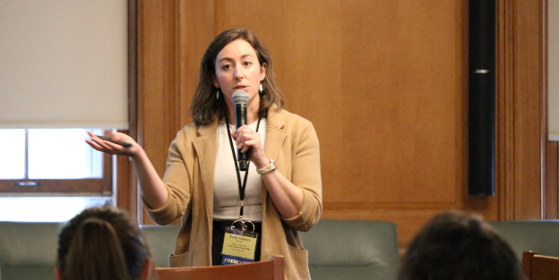
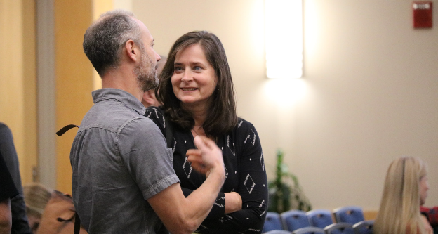
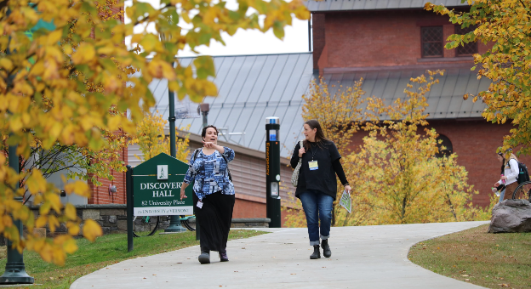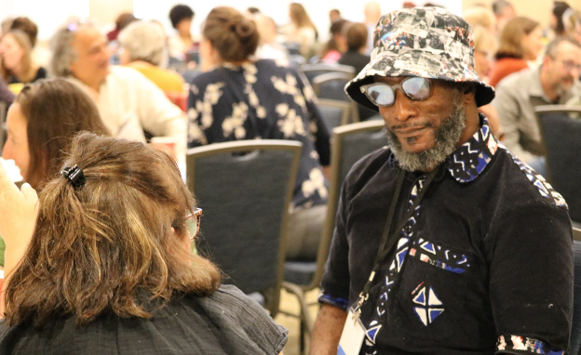
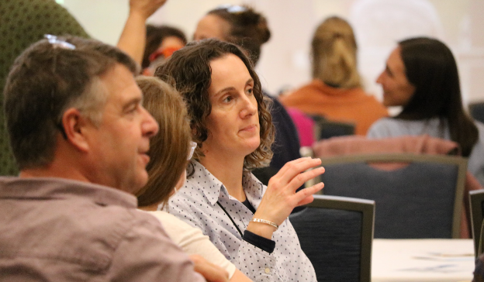
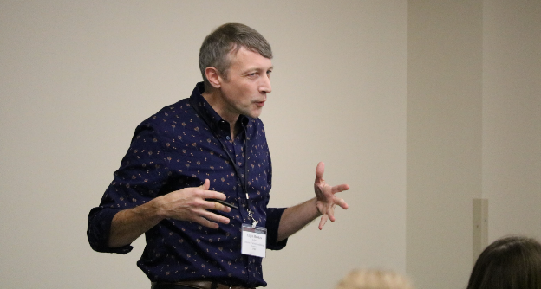
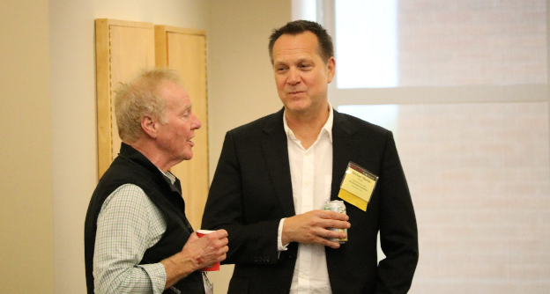
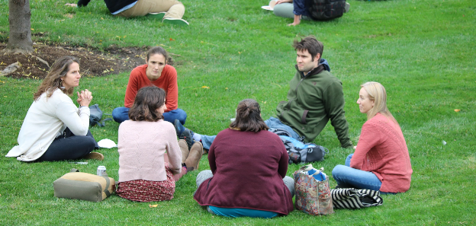
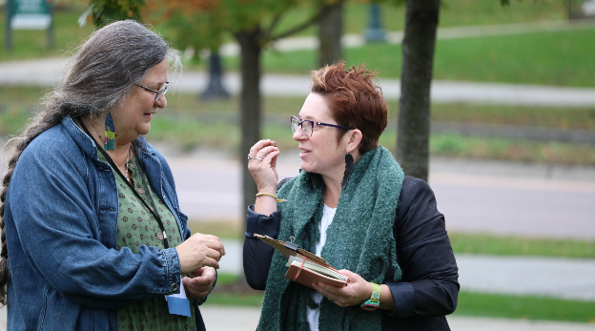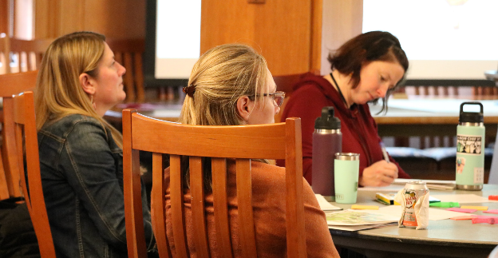
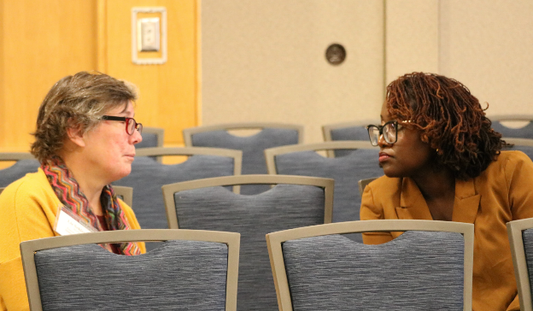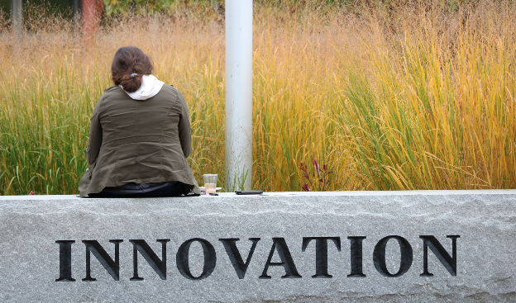
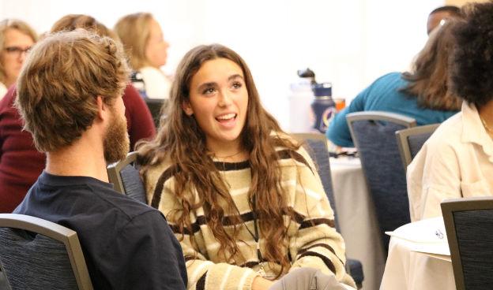
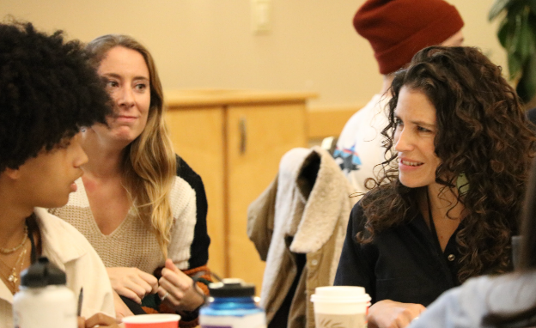
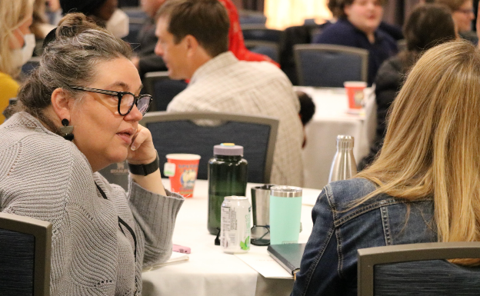
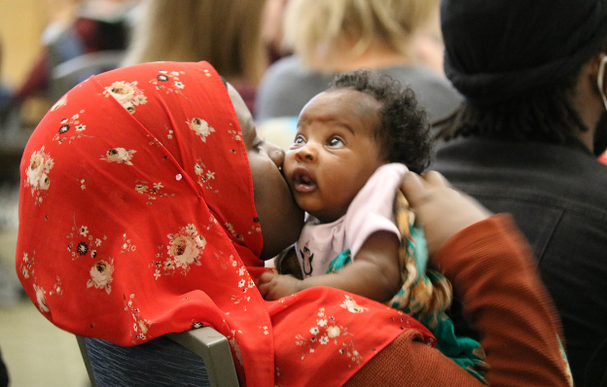
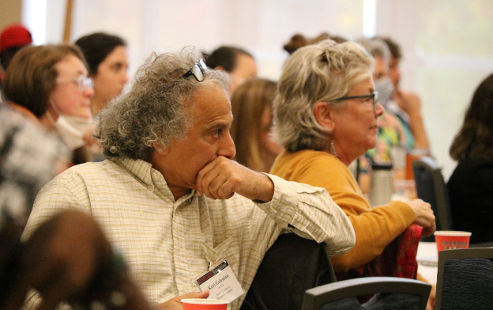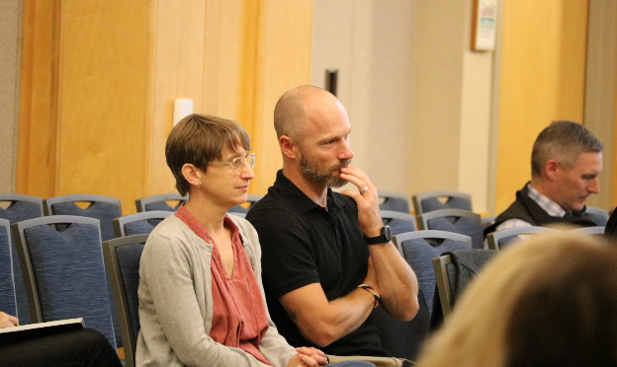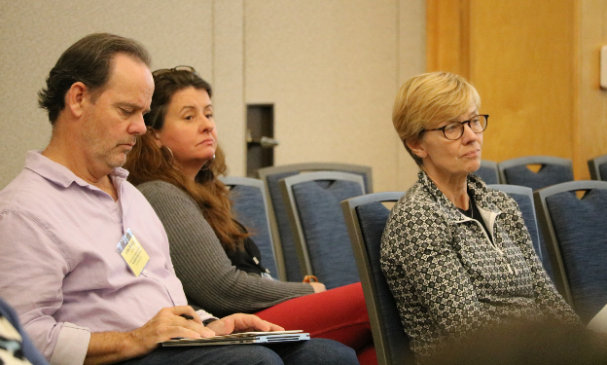
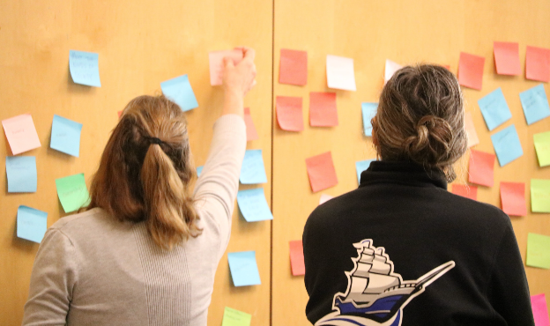
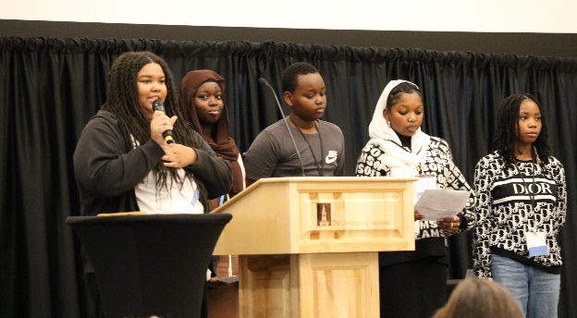

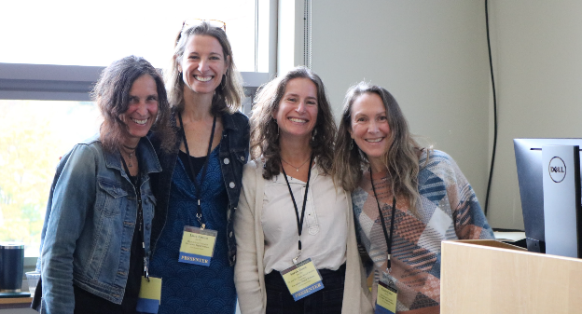

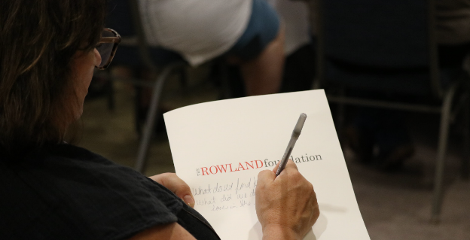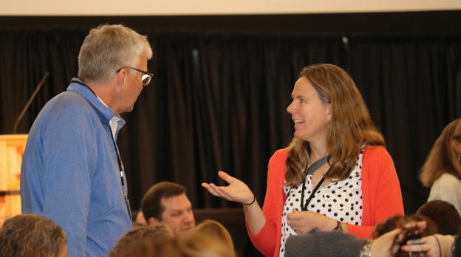
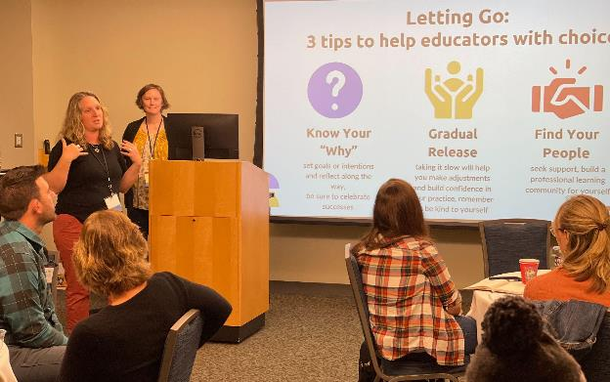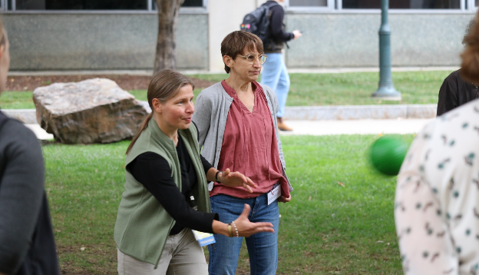
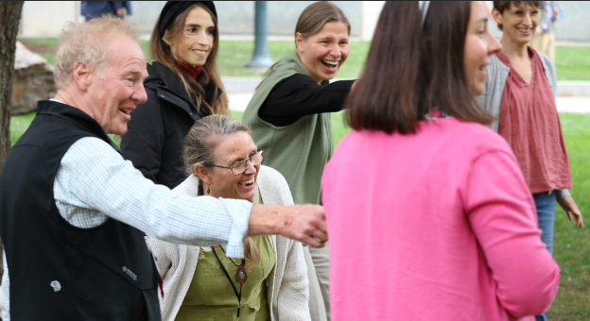

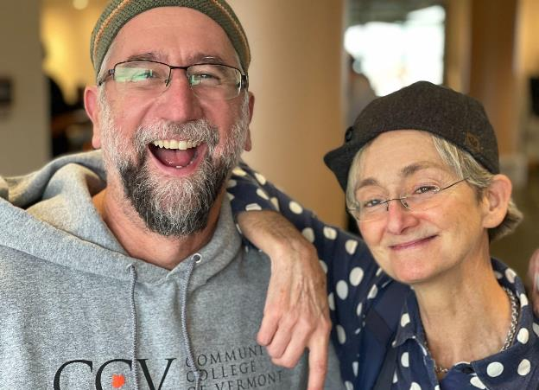
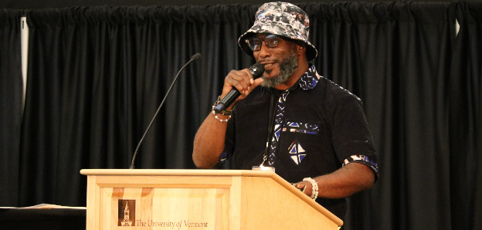

Gratitude

Devon Karpak (RF22) and his wife Kaitlyn, seen here in Rutland at her father’s place, celebrated their wedding on October 5th. Devon is grateful to Kaitlyn for putting up with his “crazy schedule over the last year and for her support, [making] the day perfect.” Writing about his Rowland Fellowship, Devon said, “I am so thankful for this journey, and I look forward to seeing what the rest of the second year has in store”

Celebrations
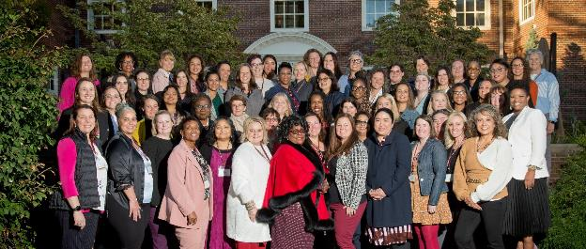
Sandra Mings Lamar participated in the Women in Educational Leadership program at Harvard October 12 - 14th. She highly recommends the program for women in leadership positions in schools, saying "It was one of the most phenomenal educational programs I have been a part of.” Harvard will be hosting the program again in April. You can learn more about the program and how to apply here: Women in Education Leadership | Harvard Graduate School of Education.

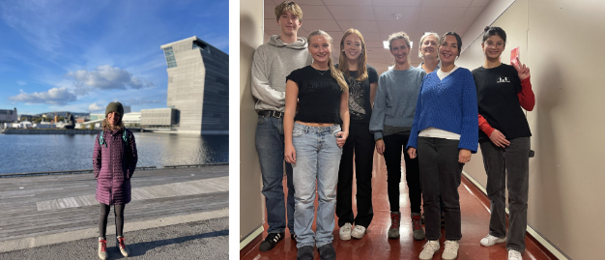
Jessica Kessler (RF23) recently worked with students in Norway and visited a number of agencies and universities. Jess is seen here with students from Marienlyst Secondary School outside of Oslo who are mentors for younger students. Jess worked with Voksne for Barn (translates to "adults for children") whose mission is to create programming that supports adults and gives them the tools they need to support children, working off of the assumption that if adults have the support they need they will be more equipped to support students. Jess learned about the peer mentoring programs they run in schools throughout Norway. The program "Dream Schools" works to address loneliness, isolation and exclusion in schools.

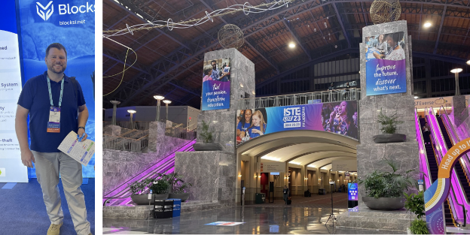
With inspiration and support from Principal Michael Ruppel (RF17), Devon Karpak– seen here at ISTE (The International Society for Technology in Education) in Philadelphia, PA–conducted research, talked with stakeholders, teachers, and administrators, visited Germany, and worked with his cohort, even as he kept teaching this past spring. Devon is happy to say that the vision for Otter Valley’s Career Preparation Pathway is taking shape in ways that he could never have expected when he penned his Fellowship application back in the early winter of 2021. Devon is excited about major improvements to his school’s shop/lab space and to be recruiting for their first cohort for the '24-'25 school year.

Courtesy Postings
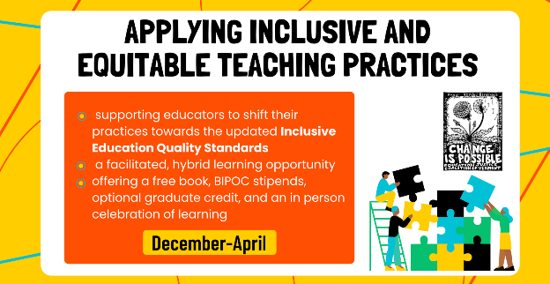
With the newly revised Vermont Educational Quality Standards nearing final approval from the State Board and interagency review, the Education Justice Coalition is offering related coursework with Vermont instructors around the state in hybrid format. Visit their website to learn more about this important opportunity and register by November 17th!

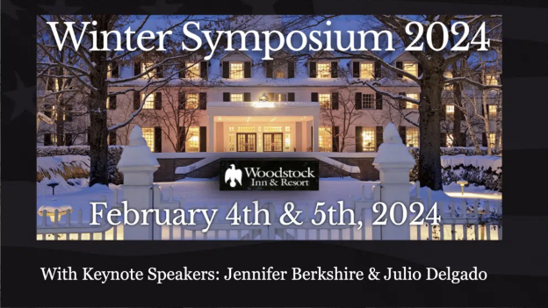

Join colleagues from around the state at the beautiful Woodstock Inn for the VPA 2024 Winter Symposium, Learn More & Register Here. Discounted Room Reservations now open to book.

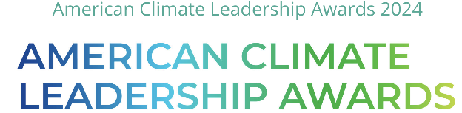

ecoAmerica's American Climate Leadership Awards 2024 (#ACLA24) is in its fifth year. And for the first time, we are providing a separate awards program for high school students, the American Climate Leadership Awards for High School Students, with $125,000 additional awards to showcase the leadership of the next generation. High school students and their advisors can find the application form, or make a nomination here. If you know a high schooler, group of high schoolers, high school, high school club or grade taking action on climate and making change in their local community, please invite them to apply! You can read more about the FAQ here. The high school students program has earmarked $25,000 for the winning application, 5 applicants will take home $10,000 each and 10 high schoolers will be recognized with $5,000 awards. The deadline to apply is December 15th. Accepting nominations until November 1st. The 2024 ACLA Selection Committees comprise exemplary climate leaders. You can read more about those individuals here. If you have questions, send an email to acla@ecoamerica.org. And please check out the 2023 awards ceremony here to learn about our most recent group of finalists.

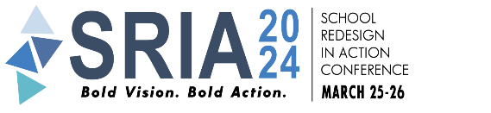
The annual conference School Reform In Action (SRIA) will take place March 25-26, 2024 in Providence, Rhode Island with keynote speaker Dr. Jamila Dugan. The deadline for workshop proposals is November 15th. Click here for more information.

