 | Letter to Fellows  Our Mission  October 2022

Dear Rowland Fellows,

I hope you are enjoying autumn in Vermont.

When Chuck Scranton first pitched the idea of the Rowland Foundation to Barry & Wendy Rowland, it was based on a simple premise–if you want to improve school culture & climate, invest in teachers. So when our Board of Trustees revisited our mission this past year, they decided not to add to our mission statement, but instead, to pare it down to clarify our message.

I’m very pleased to share with you for the first time here our newly updated mission statement which was formally adopted by the Rowland Foundation Board of Trustees last month:

The Rowland Foundation invests in Vermont teachers to positively change the culture and climate of schools.

Of course, as you can imagine, the Board of Trustees considered many possible changes to our mission statement over the course of this work. There was a great deal of support for adding the word “student” since we are a learner-centered organization, or “equity” since we believe in the democratic mission, or “joyfully” to explicitly name a core value we hold dear. However, in the end, the Board chose the power of plain language over trying to weave in all of our core values and philosophy. It is our hope that this new wording of our original mission is sharp and succinct enough for people to remember. We want Rowland Fellows, students, principals, and community members to be able to say what we do in a single breath, whether in the grocery store, on the soccer field, or at a school board meeting.

Our Board of Trustees also believes in the power of deeds, not just words, which is why I’m so proud of the new strategies approved this year to advance our mission. Dear Rowland Fellows, to advance our mission, please consider getting involved in some of the new opportunities listed below, whether by submitting an application, participating in a Rowland event, or recruiting eligible colleagues to apply.

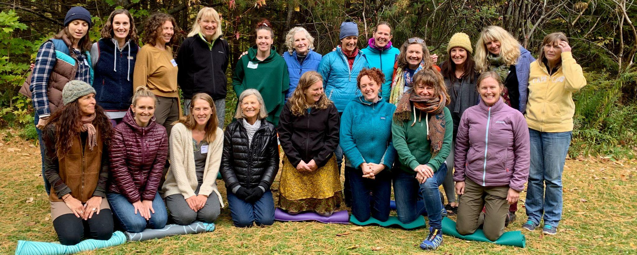
Rowland Fellows at the last Rowland Women Retreat seen here at Seyton Lodge in Groton in October 2019. (front row, left to right) Anne Bergeron (RF11), Lori Lisai (RF15), Amber March-Carbine (RF18), Kathy Cadwell (RF16), Kim Hoffman (RF18), Caitlin Steele (RF09), Jess DeCarolis (RF09), Abbie Bowker (RF17) (back row, left to right) Lindsey Cox (RF17), Gretchen Muller (RF17), Kendra LaRoche (RF11), Sandra Mings-Lamar (RF16), Alyssa Urban (RF18), Lauren Parren (RF12), Jen Kravitz (RF12), Erica Wallstrom (RF14), Marsha Cassel (RF14), Tara Cariano (RF18), Mary Schell (RF10), Ellen Berrings (RF13) Photo credit: Jeanie Phillips (RF14)

The Rowland Women Leadership Retreat is now an annual event which is funded by our operating budget and organized by Rowland Women. This grew out of Lauren Parren’s (RF12) “Weston Women” writers group and builds on a past Rowland Leadership Grant which funded a retreat for Rowland Women. With this annual investment, the Rowland Foundation Board of Trustees recognizes that women leaders face unique challenges, including in the field of education. If you would like to lead this year’s Planning Team, you can find the new Rowland Women Leadership Retreat (RWLR) grant guidelines & proposal form here. Our first application deadline is fast approaching, so feel free to contact me with any questions or to find out more. Please note: In order to allow the time to make site reservations, we will prioritize all Planning Team applications received by November 15th, 2022.

Vermont Middle Grades Teachers can now apply for Rowland Fellowships! Here’s a sneak preview of our press release coming out next week. Please tell your middle grades colleagues that they’re eligible to apply to become Rowland Fellows now! We are excited about expanding to include middle grades teachers in our Fellowship work and look forward to the new learning opportunities that will come from them joining our cohorts and Rowland Network of Fellows.

Our new Diversifying the Educator Workforce Grant (DEW) was formally approved by the Rowland Foundation Board of Trustees last month. This grant is intended to remove barriers to licensure for aspiring educators of color in Vermont. It builds on regional and statewide work led by Jess DeCarolis (RF09), Caitlin Steele (RF09), and Marsha Cassel (RF14). We are working to have the selection process and mentor guidelines in place in order to begin accepting applications in early 2023. Stay tuned for updates! You can read more about the Rowland DEW Grant here.

Over the years, when asked what they would like to see more of, Rowland Fellows have often said they wanted more opportunities to work with the Rowland Foundation after their Cohort Cycle, and more opportunities to connect with Rowland Fellows. That’s why I am so pleased with how these new strategies bring teachers together to advance our mission.

These are tough times for teachers. A recent PDK Survey shows a historically high number of parents would not want their children to become teachers. That’s why Chuck’s original vision of investing in teachers is so powerful–our future generations need great teachers and great schools…and we teachers need to support each other in order to create the school culture and climate our children deserve.

We are very fortunate to have our amazing network of 93 Rowland Fellows. Whenever I meet with Rowland Fellows, I leave with renewed optimism, fresh ideas, and deep gratitude. If you are looking to connect or reconnect with the Rowland Foundation to advance our mission, here are some ways you can get involved:

- Join us at the All Fellows Retreat & Social on Oct. 25th!
- Bring a school team to the 11th Annual Conference on Oct. 26th.
- Form a Planning Team with other Rowland Women and submit a Rowland Women Leadership Retreat proposal before Nov. 15th.
- Form a team with 2-3 other Rowland Fellows to submit a shared proposal for a Rowland Encore Grant before Dec. 31st.
- Encourage a middle grades or high school colleague to apply for a Rowland Fellowship before Dec. 31st.
- Recommend an aspiring colleague of color to me, in writing or in person, so I can send them information about how to apply for a DEW Grant when applications open early next year.
- Join Senior Associate Lori Lisai lori@therowlandfoundation.org in person or online, to share ideas for our new Rowland Foundation website before its launch next year.
- Submit a Rowland Leadership Grant before Dec. 31st.
- Retweet, celebrate, or recommend the work of a fellow Rowland Fellow!

Any and all of these things will help strengthen our network and advance the mission of the Rowland Foundation. And it will be fun and rewarding work. I promise.

Take care and see you soon,

Mike

P.S. Please send me your news! Each month, I’m sharing courtesy posts for upcoming courses & events, and also celebrating new jobs, family vacations, and other news from our extended Rowland Family of Fellows. So please email whatever you’d like to share to michael@therowlandfoundation.org

Rowland Foundation Updates

The All Fellows Retreat & Social
Please click here to RSVP for the All Fellows Retreat on Tuesday, October 25th (1:00-4:00pm) at the Hilton Burlington/Lake Champlain. We’ll have brief presentations about our Rowland Encore Grant and new Rowland Foundation website, and will be discussing the new Diversifying the Educator Workforce Grant, Rowland Women’s Leadership Retreat, and expansion to the middle grades Rowland Fellowships, among other topics. You can see our agenda here.

If you can’t get out of school early, please join us at the All Fellows Social (4:30-6:00pm), immediately afterwards at The Farmhouse Tap & Grill in Burlington. We’ll have the entire Parlor Bar downstairs just for us again! Did somebody say cheddar scallion biscuits?

Rowland Fellowship Information Nights
With middle grades and high school teachers now eligible to apply for Rowland Fellowships, Executive Director Mike Martin will be hosting a series of Rowland Fellowship Information Nights for Vermont teachers interested in submitting a Rowland Fellowship proposal this year. Mike will offer general information about our mission, our Fellowships, our Cohort Model, and our application process, however, each meeting will mostly be question & answer format.

Please help us recruit new Rowland Fellows! Please tell your colleagues about our mission and our work, and encourage them to attend one or more of these upcoming informational meetings:

Wed., Nov. 9 | 6:30 - 7:30 pm | Google Meet: meet.google.com/wvq-nozq-exz
Mon., Nov. 14 | 7:00 - 8:00 pm | Live Twitter Chat: #RowFn23
Wed., Dec. 7 | 4:00 - 6:00 pm | In-Person Discussion with Refreshments at the KBH Gallery Space (Kestrel) at 47 Maple St. in Burlington

Interested teachers should also consult our website for helpful information about the types of Rowland Fellowship proposals we’re looking for and our application process.

New Rowland Foundation Website
Senior Associate Lori Lisai is leading our work to design and develop a new Rowland Foundation website. Special thanks to Bianca McKeen (RF16), Charlie MacFadyen (RF20), Mike McRaith (RF13), and all the Rowland Fellows who have been contributing to this work, both synchronously and asynchronously. If you would like to share your ideas for our new site, join the discussion at the next Website Design Team Meetings on November 2nd & December 8th at 3:30pm. And always feel free to contact Lori with any questions or to learn more about this important work: lori@therowlandfoundation.org

All Students Thriving: Rethinking School & Community
The 11th Annual Rowland Conference at UVM on October 26th, 2022
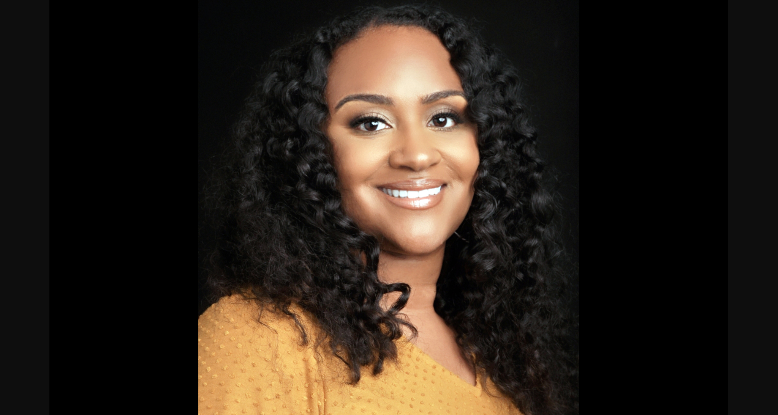
Keynote Speaker Dr. Gholdy Muhammad

Registration for the 11th Annual Rowland Conference, Wednesday, October 26, 2022 will close on October 14th or when we run out of room–whichever comes first! We currently have over 350 participants and will close registration early if we run out of space. Feel free to share the program for this year’s conference with colleagues: All Students Thriving: Rethinking School & Community .

Special thanks to our seven Rowland Fellows who are sharing work in workshop sessions this year! Also, here’s a sneak preview of a new workshop we’ve added to the program, Community Schools in Vermont, led by Jess DeCarolis (RF09) and offered in the morning session only.

Dr. Gholdy Muhammad will deliver our keynote on the theme of Cultivating Genius: An Equity Model for Culturally & Historically Responsive Education. To start the school year, check out this article of hers if you haven’t seen it yet, Debunking Deficit-Centered Views of Our Children. Our 2022 Cohort read this with their Steering Committees at the Shared Leadership Retreat and found it to be very useful.

Collaborative Practices for Equity
We are pleased to announce a new course designed for new Rowland Fellows! Our entire 2022 Cohort of Rowland Fellows joined veteran Fellows at Shelburne Farms for three full days last month to deepen their collaborative practice skills in Senior Associate Jeanie Phillips’s new course Collaborative Practices for Equity. This new course is co-sponsored by the Rowland Foundation, Great Schools Partnership, and Shelburne Farms. Participants shared meals each day provided by local BIPOC-owned businesses.
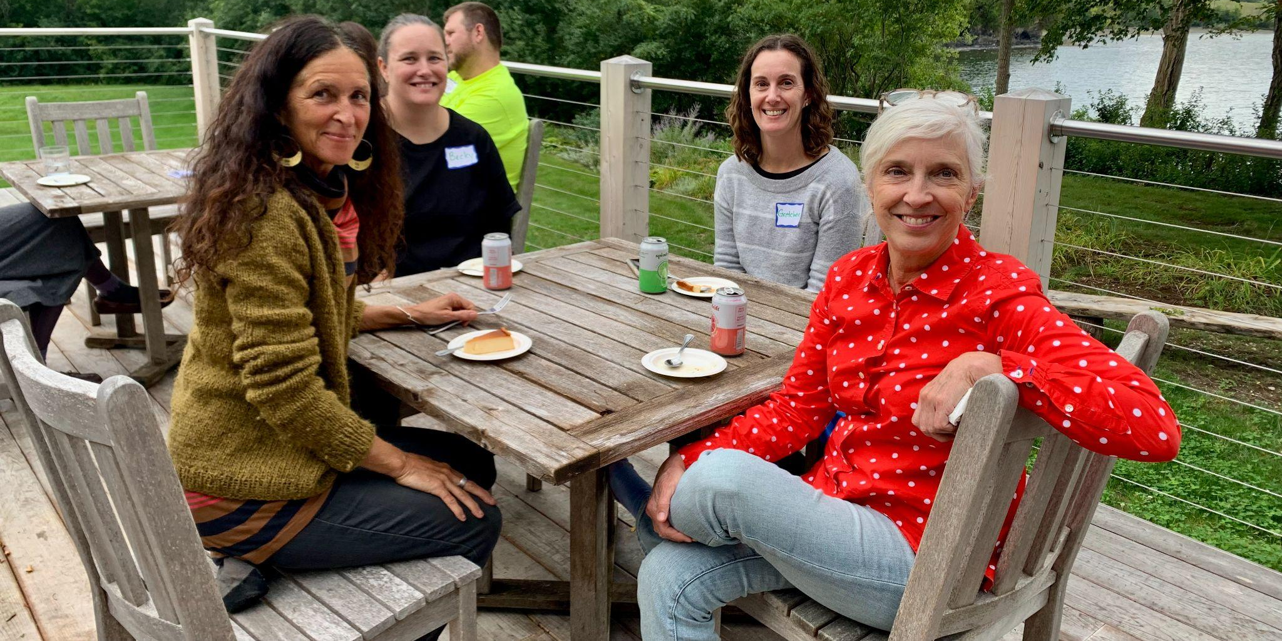
Veteran Rowland Fellows and new Rowland Fellows sharing a meal at Orchard Cove, Shelburne Farms. Seen here (left to right) Anne Bergeron (RF11), Becky Ebel (RF22), Gretchen Muller (RF17), and Patti Tomashot (RF22). (background) Devon Karpak (RF22)

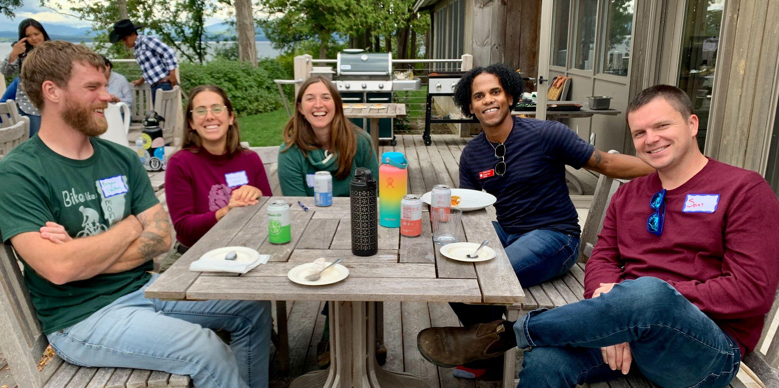
Rowland Fellows in Collaborative Practices for Equity at Orchard Cove. Seen here (left to right) Bryan Dickinson (RF22), Hannah Corbin (Shelburne Farms), Kat Robbins (RF21), Delanté Keys (Shelburne Farms), Sam Bromley (RF22)

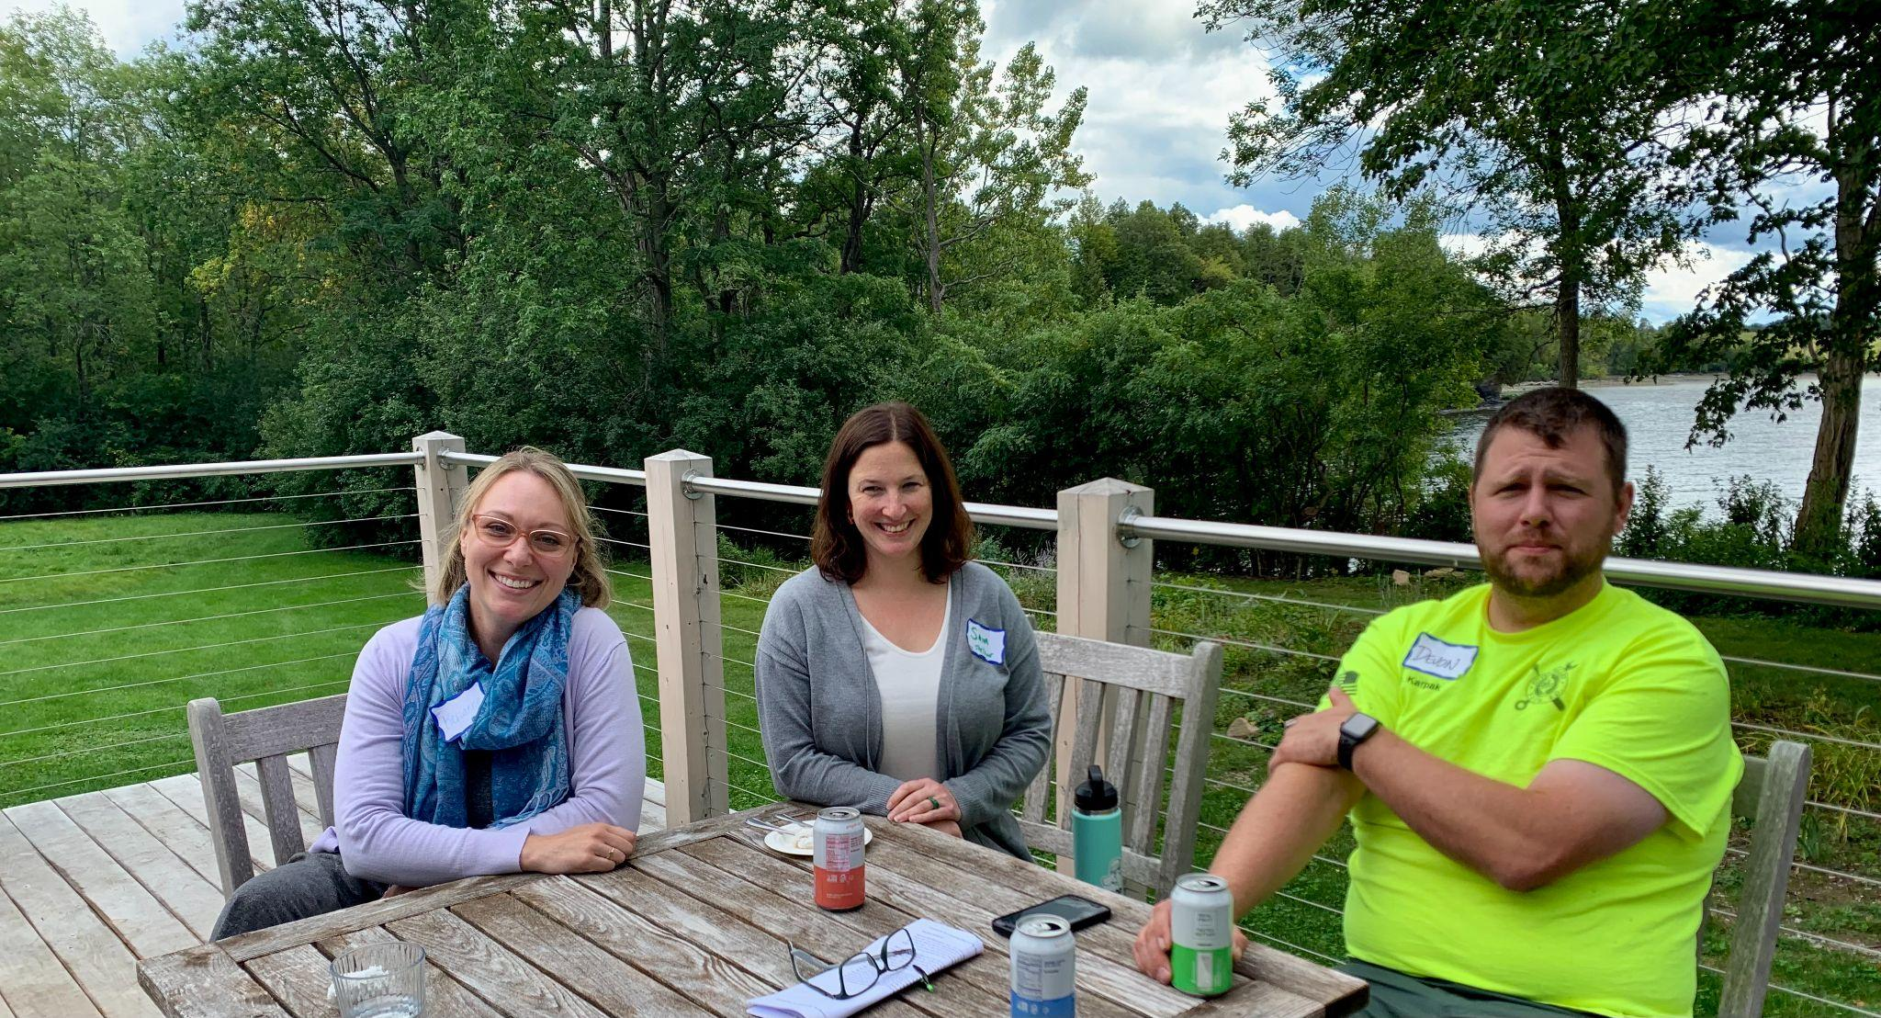
Rowland Fellows in Collaborative Practices for Equity at Orchard Cove. Seen here (left to right) Kerianne Severy (RF17), Samantha Mundt (RF21), and Devon Karpak (RF22)

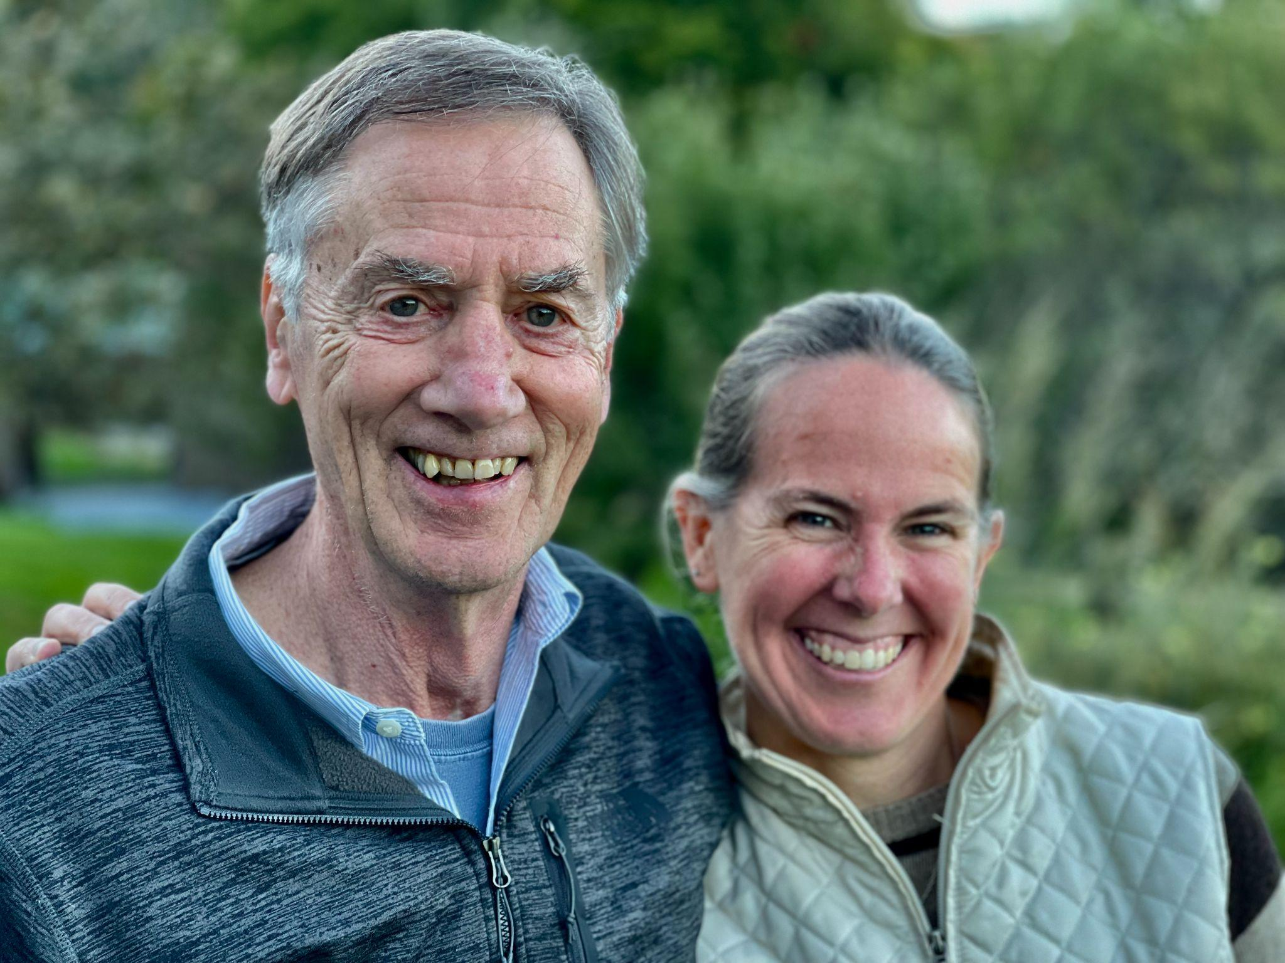
Rowland Foundation Trustees Chuck Scranton and Erica Wallstrom (RF14) at the Board of Trustees September Meeting in Dorset.

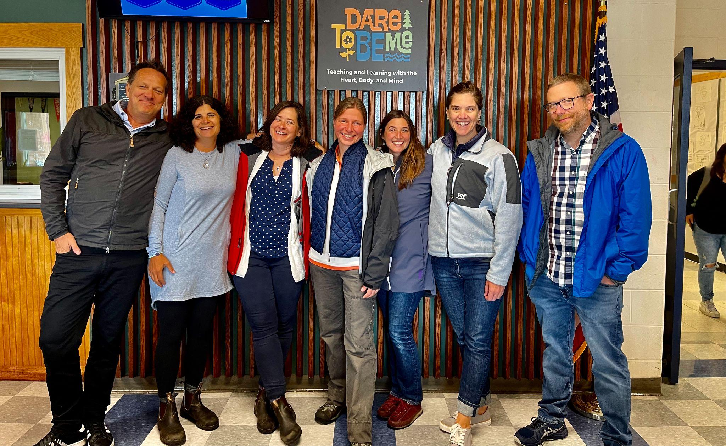
The 2021 Rowland Fellows met for their September cohort meeting at Hazen Union High School in Hardwick. Seen here under the Dare to Be Me sign at the school’s main entrance (left to right) Executive Director Mike Martin, Janis Boulbol, Senior Associate Jeanie Phillips, Anja Pfeffer, Kat Robbins, Rachel Howes & Brent Litterer.

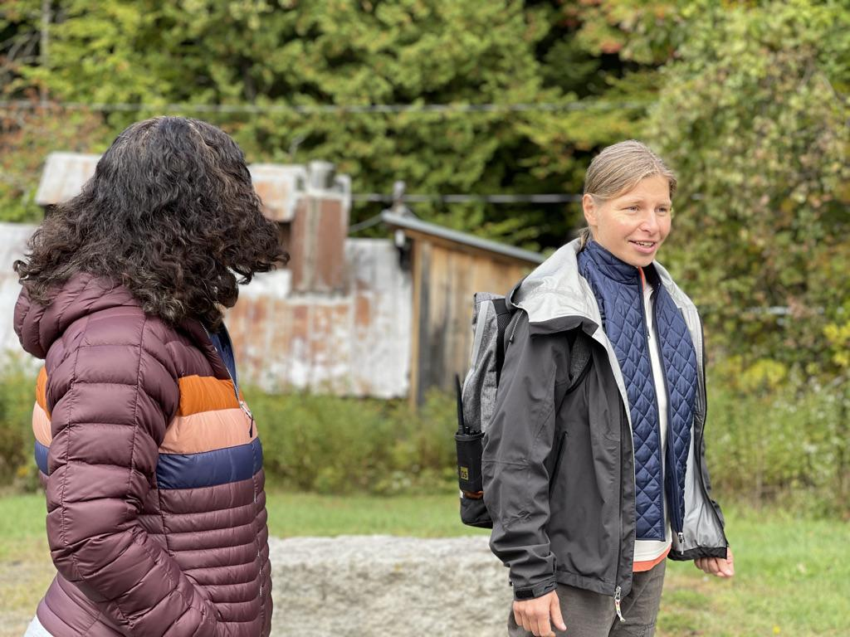
Anja Pfeffer (RF21), seen here with Janis Boulbol (RF21), led cohort mates through some Dare to Be Me activities on Hazen’s beautiful campus.

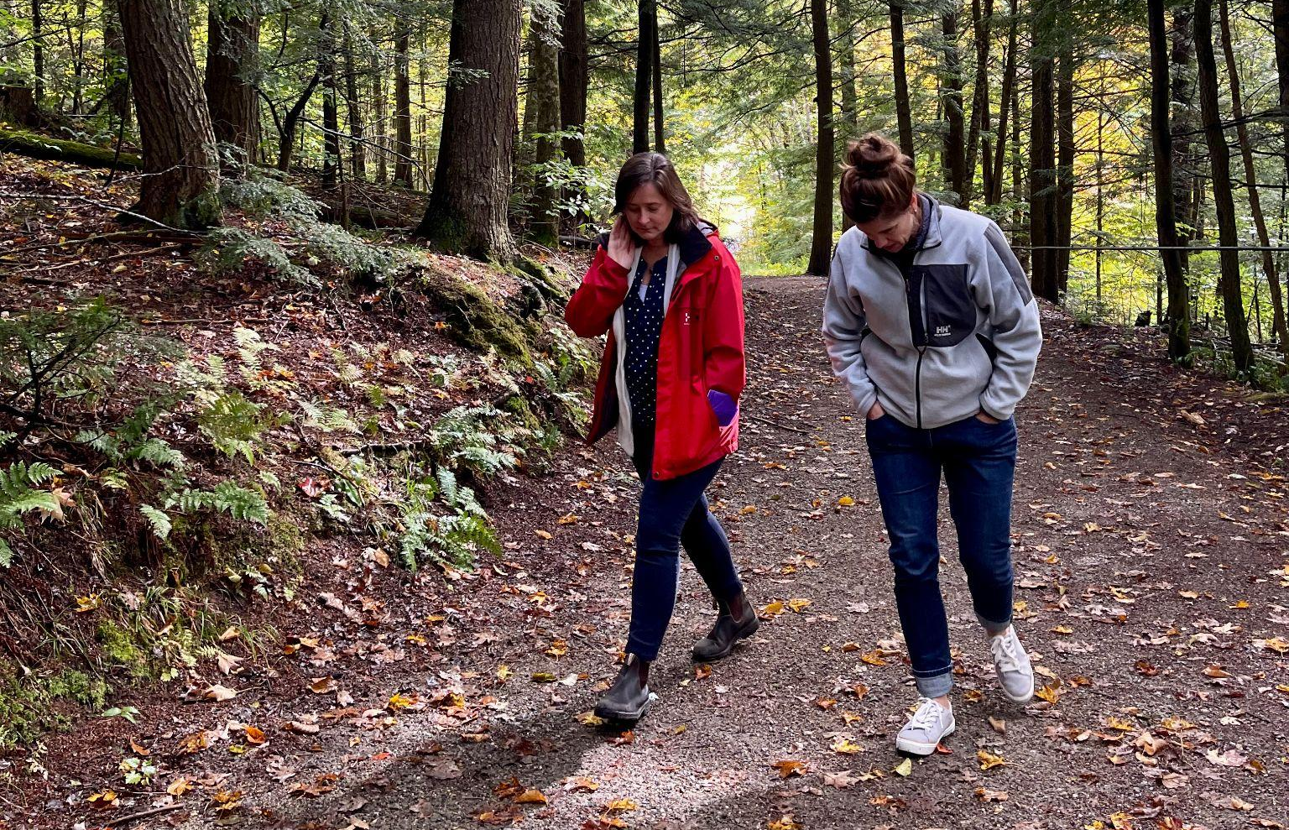
Senior Associate Jeanie Phillips (RF14) and Rachel Howes (RF21) on Hazen’s walking trails.

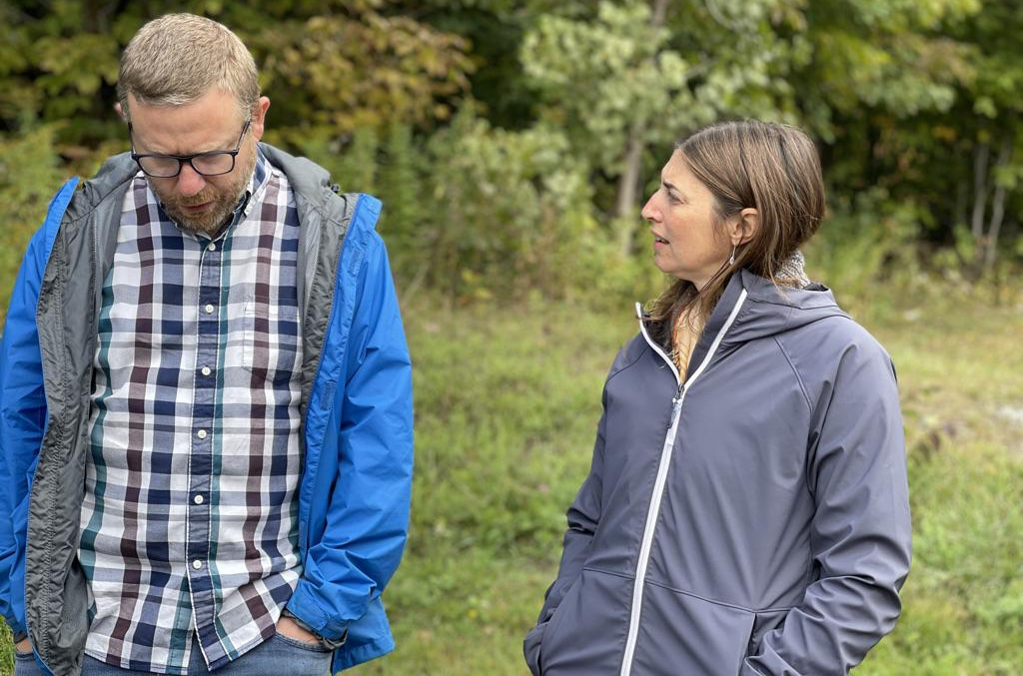
Brent Litterer (RF21) and Kat Robbins (RF21) at their cohort meeting at Hazen Union High School.

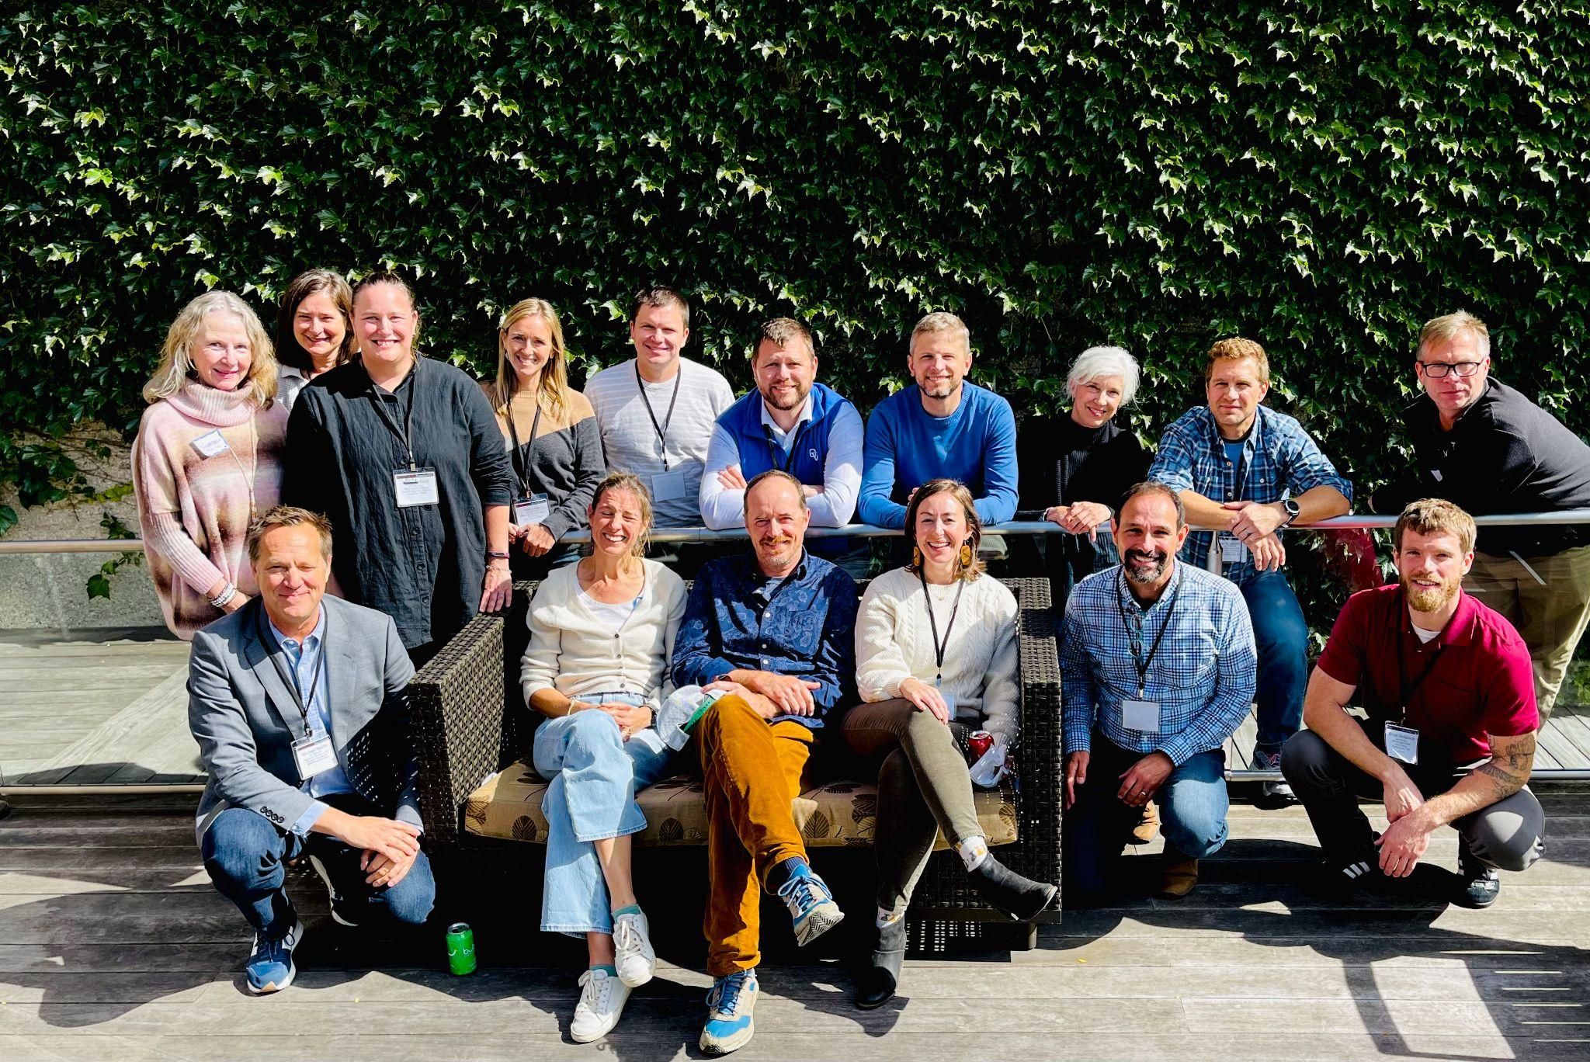
16 Rowland Fellows contributed in different capacities to make last month’s Shared Leadership Retreat at the Hilton Burlington/Lake Champlain a smashing success for our new Rowland Fellows and their Steering Committees. Seen here (back row, left to right) Kristine Kirkaldy (RF10), Jeanie Phillips (RF14), Becky Ebel (RF22), Lori Lisai (RF15), Sam Bromley (RF22), Devon Karpak (RF22), Michael Ruppel (RF17), Patti Tomashot (RF22), John Painter (RF14), Tom Sabo (RF11) (front row, left to right) Mike Martin (RF09), Lissa Knauss (RF18), Roger Murphy (RF18), Emily Gilmore (RF17), Jean Berthiaume (RF09), Bryan Dickinson (RF22)

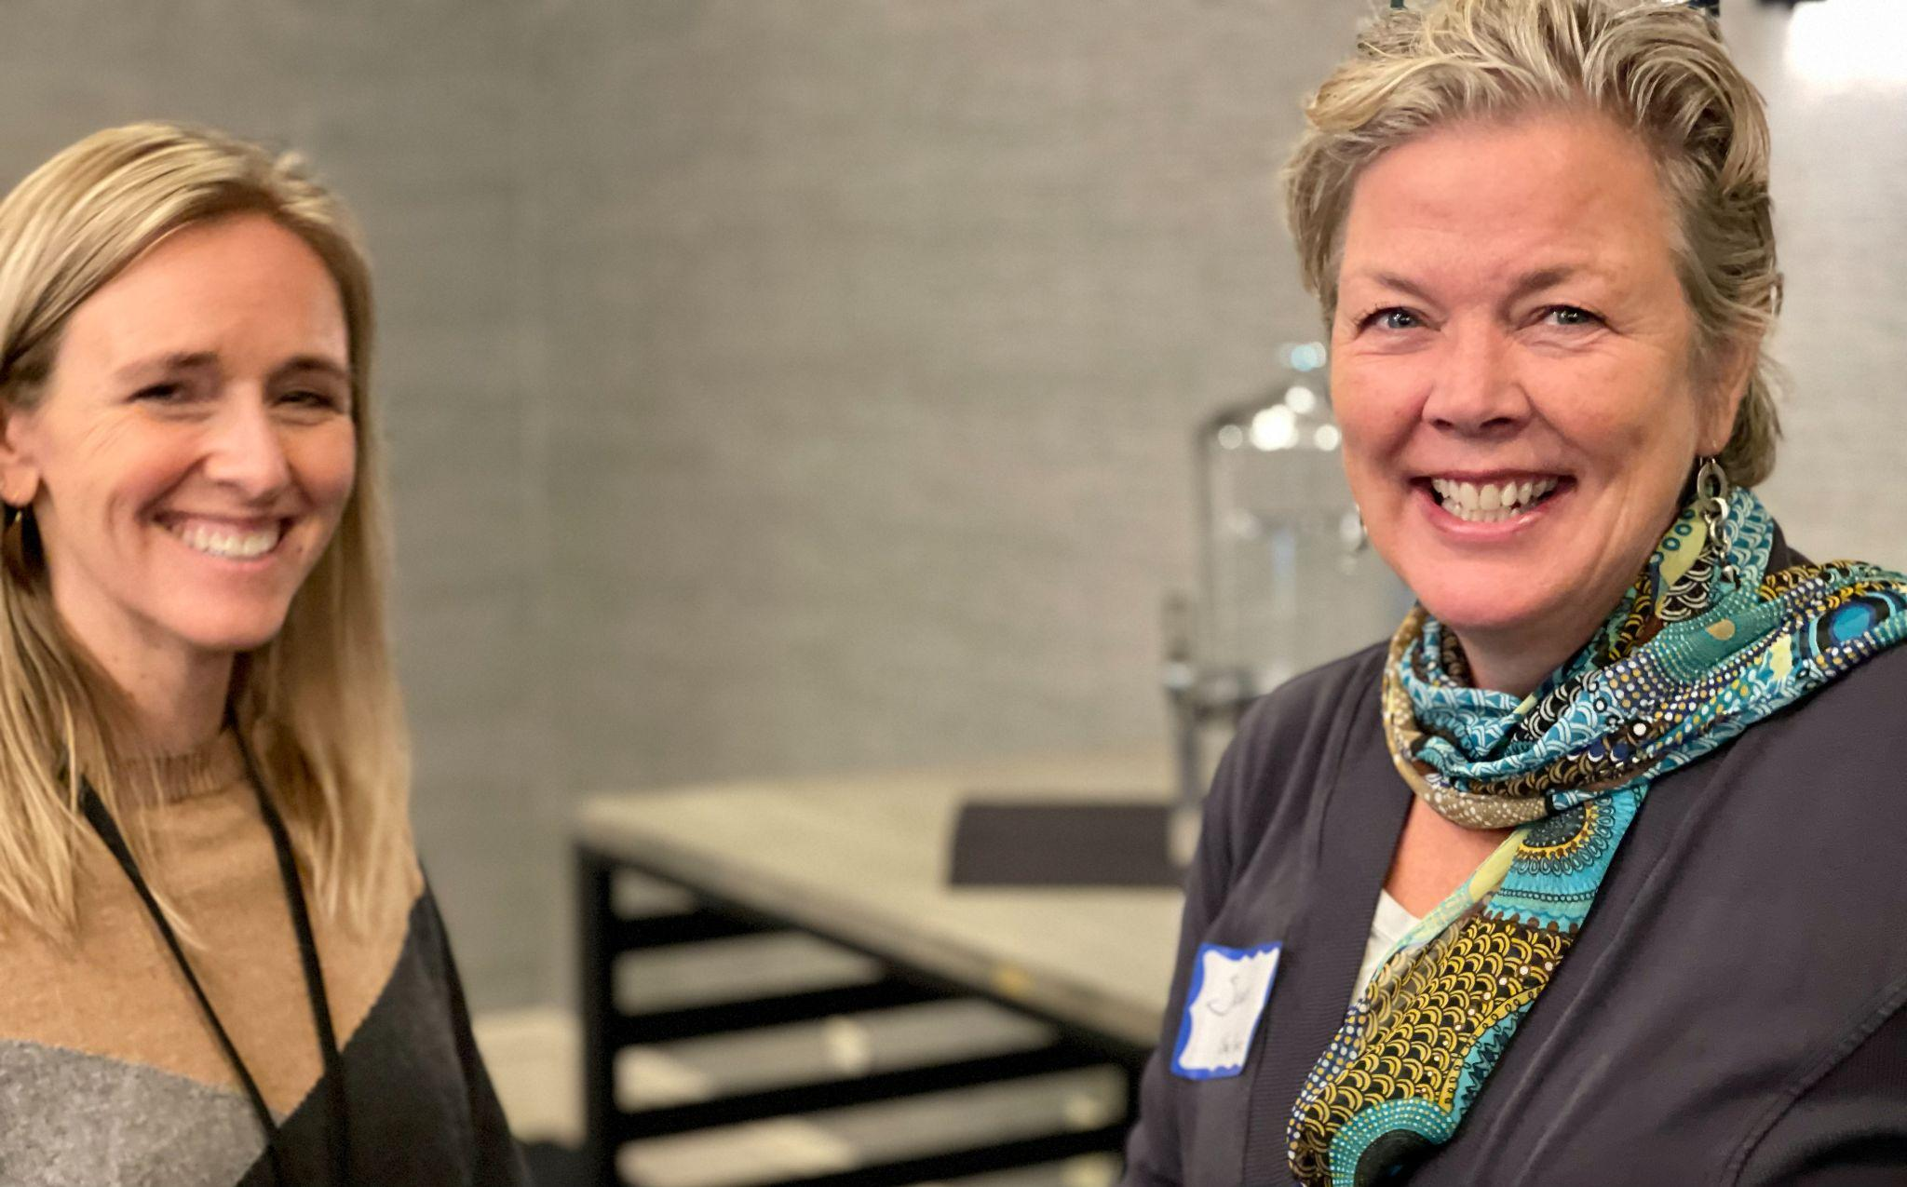
Senior Associate for Social Media & Technology Lori Lisai (RF15) seen here at the Shared Leadership Retreat with Vermont educator Susan Hennessey.

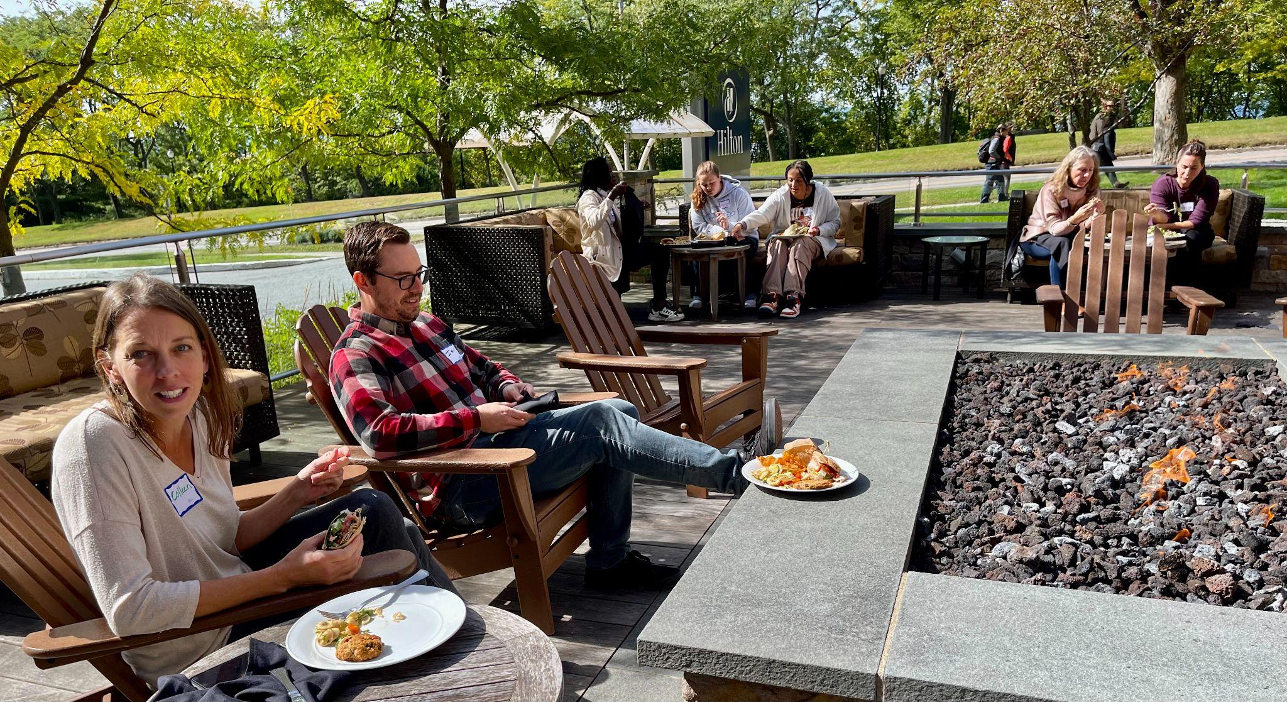
Montpelier teachers taking a break from Steering Committee work and enjoying lunch at the Hilton Burlington’s fire pit.

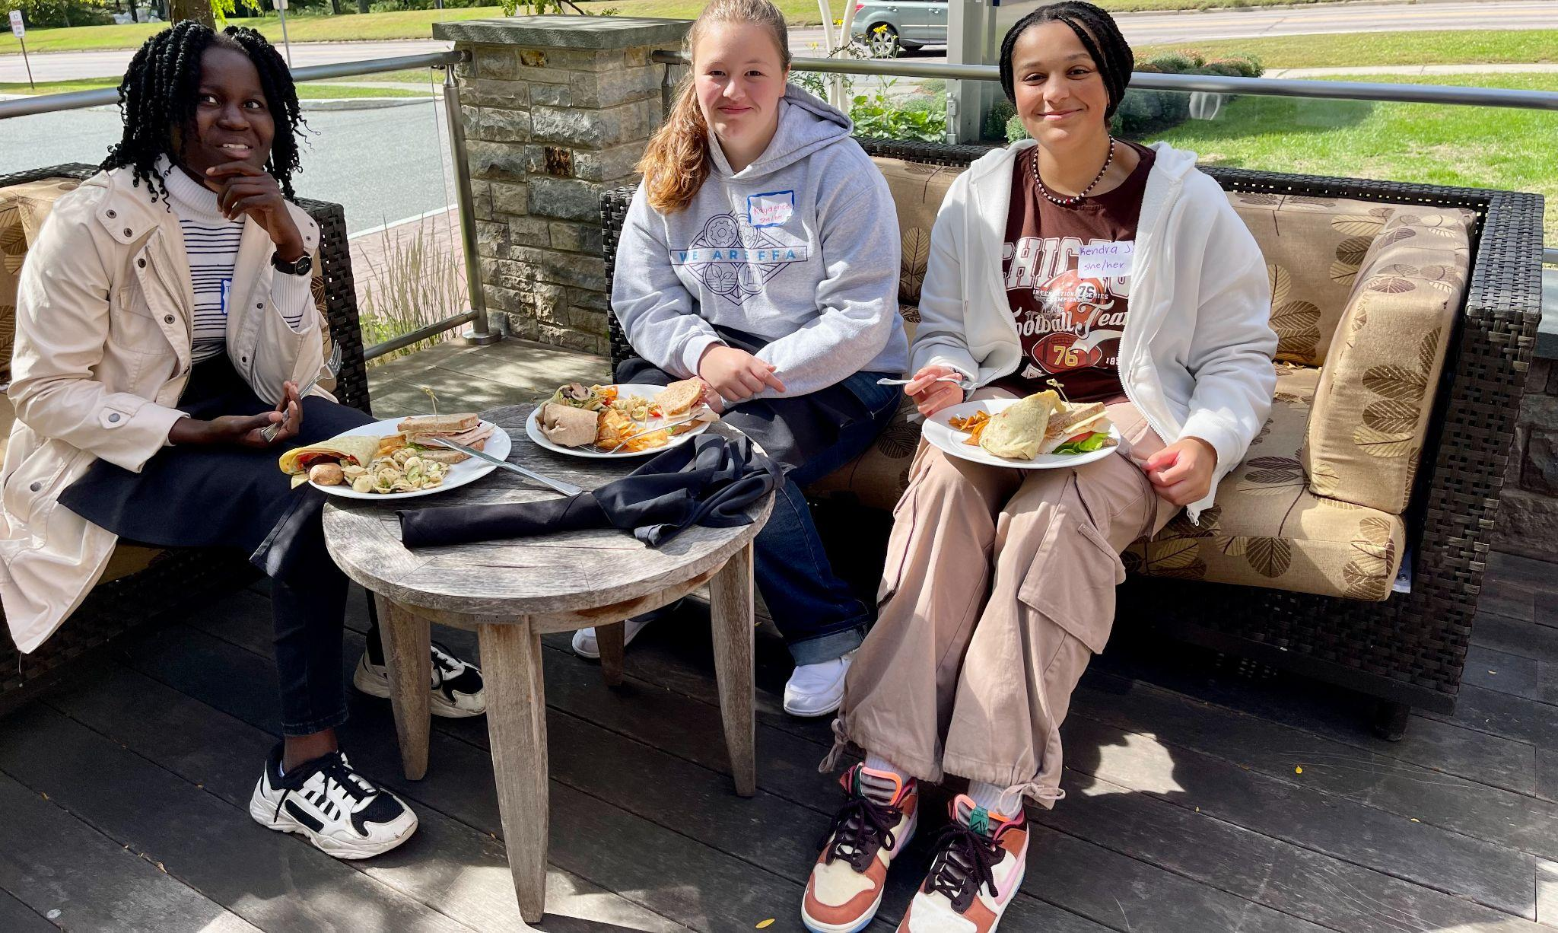
Vergennes students taking a break from Steering Committee work and enjoying lunch outside at last month’s Shared Leadership Retreat.

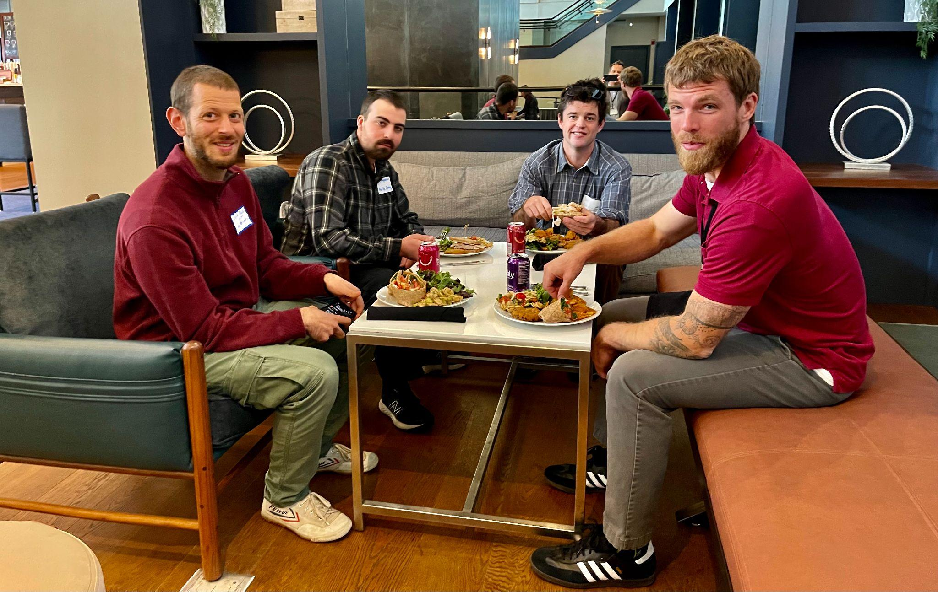
Bryan Dickinson (RF22) (on left) enjoying a meal with North Country High School colleagues who serve on his Steering Committee.

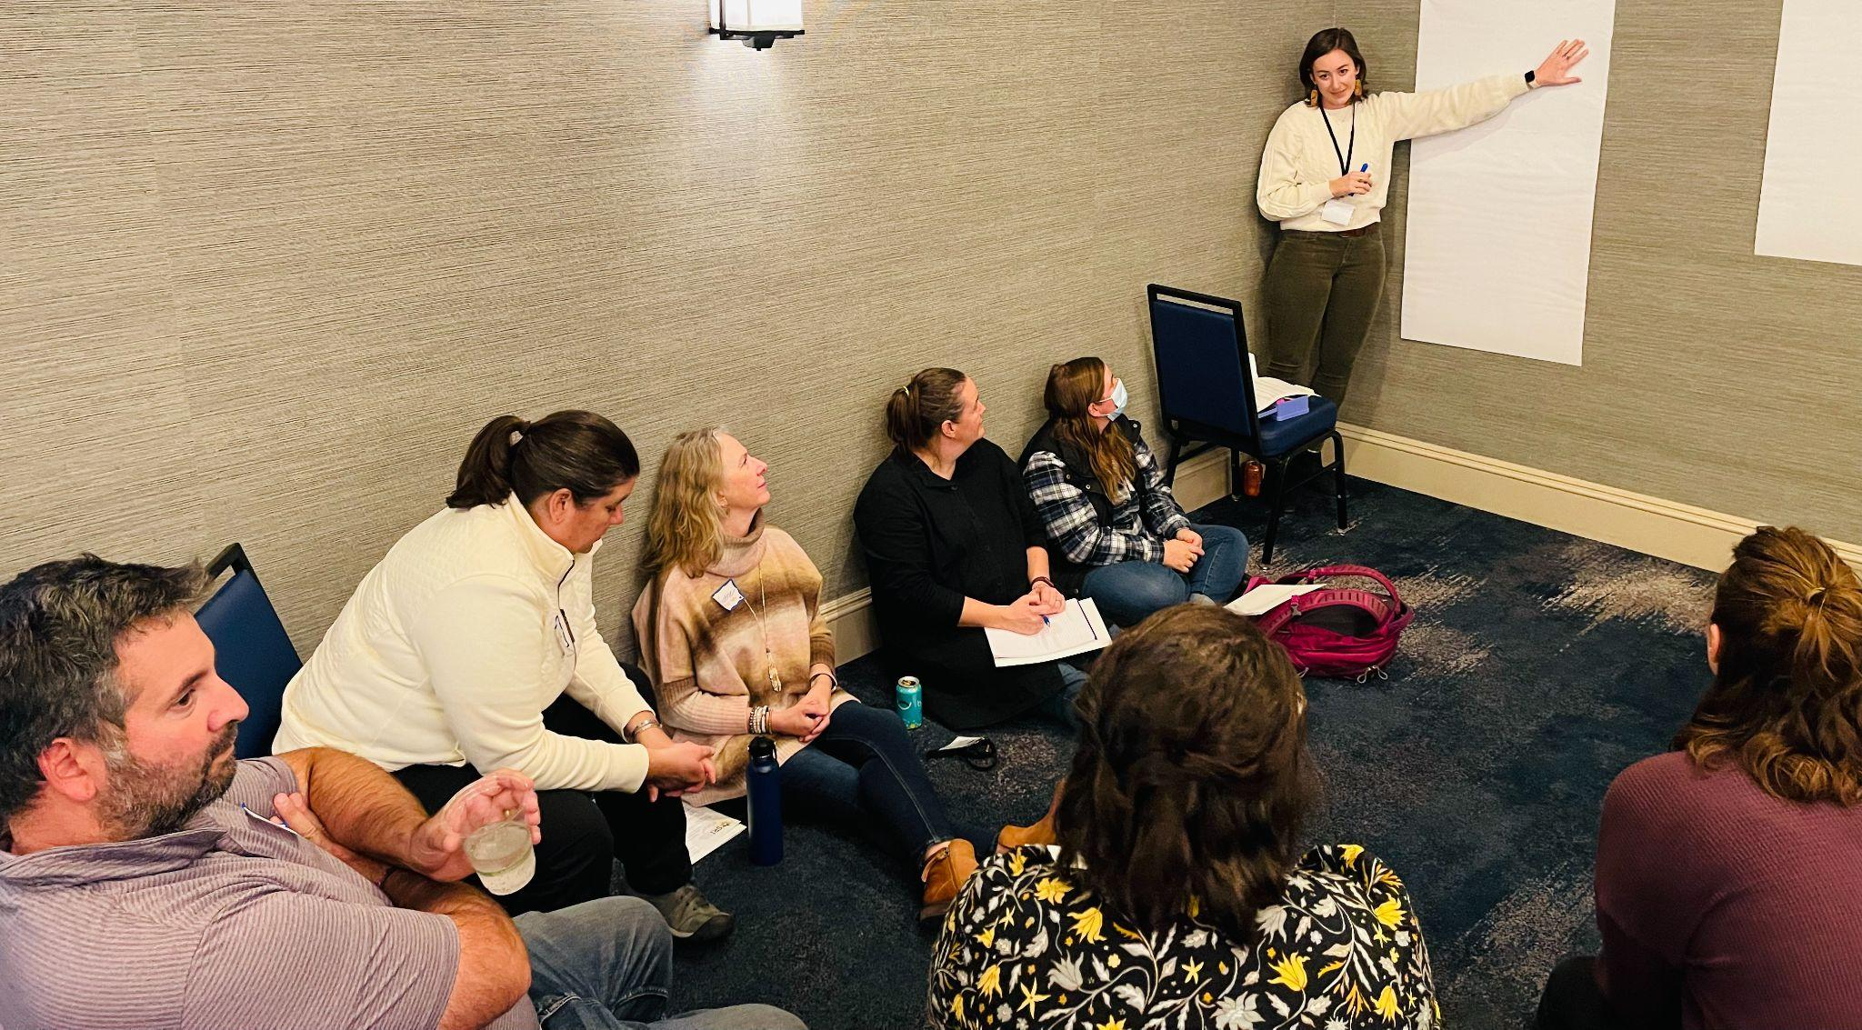
Emily Gilmore (RF17) facilitating the Future Protocol with Becky Ebel (RF22), Kristine Kirkaldy (RF11), and other Vergennes teachers and students.

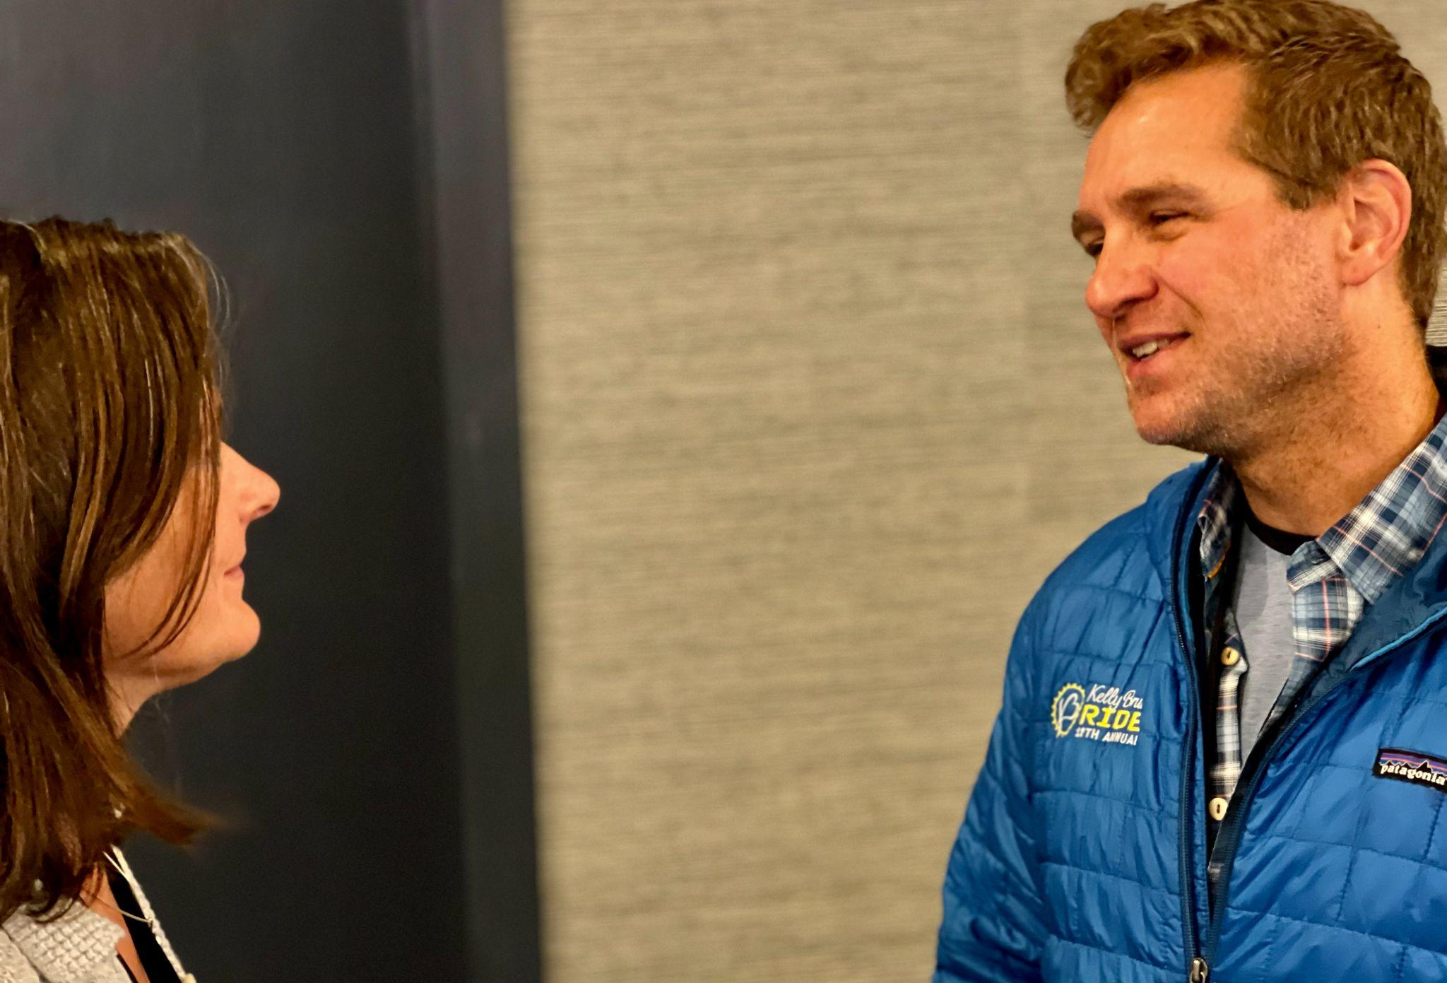
2014 cohort mates and dear friends Jeanie Phillips and John Painter catching up at the Shared Leadership Retreat.

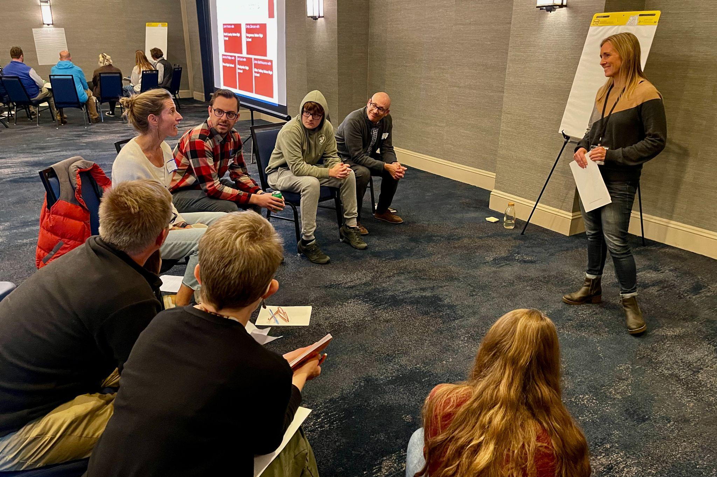
Lori Lisai (RF15) facilitating the Future Protocol with Montpelier High School Steering Committee members.

Gratitude
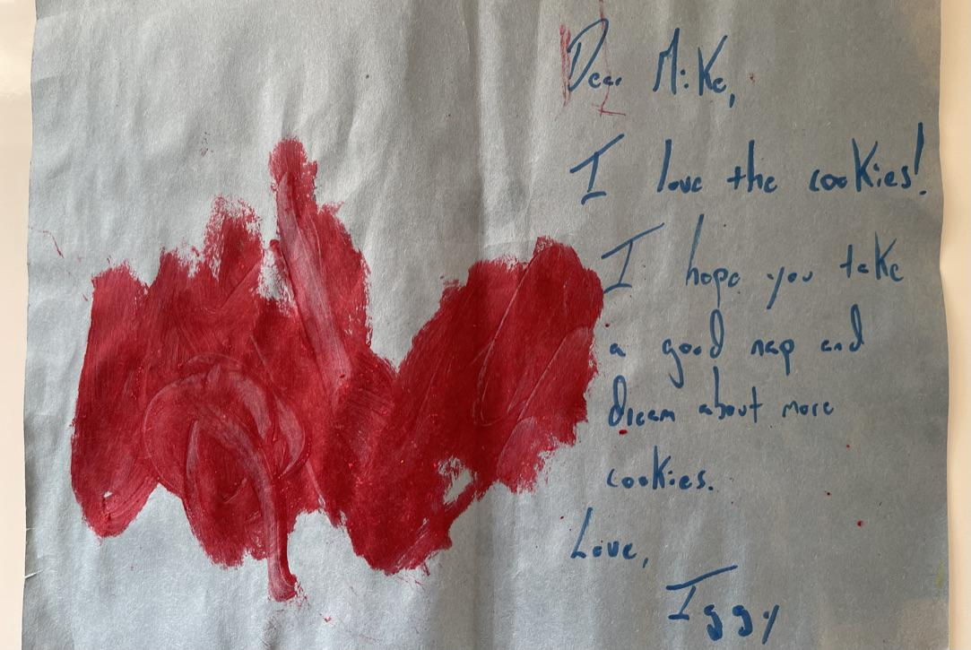
Iggy, Mike Martin’s 3 ½ year old neighbor, was so happy about getting some leftover chocolate chip cookies from the Rowland Foundation’s Shared Leadership Retreat that he asked his mom to help him express his gratitude with this card–where he wished Mike a good nap and dreams of more cookies.

Celebrations
2021 Rowland Fellows Janis Boulbol & Kat Robbins are thrilled by how their Fellowship project CRAFT (Community & Climate Resilience through Agriculture, Forestry and Technology) has spread throughout Woodstock Union Middle/High School curriculum and wider community. They shared the following celebrations below.

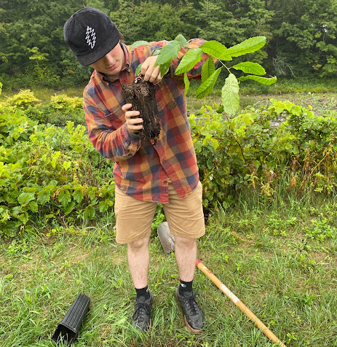
In SAP (Stewardship Action Project) students have created their own definition of stewardship, come up with action project ideas and helped with stewardship actions on our campus like planting these American Chestnut Trees to help a non-profit bring this species back to our forests.
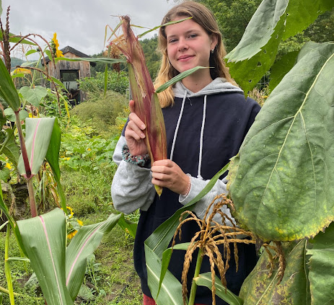
SAP students are also helping to grow and harvest Abenaki red flint corn and cranberry beans as part of the Abenaki Land Link Project which helps to cultivate heirloom Abenaki seeds to give back to the indigenous community to continue growing their native crops in the future.
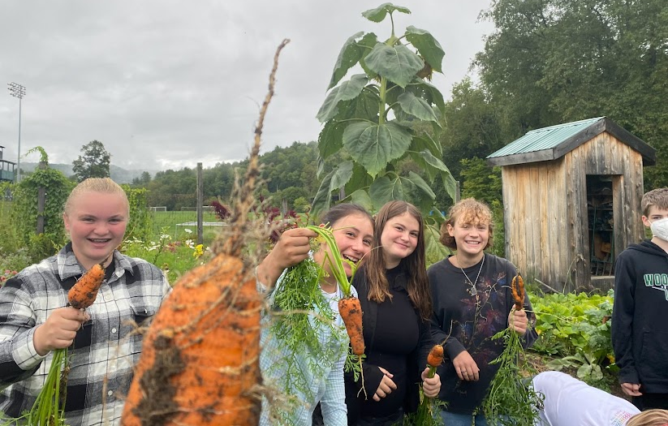
In our middle school class, Gardens and Greenhouses, students have been learning about the medicinal, edible and ecological benefits of cultivated and wild plants, the features and processes of plants, and how to grow and use herbs. They got to make and eat parmesan roasted carrots with thai basil, roasted beets and kale chips using the local food from our gardens!

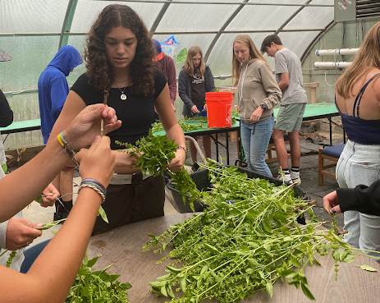
Students in Foundations of Agriculture have been focused on harvesting, weighing and processing the many crops in our garden like beets (40 lbs), carrots (40 lbs), basil (3.8 lbs), kale (15 lbs), butternut squash (70.6 lbs), spaghetti squash (50.75 lbs), garlic, onions, pumpkins and herbs. We have sent most of that food to the cafeteria while some of it is waiting to cure. We have also cooked with our produce, making herbed garlic bread and kale basil pesto. YUM! FA students have also been testing our soil to see what nutrients are needed in the garden, growing microgreens for our cafeteria and starting seeds for our hydroponic system.

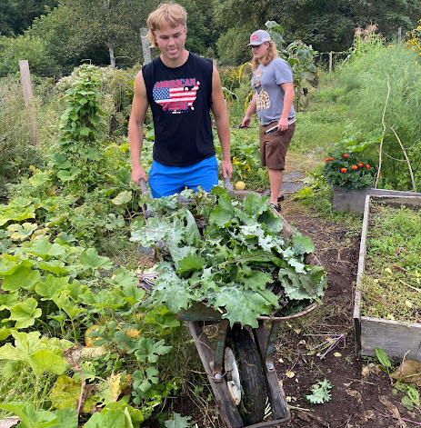
In Food and Forest Systems, students have been helping with the harvest as well as putting the garden to bed by planting cover crops. Students have been exploring the components of an ecosystem, thinking about how their food gets to their forks, as well as learning how to use iNaturalist to locate wild pollinator plants to save seeds and plant for the spring sale. These students also got to make and eat herbed garlic bread and kale basil pesto.

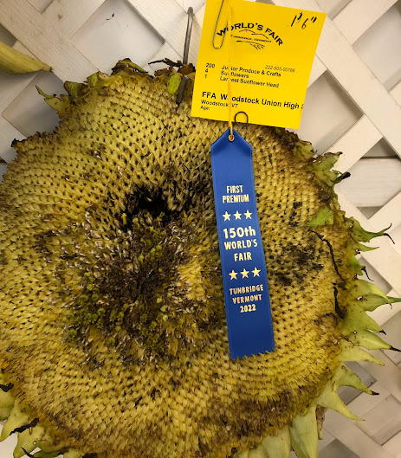
Thanks to some of our students noticing our huge sunflower in the garden, we entered this sunflower head in the 150th Tunbridge Fair, tying for 1 st place with a diameter of 1’ 6”. FFA students went on their first field of the year to the Tunbridge Fair after earning funds from their bake sales last year.

