 | Letter to Fellows  The All Fellows Retreat  October 2023

Dear Rowland Fellows,

I hope this beautiful Vermont autumn is treating you well.

Last June, an amazing edition of the Rowland Women’s Leadership Retreat took place at the Basin Harbor Club, which included: a campfire discussion, professional facilitators, adirondack chairs, lakeside views, great food, and honors for the organizer of the first women’s retreat, Lauren Parren (RF11). The retreat planning team brought together the talents and ideas of Rowland Women from three different Rowland cohorts, and they seemed to have fun as they worked hard to plan and prepare this special event. In a word, Tara Cariano (RF18), Marsha Cassel (RF14) & Gretchen Mueller (RF17) really clicked. They also made a formidable team (see below).

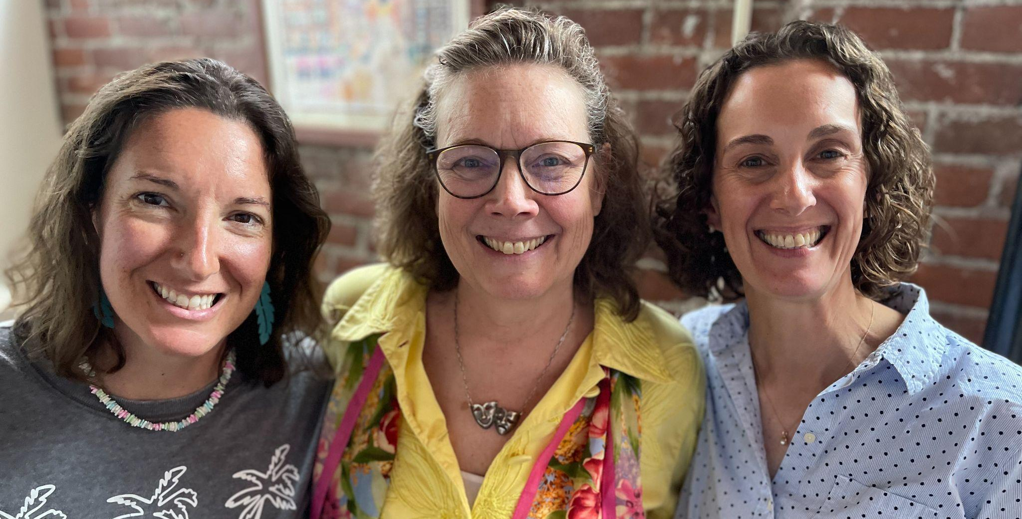

Here’s the thing though–they didn’t really know each other until they connected at last fall’s All Fellows Retreat.

That’s what the All Fellows Retreat is all about. It’s a once-a-year opportunity to catch up with friends from across the Rowland Foundation and also make new ones. It’s a unique opportunity to come together across school communities and do work that really makes a difference for Vermont teachers and students. The Rowland Women’s Leadership Retreat Planning Team and our Rowland Encore Grant Teams are just two examples of great ideas that grew out of the All Fellows Retreat.

This year’s format will favor conversation over presentation once again. We have the following topics planned for discussion table rounds, and will provide table space for any new topics that emerge too:
- The Rowland Women’s Leadership Retreat (Gretchen Mueller)
- The Rowland Encore Grant (Jeanie Phillips)
- The New Rowland Foundation Website (Lori Lisai)
- Deeper Learning in Vermont Schools (REG24: Jess DeCarolis, Andrew Jones & Gabe Hamilton)
- The Rowland Approach (Jean Berthiaume)
- The Vermont IRIS Ethnic Studies Standards Framework (Mike Martin)

I know how hard it is to be out of school these days. Sincere thanks to everyone who has already signed up or is helping out at this year’s event! To make it easier to attend the All Fellows Retreat this year we will provide free parking nearby at UVM and hold the All Fellows Social in the same room, instead of moving over to the Farm House Tap & Grill. And professional development certificates will be provided to help with relicensure credit, of course.

Please register here to attend this year’s All Fellows Retreat!
You can also see our agenda here.

To sum up, in the finest internet click-bait tradition, here are the top 10 reasons to come to the All Fellows Retreat on October 25th this year:
- Find your Rowland Encore Grant Team (and topic) for new regional or state-level work.
- Connect with other Rowland Women and possibly help plan that annual event.
- Meet the new Rowland Fellows and share your experience.
- Talk with Rowland Fellows who are leading important work in the field (e.g., deeper learning, racial equity, digital wellness)
- Find out more about new Rowland Foundation work (e.g., new website launch in November, DEW Grants, Rowland short films)
- Enjoy the camaraderie and brilliant thinking of your fellow Rowland Fellows.
- Catch up with old friends!
- Get some new inspiration.
- Dream big.
- Join the group for the annual Rowland Fellows photo!

Take care and see you soon,

Mike

Rowland Foundation Updates

The 12th Annual Rowland Conference
Growing Community: Making Space for Joy & Creativity in School
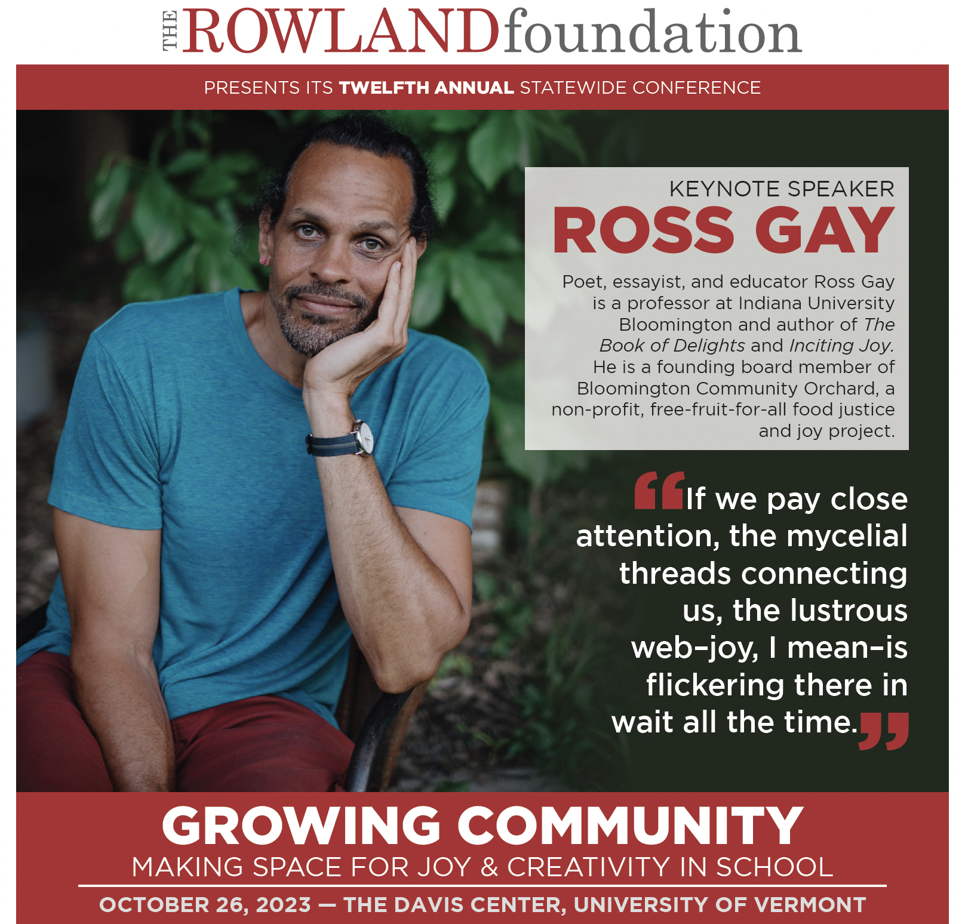
Registration for The 12th Annual Rowland Conference will close on October 17th! If your school or a colleague’s school wants to send a team, please let them know they can register here. Ross Gay is excited to be coming to Vermont, and this year’s theme feels more timely than ever.

Thanks again to the many Rowland Fellows who are presenting workshops or bringing teams this year. If you’re leading a team, remember to make the most of Team Time after lunch (12:45 - 1:20pm) to consolidate new learning and share ideas with your colleagues.

The All Fellows Retreat
Please register for the All Fellows Retreat here (on or before October 20th). This year’s All Fellows Retreat will be on Wednesday, Oct. 25th (1:00 - 4:00pm) at UVM’s Davis Center in the Grand Maple Ballroom, to be followed immediately afterward by the All Fellows Social in the same location. UVM parking permits and light refreshments will be provided for participants. This annual convening is a unique opportunity to share ideas and network with other Rowland Fellows. It’s also a great way to learn more about team grant opportunities available to veteran Rowland Fellows.

Rowland Women’s Leadership Retreat
November 15th is the deadline for veteran Rowland Fellows to submit a Planning Team proposal for the next Rowland Women’s Leadership Retreat. The late fall deadline allows time for the Planning Team to reserve a location once their proposal is accepted. One of last year’s planners, Gretchen Mueller (RF17) will be leading a table discussion at the All Fellows Retreat to share information about this annual event. Please join the discussions and consider contributing to this important Rowland Foundation tradition.

The Rowland Encore Grant (REG)
December 31st is the deadline for veteran Rowland Fellows to submit a Rowland Encore Grant Team proposal for a regional or statewide initiative. You can see the guidelines here. Members of our 2023 REG Team will lead a table discussion at the All Fellows Retreat to share information about their work to date on deeper learning. Members of our 2022 REG Team will be presenting their work on Digital Wellness in a workshop at the 12th Annual Rowland Conference.

Rowland Fellowship Info Nights
Please help spread the word about Rowland Fellowships! The December 31st deadline for this incredible opportunity for Vermont teachers will come up quickly. With a new round of spots we’re airing on Vermont Public from October 30th - November 17th, your friends and neighbors may be asking you about the Rowland Foundation and our work. You can also let prospective candidates know that our Senior Rowland Associates are available to help them with their applications since they are not part of the selection process: jean@therowlandfoundation.org jeanie@therowlandfoundation.org lori@therowlandfoundation.org

You can also let interested teachers know about these upcoming Rowland Fellowship Info Nights to be held around the state and online. Teachers will be able to meet with Executive Director Mike Martin and ask any questions they have over light refreshments. Directions and other details will be shared on our website and in the November Letter to Fellows.

Wednesday, November 8th (4:00 - 5:00pm) St. Johnsbury Academy
Thank you, Sandra Mings-Lamar!

Tuesday, November 14th (4:00 - 5:00pm) Google Meet
https://meet.google.com/ysp-tsns-tgu

Thursday, November 16th (4:00 - 5:00pm) Rutland High School
Thank you, Bianca McKeen!

Tuesday, November 28th (4:00 - 5:00pm) Kestrel Coffee Shop, Burlington
(just downstairs from our offices)

The Rowland DEW Grant
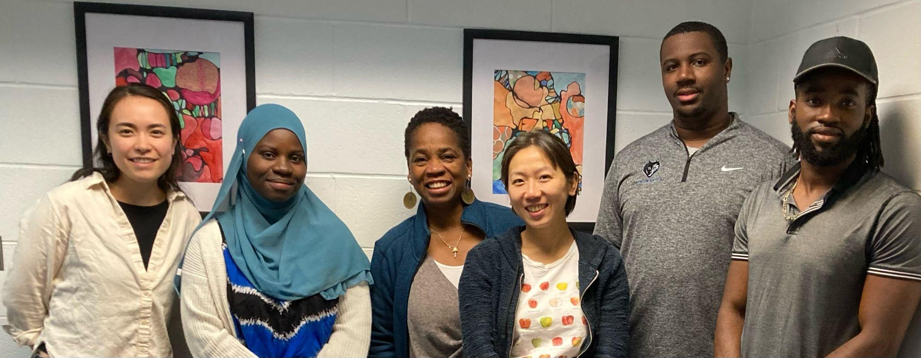
Congratulations to our newest DEW Scholar Lijuan Merkel! To help diversify the educator workforce in Vermont, the Rowland Foundation provides four $20,000 grant awards each year to support aspiring educators of color as they seek licensure in our state. The DEW Scholars meet monthly with our DEW Mentor Bonnie Johnson-Aten. In the first two years of this new grant investment, the Rowland Foundation has provided support to seven educators of color. Seen here (left to right) Tessie Sakai, Safia Haji, Bonnie Johnson-Aten, Lijuan Merkel, Kenneth Phillips II, and Jonas Kambire.

The Shared Leadership Retreat
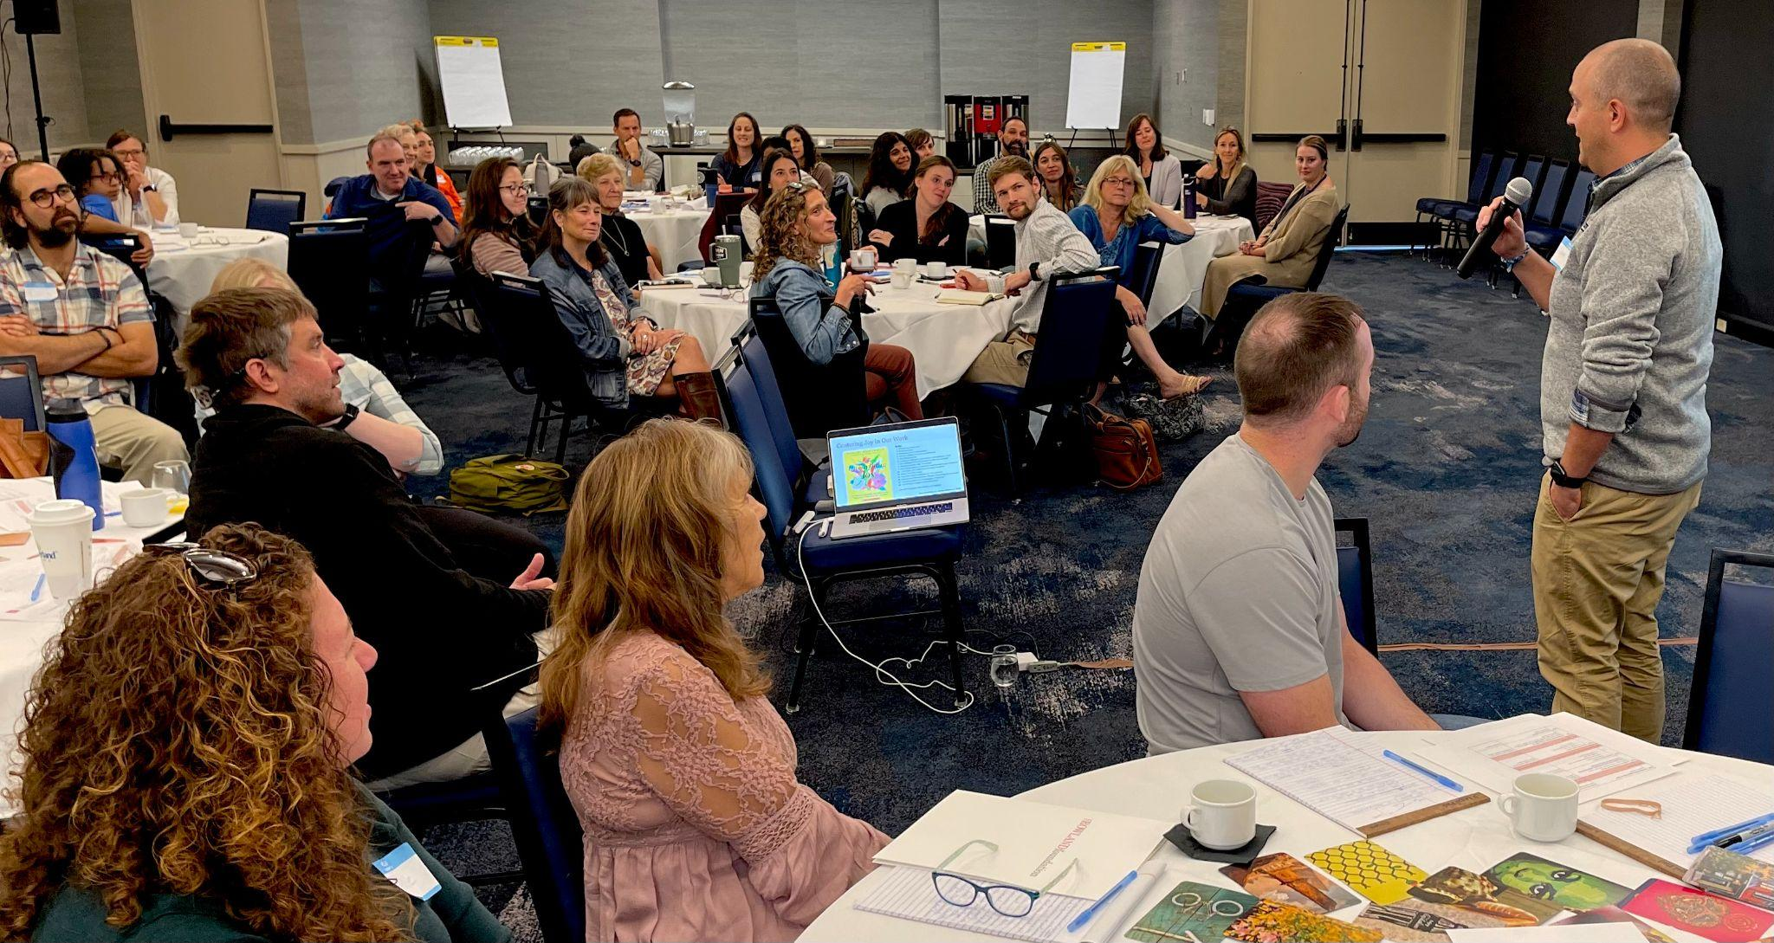
The Shared Leadership Retreat brought together nearly 70 teachers, students, staff & principals at the Hilton Burlington Lake Champlain in September. New Rowland Fellows do initial fellowship visioning & planning work with their Steering Committees, with facilitation support from Senior Rowland Associates and veteran Rowland Fellows.
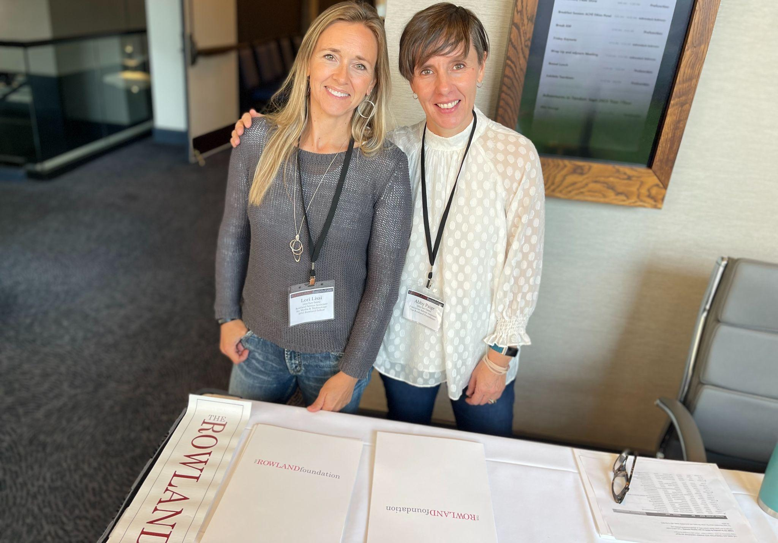
Senior Rowland Associate Lori Lisai (RF15) and Executive Assistant Abby Paige seen here welcoming participants to the Shared Leadership Retreat.
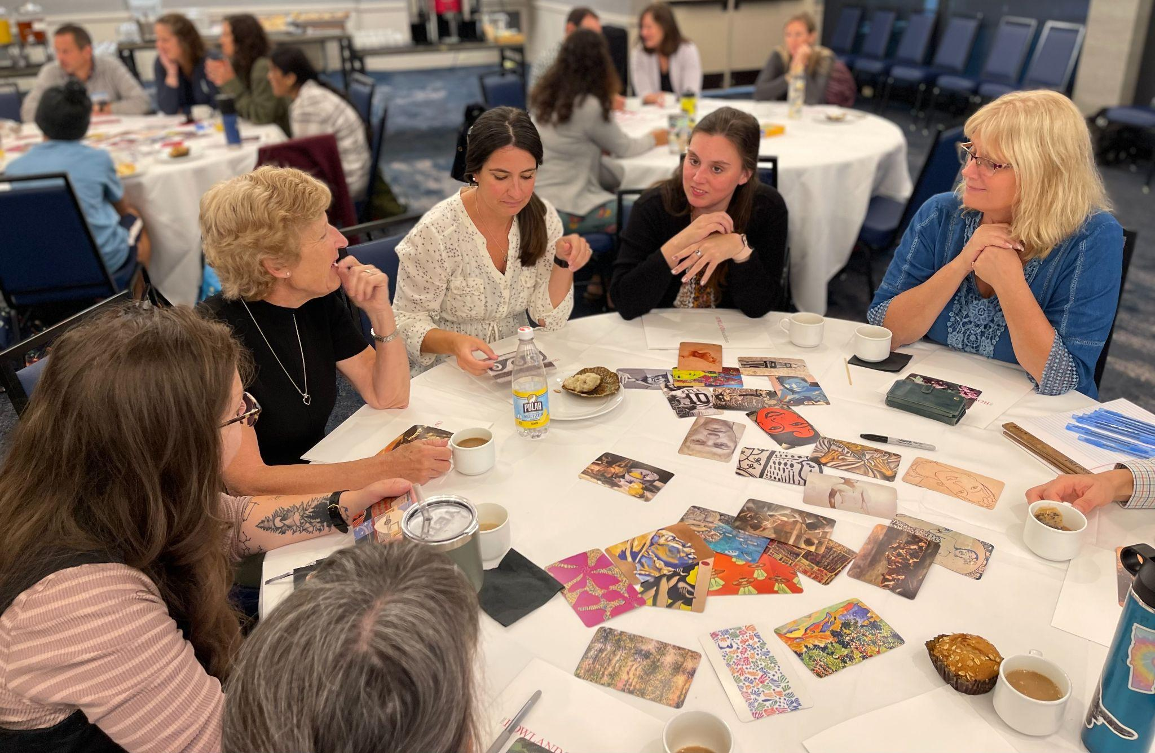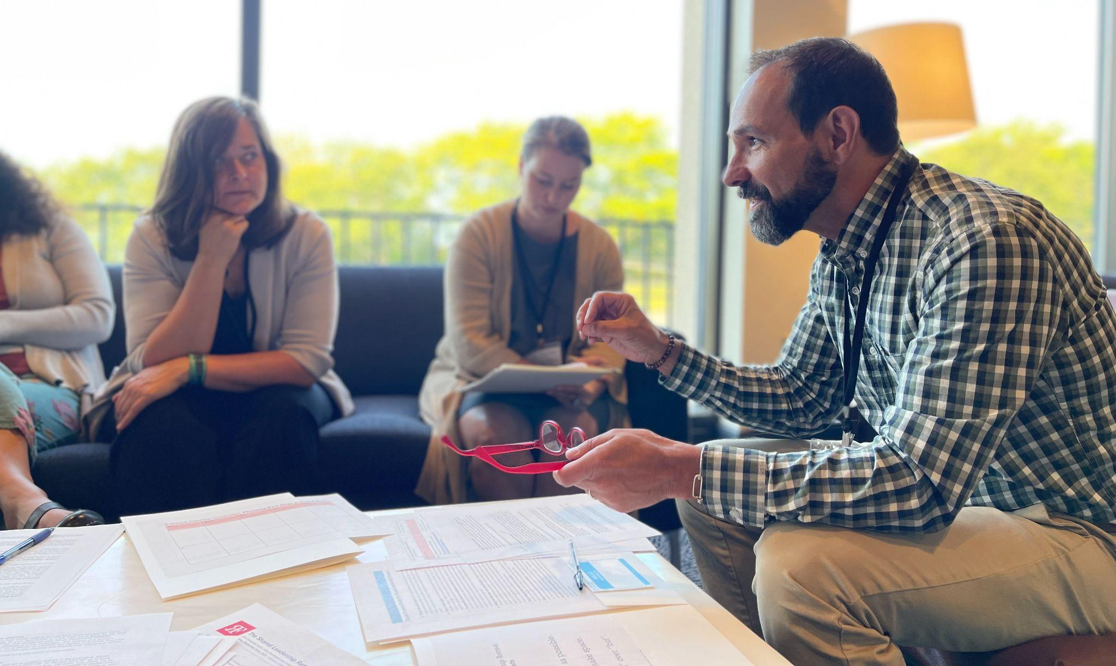
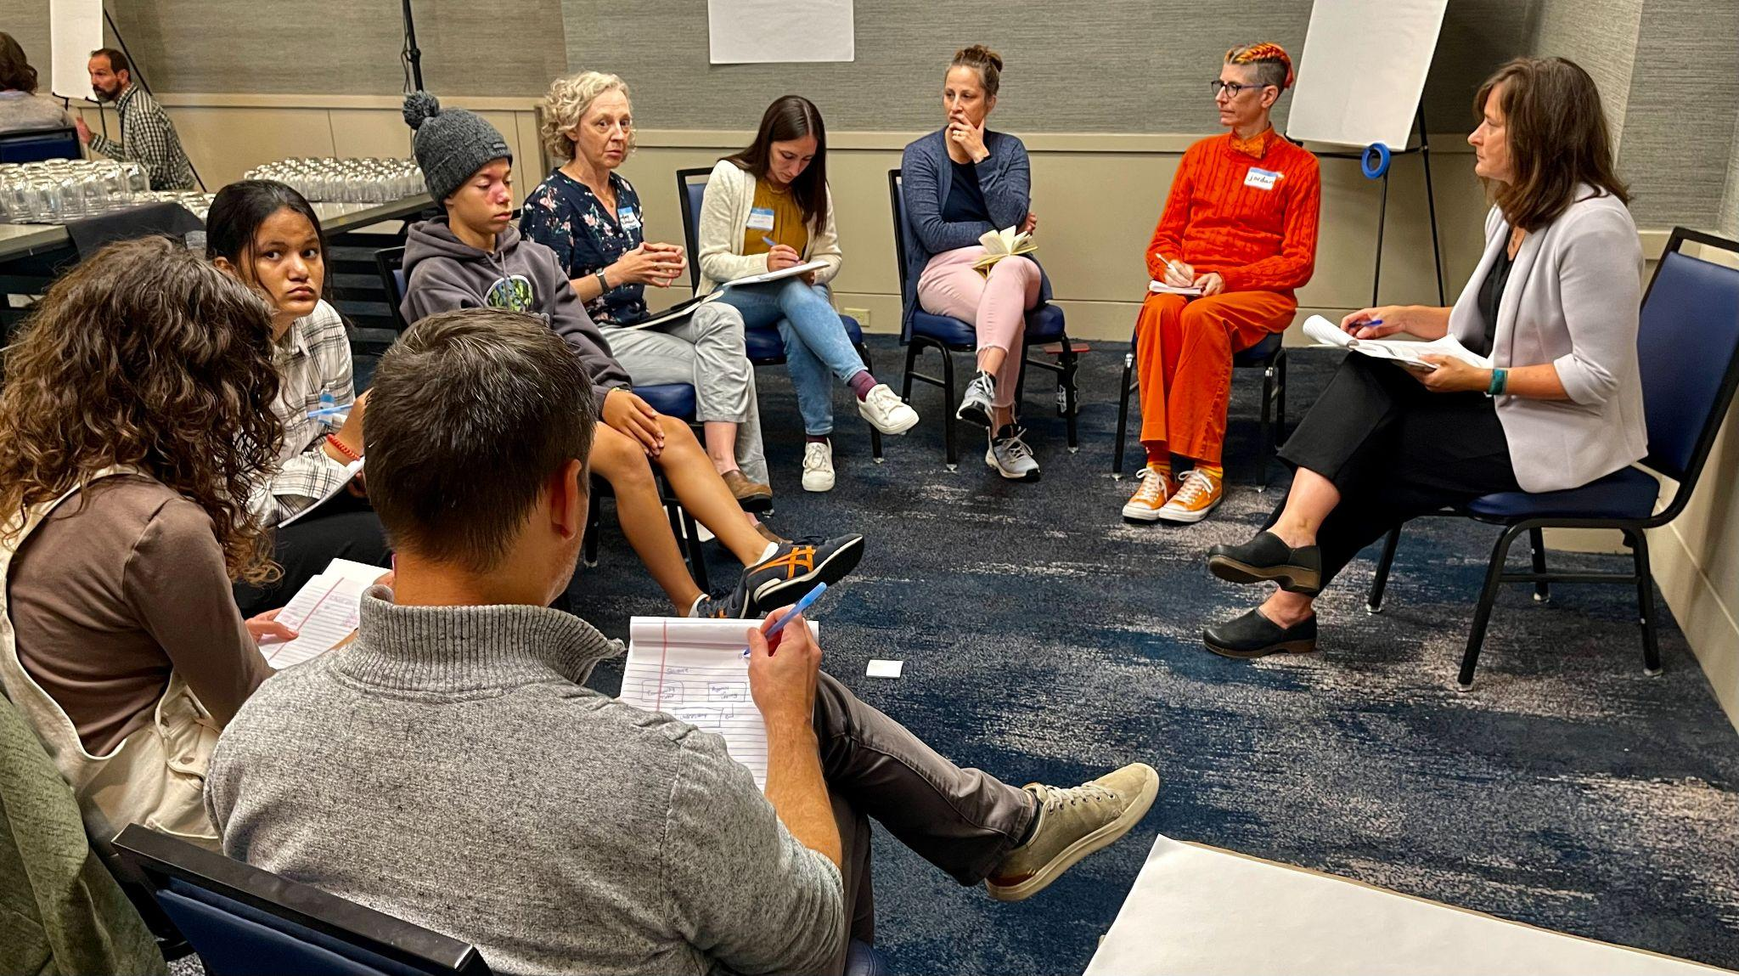
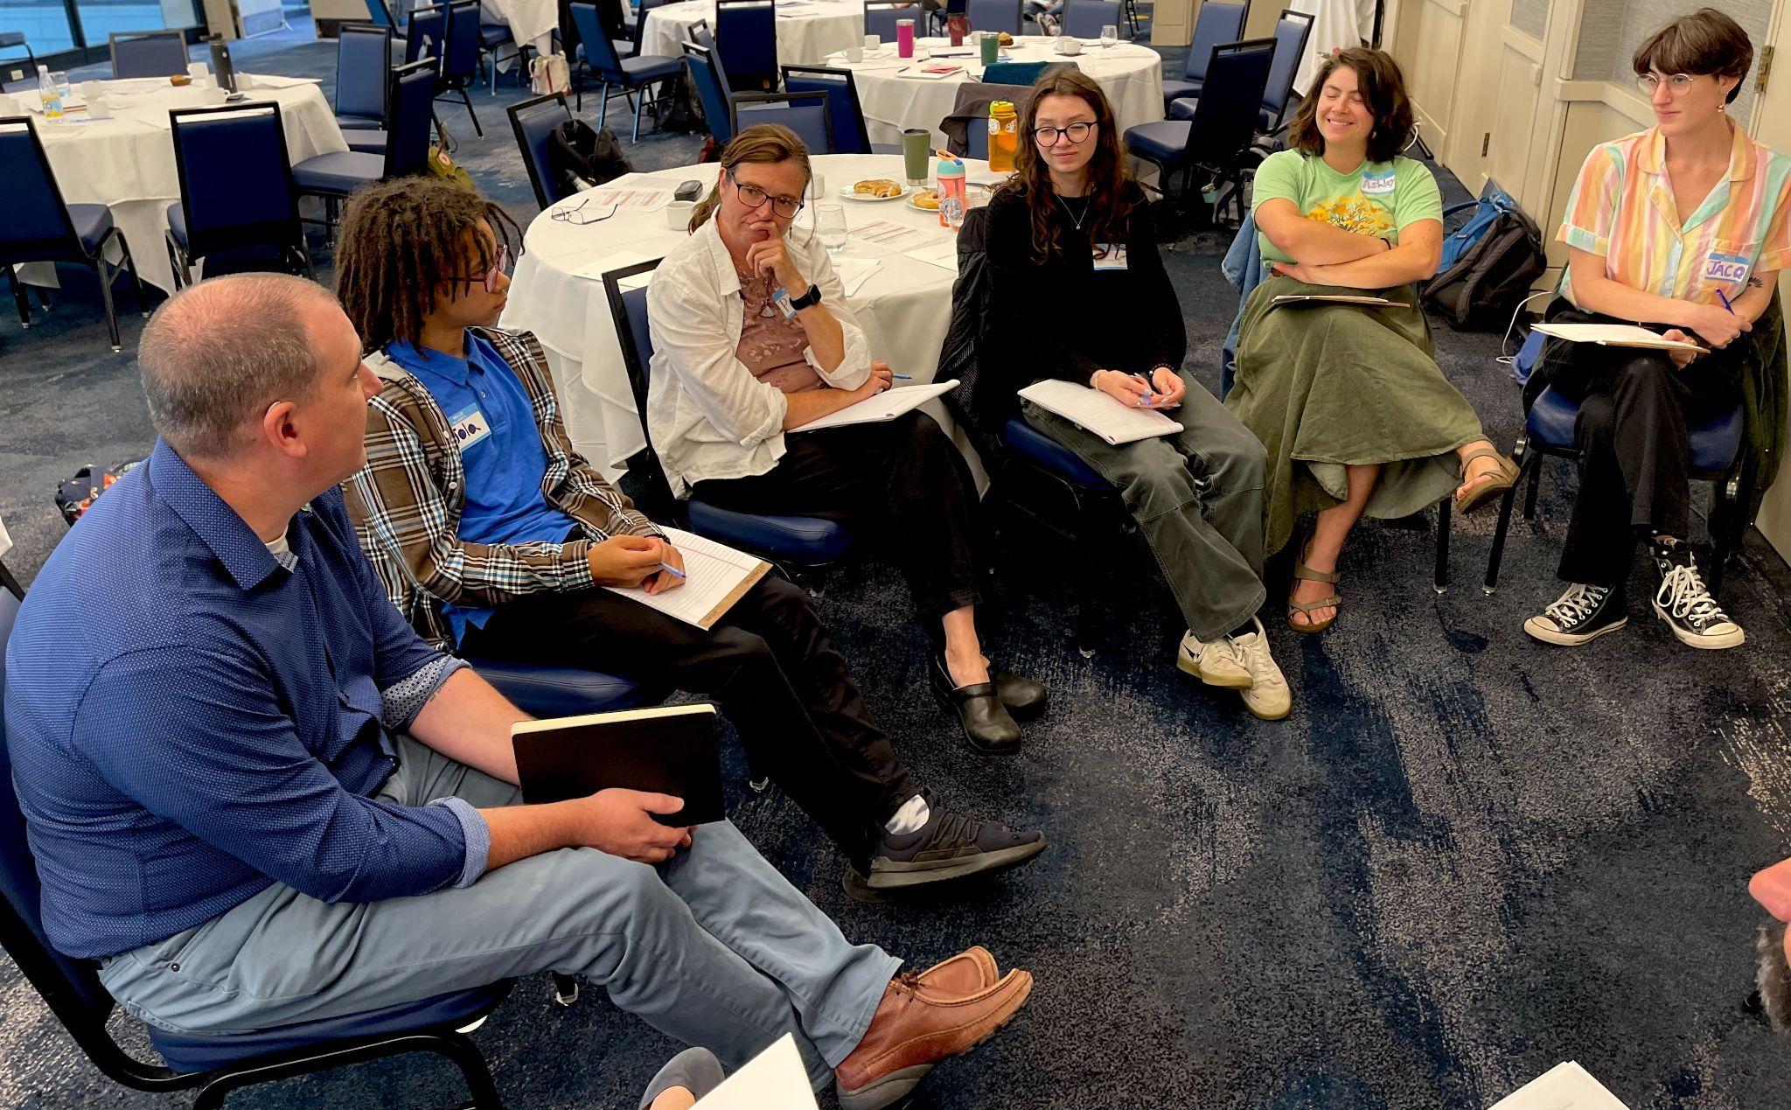

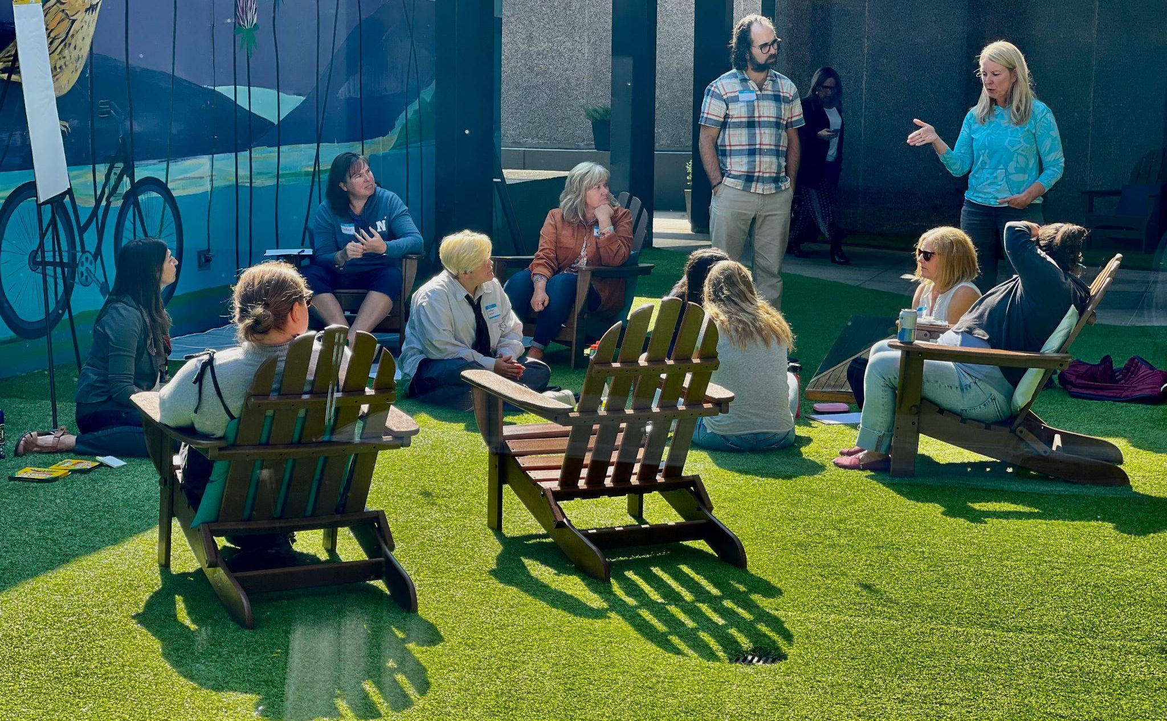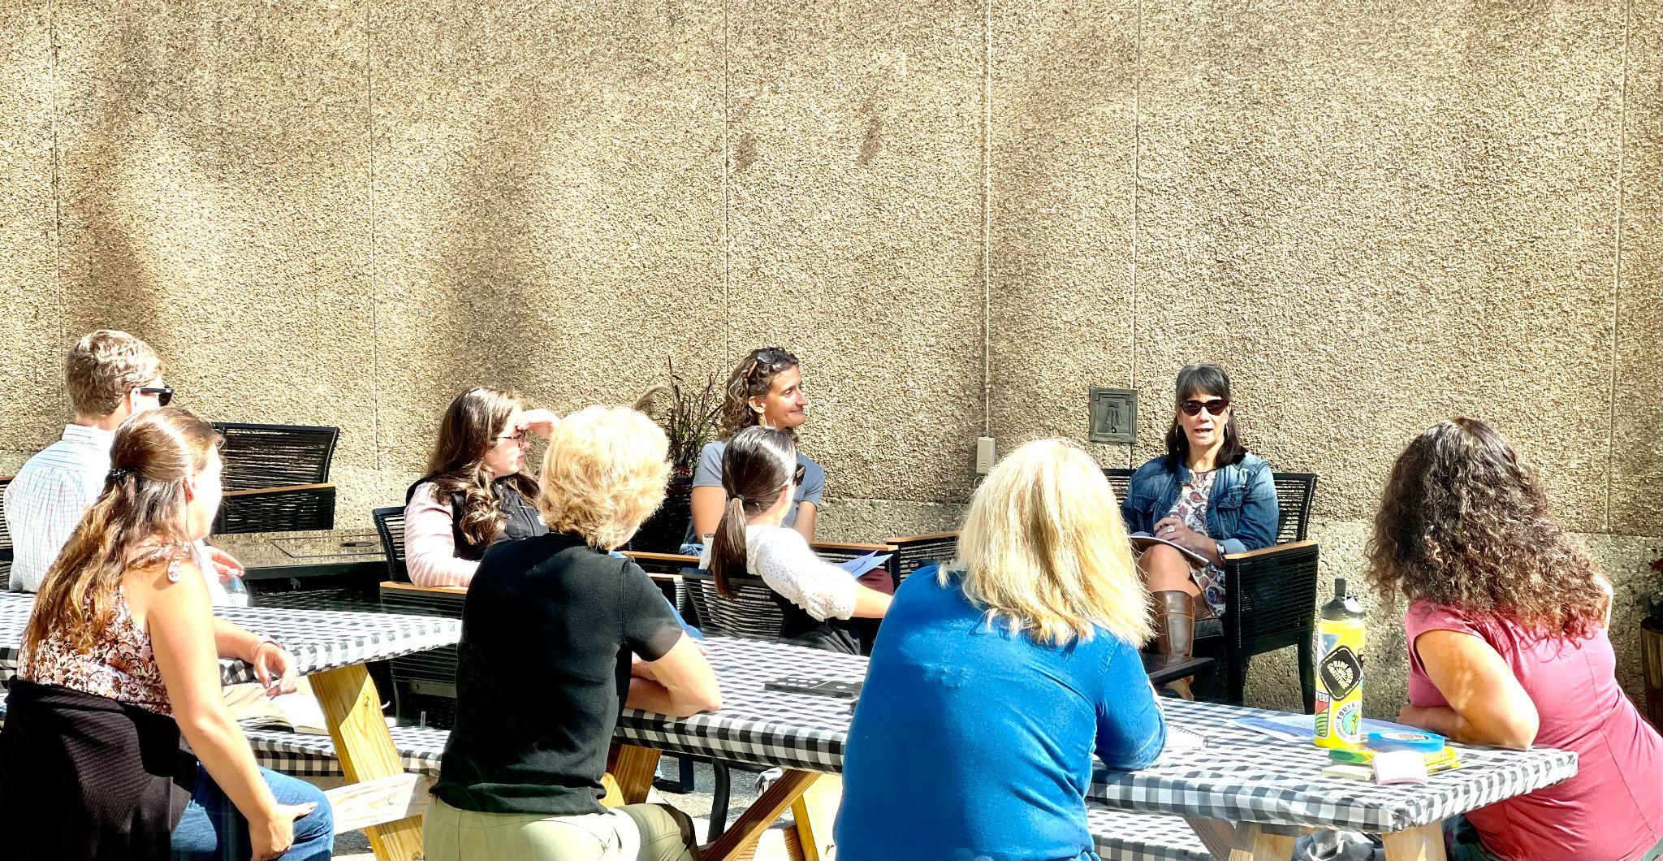
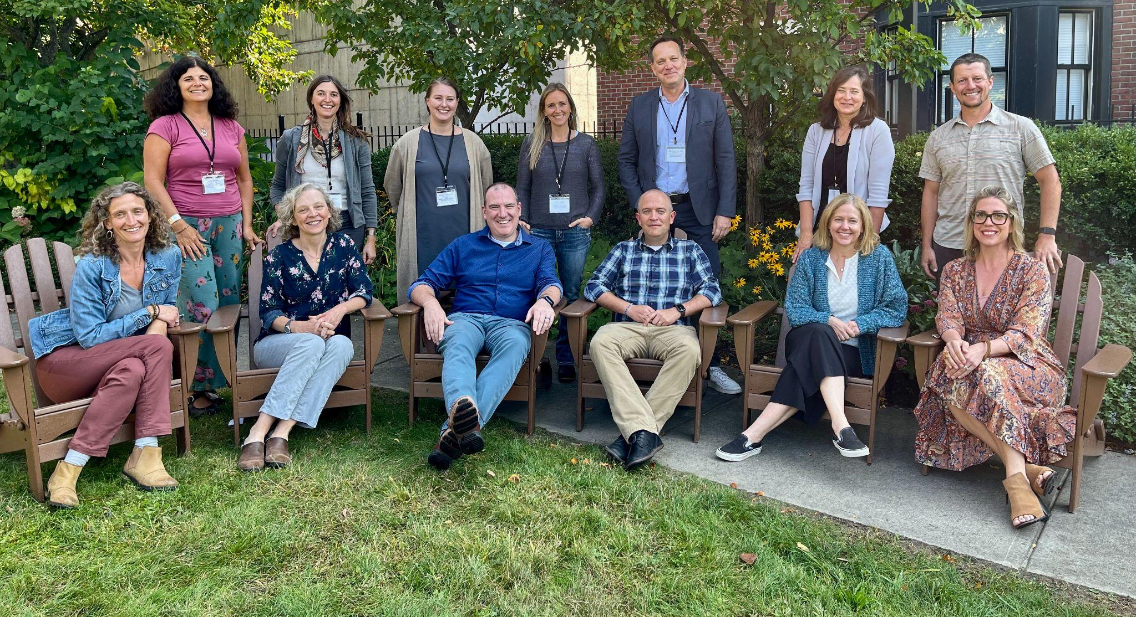
Veteran Rowland Fellows seen here standing behind our 2023 Fellows at the Shared Leadership Retreat (back row, from left to right) Janis Boulbol (RF21), Kat Robbins (RF21), Emily Therrien (RF19), Lori Lisai (RF15), Mike Martin (RF09), Jeanie Phillips (RF14) & Luke Foley (RF19) (front row, from left to right) Jessica Kessler (RF23), Lindsay McQueen (RF23), Chris Sheehan (RF23), Adam Murray (RF23), Elizabeth Placencia (RF23) & Carrie Gilman (RF23).

Gratitude
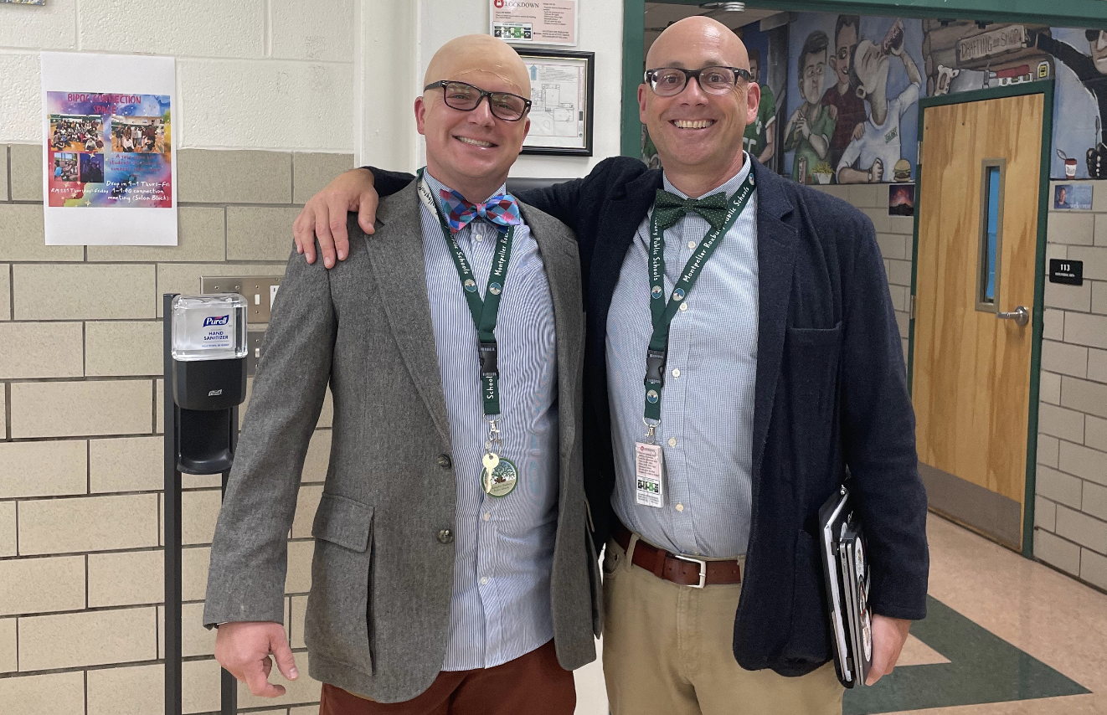
Sam Bromley (RF22), seen here with Montpelier High School Principal Jason Gingold, is grateful to be working with a school leader who really “gets him” for some reason.

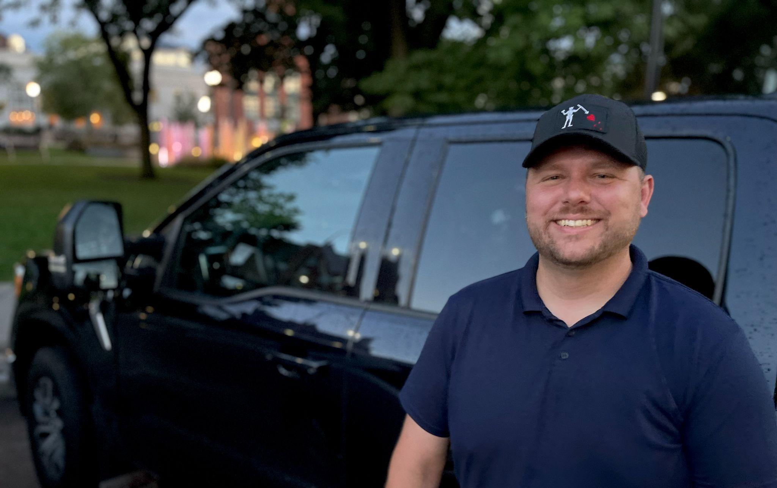
Devon Karpak (RF22) is grateful to be a Rowland Fellow. He is also grateful for his new truck, new house, and upcoming wedding!

Celebrations

Congratulations to Emily Gilmore (RF17) for her recent article, Time, Clarity, and Relationships: The Keys to Meaningful Habits of Work, which was featured on the Great Schools Partnership website as a blog post last month.

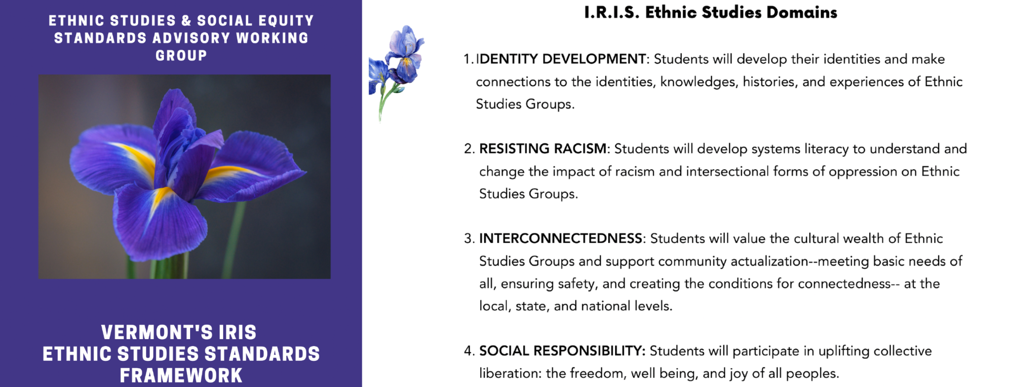
Act 1 of 2019 created a diverse statewide working group to 1) “review standards for student performance adopted by the State Board of Education”, and 2) “recommend to the State Board updates and additional standards to recognize fully the history, contributions, and perspectives of ethnic groups and social groups.” Both of these charges have now been completed. Act 1 Working Group revisions to Vermont’s Educational Quality Standards were adopted by the State Board of Education earlier this year. Most recently, the Act 1 Working Group worked with national consultants to develop Vermont’s IRIS Ethnic Studies Framework, which has been submitted to the State Board for adoption. Rowland Fellows Mike McRaith (RF13) and Mike Martin (RF09) both served on the Act 1 Working Group, and Jess DeCarolis (RF09) provided expert guidance to the group’s work in her role as an AOE Division Director.

Courtesy Postings
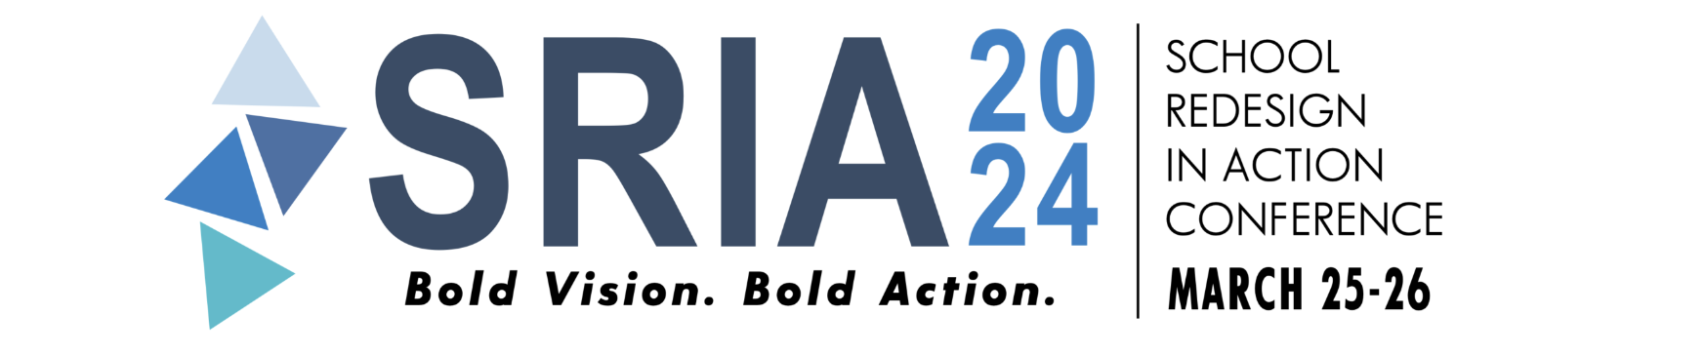
The annual conference School Reform In Action (SRIA) will take place March 25-26, 2024 in Providence, Rhode Island with keynote speaker Dr. Jamila Dugan. The deadline for workshop proposals is November 15th. Click here for more information.

