 | Letter to Fellows  October 2021
Dear Rowland Fellows,

I hope this message finds you and your loved ones doing well.

In this moment of working and living with COVID, I’m so grateful for the dedicated teachers and school leaders that we have in Vermont public schools. In a moment when controversy is the norm, when the Governor’s press conferences feel like the movie Groundhog Day, and when we’re all feeling COVID fatigue, it’s easy to forget that we are fighting for democratic values in our schools and communities. As Rowland Fellows, and as educators in general, we are fighting the good fight right now. We are doing more than surviving—we are working to change systems so that our schools and communities are more equitable, inclusive, and successful. The pandemic has taught us that we really are all in this together, however, we may not clearly see the results of our collective action and hard work until we’re on the other side.

We need inspiration and connection more than ever in this moment. That’s why I’m so glad to see our registration filling up for the 10th Annual Rowland Conference at UVM on October 27th. Carla Shalaby’s message of love and liberation couldn’t come at a better time. And her idea that our Troublemakers are, in fact, our greatest asset because they show us where our system is failing is original, unsettling, and powerful. If you haven’t done so already, make sure you register here a team from your school or organization, and feel free to contact me directly with any questions.

Chuck & I have been working closely with UVM event services to ensure we have a safe and successful conference, despite the challenges of COVID. UVM’s campus-wide masking policy will be in effect and all attendees will provide proof of vaccination in order to attend. Even with masks and elbow bumps (instead of hugs), the conference workshops, conversations, and keynote are going to help us recharge our batteries and get inspiration from each other just when we need it most.

Along the same lines, please make sure to mark your calendar for the annual All Fellows Retreat & Social October 26th, the day before the Conference. We will convene at the Hilton Hotel’s Green Mountain Ballroom at 1:00pm and welcome Chuck to join us for some gratitude and love at 3:30pm with help from Brian Boyes (RF14). Shortly after 4:00 pm, we’ll head over to the Farmhouse Tap & Grill for our traditional social, this year outdoors in their beer garden. We’ll send out a retreat agenda soon for the annual All Fellows Retreat, but our main goals together are to:
- connect across cohorts
- explore ideas for Rowland Encore Grants & Rowland Leadership Grants
- express our gratitude for Rowland Foundation Founder & Past Executive Director Chuck Scranton.
It’s going to be great to (safely) gather again. Feel free to contact me directly with any questions or suggestions!

Also, thanks to our new Associate for Social Media & Technology Lori Lisai (RF15), we’re proud to announce a Rowland Foundation Twitter Chat Series Monday nights at 8:00pm. Check out the hashtag #RowFnchat for inspiration as we gear up for the Annual Rowland Foundation Conference. Our Twitter Chat series began with a wonderful conversation with workshop presenter Alex Shevrin-Venet on Monday, Sept. 27th, about her amazing work, Equity-Centered Trauma Informed Education. If you missed it, feel free to hop on the "slow chat" and weigh in with your thoughts! This Monday Oct. 4th will feature Elijah Hawkes with a chat centered around his book, School for the Age of Upheaval: Classrooms That Get Personal, Get Political, and Get to Work. Please put it on your calendars and join us! Finally, on Oct. 18th, we will be chatting with Carla Shalaby, our keynote extraordinaire. Join us then to dive into Troublemakers. We look forward to these conversations as a new way of connecting and bringing together our community of incredible minds as we all seek to improve our education system. Come join the conversation!

See you soon,

Mike

P.S. Please send me your news! Each month, I’m sharing courtesy posts for courses & events, and also celebrating new jobs, family vacations, and other news from our extended Rowland Family of Fellows. So please email whatever you’d like to share to rowland.foundation@gmail.com

Rowland Foundation Upcoming Dates

Monday, October 4 (8:00-9:00) Twitter Chat with Elijah Hawkes #RowFnchat
Monday, October 18 (8:00-9:00) Twitter Chat with Carla Shalaby #RowFnchat
Tuesday, October 26 (1:00-4:00) All Fellows Retreat at the Hilton Burlington
Tuesday, October 26 (4:30-6:30) All Fellows Social at the Farmhouse Tap & Grill
Wednesday, October 27 (8:00-3:00) 10th Annual Rowland Conference at UVM

Rowland Foundation Updates

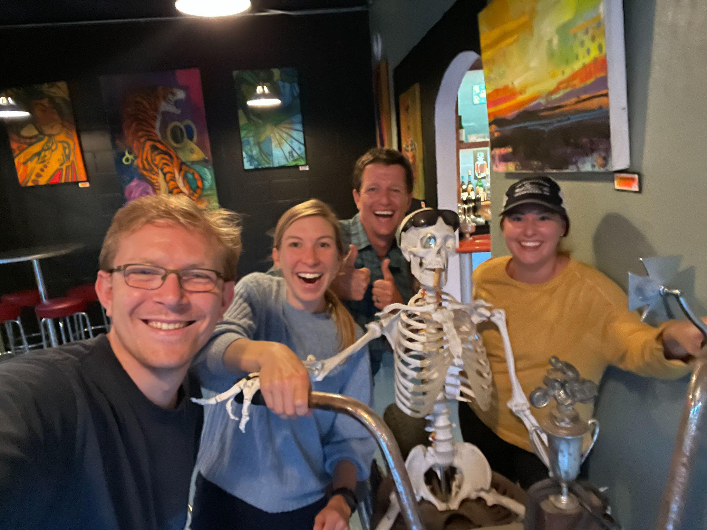
The 2019 Cohort of Fellows, Luke Dorfman (RF19), Rachel Cohen (RF19), Luke Foley (RF19), and Emily Therrien (RF19) met up in August for a back-to-school dinner together.

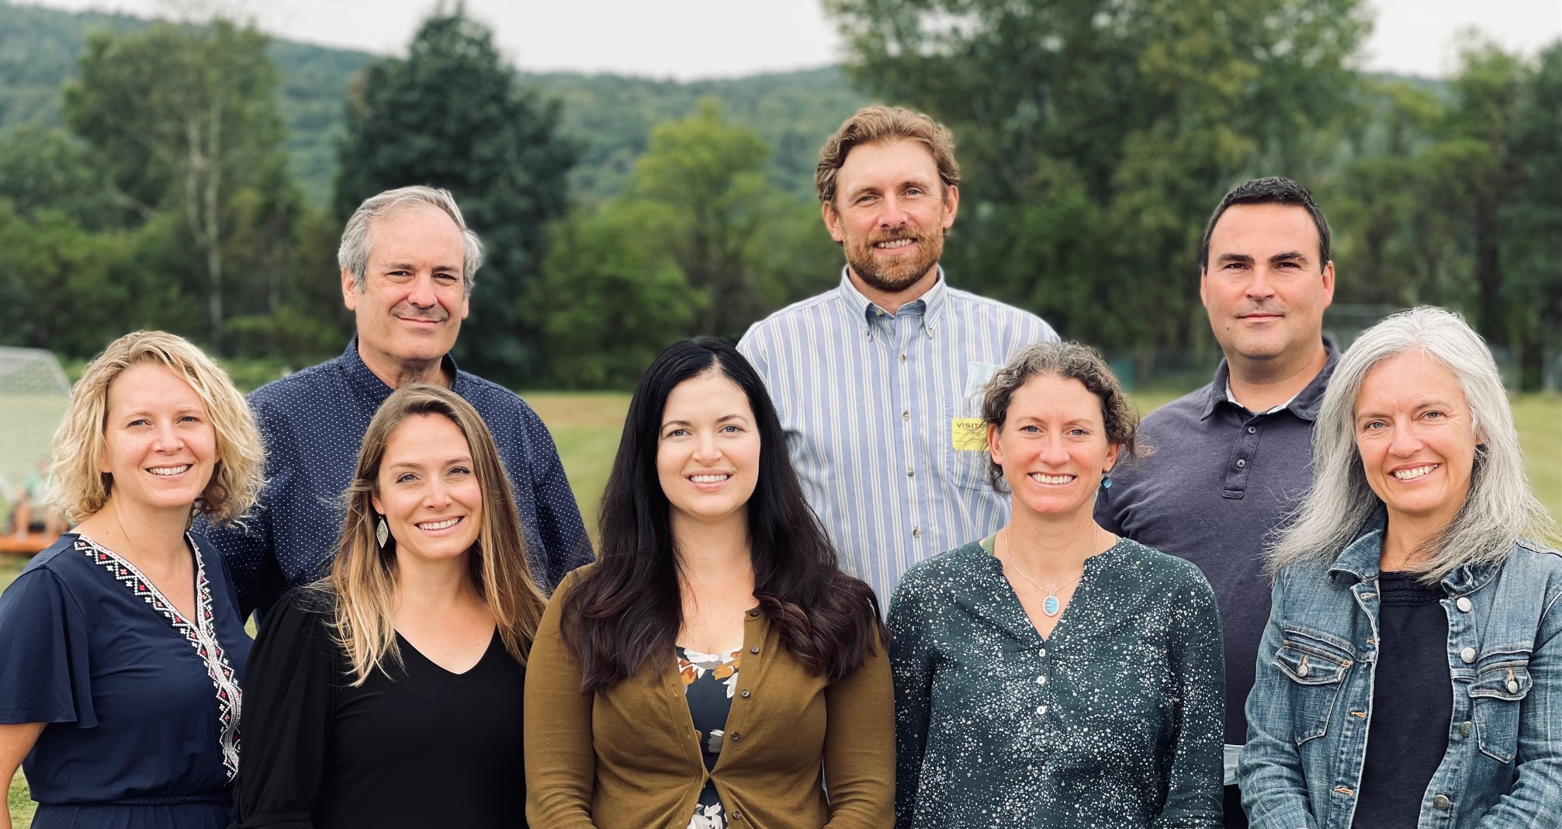
The 2020 Cohort of Rowland Fellows met at Mill River Union High School. Seen here (front to back, left to right) Maryann Carlson, Kristin Cimonetti, Allie Vega, Jillian Joyce, Stacy Shortle, Charlie MacFadyen, Ben Heintz & Tim O’Leary.

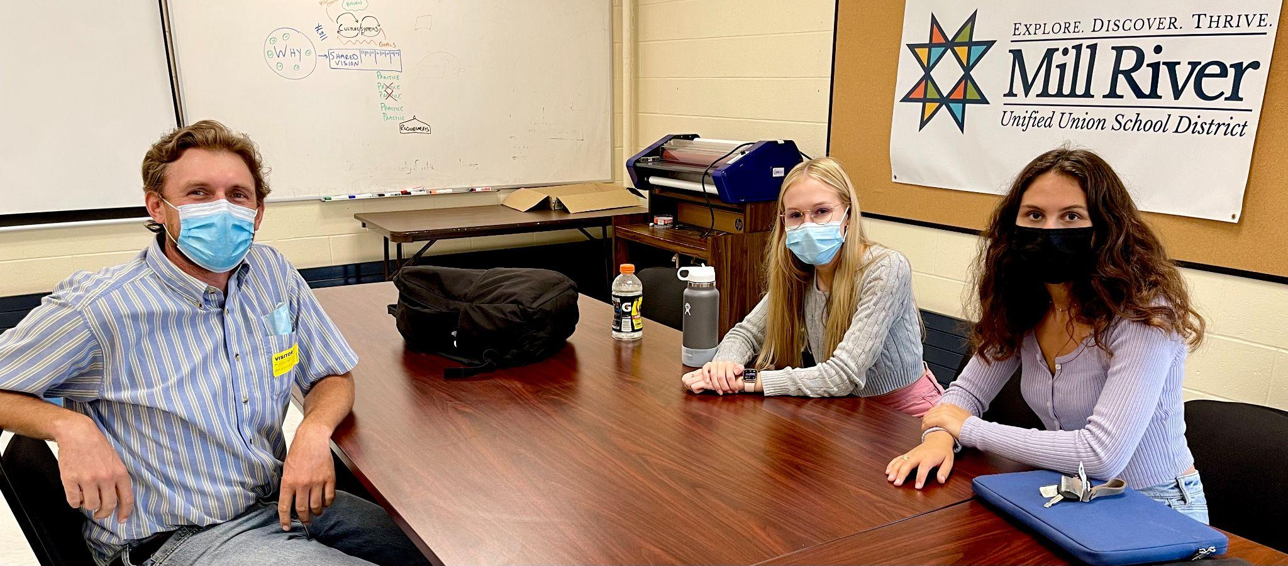
Ben Heintz (RF20) met in person for the first time with Annika Heintz (no relation) and Morgan Manley, both contributors to the Underground Workshop. You can read their article in VTdigger here.

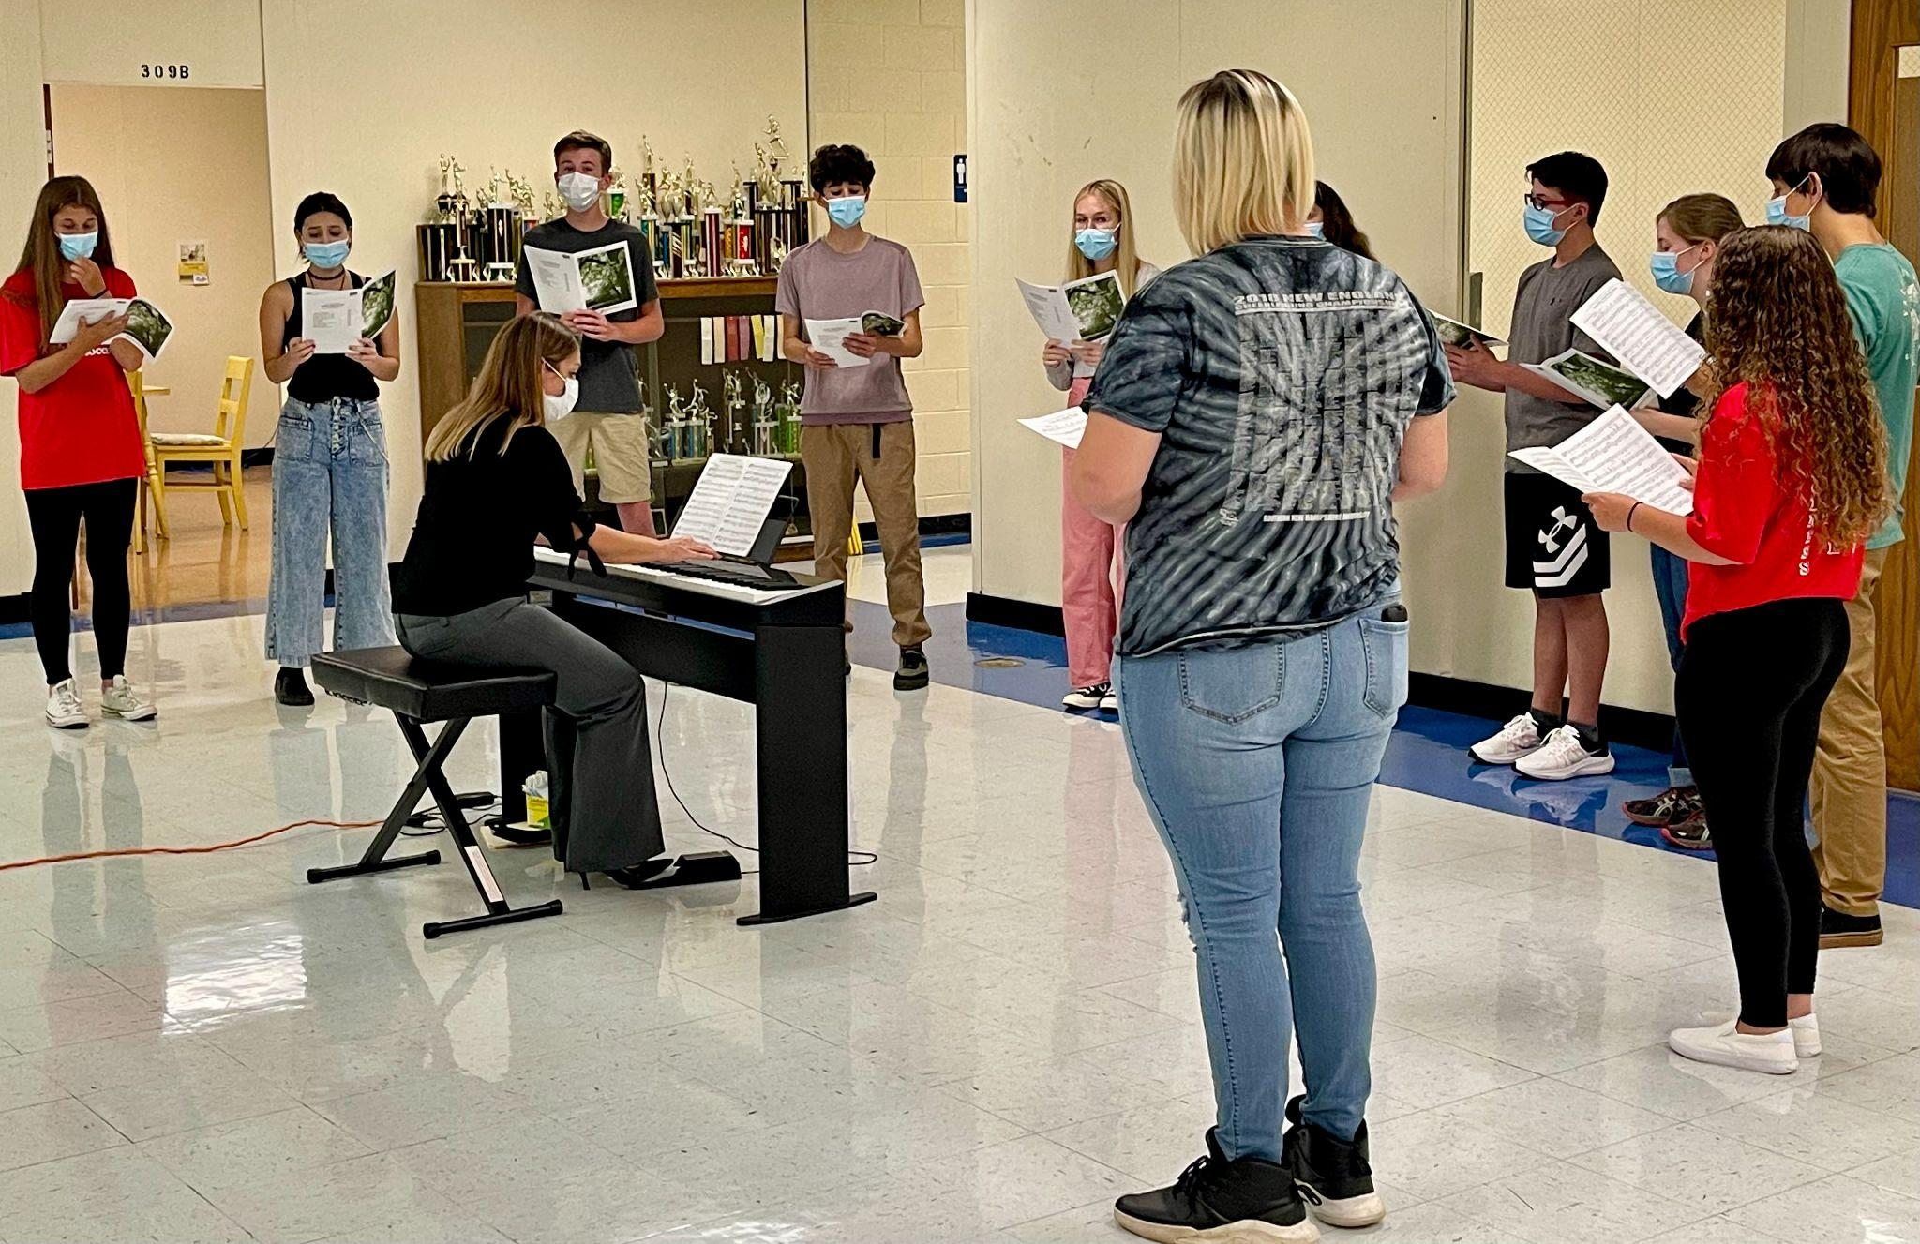
Kristin Cimonetti’s choral students gave an amazing vocal performance through their masks for the 2020 Rowland Fellows Cohort. They have continued to rehearse throughout the pandemic, even outdoors during the Vermont winter.

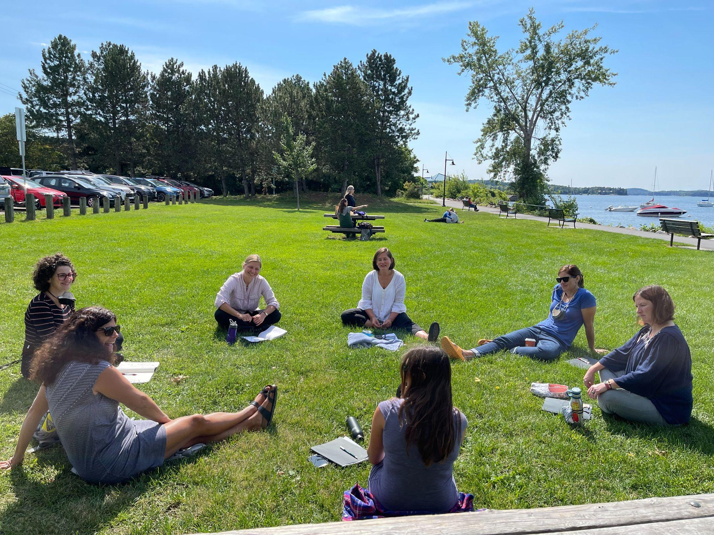
The 2021 Cohort of Rowland Fellows met in Burlington with Senior Associate Jeanie Phillips (RF14) facilitating for the day. Seen here (clockwise from lower left), Janis Boulbol, Nicole Awwad, Anja Pfeffer, Jeanie Phillips, Rachel Howes, Samantha Mundt, and Kathleen Robbins.

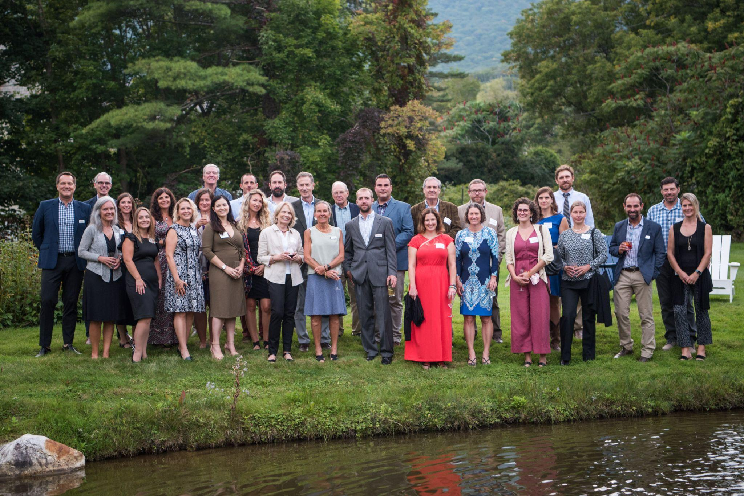
The Rowland Foundation celebrated its 2021 Fellows, 2020 Fellows, and Founder & past Executive Director Chuck Scranton at our first annual dinner since the pandemic at the Reluctant Panther in Manchester. As a special surprise, Arden & Chuck’s children joined the celebration with their partners. Seen here (front row, left to right) Stacy Shortle (RF20), Kristin Cimonetti (RF20), Marann Carlson (RF20), Allie Vega (RF20), Arden Scranton, Heidi Lynn, Carter Rawson, Samantha Mundt (RF21), Jillian Joyce (RF20), Nicole Awwad (RF21), Anja Pfeffer (RF21), Jean Berthiaume (RF09), Sarah Marcks (middle, left to right) Michael Martin (RF09), Kat Robbins (RF21), Janis Boulbol (RF21), Jeanie Phillips (RF14), Gretchen Scranton, Chuck Scranton, Dan Rowland, Tim O’Leary (RF20), Charlie MacFadyen (RF20), Brent Litterer (RF21), Rachel Howes (RF21), Dax Loniewski (back, left to right) Garon Smail, Jake Shepard, Trevor Bickford, Dave Scranton, Ben Heintz (RF20)

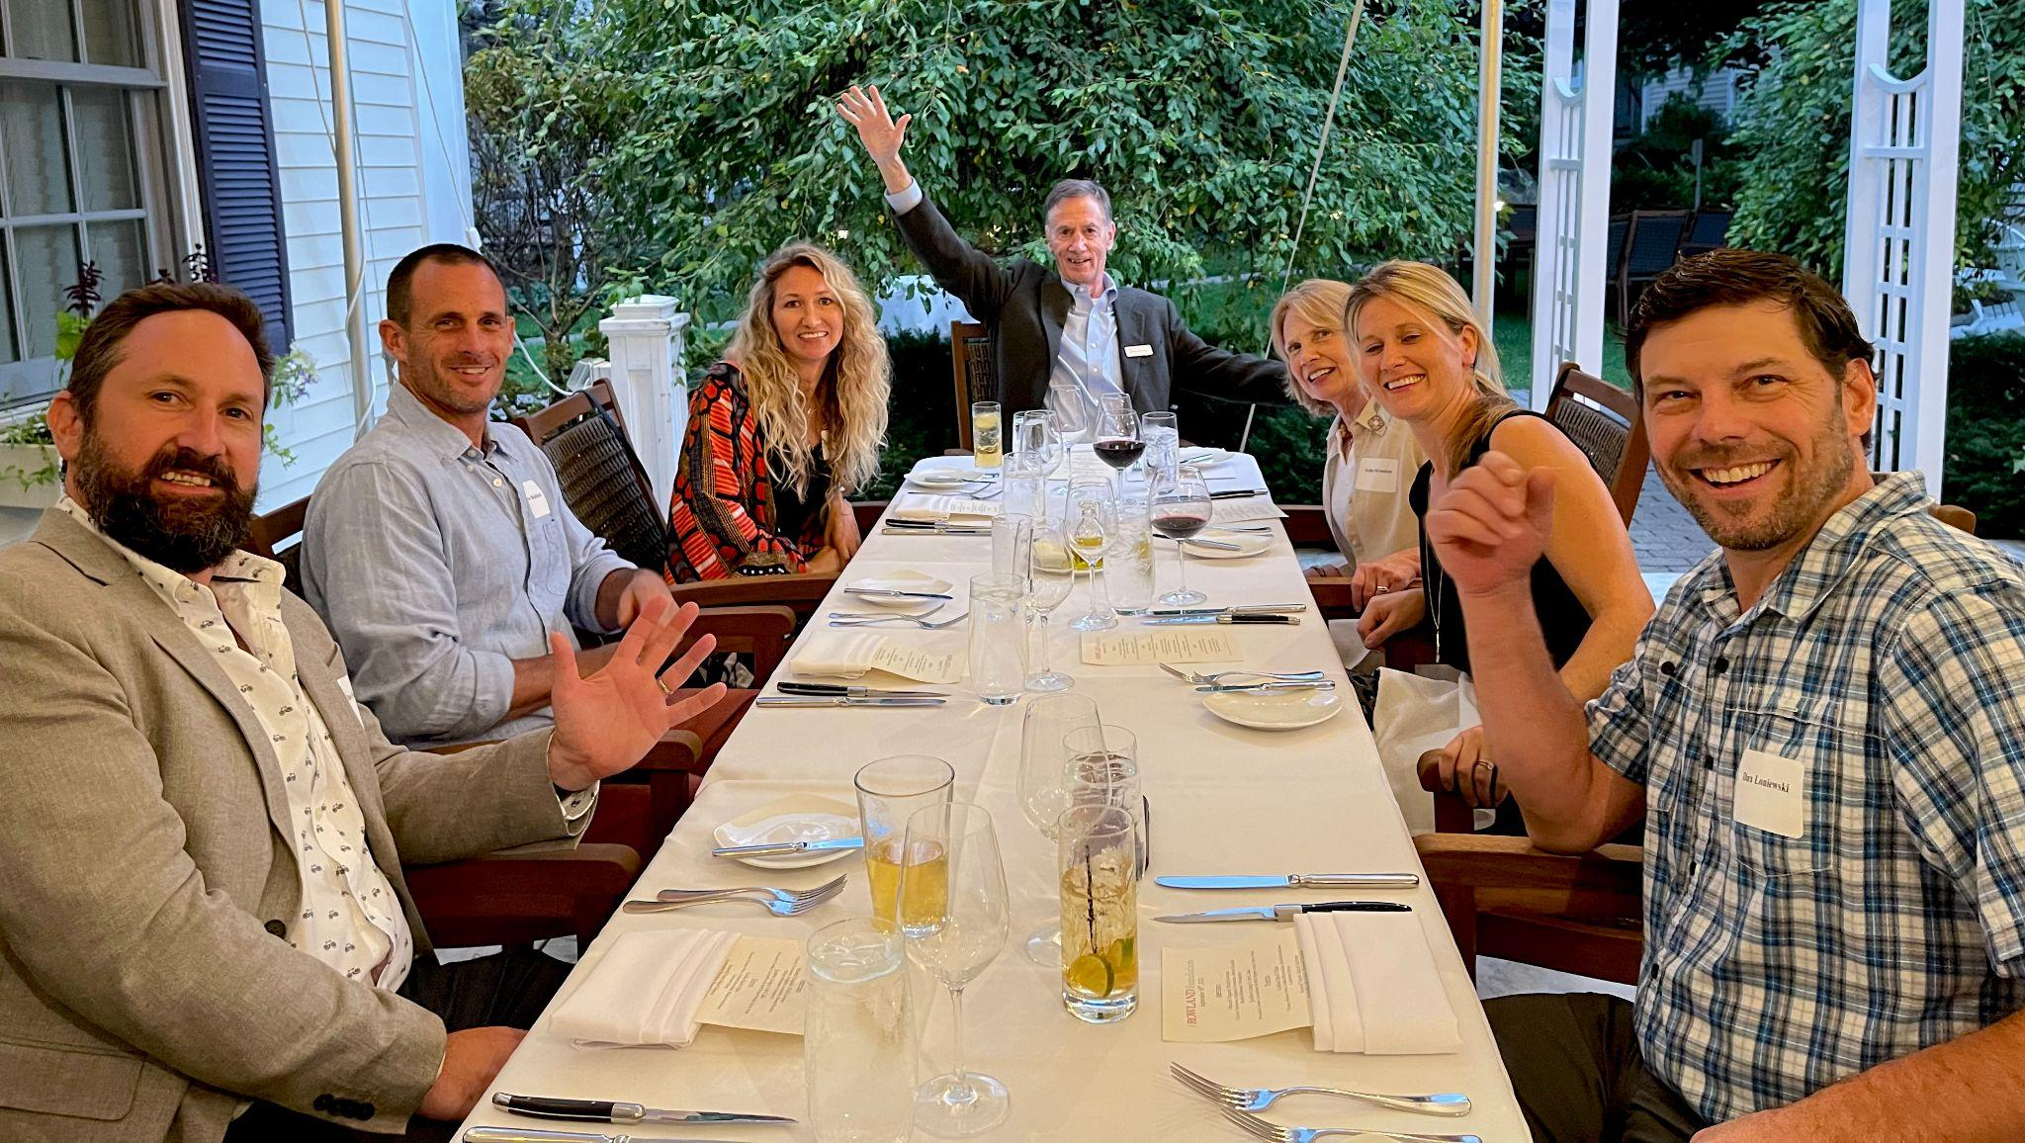
Rowland Foundation Founder & Past Executive Director Chuck Scranton seen here at the Annual Dinner at the Reluctant Panther with his family. (from left to right, Dave Scranton, Trevor Bickford, Gretchen Scranton, Chuck Scranton, Arden Scranton, Sarah Marcks Loniewski.

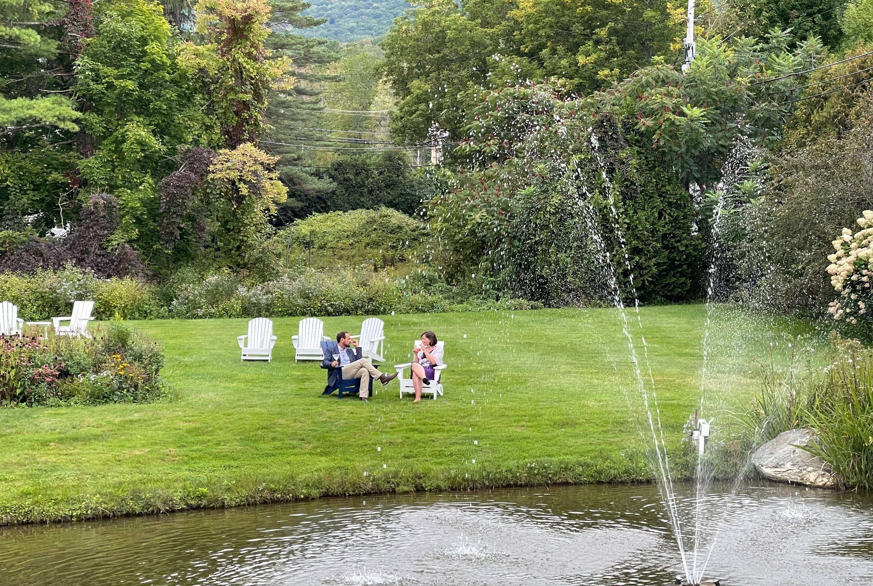
Senior Associates Jean Berthiaume (RF09) & Jeanie Phillips (RF14) at the Reluctant Panther

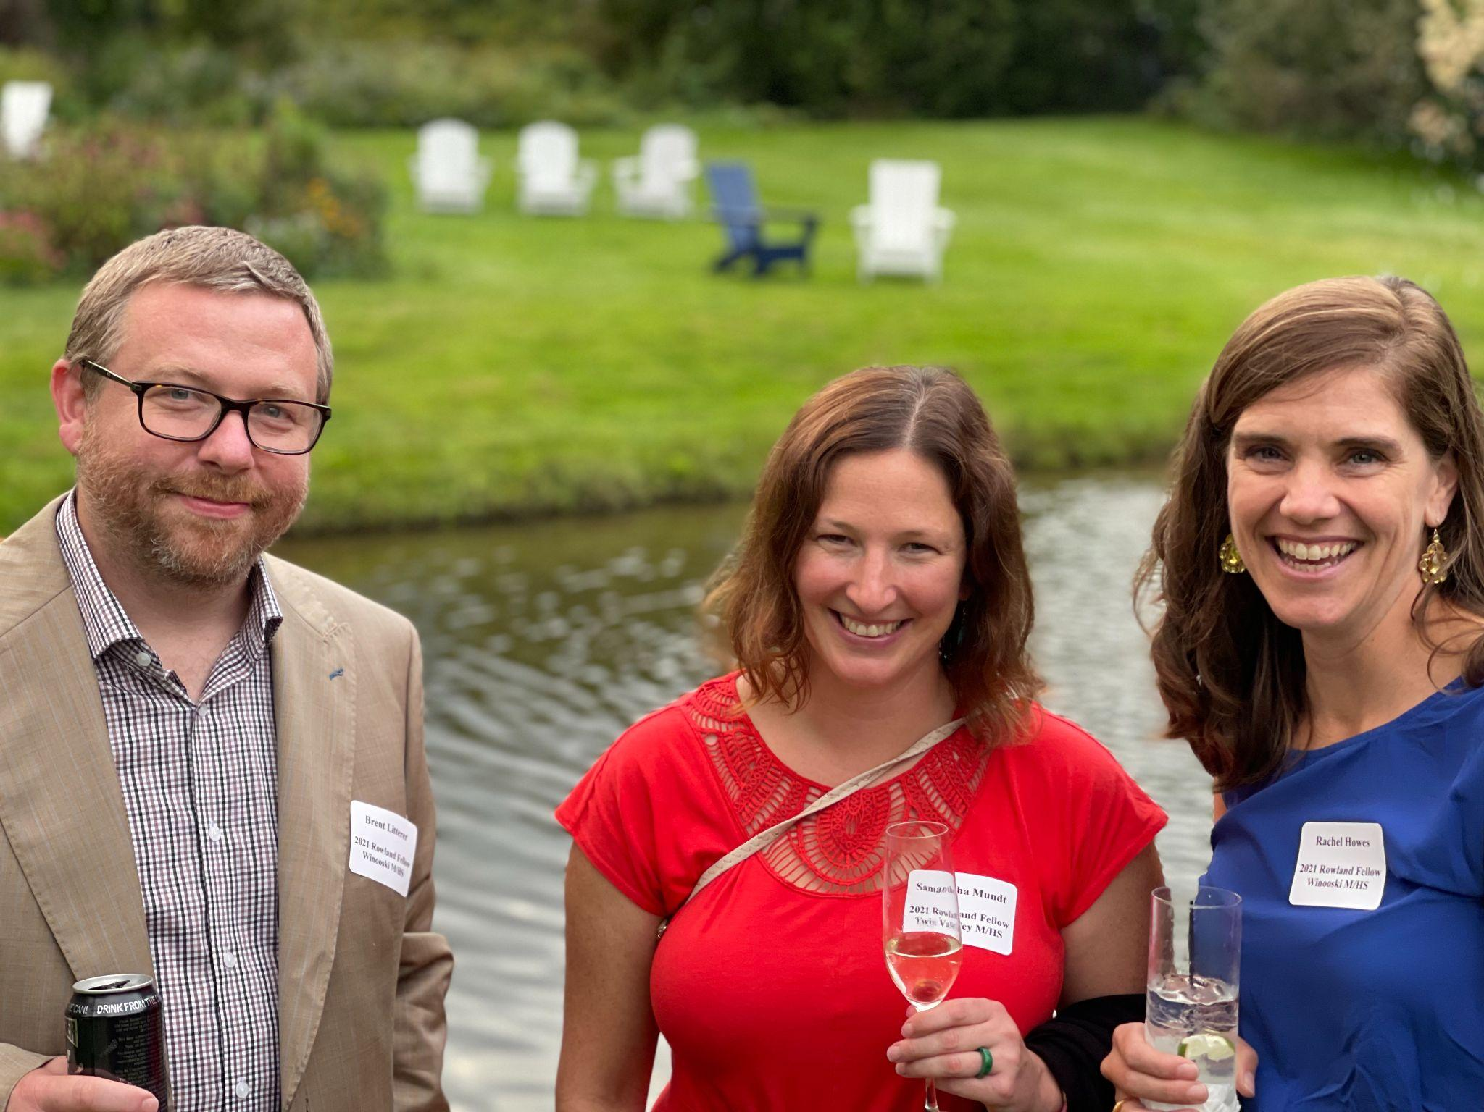
Brent Litterer (RF21), Samantha Mundt (RF21) & Rachel Howes (RF21) at the Annual Dinner.

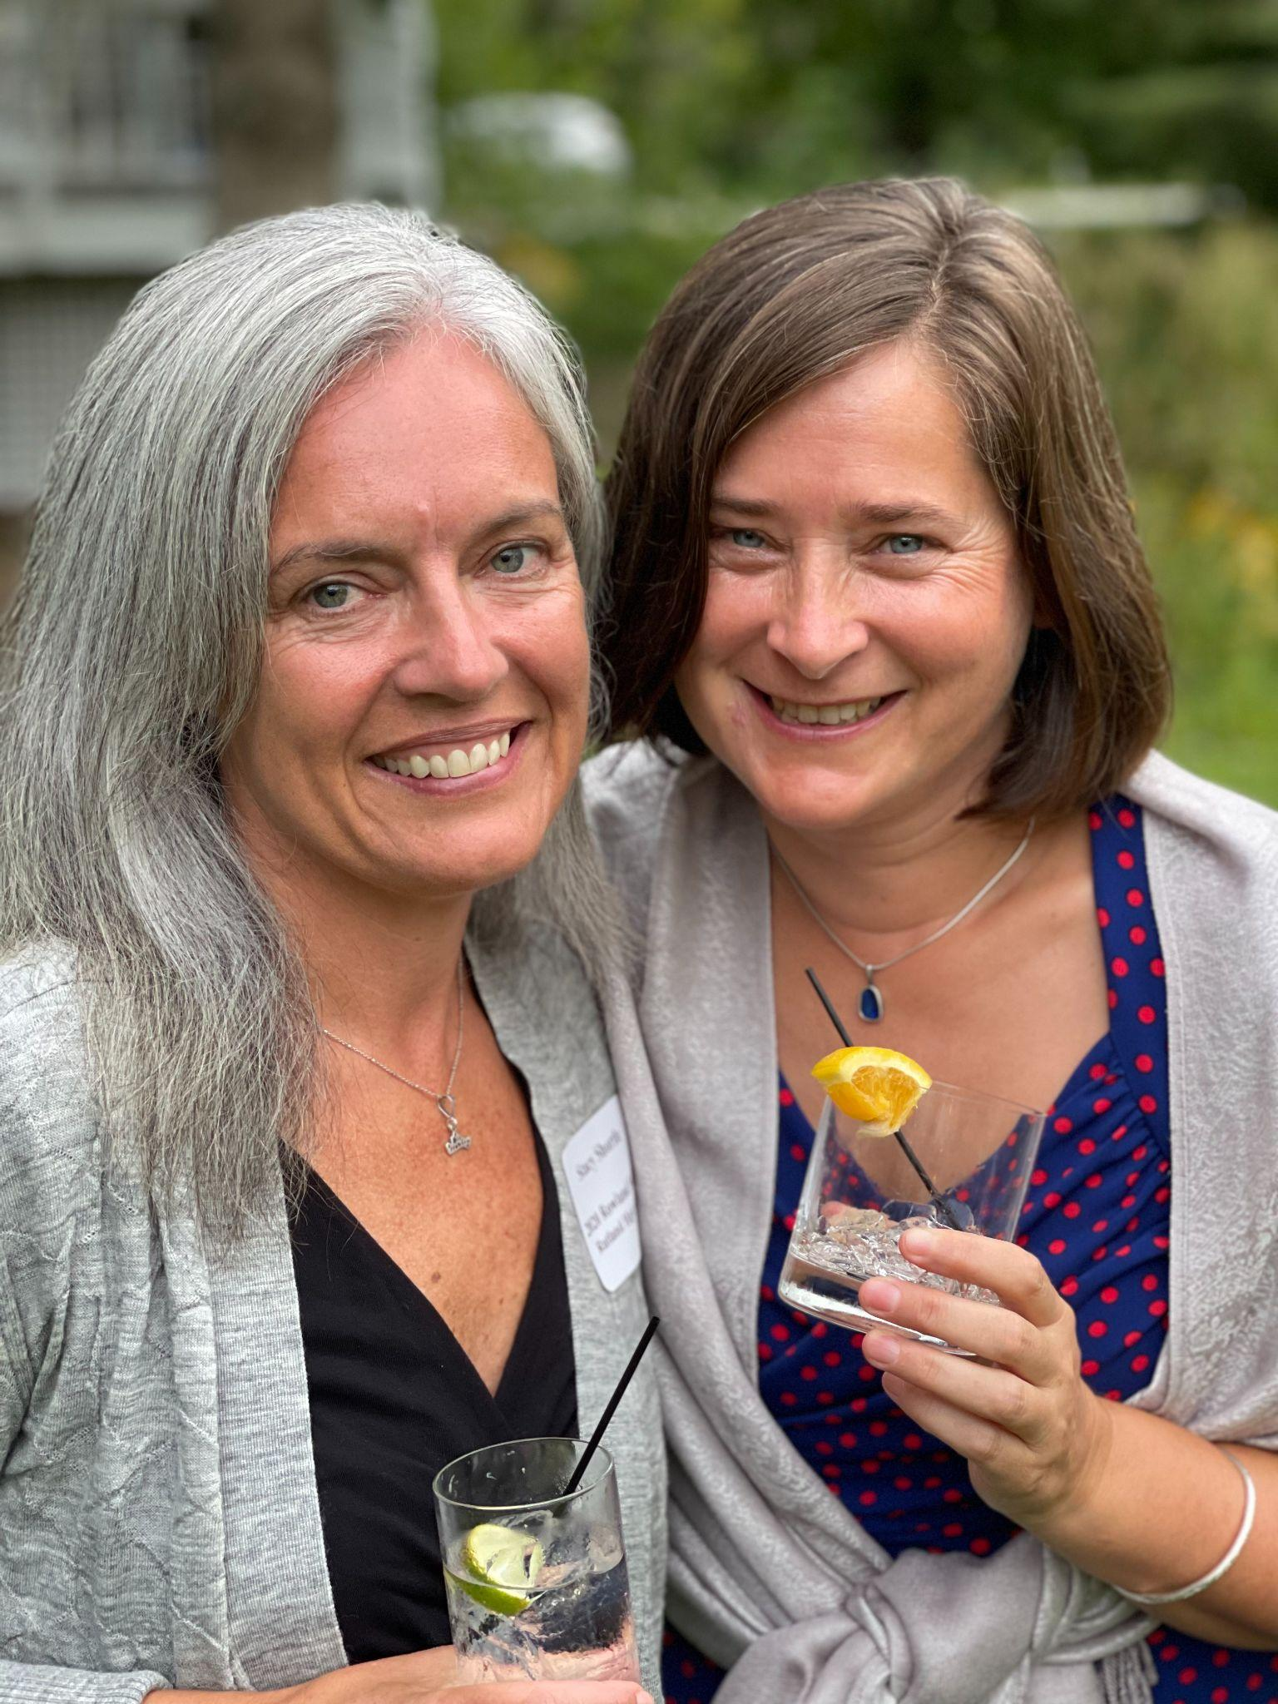
Stacy Shortle (RF21) & Jeanie Phillips (RF14) at the Annual Diner

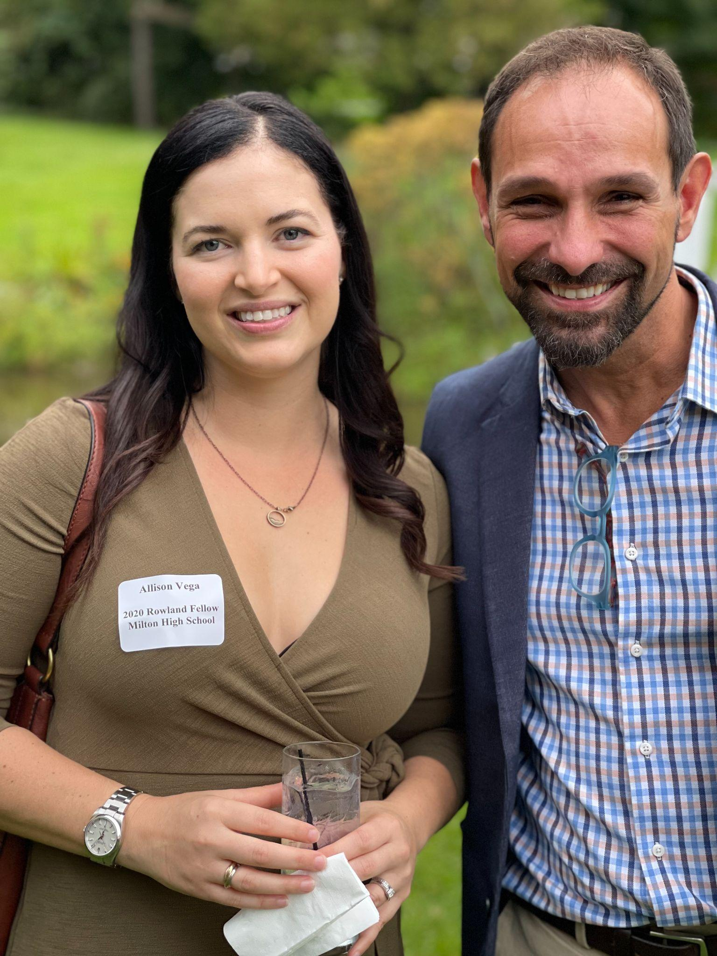
Allie Vega (RF21) & Jean Berthiaume (RF09) at the Annual Dinner
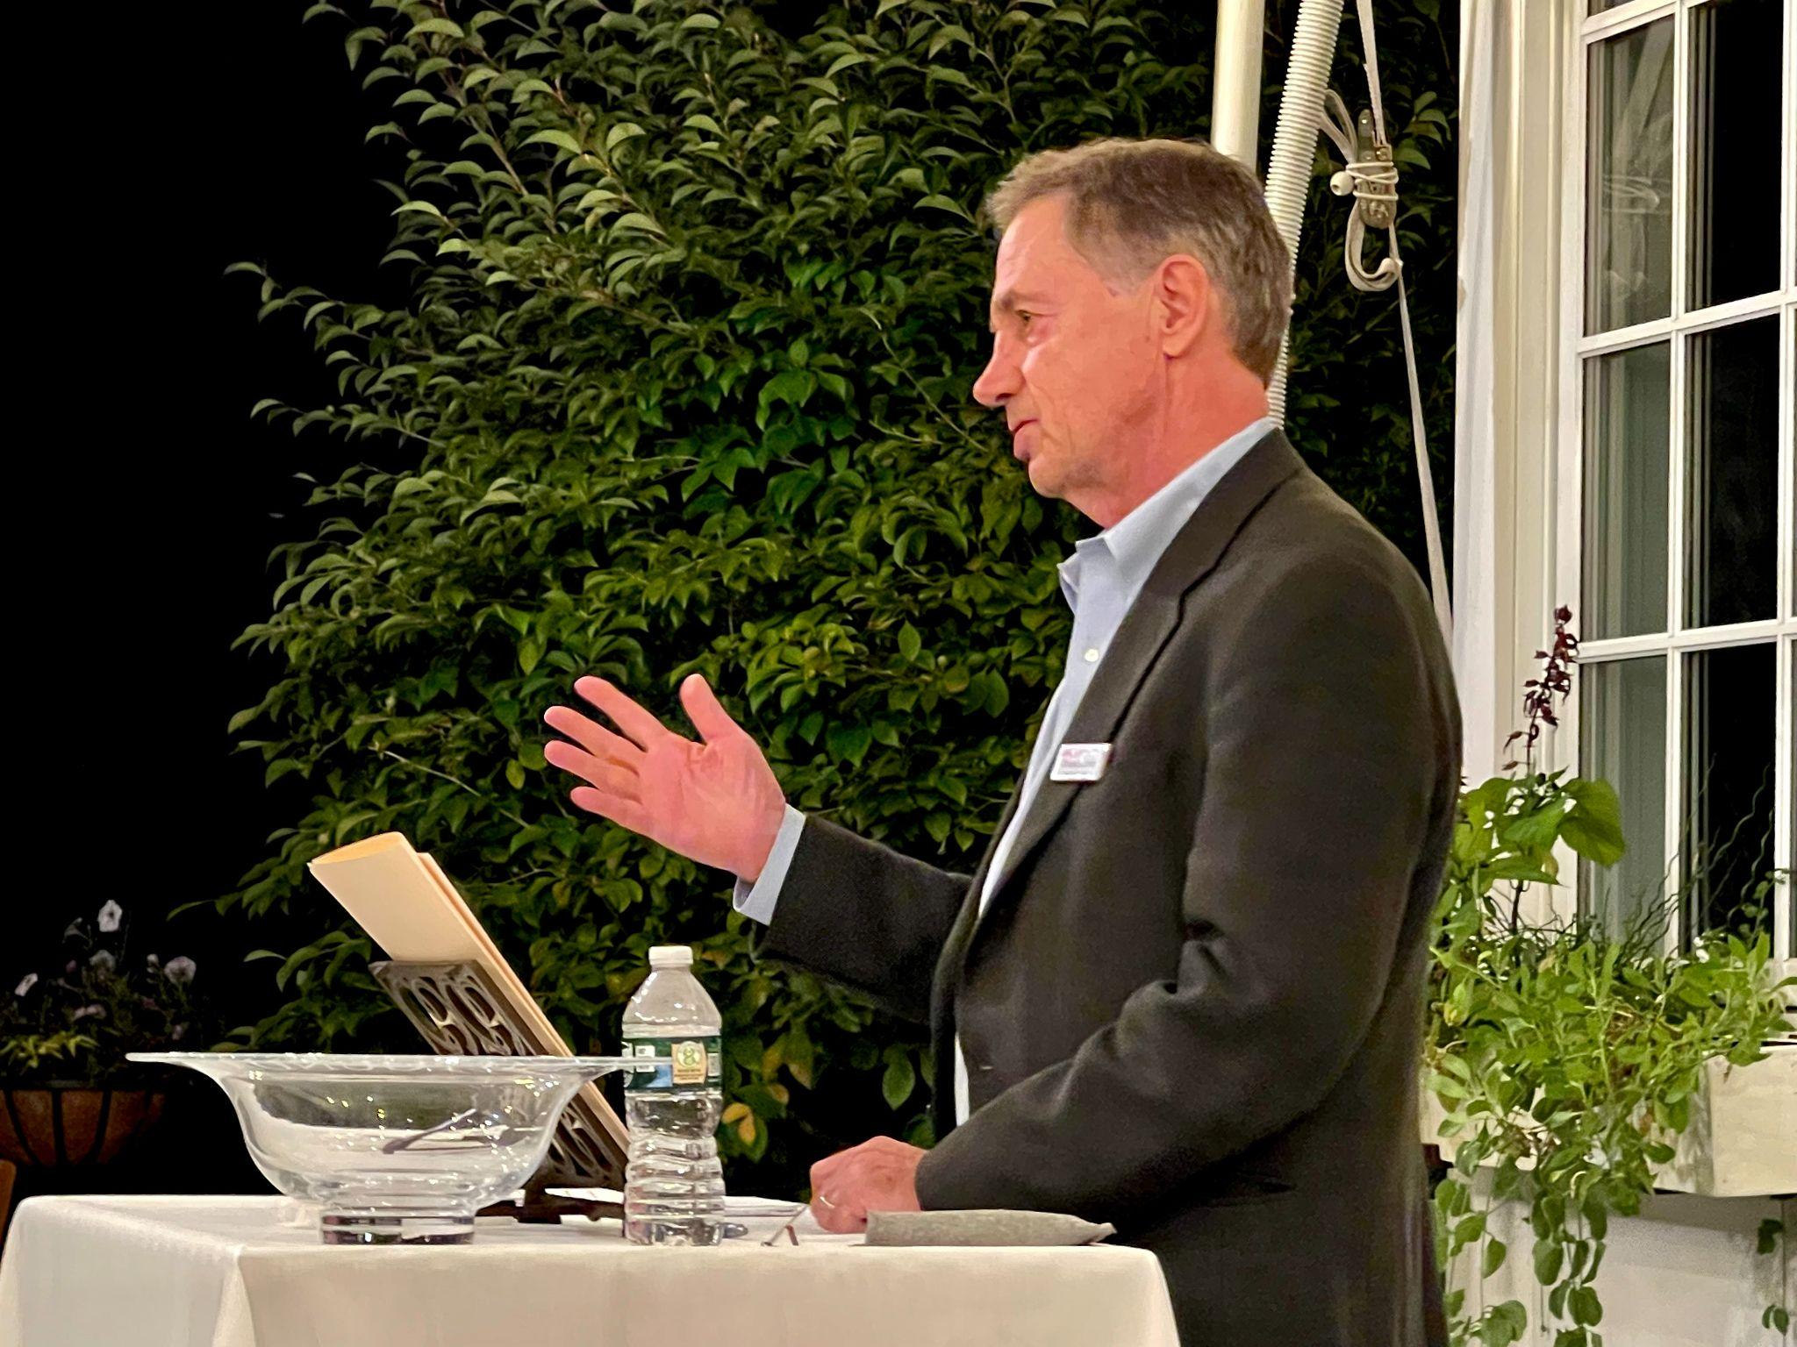
Chuck Scranton accepted recognition for his work on behalf of the Rowland Foundation for the past 13 years at the Annual Dinner.

Marge Malko, Executive Administrative Assistant for the Rowland Foundation for the past 13 years, officially retired from this role on July 1st. She was unable to attend the Annual Dinner, so attendees conveyed their gratitude for her many contributions in this video message. All Rowland Fellows are welcome to send Marge messages of gratitude at her personal email: margemalko@gmail.com

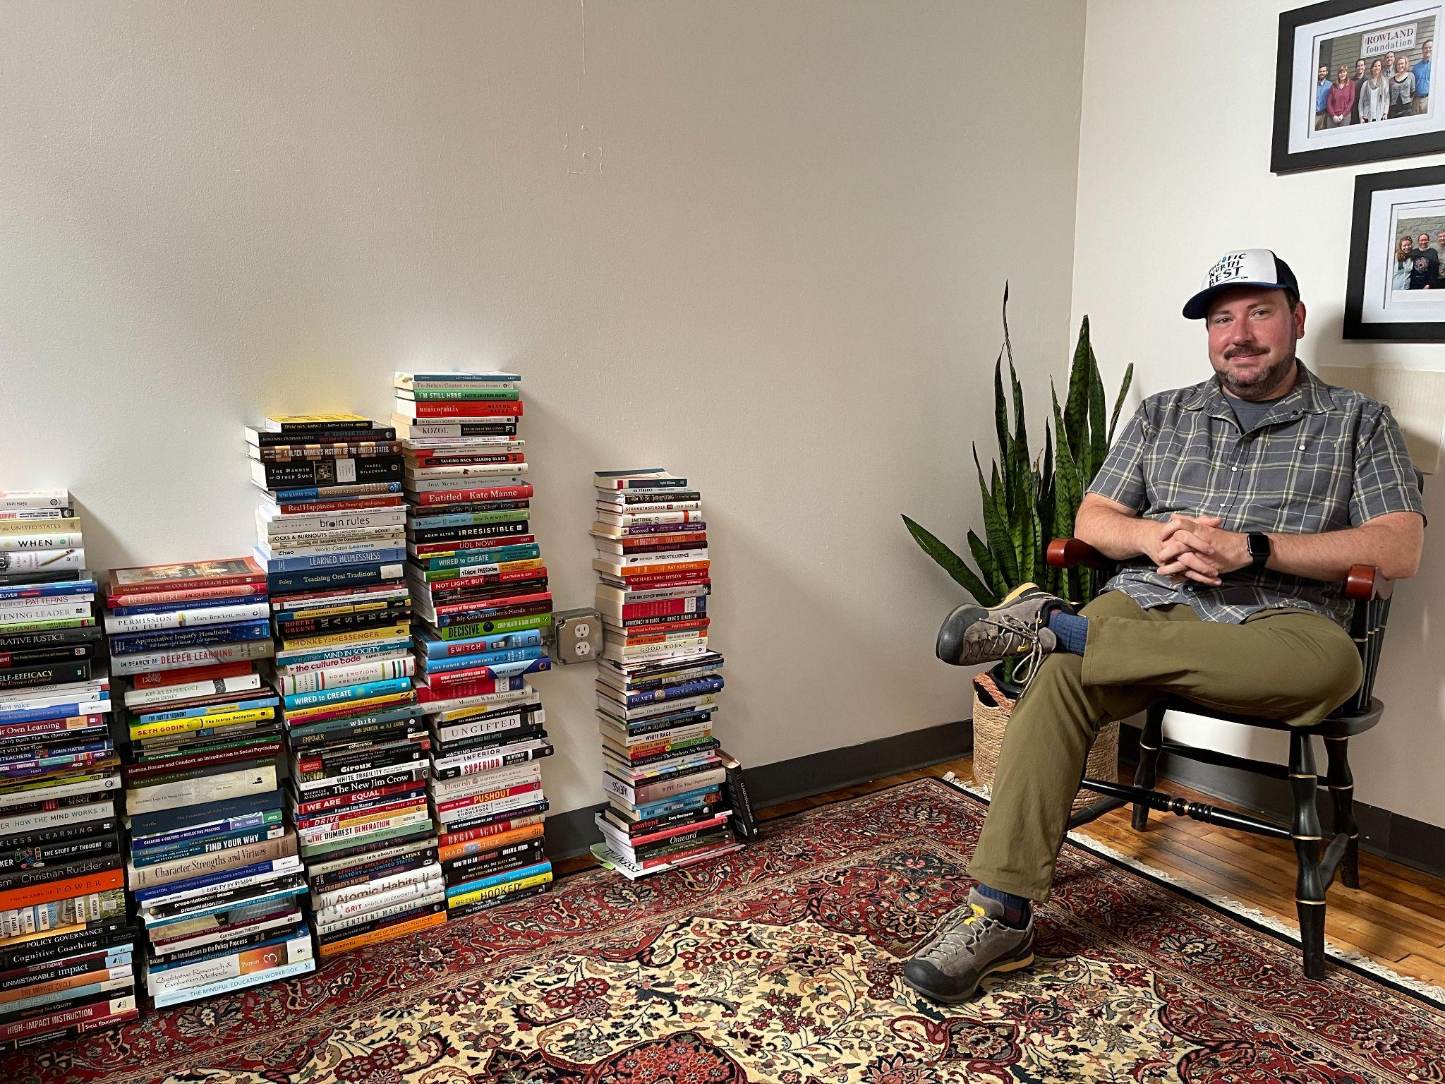
Andrew Jones (RF15) met at the new Rowland Offices in Burlington with Mike Martin (RF09) to discuss Universal Design for Learning (UDL) and professional learning.

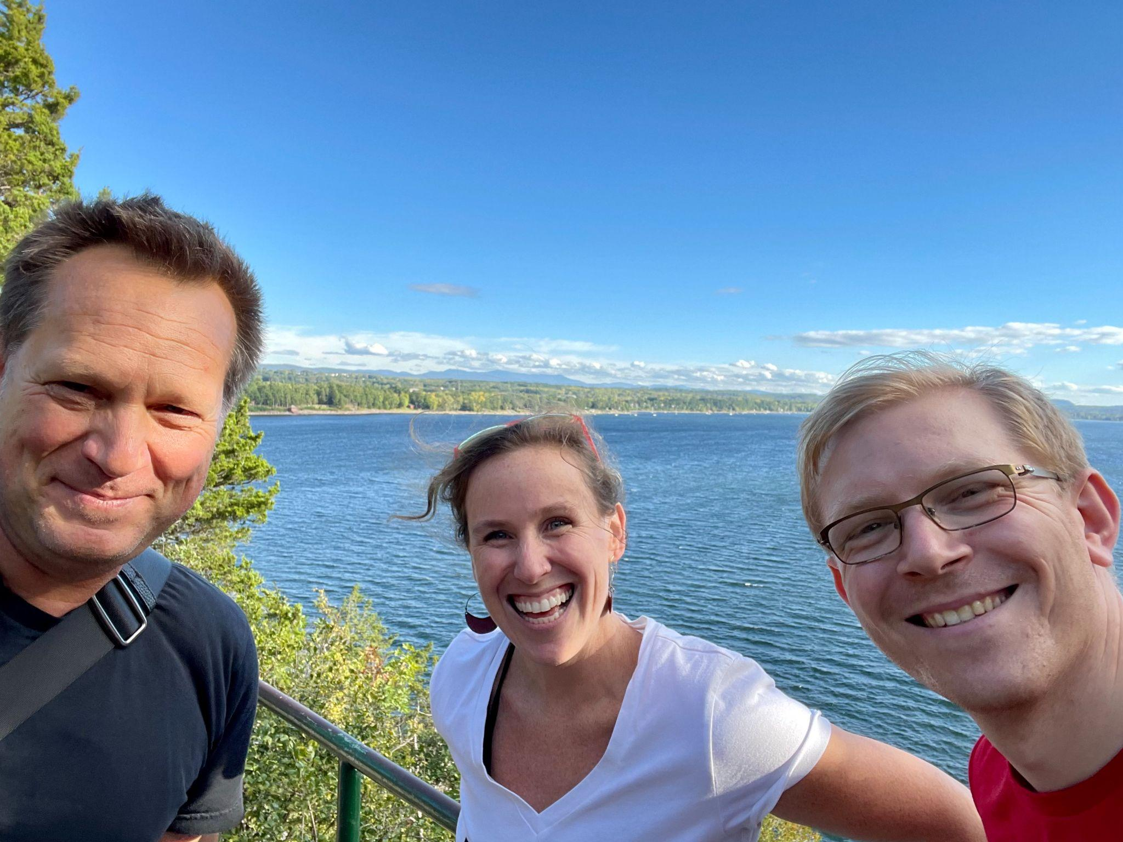
Rowland Conference presenters Christie Nold & Luke Dorfman (RF19) met at Red Rocks Park in Burlington with Mike Martin (RF09).

Gratitude
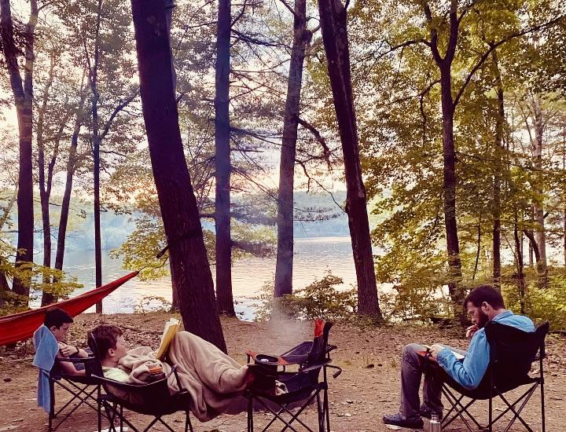
Peter McConville (RF11) is grateful for camping trips with his family this summer. Seen here with sons Hayden and Max at Bomoseen State Park.

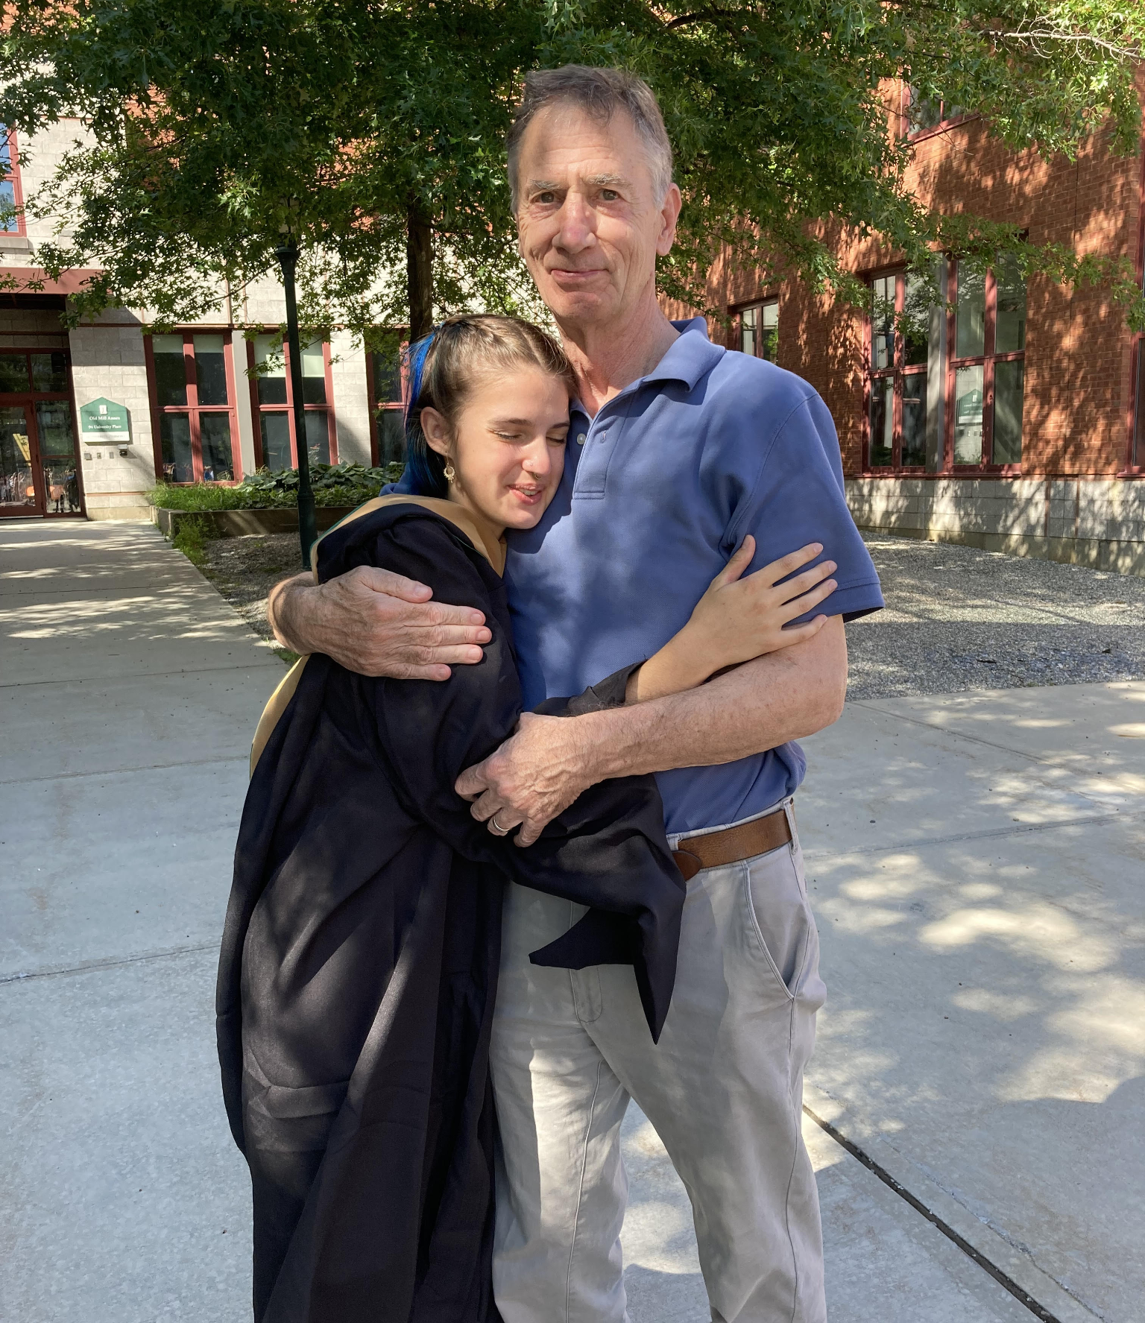
Cecilia “Ceal” Giordano seen here with Chuck Scranton after receiving her MBA from UVM. Many will perhaps remember her as the Big Picture South Burlington student whose speech brought down the house at our 2013 conference with Dennis Littky. Chuck has served as a mentor to Ceal for the past eight years.

Courtesy Postings
Kathy Cadwell (RF16) is available to consult with districts as a Harkness expert. She is currently teaching a related graduate-level contract course through St. Michael’s College for staff at Champlain Valley Union High School. Check out her resource-rich website Strategies in Classroom Dialogue and feel free to recommend her to school leaders looking to develop meaningful student voice, civic discourse, or collaborative practice for equity in the classroom.

Sandra Mings-Lamar (RF16) recommends in-person leadership courses offered through St. Johnsbury Academy’s adult school to be held in the media room of our campus library. From Sandra, “The series is taught by Dr. Martha Dubuque, a distinguished Vermont educator and administrator, who is also an award-winning consultant. These courses are great for new administrators and teacher leaders. They are great for any staff members. They are informative and practical courses that give participants tools for managing conflict, addressing the culture and climate of an organization and learning how to lead others to be their best selves.”

