 | Letter to Fellows  Work  September 2022

Dear Rowland Fellows,

I hope you and your families are having a great start to the school year.

Even as we celebrate Labor Day this holiday weekend, a lot of people are rethinking work in their lives. The pandemic has given us a whole new lexicon when it comes to work, expressions like “The Great Resignation”, “quiet quitting”, and “pandemic burnout”. Plus, with support for unions at the highest it’s been in decades, U.S. workers seem to be demanding a new approach to work as they try to balance their lives and their labor.

However, even though many companies reported a “pandemic productivity boom” when their employees had to work from home, it has come to light that some employers are using increasingly invasive electronic monitoring to track their employees doing remote work. It’s worth reading this New York Times investigative report because you will experience what this tracking feels like as you do. You’ll also notice that some of the activity it tracks does not correlate with productivity, which is the point, of course. Higher-order productivity doesn’t always come from a mouse in front of a screen.

By now we know that working from home raises a host of issues for both employees and students, from privacy concerns to after-hours work, or the disappearance of any separation between work and homelife altogether. The new TV series Severance seems to reflect our collective anguish about that last problem.

Traveling on vacation this summer, I was struck by how different Europeans are from Americans when it comes to work. It’s well known that Europeans typically have more vacation time than we do—in France, it’s a minimum of five weeks vacation required by law—but more importantly, European workers actually take their vacations, unlike in the U.S., where half of all workers don’t use all of their vacation time. Many European countries have also adopted email curfew laws to protect employees from the creeping encroachment of after-hours work. And since 2000, the full-time work week is limited to 35 hours by law in France, which improved productivity and decreased unemployment. The reduction in hours was also a precursor to similar reforms in Japan, Iceland, and other countries where shorter work weeks typically increased productivity and improved employee happiness. Even in the U.K. and the U.S. more and more employers are experimenting with shorter work weeks.

However, the strangest thing I noticed in Europe this summer (after my wife, Magali, kept pointing it out to me) was that people don’t start every conversation by asking you what you do for work. It was as if people could see each other as more than their jobs, as full-blown human beings with unique talents, opinions, and dispositions. Magali and I noticed that we spent more time than usual discussing books, films, shows, politics, life, food, and kids with good friends, and even with people we’d just met, from the taxi driver to the cheesemonger.

In Italy, I met a man my age at the beach whose name was Michele. Pointing to the sun, the sea, and making the international gesture for eating, he said, “Il sole, il mare, mangiare, amare…è tutto ciò di cui hai bisogno.” That’s all you need, he said. Michele really got me thinking about how hard it is to really enjoy life—you know, la dolce vita—in our hypercompetitive, capitalist society. I mean, are most of us working to live or living to work? In Europe, I think they get the order right more often.

In 1930, the economist John Maynard Keynes famously predicted that technology would allow us all to work 15-hour work weeks in the future, in other words, now. Well, that sure didn’t happen. In fact, it seems like technology has done just the opposite to us. Just the same, we can find some hope in the fact that economists and business leaders continue to confirm that longer hours don’t always correlate with greater productivity.

Those long hours remind me of “junk miles”, something my friend Adam Bunting used to always say. Adam was a serious runner and told me the expression describes the diminishing returns that distance runners get when they’re training, if they’re not carefully managing their training distances. As a high school principal, Adam would also call “junk miles” overly long homework assignments that lacked a clear focus, or overly long faculty meetings without a clear purpose. Sometimes less is more, obviously, but I’m not making a case against hard work here—I’m trying to say that burnout isn’t just about effort, but also when we don’t see a good return on our hard work.

More than once, when I was teaching graduate students, they thanked me for being strategic in the readings that I assigned. They told me they appreciated the fact that I didn’t confuse length with rigor. Sometimes it’s less about how many pages you assign, and more about what you do with them.

As we embark on a new school year, I hope our school leaders can keep an eye on the junk miles: the volume of email, the number of rambly meetings, the quantity of assessment, grading, and reporting they expect of teachers. And I hope that teachers can avoid conflating rigor with volume too, that they can keep concerns of “coverage” and “learning loss” in check as they work with their students.

These days, there are a lot of people quoting that Keynes prediction from 90 years ago about the 15-hour work week, but it’s worth it to read the full text that it comes from, Economic Possibilities for Our Grandchildren. As he describes a future where leisure will be as much a part of the human experience as work, Keynes writes,

“Yet there is no country and no people, I think, who can look forward to the age of leisure and of abundance without a dread. For we have been trained too long to strive and not to enjoy. It is a fearful problem for the ordinary person, with no special talents, to occupy himself, especially if he no longer has roots in the soil or in custom or in the beloved conventions of a traditional society.”

Perhaps this should be our greatest fear, namely, that work defines us so much now that we no longer know what to do with ourselves when we’re not working. For teachers, this is especially tricky because we care so much about our work and see it as a vocation.

But just like the cheesemonger and the taxi driver, we need to relearn how to call it a day, how to disconnect. Our productivity depends on it, of course, but our happiness and wellbeing do too.

Take care and see you soon,

Mike

P.S. Please send me your news! Each month, I’m sharing courtesy posts for upcoming courses & events, and also celebrating new jobs, family vacations, and other news from our extended Rowland Family of Fellows. So please email whatever you’d like to share to michael@therowlandfoundation.org

Rowland Foundation Updates

All Students Thriving: Rethinking School & Community
The 11th Annual Rowland Conference at UVM on October 26th, 2022
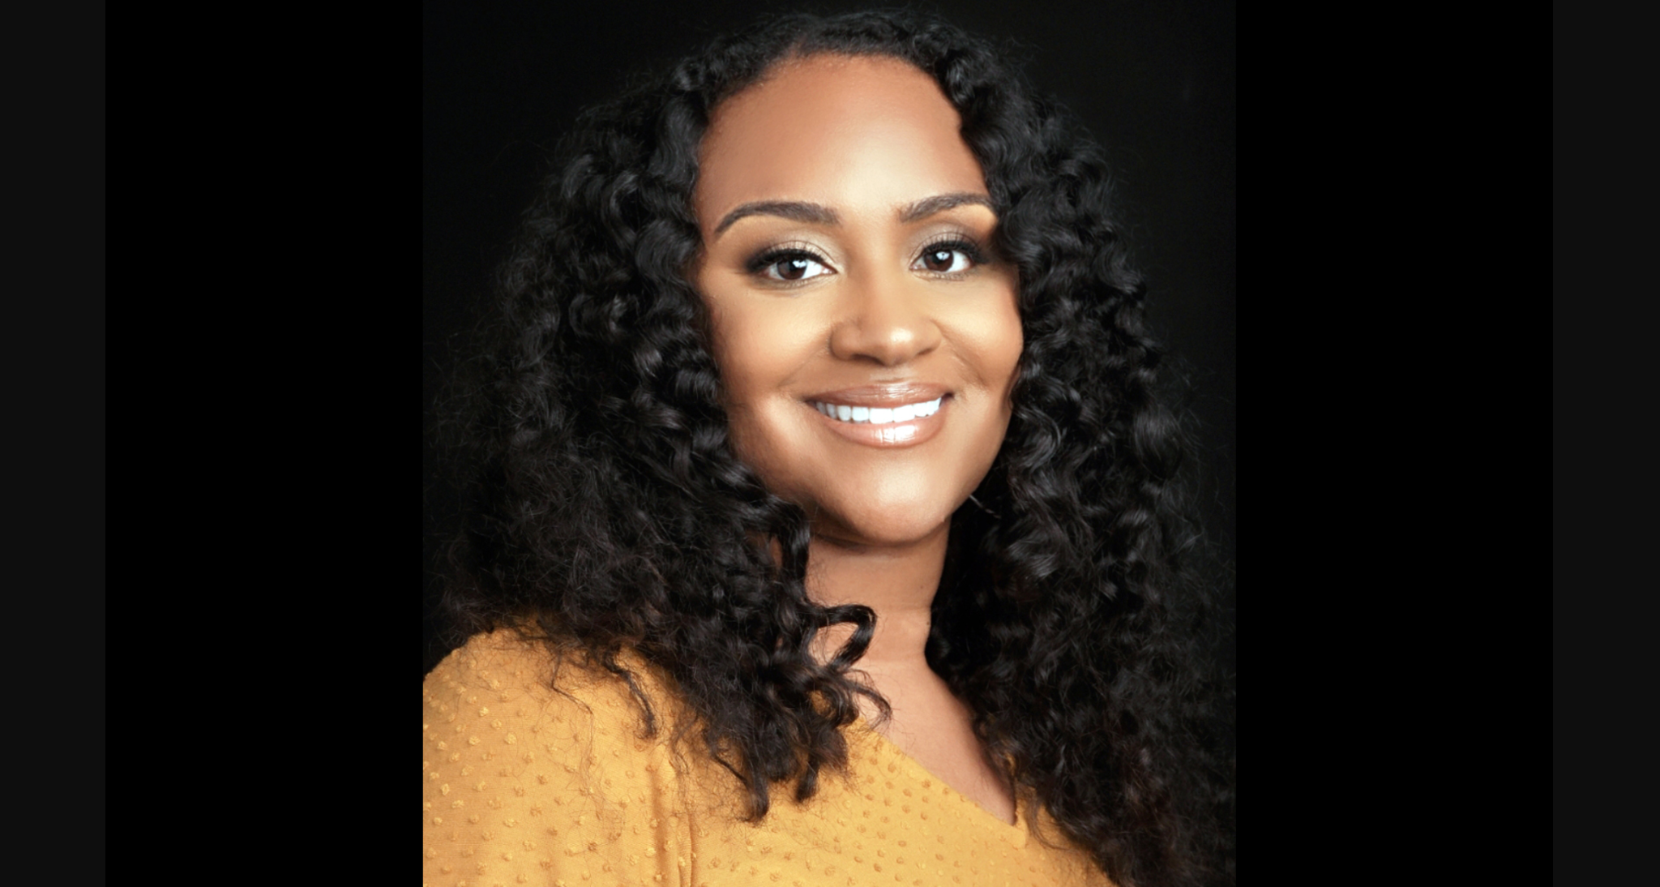
Keynote Speaker Dr. Gholdy Muhammad

Registration for the 11th Annual Rowland Conference opens on September 6th! Check out the workshops and program for this year’s conference, All Students Thriving: Rethinking School & Community at UVM’s Davis Center on Wednesday, October 26, 2022.

Congratulations to everyone who pre-registered conference teams in June! You have your teams’ spots reserved and will save 20% on the conference fee. Stay tuned for the registration link coming your way soon.

We are thrilled that Dr. Gholdy Muhammad will deliver our keynote on the theme of Cultivating Genius: An Equity Model for Culturally & Historically Responsive Education. To start the school year, check out this article of hers if you haven’t seen it yet, Debunking Deficit-Centered Views of Our Children.

The All Fellows Retreat & Social
Save the date! The All Fellows Retreat will take place on Tuesday, October 25th (1:00-4:00pm) at the Hilton Burlington/Lake Champlain again. The traditional All Fellows Social will take place immediately afterwards at The Farmhouse Tap & Grill in Burlington.

The All Fellows Survey Results
If you still haven’t had the chance to, be sure to check out the Summary of Results from the All Fellows Survey for some excellent thinking and strategies relating to leading change in schools. You can also watch this short video for survey highlights in Rowland Fellows’ own words—the quotes are inspiring and also provide great insights on the joys and challenges of leading school change.

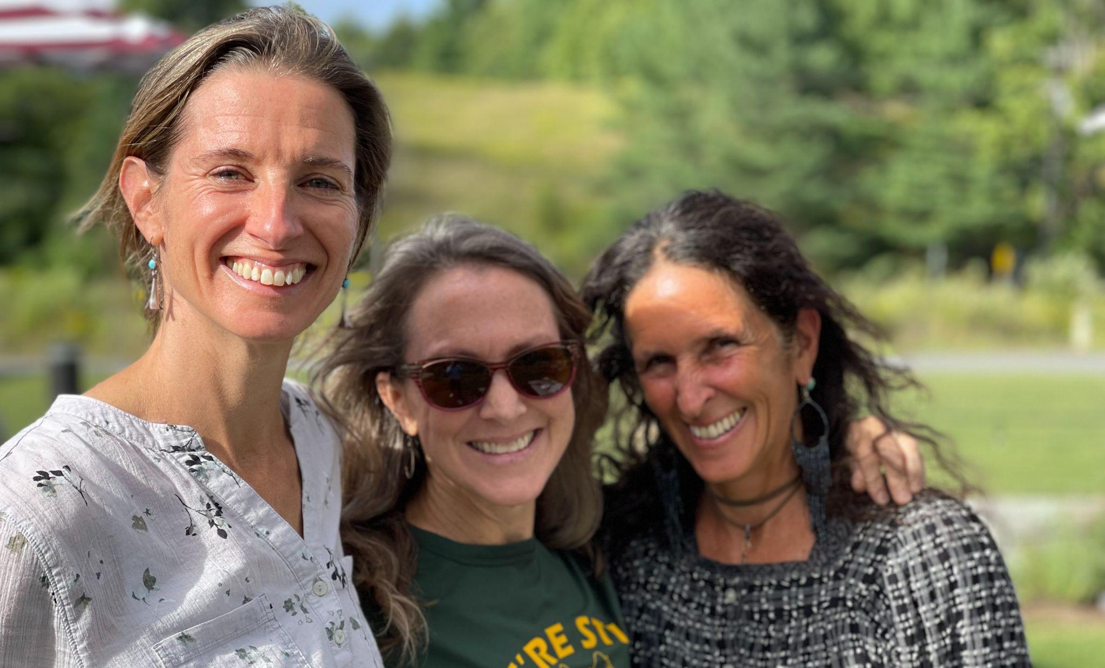
After presenting to teachers at Peoples Academy MS/HS and soliciting feedback on their Disconnect/Reconnect Rowland Encore Grant work, Lissa Knauss (RF18) Carrie Felice (RF13) & Anne Bergeron (RF11) from our first-ever Rowland Encore Grant Team met with Mike Martin in Montpelier.

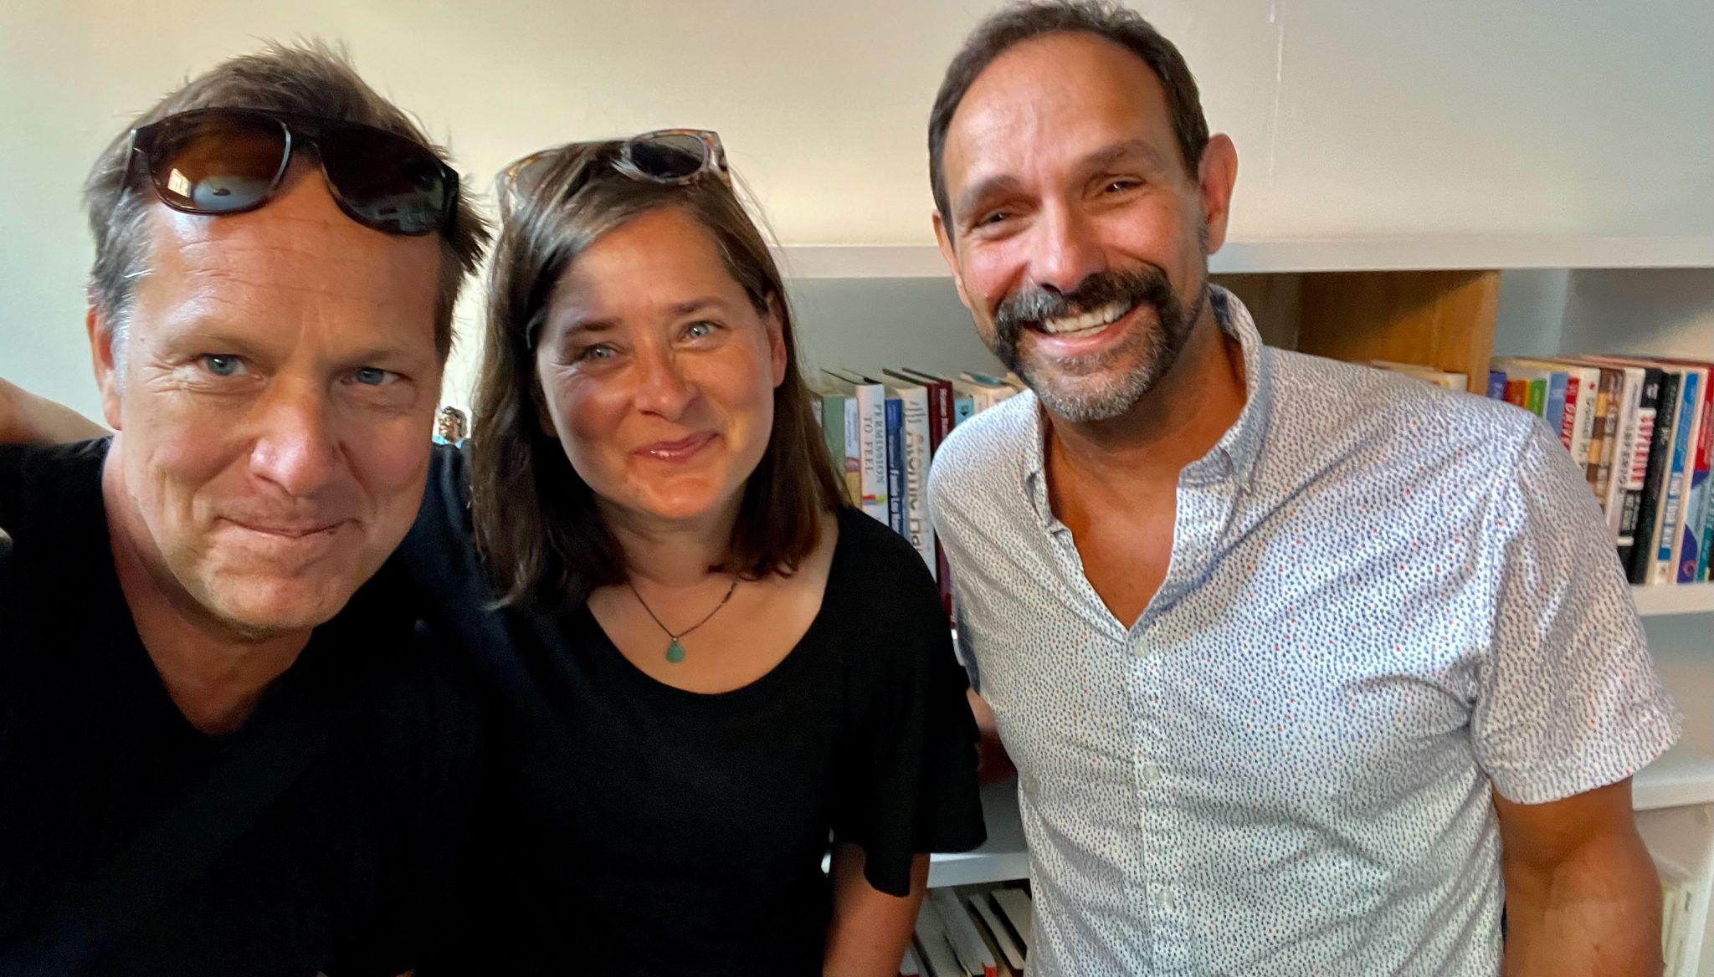
Executive Director Mike Martin (RF09) met with Senior Associates Jeanie Phillips (RF14) & Jean Berthiaume (RF09) to work on prepare for upcoming cohort meetings, the Shared Leadership Retreat with RF21 Steering Committees, and the All Fellows Retreat at the Hilton Burlington.

Gratitude
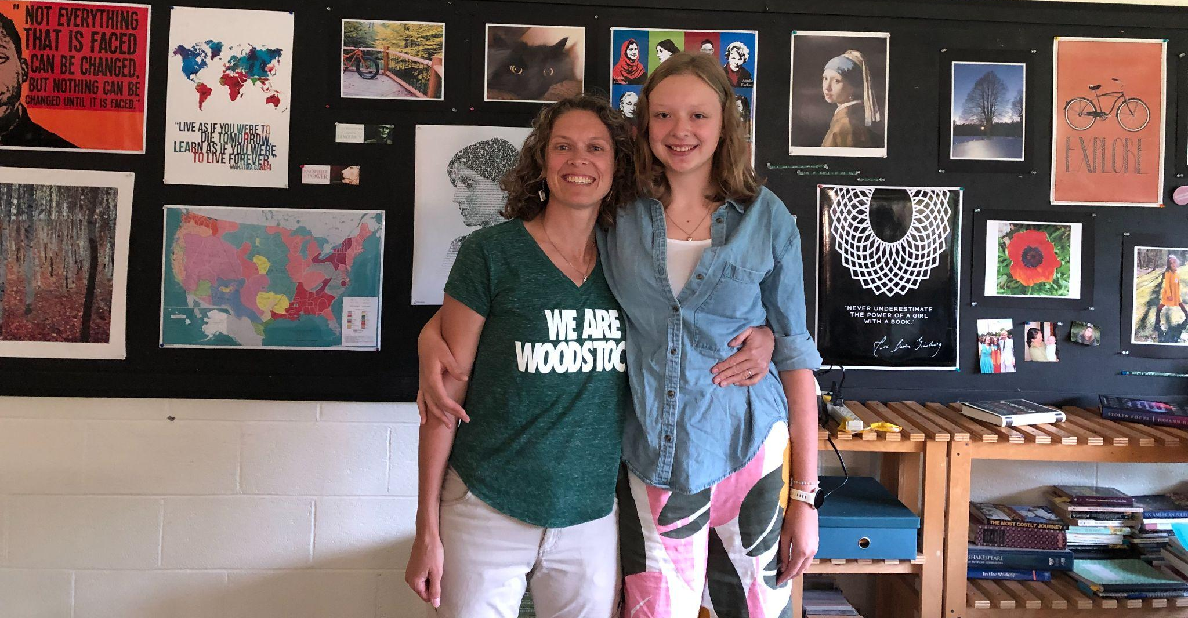
Sarah Hagge (RF16) is happy to be starting her first year teaching at Woodstock Union MS/HS where her daughter Schuyler is in 9th grade.

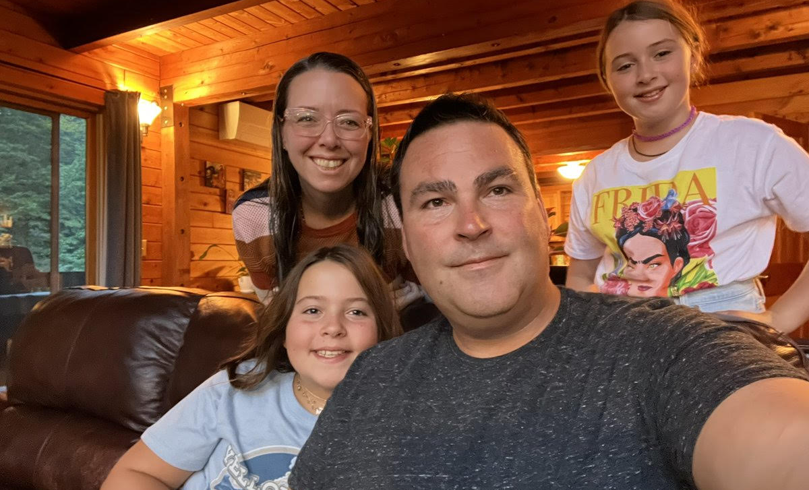
Tim O’Leary (RF20) wishing a happy first day of school to all with family members starting 4th grade, 5th grade, and Year 22 of teaching. Seen here with Eleanor O’Leary (Grade 5 with the Frida shirt), Cecily O’Leary (Grade 4), and Lauren Young.

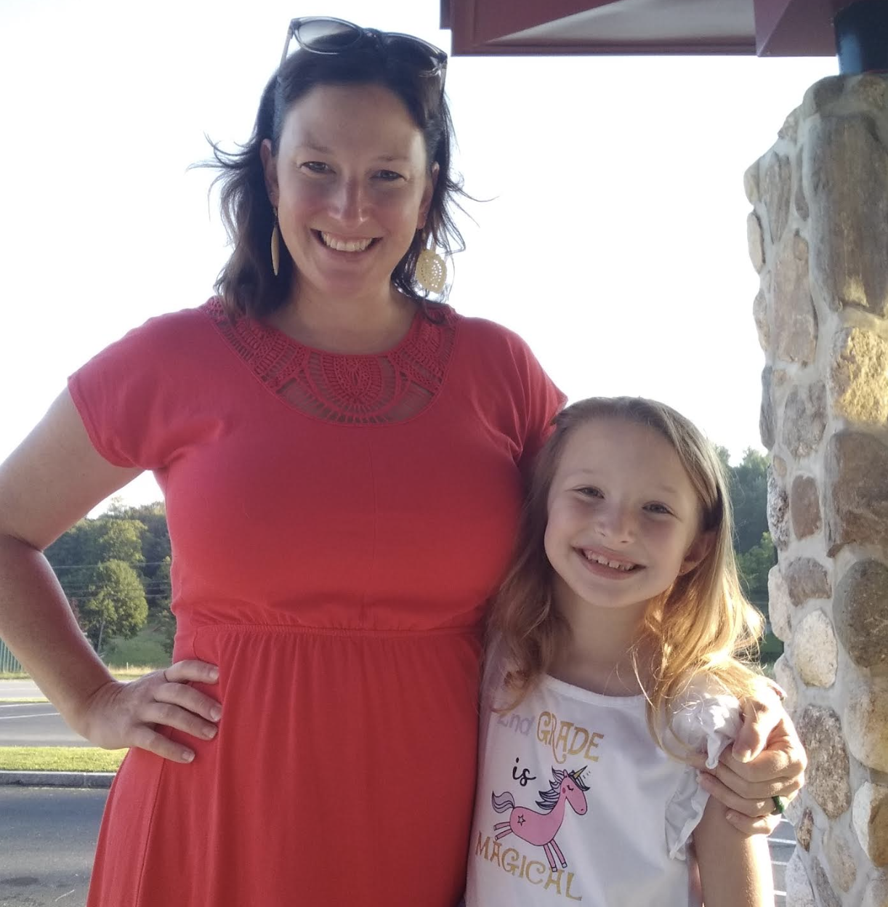
Samantha Mundt (RF21) is grateful to be kicking off the new school year at Twin Valley where her daughter Matilda is in second grade.
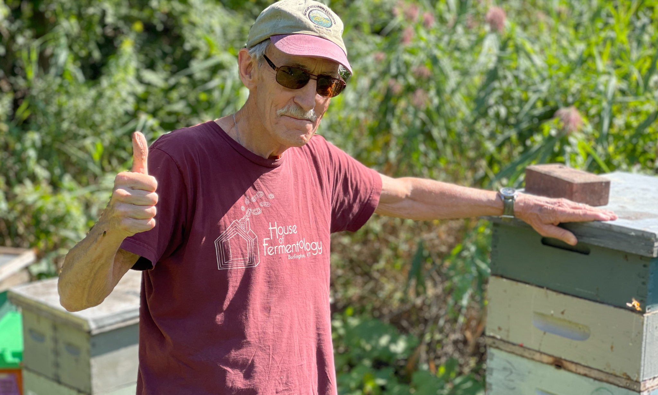
Mike Martin (RF09) is grateful to have friends like Bill Mares, Vermont author, educator, microbrewer & apiculturist seen here with his hives at the Burlington Intervale.

Courtesy Postings

The Rowland Foundation is pleased to announce a unique learning opportunity that has been specifically designed for Rowland Fellows. With support from the Great Schools Partnership, Shelburne Farms, and the Rowland Foundation, starting this fall, Senior Associate Jeanie Phillips (RF14) will be teaching Collaborative Practices for Equity (Sept. 21-23). You’ll want to click on the link to register right away because we believe this course will fill quickly. Jeanie has also arranged for overnight lodgings at Orchard Cove as an option for course participants. Shelburne Farms is generously offering two nights at Orchard Cove for $100 for September 21 & 22. Limited rooms are available, so if you are interested, please contact Jeanie right away: jeanie@therowlandfoundation.org

Brian Boyes (RF14) shares that SoundCheck, a band of high school musicians and singers creating and performing music to fight for social justice, will be launching a new cohort starting this fall. Students can apply here by September 16 and then will be invited to audition later in the month. Please consider sharing this opportunity with any high school students you think may be interested! Here is a poster for distribution as well. This is a wonderful project that has had a profound impact on young people's lives. Thanks to our partnership with the Flynn, there is a sliding scale donation option to participate in the program. Throughout the season, SoundCheck students work with music educators, prominent singer-songwriters and anti-racist educators to develop original material that tackles racism, injustice and hate. The band performs regularly and facilitates workshops at Vermont high schools using art and music as a catalyst to spark dialogue, action and awareness.

