 | Letter to Fellows  Back to School with AI  September 2023

Dear Rowland Fellows,

I hope your back-to-school transition is going okay for you and your families.

After the shock of Chat GPT coming out last spring, it feels like we’re going into this new school year with a lot of unresolved questions. And to complicate things even more, several new artificial intelligence (AI) platforms have come out since then, with cheeky names like Bard, Bing, and Claude. So if you’re an educator going back to school this month, you may be uncertain where we’re at with AI and wondering:

Am I supposed to be…

- policing student work for AI?
- using AI with my students in our coursework?
- giving my students guidelines for how to use AI?
- asking my students to teach me how to use it?
- giving up on technology until I understand what’s going on with AI?

Well, assuming that most teachers are not able to go 100% tech-free just yet, we’re probably going to need some AI survival strategies for the classroom. And since there’s no way to guarantee your students’ homework is AI-free, it will probably be pretty fruitless to try to monitor AI use in all of your students’ work. After all, we want to be teachers, not the technology police!

If you’re feeling uncertain or a little anxious about what all this means for teachers, allow me to recommend this episode of the New York Times Hard Fork podcast—the AI part starts about 25 minutes in and lasts about 25 minutes. The interview is with Ethan Mollick, who teaches Innovation & Entrepreneurship at the University of Pennsylvania’s Wharton School of Business. Professor Mollick brings some levity and perspective to the AI discussion, saying,

People always cheat; it’s not a new thing. There are 20,000 people employed in Kenya whose job is writing essays for people. This is not a new phenomenon, but now it’s much more obvious. Since the internet, the value of homework dropped precipitously. Cheating was pretty ubiquitous. Cheating was already happening but you could kind of ignore it. [Generative AI] forces us to acknowledge changes that were already happening in classroom environments.
In response to this, Mollick suggests we give up on AI enforcement and rethink our instruction & assessment strategies. I was pleased to hear him make this recommendation (in part because I did too, way back in my February Letter to Fellows earlier this year). To start, Mollick says that teachers need to recognize that homework is broken, and probably need to move towards a “flipped classroom” approach.

As you probably know, the flipped classroom begins with students investigating a prompt, problem, or query at home on their own, before the teacher presents on the topic. This inquiry-driven approach disrupts the traditional sequence of teacher lecture in class, then student worksheets at home, and then a quiz or test for students to repeat back the same information once more (but with books closed). By starting at home with investigation instead of presentation, teachers and students spend more of their class time digging into thorny questions together. To learn more, you can find a lot of flipped classroom resources online, or check out my homemade flipped classroom video here (watch :50 - 8:25).

“The way good teaching works is you solicit explanations from people, and then you critique the explanations. You don’t explain things to them and ask if they get it,” Mollick says. Above all, he points out how the flipped classroom leads to higher-order thinking and more co-constructed learning experiences.

Of course, co-constructed learning is subversive. “It broke the old-style culture. One of the things we trusted people would do in the classroom is to show ignorance so we can explain things to them,” Mollick explains. Instead of teachers stuffing students with knowledge as if they were empty vessels, in a flipped classroom, teachers and students investigate together so that students become active participants in thinking and learning. When teachers are not the sole holders of content knowledge (see The Internet, Google Search, AI, etc.) their role necessarily changes. An inquiry-driven approach doesn’t just change instruction, it also messes with power hierarchies because students are no longer passive receivers of information.

Pablo Freire called the traditional, presentational approach to teaching the “banking model” of education and critiqued it in this way:

The teacher's task is to…“fill” the students by making deposits of information which he or she considers true knowledge. And since people “receive” the world as passive entities, education should make them more passive still, and adapt them to the world.
— Pedagogy of the Oppressed, Chapter 2 (1970)

In an age when democracy is in danger, information is everywhere, and misinformation is too, educators can no longer just be information purveyors or content gatekeepers. Instead, we need to teach students how to think critically, learn autonomously, and ask great questions. For teachers interested in new approaches in this moment — in getting past the banking model of school— Mollick has written some great blog entries on dealing with AI, including, Assigning AI: Seven Ways of Using AI in Class and How to Use AI to Do Stuff: An Opinionated Guide.

Wishing all you educators, school leaders, and parents strength & serenity this fall,

Mike

Rowland Foundation Updates

The 12th Annual Rowland Conference
Growing Community: Making Space for Joy & Creativity in School
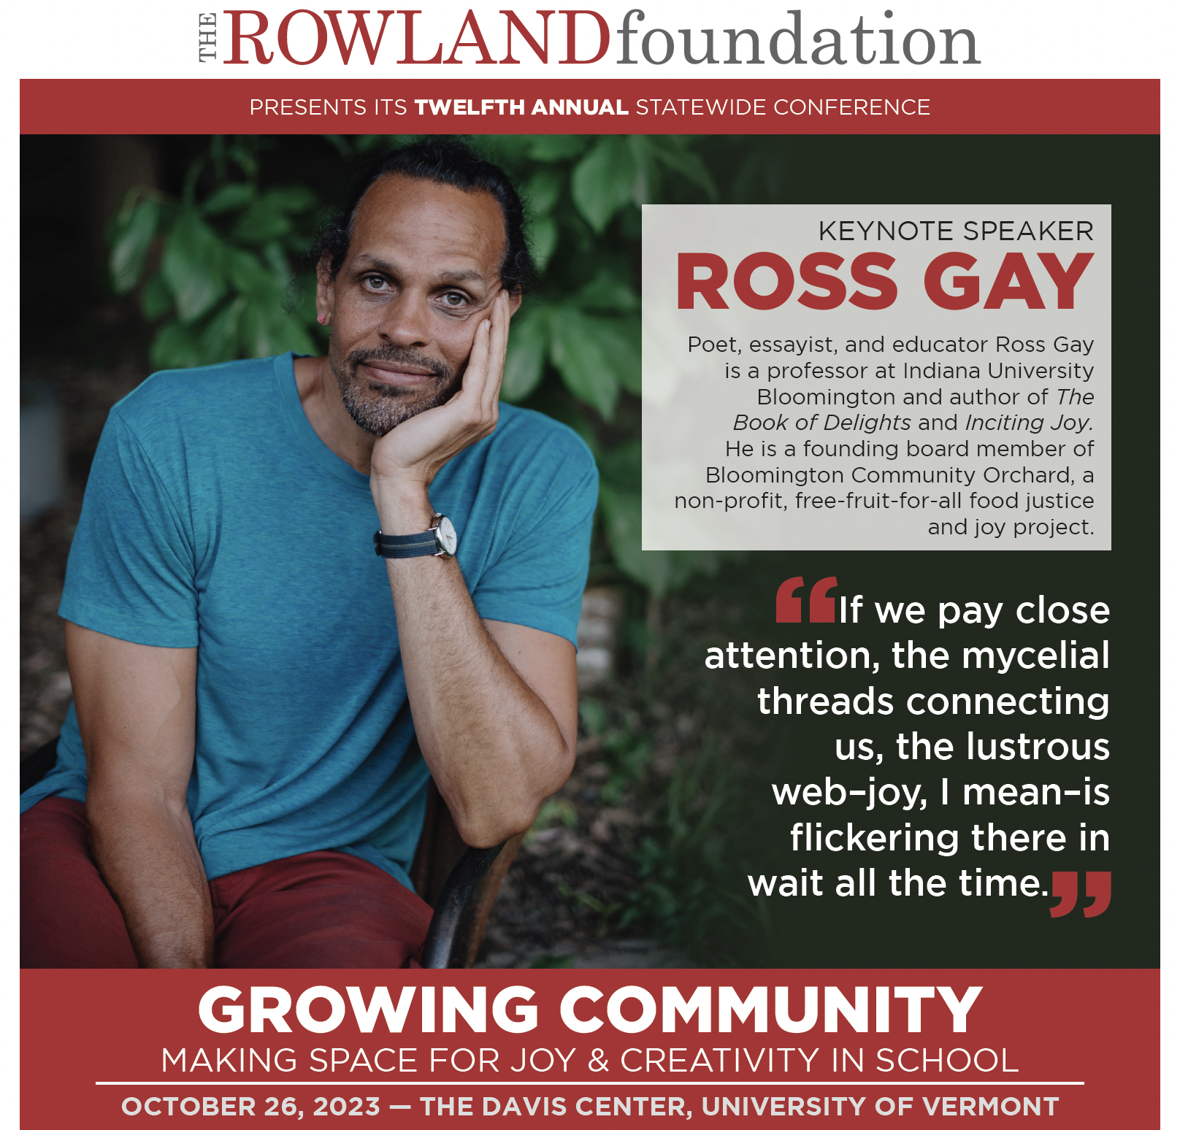
Rowland Conference registration will open on September 6th! If you pre-registered one or more school teams, you’ll receive an early-bird code for a reduced rate via email. You will then just need to enter your team information (team members, workshop choices, dietary restrictions, etc.) with UVM Event Registration, and you’ll be all set. The excitement about Ross Gay is palpable, and this year’s early-bird spots filled faster than ever. Make sure you get your team registered first thing once you’re back at school.

At this fall’s Annual Rowland Conference, Growing Community: Making Space for Joy & Creativity in School, we’re pleased to announce that nearly half of the workshop presenters are Rowland Fellows, including: Anne Bergeron (RF11) Janis Boulbol (RF21), Abbie Bowker (RF17), Carrie Felice (RF13), Emily Gilmore (RF17), Sarah Ibson (RF13), Lissa Knauss (RF18), Anja Pfeffer (RF21), Kat Robbins (RF21). Please consider submitting your own workshop proposal in the spring for next year’s fall conference!

Digital Wellness Resource Guide
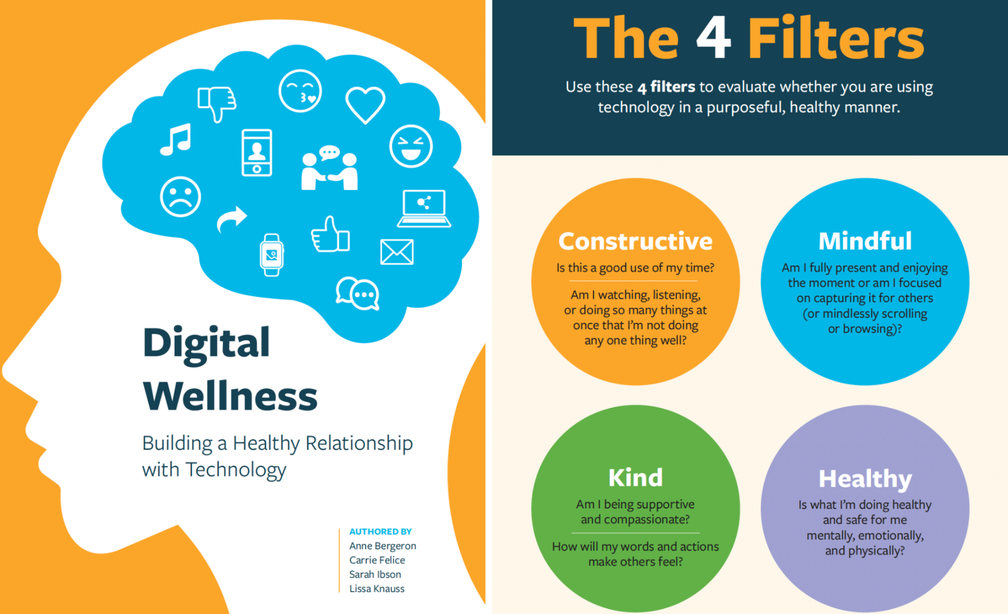
The Rowland Foundation is pleased to announce the publication of Digital Wellness: Building a Healthy Relationship with Technology, authored by our 2022 Rowland Encore Grant Team: Anne Bergeron (RF11), Carrie Felice (RF13), Sarah Ibson (RF13) & Lissa Knauss (RF18). We are proud of our Rowland Fellow authors’ approach, which is pragmatic and positive instead of shaming and blaming young people about their tech use. Instead of solely thinking in terms of “screen time”, the authors propose four filters to better understand the nature of our technology use, namely, asking, Is it Constructive? Mindful? Healthy? Kind?

Please share this timely resource guide with your students, colleagues, and families! This publication couldn’t come at a better time, as we realize the challenge of managing our technology use — adults and children alike! The authors have field-tested this resource guide in Vermont schools and thoughtfully curated relevant and useful classroom activities combined with helpful resources.

The Rowland DEW Grant

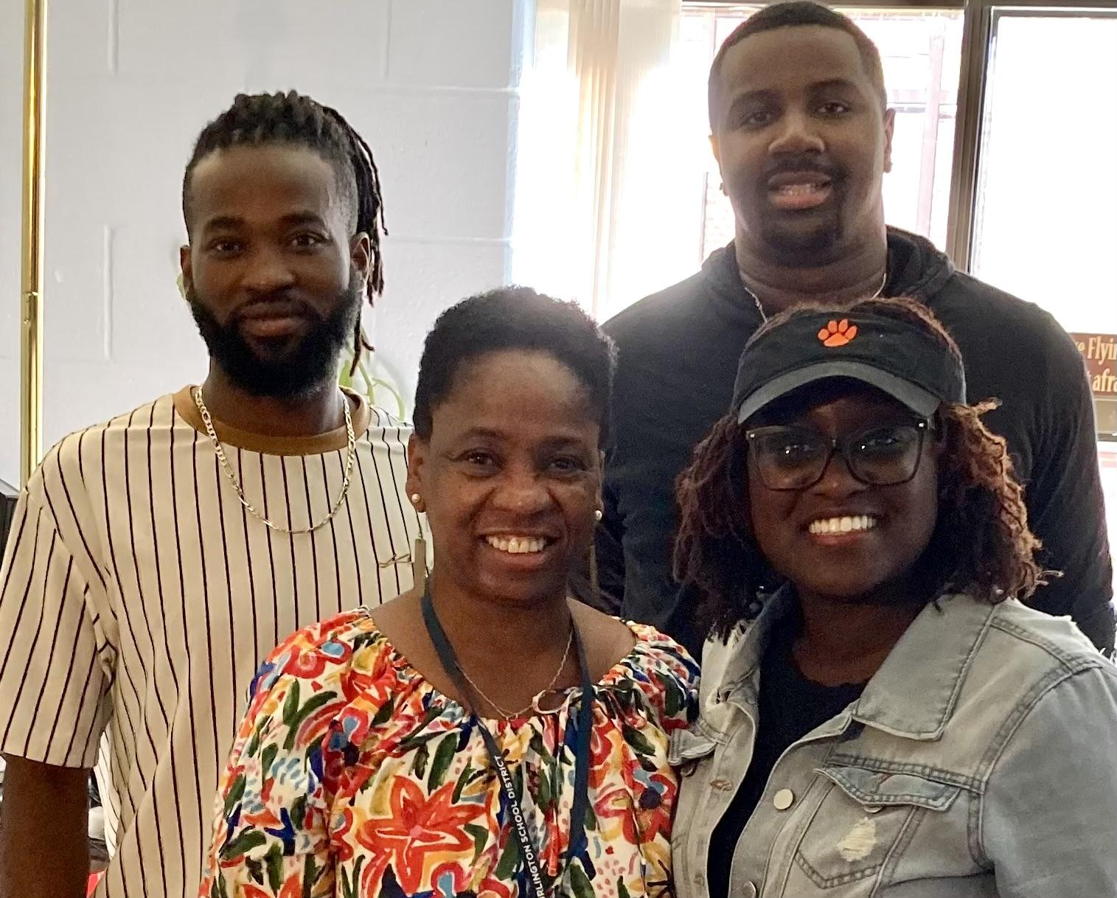
Congratulations to DEW Grant recipients Jonas Kambire (back left) and Kenneth Phillips II (back right), seen here at a recent cohort meeting with DEW Mentor Bonnie Johnson-Aten & Esther Charlestin. Jonas has received a teaching fellowship and is pursuing a M.A. in Elementary & Early Childhood Education at Saint Michael’s College. Kenneth works at South Burlington High School as a Behavior Interventionist and is pursuing a M.Ed. in Special Education at the University of Vermont.
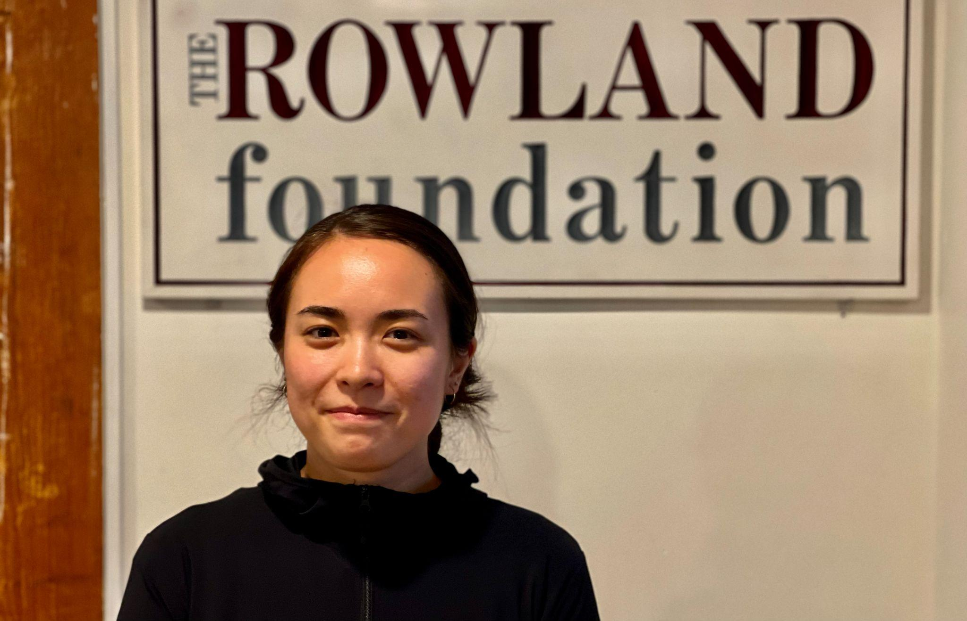
Congratulations to Tessie Sakai, our newest DEW Grant recipient! Tessie is pursuing educator licensure through the Teacher Apprenticeship Program (TAP) at Champlain College and is doing her teaching practicum in Winooski School District. Tessie would like to work as a middle grades ELA or Social Studies teacher.

Collaborative Practices for Equity
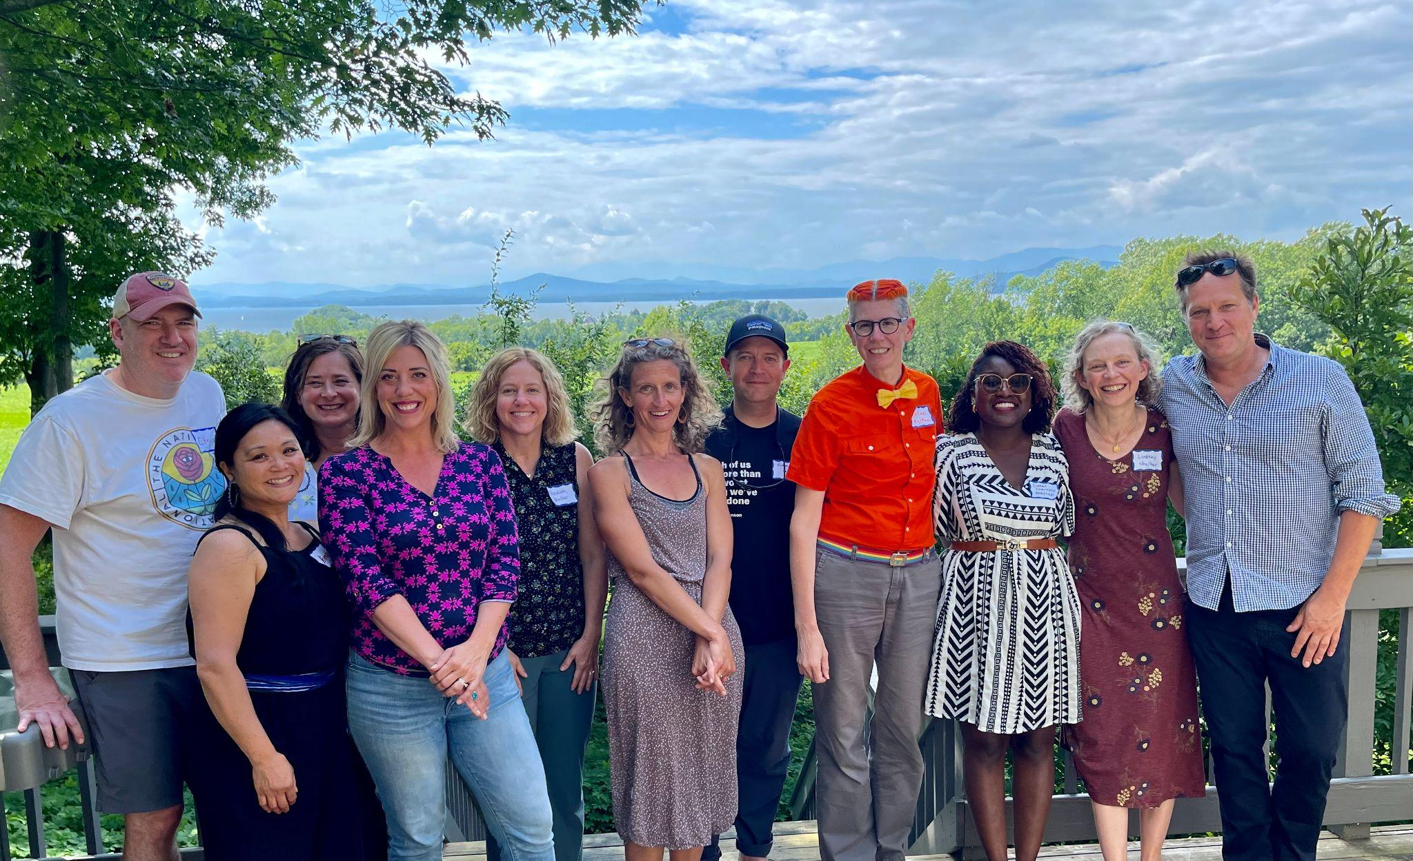
Senior Associate Jeanie Phillips (RF14) taught our new Collaborative Practices for Equity course with Aimee Arandia Østensen at Shelburne Farms last month. The course is co-sponsored by the Rowland Foundation, Great Schools Partnership, and Shelburne Farms. Seen here: Chris Sheehan (RF23), Aimee, Jeanie, Carrie Gilman (RF23), Elizabeth Placencia (RF23), Jessica Kessler (RF23), Adam Murray (RF23), Jordan Funke, Esther Charlestin, Lindsay McQueen (Rf23) & Executive Director Michael Martin (RF09).

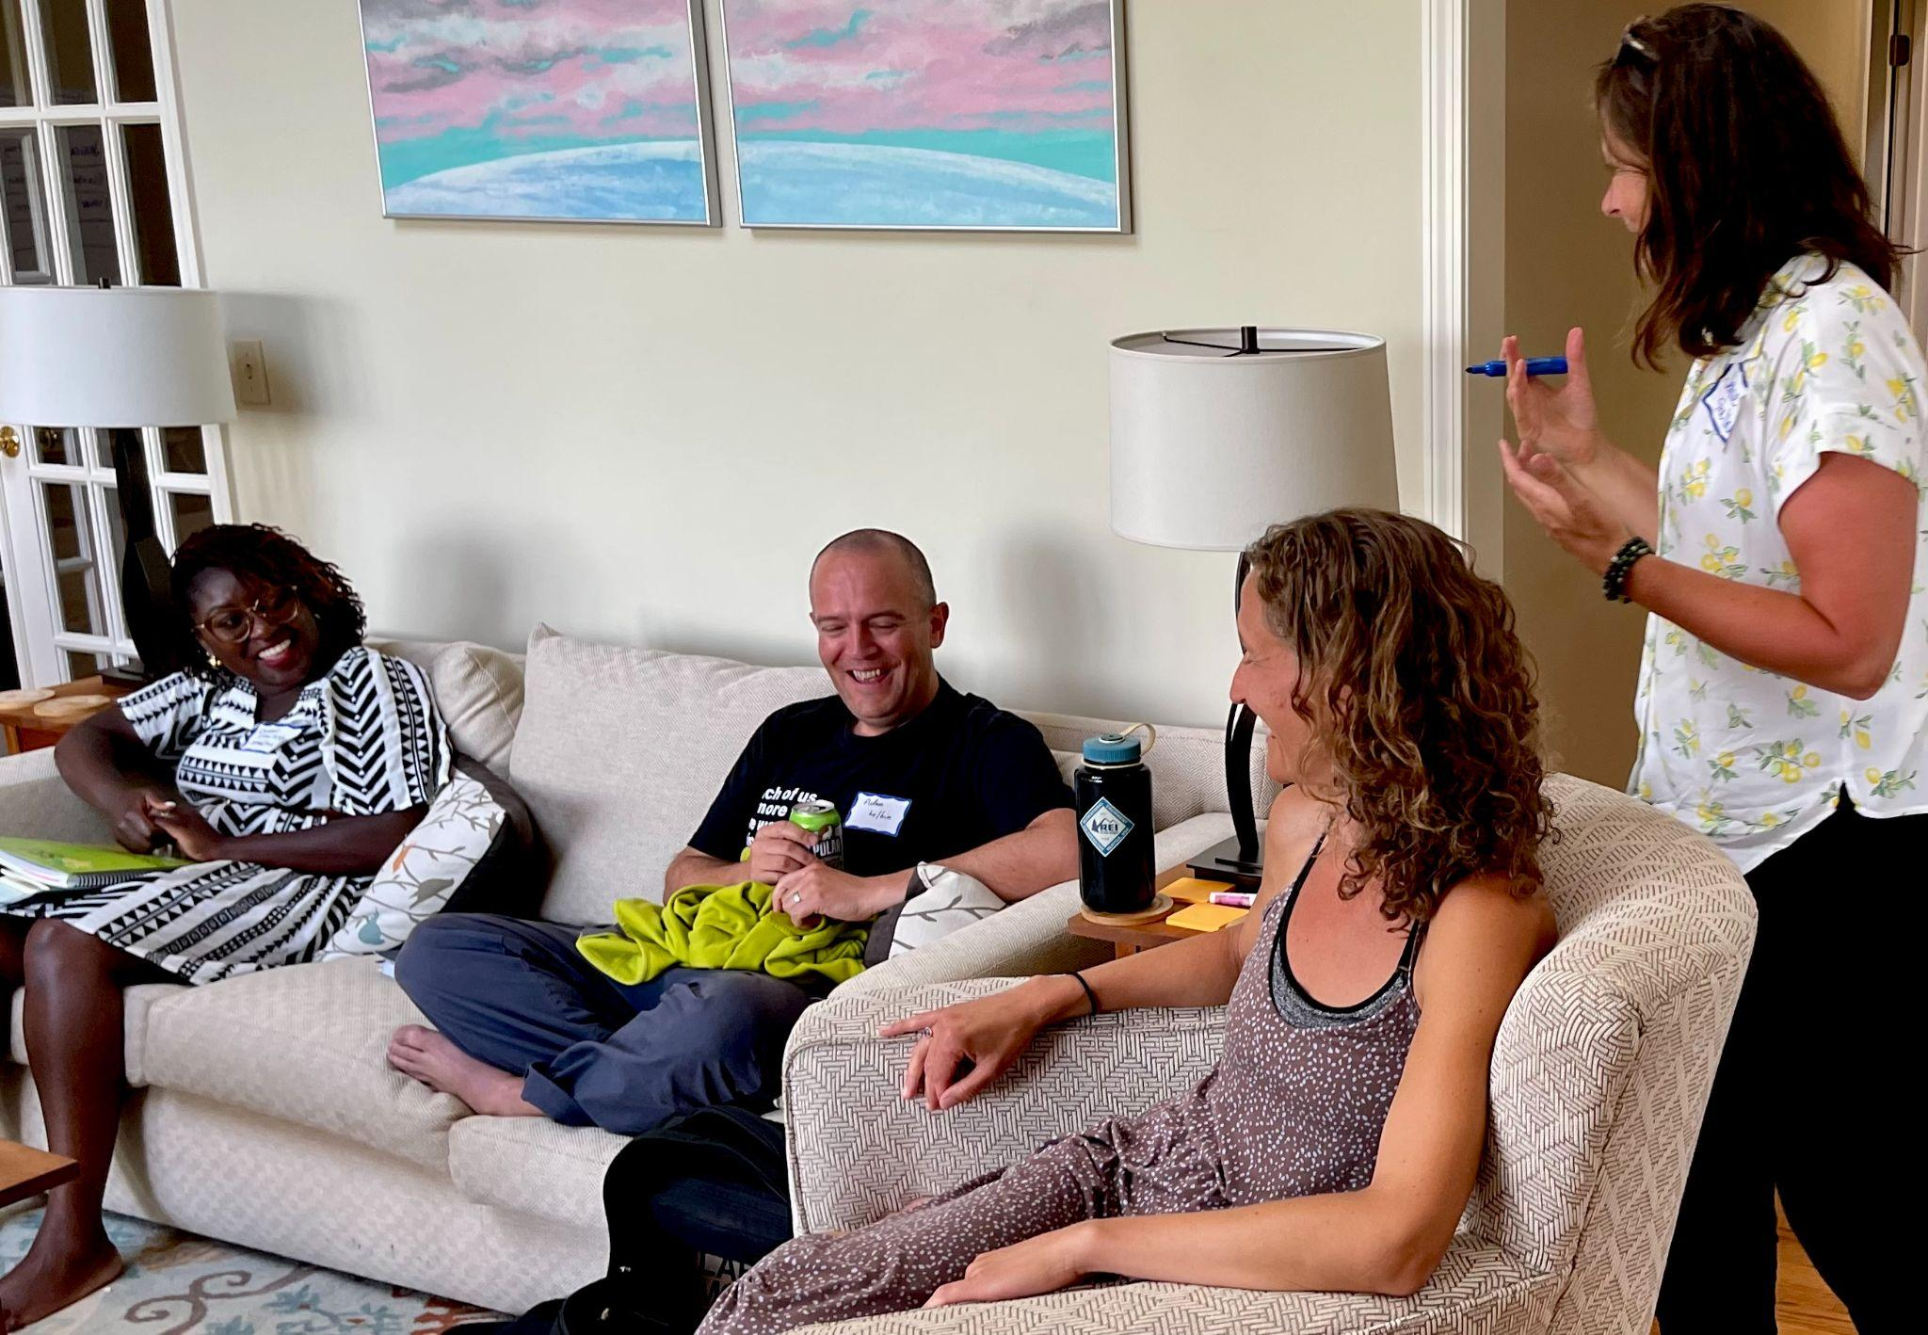
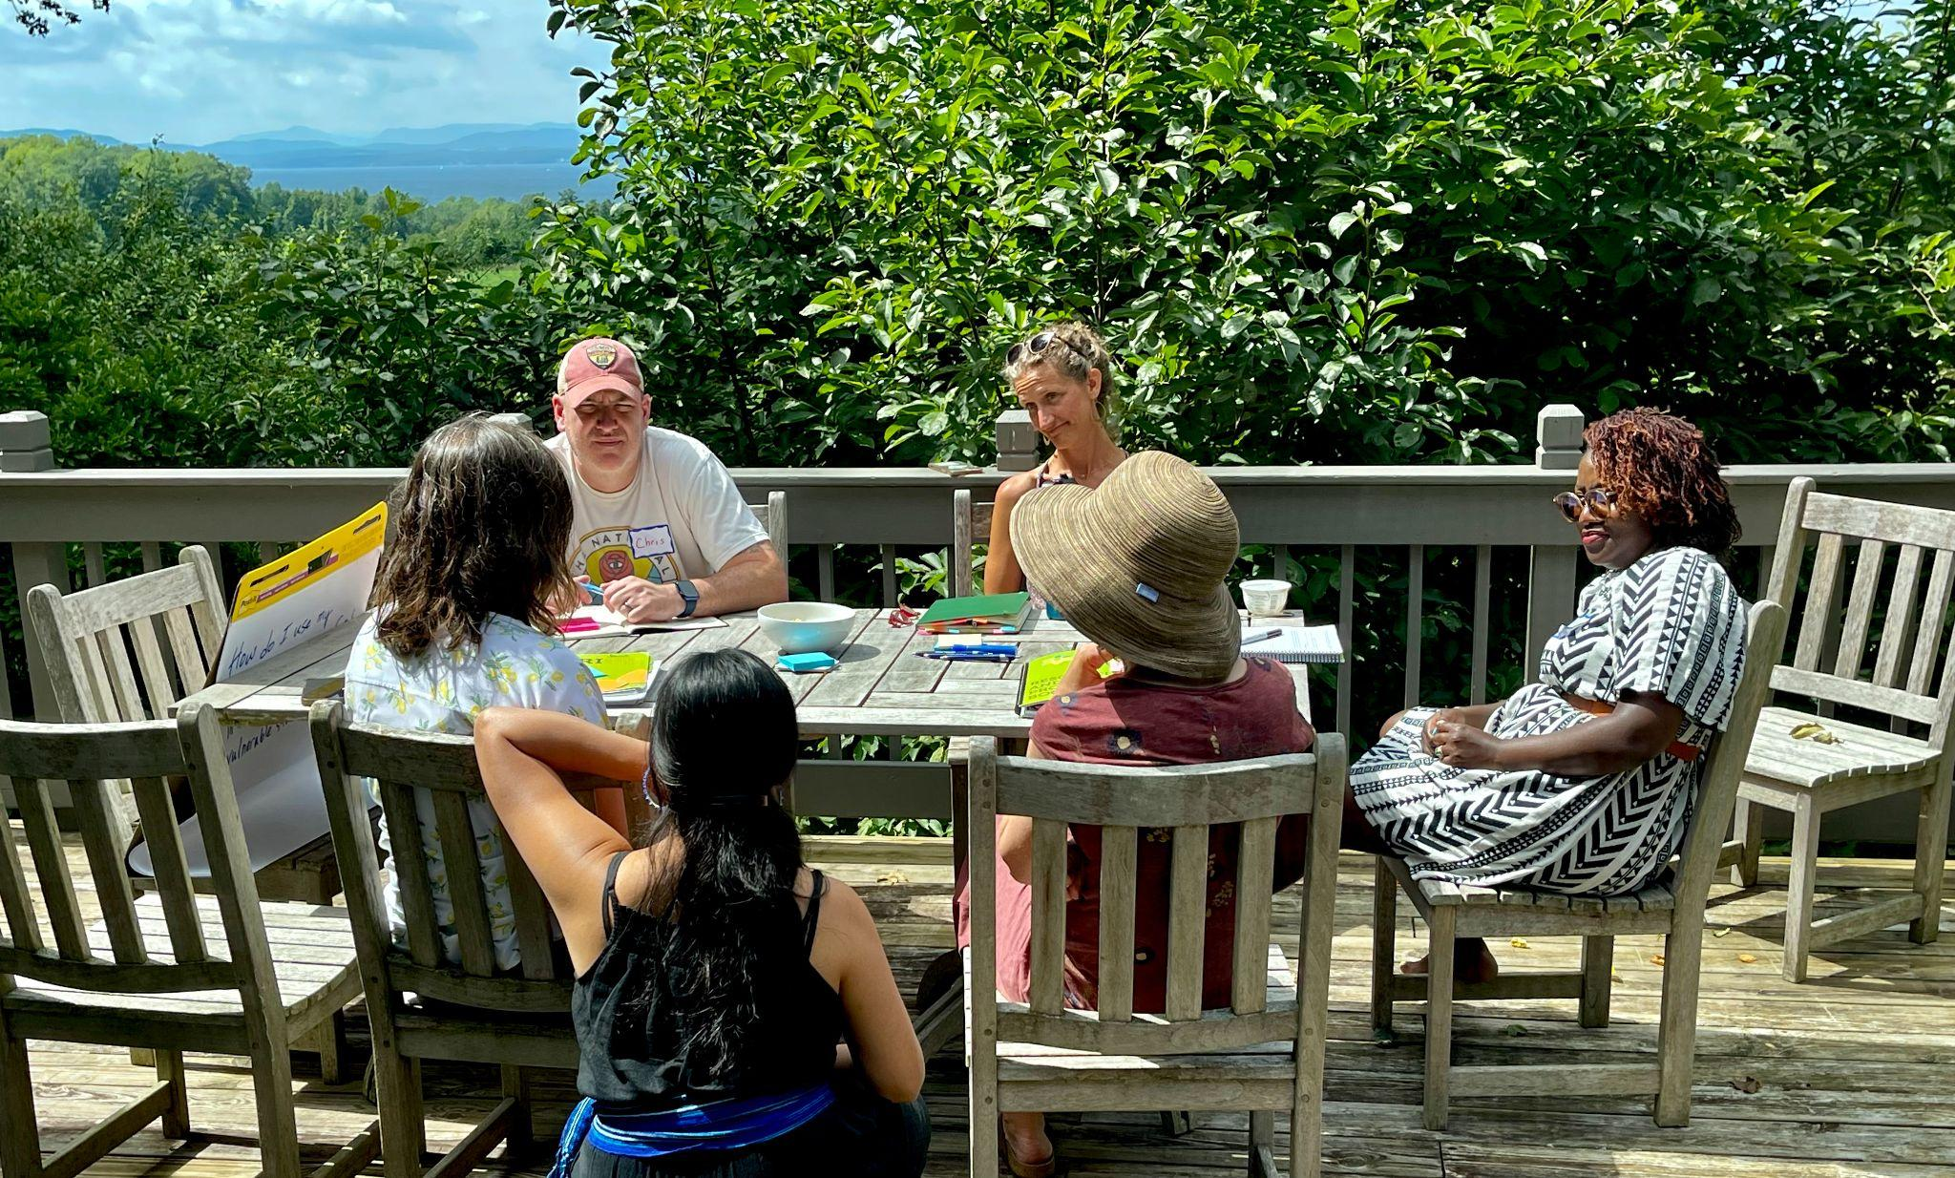

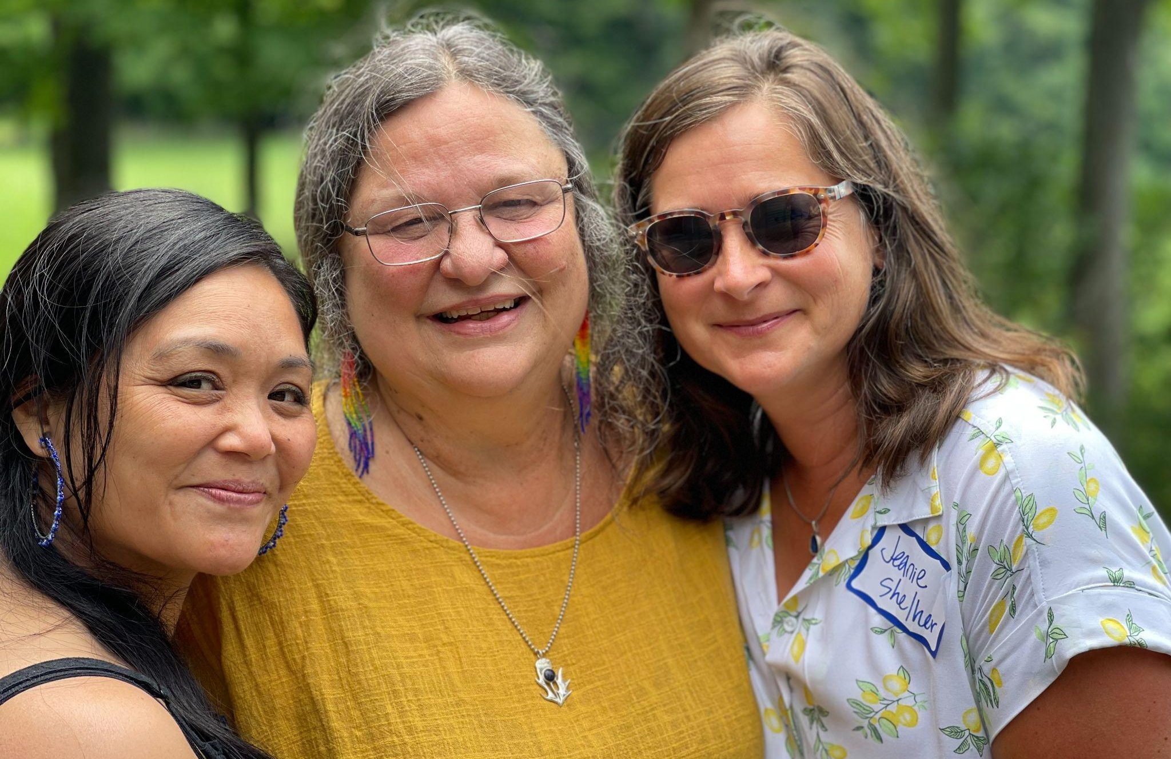

Celebrations

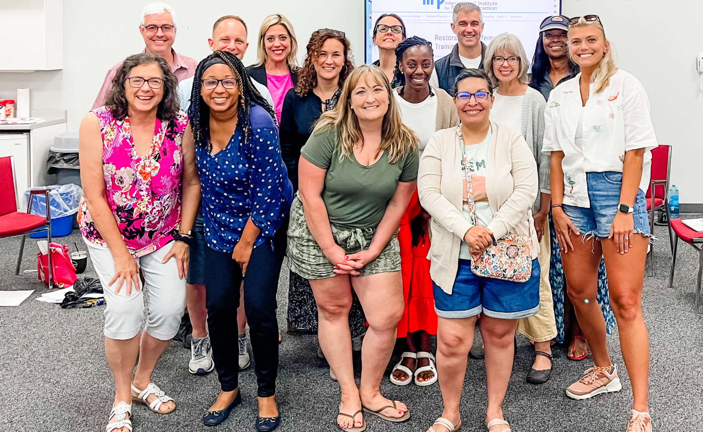
In July, Carrie Gilman (RF23) attended a Restorative Practices certification course, provided by the International Institute for Restorative Practices (IIRP) in Bethlehem, PA. This intensive course certified participants to train trainers in the field of Restorative Conferencing.

Congratulations to Allie Vega (RF20) who has accepted a new position at CVU this year as the part-time librarian. She is super grateful to be able to have more time at home with her two daughters, Evangeline and Arizona

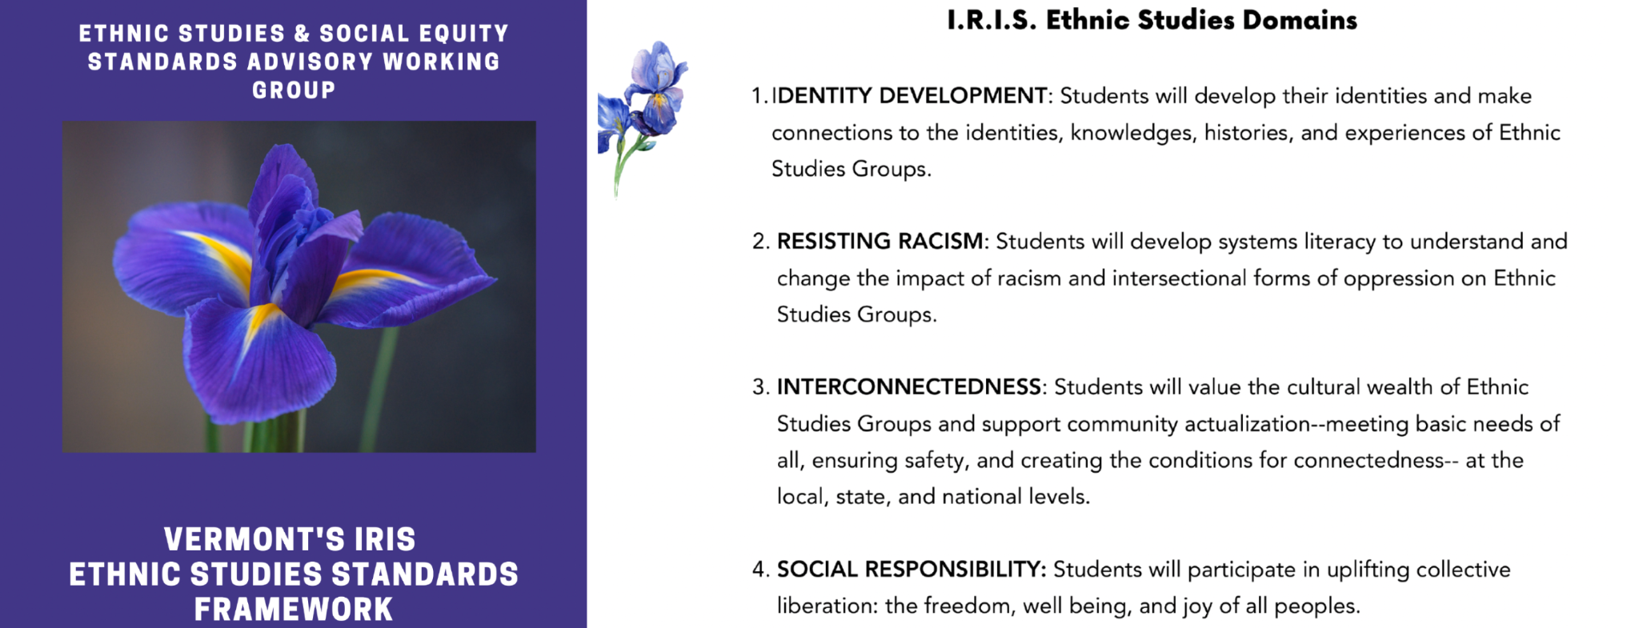
Act 1 of 2019 created a diverse statewide working group to 1) “review standards for student performance adopted by the State Board of Education”, and 2) “recommend to the State Board updates and additional standards to recognize fully the history, contributions, and perspectives of ethnic groups and social groups.” Both of these charges have now been completed. Act 1 Working Group revisions to Vermont’s Educational Quality Standards were adopted by the State Board of Education earlier this year. Most recently, the Act 1 Working Group worked with national consultants to develop Vermont’s IRIS Ethnic Studies Framework, which has been submitted to the State Board for adoption. Rowland Fellows Mike McRaith (RF13) and Mike Martin (RF09) both served on the Act 1 Working Group, and Jess DeCarolis (RF09) provided expert guidance to the group’s work in her role as an AOE Division Director.

