 | Letter to Fellows  September 2021
Dear Rowland Fellows,

I hope your return to school is going okay and that you & your loved ones are doing well.

Over the years, after their initial Fellowship project, many Rowland Fellows have asked about how they could continue to do work with or on behalf of the Rowland Foundation. In response to these queries, Rowland Foundation Founder Chuck Scranton convened an ad hoc work group with Senior Associate Jean Berthiaume (RF09), Trustees Caitlin Steele (RF09) & Erica Wallstrom (RF14), and myself to work on the question. After several months of design work led by Chuck, this past May the Board of Trustees gave final approval for the Rowland Encore Grant (REG) to begin this year.

I couldn’t be happier to share this news with you. The purpose of the Rowland Encore Grant (REG) is to provide support for a group of Rowland Fellows to work together on a project for statewide impact. Each year, Rowland Fellows who have completed their two-year fellowship cycle will be able to form a team of 4-5 Fellows and submit a joint application to the Rowland Foundation Executive Director for a shared project. The Board of Trustees will review any applications received and select the proposal with the most merit at their February meeting. The team of Rowland Fellows awarded a REG will schedule a full week’s work together to design, plan, write, or create, as the case may be, at a hotel or retreat site. For this work on their statewide project, each Fellow will receive a stipend of $3,000 and have their meals & accommodations paid for. The REG Team may decide to use remaining funds to cover expenses for teaching substitutes, travel, or site rental for related follow-up meetings. REG Teams will share their final product with the Executive Director before the end of the same calendar year.

If you have an idea for a Rowland Encore Grant (REG) and/or would like to find Rowland Fellows interested in forming a REG Team, don’t miss the All Fellows Retreat at the Hilton Burlington on October 26th where we’ll take the time to explore possibilities and make connections across cohorts. Fellows can continue the conversations immediately afterwards at the All Fellows Social, which will take place at the Farmhouse Tap & Grill’s outdoor beer garden.

If you’re wondering about the Rowland Leadership Grants (RLG) as you read this, don’t worry, they’re still happening! And since they are granted on a rolling basis starting every July 1st, you can submit an application anytime as long as funds remain. Rowland Leadership Grants are smaller in scope and typically involve 1-2 stipended veteran Rowland Fellows who lead the work. You can see a side-by-side comparison of these two grant opportunities here. Please feel free to contact me anytime with your questions or ideas for a proposal.

Finally, I’ll just share that Chuck & I have been working closely with UVM to ensure that the 10th Annual Rowland Conference will be safe, happy, and healthy. To ensure everyone’s safety, all participants will be asked to upload a photo of their vaccination card as part of registration, and the UVM campus-wide masking policy will be in effect. We are also making contingency plans for the entire conference to “go virtual” should circumstances require it. Even if you pre-registered, make sure to register your team as soon as registration opens on Tuesday, September 7th! You’ll be able to add team members and choose workshops at that time.

I hope you’re holding up with this long, long pandemic. Thank you for all the work you do on behalf of students & families.

See you soon,

Mike

P.S. I’m trying out a new monthly newsletter here to help keep us all connected, so please send me your news! Each month, I’ll be bundling courtesy posts for courses & events, and also celebrating new jobs, family vacations, and other news from our extended Rowland Family of Fellows. So please email whatever you’d like to share to rowland.foundation@gmail.com

Rowland Foundation Updates
The 10th Annual Rowland Conference with keynote Dr. Carla Shalaby and the theme of Teaching Love & Learning Freedom: Practicing Community in the Classroom at the University of Vermont’s Davis Center on October 27th is going to be amazing. Special thanks to all of the Rowland Fellows who submitted workshop proposals. Registration will open September 7th, at which time team members will be able to select workshops. Carla is the author of Troublemakers, which is a book that will change the way you think about school.

Mark your calendars for this year’s All Fellows Retreat which will be at the Hilton Burlington on October 26th, followed by our traditional All Fellows Social at the Farmhouse immediately afterwards. In addition to the usual RF cohort cross-pollination, this year’s edition will explore ideas for Rowland Encore Grant proposals. Stay tuned for more details in the months to come.

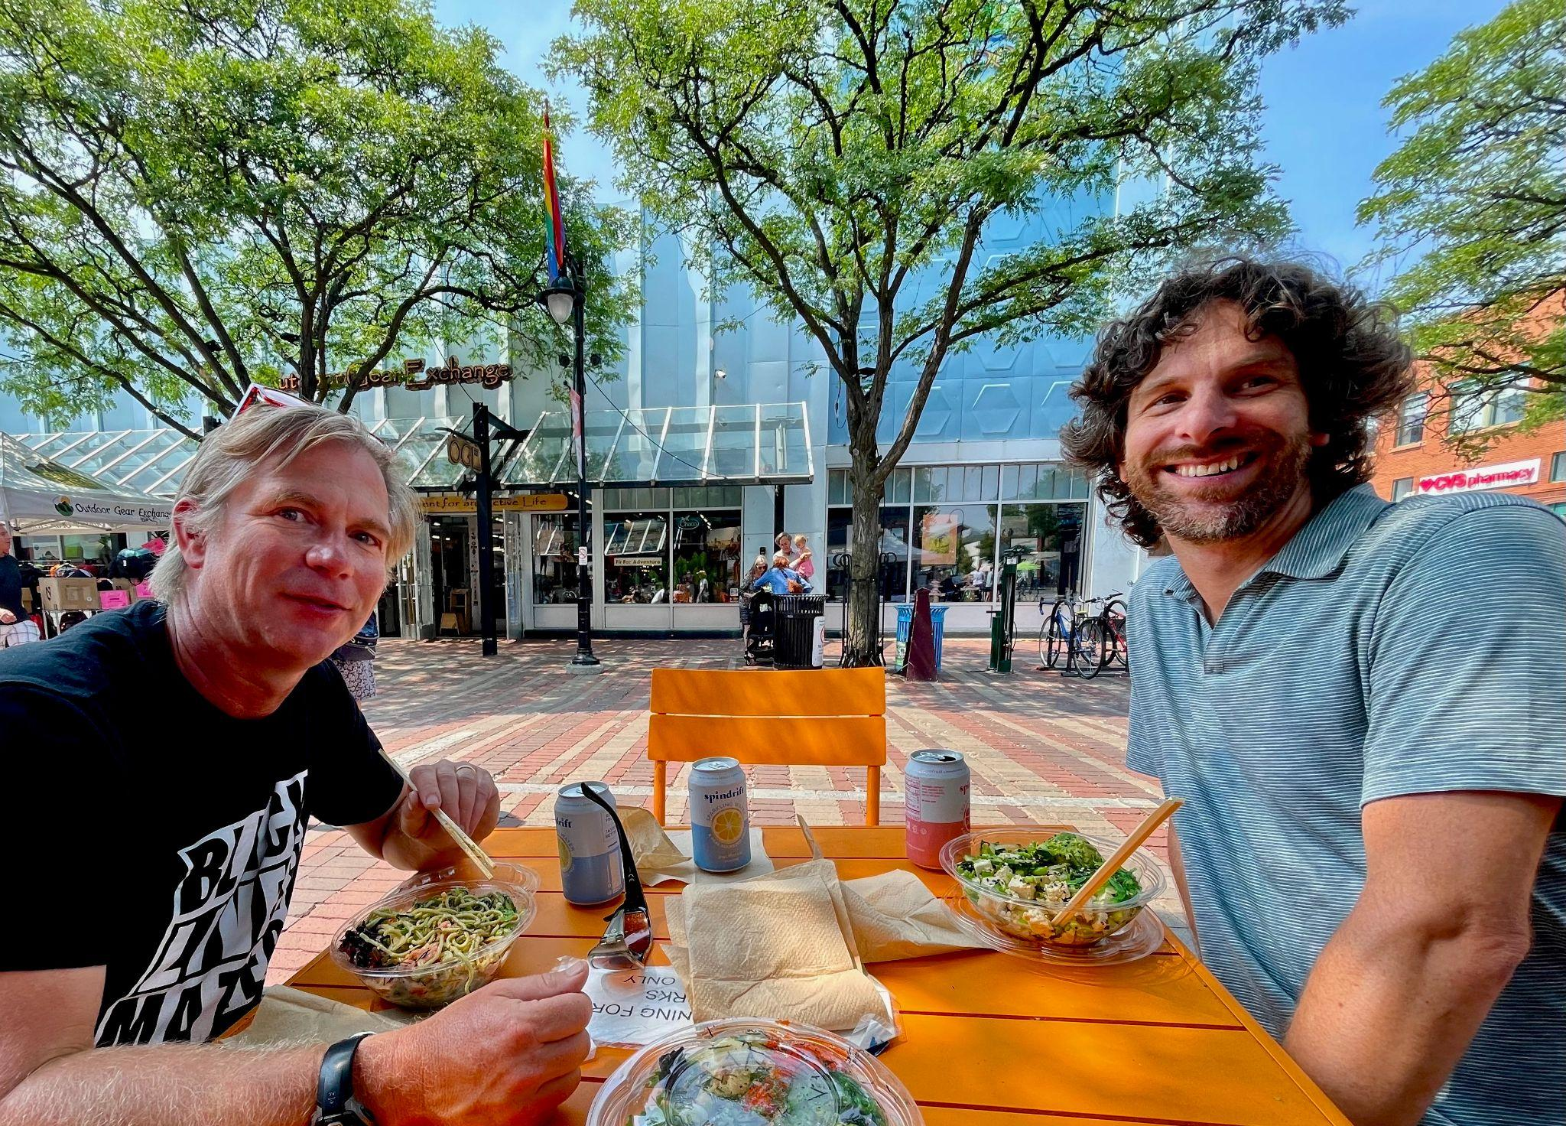

Tom Sabo (RF11) and Brian Boyes (RF14) got lunch in Burlington with Mike Martin (RF09) to talk about music, education, and school leadership.

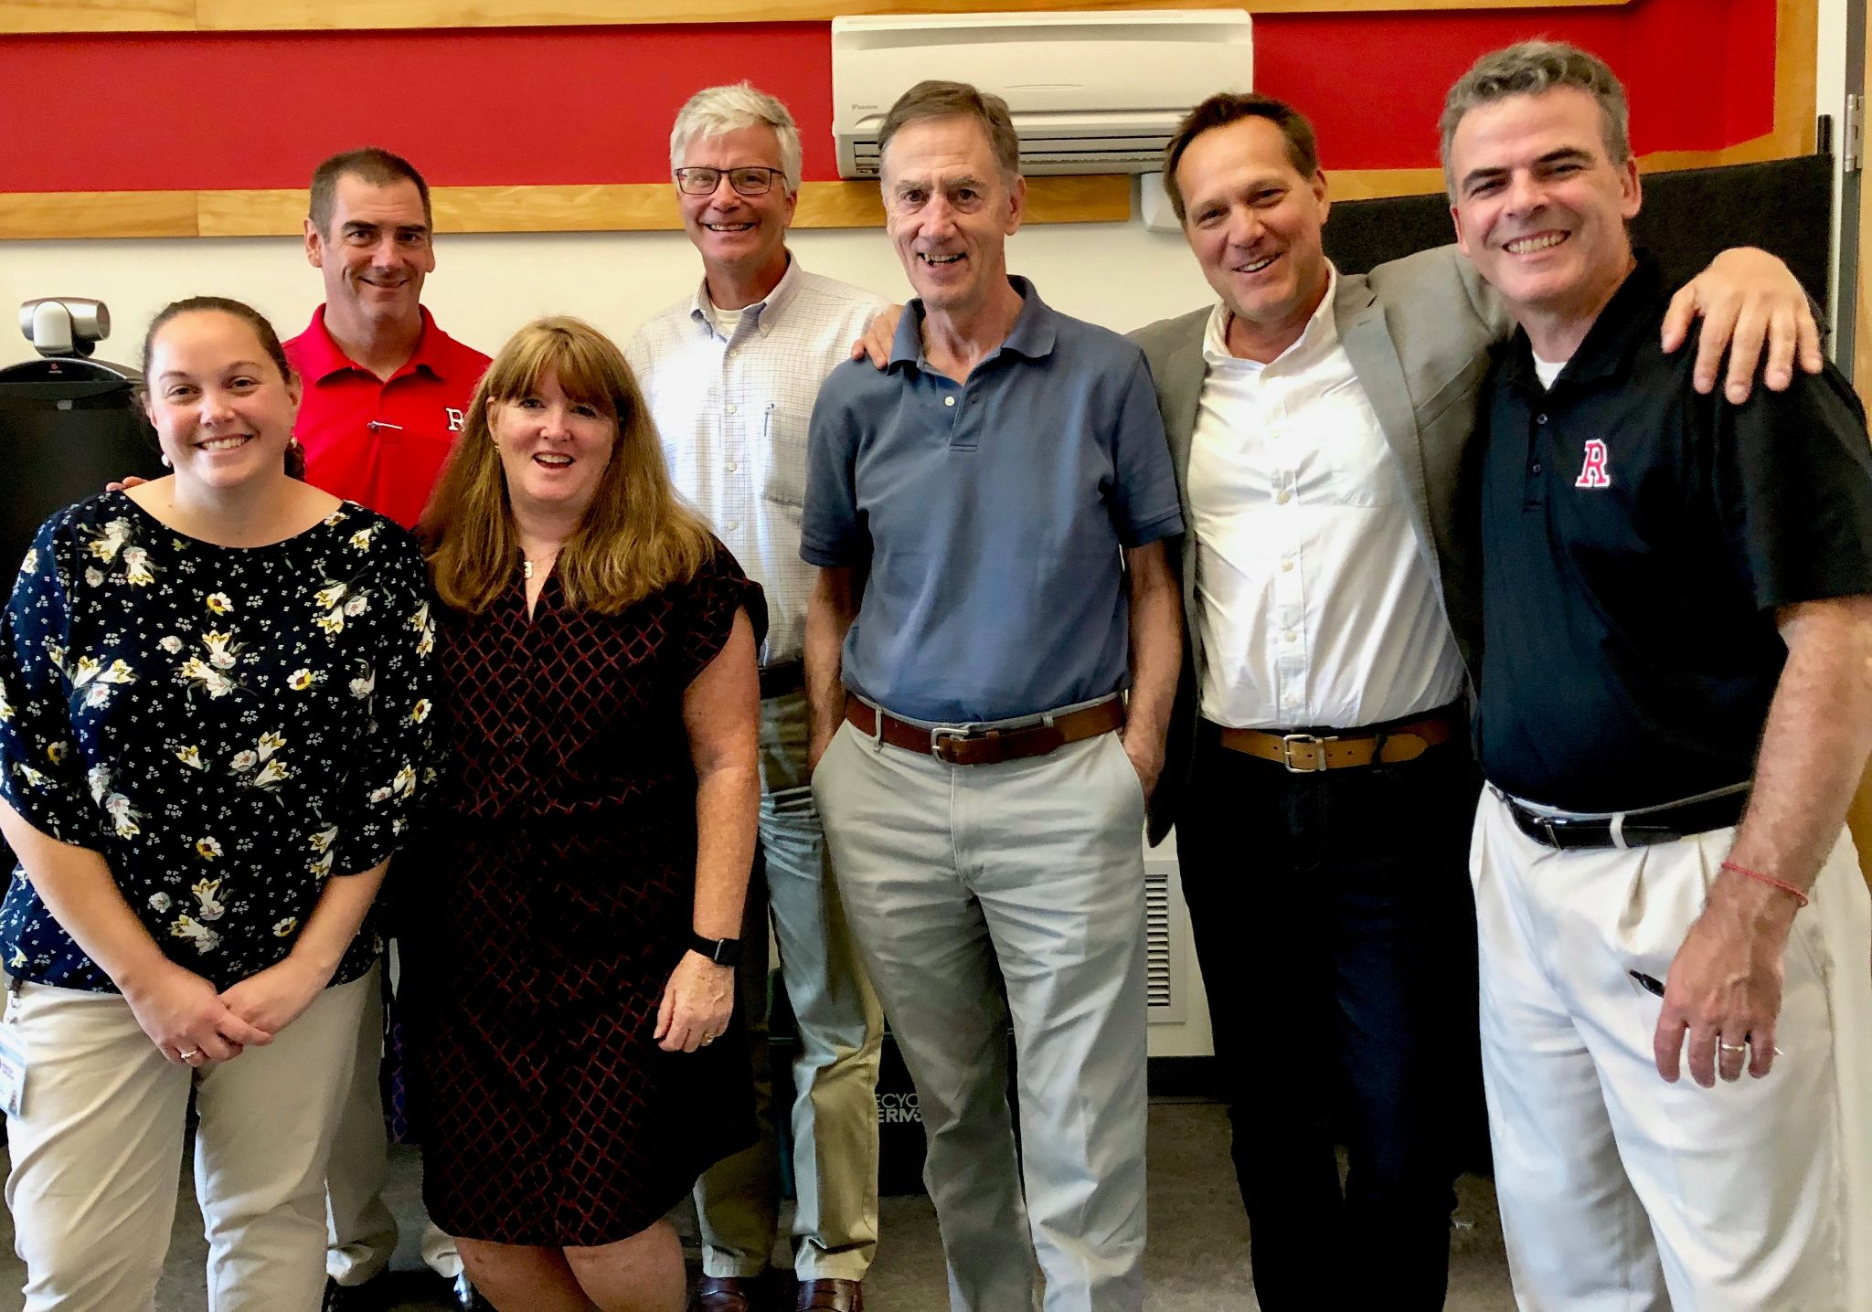
Rutland High School Principal Greg Schillinger, Associate Principals Bianca McKeen (RF16), Steve Sampson, and Jen Wigmore (RF16) met with Superintendent Bill Olsen, Chuck Scranton, and Mike Martin (RF09) to discuss community-based learning programs.
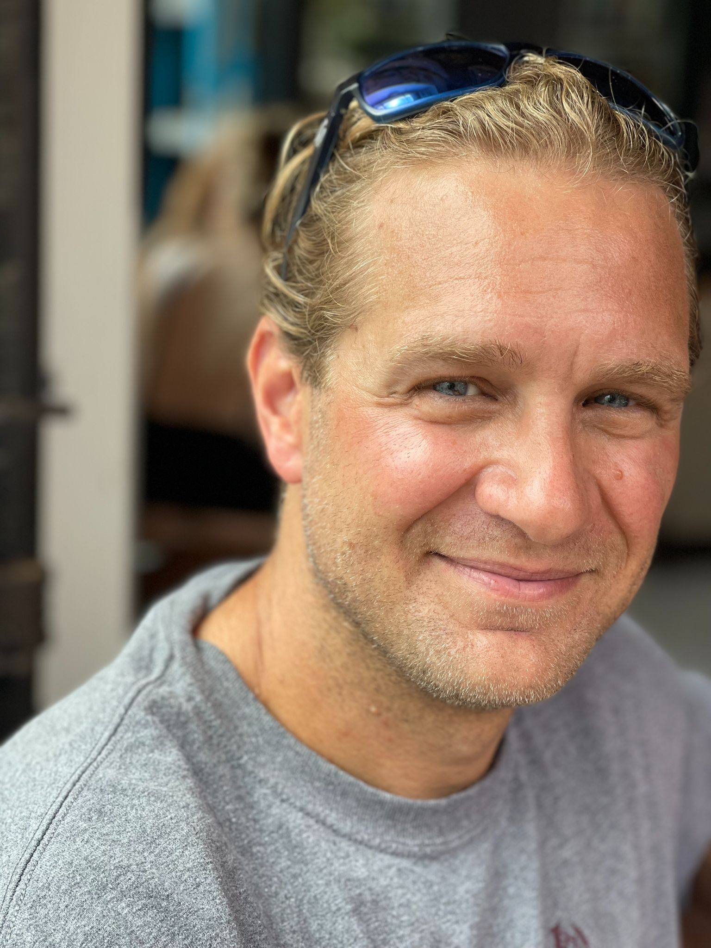
John Painter (RF14) met at the new Rowland Foundation offices at 47 Maple St., Burlington with Mike Martin (RF09) to discuss math curriculum and public school governance.

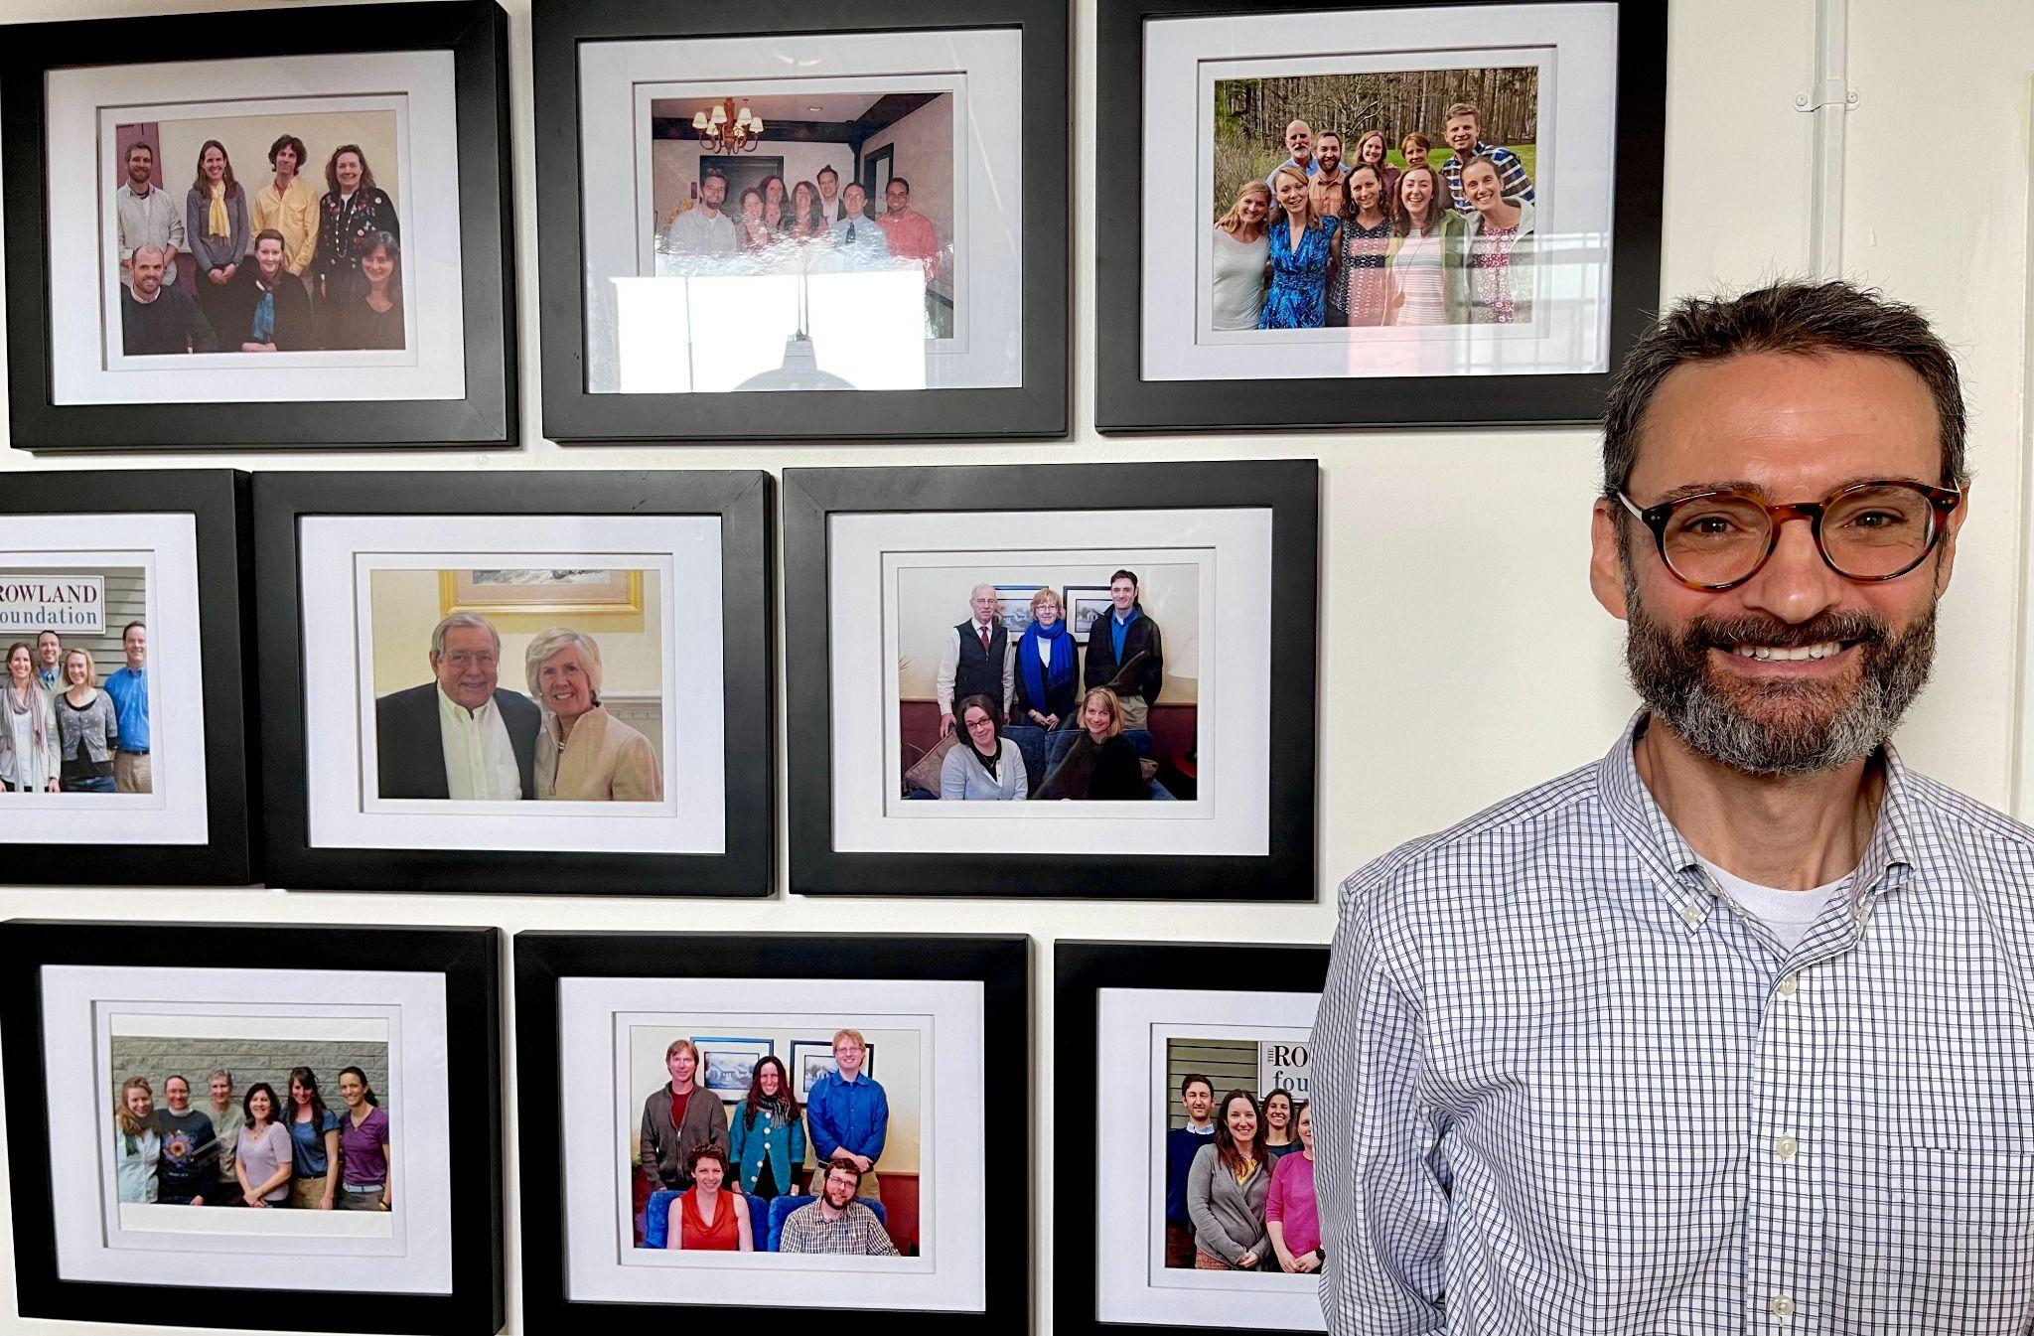
Adam Rosenberg (RF10) visited the new Rowland Foundation offices and met with Mike Martin (RF09) to share ideas about shared leadership.

Gratitude

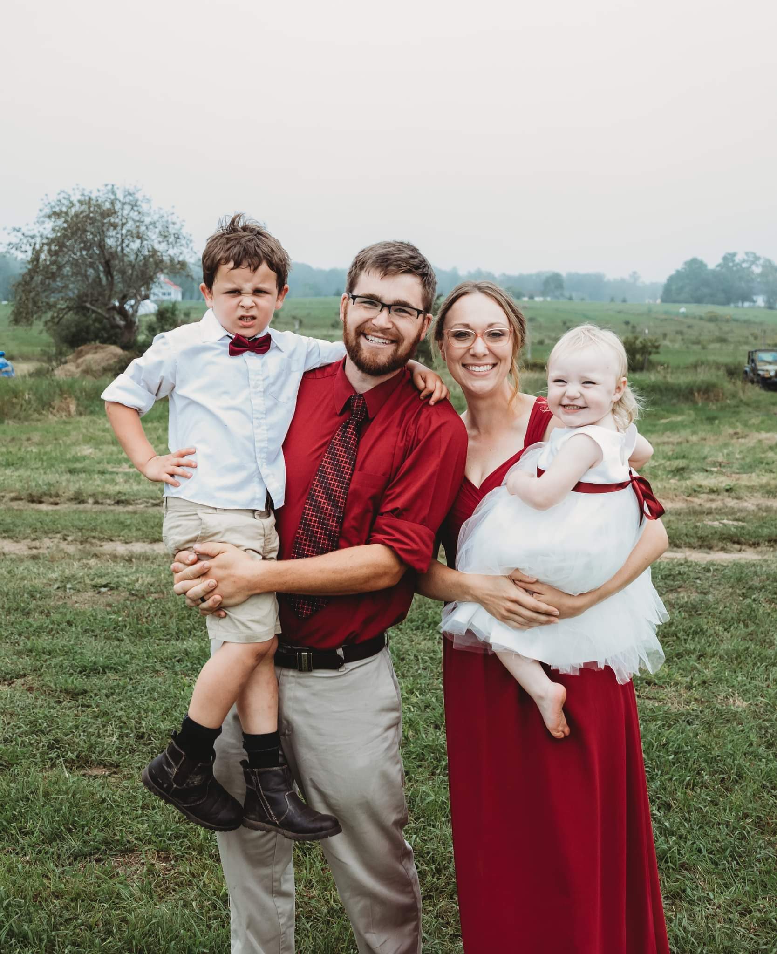
Kerianne Severy (RF17) attended a wedding with her son Caleb, her husband Nate, and her daughter Rachel, who served as “ringbearess”.

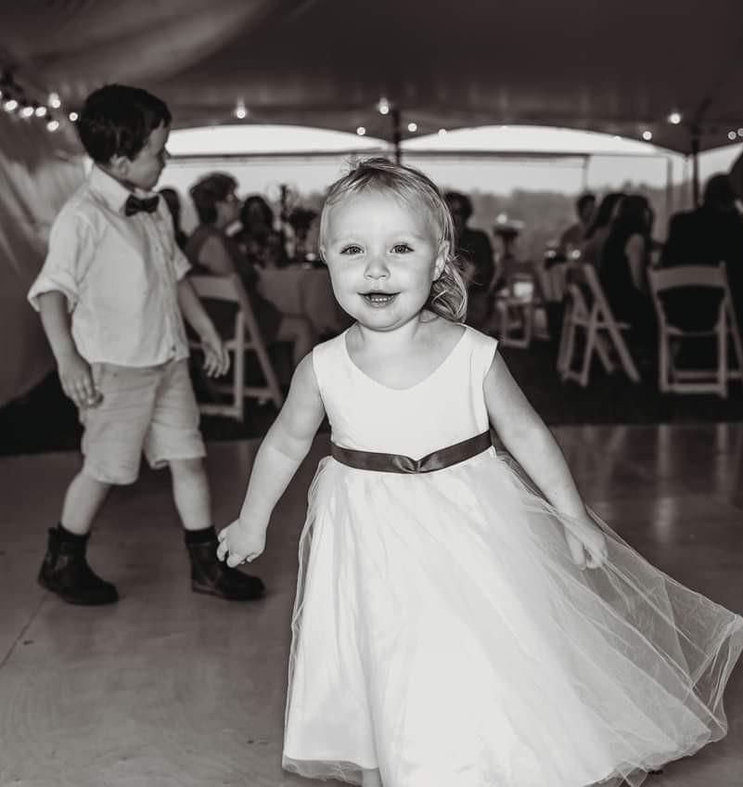
...and some Rowland Fellows may recognize Rachel as the newborn who attended the All Fellows Retreat with Kerianne in October 2019.

Celebrations
Kristin Cimonetti (RF20) will be serving as K-12 Fine Arts Coordinator for the Mill River Unified Union School District, in addition to her vocal/choral music teaching position.

Emily Gilmore (RF17) has accepted the position of Senior Associate with the Great Schools Partnership.

Sandra Mings-Lamar (RF16) is now the Director of Adult Education for Saint Johnsbury Academy. She also won the election to serve as the newest trustee of the Vermont State Teachers Retirement System Board.

Tim O’Leary (RF20) has started in a new role as an Instructional Coach & Curriculum Leader at Shelburne Community School.

Kerianne Severy (RF17) has been hired to work as a Systems Coach & Math Instructional Coach for the Mount Abraham Unified School District.

Caitlin Steele (RF09) has been named Assistant Superintendent of Teaching and Learning for Addison Central School District.

Courtesy Postings
Kathy Cadwell (RF16) is available to consult with districts as a Harkness expert. She is currently teaching a related graduate-level contract course through St. Michael’s College for staff at Champlain Valley Union High School. Check out her resource-rich website Strategies in Classroom Dialogue and feel free to recommend her to school leaders looking to develop meaningful student voice, civic discourse, or collaborative practice for equity in the classroom.

Anja Pfeffer (RF21) is teaching Dare to Be Me for Castleton University’s fall semester. This trauma-informed course which seeks to reconnect educators with nature, mindfulness, and holistic wellbeing could not come at a better time for teachers, guidance counselors, and administrators.

