 | Letter to Fellows  Social Media & Mental Health  June 2023

Dear Rowland Fellows,

I hope you’re seeing summer on the horizon.

Sometimes it’s hard to see change. Nowadays, with technology moving so fast, we’re used to things changing all the time, which makes it easy to forget how different life was just a few years ago. Saying “I remember when…” doesn’t help either. It just makes young people roll their eyes. And yet, remember family dinner before cell phones? The truism that tech changes everything is so obvious that we sort of stop thinking about it. But if we take a moment, we can see that the way we live now is very different from just a decade ago...and that change is accelerating. In fact, the more things change, the harder it is to take stock of this continuous change, which, paradoxically, becomes its own kind of constant.

And when it comes to the pernicious effects of social media and technology, not all change is good.

For example, I’m just old enough to remember teaching before email. That’s right, I started teaching in the last millennium, and I can assure you that it was an entirely different job back then. A few years later, in the 2010’s, Magali & I were able to keep our kids from getting cell phones until 8th Grade, and even then, only flip phones–so, totally different from what parents are up against now. Honestly, I can’t imagine how hard it must be to be a parent these days, trying to safeguard your kid’s self-esteem, social skills, autonomy, and physical health in the face of the social media juggernaut.

Things really are totally different now for our young people, although it’s hard to put your finger on exactly when everything went weird. It’s strange to think that 38% of Americans didn’t even own a cell phone as recently as 2002, compared to 97% now, according to the Pew Research Center. And if that’s too far back for you, consider that only 35% of Americans owned a smartphone in 2011, compared to over 85% today. It makes you wonder if we’re using that expression “The Before Times” correctly…

I remember laughing the first time I heard about phantom vibration syndrome about ten years ago. Peter McConville (RF11) told me it kept happening to him during a backcountry trip in the Adirondacks he did without his cell phone. However, I definitely did not laugh when I first heard about the video game detox centers that were starting to spring up in Asia around that time. Of course, treatment for technology addiction is commonplace now, a whole industry actually.

So as sobering as it was, I was glad to see the recent U.S. Surgeon General’s warning that social media carries a “profound risk of harm” for children and adolescents. At minimum, the report lays down a marker that we’re not on a great path and calls for action. And by framing the problem as a health epidemic–similar to obesity (which also has systemic causes)–it seems like we may finally be taking this threat to our children's wellbeing a little more seriously.

As educators and/or parents, I recommend you check out Social Media and Youth Mental Health: The U.S. Surgeon General’s Advisory, which also includes recommended action steps for parents, caregivers, children, adolescents, companies, and policymakers. If you’re looking for an even shorter read (so you can get back to your social media, of course), you may want to check out the American Psychological Association’s Health Advisory on Social Media Use in Adolescence, just out this month, which also includes practical recommendations.

If you’ve read this far, it will come as no surprise that I am incredibly excited about Digital Wellness: Building a Healthy Relationship with Technology, a timely new resource guide for teachers & parents, written and created by our 2022 Rowland Encore Grant Team “Disconnect/Reconnect” made up of Anne Bergeron (RF11), Carrie Felice (RF13), Sarah Ibson (RF13) & Lissa Knauss (RF18). Over the past year, they have been compiling their research and field-testing their work with students and colleagues across school districts. The team will be presenting its findings at a Rowland Conference workshop on October 26th. Our Rowland Fellow author-educators are in the final stages of editing and page design, so stay tuned for this first-ever Rowland Foundation publication!

Wishing you a wonderful, unplugged summer,

Mike

P.S. Thanks to everyone for sending their personal, professional & family news! It’s important to celebrate these big life changes, and it’s helpful to use our network to share professional learning and other opportunities.

P.P.S. There’s no July newsletter, so see you in August. Hope you get outside and have fun!

Rowland Foundation Updates

The 12th Annual Rowland Conference
Growing Community: Making Space for Joy & Creativity in School

Pre-registration for the 12th Annual Rowland Conference only has room for a couple more teams, so we will almost definitely close pre-registration well before June 30th.
Click here to save a spot for your school’s team(s) at the early bird rate.
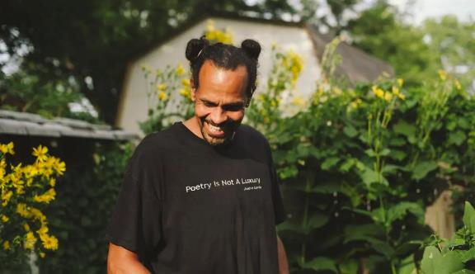
The essayist, poet, and educator Ross Gay will be our next keynote speaker for the 12th Annual Rowland Conference, to take place at UVM on Thursday, October 26, 2023. Dr. Gay is a professor at Indiana University Bloomington and the author of the New York Times best-seller The Book of Delights. His new book of essays is Inciting Joy. He won the National Book Critics Circle Award for poetry in 2016 and is a founding board member of Bloomington Community Orchard, a non-profit, free-fruit-for-all food justice and joy project.

Diversifying the Educator Workforce
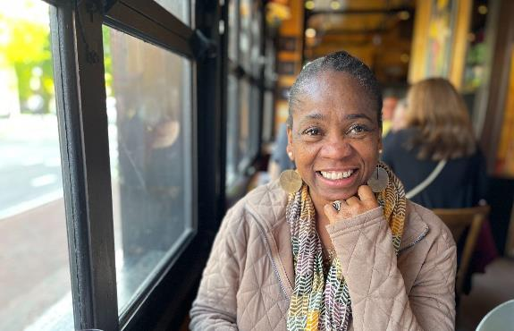
Rowland DEW Mentor Bonnie Johnson-Aten, a longtime Vermont teacher, principal and former member of the State Board of Education, met with Executive Director Mike Martin to debrief her first year supporting aspiring educators of color through the Rowland Diversifying the Educator Workforce (DEW) Grants. DEW Grant recipients have said that they value the mini-cohort model and mentoring support as they navigate pathways to Vermont educator licensure. Bonnie currently serves as Executive Director of Leadership for Burlington School District and also facilitates “A Place of Our Own”, an affinity group for Vermont administrators of color which operates with support from the Vermont Principals Association.

Rowland Encore Grant Teams
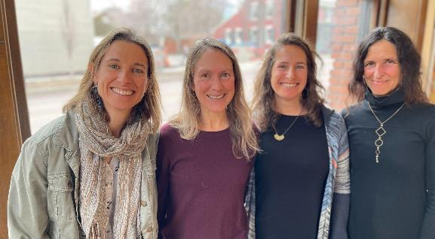
Our 2022 Rowland Encore Grant Team Disconnect/Reconnect, Lissa Knauss (RF18), Carrie Felice (RF13), Sarah Ibson (RF13), and Anne Bergeron (RF11), recently presented Digital Wellness for Teens, a workshop for educators at Dynamic Landscapes, a statewide education technology conference held at Champlain College. Lissa & Carrie also presented to the Rowland Foundation Board of Trustees a preview of their upcoming white paper, which focuses on technology and wellbeing, and includes practical resources for educators and parents alike.

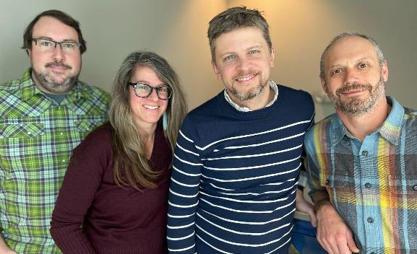
Our 2023 Rowland Encore Grant Team on Deeper Learning, Andrew Jones (RF15), Jess DeCarolis (RF09), Michael Ruppel (RF17) & Gabe Hamilton (RF15) have begun work and are looking forward to an extended weeklong work session together this summer in Maine.

Cohort Meetings
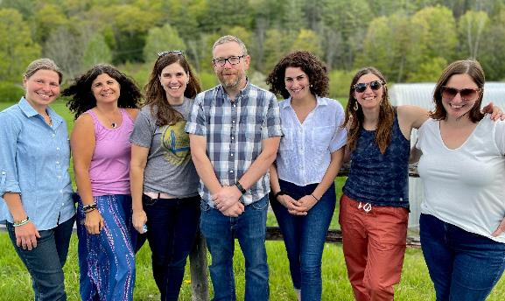
Our 2021 Rowland Fellows had their last official cohort meeting this month in Woodstock. It was an amazing day of shared gratitude, connection, and reflection together.
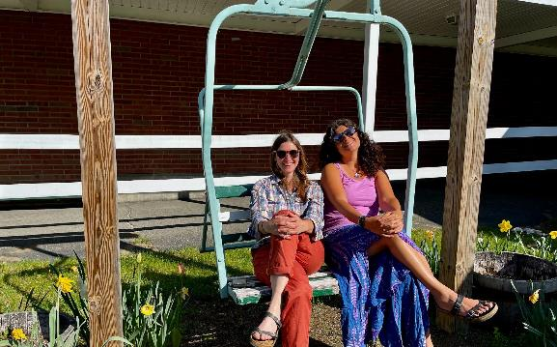
Kat Robbins & Janis Boulbol wait for their cohortmates to arrive in the chairlift in front of Woodstock Union Middle School & High School.
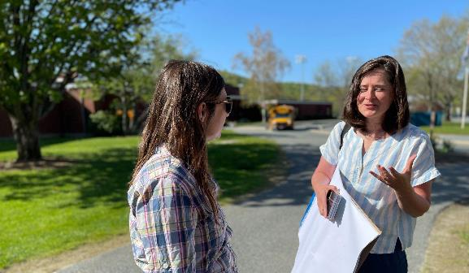
Senior Associate Jeanie Phillips (RF14) looking forward to a great day of facilitating with the 2021 Cohort of Rowland Fellows.
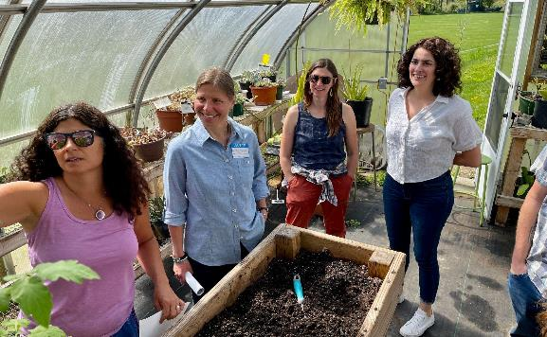
Janis Boulbol giving a tour of the Woodstock greenhouse to her fellow 2021 Fellows, Anja Pfeffer, Kat Robbins & Nicole Awwad, seen here stopping at a student’s favorite tomato plant.
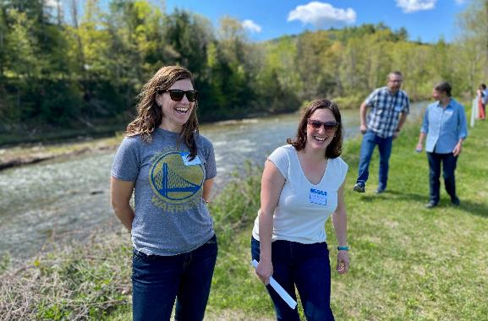
Rachel Howes, Samantha Mundt, Brent Litterer & Anja Pfeffer reflecting on their Rowland Fellowship experience with a walk & talk.
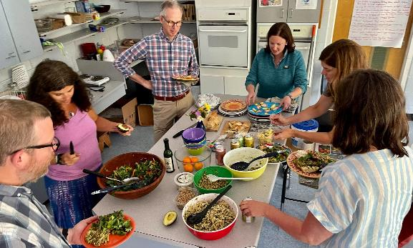
Woodstock Principal Garon Smail joined the cohort meeting to take part in the incredible localvore lunch!
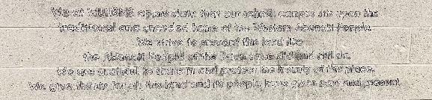
A powerful new land acknowledgement visible in the halls of WUMHS, still in the process of being completed by students.
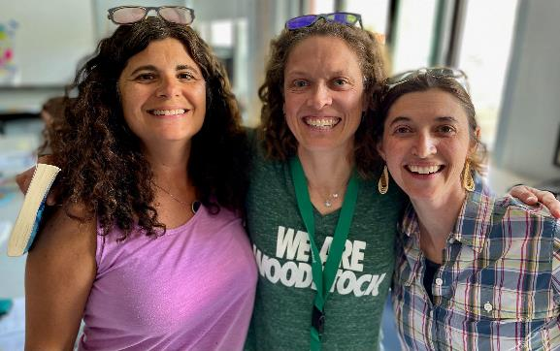
Sarah Hagge (RF16) who now teaches at Woodstock came by to say hi to her fellow Fellows!
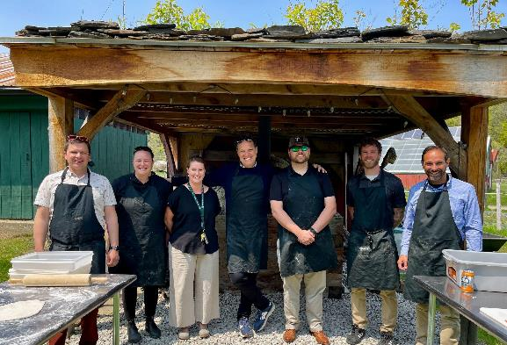
The 2022 Cohort of Rowland Fellows met in Montpelier, seen here in front of the Montreal style earth oven built by the students of Sam Bromley and Tom Sabo (RF11), with Assistant Principal Emily Therrien (RF19). (left to right) Sam Bromley, Becky Ebel, Emily Therrien, Executive Director Mike Martin (RF09), Devon Karpak, Bryan Dickinson & Senior Associate Jean Berthiaume (RF09).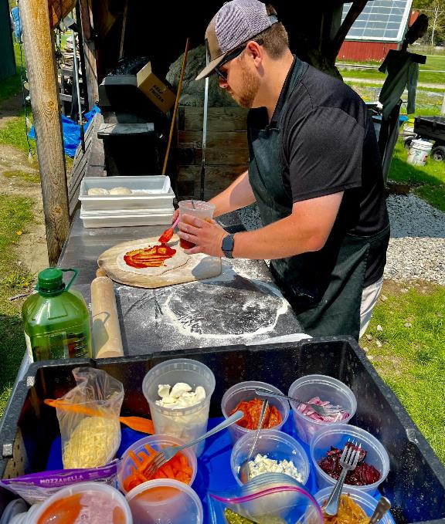
Devon Karpak working with flatbread fixin’s that originate for the most part in the Montpelier High School greenhouse just yards away from this meal.
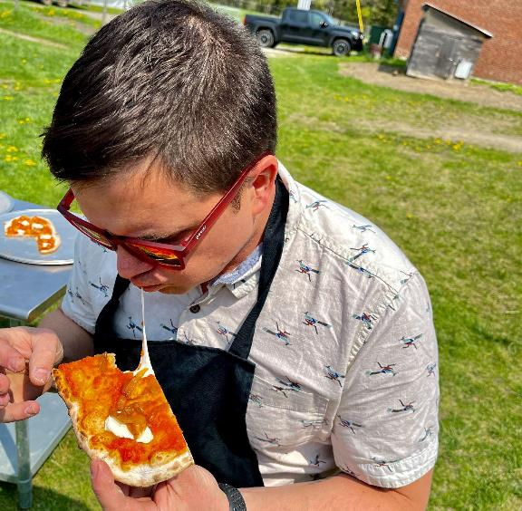
Sam Bromley savoring his localvore flatbread.
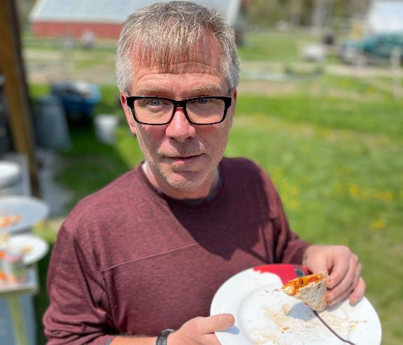
Tom Sabo (RF11), whose Rowland Fellowship focused on sustainable food systems, came by to say hi to the 2022 Cohort.

The Rowland Women Leadership Retreat
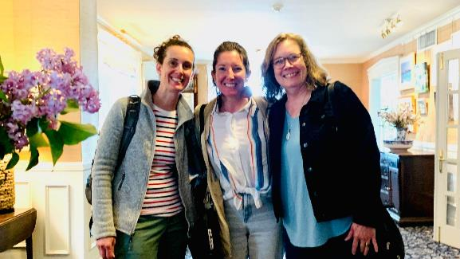
The 2023 Rowland Women Leadership Retreat is only days away! Gretchen Muller (RF17), Tara Cariano (RF18), and Marsha Cassel (RF14), seen here at Basin Harbor Club, are excited to have this amazing opportunity to convene Rowland Women on Sunday, June 4th through Monday, June 5th.

The Board of Trustees
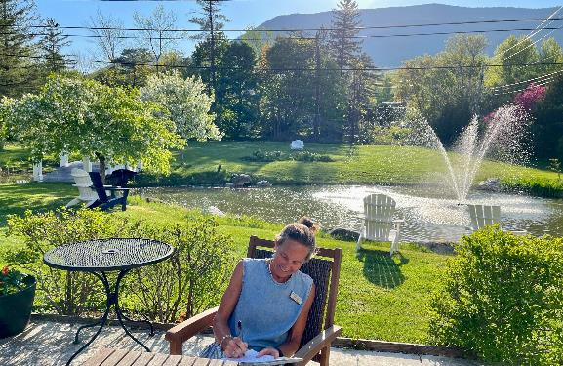
The Rowland Foundation Board of Trustees held their spring meeting at the Reluctant Panther before the Annual Dinner & Reception. Board Chair Heidi Lynn seen here preparing her notes.
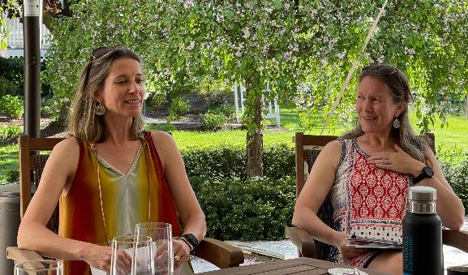
Lissa Knauss (RF18) & Carri Felice (RF13) presented some of their Rowland Encore Grant work on digital wellness to the Board of Trustees.
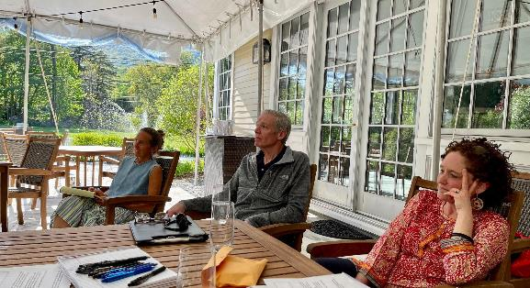
Board Chair Heidi Lynn seen here with Trustees Jake Shepard & Dr. Caitlin Steele (RF09) at the spring meeting of the Rowland Foundation Board of Trustees.
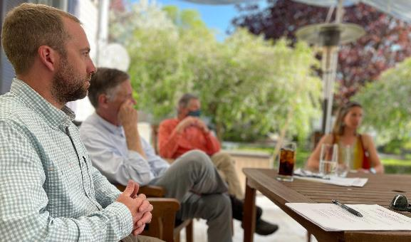
Board Secretary Carter Rawson seen here with Past Executive Director & Trustee Chuck Scranton, Trustee Jim Mooney, and Lissa Knauss (RF18).
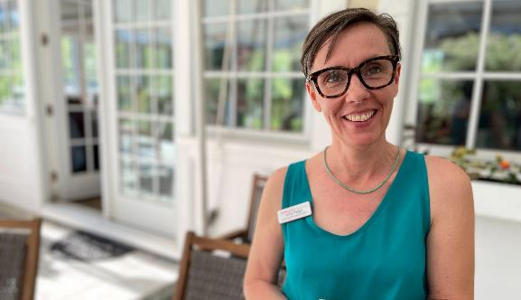
Executive Assistant Abby Paige seen here at the Board of Trustees meeting.

The Annual Dinner & Reception
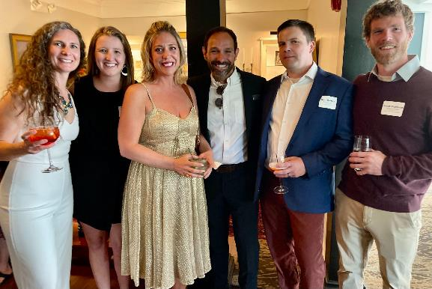
The Annual Dinner & Reception was held at the Reluctant Panther in Manchester to formally induct new Rowland Fellows and honor last year’s cohort’s work to date. Seen here at the reception (left to right) Northfield Middle & High School Principal Lee Ann Monroe, Northfield Assistant Principal Christine High, Carrie Gilman (RF23), Senior Associate Jean Berthiaume (RF09), Sam Bromley (RF22) & Bryan Dickinson (RF22).
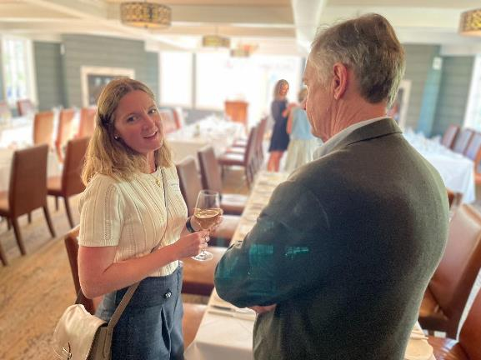
Edmunds Middle School Principal Sabrina Westdijk (RF17) attended the Annual Dinner in support of Lindsay McQueen (RF23), seen here catching up with Chuck Scranton.
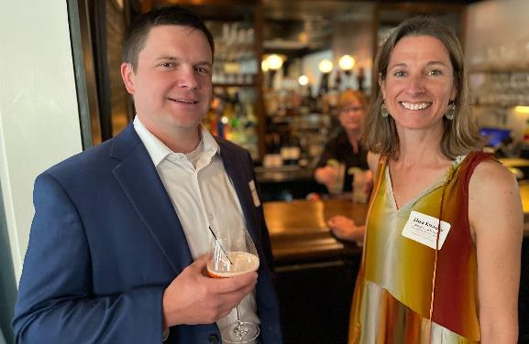
Montpelier colleagues Sam Bromley (RF22) & Lissa Knauss (RF18) connected with each other at the Annual Dinner & Reception.
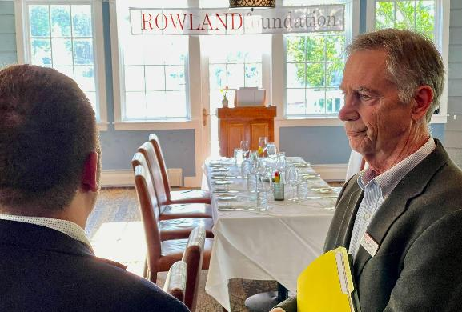
Rowland Foundation Co-Founder, Past Executive Director & Trustee Chuck Scranton spoke with Devon Karpak (RF22).
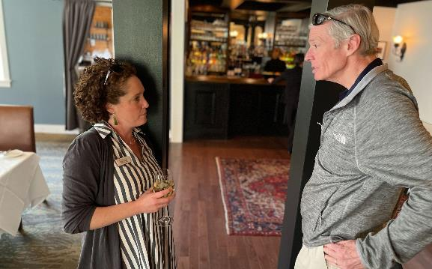
Trustees Dr. Caitlin Steele (RF09) and Jake Shepard connected at the Annual Dinner & Reception.
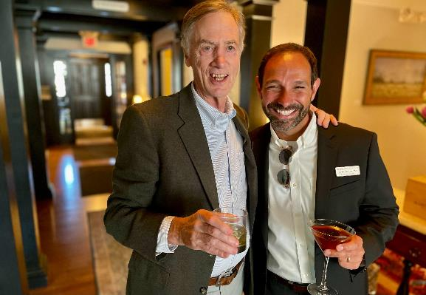
Longtime friends Chuck Scranton & Jean Berthiaume (RF09) were glad to see each other in person.
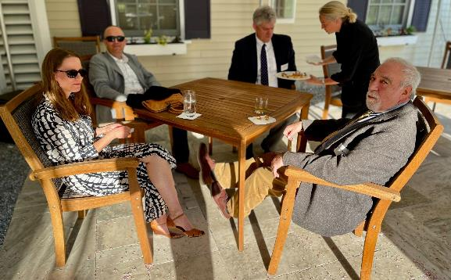
Jessica Dow, Adam Murray (RF23), Essex High School Principal Donald Nostrand & Robert Bursky enjoyed the nice weather on the patio at the Annual Dinner & Reception.
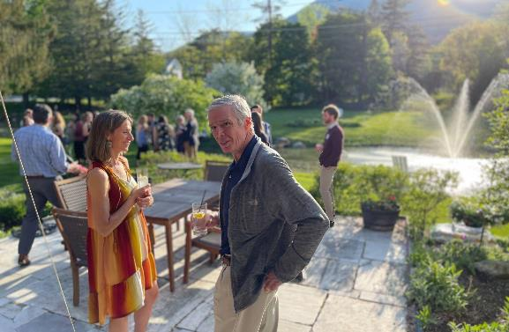
Lissa Knauss (RF18) & Trustee Jake Shepard at the Annual Dinner & Reception.
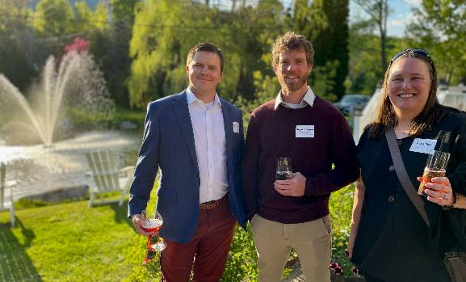
2022 Cohortmates Sam Bromley, Bryan Dickinson & Becky Ebel at the Annual Dinner & Reception.
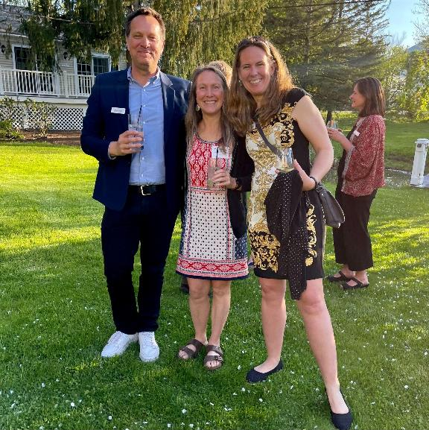
Mike Martin (RF09), Carrie Felice (RF13) & Trustee Erica Wallstrom (RF14)
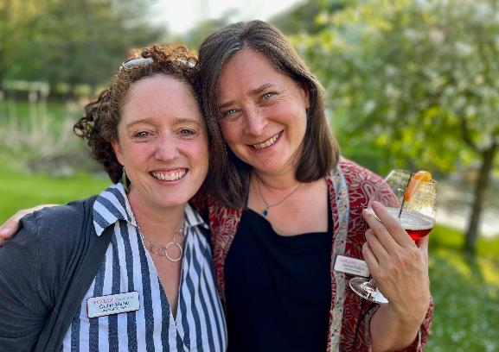
Trustee Caitlin Steele (RF09) & Senior Associate Jeanie Phillips (RF14) catching up.
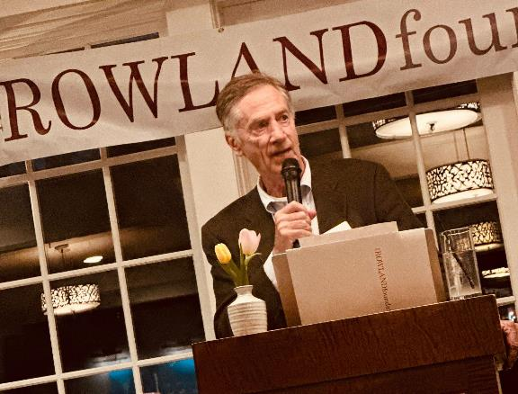
Annual dinner closing remarks came from Co-Founder, Past Director & Trustee Chuck Scranton.
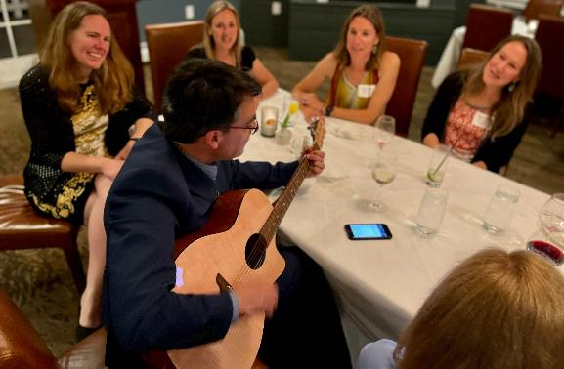
Rodrigo Placencia led a singalong at the end of the evening, seen here (clockwise) with Trustee Erica Wallstrom (RF14), Senior Associate Lori Lisai (RF15), Lissa Knauss (RF18), Carrie Felice (RF13) & Elizabeth Placencia (RF23).

The Fellowship Launch
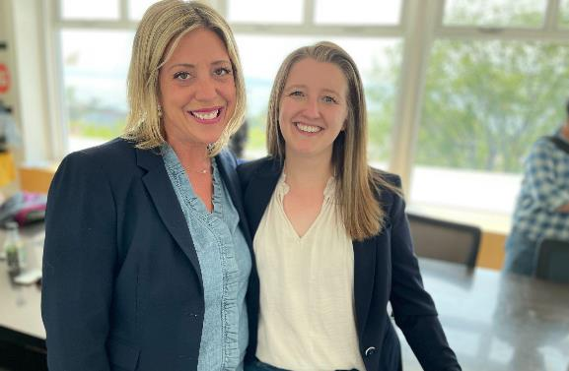
For the third year in a row, during the week following the Annual Dinner, new Rowland Fellows and their principals met at the Karma Birdhouse rooftop conference room for a daylong planning session called the Fellowship Launch. Carrie Gilman (RF23) is seen here with Northfield Assistant Principal Christine High. Principals will also join their Rowland Fellows for the daylong Shared Leadership Retreat with Steering Committees in September.

Connecting the Dots
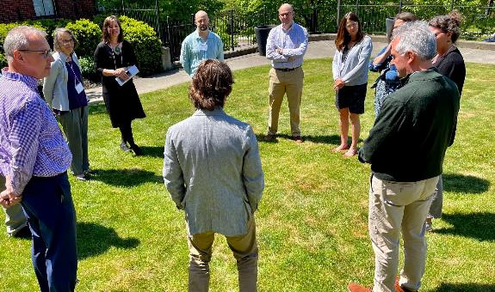
Jeanie Phillips (RF14) & Mike Martin (RF09) led a workshop called The Rowland Approach: Shared Leadership for Strong School Culture at “Connecting the Dots”, the annual VSA/VCSEA/VTCLA Conference at the Hilton Burlington Lake Champlain. Jeanie is seen here with Superintendents Sherry Sousa of Windsor Central Supervisory Union, Mike Leichliter of Harwood Union SD, Brian Alexander Hill of Mill River Schools, and Layne Millington of Orange Southwest SD (counterclockwise from Jeanie).
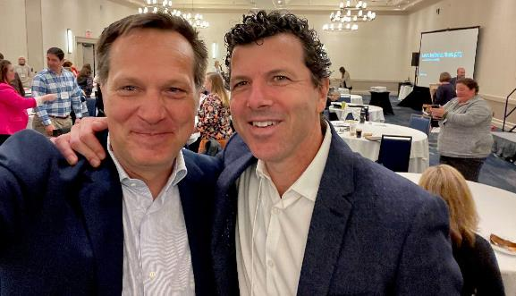
Mike Martin (RF09) seen here at the Connecting the Dots conference with Addison Central SD Superintendent Peter Burrows. Peter has accepted a new position as superintendent in Massachusetts and will be missed by his Vermont colleagues.

Gratitude
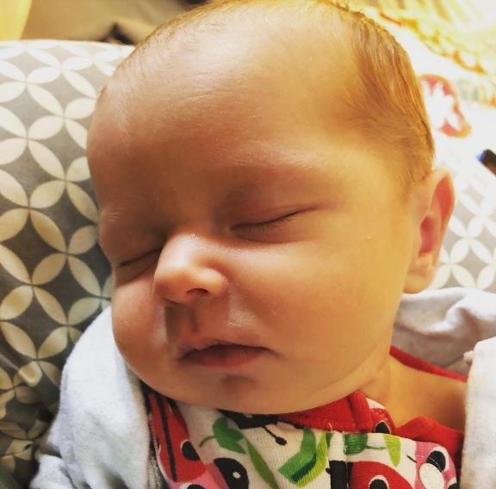
Jess Barewicz (RF14) welcomed a new baby, Elora Marcelle, into her family on April 14.

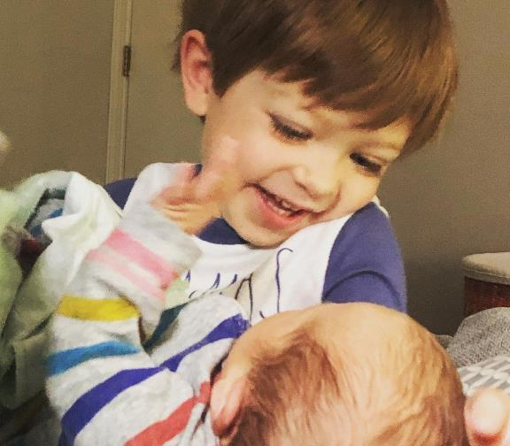
Three year old Emerson is also over the moon in love with his new sibling!

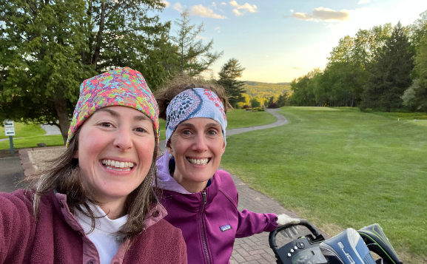
2017 Cohort mates Emily Gilmore & Gretchen Muller are grateful for their friendship, both on and off the links. “Nothing says, ‘Yay! Golf!’ like 48 degrees” Emily said.


Now that it is spring, Andrew Jones (RF15) has transitioned into rock climbing mode, seen here doing a “trad lead” over at Chapel Pond in the Adirondacks.

Celebrations

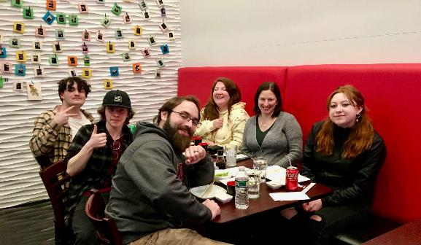
Samantha Mundt (RF21) took a group of Twin Valley High School teachers and leadership students to Brookline High School to experience the town meeting at their School Within a School Program. Samantha and her colleagues plan to use the town meeting structure first in student leadership, then slowly implement it in their school democracy to foster more student voice and choice at Twin Valley High School.

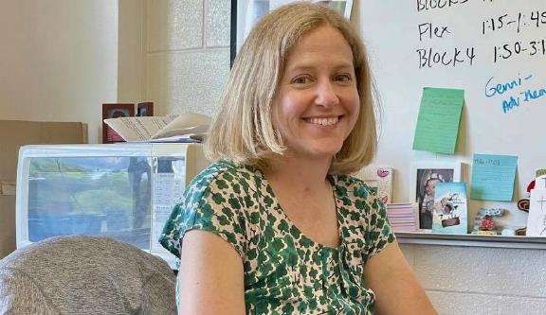
Congratulations to Elizabeth Placencia (RF23)! Her Rowland Fellowship work on new teacher mentoring was recently featured in this nice article from the Addison Independent.

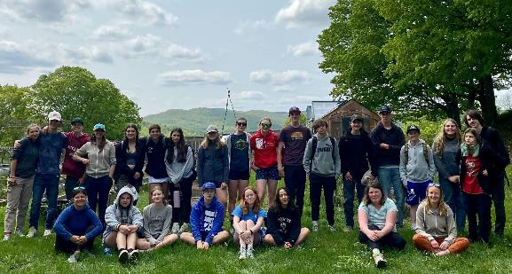
The first official year for the CRAFT program at Woodstock Union High School is wrapping up! Current and rising CRAFT students gathered at Springbrook Farm in Reading to tour the cheese making operation and dairy barns. We also reflected on the first year of classes and experiences and set some good structures and excitement in place for the 23-24 school year. For a closing reflection, students completed this phrase: "CRAFT IS" with the following words: hands-on, community, helps you get outside, fun, an adventure, a lot of trees, community building, creative, gardening, fun, cool, awesome, amazing, great, exciting, building resilient systems, not boring, creativity, our future, growing and eating a lot of good food, learning, an experience, outdoorsy, interesting, and crucial for our future. Couldn't have said it better!

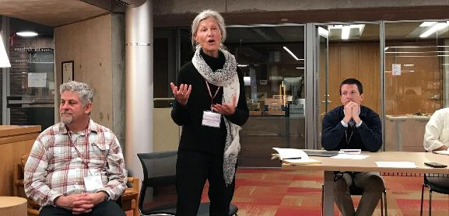
Kathy Cadwell (RF16) was recently invited to present at the Harkness Leadership Conference hosted by Phillips Exeter Academy. Harwood, CVU and Hazen (all schools Kathy has been working with) were invited to attend. Harwood gave a presentation on the Harkness work that has been in place for the past 7 years.

Congratulations to Kendra LaRoche (RF11)! Starting July 1, she will be serving as the Executive Director of the Special Needs Support Center in White River Junction.

Courtesy Postings
VPA Professional Learning: Five New Offerings Announced
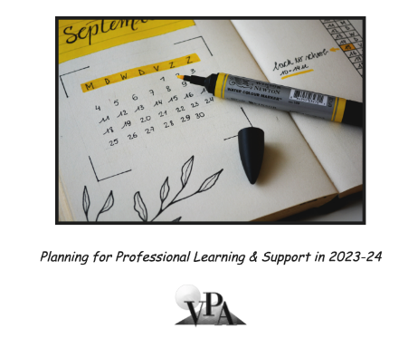
Onward: A Yearlong Emotional Resiliency Immersion for Educators
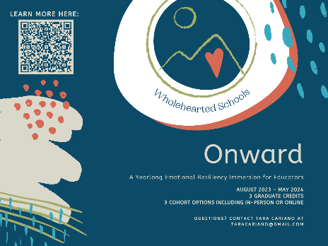
3 Graduate Credits from Castleton University
In this immersive experience, educators will be provided the structure, knowledge, and guidance to reflect on their professional journey, contemplate change, practice new ways of being, and co-create a community of support. Throughout the school year, we will learn strategies and apply mindset shifts to manage stress and overcome the challenges of the teaching profession. Monthly class times will be supported as a confidential place to celebrate bright spots and share struggles as we work to learn from one another and cultivate resilience.

Audience: All educators including PK-12 teachers, administrators, school counselors, school-based clinicians, school social workers, librarians, school nurses, instructional coaches, interventionists, and any additional support staff and personnel
Format: Options for both in-person cohorts (including a Central Vermont cohort and a Northern Vermont cohort) and a fully online cohort
Dates: August 2023 - May 2024, Course will meet for a full-day in August (Two ½ days for online cohort) followed by monthly two hour classes in September through May (either in-person or online depending on your cohort)
For more information including dates and times, check out the registration form here which also includes a link to the syllabus with all the details.
Questions? Contact Tara Cariano at taracariano@gmail.com
BIPOC Summer Camp
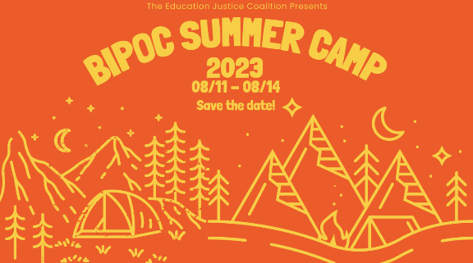
The Education Justice Coalition of Vermont is hosting an informational session on Wednesday, June 7 (6:00-7:00 pm) for its upcoming BIPOC Summer Camp. Feel free to contact Education Justice Organizer Kayla Loving with any questions: kayla.edjvt@gmail.com

William Parker VT School Tour
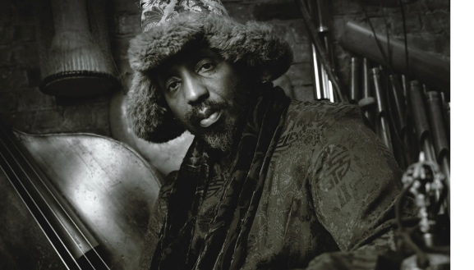
Rowland Foundation Executive Assistant Abby Paige is working with a group that is planning to bring renowned free-jazz musician William Parker to Vermont for a tour of a handful of middle or high schools. Mr. Parker is an African American bassist, improviser, composer, writer, and educator, familiar to many Vermonters as a long-time collaborator with the late Vermont poet David Budbill. If your school might be interested in hosting William, please get in touch with Abby for more information: emailabbypaige@gmail.com
Rowland Foundation & Great Schools Partnership Summer Course!

If you missed our new Collaborative Practices for Equity course last fall, mark your calendars for the next time it will run with our 2023 Cohort and other Vermont educators: August 16-18, Sept. 25, and Nov. 10. Senior Associate Jeanie Phillips (RF14) will be teaching the course at Shelburne Farms again, sharing wonderful food and a beautiful setting each day. The course is co-sponsored by the Rowland Foundation, Great Schools Partnership, and Shelburne Farms. If you’d like to learn more about this amazing professional learning opportunity, feel free to contact Rowland Fellows from this year’s alumni: Anne Bergeron (RF11), Sam Bromley (RF22), Bryan Dickinson (RF22), Devon Karpak (RF22), Becky Ebel (RF22), Gretchen Muller (RF17), Samantha Mundt (RF21), Anja Pfeffer (RF21), Kat Robbins (RF21), Kerianne Severy (RF17) & Patti Tomashot (RF22)

