 | Letter to Fellows  Capacity  December 2023

Dear Rowland Fellows,

I hope you’re enjoying the holidays so far and that you’ll soon find some rest and quiet too.

Thank you for recruiting new Rowland Fellows! At our recent Fellowship Info Nights in St. Johnsbury, Rutland, Burlington, and online, many teachers mentioned the ideas and encouragement that they’d received from Rowland Fellows this fall. Dear Fellows, you are the single most important factor in the quantity and quality of the Fellowship applications we receive each year. Thank you for spreading the word with your colleagues, neighbors, and kids’ teachers about the amazing opportunity that is a Rowland Fellowship.

In a moment when schools and teachers are up against so many challenges, I am truly grateful to work for an organization that honors teachers. A Rowland Fellowship gives teachers the opportunity to be innovators, leaders, and collaborators. Over the years, many Fellows have said that receiving a Rowland Fellowship validated their work in a way that changed their career, and even changed their life.

When you consider our country’s political divisions and the social ills that COVID only worsened, teachers are certainly up against a lot these days. This is surely part of why schools sometimes struggle nowadays to hire and retain classroom teachers, instructional assistants, or substitutes.

Unfortunately, I’ve heard some school leaders and teachers say they “don’t have the capacity” to support or lead Rowland Fellowship work right now. While I certainly understand the feeling — it’s hard to feel innovative when you’re in survival mode — I couldn’t disagree more with this idea. A Rowland Fellowship is not simply recognition. With the shared purpose, new learning, and collaboration that comes with a Rowland Fellowship, it is also a major boost to any school. With principals spread thinner than ever, shared leadership is a must, and Rowland Fellowships provide the means to develop leaderful organizations. Along the same lines, our mission to “positively change the culture and climate of schools” seems more important than ever. Plus, connecting your school to the Rowland network of educators around Vermont helps teachers feel a little less isolated and a little more empowered.

I understand that some principals and superintendents will struggle to grant a “sabbatical” to one or more of their best teachers, but I would argue that a new Rowland Fellow is still working very hard for their school, just in a different capacity — and in a way that actually increases their school’s internal capacity. Many principals have a mental list of school change ideas that they want for their schools, but that seem out of reach given the daily demands of their jobs. A Rowland Fellowship can help! Rowland Fellows mobilize and support teachers’ work together to positively change culture and climate in any number of ways. At a time when teachers are in short supply, a Rowland Fellowship can nourish teachers in a way that sustains them.

We know that the pandemic has taken a toll on our society — schools included, of course — and our country is also living through concurrent epidemics of gun violence, opiate addiction, suicide, and homelessness. I don’t say “epidemic” here because any of these are naturally occurring, but only because they are so widespread and seemingly contagious.

So even as we head into the hopefully joyful, but often exhausting, holiday season, many of us are thinking about how fragile everything feels in this moment, including our own wellbeing. Apparently some people are now turning to the holiday “pretox” or “preset” as a way to keep it together. Expectations with work, family, and everything in between can pile up during the holidays in a way that’s not always good for us.

All that is to say that our society needs to change, including the way we do school. When we feel that everything’s broken and nothing’s working, we don’t always feel we have the capacity to lead change, when in fact that’s when we need it most. Our exhaustion is telling us that we need systemic change and not just a few tweaks, or a new app, or longer hours.

When I think about Rowland Fellowship work, I think of a systemic, transformational approach, whether the focus is restorative practices, racial equity, climate justice, social emotional learning, nature-based education, collaborative practices, or community-based learning, just to name a few examples. I also think about a way of working that is joyful. This type of work is just what schools need most right now. When I see Rowland Fellows working with their Steering Committees, there’s a hopefulness, generosity, and productivity that looks like collective teacher efficacy. Who wouldn’t want that for their school community?

I wish every Vermont school could benefit from a Rowland Fellowship. I’m going to keep working to spread the word, and I hope you will too. I’m often inspired by how veteran Rowland Fellows help new Fellows’ work in their school communities. Thank you.

I wish you strength and serenity in these last weeks before vacation. I hope that your school community is doing okay as we head into the holidays.

Take care and see you soon,

Mike

P.S. Thank you for sending me your news, celebrations, photos, and courtesy postings!

Rowland Foundation Updates
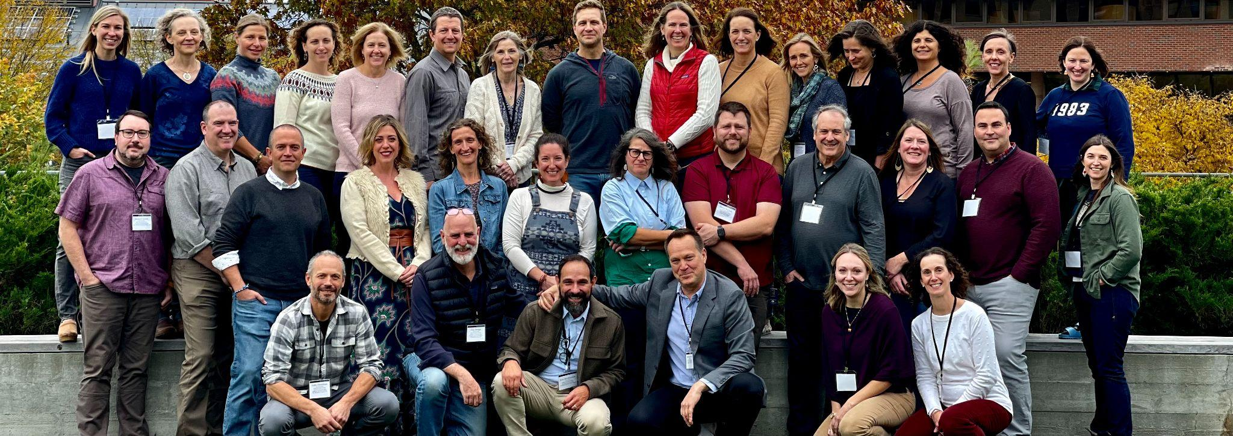
Rowland Fellowship Application Deadline
Please keep spreading the word about Rowland Fellowships! The December 31st deadline for this incredible opportunity will come up quickly. Teachers can find helpful information and a link to the application on our website’s homepage. Any public Vermont middle or high school and any of the four academies can submit up to two Rowland Fellowship applications, provided they don’t already have a Fellow in the two-year cycle. And please let prospective candidates know that our Senior Rowland Associates are available to help them with their applications since they are not part of the selection process:
Jean Berthiaume jean@therowlandfoundation.org
Jeannie Phillips jeanie@therowlandfoundation.org
Lori Lisai lori@therowlandfoundation.org

The Rowland Encore Grant (REG)
December 31st is the deadline for veteran Rowland Fellows to submit a Rowland Encore Grant Team proposal for a regional or statewide initiative. You can see the guidelines here. Members of our 2023 REG Team shared some of their work and led a lively table discussion at the All Fellows Retreat on deeper learning for democracy. Members of our 2022 REG Team presented their work on digital wellness in a workshop at this year’s Annual Rowland Conference.

Rowland Women’s Leadership Retreat
Heartfelt congratulations and sincere thanks to Angela Bauer (RF15), Ellen Berrings (RF13), and Abbie Bowker (RF17)! They are the Planning Team for the 2024 Rowland Women’s Leadership Retreat. They will be getting together soon for initial planning and then reserve a retreat venue for the spring. Stay tuned for more details in the months ahead!

The All Fellows Retreat
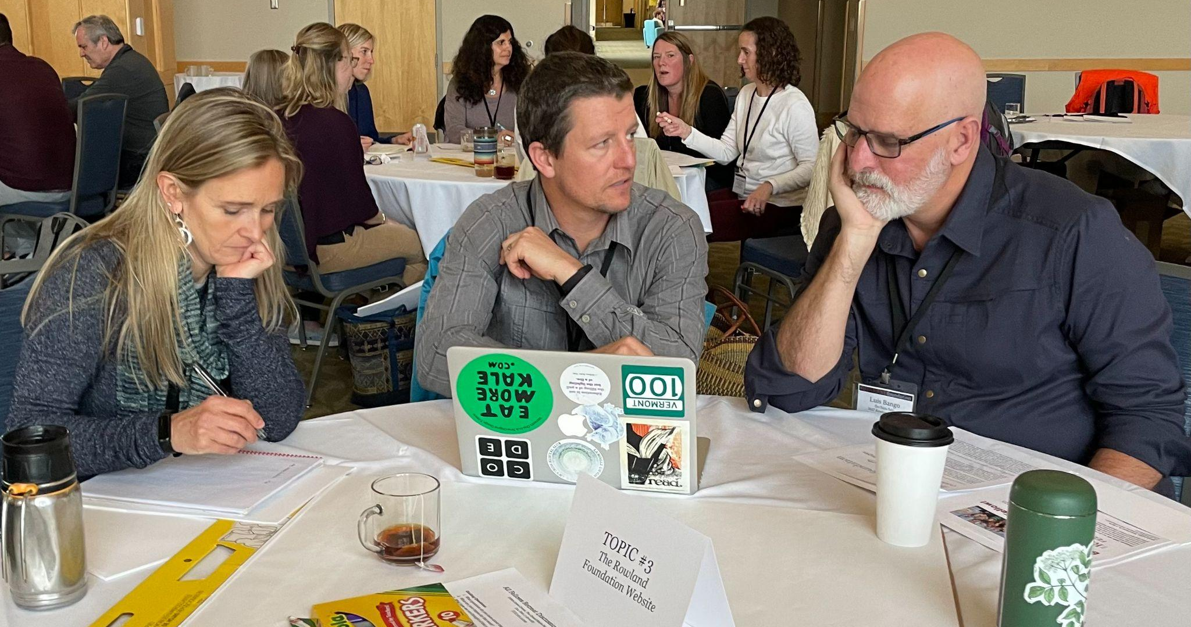
The conversations were terrific at the All Fellows Retreat this year! You can see here the Round Table Discussion Notes & the 2023 Rowland Encore Grant Team’s slidedeck on Deeper Learning for Democracy.

Rowland Fellowship Info Nights
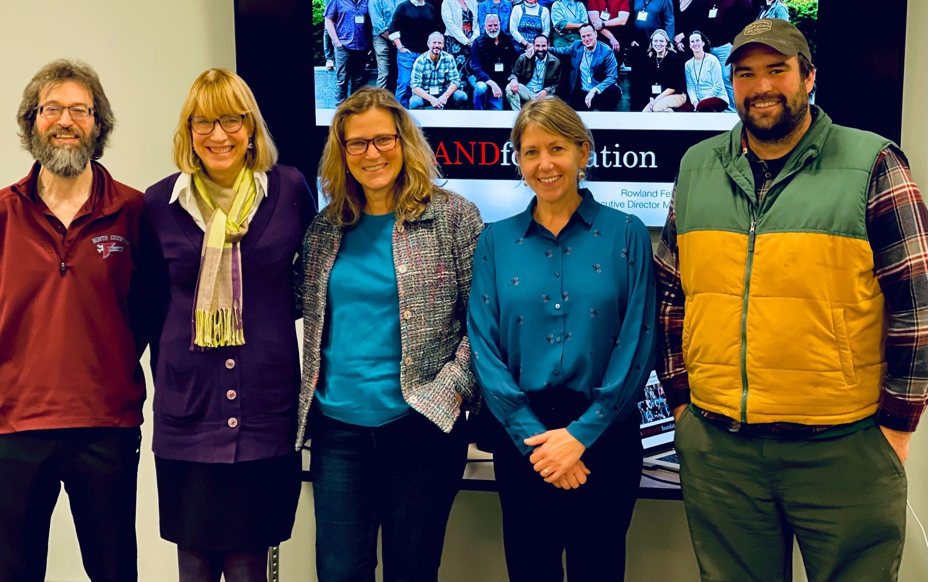
Sandra Mings-Lamar (RF16) co-hosted a Rowland Fellowship Info Night with Mike Martin in St. Johnsbury, which attracted teachers from around the Northeast Kingdom.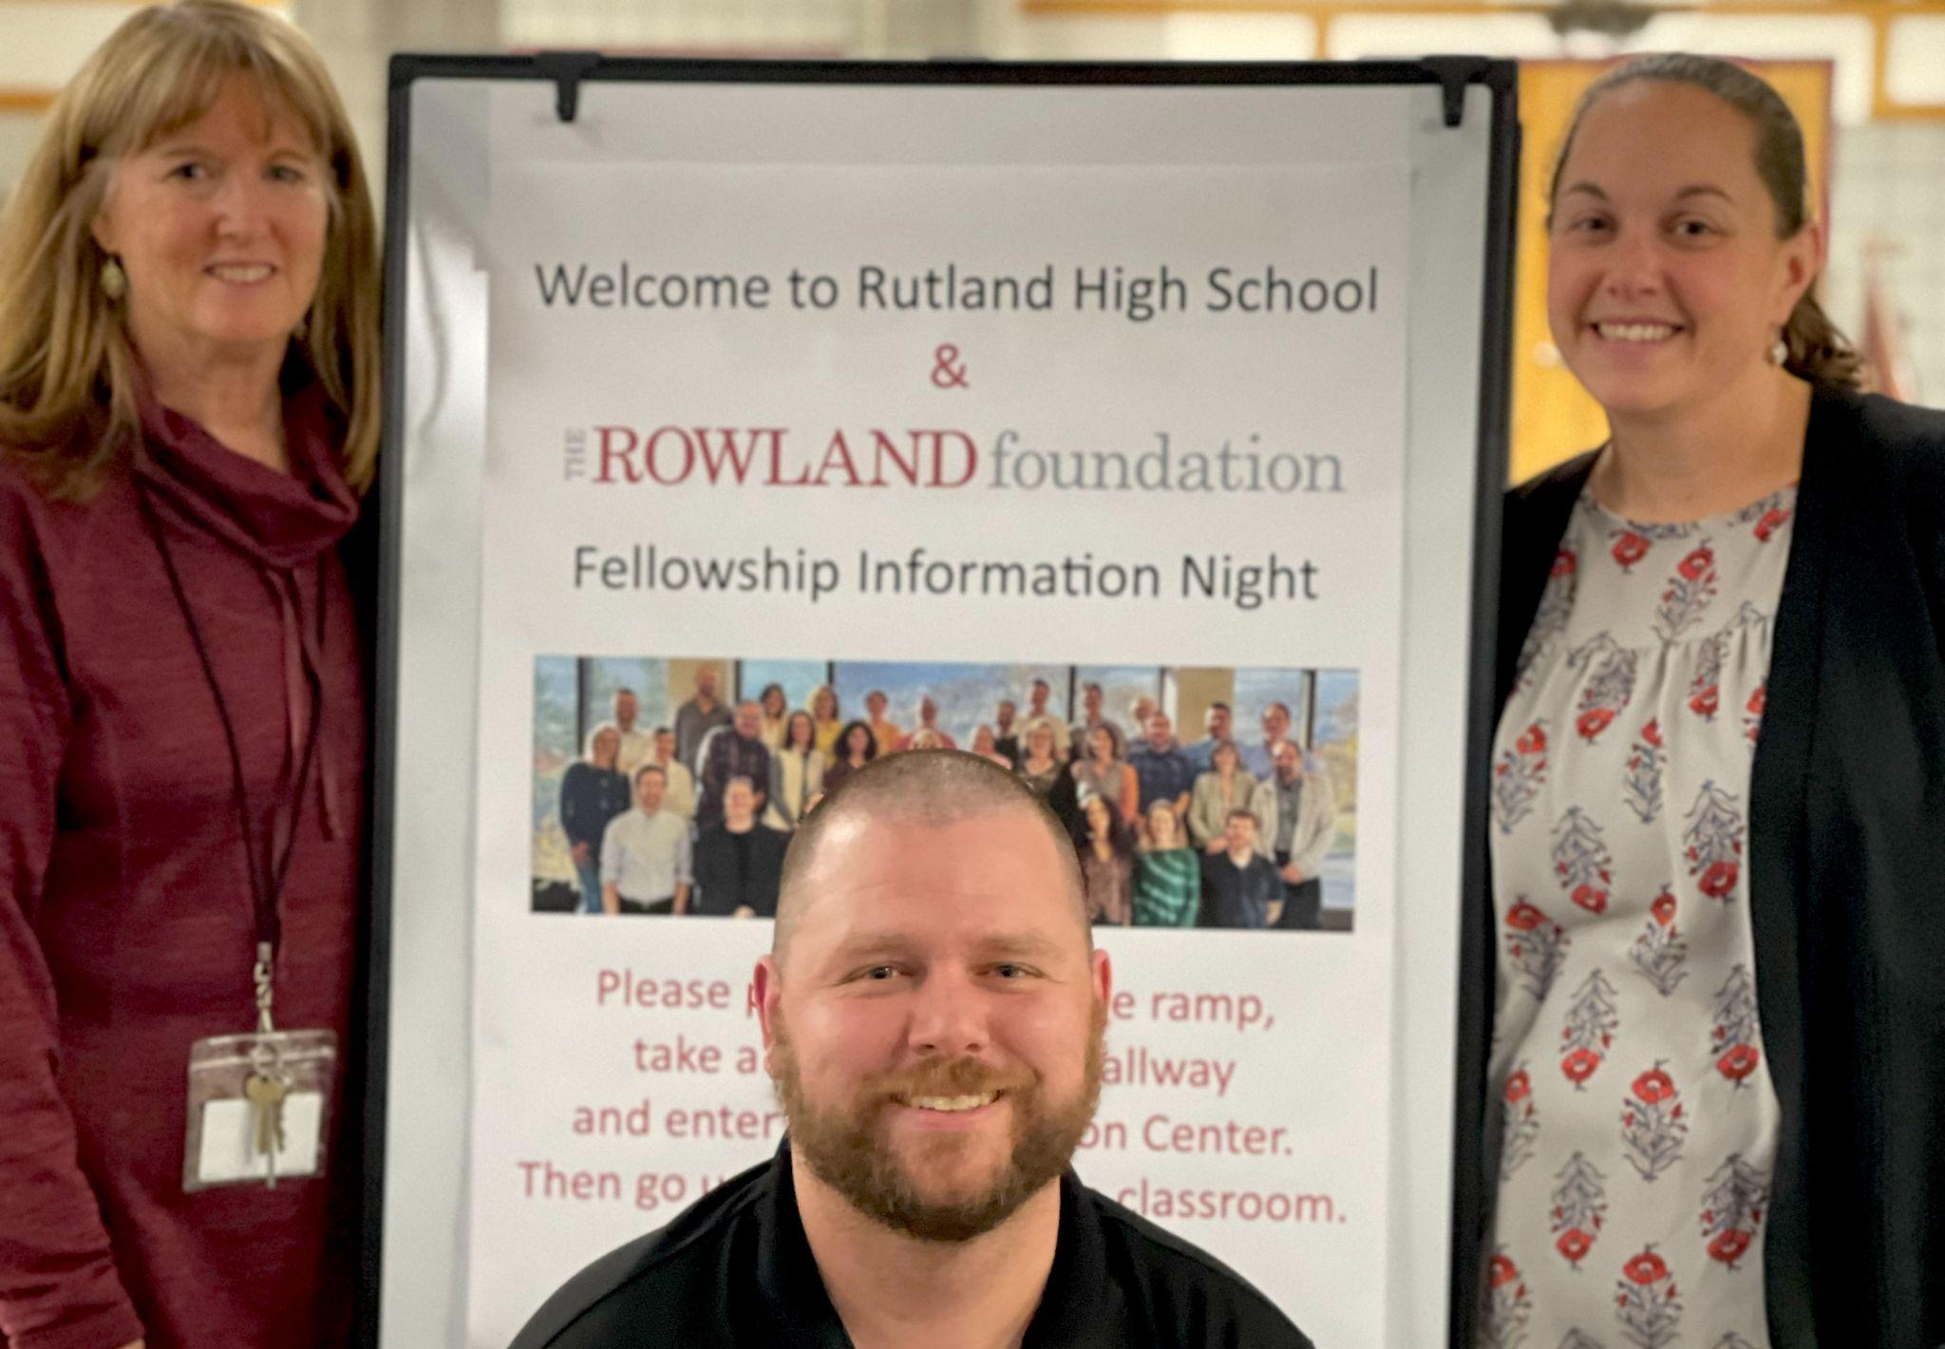
Bianca McKeen (RF16) co-hosted a Rowland Fellowship Info Night with Mike Martin in Rutland. Bianca seen here welcoming participants with her Fellowship Partner Jennifer Wigmore (RF16) and Devon Karpak (RF22).
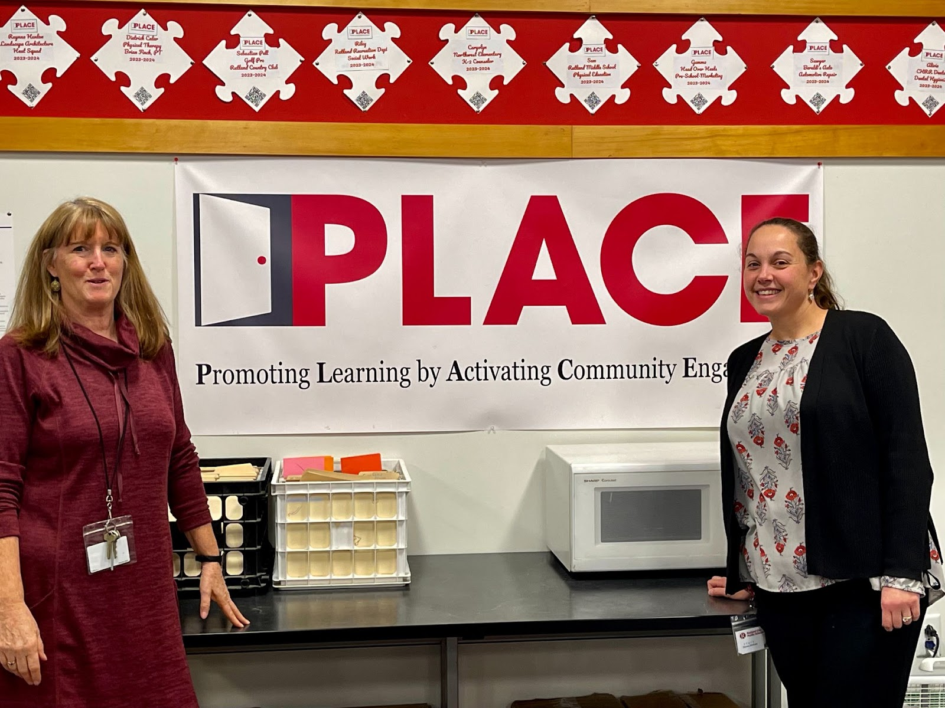
Rutland High School Associate Principals Jennifer Wigmore (RF16) & Bianca McKeen (RF16) are seen here in the PLACE meeting room at their school with student community “PLACEments” displayed above the poster. PLACE is the result of Jen and Bianca’s Rowland Fellowship work with Sarah Hagge (RF16) who now teaches at Woodstock Union High School.

2022 Cohort Meeting in Northfield
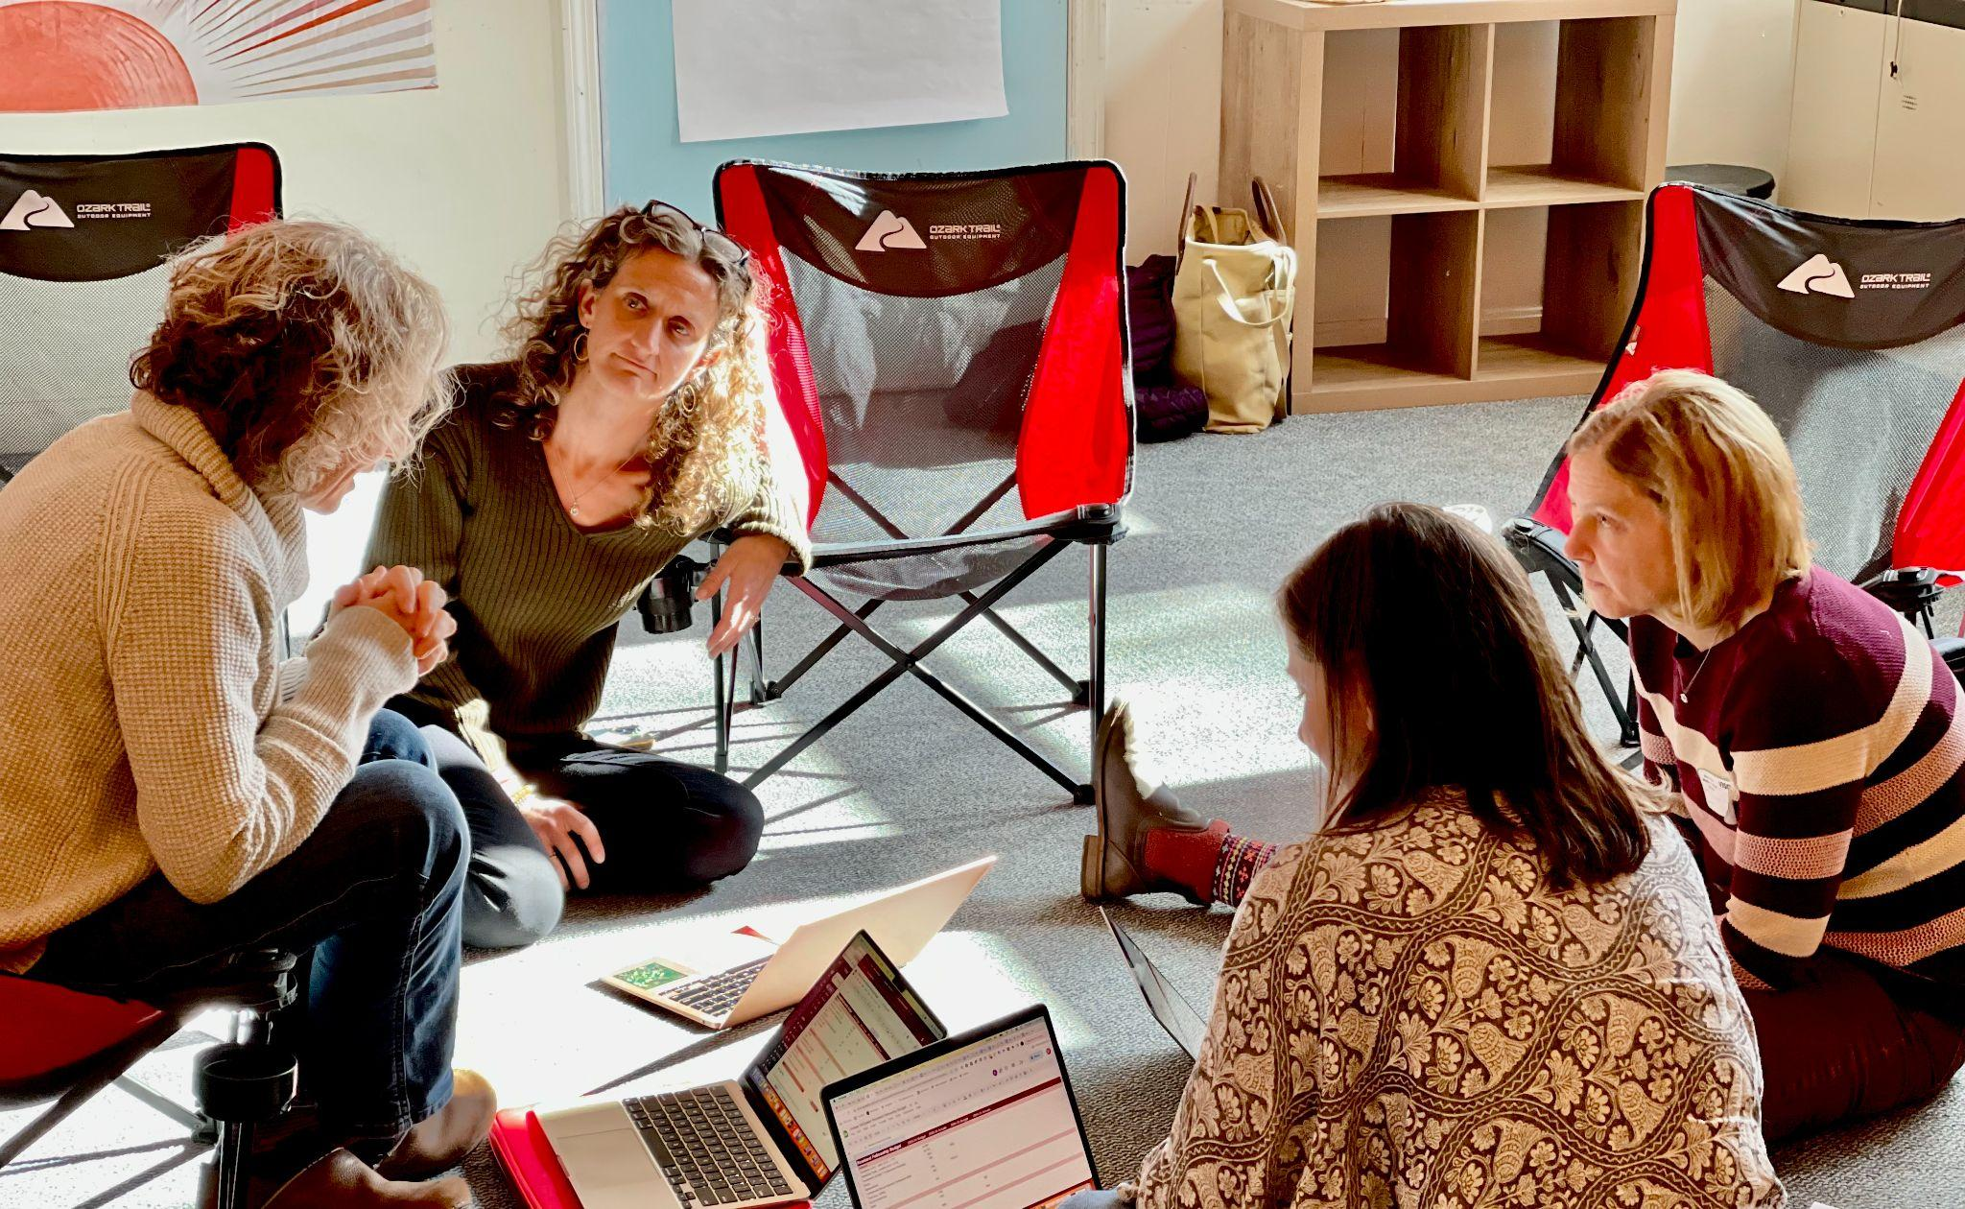

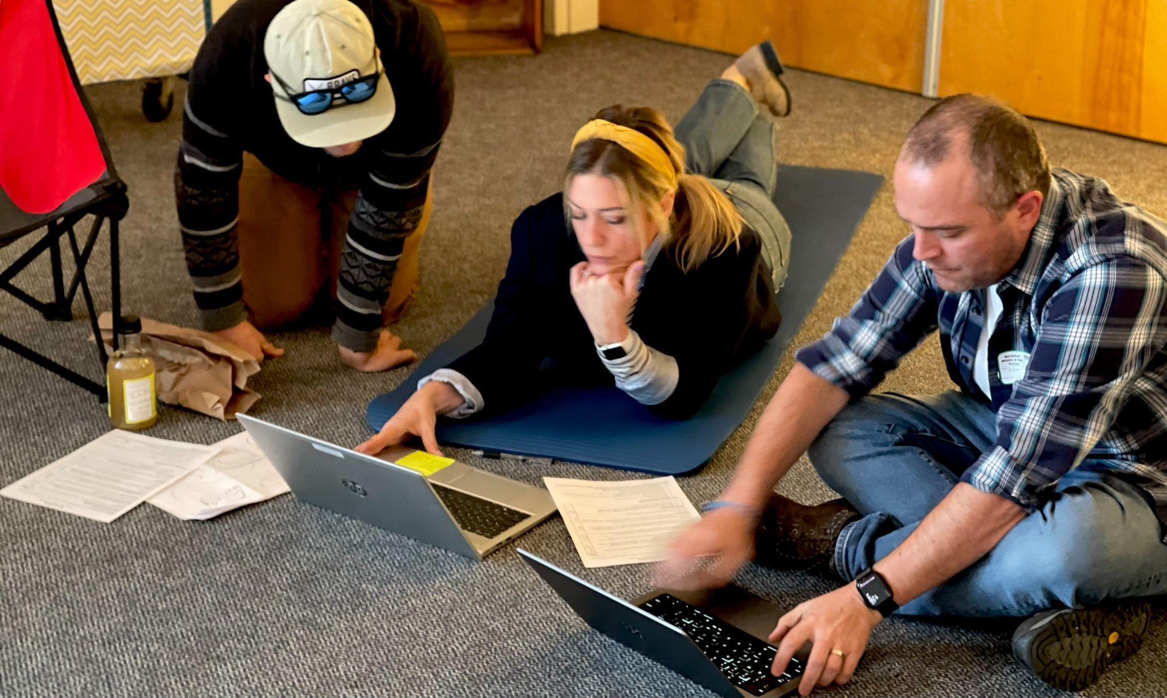
Luke Foley (RF19) joined part of the 2023 Rowland Fellows Cohort meeting hosted by Carrie Gilman (RF23) in Northfield, which included a restorative circle led by students.

2023 Cohort Meeting at North Country
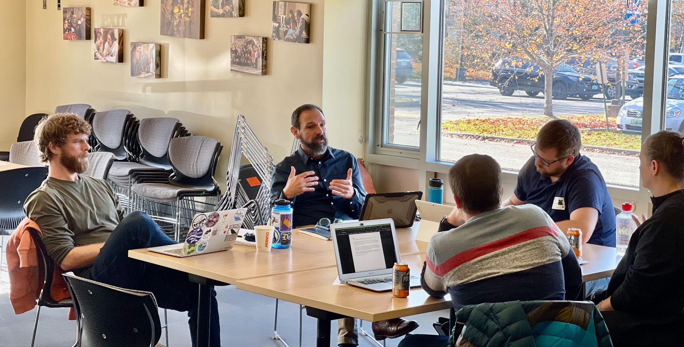

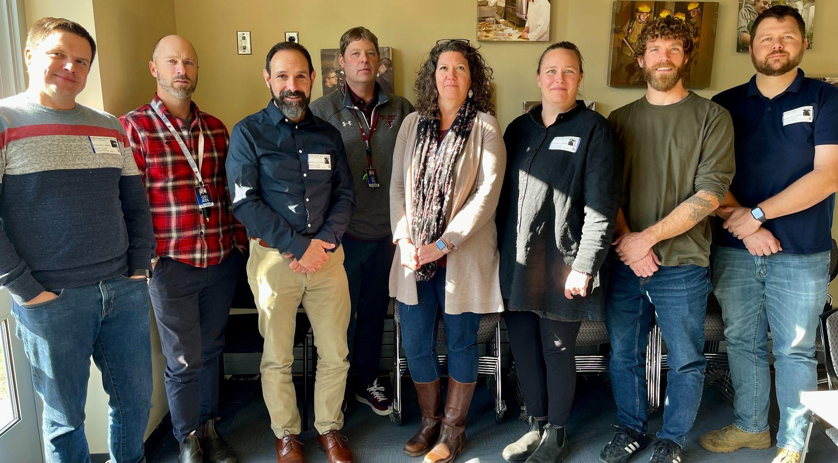
School leaders joined the 2022 Rowland Fellows Cohort for lunch at their recent meeting at North Country High School. Seen here (left to right) Sam Bromley (RF22), Asst. Director of Learning Design Michael Moriarty, Senior Rowland Associate Jean Berthiaume (RF09), Principal Chris Young, Director of Learning Design Jessica Applegate, Becky Ebel (RF22), Bryan Dickinson (RF22) & Devon Karpak (RF22).

Collaborative Practices for Equity Course
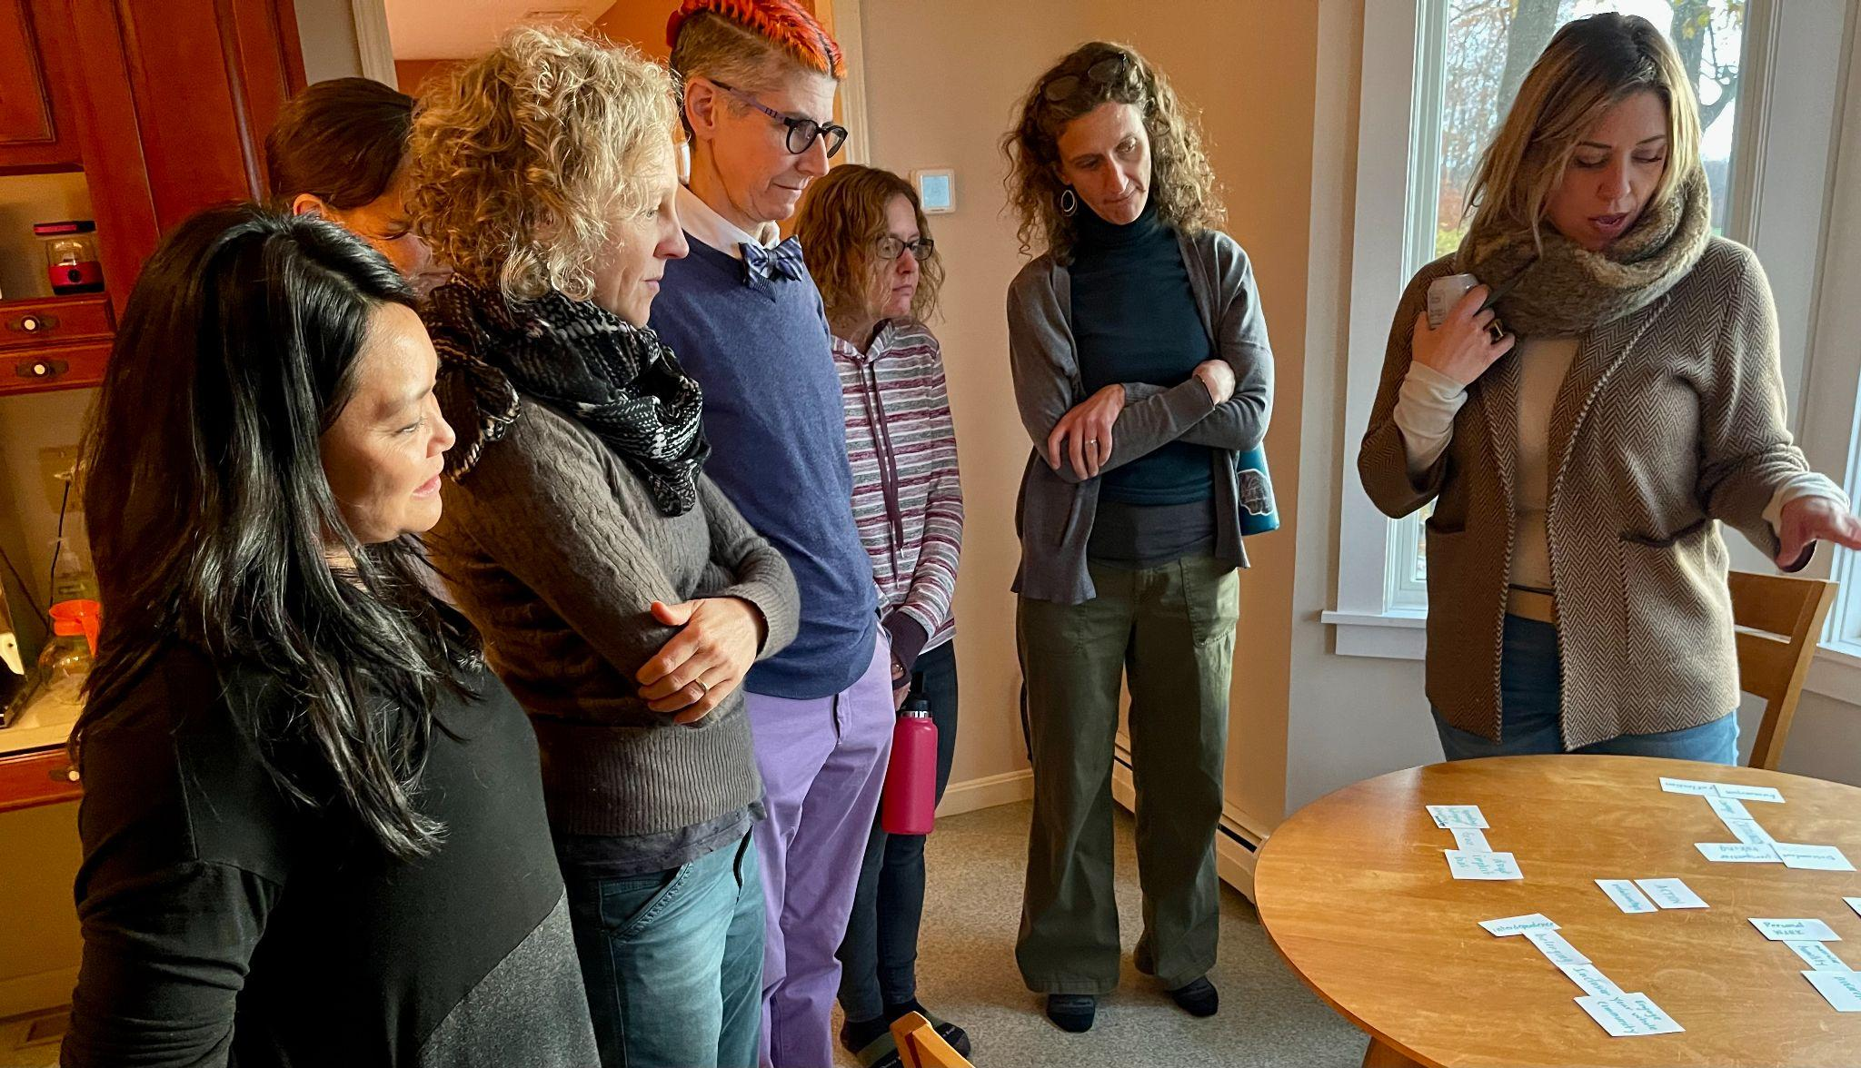
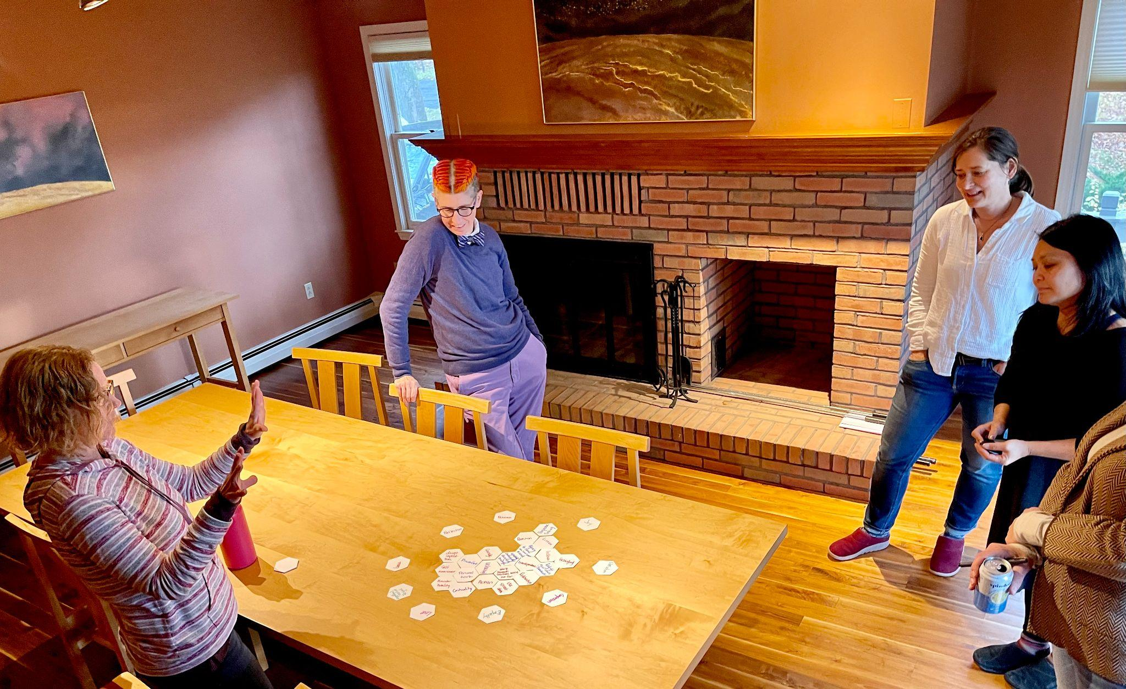

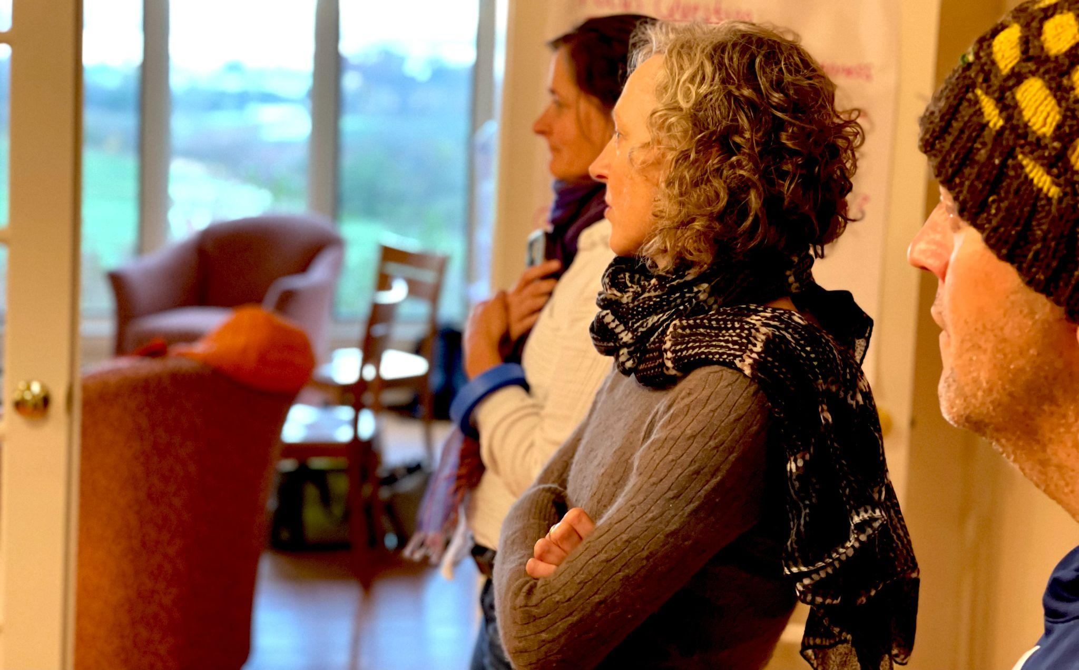
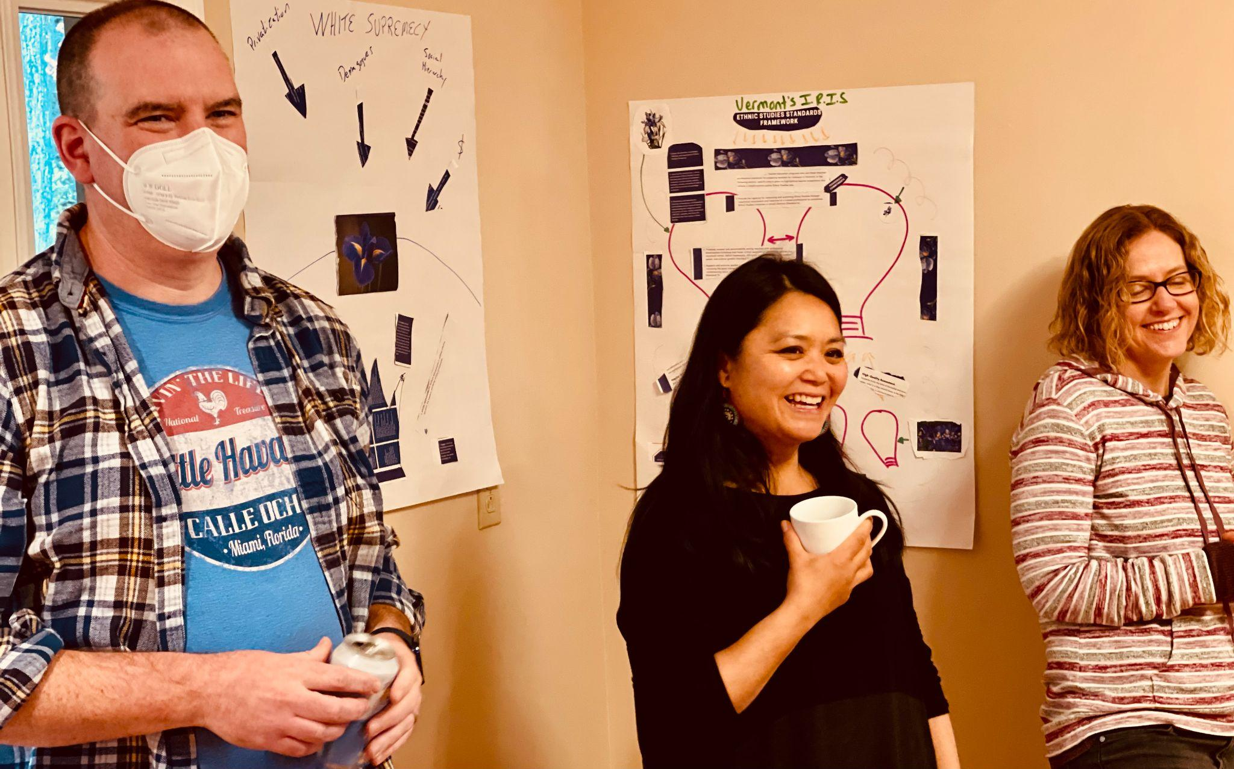

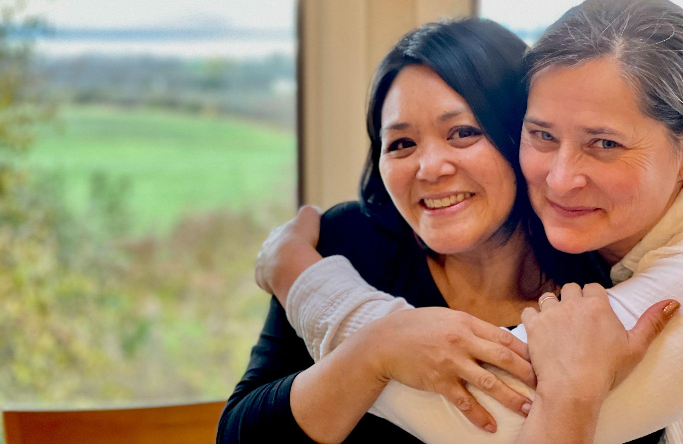
The 2023 Rowland Fellows Cohort marked the end of the Collaborative Practices for Equity course with DEW Scholar Esther Charlestin and Edmunds Middle School Steering Committee Member Jordan Funke joining a wonderful day of learning at Shelburne Farms. The course was created and taught by Senior Rowland Associate Jeanie Phillips (RF14) with Aimee Arandia Østensen. All new Rowland Fellows take this course as a foundational cohort experience now. The course is made possible thanks to support from the Rowland Foundation, Great Schools Partnership & Shelburne Farms.

Celebrations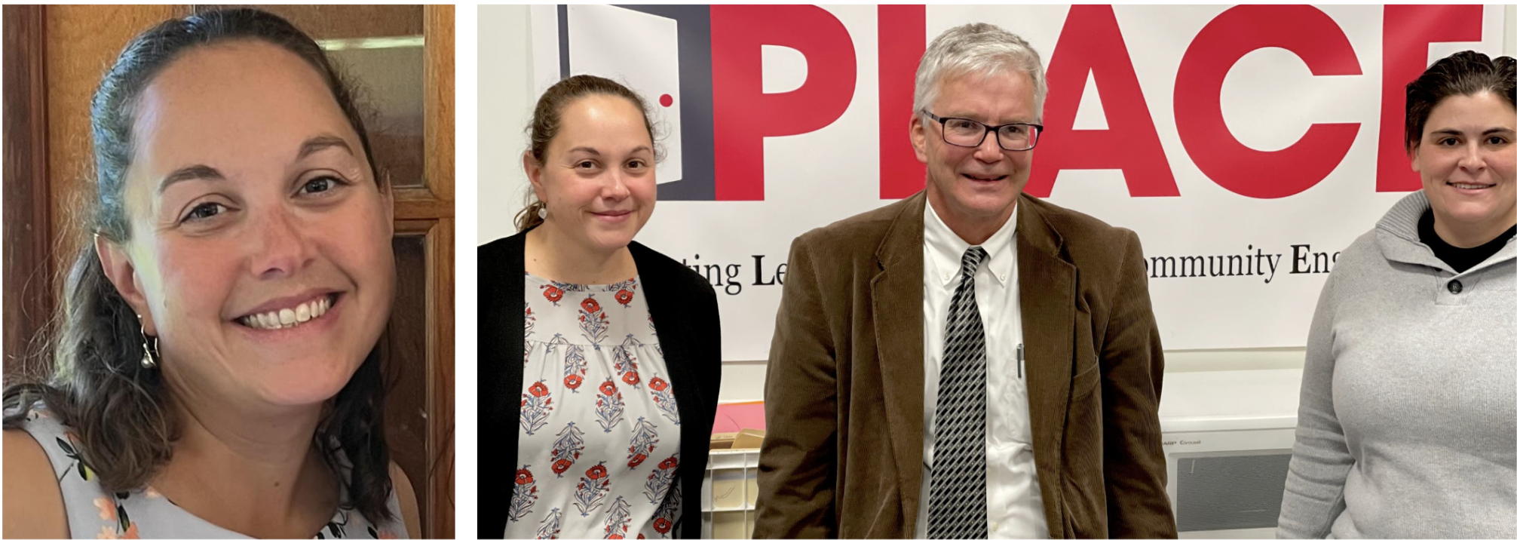
Bianca McKeen (RF16) has been named as the next Assistant Superintendent of the Rutland City Public Schools beginning July 1. Seen here with Superintendent Bill Olsen and Abby Bennett, Director of Student Engagement at Rutland Middle School, Bianca has worked as both a teacher and administrator K-12. Bianca has served as an Associate Principal at Rutland High School since 2020 and was the principal at Barstow Memorial School from 2018-2020. Prior to that work she was a science teacher in RCPS for 13 years. She has been a consultant, adjunct professor, and has taught theater in various summer and afterschool programs. Warmest congratulations on your new position, Bianca!

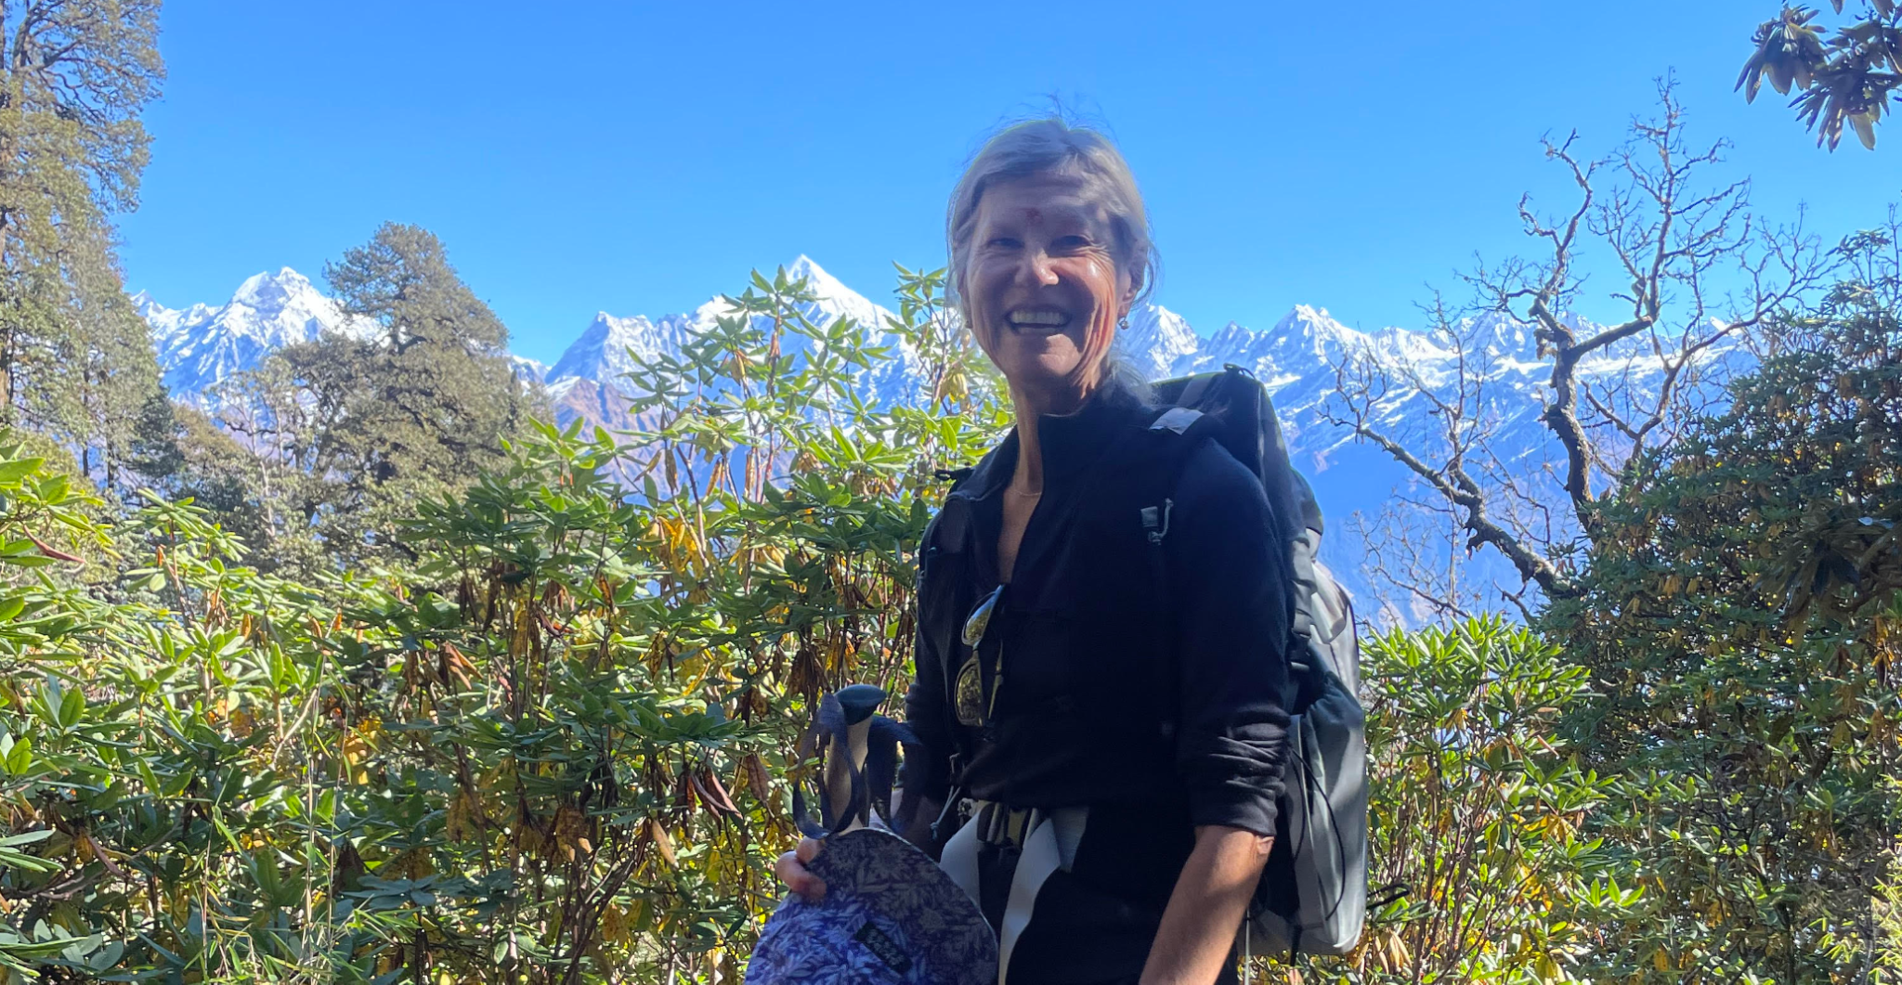


Kathy Cadwell (RF16) and Tara Cariano (RF18) have returned from northern India safe and sound as part of an exchange program with Harwood Union High School colleague Steve Rand and support from the U.S. Department of Education. From Vermont, it takes four days of travel each way to get to Himalayan Inter College, the small school in Chakouri that Harwood is going to partner with. Indian teachers are consulting with Harwood colleagues as they incorporate more student-driven inquiry and student-to-student dialogue into teaching and learning at their school.

Courtesy Postings
Do you identify as a woman? Are you looking for a mid-year retreat? Tara Cariano (RF18) is co-leading TWO beautiful upcoming retreats for individuals who identify as a woman: Hygge Weekend Hideaway: A Soul Sisters Retreat, January 12th-14th in the woods of New Hampshire and Disconnect to Reconnect : a Goddess Women’s Rejuvenation Retreat February 24th-March 1st in Ocotal, Guanacaste, Costa Rica. Invest in YOU for your February break! More information can be found here or reach out to Tara directly for more information at taracariano@gmail.com

Building Authentic Performance Assessments for Learning
Audience: Curriculum Directors, Principals, and Grades 9 – 12 Educators
The Agency of Education in collaboration with Great Schools Partnership is seeking 9th through 12th grade teachers interested in working with a cohort of educators to develop, pilot, and refine content-specific performance assessments. In January 2024, cohorts will form to develop performance assessments that align with the Priority Performance Indicators outlined in the Proficiency-Based Graduation Requirement Hierarchies. Educators will work within their preferred content area to develop performance assessments, facilitator guidelines, and supporting rubrics. If you are interested in developing assessments that will be made available statewide, please complete this brief form providing an overview of your preferences and experiences. Contacts: Pat Fitzsimmons at pat.fitzsimmons@vermont.gov and Erica Wallstrom at ewallstrom@greatschoolspartnership.org

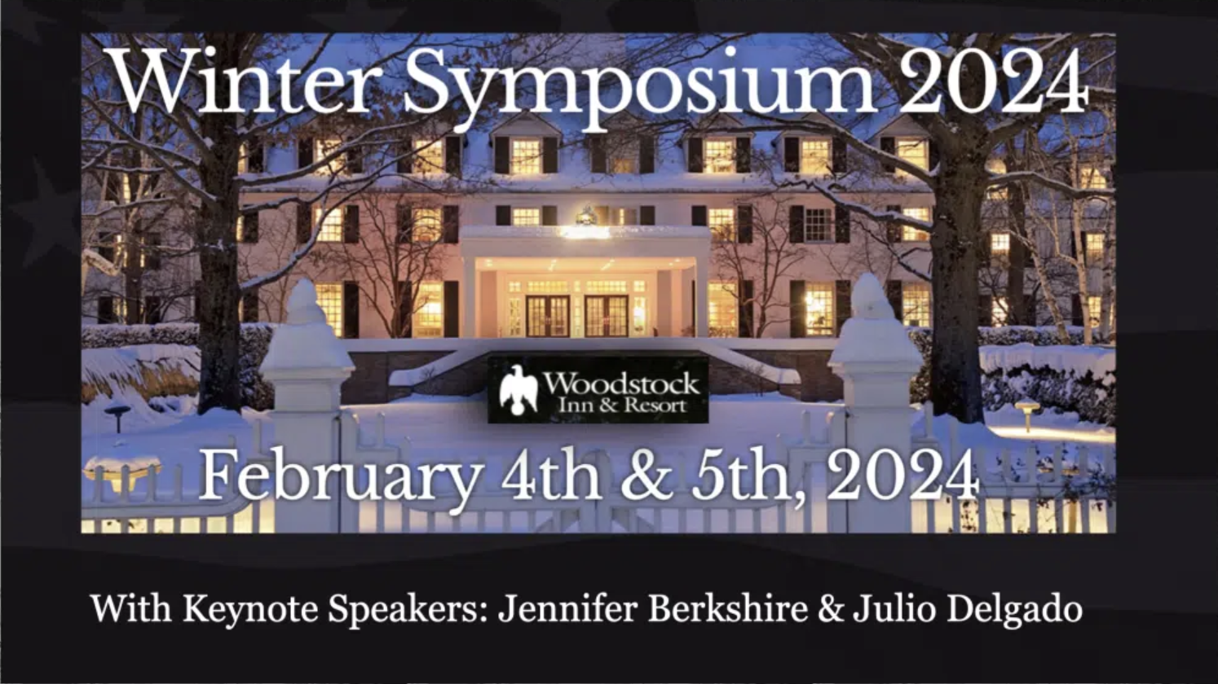
Join colleagues from around the state at the beautiful Woodstock Inn for the VPA 2024 Winter Symposium, Learn More & Register Here. Discounted Room Reservations now open to book.

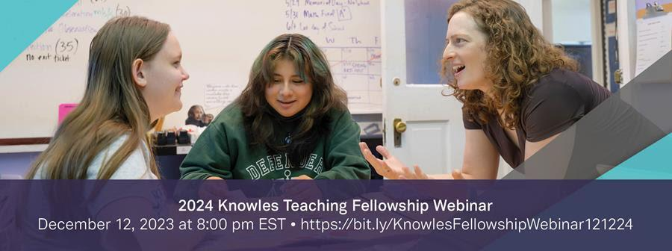
The Knowles Teaching Fellows Program is a five-year program that supports early-career, high school mathematics and science teachers in their efforts to become great teachers who lead from the classroom. Knowles Teaching Fellows have access to invaluable resources, including membership in a national community of more than 500 math and science teachers who are committed to supporting all students, mentoring and coaching from experienced educators and access to more than $50,000 in financial support, including stipends and grants for professional development and classroom materials.

If you know a first-year, second-year or pre-service math, chemistry, physics, or biology teacher who would benefit from participation in an intensive and cohesive professional development program, please use the buttons below to share this message and encourage them to apply for a Fellowship.

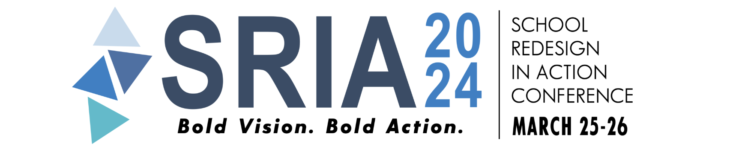
The annual conference School Reform In Action (SRIA) will take place March 25-26, 2024 in Providence, Rhode Island with keynote speaker Dr. Jamila Dugan. The deadline for workshop proposals is November 15th. Click here for more information.

